1. Advanced Calculation: Aggregate Dimension:

(1). Aggregate dimensions using max, min, count, count distinct, attribute (Sales Amount and Color);

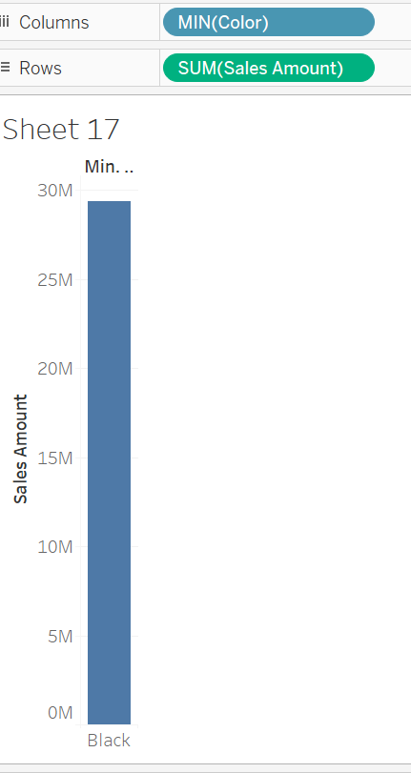

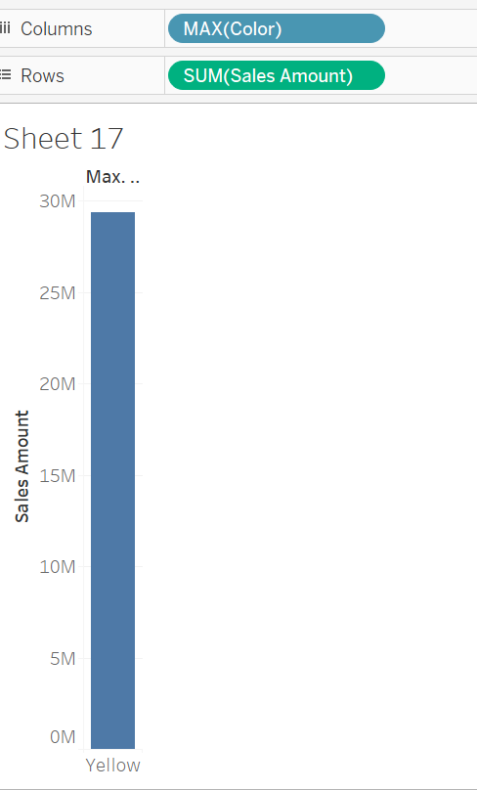

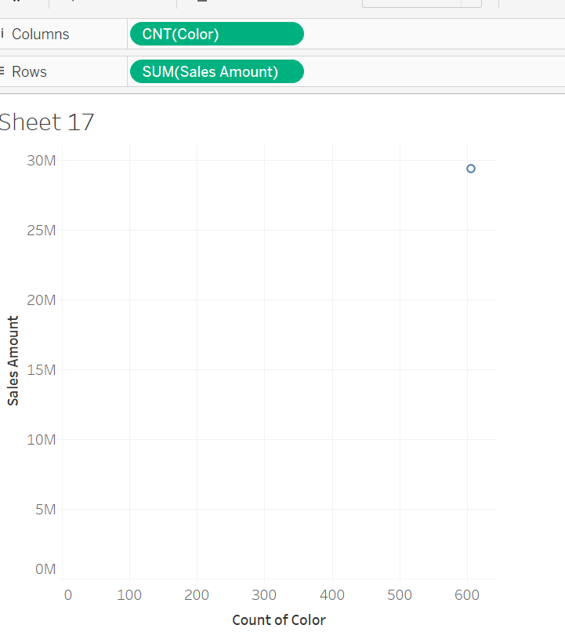

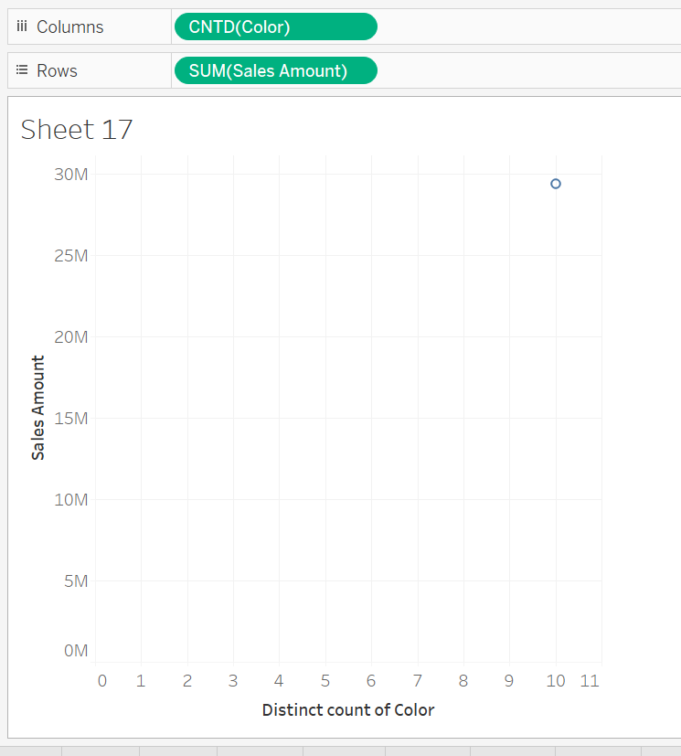

(2). Create a new field: Profitable (avg of unit profict) by Product Line, categorizing product lines into two levels: Profitable and Non-profitable:

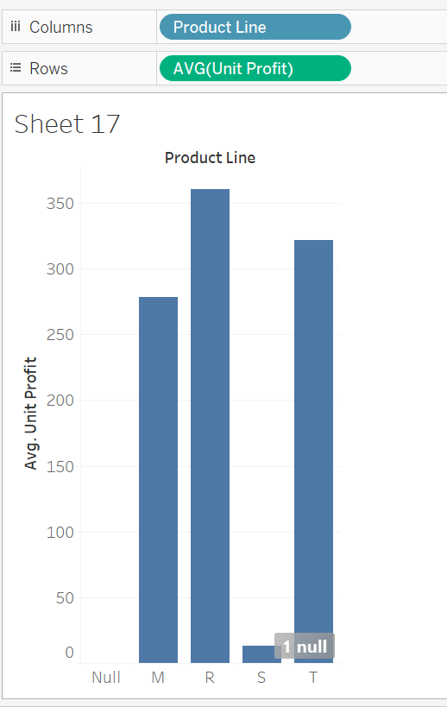

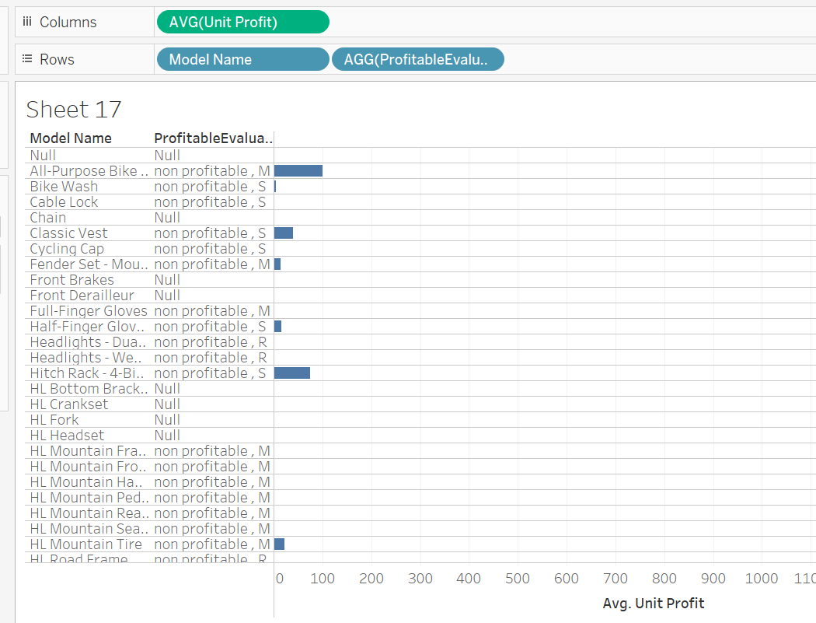

Question 3:

You would like to know the number of unique codes are in your sales region. Which aggregation would you select?

a. Count distinct;

b. Attribute;

c. Minimum;

d. Maximum;

2. Union data and merge fields:

Use nuts data;

(1). Union all the tables (almonds, hazelnuts, macadamias, pistachios, walnuts) into one data source;

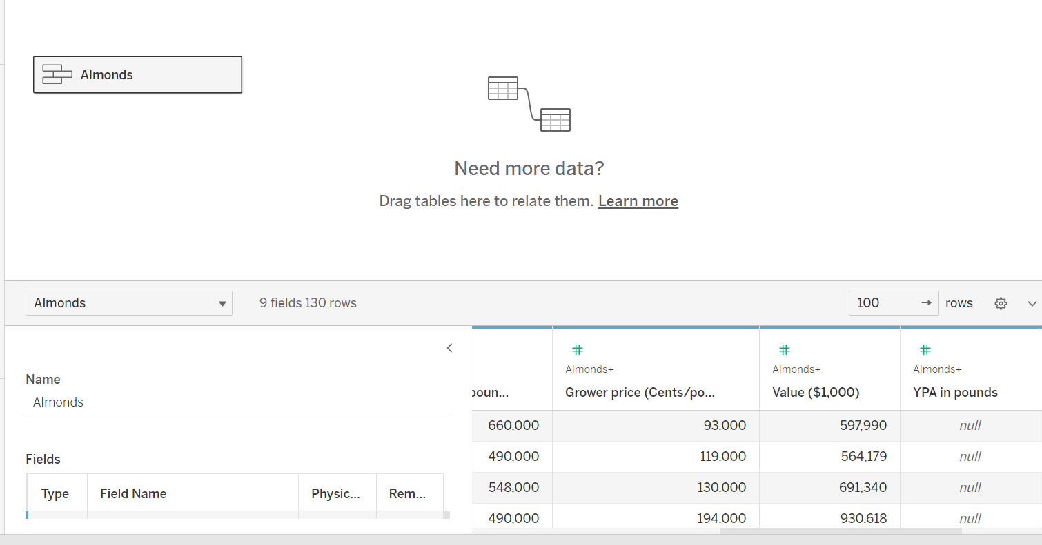

(2). Merge fields that are not correctly identified, and rename the columns that are misidentified;

Merge and without rename

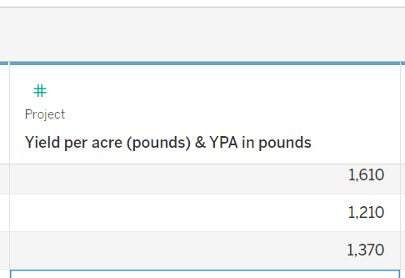

After rename

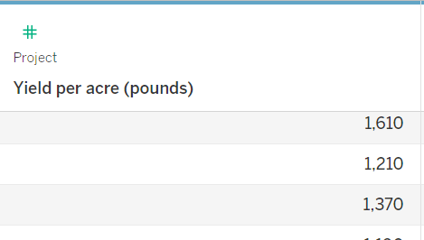

3. Showing statistics and forecasting: use the analytics pane and trend lines:

(1). Build a trend line between weight and standard cost, enable confidence interval, are the correlation coefficient between these two facts significant?

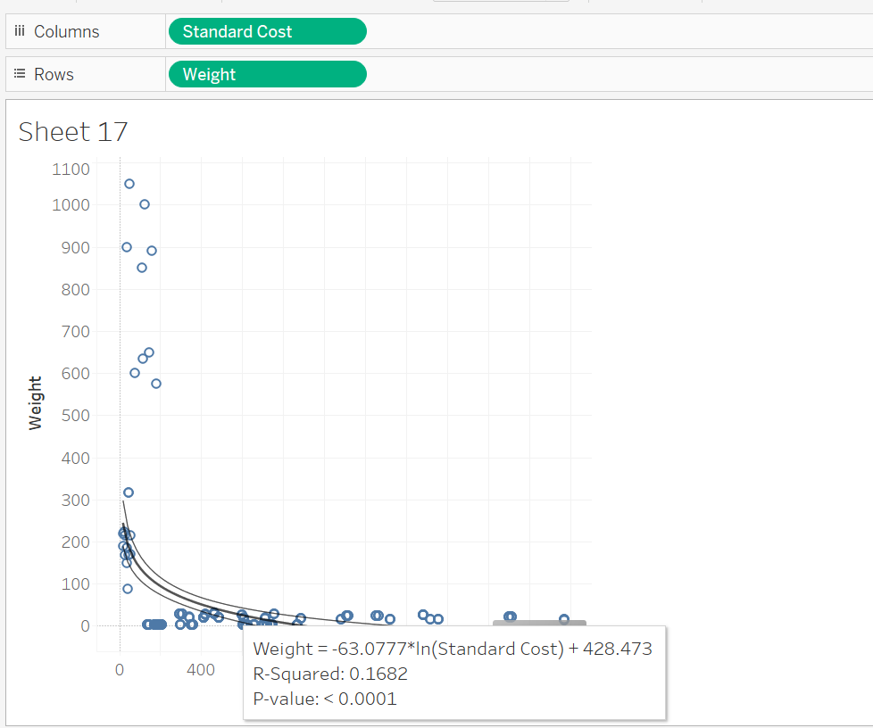

Yes both of them are significant because the p value is less than 0.05

(2). Generate a forecast in the View: build a forecast line to predict the sum of sales amount in 2015 (order date);

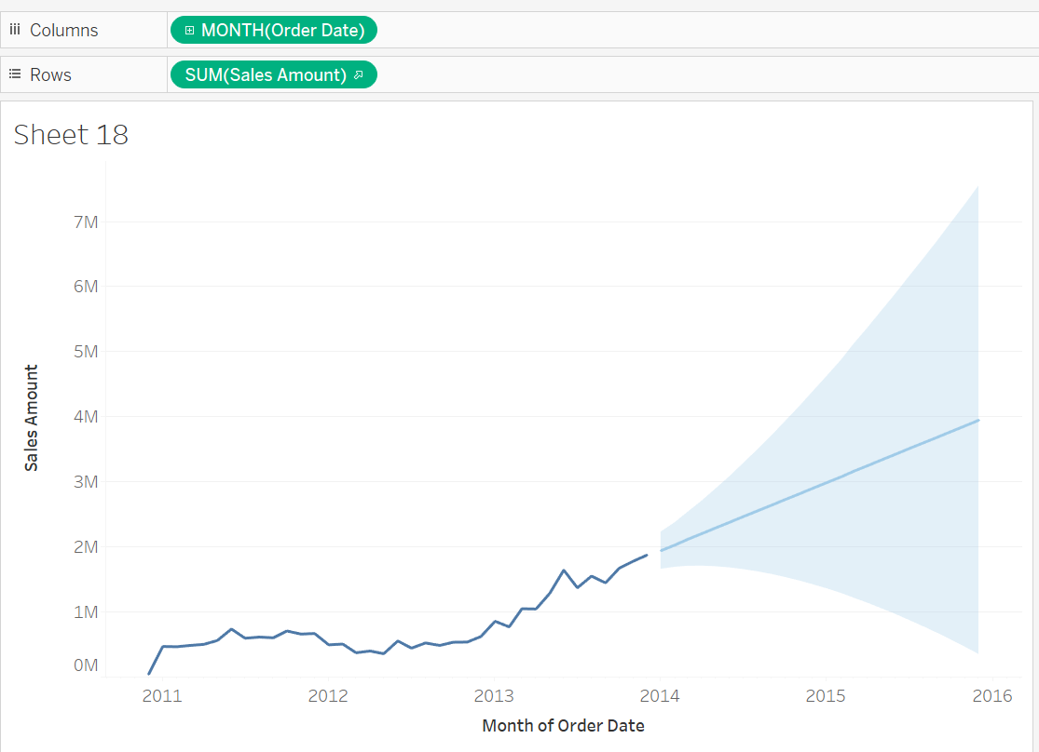

4. Find Clusters in Data:

(1). Find clusters in the scatterplot of weight and product cost from production dimension; How many clusters are generated automatically? Distinguish these clusters using different colors;

4 number of cluster are generated automatically. Also they are shown in different colors.

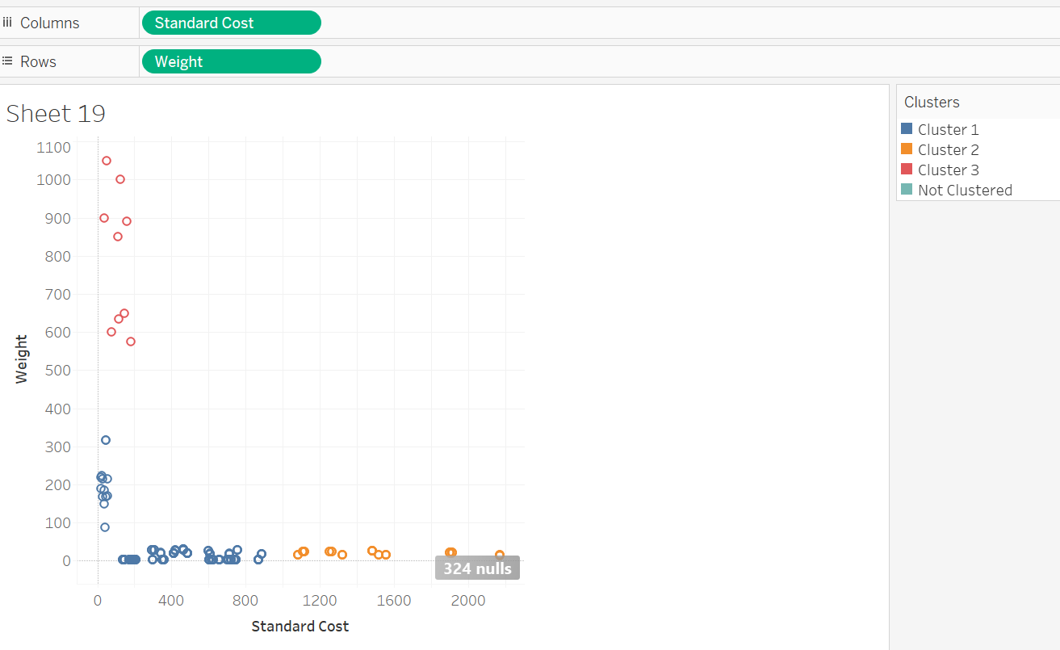

(2). Display only cluster 1 and cluster 2 in the view; Save clusters as groups in the data field, and rename the groups;

