1. Cross Table: Working with Totals and Aggregation:

(1). Add Grand Totals to the rows and columns, add all subtotals (Country, Product Line, Color and Sum of Sales);

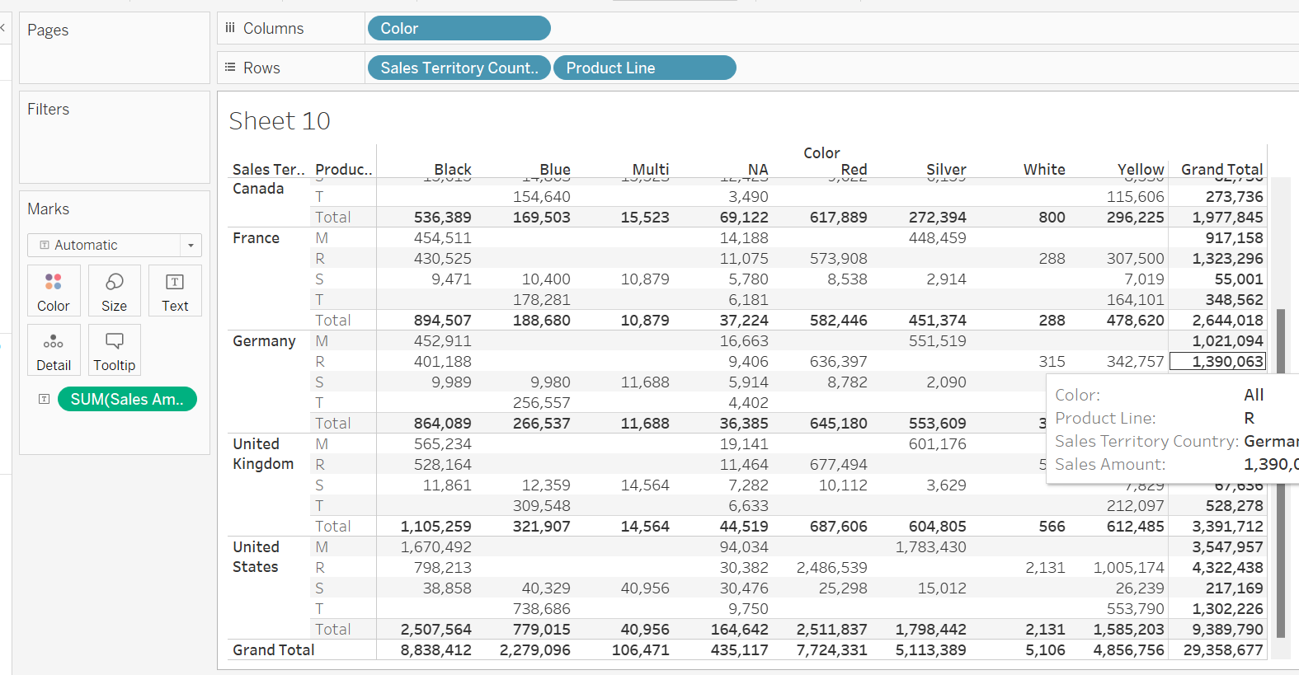

(2). Change the sum aggregation to the averages, and change the labels;

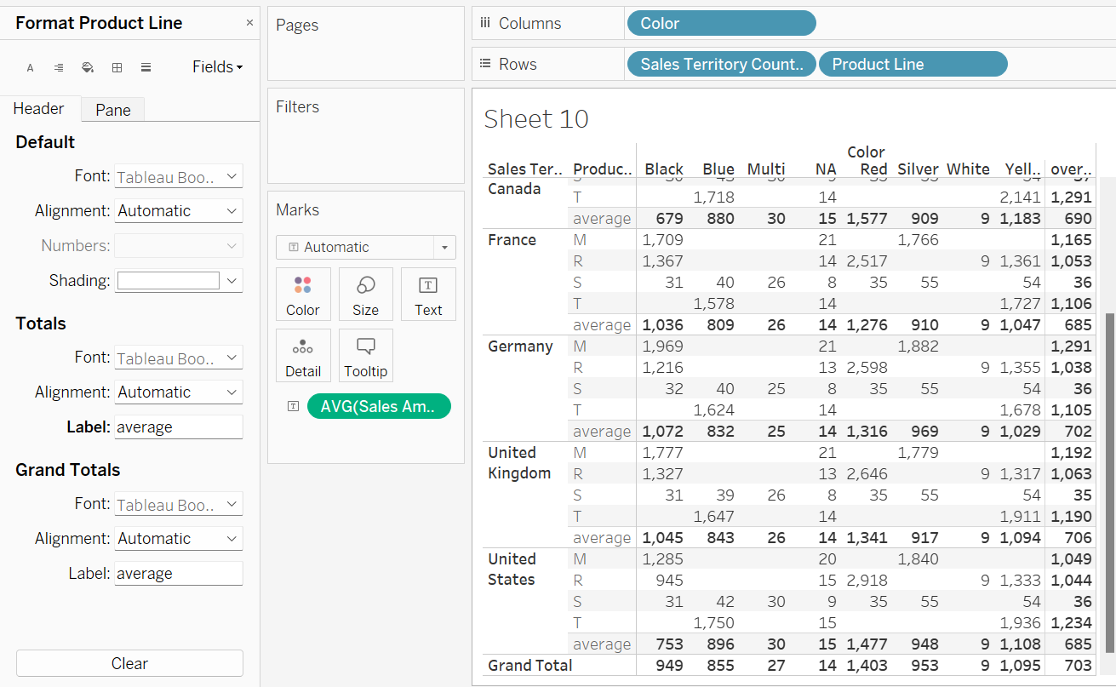

(3). Use “Total All Using” to average the values in the View;

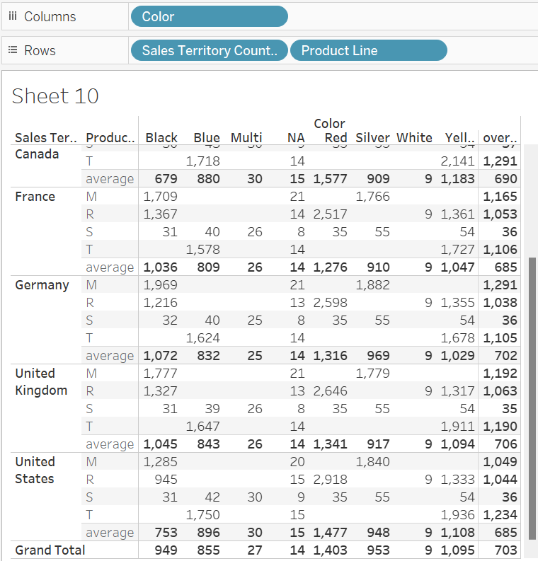

2. Cross Table: Creating Highlight Tables and Heat Maps:

(1). Create highlight table highlighting the Sum of Order quantity ordered from different model names from different customers: Set color center to 10.

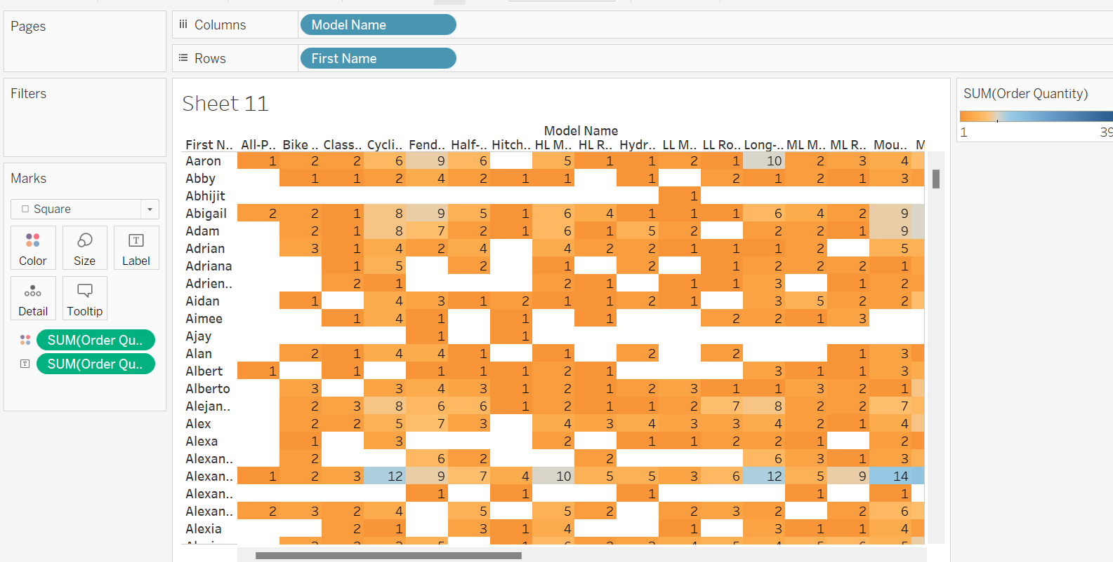

(2). Create a heat map in the crosstab to compare the product cost and unit price in different regions from different product line.

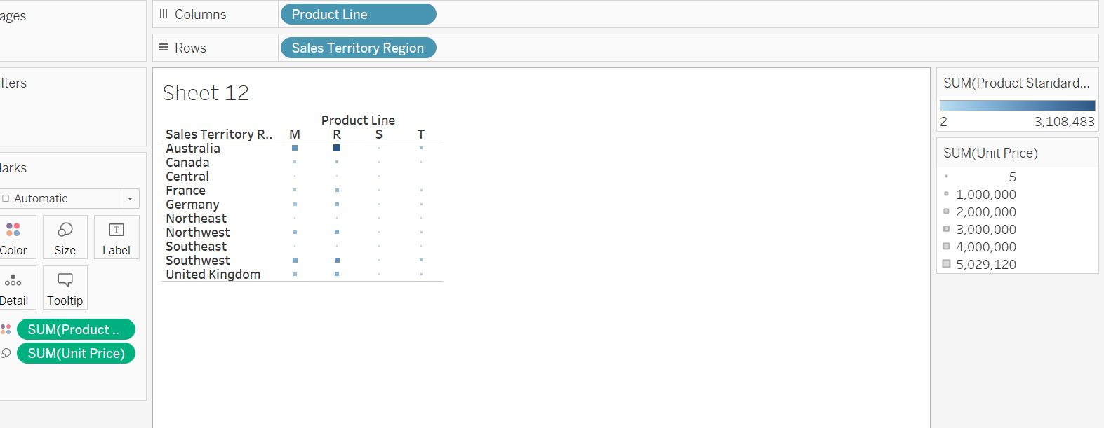

3. Create the calculated fields:

(1). Create the calculated fields: Unit profit = unit price – product standard cost; Total profit = unit profit \* order quantity; Profit Margin = total profit/sales amounts; Overall average profit margin = average (total profit)/ average (sales amounts);

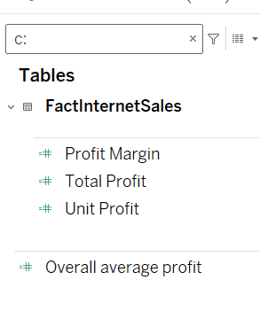

(2). Compare the average of profit margin and overall average margin profit by the product line;

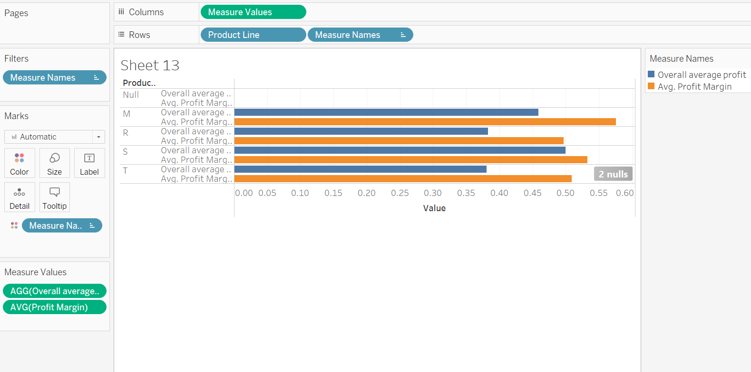

4. Create Calculations using strings, mix types, and date functions:

(1). Create a “Customer Full Name” field that concatenate “First Name”, “Middle Name” and “Last Name”;

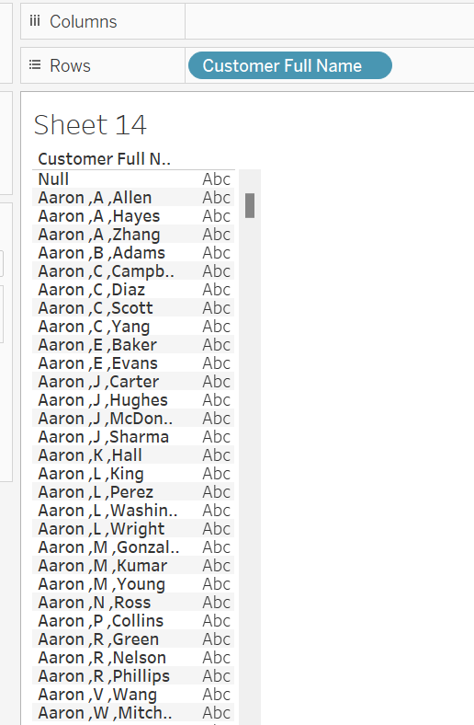

(2). Create a concatenate field including “Customer Full Name” and yearly income;

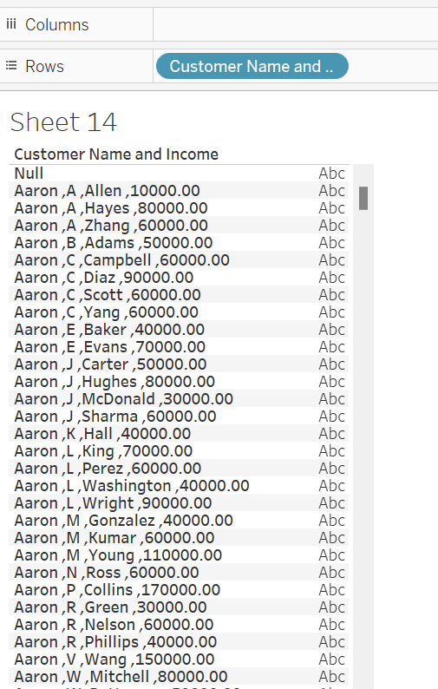

(3). Use the date difference function to calculate the date/month differences;

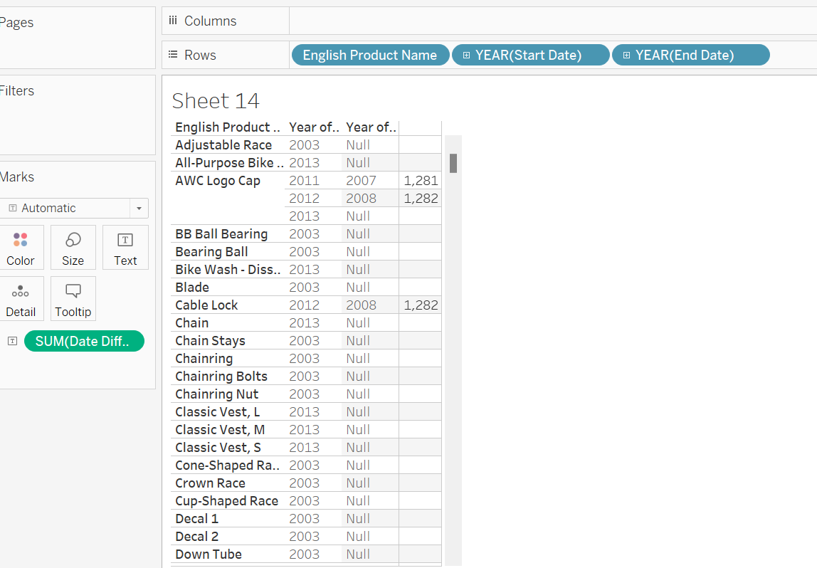

5. Running total and percentage of the total:

(1). Create the running total and percentage of the total using pane across (Due Date, Product Line, Color and Sales Amount;

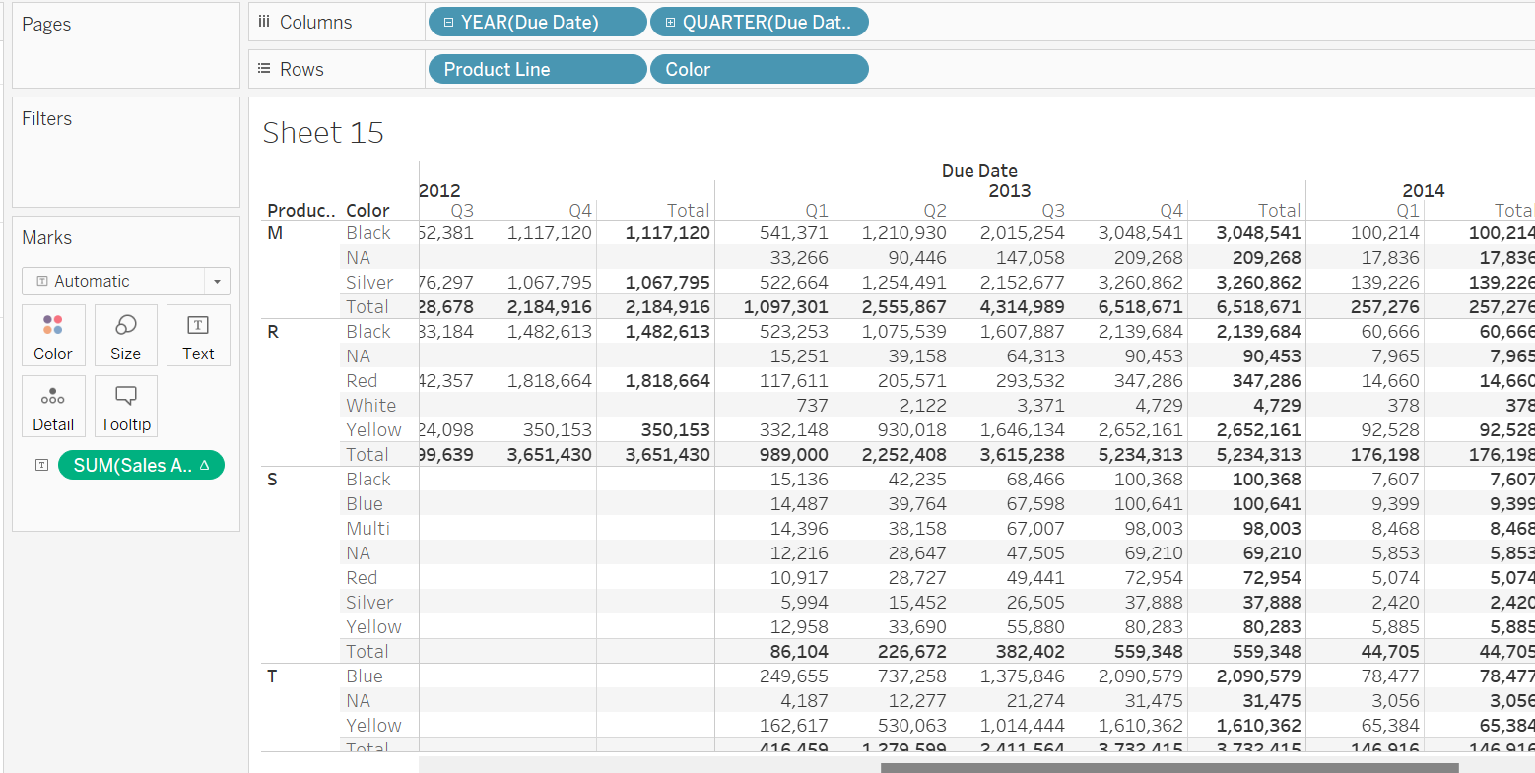

Pane is the category (not the subcategory, not the entire table)

Pane across (from left to right), category is year, subcategory is quarter

Pane is unit of analysis

Table across (all four year is one unit of analysis) from left to right

Table down (from top to bottom) (all product lines is one unit of analysis)

Pane down (from top to bottom)(each product line is one pane/unit)

(2). Create ranks using quick table calculation (Country, Region, and Profit);

Question 1:

This table shows a quick table calculation using percent of total. How was it computed?

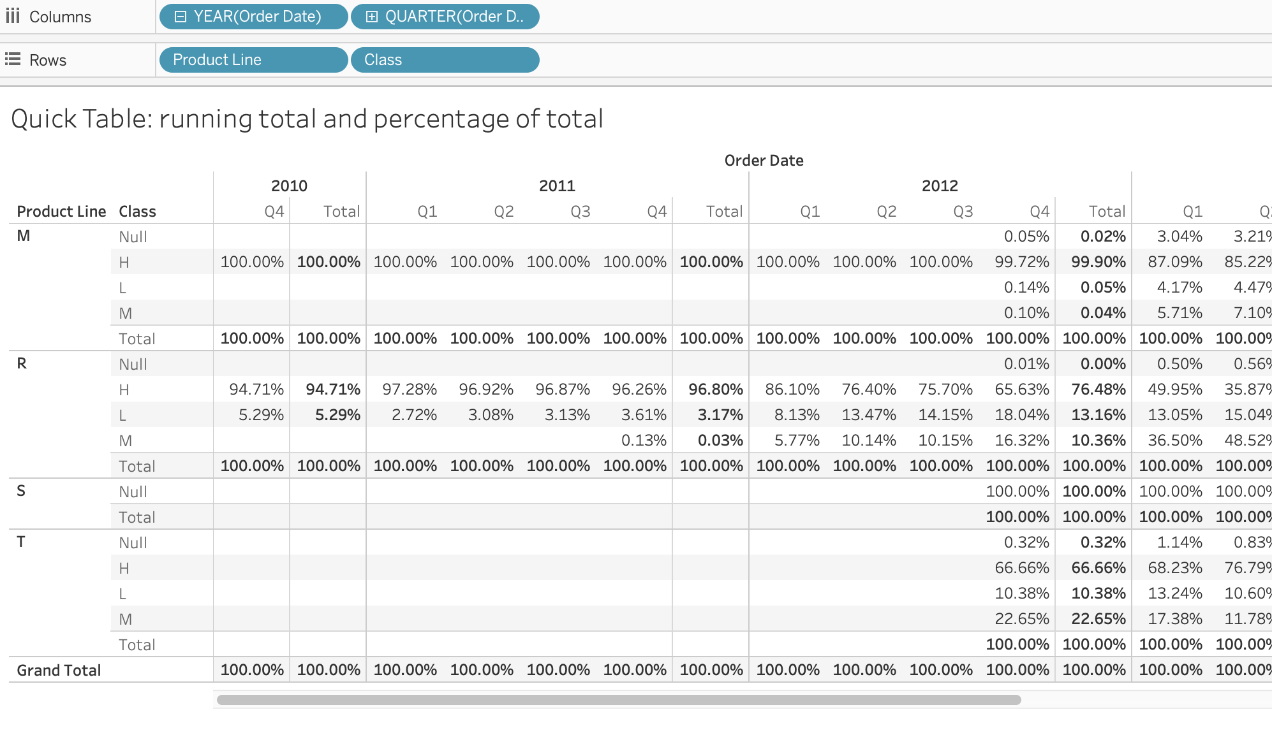

a. Table (across)

b. Table (down)

c. Pane (across)

d. Pane (down)

Question 2:

The table calculation has a compute using value of Table. If we change the value to Cell, what do you expect the outcome to be?

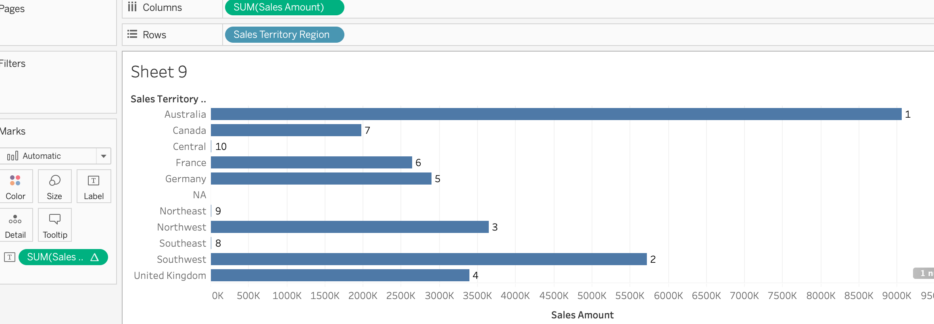

a. All regions are ranked as 1;

b. Each region is ranked against all other cells;

c. Countries are ranked against the countries in their region;

d. Regions are ranked by their best year.