Computer Networks Lab

**Name:** S. Vishwajith

Assignment-10

**Register Number:** 23BCE1145

1.

**Question:**

## Develop a multi client UDP application in which client sends a number and server receives it and count the number of digits in it and send the same to the corresponding client.

**Code:**

Server:

import java.net.*;

public class Server1_23BCE1145 { public static void main(String[] args) {

final int SERVER_PORT = 12345; DatagramSocket serverSocket = null; try {

serverSocket = new DatagramSocket(SERVER_PORT); System.out.println("UDP Server is running on port " + SERVER_PORT);

byte[] receiveBuffer = new byte[1024];

while (true) {

DatagramPacket receivePacket = new DatagramPacket(receiveBuffer, receiveBuffer.length);

serverSocket.receive(receivePacket);

String receivedMessage = new String(receivePacket.getData(), 0, receivePacket.getLength());

System.out.println("Received from " + receivePacket.getAddress() + ":" + receivePacket.getPort() + " - " + receivedMessage);

String responseMessage = ((Integer.parseInt(receivedMessage)+"").length()) +

"";

byte[] sendBuffer = responseMessage.getBytes(); System.out.println("Sending response: " + responseMessage);

DatagramPacket sendPacket = new DatagramPacket(sendBuffer,

sendBuffer.length, receivePacket.getAddress(), receivePacket.getPort()); serverSocket.send(sendPacket);

}

}

catch (Exception e) { e.printStackTrace();

}

finally { serverSocket.close();

}

}

}

Client:

import java.net.*; import java.util.*;

public class Client1_23BCE1145 { public static void main(String[] args) {

final String SERVER_IP = "127.0.0.1"; final int SERVER_PORT = 12345;

try {

DatagramSocket clientSocket = new DatagramSocket();

InetAddress serverAddress = InetAddress.getByName(SERVER_IP); Scanner scanner = new Scanner(System.in);

while (true) {

System.out.print("Enter number: "); String message = scanner.nextLine();

if (message.equalsIgnoreCase("exit")) { break;

}

try{

Integer.parseInt(message);

}

catch (NumberFormatException e) { System.out.println("Invalid input. Please enter a number."); continue;

}

byte[] sendBuffer = message.getBytes();

DatagramPacket sendPacket = new DatagramPacket(sendBuffer, sendBuffer.length, serverAddress, SERVER_PORT);

clientSocket.send(sendPacket);

byte[] receiveBuffer = new byte[1024];

DatagramPacket receivePacket = new DatagramPacket(receiveBuffer, receiveBuffer.length);

clientSocket.receive(receivePacket);

String response = new String(receivePacket.getData(), 0, receivePacket.getLength());

System.out.println("Number of digits(Server Response): " + response);

}

clientSocket.close(); scanner.close();

}

catch (Exception e) { e.printStackTrace();

}

}

}

# Output:

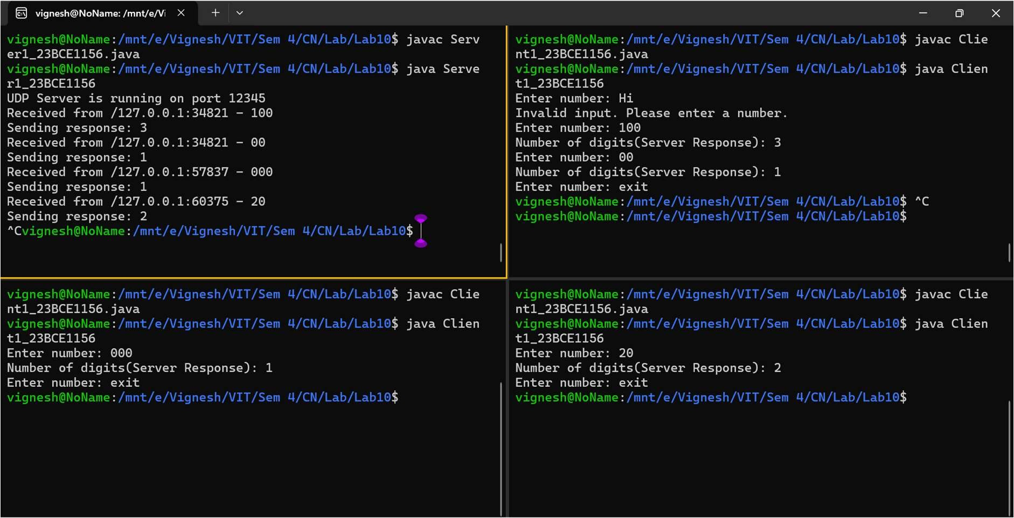

2.

**Question:**

Develop a minimal chat application using sinlge udp client server application.

**Code:**

Server: import java.net.*; import java.util.*;

public class Server2_23BCE1145{ public static void main(String[] args) {

final int SERVER_PORT = 12345; DatagramSocket serverSocket = null; Scanner sc=new Scanner(System.in); try {

serverSocket = new DatagramSocket(SERVER_PORT); System.out.println("UDP Server is running on port " + SERVER_PORT); while (true){

byte[] receiveBuffer = new byte[1024];

DatagramPacket receivePacket = new DatagramPacket(receiveBuffer, receiveBuffer.length);

serverSocket.receive(receivePacket);

String receivedMessage = new String(receivePacket.getData(), 0, receivePacket.getLength());

if (receivedMessage.equalsIgnoreCase("exit")) { System.out.println("Client has exited. Shutting down server."); break;

}

System.out.println("Message from Client:" + receivedMessage); System.out.print("Enter message (type 'exit' to quit): ");

String msg=sc.nextLine();

byte[] sendBuffer = msg.getBytes();

DatagramPacket sendPacket = new DatagramPacket(sendBuffer, sendBuffer.length, receivePacket.getAddress(), receivePacket.getPort());

serverSocket.send(sendPacket);

if (msg.equalsIgnoreCase("exit")) { break;

}

}

}

catch (Exception e) { e.printStackTrace();

}

finally{

serverSocket.close(); sc.close();

}

}

}

Client: import java.net.*; import java.util.*;

public class Client2_23BCE1145 { public static void main(String[] args) {

final int SERVER_PORT = 12345;

try {

DatagramSocket clientSocket = new DatagramSocket(); InetAddress serverAddress = InetAddress.getLocalHost(); Scanner scanner = new Scanner(System.in);

while (true) {

System.out.print("Enter message (type 'exit' to quit): "); String message = scanner.nextLine();

byte[] sendBuffer = message.getBytes();

DatagramPacket sendPacket = new DatagramPacket(sendBuffer, sendBuffer.length, serverAddress, SERVER_PORT);

clientSocket.send(sendPacket);

if (message.equalsIgnoreCase("exit")) { break;

}

byte[] receiveBuffer = new byte[1024];

DatagramPacket receivePacket = new DatagramPacket(receiveBuffer, receiveBuffer.length);

clientSocket.receive(receivePacket);

String response = new String(receivePacket.getData(), 0, receivePacket.getLength());

if (response.equalsIgnoreCase("exit")) { break;

}

System.out.println("Message from Server: " + response);

}

clientSocket.close(); scanner.close();

}

catch (Exception e) { e.printStackTrace();

}

}

}

# Output:

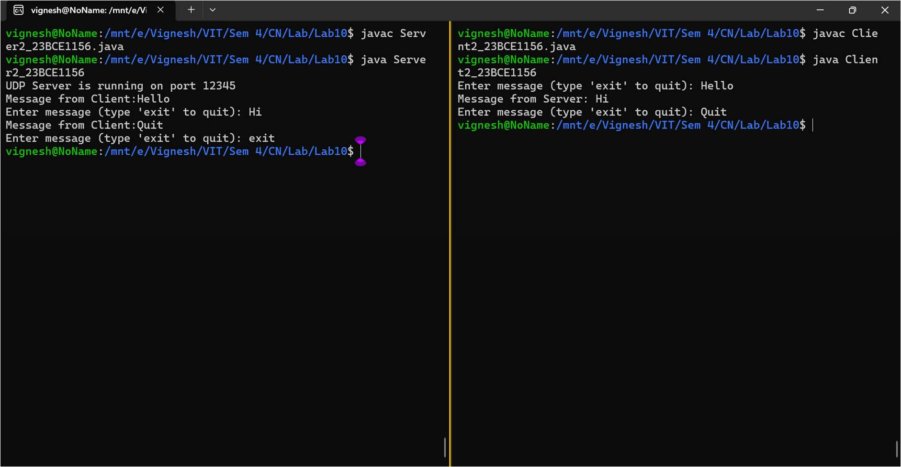

3.

**Question:**

Develop a udp data transfer between single client and server using CRC error control mechanism.

**Code:**

SServer:

import java.net.*; import java.util.*;

public class Server3_23BCE1145{ public static void main(String[] args) {

final int SERVER_PORT = 12345; DatagramSocket serverSocket = null; Scanner sc=new Scanner(System.in); String divisor="10011";

try {

serverSocket = new DatagramSocket(SERVER_PORT); System.out.println("UDP Server is running on port " + SERVER_PORT); while (true){

byte[] receiveBuffer = new byte[1024];

DatagramPacket receivePacket = new DatagramPacket(receiveBuffer, receiveBuffer.length);

serverSocket.receive(receivePacket);

String receivedMessage = new String(receivePacket.getData(), 0, receivePacket.getLength());

if (receivedMessage.equalsIgnoreCase("exit")) { System.out.println("Client has exited. Shutting down server."); break;

}

// receivedMessage=xor(receivedMessage,"0".repeat(receivedMessage.length()- 4)+"1010"); //Uncomment for error

System.out.println("Received Codeword:"+ receivedMessage); String r=divide(receivedMessage,divisor).substring(1); System.out.println("Remainder: "+ r);

if (r.equals("0".repeat(divisor.length()-1))){ System.out.println("No Error");

System.out.println("Message from Client:" + receivedMessage.substring(0,receivedMessage.length()-4));

}

else{

System.out.println("Error Detected");

}

}

}

catch (Exception e) { e.printStackTrace();

}

finally{

serverSocket.close();

sc.close();

}

}

public static String divide(String dividend,String divisor){ String q="",r="";

int n=dividend.length()-divisor.length(); for (int i=0;i<n+1;i++){

if (dividend.charAt(i)=='0'){ q+='0';

r=xor(dividend.substring(i,i+divisor.length()),"0".repeat(divisor.length()));

}

else{

q+='1';

r=xor(dividend.substring(i,i+divisor.length()),divisor); dividend=dividend.substring(0,i)+r+dividend.substring(i+divisor.length());

}

}

return r;

}

public static String xor(String a,String b){ String c="";

for (int i=0;i<a.length();i++){

int a1=Integer.parseInt(a.charAt(i)+""); int b1=Integer.parseInt(b.charAt(i)+""); c+=(a1^b1)+"";

}

return c;

}

}

Client:

import java.math.BigInteger; import java.net.*;

import java.util.*;

public class Client3_23BCE1145 { public static void main(String[] args) {

final int SERVER_PORT = 12345; String divisor="10011";

String r=""; try {

DatagramSocket clientSocket = new DatagramSocket(); InetAddress serverAddress = InetAddress.getLocalHost(); Scanner scanner = new Scanner(System.in);

while (true) {

System.out.print("Enter message: "); String message = scanner.nextLine();

if (message.equalsIgnoreCase("exit")) { byte[] sendBuffer = message.getBytes();

DatagramPacket sendPacket = new DatagramPacket(sendBuffer, sendBuffer.length, serverAddress, SERVER_PORT);

clientSocket.send(sendPacket); break;

}

message=new BigInteger(message.getBytes()).toString(2); System.out.println("Data:"+message);

for (int i=0;i<divisor.length()-1;i++) message+='0';

r=divide(message,divisor).substring(1); message=message.substring(0,message.length()-4)+r; System.out.println("Code Word: "+message);

byte[] sendBuffer = message.getBytes();

DatagramPacket sendPacket = new DatagramPacket(sendBuffer, sendBuffer.length, serverAddress, SERVER_PORT);

clientSocket.send(sendPacket);

}

clientSocket.close(); scanner.close();

}

catch (Exception e) { e.printStackTrace();

}

}

public static String divide(String dividend,String divisor){ String q="",r="";

int n=dividend.length()-divisor.length(); for (int i=0;i<n+1;i++){

if (dividend.charAt(i)=='0'){ q+='0';

r=xor(dividend.substring(i,i+divisor.length()),"0".repeat(divisor.length()));

}

else{

q+='1';

r=xor(dividend.substring(i,i+divisor.length()),divisor); dividend=dividend.substring(0,i)+r+dividend.substring(i+divisor.length());

}

}

return r;

}

public static String xor(String a,String b){ String c="";

for (int i=0;i<a.length();i++){

int a1=Integer.parseInt(a.charAt(i)+""); int b1=Integer.parseInt(b.charAt(i)+""); c+=(a1^b1)+"";

}

return c;

}

}

# Output:

Without Error:

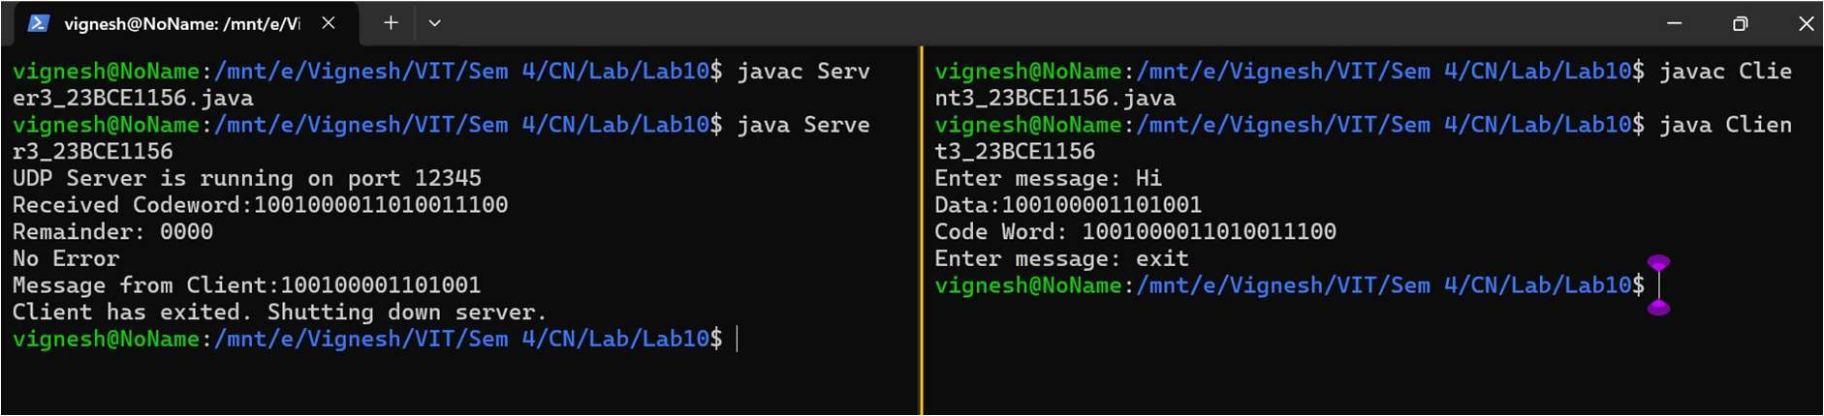

With Error:

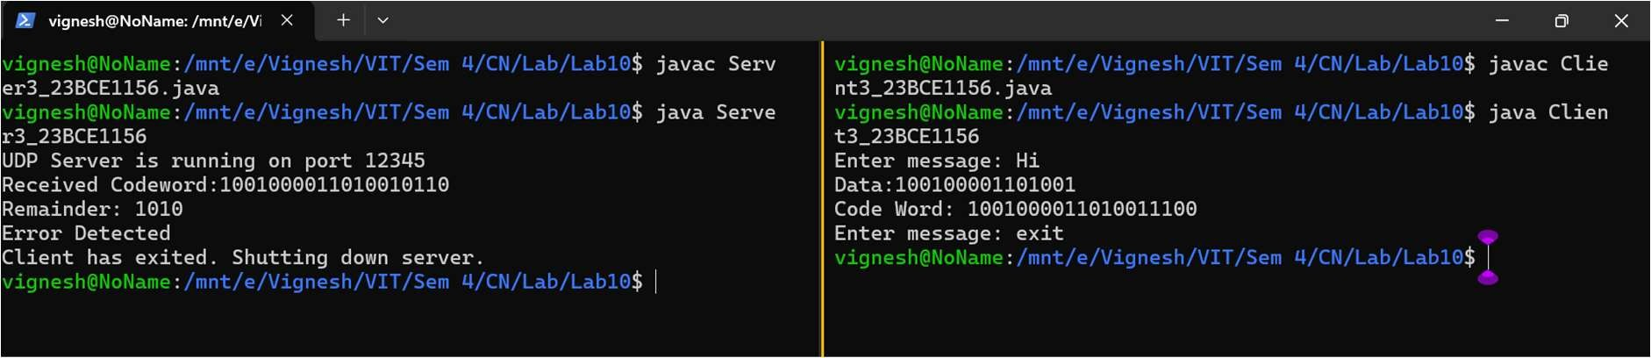

4.

**Question:**

Develop a udp data transfer between single client and server using Select Repeat protocol and show the intermediate steps outputs in detail. Assume that client sends server "hello how are you? Welcome to CN lab. Have a great learning". Assume that m=3 and 3rd frame

lost and 5th acknowledgement lost. Show the out of order delivery in receiver's side and how SR protocol takes care of order of delivery.

**Code:**

Server: import java.net.*; import java.util.*;

public class Server4_23BCE1145 { private static int m = 3;

private static int ws = (int) Math.pow(2, m - 1);

private static HashMap<Integer, String> receivedFrames = new HashMap<>();

public static void main(String[] args) { final int SERVER_PORT = 12345; DatagramSocket serverSocket = null;

try {

serverSocket = new DatagramSocket(SERVER_PORT); System.out.println("UDP Server is running on port " + SERVER_PORT);

while (true) {

byte[] receiveBuffer = new byte[1024];

DatagramPacket receivePacket = new DatagramPacket(receiveBuffer, receiveBuffer.length);

serverSocket.receive(receivePacket);

String receivedMessage = new String(receivePacket.getData(), 0, receivePacket.getLength());

if (receivedMessage.equalsIgnoreCase("exit")) { System.out.println("Closing server.");

break;

}

String[] parts = receivedMessage.split(" "); String frameData = parts[0];

int seq = Integer.parseInt(parts[1]);

if (!receivedFrames.containsKey(seq)) { receivedFrames.put(seq, frameData);

System.out.println("Received Frame with Seq No. " + seq + ": " + frameData); byte[] sendBuffer = String.valueOf(seq).getBytes();

DatagramPacket sendPacket = new DatagramPacket(sendBuffer, sendBuffer.length, receivePacket.getAddress(), receivePacket.getPort());

if (seq!=4) // Comment for no ack loss serverSocket.send(sendPacket); System.out.println("ACK "+ seq + " sent to client.");

}

else {

System.out.println("Duplicate Frame " + seq + " discarded.");

byte[] sendBuffer = String.valueOf(seq).getBytes(); DatagramPacket sendPacket = new DatagramPacket(sendBuffer,

sendBuffer.length, receivePacket.getAddress(), receivePacket.getPort()); serverSocket.send(sendPacket);

}

}

}

catch (Exception e) { e.printStackTrace();

}

finally {

if (serverSocket != null) serverSocket.close();

}

}

}

Client: import java.net.*; import java.util.*; import java.io.*;

public class Client4_23BCE1145 { private static int m = 3;

private static int ws = (int) Math.pow(2, m - 1);

private static HashMap<Integer, String> windows = new HashMap<>();

private static Set<Integer> acks = Collections.synchronizedSet(new HashSet<>()); private static DatagramSocket clientSocket;

private static InetAddress serverAddress;

public static void main(String[] args) { final int SERVER_PORT = 12345;

Scanner scanner = new Scanner(System.in);

try {

clientSocket = new DatagramSocket(); serverAddress = InetAddress.getLocalHost();

while (true) {

System.out.print("Enter message (type 'exit' to quit): "); String message = scanner.nextLine();

if (message.equalsIgnoreCase("exit")) { byte[] sendBuffer = message.getBytes();

DatagramPacket sendPacket = new DatagramPacket(sendBuffer, sendBuffer.length, serverAddress, SERVER_PORT);

clientSocket.send(sendPacket); break;

}

String[] arr = message.split(" "); int totalFrames = arr.length;

for (int i = 0; i < totalFrames; i++) { windows.put(i, arr[i]);

acks.add(i % (ws * 2));

}

new Thread(() -> receiveACKs()).start();

int fc = 0;

while (!acks.isEmpty()) {

for (int i = 0; i < ws*2 && fc < totalFrames; i++) { if (acks.contains(fc)) {

if (fc!=2) //Comment for no data loss send(fc);

}

fc++;

}

Thread.sleep(3000); resendUnacknowledgedFrames();

}

}

}

catch (Exception e) { e.printStackTrace();

}

finally {

clientSocket.close(); scanner.close();

}

}

public static void send(int i) { try {

String msg = windows.get(i) + " " + (i % (ws * 2)); byte[] sendBuffer = msg.getBytes();

DatagramPacket sendPacket = new DatagramPacket(sendBuffer, sendBuffer.length, serverAddress, 12345);

clientSocket.send(sendPacket);

System.out.println("Sent Frame " + (i + 1) + " with Seq No. " + (i % (ws * 2)));

}

catch (Exception e) { System.out.println(e);

}

}

public static void receiveACKs() { try {

while (!acks.isEmpty()) {

byte[] ackBuffer = new byte[1024];

DatagramPacket ackPacket = new DatagramPacket(ackBuffer, ackBuffer.length); clientSocket.receive(ackPacket);

String ack = new String(ackPacket.getData(), 0, ackPacket.getLength()); int ackNum = Integer.parseInt(ack);

if (acks.contains(ackNum)) {

System.out.println("Ack " + ackNum + " received");

acks.remove(ackNum);

}

}

}

catch (IOException e) { System.out.println(e);

}

}

public static void resendUnacknowledgedFrames() { for (int index : new ArrayList<>(acks)) {

if (acks.contains(index)) {

System.out.println("Timeout for Frame " + index + ", resending..."); send(index);

}

}

}

}

# Output:

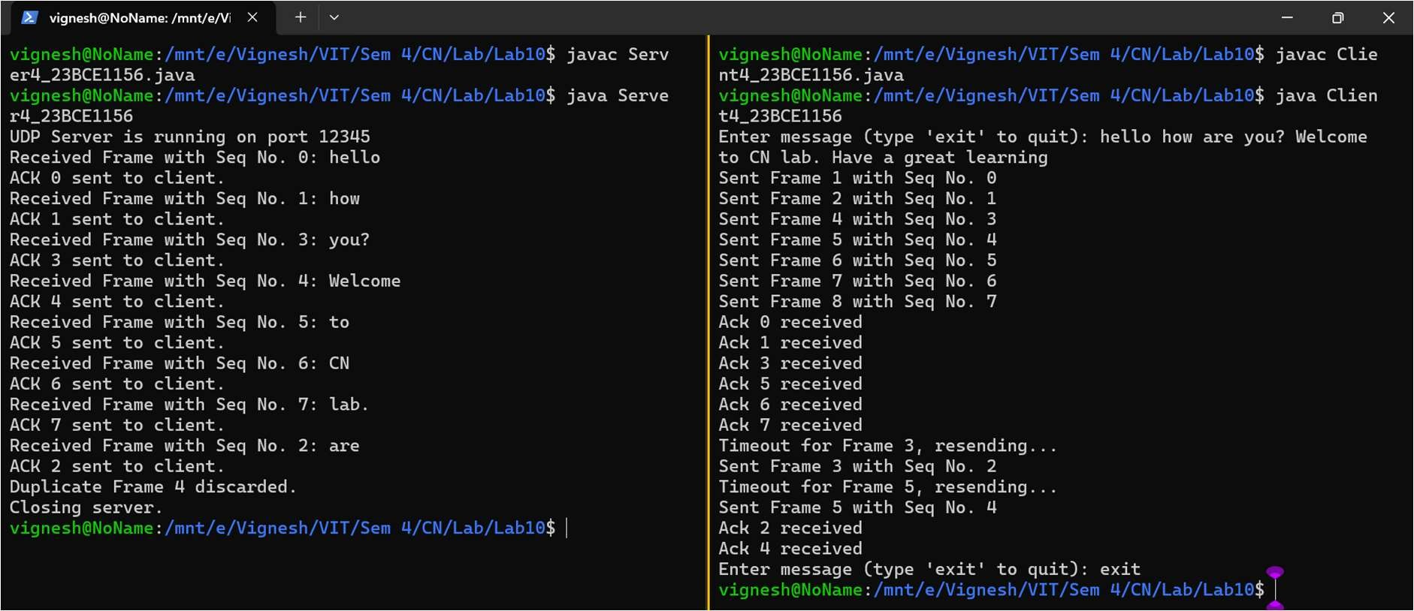

With no loss:

