Computer Networks

# Assignment-3

# Question-1:

# Code:

import java.net.*;

public class Main {

public static void main(String[] args){

try{

InetAddress inetAddress = InetAddress.getLocalHost();

System.out.println("IP Address: " + inetAddress.getHostAddress());

}

catch (UnknownHostException u) {

System.out.println(u);

return;

}

}

}

# Output:

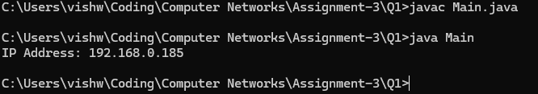

# Question-2:

# Code for Client:

import java.io.*;

import java.net.*;

public class Client_23BCE1145{

private Socket socket = null;

private DataInputStream input = null;

private DataOutputStream output = null;

public Client_23BCE1145(String address, int port){

try{

socket = new Socket(address, port);

System.out.println("Client is connected!\nCheck the Server for the IP Address of the Client.\n");

input = new DataInputStream(System.in);

output = new DataOutputStream(socket.getOutputStream());

}

catch(UnknownHostException u){

System.out.println(u);

}

catch(IOException i){

System.out.println(i);

}

}

public void Work(){

InetAddress ip = socket.getInetAddress();

String line = ip.getHostAddress();

try{

output.writeUTF(line);

}

catch(IOException i){

System.out.println(i);

}

System.out.println("Closing the connection...");

try{

input.close();

output.close();

socket.close();

}

catch(IOException i){

System.out.println(i);

}

}

public static void main(String[] args){

Client_23BCE1145 client = new Client_23BCE1145("127.0.0.1", 5000);

client.Work();

}

}

## Code for Server:

import java.io.*;

import java.net.*;

public class Server_23BCE1145 {

private ServerSocket server = null;

private Socket socket = null;

private DataInputStream input = null;

public Server_23BCE1145(int port){

try{

System.out.println("Starting server.");

server = new ServerSocket(port);

System.out.println("Waiting for a connection.");

socket = server.accept();

System.out.println("Connection with client established.\n");

input = new DataInputStream(socket.getInputStream());

}

catch(UnknownHostException u){

System.out.println(u);

}

catch(IOException i){

System.out.println(i);

}

}

public void Work(){

String line = "";

try{

line = input.readUTF();

String[] arr = {"192.166.0.1", "192.168.0.168", "127.0.0.1"};

boolean flag = false;

for(String s: arr){

if(s.equals(line)){

flag = true;

break;

}

}

if(flag){

System.out.println("Hello\n");

}

else{

System.out.println("Invalid\n");

}

}

catch(IOException i){

System.out.println(i);

}

System.out.println("Closing Connection...");

try{

input.close();

socket.close();

server.close();

}

catch(IOException i){

System.out.println(i);

}

}

public static void main(String[] args){

Server_23BCE1145 server = new Server_23BCE1145(5000);

server.Work();

}

}

## Outputs:

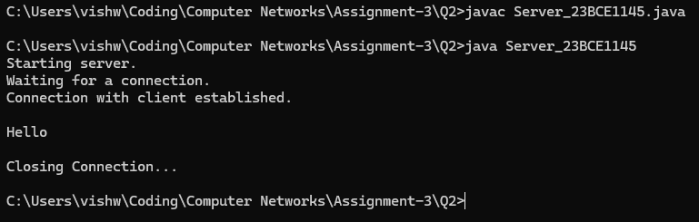

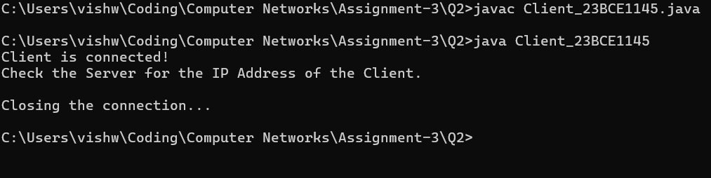

# Question-3:

## Code:

import java.net.*;

public class Main {

@SuppressWarnings("deprecation")

public static void main(String[] args) {

try{

URL url = new URL("https://vishwajith-s-vit.github.io/");

InetAddress ip = InetAddress.getByName(url.getHost());

System.out.println("IP Address: " + ip.getHostAddress());

}

catch(MalformedURLException m){

System.out.println(m);

}

catch(UnknownHostException u){

System.out.println(u);

}

}

}

## Output:

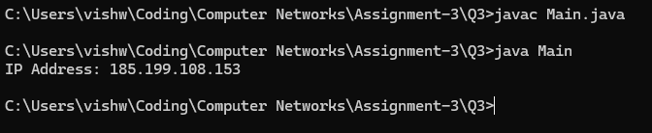

# Question-4:

## Code for Client:

import java.io.*;

import java.net.*;

public class Client{

private Socket socket = null;

private DataInputStream input = null;

private DataOutputStream output = null;

public Client(String address, int port){

try{

socket = new Socket(address, port);

System.out.println("Client is connected!\nSending the Wesbite address to the server...\n");

input = new DataInputStream(socket.getInputStream());

output = new DataOutputStream(socket.getOutputStream());

}

catch(UnknownHostException u){

System.out.println(u);

}

catch(IOException i){

System.out.println(i);

}

}

@SuppressWarnings("deprecation")

public void Work(){

try{

URL url = new URL("https://vishwajith-s-vit.github.io/");

output.writeUTF(url.toString());

String line = input.readUTF();

System.out.println("The IP Address of the Website is: " + line);

}

catch(MalformedURLException m){

System.out.println(m);

}

catch(IOException i){

System.out.println(i);

}

System.out.println("\nClosing the connection...");

try{

input.close();

output.close();

socket.close();

}

catch(IOException i){

System.out.println(i);

}

}

public static void main(String[] args){

Client client = new Client("127.0.0.1", 5000);

client.Work();

}

}

## Code for Server:

import java.io.*;

import java.net.*;

public class Server {

private ServerSocket server = null;

private Socket socket = null;

private DataInputStream input = null;

private DataOutputStream output = null;

public Server(int port){

try{

System.out.println("Starting server.\n");

server = new ServerSocket(port);

System.out.println("Waiting for a connection.\n");

socket = server.accept();

System.out.println("Connection with client established.\n");

input = new DataInputStream(socket.getInputStream());

output = new DataOutputStream(socket.getOutputStream());

}

catch(UnknownHostException u){

System.out.println(u);

}

catch(IOException i){

System.out.println(i);

}

}

public void Work(){

String line = "";

try{

line = input.readUTF();

InetAddress ip = InetAddress.getByName(new URL(line).getHost());

System.out.println("The IP Address of the Website is: " + ip.getHostAddress());

output.writeUTF(ip.getHostAddress());

}

catch(MalformedURLException m){

System.out.println(m);

}

catch(IOException i){

System.out.println(i);

}

System.out.println("\nClosing Connection...");

try{

input.close();

socket.close();

server.close();

}

catch(IOException i){

System.out.println(i);

}

}

public static void main(String[] args){

Server server = new Server(5000);

server.Work();

}

}

## Outputs:

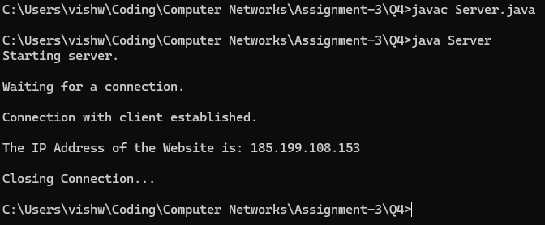

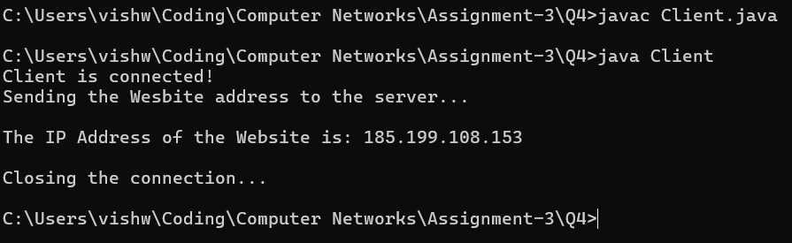

# Question-5:

## Command and outputs:

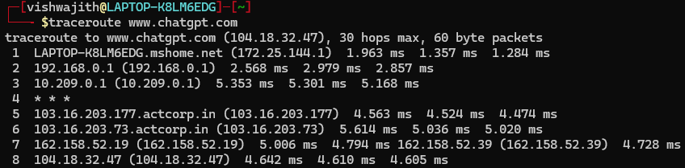



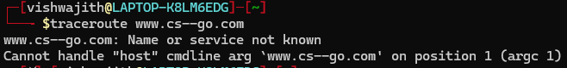

## Done By:

### S. Vishwajith

### 23BCE1145