Compiler Design Lab
Date: 18-12-2025 | Name: S Vishwajith
Assignment No.: 3 | Register No.: 23BCE1145

Aim:
To write a C++ code to find Nullable(), Firstpos(), Lastpos() and Followpos() for the given Regular Expressions: (a|b)*a(a|b)(a|b), (a|b)*a(a|b)*, (a|b)*|(ac)*.

Algorithm:
- Concatenate the Regular Expression with ‘#’ for the end marker.
- Construct a syntax tree.
- Calculate the Nullable(), Firstpos(), Lastpos() and Followpos() using the rules for leaf nodes, Star (*) nodes, Concatenation (.) nodes and Or (|) nodes.
- Maintain a vector of the number of characters that are not operators and print their Followpos().

Code:

RE_to_DFA.cpp:
#include <iostream>
#include <vector>
#include <string>
#include <set>
#include <stack>
#include <algorithm>
using namespace std;

string infix_to_postfix(string infix)
{
string pf = "";
stack<char> op_stack;
for (char c : infix)
{
if (c != '*' && c != '|' && c != '.' && c != '(' && c != ')')
{
pf += c;
}
else if (c == '(')
{
op_stack.push(c);
}
else if (c == ')')
{
while (!op_stack.empty() && op_stack.top() != '(')
{
pf += op_stack.top();
op_stack.pop();
}
op_stack.pop();
}
else
{
while (!op_stack.empty() &&
((c == '*' && (op_stack.top() == '*')) ||
(c == '.' && (op_stack.top() == '*' || op_stack.top() == '.')) ||
(c == '|' && (op_stack.top() == '*' || op_stack.top() == '.' || op_stack.top() == '|'))))
{
pf += op_stack.top();
op_stack.pop();
}
op_stack.push(c);
}
}
while (!op_stack.empty())
{
pf += op_stack.top();
op_stack.pop();
}
return pf;
}

vector<int> operator+(vector<int> a, vector<int> b)
{
a.insert(a.end(), b.begin(), b.end());
sort(a.begin(), a.end());
a.erase(unique(a.begin(), a.end()), a.end());
return a;
}

class tree
{
public:
char c;
int lno;
vector<int> first, last;
bool nullable;
tree *left;
tree *right;

tree(char ch, int n)
{
c = ch;
lno = n;
nullable = false;
left = nullptr;
right = nullptr;
first.clear();
last.clear();
}
};

int main()
{
string rx;
cout << "Enter a Regular Expression in infix form: ";
cin >> rx;
rx = "(" + rx + ").#";
string postfix = infix_to_postfix(rx);
cout << "Postfix Expression: " << postfix << endl
<< endl;

vector<vector<int>> follow;
vector<char> chars;
set<char> inputs;
stack<tree *> st;
int leafno = 0;
tree *temp;

for (int i = 0; i < postfix.size(); i++)
{
char t = postfix[i];
if (t != '*' && t != '.' && t != '|')
{
cout << "Character at leaf node number " << leafno << " is: " << t << ". ";
chars.push_back(t);
if (t != '#')
inputs.insert(t);
temp = new tree(t, leafno);
temp->first.push_back(leafno);
temp->last.push_back(leafno);

follow.push_back(vector<int>());
cout << "This node isn't nullable." << endl;
cout << "Firstpos: {" << leafno << "}." << endl;
cout << "Lastpos: {" << leafno << "}." << endl
<< endl;

leafno++;
}
else if (t == '*')
{
cout << "This isn't a leaf node. It contains the character: '*' (star). It is nullable." << endl;
temp = new tree(t, -1);
temp->left = st.top();
st.pop();
temp->first = temp->left->first;
temp->last = temp->left->last;
temp->nullable = true;
cout << "Firstpos: {";
for (int j = 0; j < temp->first.size(); j++)
{
cout << temp->first[j] << ", ";
}
cout << "}." << endl;
cout << "Lastpos: {";
for (int j = 0; j < temp->last.size(); j++)
{
cout << temp->last[j] << ", ";
follow[temp->last[j]] = follow[temp->last[j]] + temp->first;
}
cout << "}." << endl
<< endl;
}
else if (t == '.')
{
cout << "This isn't a leaf node. It contains the character: '.' (concatenation). ";
temp = new tree(t, -1);
temp->right = st.top();
st.pop();
temp->left = st.top();
st.pop();
temp->nullable = temp->left->nullable && temp->right->nullable;
if (temp->nullable)
cout << "The node is nullable." << endl;
else
cout << "The node isn't nullable." << endl;

if (temp->left->nullable)
temp->first = temp->left->first + temp->right->first;
else
temp->first = temp->left->first;
cout << "Firstpos: {";
for (int j = 0; j < temp->first.size(); j++)
{
cout << temp->first[j] << ", ";
}
cout << "}." << endl;

if (temp->right->nullable)
temp->last = temp->right->last + temp->left->last;
else
temp->last = temp->right->last;
cout << "Lastpos: {";
for (int j = 0; j < temp->last.size(); j++)
{
cout << temp->last[j] << ", ";
}
cout << "}." << endl
<< endl;

for (int j = 0; j < temp->left->last.size(); j++)
{
follow[temp->left->last[j]] = follow[temp->left->last[j]] + temp->right->first;
}
}
else if (t == '|')
{
cout << "This isn't a leaf node. It contains the character: '|' (or). ";
temp = new tree(t, -1);
temp->right = st.top();
st.pop();
temp->left = st.top();
st.pop();
temp->nullable = temp->left->nullable || temp->right->nullable;
if (temp->nullable)
cout << "The node is nullable." << endl;
else
cout << "The node isn't nullable." << endl;

temp->first = temp->left->first + temp->right->first;
cout << "Firstpos: {";
for (int j = 0; j < temp->first.size(); j++)
{
cout << temp->first[j] << ", ";
}
cout << "}." << endl;

temp->last = temp->right->last + temp->left->last;
cout << "Lastpos: {";
for (int j = 0; j < temp->last.size(); j++)
{
cout << temp->last[j] << ", ";
}
cout << "}." << endl
<< endl;
}
st.push(temp);
}
cout << endl;
for (int i = 0; i < leafno; i++)
{
cout << "Leaf number: " << i << ". ";
cout << "Character: " << chars[i] << "." << endl;
cout << "Followpos: {";
for (int j = 0; j < follow[i].size(); j++)
cout << follow[i][j] << ", ";
cout << "}." << endl
<< endl;
}
return 0;
}

Inputs:
- (a|b)*a(a|b)(a|b)
- (a|b)*a(a|b)*
- (a|b)*|(ac)*

Output:
Enter a Regular Expression in infix form: (a|b)*.a.(a|b).(a|b)
Postfix Expression: ab|*a.ab|.ab|.#.

Character at leaf node number 0 is: a. This node isn't nullable.
Firstpos: {0}.
Lastpos: {0}.

Character at leaf node number 1 is: b. This node isn't nullable.
Firstpos: {1}.
Lastpos: {1}.

This isn't a leaf node. It contains the character: '|' (or). The node isn't nullable.
Firstpos: {0, 1, }.
Lastpos: {0, 1, }.

This isn't a leaf node. It contains the character: '*' (star). It is nullable.
Firstpos: {0, 1, }.
Lastpos: {0, 1, }.

Character at leaf node number 2 is: a. This node isn't nullable.
Firstpos: {2}.
Lastpos: {2}.

This isn't a leaf node. It contains the character: '.' (concatenation). The node isn't nullable.
Firstpos: {0, 1, 2, }.
Lastpos: {2, }.

Character at leaf node number 3 is: a. This node isn't nullable.
Firstpos: {3}.
Lastpos: {3}.

Character at leaf node number 4 is: b. This node isn't nullable.
Firstpos: {4}.
Lastpos: {4}.

This isn't a leaf node. It contains the character: '|' (or). The node isn't nullable.
Firstpos: {3, 4, }.
Lastpos: {3, 4, }.

This isn't a leaf node. It contains the character: '.' (concatenation). The node isn't nullable.
Firstpos: {0, 1, 2, }.
Lastpos: {3, 4, }.

Character at leaf node number 5 is: a. This node isn't nullable.
Firstpos: {5}.
Lastpos: {5}.

Character at leaf node number 6 is: b. This node isn't nullable.
Firstpos: {6}.
Lastpos: {6}.

This isn't a leaf node. It contains the character: '|' (or). The node isn't nullable.
Firstpos: {5, 6, }.
Lastpos: {5, 6, }.

This isn't a leaf node. It contains the character: '.' (concatenation). The node isn't nullable.
Firstpos: {0, 1, 2, }.
Lastpos: {5, 6, }.

Character at leaf node number 7 is: #. This node isn't nullable.
Firstpos: {7}.
Lastpos: {7}.

This isn't a leaf node. It contains the character: '.' (concatenation). The node isn't nullable.
Firstpos: {0, 1, 2, }.
Lastpos: {7, }.

Leaf number: 0. Character: a.
Followpos: {0, 1, 2, }.

Leaf number: 1. Character: b.
Followpos: {0, 1, 2, }.

Leaf number: 2. Character: a.
Followpos: {3, 4, }.

Leaf number: 3. Character: a.
Followpos: {5, 6, }.

Leaf number: 4. Character: b.
Followpos: {5, 6, }.

Leaf number: 5. Character: a.
Followpos: {7, }.

Leaf number: 6. Character: b.
Followpos: {7, }.

Leaf number: 7. Character: #.
Followpos: {}.
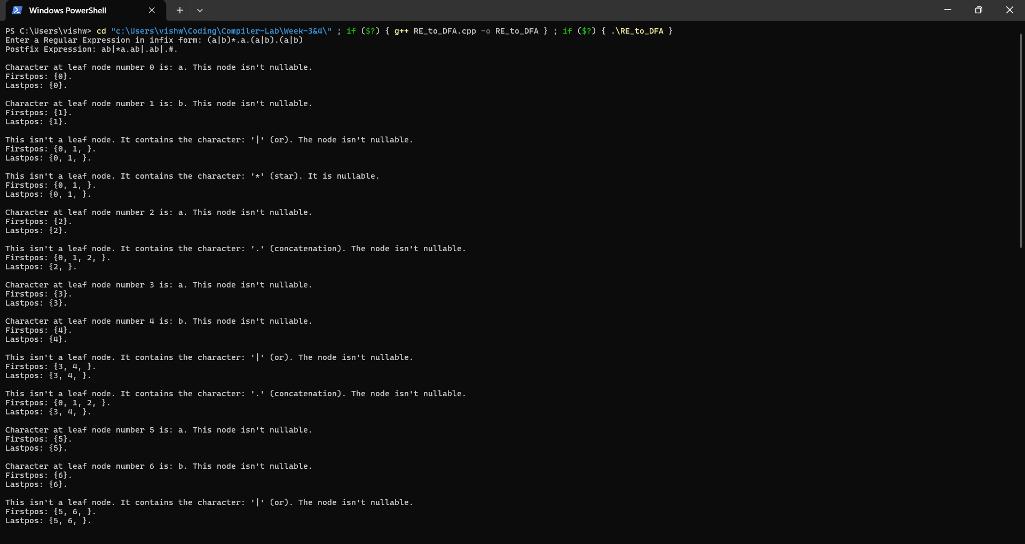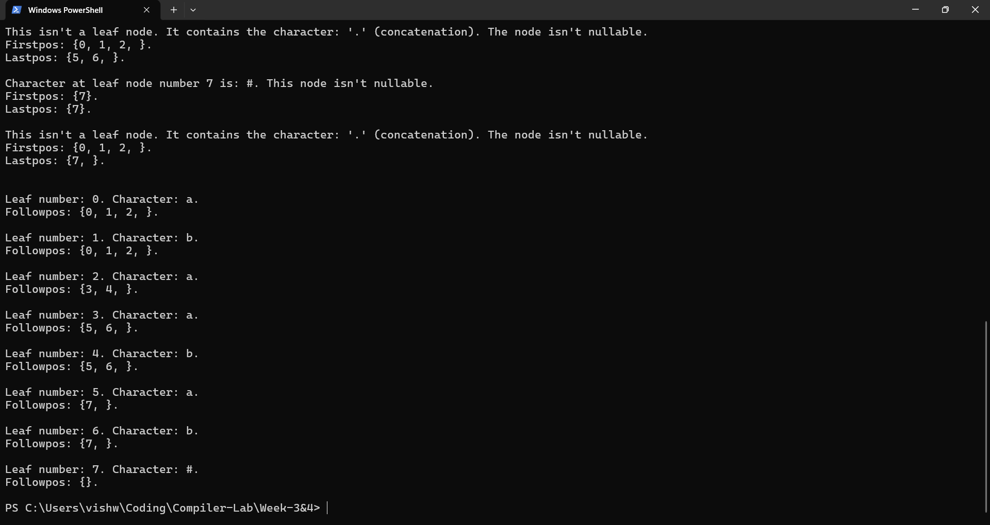
Enter a Regular Expression in infix form: (a|b)*.a.(a|b)*
Postfix Expression: ab|*a.ab|*.#.

Character at leaf node number 0 is: a. This node isn't nullable.
Firstpos: {0}.
Lastpos: {0}.

Character at leaf node number 1 is: b. This node isn't nullable.
Firstpos: {1}.
Lastpos: {1}.

This isn't a leaf node. It contains the character: '|' (or). The node isn't nullable.
Firstpos: {0, 1, }.
Lastpos: {0, 1, }.

This isn't a leaf node. It contains the character: '*' (star). It is nullable.
Firstpos: {0, 1, }.
Lastpos: {0, 1, }.

Character at leaf node number 2 is: a. This node isn't nullable.
Firstpos: {2}.
Lastpos: {2}.

This isn't a leaf node. It contains the character: '.' (concatenation). The node isn't nullable.
Firstpos: {0, 1, 2, }.
Lastpos: {2, }.

Character at leaf node number 3 is: a. This node isn't nullable.
Firstpos: {3}.
Lastpos: {3}.

Character at leaf node number 4 is: b. This node isn't nullable.
Firstpos: {4}.
Lastpos: {4}.

This isn't a leaf node. It contains the character: '|' (or). The node isn't nullable.
Firstpos: {3, 4, }.
Lastpos: {3, 4, }.

This isn't a leaf node. It contains the character: '*' (star). It is nullable.
Firstpos: {3, 4, }.
Lastpos: {3, 4, }.

This isn't a leaf node. It contains the character: '.' (concatenation). The node isn't nullable.
Firstpos: {0, 1, 2, }.
Lastpos: {2, 3, 4, }.

Character at leaf node number 5 is: #. This node isn't nullable.
Firstpos: {5}.
Lastpos: {5}.

This isn't a leaf node. It contains the character: '.' (concatenation). The node isn't nullable.
Firstpos: {0, 1, 2, }.
Lastpos: {5, }.

Leaf number: 0. Character: a.
Followpos: {0, 1, 2, }.

Leaf number: 1. Character: b.
Followpos: {0, 1, 2, }.

Leaf number: 2. Character: a.
Followpos: {3, 4, 5, }.

Leaf number: 3. Character: a.
Followpos: {3, 4, 5, }.

Leaf number: 4. Character: b.
Followpos: {3, 4, 5, }.

Leaf number: 5. Character: #.
Followpos: {}.
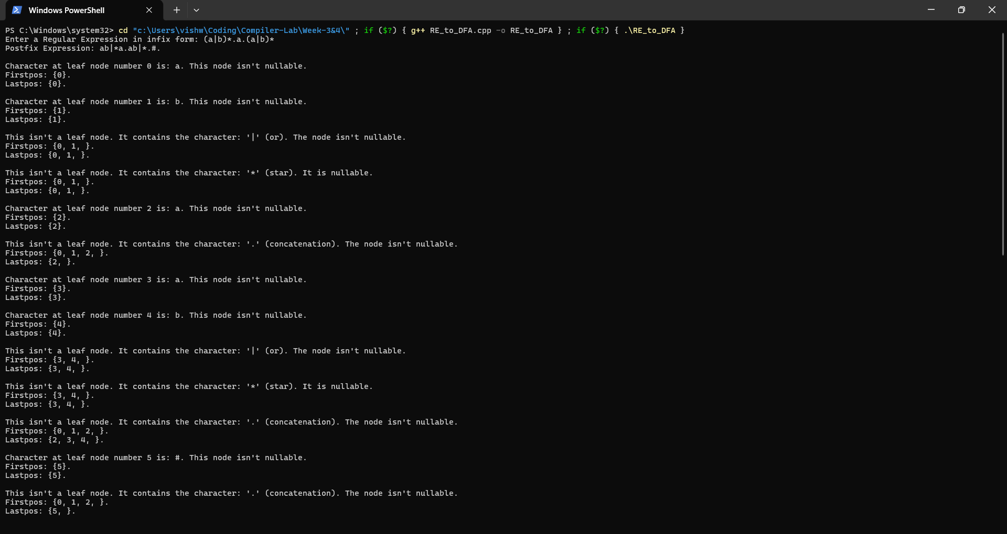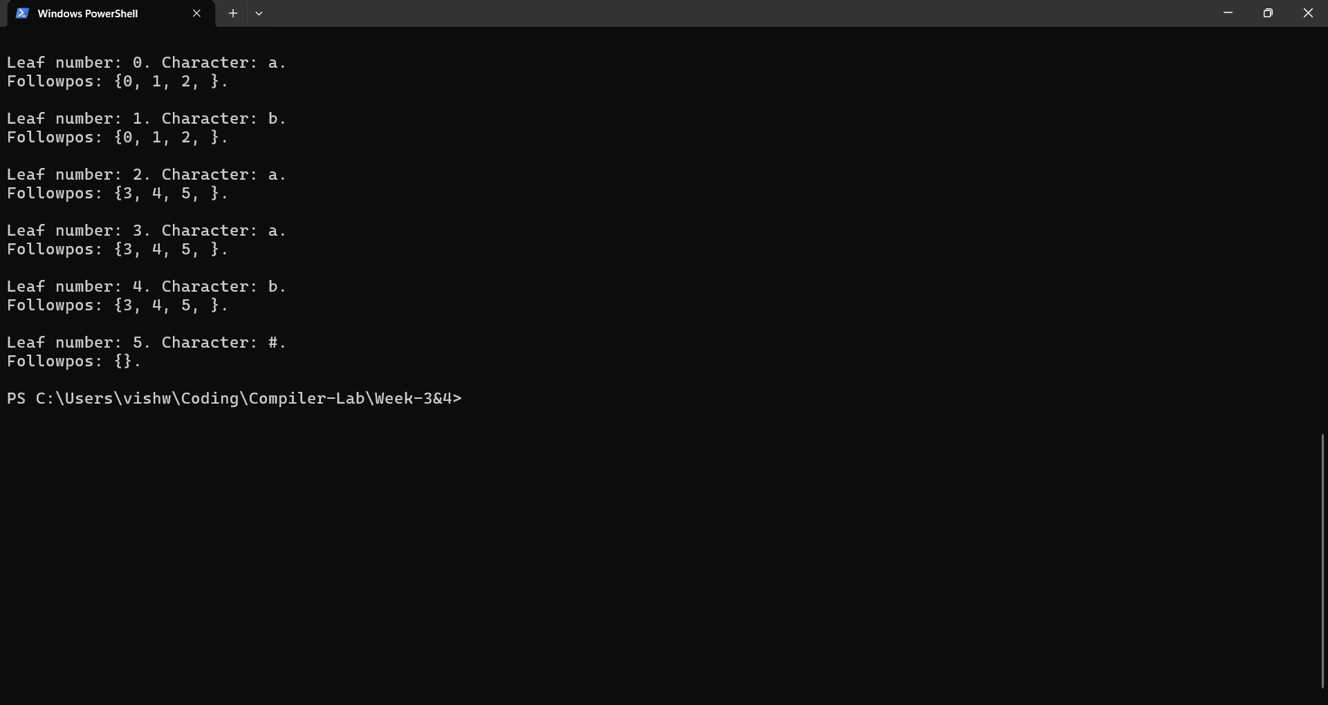
Enter a Regular Expression in infix form: (a|b)*|(a.c)*
Postfix Expression: ab|*ac.*|#.

Character at leaf node number 0 is: a. This node isn't nullable.
Firstpos: {0}.
Lastpos: {0}.

Character at leaf node number 1 is: b. This node isn't nullable.
Firstpos: {1}.
Lastpos: {1}.

This isn't a leaf node. It contains the character: '|' (or). The node isn't nullable.
Firstpos: {0, 1, }.
Lastpos: {0, 1, }.

This isn't a leaf node. It contains the character: '*' (star). It is nullable.
Firstpos: {0, 1, }.
Lastpos: {0, 1, }.

Character at leaf node number 2 is: a. This node isn't nullable.
Firstpos: {2}.
Lastpos: {2}.

Character at leaf node number 3 is: c. This node isn't nullable.
Firstpos: {3}.
Lastpos: {3}.

This isn't a leaf node. It contains the character: '.' (concatenation). The node isn't nullable.
Firstpos: {2, }.
Lastpos: {3, }.

This isn't a leaf node. It contains the character: '*' (star). It is nullable.
Firstpos: {2, }.
Lastpos: {3, }.

This isn't a leaf node. It contains the character: '|' (or). The node is nullable.
Firstpos: {0, 1, 2, }.
Lastpos: {0, 1, 3, }.

Character at leaf node number 4 is: #. This node isn't nullable.
Firstpos: {4}.
Lastpos: {4}.

This isn't a leaf node. It contains the character: '.' (concatenation). The node isn't nullable.
Firstpos: {0, 1, 2, 4, }.
Lastpos: {4, }.

Leaf number: 0. Character: a.
Followpos: {0, 1, 4, }.

Leaf number: 1. Character: b.
Followpos: {0, 1, 4, }.

Leaf number: 2. Character: a.
Followpos: {3, }.

Leaf number: 3. Character: c.
Followpos: {2, 4, }.

Leaf number: 4. Character: #.
Followpos: {}.
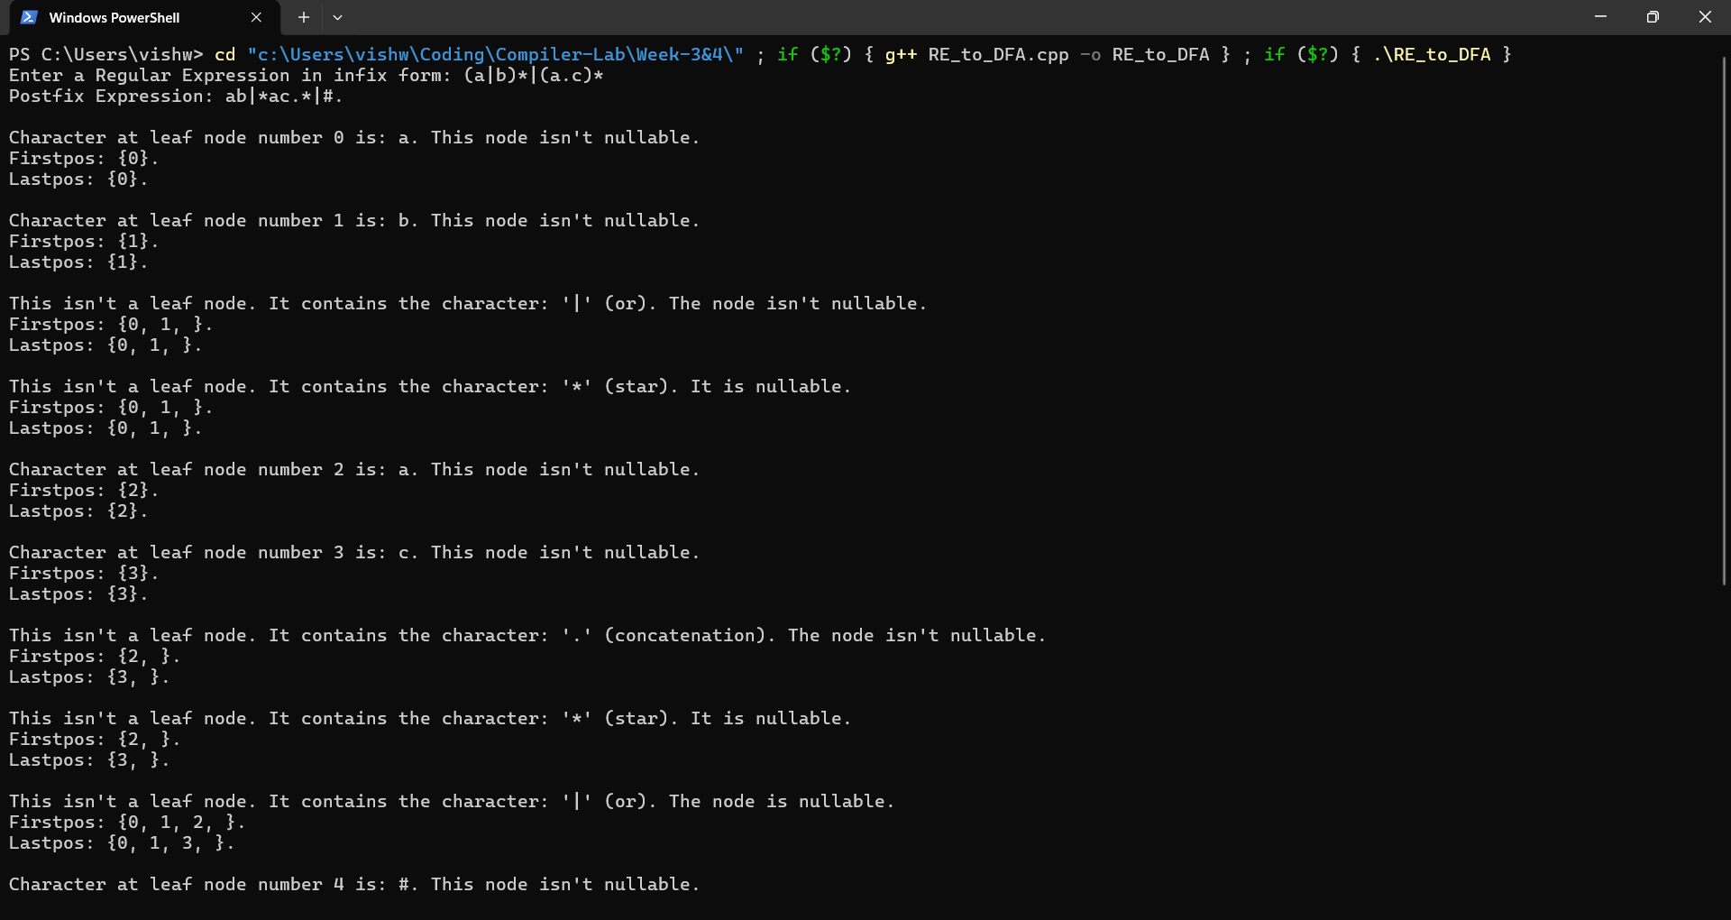
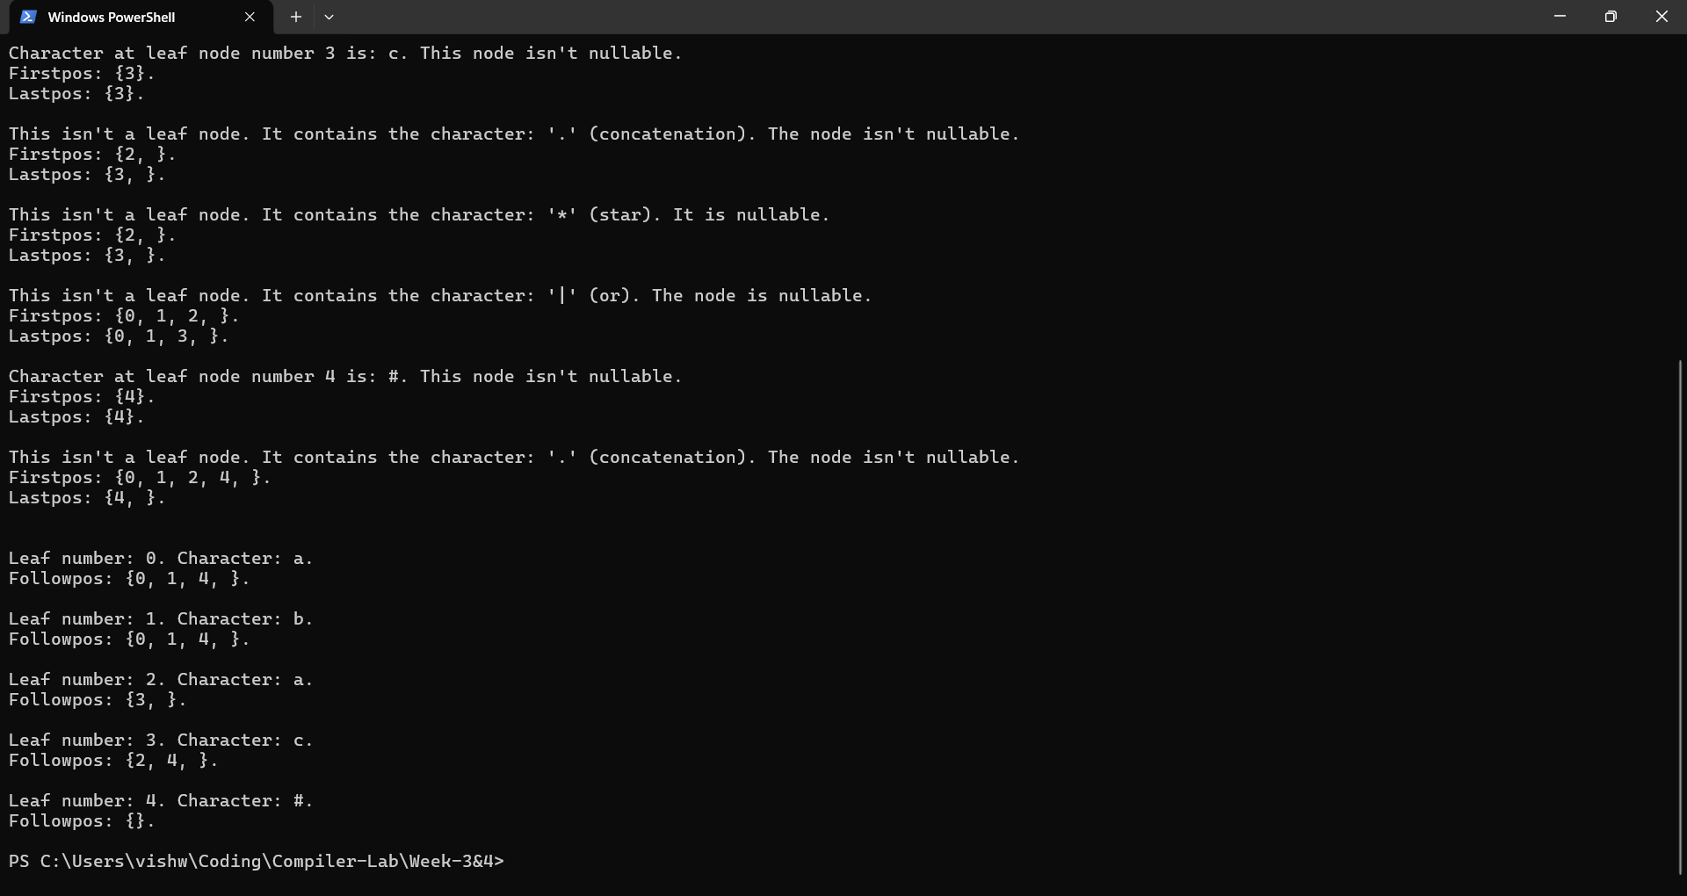

Result:
The C++ program to find Nullable(), Firstpos(), Lastpos(), and Followpos() for the given Regular Expressions was successfully run and the results were verified.

