Compiler Design Lab
Date: 19-12-2025 | Name: S Vishwajith
Assignment No.: 4 | Register No.: 23BCE1145

Aim:
To write a C++ program that converts the regular expression (a|b)*a(a|b) to NFA with epsilon-transition and check whether the given string is accepted or rejected by the NFA.

Algorithm:
- For the regular expression (a|b)*a(a|b), construct a transition table for NFA with epsilon (null) transitions containing the current state, symbol for transition and the new state.
- Initiate states = {0} where 0 is the initial state and take the null closure of states in the variable and store it in the states variable itself.
- For each symbol ‘c’ in the string:
  - Take a new empty variable ‘next_states’ or clear it if it exists.
  - For each ‘st’ in states:
    - If there are any possible transitions, add them to ‘next_states’
  - Take the null closure of ‘next_state’.
  - Replace state with ‘next_state’.
- If the states set contains the final state number 3, then the given string is accepted. Else, the given string is rejected.

Code:
#include <iostream>
#include <string>
#include <set>
#include <vector>
#include <map>
using namespace std;

map<int, vector<pair<char, int>>> get_transition_table()
{
map<int, vector<pair<char, int>>> tt;

tt[0].push_back({'a', 0});
tt[0].push_back({'b', 0});
tt[0].push_back({'e', 1});
tt[1].push_back({'a', 2});
tt[2].push_back({'a', 3});
tt[2].push_back({'b', 3});

return tt;
}

int get_next_state(vector<pair<char, int>> transitions, char symbol)
{
for (auto &[c, i] : transitions)
{
if (c == symbol)
return i;
}
return -1;
}

void null_closure(set<int> &states, map<int, vector<pair<char, int>>> tt)
{
bool changed;
do
{
changed = false;
set<int> snapshot = states;
for (int s : snapshot)
{
int e = get_next_state(tt[s], 'e');
if (e != -1 && !states.count(e))
{
states.insert(e);
changed = true;
}
}
} while (changed);
}

int main()
{
string s;
cout << "Enter a string: ";
cin >> s;

map<int, vector<pair<char, int>>> tt = get_transition_table();
cout << endl
<< "Current State\tSymbol\tNew State" << endl;
for (auto &[old_state, transitions] : tt)
{
for (auto &[symbol, new_state] : transitions)
{
cout << old_state << "\t\t" << symbol << "\t\t" << new_state << endl;
}
}
cout << endl;

set<int> states = {0};
null_closure(states, tt);
for (char c : s)
{
set<int> next_states;
for (int st : states)
{
int ns = get_next_state(tt[st], c);
if (ns != -1)
next_states.insert(ns);
}

states = next_states;
null_closure(states, tt);
}

for (int i : states)
{
if (i == 3)
{
cout << "The given string is accepted." << endl;
return 0;
}
}

cout << "The given string is rejected." << endl;
return 0;
}

Inputs:
- aa
- ab
- abba

Outputs:
Enter a string: aa

Current State Symbol New State
0 a 0
0 b 0
0 e 1
1 a 2
2 a 3
2 b 3

The given string is accepted.
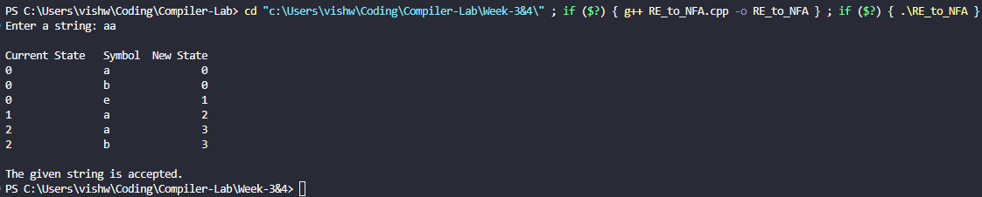
Enter a string: ab

Current State Symbol New State
0 a 0
0 b 0
0 e 1
1 a 2
2 a 3
2 b 3

The given string is accepted.
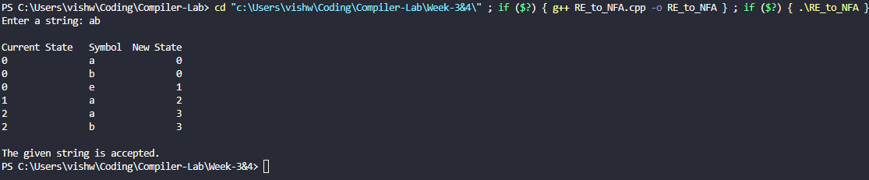
Enter a string: abba

Current State Symbol New State
0 a 0
0 b 0
0 e 1
1 a 2
2 a 3
2 b 3

The given string is rejected.
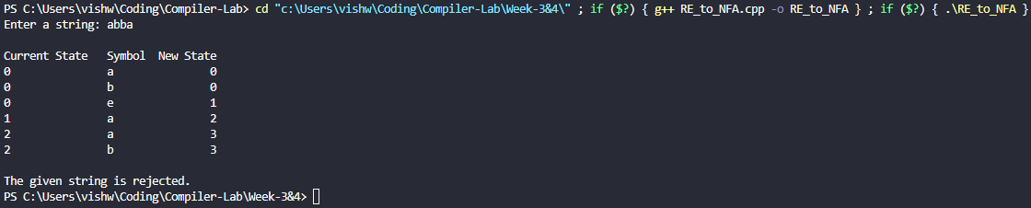

Result:
The C++ program to convert the regex (a|b)*a(a|b) into NFA with epsilon transitions and check whether the given string is accepted or not was successfully run and the results were verified.

