Compiler Design Lab
Date: 23-1-2026 | Name: S Vishwajith
Assignment No.: 5 | Register No.: 23BCE1145

Aim:
To write a C++ program to construct the Leading() and Trailing() for the given grammar.

Algorithm:
- Read the Grammar.
- For each non-terminal A, find Leading() by analysing each of its production.
  - If the non-terminal produces a terminal first, add the terminal to its Leading().
  - If it produces a non-terminal B first and then a terminal, add terminal to its Leading() and if B is not A, add Leading(B) to Leading(A)
- For each non-terminal A, find Trailing() by analysing each of its production.
  - If the non-terminal produces a terminal last, add the terminal to its Trailing().
  - If it produces a non-terminal B at the last and then a terminal, add terminal to its Trailing() and if B is not A, add Trailing(B) to Trailing(A).
- Display the Leading() and Trailing() of each non-terminal.

Code:
#include <iostream>
#include <string>
#include <vector>
#include <set>
#include <map>
#include <stack>
#include <limits>
using namespace std;

struct NonTerminal
{
char nt;
vector<string> rhs;
set<char> lead;
set<char> trail;
};

vector<struct NonTerminal> p;

bool isNonTerminal(char c)
{
for (struct NonTerminal temp_p : p)
{
if (temp_p.nt == c)
{
return true;
}
}
return false;
}

set<char> getLeading(char nt)
{
set<char> lead;
for (struct NonTerminal temp_p : p)
{
if (temp_p.nt == nt)
{
for (string s : temp_p.rhs)
{
if (!isNonTerminal(s[0]))
{
lead.insert(s[0]);
}
else if (s.length() > 1)
{
if (!isNonTerminal(s[1]))
{
lead.insert(s[1]);
}
if (s[0] != temp_p.nt)
{
for (char c : getLeading(s[0]))
{
lead.insert(c);
}
}
}
}
}
}
return lead;
}

set<char> getTrailing(char nt)
{
set<char> trail;
for (struct NonTerminal temp_p : p)
{
if (temp_p.nt == nt)
{
for (string s : temp_p.rhs)
{
if (!isNonTerminal(s[s.length() - 1]))
{
trail.insert(s[s.length() - 1]);
}
else if (s.length() > 1)
{
if (!isNonTerminal(s[s.length() - 2]))
{
trail.insert(s[s.length() - 2]);
}
if (s[s.length() - 1] != temp_p.nt)
{
for (char c : getTrailing(s[s.length() - 1]))
{
trail.insert(c);
}
}
}
}
}
}
return trail;
}

void createStruct(string s)
{
struct NonTerminal temp;
vector<string> temp_rhs;
int i = 0;
bool start_rhs = false;
string temp_r = "", temp_l = "";
while (i < s.length())
{
if (s[i] == ' ')
{
i++;
continue;
}
if (start_rhs)
{
if (s[i] != '|')
{
temp_r += s[i];
}
else
{
temp_rhs.push_back(temp_r);
temp_r = "";
}
}
else
{
if (s[i] == '-' && s[i + 1] == '>')
{
start_rhs = true;
i += 2;
}
else
temp_l += s[i];
}
i++;
}
temp_rhs.push_back(temp_r);
temp.nt = temp_l[0];
temp.rhs = temp_rhs;
p.push_back(temp);
}

int main()
{
int n;
cout << "Enter number of productions: ";
cin >> n;
cin.ignore(numeric_limits<streamsize>::max(), '\n');
vector<string> temp_prod;
string input;
for (int i = 0; i < n; i++)
{
cout << "Enter Production " << i + 1 << ": ";
getline(cin, input);
temp_prod.push_back(input);
}
for (int i = 0; i < n; i++)
{
// cout<<temp_prod[i]<<endl;
createStruct(temp_prod[i]);
}
cout << "Productions" << endl;
for (struct NonTerminal temp_p : p)
{
cout << temp_p.nt << " -> ";
for (int i = 0; i < temp_p.rhs.size(); i++)
{
cout << temp_p.rhs[i];
if (i != temp_p.rhs.size() - 1)
{
cout << '|';
}
}
cout << endl;
}
cout << "\nLeading:" << endl;
for (auto &temp_p : p)
{
temp_p.lead = getLeading(temp_p.nt);
cout << temp_p.nt << ":{ ";
for (char c : temp_p.lead)
{
cout << c << " ";
}
cout << "}" << endl;
}
cout << "\nTrailing:" << endl;
for (auto &temp_p : p)
{
temp_p.trail = getTrailing(temp_p.nt);
cout << temp_p.nt << ":{ ";
for (char c : temp_p.trail)
{
cout << c << " ";
}
cout << "}" << endl;
}
return 0;
}

Inputs:
- E -> EAE | (E) | id ; A -> + | - | * | /
- S -> (L) | a ; L -> L,S | S

Outputs:
1.
Enter number of productions: 2
Enter Production 1: E -> EAE | (E) | id
Enter Production 2: A -> + | - | * | /
Productions
E -> EAE|(E)|id
A -> +|-|*|/

Leading:
E:{ ( i }
A:{ * + - / }

Trailing:
E:{ ) d }
A:{ * + - / }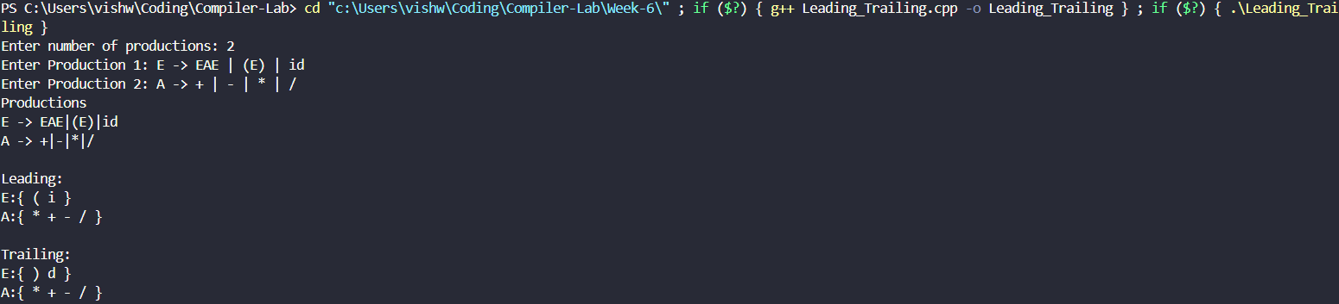
2.
Enter number of productions: 2
Enter Production 1: S -> (L) | a
Enter Production 2: L -> L,S | S
Productions
S -> (L)|a
L -> L,S|S

Leading:
S:{ ( a }
L:{ , }

Trailing:
S:{ ) a }
L:{ ) , a }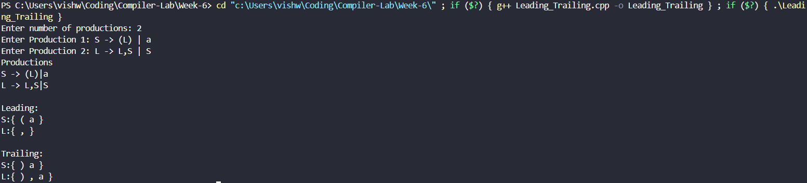

Result:
The C++ program to construct the Leading() and Trailing() for the given grammar was successfully run and the results were verified.

