Compiler Design Lab
Date: 6-2-2026 | Name: S Vishwajith
Assignment No.: 7 | Register No.: 23BCE1145

Aim:
To write the given programs in LEX:
- Write a LEX program to count the number of characters in a given input.
- Write a LEX program to count the number of words in a sentence.
- Write a LEX program to count the number of lines in a file.
- Write a LEX program to count the number of vowels in the given input.
- Write a LEX program to convert all lowercase letters to uppercase.
- Write a LEX program to identify and count digits in the input.
- Write a LEX program to identify and count keywords and identifiers.
- Write a LEX program to recognize integers and floating-point numbers.
- Write a LEX program to count the number of operators and operands.
- Write a LEX program to remove single-line and multi-line comments from a C program.
- Write a LEX program to recognize relational and logical operators.
- Write a LEX program to count the number of uppercase and lowercase letters.
- Write a LEX program to identify valid and invalid identifiers.
- Write a LEX program to find and print all email IDs from a given text.
- Write a LEX program to perform lexical analysis of a C program.
- Write a LEX program to generate tokens for keywords, identifiers, constants, and operators.
- Write a LEX program to implement a symbol table.
- Write a LEX program to validate arithmetic expression.

Codes:
1.
/* Write a LEX program to count the number of characters in a given input. */

%{
#include <stdio.h>
int characters = 0;
%}

%%
. {characters++;}
\n {characters++;}
%%

int yywrap(){
return 1;
}

int main(){
printf("Input here: ");
yylex();
printf("The number of characters in the given input is: %d.\n", characters);
return 0;
}
2.
/* Write a LEX program to count the number of words in a sentence. */

%{
#include <stdio.h>
int words = 0;
%}

%%
[a-zA-z]+ {words++;}
[ \n\t]+ {}
. {}
%%

int yywrap(){
return 1;
}

int main(){
printf("Input here: ");
yylex();
printf("The number of words is: %d.\n", words);
return 0;
}
3.
/* Write a LEX program to count the number of lines in a file. */

%{
#include <stdio.h>
int lines = 0;
%}

%%
. {}
\n {lines++;}
%%

int yywrap() {
return 1;
}

int main() {
printf("Input here: ");
yylex();
printf("The number of lines is: %d.\n", lines);
return 0;
}
4.
/* Write a LEX program to count the number of vowels in the given input. */

%{
#include <stdio.h>
int vowels = 0;
%}

%%
[aeiouAEIOU] {vowels++;}
.|\n {}
%%

int yywrap() {
return 1;
}

int main(){
printf("Input here: ");
yylex();
printf("The number of vowels are: %d.\n", vowels);
return 0;
}
5.
/* Write a LEX program to convert all lowercase letters to uppercase. */
%{
#include <stdio.h>
#include <ctype.h>
%}

%%
[a-z] { yytext[0] = toupper(yytext[0]); ECHO; }
.|\n { ECHO; }
%%

int yywrap() {
return 1;
}

int main() {
printf("Input here: ");
fflush(stdout);
yylex();
return 0;
}
6.
/* Write a LEX program to identify and count digits in the input. */

%{
#include <stdio.h>
int digits = 0;
%}

%%
[0-9] {digits++;}
.|\n {}
%%

int yywrap() {
return 1;
}

int main() {
printf("Input here: ");
yylex();
printf("The number of digits is: %d.\n", digits);
return 0;
}
7.
/* Write a LEX program to identify and count keywords and identifiers. */

%{
#include <stdio.h>
#include <string.h>
int keywords = 0;
int identifiers = 0;
int is_keyword(char* token) {
char *keywords[] = {"auto", "break", "case", "char", "const", "continue",
"default", "do", "double", "else", "enum", "extern",
"float", "for", "goto", "if", "int", "long", "register",
"return", "short", "signed", "sizeof", "static", "struct",
"switch", "typedef", "union", "unsigned", "void", "volatile",
"while"};
int n = sizeof(keywords) / sizeof(char*);
for(int i = 0; i < n; i++) {
if(strcmp(token, keywords[i]) == 0) {
return 1;
}
}
return 0;
}
%}

identifier [a-zA-Z_][a-zA-Z0-9_]*
whitespace [ \t\n]+

%%
{identifier} {
if(is_keyword(yytext)) {
keywords++;
printf("KEYWORD: %s.\n", yytext);
}
else {
identifiers++;
printf("IDENTIFIER: %s.\n", yytext);
}
}
{whitespace} {}
. {}
%%

int yywrap() {
return 1;
}

int main() {
printf("Write code here:\n");
yylex();
printf("The number of keywords is: %d.\n", keywords);
printf("The number of identifiers is: %d.\n", identifiers);
}
8.
/* Write a LEX program to recognize integers and floating-point numbers. */

%{
#include <stdio.h>
%}

%%
[0-9]+[.][0-9]+ {printf("Floating point value.\n");}
[0-9]+ {printf("Integer.\n");}
.|\n {}
%%

int yywrap() {
return 1;
}

int main() {
printf("Input here:\n");
yylex();
return 0;
}
9.
/* Write a LEX program to count the number of operators and operands. */

%{
#include <stdio.h>
int operators = 0;
int operands = 0;
%}

operator "<<"|">>"|"&&"|"||"|"<="|">="|"=="|"++"|"--"|"+"|"-"|"*"|"/"|"%"|"<"|">"|"="|"&"|"|"|"^"
operand [a-zA-Z_][a-zA-Z0-9_]*
whitespace [ \t\n]+

%%
{operator} {operators++;}
{operand} {operands++;}
{whitespace} {}
. {}
%%

int yywrap() {
return 1;
}

int main() {
printf("Inputs here:\n");
yylex();
printf("Number of operands: %d.\n", operands);
printf("Number of operators: %d.\n", operators);
return 0;
}
10.
/* Write a LEX program to remove single-line and multi-line comments from a C program. */

%{
#include <stdio.h>
#include <string.h>
#define MAX 100000
char code[MAX];
int x = 0;
void add_text(const char *text) {
int len = strlen(text);
if (x + len < MAX) {
strcpy(&code[x], text);
x += len;
}
}
%}

%x SINGLE MULTI

%%
\"([^\\\"]|\\.)*\" {add_text(yytext);}
\'([^\\\']|\\.)*\' {add_text(yytext);}
"//" {BEGIN(SINGLE);}
"/*" {BEGIN(MULTI);}

<SINGLE>\n {BEGIN(INITIAL); add_text("\n");}
<SINGLE>. {}

<MULTI>"*/" {BEGIN(INITIAL);}
<MULTI>\n {add_text("\n");}
<MULTI>. {}

.|\n {add_text(yytext);}
%%

int yywrap() {
return 1;
}

int main() {
printf("Enter C Code:\n");
yylex();
printf("The C code without any comments is:\n\n%s\n", code);
return 0;
}
11.
/* Write a LEX program to recognize relational and logical operators. */

%{
#include <stdio.h>
%}

relational "<="|">="|"=="|"!="|"<"|">"
logical "&&"|"||"|"!"

%%
{relational} {printf("RELATIONAL OPERATOR: %s.\n", yytext);}
{logical} {printf("LOGICAL OPERATOR: %s.\n", yytext);}
.|\n {}
%%

int yywrap() {
return 1;
}

int main() {
printf("Inputs here:\n");
yylex();
return 0;
}
12.
/* Write a LEX program to count the number of uppercase and lowercase letters. */

%{
#include <stdio.h>
int upper = 0;
int lower = 0;
%}

%%
[a-z] {lower++;}
[A-Z] {upper++;}
.|\n {}
%%

int yywrap() {
return 1;
}

int main() {
printf("Input here:");
yylex();
printf("Number of uppercase letters is: %d.\n", upper);
printf("Number of lowercase letters is: %d.\n", lower);
return 0;
}
13.
/* Write a LEX program to identify valid and invalid identifiers. */

%{
#include <stdio.h>
#include <string.h>
const char *keywords[] = {
"int","float","char","double","if","else","while","for",
"return","void","break","continue","switch","case","default",
"do","struct","union","typedef","enum","const","unsigned",
"signed","extern","static","sizeof","long","short","goto"
};
int isKeyword(const char *word) {
int n = sizeof(keywords)/sizeof(keywords[0]);
for(int i = 0; i < n; i++) {
if(strcmp(word, keywords[i]) == 0)
return 1;
}
return 0;
}
%}

valid_id [a-zA-Z_][a-zA-Z0-9_]*
invalid_id [0-9][a-zA-Z0-9_]*

%%
{valid_id} {
if(isKeyword(yytext))
printf("%s : Keyword (not identifier)\n", yytext);
else
printf("%s : Valid Identifier\n", yytext);
}

{invalid_id} {printf("%s : Invalid Identifier\n", yytext);}

[ \t\n]+ {}

. {printf("%s : Invalid Identifier\n", yytext);}
%%

int yywrap() {
return 1;
}

int main() {
printf("Enter tokens:\n");
yylex();
return 0;
}
14.
/* Write a LEX program to find and print all email IDs from a given text. */

%{
#include <stdio.h>
%}

email [a-zA-Z0-9._%+-]+@[a-zA-Z0-9.-]+\.[a-zA-Z]{2,}

%%
{email} {printf("Email found: %s\n", yytext);}

.|\n {}
%%

int yywrap() {
return 1;
}

int main() {
printf("Inputs here:\n\n");
yylex();
return 0;
}
15.
/* Write a LEX program to perform lexical analysis of a C program. */

%{
#include <stdio.h>
#include <string.h>
%}

keyword int|float|char|double|if|else|while|for|return|void|break|continue
id [a-zA-Z_][a-zA-Z0-9_]*
number [0-9]+(\.[0-9]+)?
operator "=="|"!="|"<="|">="|"++"|"--"|"+"|"-"|"*"|"/"|"="|"<"|">"
delimiter [;(),{}]

%%
{keyword} {printf("Keyword: %s\n", yytext);}
{id} {printf("Identifier: %s\n", yytext);}
{number} {printf("Constant: %s\n", yytext);}
{operator} {printf("Operator: %s\n", yytext);}
{delimiter} {printf("Delimiter: %s\n", yytext);}
[ \t\n]+ {}
. {printf("Unknown: %s\n", yytext);}
%%

int yywrap(){
return 1;
}

int main(){
printf("Enter the C code here:\n");
yylex();
return 0;
}
16.
/* Write a LEX program to generate tokens for keywords, identifiers, constants, and operators. */

%{
#include <stdio.h>
%}

%%
int|float|char|double|if|else|while|for|return|void {printf("<KEYWORD, %s>\n", yytext);}
[a-zA-Z_][a-zA-Z0-9_]* {printf("<ID, %s>\n", yytext);}
[0-9]+(\.[0-9]+)? {printf("<CONST, %s>\n", yytext);}
"=="|"!="|"<="|">="|"+"|"-"|"*"|"/"|"=" {printf("<OP, %s>\n", yytext);}
[ \t\n]+ {}
. {printf("<INVALID, %s>\n", yytext);}
%%

int yywrap(){
return 1;
}

int main(){
printf("Enter the C code here:\n");
yylex();
return 0;
}
17.
/* Write a LEX program to implement a symbol table. */

%{
#include <stdio.h>
#include <string.h>
char symtab[100][50];
int count = 0;
int exists(char *s){
for(int i=0;i<count;i++)
if(strcmp(symtab[i],s)==0) return 1;
return 0;
}
%}

%%
int|float|char|double|if|else|while|for|return|void {}

[a-zA-Z_][a-zA-Z0-9_]* {
if(!exists(yytext)){
strcpy(symtab[count++], yytext);
printf("Inserted into Symbol Table: %s\n", yytext);
}
}

[ \t\n]+ ;
. ;
%%

int yywrap(){
return 1;
}

int main(){
printf("Enter the C code here:\n");
yylex();
printf("\nSymbol Table:\n");
for(int i=0;i<count;i++)
printf("%d. %s\n", i+1, symtab[i]);
return 0;
}
18.
/* Write a LEX program to validate arithmetic expression */

%{
#include <stdio.h>
int valid = 1;
int paren = 0;
%}

%%
[0-9]+ {}
[a-zA-Z_][a-zA-Z0-9_]* {}
"(" {paren++;}
")" {paren--;if(paren<0) valid=0;}
[+\-*/] {}
[ \t\n]+ {}
. {valid = 0;}
%%

int yywrap(){
return 1;
}

int main(){
printf("Enter expression:\n");
yylex();
if(valid && paren==0)
printf("Valid Arithmetic Expression\n");
else
printf("Invalid Arithmetic Expression\n");
return 0;
}

Inputs and Outputs:
1.
Executing task: cd "C:\Users\vishw\Coding\Compiler-Lab\Week-7"; flex Q1.l; gcc lex.yy.c; ./a.exe

Input here: Hello World!
^Z
The number of characters in the given input is: 13. 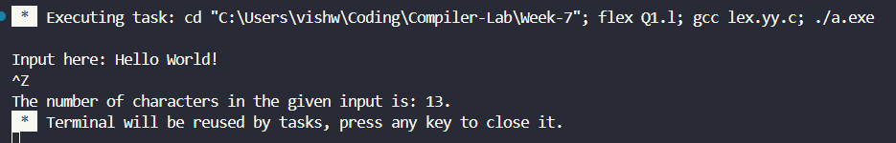
2.
Executing task: cd "C:\Users\vishw\Coding\Compiler-Lab\Week-7"; flex Q2.l; gcc lex.yy.c; ./a.exe

Input here: Hello world, this is compiler assignment.
^Z
The number of words is: 6. 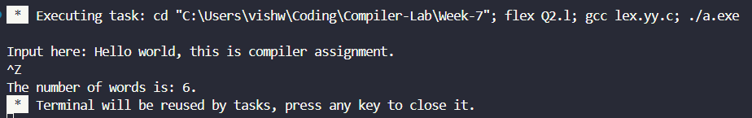
3.
Executing task: cd "C:\Users\vishw\Coding\Compiler-Lab\Week-7"; flex Q3.l; gcc lex.yy.c; ./a.exe

Input here: Hello
Bye
Compiler.
^Z
The number of lines is: 3. 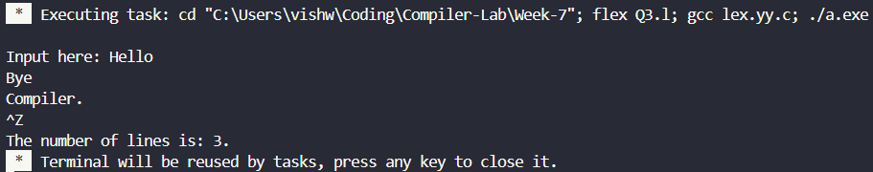
4.
Executing task: cd "C:\Users\vishw\Coding\Compiler-Lab\Week-7"; flex Q4.l; gcc lex.yy.c; ./a.exe

Input here: Hello World!
^Z
The number of vowels are: 3. 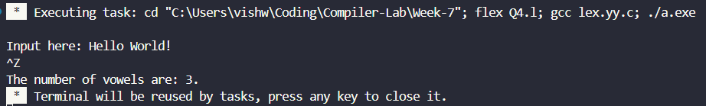

5.
Executing task: cd "C:\Users\vishw\Coding\Compiler-Lab\Week-7"; flex Q5.l; gcc lex.yy.c; ./a.exe

Input here: Hello world!
HELLO WORLD!
Bye.
BYE.
^Z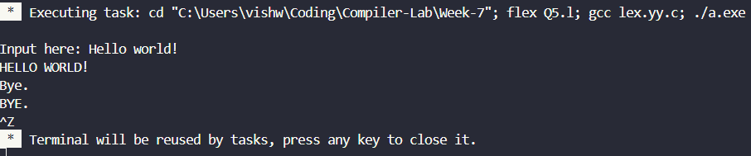
6.
Executing task: cd "C:\Users\vishw\Coding\Compiler-Lab\Week-7"; flex Q6.l; gcc lex.yy.c; ./a.exe

Input here: H3ll0 Fl4m3s!
^Z
The number of digits is: 4.
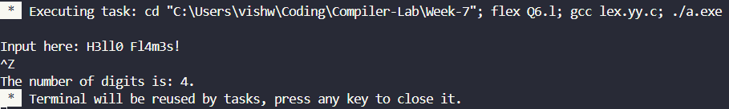
7.
Executing task: cd "C:\Users\vishw\Coding\Compiler-Lab\Week-7"; flex Q7.l; gcc lex.yy.c; ./a.exe

Write code here:
#include <stdio.h>
IDENTIFIER: include.
IDENTIFIER: stdio.
IDENTIFIER: h.
int main(){
KEYWORD: int.
IDENTIFIER: main.
int a = 6 + 7;
KEYWORD: int.
IDENTIFIER: a.
return 0;
KEYWORD: return.
}
^Z
The number of keywords is: 3.
The number of identifiers is: 5. 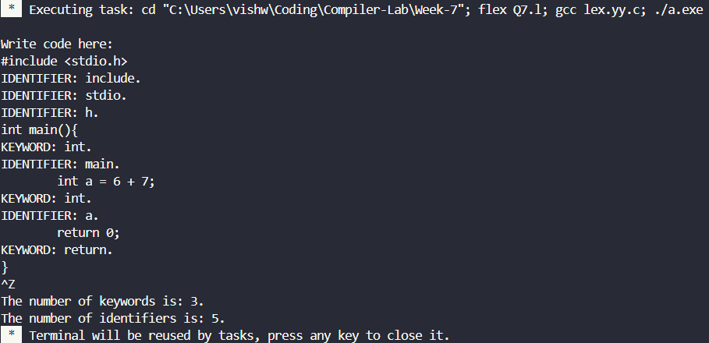
8.
Executing task: cd "C:\Users\vishw\Coding\Compiler-Lab\Week-7"; flex Q8.l; gcc lex.yy.c; ./a.exe

Input here:
11.11
Floating point value.
11
Integer.
^Z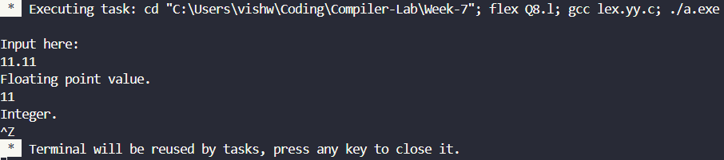
9.
Executing task: cd "C:\Users\vishw\Coding\Compiler-Lab\Week-7"; flex Q9.l; gcc lex.yy.c; ./a.exe

Inputs here:
a <<= b-- + ++c
^Z
Number of operands: 3.
Number of operators: 5. 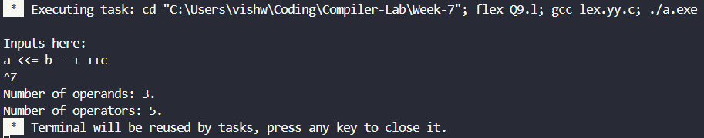
10.
Executing task: cd "C:\Users\vishw\Coding\Compiler-Lab\Week-7"; flex Q10.l; gcc lex.yy.c; ./a.exe

Enter C Code:
#include <stdio.h>
//Single line comment.
/* Multi
line
comment.
*/
int main(){
int a = 6 + 7;
return 0;
}
^Z
The C code without any comments is:

#include <stdio.h>

int main(){
int a = 6 + 7;
return 0;
}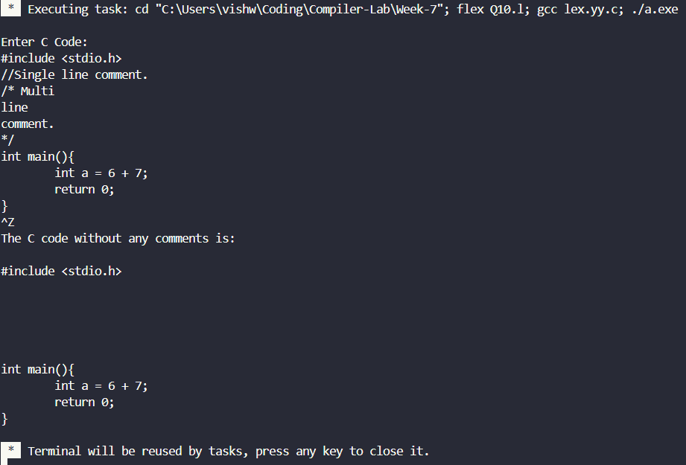
11.
Executing task: cd "C:\Users\vishw\Coding\Compiler-Lab\Week-7"; flex Q11.l; gcc lex.yy.c; ./a.exe

Inputs here:
<
RELATIONAL OPERATOR: <.
<=
RELATIONAL OPERATOR: <=.
&&
LOGICAL OPERATOR: &&.
&
||
LOGICAL OPERATOR: ||.
^Z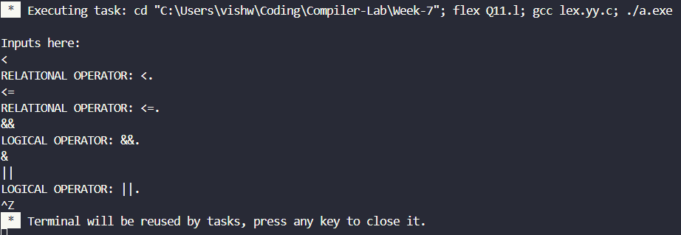
12.
Executing task: cd "C:\Users\vishw\Coding\Compiler-Lab\Week-7"; flex Q12.l; gcc lex.yy.c; ./a.exe

Input here: Hello World!
^Z
Number of uppercase letters is: 2.
Number of lowercase letters is: 8. 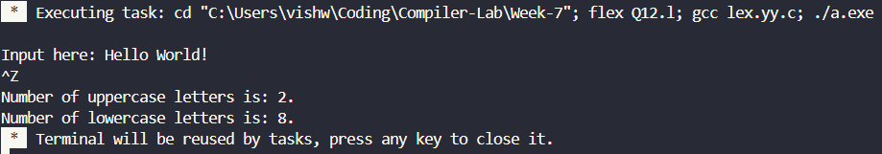
13.
Executing task: cd "C:\Users\vishw\Coding\Compiler-Lab\Week-7"; flex Q13.l; gcc lex.yy.c; ./a.exe

Enter tokens:
int sit
int : Keyword (not identifier)
sit : Valid Identifier
9ab-*bc
9ab : Invalid Identifier
- : Invalid Identifier
* : Invalid Identifier
bc : Valid Identifier
^Z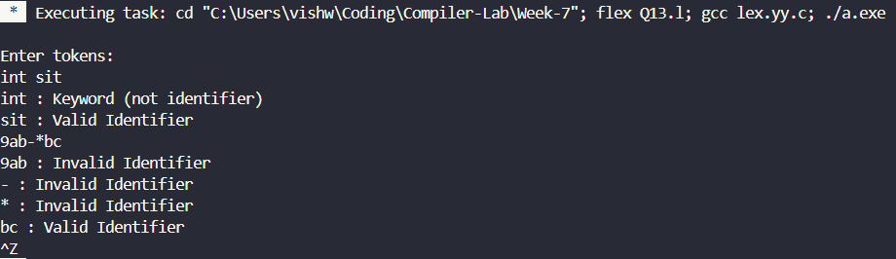
14.
Executing task: cd "C:\Users\vishw\Coding\Compiler-Lab\Week-7"; flex Q14.l; gcc lex.yy.c; ./a.exe

Inputs here:

ab
vishwajith.s2023@vitstudent.ac.in
Email found: vishwajith.s2023@vitstudent.ac.in
something@something.something
Email found: something@something.something
^Z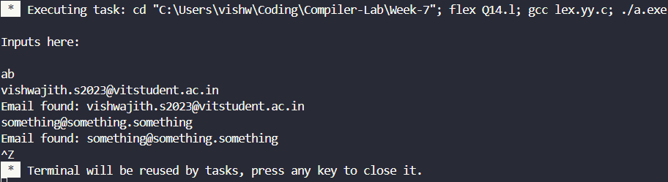
15.
Executing task: cd "C:\Users\vishw\Coding\Compiler-Lab\Week-7"; flex Q15.l; gcc lex.yy.c; ./a.exe

Enter the C code here:
#include <stdio.h>
Unknown: #
Identifier: include
Operator: <
Identifier: stdio
Unknown: .
Identifier: h
Operator: >
int main(){
Keyword: int
Identifier: main
Delimiter: (
Delimiter: )
Delimiter: {
int a = 6+7;
Keyword: int
Identifier: a
Operator: =
Constant: 6
Operator: +
Constant: 7
Delimiter: ;
return 0;
Keyword: return
Constant: 0
Delimiter: ;
}
Delimiter: }
^Z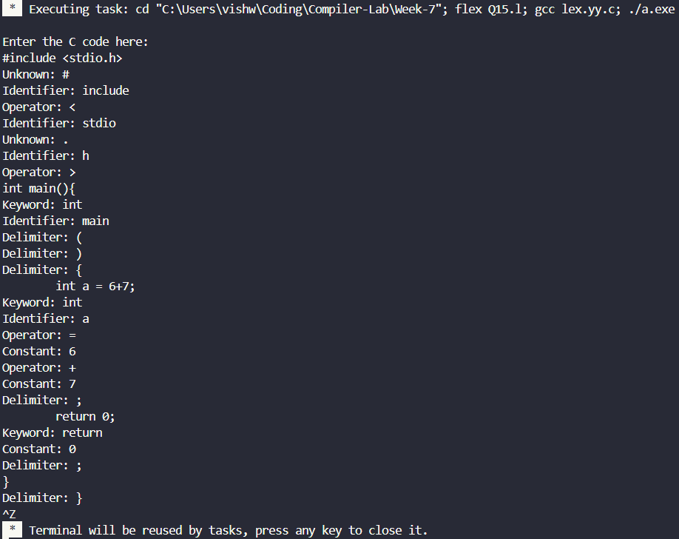
16.
Executing task: cd "C:\Users\vishw\Coding\Compiler-Lab\Week-7"; flex Q16.l; gcc lex.yy.c; ./a.exe

Enter the C code here:
int main(){
<KEYWORD, int>
<ID, main>
<INVALID, (>
<INVALID, )>
<INVALID, {>
return 0;
<KEYWORD, return>
<CONST, 0>
<INVALID, ;>
}
<INVALID, }>
^Z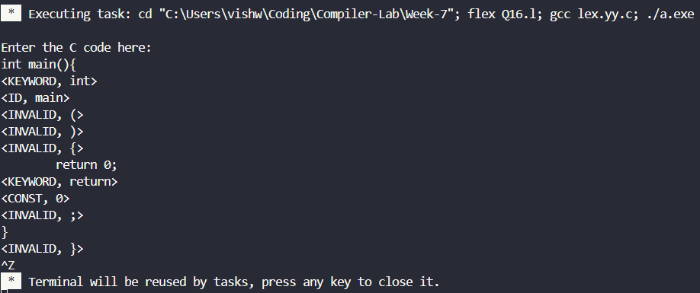
17.
Executing task: cd "C:\Users\vishw\Coding\Compiler-Lab\Week-7"; flex Q17.l; gcc lex.yy.c; ./a.exe

Enter the C code here:
int main(){
Inserted into Symbol Table: main
return 0;
}
^Z

Symbol Table:
1. main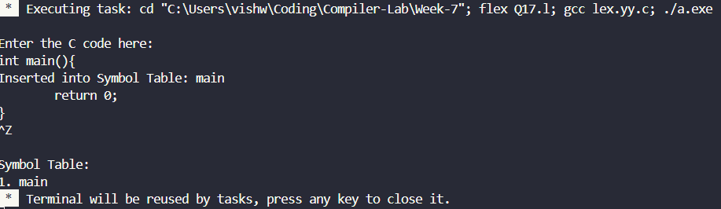
18.
Executing task: cd "C:\Users\vishw\Coding\Compiler-Lab\Week-7"; flex Q18.l; gcc lex.yy.c; ./a.exe

Enter expression:
a + (b - c) * d - ((e + f) / g)
^Z
Valid Arithmetic Expression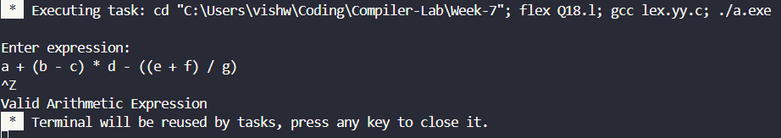

Result:
The LEX programs written for the given questions were successfully compiled and run.

