Lab Report

BCSE307P- Compiler Design Laboratory

Slots: L29+L30

CH2025260502087

School of Computer Science and Engineering

by

S Vishwajith 23BCE1145


SCHOOL OF COMPUTER SCIENCE AND ENGINEERING

April, 2026



BCSE307P –COMPILER DESIGN LABORATORY
Slots: L29+L30 CH2025260502087 (Friday- 11.40 am to 1.20 pm)
Course faculty: Dr.R.Suganya, Professor, SCOPE, VIT
Venue: AB3-310 – D1 slot
Course Outcomes | Content | Page number | Date of submission
1 | a) Recognition of Tokens  b)Regular Expressions  a)RE to DFA  b)RE to NFA | 3  10  22  38 | 14.12.2025  17.12.2025  24.12.2025  24.12.2025
2 | a) Predictive Parsing  b) Operator Precedence | 43  54 | 14.01.2026  02.02.2026
3 | LEX Programs | 61 | 11.02.2026
4 | a)SLR () Parser  bCLR() Parser | 84  102 | 20.02.2026  04.03.2026
5 | a)Three Address Code  b) TAC for Control flow structure  c)Code Optimization | 119  134  163 | 11.03.2026  25.03.2026  27.03.2026
6 | Model exam | 10.4.26
7 | FAT Lab | 17.4.26

Signature of Course Faculty
Dr. R. Suganya

Lab Assignment
Name | S Vishwajith
Registration Number | 23BCE1145
Subject | Compiler Design
Assignment Number | 1

Aim:
To write a C++ program LA.cpp that acts as a lexical analyser to read a C++ source file Factorial.cpp containing a factorial program. The program should identify tokens such as keywords, identifiers, operators, constants, and symbols. It should then print each token with its type and value.

Algorithm:
- Open the source file Factorial.cpp in read mode.
- Repeat until End of File (EOF) is reached:
  - Read each word (separated with a blank space) from the file.
  - If the word has a special symbol, split it into 3 (before, special symbol, and after) and print each part as a token.
  - Check if the word is a keyword, operator or a special symbol and print accordingly.
  - If it’s none of them, then the word is an identifier and print it accordingly.
- Close the file after reading.

Codes:

Factorial.cpp:
#include <iostream>
using namespace std;
int factorial(int n)
{
if (n <= 1)
return 1;
return n * factorial(n - 1);
}
int main()
{
int n;
cin >> n;
cout << factorial(n) << endl;
return 0;
}

LA.cpp:
#include <fstream>
#include <iostream>
#include <string>
#include <sstream>
#include <algorithm>
#include <vector>
using namespace std;
vector<string> keywords = {"include", "using", "namespace", "int", "if", "return"};
vector<string> operators = {"<", ">", "=", "-", ">>", "<<"};
vector<string> special_symbols = {"(", ")", ";", "{", "}", "#"};
bool hasPunctuator(string word)
{
for (const auto &spec : special_symbols)
{
if (word.find(spec) != string::npos)
{
return true;
}
}
return false;
}
void printToken(string word)
{
if (word.length() > 1 && hasPunctuator(word))
{
for (const auto &spec : special_symbols)
{
size_t pos;
while ((pos = word.find(spec)) != string::npos)
{
string beforePunct = word.substr(0, pos);
if (!beforePunct.empty())
{
printToken(beforePunct);
}
cout << "Type: SPECIAL SYMBOL, Value: " << spec << endl;
word = word.substr(pos + spec.length());
}
}
if (!word.empty())
{
printToken(word);
}
return;
}
if (word.find("<") != string::npos && word.find(">") != string::npos && word.length() > 1)
{
cout << "Type: OPERATOR, Value: <" << endl;
word.erase(remove(word.begin(), word.end(), '<'), word.end());
word.erase(remove(word.begin(), word.end(), '>'), word.end());
printToken(word);
cout << "Type: OPERATOR, Value: >" << endl;
return;
}
auto itk = find(keywords.begin(), keywords.end(), word);
auto ito = find(operators.begin(), operators.end(), word);
auto itp = find(special_symbols.begin(), special_symbols.end(), word);
if (itk != keywords.end())
{
cout << "Type: KEYWORD, Value: " << word << endl;
}
else if (ito != operators.end())
{
cout << "Type: OPERATOR, Value: " << word << endl;
}
else if (itp != special_symbols.end())
{
cout << "Type: PUNCTUATOR, Value: " << word << endl;
}
else
{
cout << "Type: IDENTIFIER, Value: " << word << endl;
}
}
int main()
{
ifstream inputFile("Factorial.cpp");
if (!inputFile.is_open())
{
cerr << "Error: Could not open the file 'Factorial.cpp'" << endl;
return 1;
}
string word;
while (inputFile >> word)
{
printToken(word);
}
inputFile.close();
return 0;
}

Output:
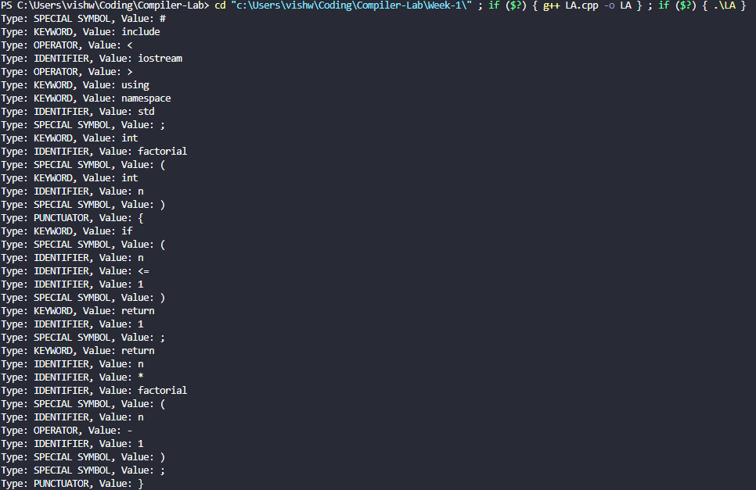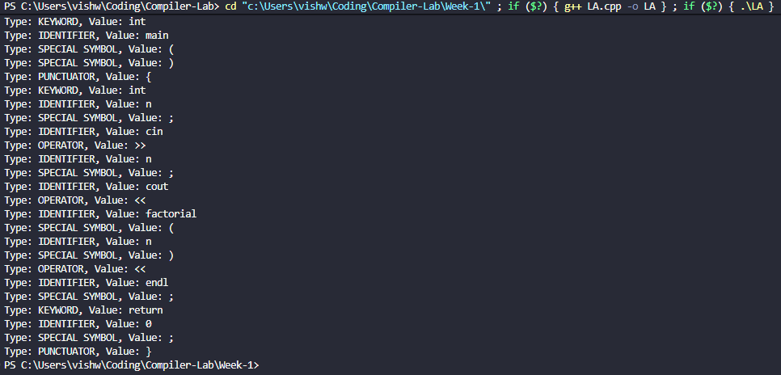
Type: SPECIAL SYMBOL, Value: #
Type: KEYWORD, Value: include
Type: OPERATOR, Value: <
Type: IDENTIFIER, Value: iostream
Type: OPERATOR, Value: >
Type: KEYWORD, Value: using
Type: KEYWORD, Value: namespace
Type: IDENTIFIER, Value: std
Type: SPECIAL SYMBOL, Value: ;
Type: KEYWORD, Value: int
Type: IDENTIFIER, Value: factorial
Type: SPECIAL SYMBOL, Value: (
Type: KEYWORD, Value: int
Type: IDENTIFIER, Value: n
Type: SPECIAL SYMBOL, Value: )
Type: PUNCTUATOR, Value: {
Type: KEYWORD, Value: if
Type: SPECIAL SYMBOL, Value: (
Type: IDENTIFIER, Value: n
Type: IDENTIFIER, Value: <=
Type: IDENTIFIER, Value: 1
Type: SPECIAL SYMBOL, Value: )
Type: KEYWORD, Value: return
Type: IDENTIFIER, Value: 1
Type: SPECIAL SYMBOL, Value: ;
Type: KEYWORD, Value: return
Type: IDENTIFIER, Value: n
Type: IDENTIFIER, Value: *
Type: IDENTIFIER, Value: factorial
Type: SPECIAL SYMBOL, Value: (
Type: IDENTIFIER, Value: n
Type: OPERATOR, Value: -
Type: IDENTIFIER, Value: 1
Type: SPECIAL SYMBOL, Value: )
Type: SPECIAL SYMBOL, Value: ;
Type: PUNCTUATOR, Value: }
Type: KEYWORD, Value: int
Type: IDENTIFIER, Value: main
Type: SPECIAL SYMBOL, Value: (
Type: SPECIAL SYMBOL, Value: )
Type: PUNCTUATOR, Value: {
Type: KEYWORD, Value: int
Type: IDENTIFIER, Value: n
Type: SPECIAL SYMBOL, Value: ;
Type: IDENTIFIER, Value: cin
Type: OPERATOR, Value: >>
Type: IDENTIFIER, Value: n
Type: SPECIAL SYMBOL, Value: ;
Type: IDENTIFIER, Value: cout
Type: OPERATOR, Value: <<
Type: IDENTIFIER, Value: factorial
Type: SPECIAL SYMBOL, Value: (
Type: IDENTIFIER, Value: n
Type: SPECIAL SYMBOL, Value: )
Type: OPERATOR, Value: <<
Type: IDENTIFIER, Value: endl
Type: SPECIAL SYMBOL, Value: ;
Type: KEYWORD, Value: return
Type: IDENTIFIER, Value: 0
Type: SPECIAL SYMBOL, Value: ;
Type: PUNCTUATOR, Value: }

Result:
The C++ program to perform lexical analysis of a factorial program was successfully run and the results were verified.

Lab Assignment
Name | S Vishwajith
Registration Number | 23BCE1145
Subject | Compiler Design
Assignment Number | 2

Question 1:
Write a regex to check if a string contains only alphabets.

Code:
// A C++ program to write a regex to check if a string contains only alphabets.
#include <iostream>
#include <regex>
using namespace std;

int main()
{
string str;
cout << "Enter a string: ";
cin >> str;

regex pattern("^[A-Za-z]+$");

if (regex_match(str, pattern))
{
cout << "The string contains only alphabets." << endl;
}
else
{
cout << "The string contains characters other than alphabets." << endl;
}

return 0;
}

Output:
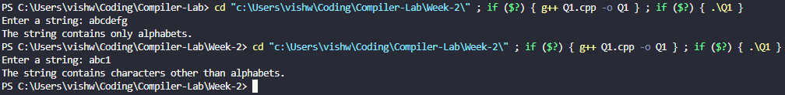

Question 2:
Write a regex to validate a 10-digit Indian mobile number starting with
digits 6 to 9.

Code:
// A C++ code to write a regex to validate a 10-digit Indian mobile number starting with digits 6 to 9.
#include <iostream>
#include <regex>
using namespace std;

int main()
{
string mobileNo;
cout << "Enter a 10-digit Indian mobile number: ";
cin >> mobileNo;
regex pattern("^[6-9][0-9]{9}$");
if (regex_match(mobileNo, pattern))
{
cout << "The mobile number is valid." << endl;
}
else
{
cout << "The mobile number is invalid." << endl;
}
}

Output:
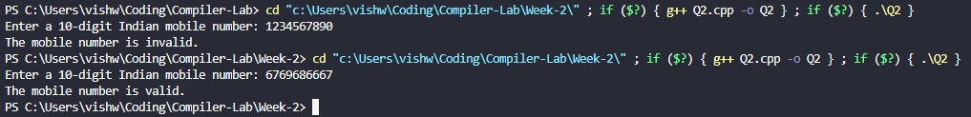

Question 3:
Write a regex to validate an email address.

Code:
// A C++ program to write a regex to validate an email address.
#include <iostream>
#include <regex>
using namespace std;

int main()
{
string emailAddresss;
cout << "Enter an email address: ";
cin >> emailAddresss;

regex ep("^([a-zA-Z]+)([a-zA-Z0-9_.-]*)@([a-zA-Z0-9.-]+)\\.([a-zA-Z]{2,5})$");

if (regex_match(emailAddresss, ep))
{
cout << "This is a valid email address." << endl;
}
else
{
cout << "This is an invalid email address." << endl;
}
return 0;
}

Output:
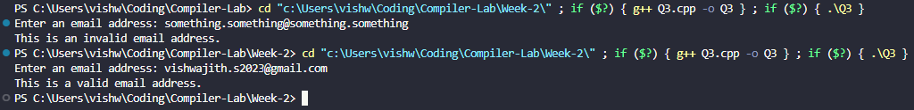

Question 4:
Write a regex to validate dates in DD-MM-YYYY format.

Code:
// A C++ program to write a regex to validate dates in DD-MM-YYYY format.
#include <iostream>
#include <regex>
using namespace std;

int main()
{
string date;
cout << "Enter a date in the format \"DD-MM-YYYY\": ";
cin >> date;

regex dp("^[0-3][0-9]\\-[0-1][0-9]\\-[0-9]{4}$");

if (regex_match(date, dp))
{
cout << "The given date matches the given format." << endl;
}
else
{
cout << "The given date doesn't match the given format." << endl;
}
return 0;
}

Output:
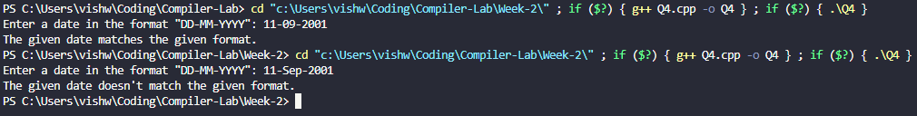

Question 5:
Write a C++ program to check whether the string is accepted or not – the
string must contain exactly two occurrences of ‘a’.

Code:
// A C++ program to check whether the string is accepted or not – the string must contain exactly two occurrences of 'a'.
#include <iostream>
#include <regex>
using namespace std;

int main()
{
string s;
cout << "Enter a string: ";
cin >> s;

regex sp("^[a]{2}$");
if (regex_match(s, sp))
{
cout << "The string has exactly 2 occurrences of a." << endl;
}
else
{
cout << "The string doesn't have exactly 2 occurrences of a." << endl;
}
return 0;
}

Output:
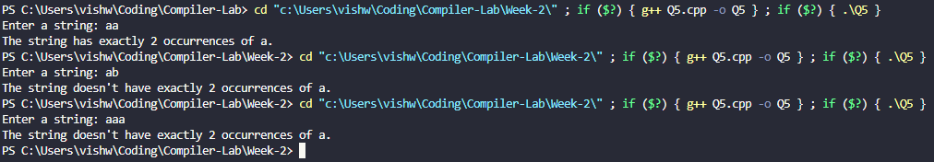

Question 6:
Write a C++ program to check whether the string is accepted or not – the
string should be of even length and contain only a and b.

Code:
// A C++ program to check whether the string is accepted or not – the string should be of even length and contain only a and b.
#include <iostream>
#include <regex>
using namespace std;

int main()
{
string s;
cout << "Enter a string: ";
cin >> s;

regex sp("^[a|b]+$");
if (regex_match(s, sp) && s.size() % 2 == 0)
{
cout << "The string is of even length and contains only a and b." << endl;
}
else
{
cout << "The string doesn't satisfy one or more of the given conditions." << endl;
}
return 0;
}

Output:
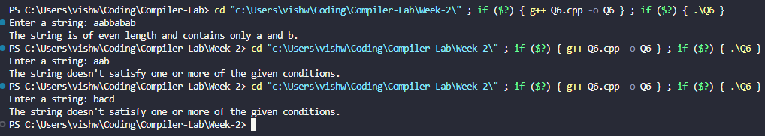

Question 7:
Write a C++ program to check whether the string is accepted or not – the
string should begin and end with the same character.

Code:
// A C++ program to check whether the string is accepted or not – the string should begin and end with the same character.
#include <iostream>
using namespace std;

int main()
{
string s;
cout << "Enter a string: ";
cin >> s;
if (s[0] == s[s.size() - 1])
{
cout << "The first and last characters are the same." << endl;
}
else
{
cout << "The first and last characters are not the same." << endl;
}
return 0;
}

Output:
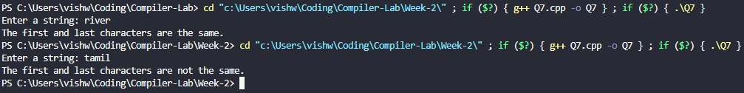

Question 8:
Write a C++ program to check whether the string is accepted or not – the
string must end with “abb”.

Code:
// A C++ program to check whether the string is accepted or not – the string must end with “abb”.
#include <iostream>
using namespace std;

int main()
{
string s;
cout << "Enter a string: ";
cin >> s;
if (s.size() >= 3 && s.substr(s.size() - 3) == "abb")
{
cout << "The string ends with \"abb\"." << endl;
}
else
{
cout << "The string does not end with \"abb\"." << endl;
}
return 0;
}

Output:
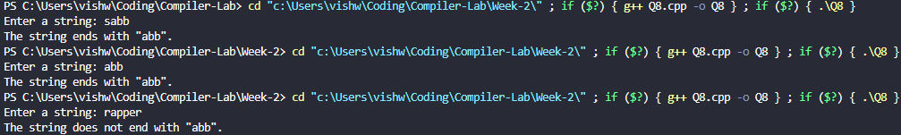

Question 9:
Write a C++ program to check whether the string is accepted or not – the
string must contain no consecutive repeating characters.

Code:
// A C++ program to check whether the string is accepted or not – the string must contain no consecutive repeating characters.
#include <iostream>
using namespace std;

int main()
{
string s;
cout << "Enter a string: ";
cin >> s;
bool flag = true;
for (int i = 0; i < s.size() - 1; i++)
{
if (s[i] == s[i + 1])
{
flag = false;
break;
}
}
if (flag)
{
cout << "There are no consecutive repeating characters." << endl;
}
else
{
cout << "There are consecutive repeating characters." << endl;
}
return 0;
}

Output:
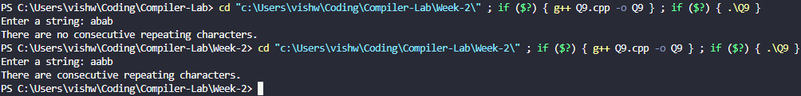

Question 10:
Write a C++ program to check whether the string is accepted or not – the string must contain both substrings “ab” and “ba” at least once, in any order.

Code:
// a C++ program to check whether the string is accepted or not – the string must contain both substrings “ab” and “ba” at least once, in any order.
#include <iostream>
#include <regex>
using namespace std;

int main()
{
string s;
cout << "Enter a string: ";
cin >> s;

regex sp1("ab"), sp2("ba");

if (regex_search(s, sp1) && regex_search(s, sp2))
{
cout << "The string contains both \"ab\" and \"ba\"." << endl;
}
else
{
cout << "The string doesn't contain either \"ab\" or \"ba\"." << endl;
}
return 0;
}

Output:
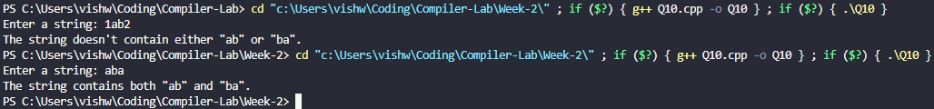

Question 11:
Write a C++ program to check whether the string is accepted or not – the string length must be a prime number, and the string must contain only 0s and 1s.

Code:
// A C++ program to check whether the string is accepted or not – the string length must be a prime number, and the string must contain only 0s and 1s.
#include <iostream>
#include <regex>
#include <math.h>
using namespace std;

bool isPrime(int n)
{
if (n <= 1)
{
return false;
}
for (int i = 2; i <= sqrt(n); i++)
{
if (n % i == 0)
{
return false;
}
}
return true;
}

int main()
{
string s;
cout << "Enter a string: ";
cin >> s;

regex sp("^[0|1]+$");
if (regex_match(s, sp) && isPrime(s.size()))
{
cout << "The string is of prime number length and contains only 0 and 1." << endl;
}
else
{
cout << "The string doesn't satisfy one or more of the given conditions." << endl;
}
return 0;
}

Output:
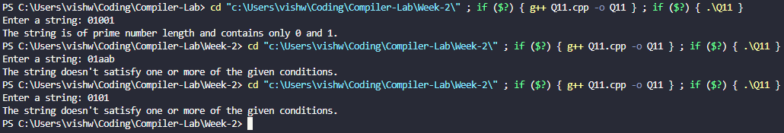

Compiler Design Lab
Date: 18-12-2025 | Name: S Vishwajith
Assignment No.: 3 | Register No.: 23BCE1145

Aim:
To write a C++ code to find Nullable(), Firstpos(), Lastpos() and Followpos() for the given Regular Expressions: (a|b)*a(a|b)(a|b), (a|b)*a(a|b)*, (a|b)*|(ac)*.

Algorithm:
- Concatenate the Regular Expression with ‘#’ for the end marker.
- Construct a syntax tree.
- Calculate the Nullable(), Firstpos(), Lastpos() and Followpos() using the rules for leaf nodes, Star (*) nodes, Concatenation (.) nodes and Or (|) nodes.
- Maintain a vector of the number of characters that are not operators and print their Followpos().

Code:

RE_to_DFA.cpp:
#include <iostream>
#include <vector>
#include <string>
#include <set>
#include <stack>
#include <algorithm>
using namespace std;

string infix_to_postfix(string infix)
{
string pf = "";
stack<char> op_stack;
for (char c : infix)
{
if (c != '*' && c != '|' && c != '.' && c != '(' && c != ')')
{
pf += c;
}
else if (c == '(')
{
op_stack.push(c);
}
else if (c == ')')
{
while (!op_stack.empty() && op_stack.top() != '(')
{
pf += op_stack.top();
op_stack.pop();
}
op_stack.pop();
}
else
{
while (!op_stack.empty() &&
((c == '*' && (op_stack.top() == '*')) ||
(c == '.' && (op_stack.top() == '*' || op_stack.top() == '.')) ||
(c == '|' && (op_stack.top() == '*' || op_stack.top() == '.' || op_stack.top() == '|'))))
{
pf += op_stack.top();
op_stack.pop();
}
op_stack.push(c);
}
}
while (!op_stack.empty())
{
pf += op_stack.top();
op_stack.pop();
}
return pf;
}

vector<int> operator+(vector<int> a, vector<int> b)
{
a.insert(a.end(), b.begin(), b.end());
sort(a.begin(), a.end());
a.erase(unique(a.begin(), a.end()), a.end());
return a;
}

class tree
{
public:
char c;
int lno;
vector<int> first, last;
bool nullable;
tree *left;
tree *right;

tree(char ch, int n)
{
c = ch;
lno = n;
nullable = false;
left = nullptr;
right = nullptr;
first.clear();
last.clear();
}
};

int main()
{
string rx;
cout << "Enter a Regular Expression in infix form: ";
cin >> rx;
rx = "(" + rx + ").#";
string postfix = infix_to_postfix(rx);
cout << "Postfix Expression: " << postfix << endl
<< endl;

vector<vector<int>> follow;
vector<char> chars;
set<char> inputs;
stack<tree *> st;
int leafno = 0;
tree *temp;

for (int i = 0; i < postfix.size(); i++)
{
char t = postfix[i];
if (t != '*' && t != '.' && t != '|')
{
cout << "Character at leaf node number " << leafno << " is: " << t << ". ";
chars.push_back(t);
if (t != '#')
inputs.insert(t);
temp = new tree(t, leafno);
temp->first.push_back(leafno);
temp->last.push_back(leafno);

follow.push_back(vector<int>());
cout << "This node isn't nullable." << endl;
cout << "Firstpos: {" << leafno << "}." << endl;
cout << "Lastpos: {" << leafno << "}." << endl
<< endl;

leafno++;
}
else if (t == '*')
{
cout << "This isn't a leaf node. It contains the character: '*' (star). It is nullable." << endl;
temp = new tree(t, -1);
temp->left = st.top();
st.pop();
temp->first = temp->left->first;
temp->last = temp->left->last;
temp->nullable = true;
cout << "Firstpos: {";
for (int j = 0; j < temp->first.size(); j++)
{
cout << temp->first[j] << ", ";
}
cout << "}." << endl;
cout << "Lastpos: {";
for (int j = 0; j < temp->last.size(); j++)
{
cout << temp->last[j] << ", ";
follow[temp->last[j]] = follow[temp->last[j]] + temp->first;
}
cout << "}." << endl
<< endl;
}
else if (t == '.')
{
cout << "This isn't a leaf node. It contains the character: '.' (concatenation). ";
temp = new tree(t, -1);
temp->right = st.top();
st.pop();
temp->left = st.top();
st.pop();
temp->nullable = temp->left->nullable && temp->right->nullable;
if (temp->nullable)
cout << "The node is nullable." << endl;
else
cout << "The node isn't nullable." << endl;

if (temp->left->nullable)
temp->first = temp->left->first + temp->right->first;
else
temp->first = temp->left->first;
cout << "Firstpos: {";
for (int j = 0; j < temp->first.size(); j++)
{
cout << temp->first[j] << ", ";
}
cout << "}." << endl;

if (temp->right->nullable)
temp->last = temp->right->last + temp->left->last;
else
temp->last = temp->right->last;
cout << "Lastpos: {";
for (int j = 0; j < temp->last.size(); j++)
{
cout << temp->last[j] << ", ";
}
cout << "}." << endl
<< endl;

for (int j = 0; j < temp->left->last.size(); j++)
{
follow[temp->left->last[j]] = follow[temp->left->last[j]] + temp->right->first;
}
}
else if (t == '|')
{
cout << "This isn't a leaf node. It contains the character: '|' (or). ";
temp = new tree(t, -1);
temp->right = st.top();
st.pop();
temp->left = st.top();
st.pop();
temp->nullable = temp->left->nullable || temp->right->nullable;
if (temp->nullable)
cout << "The node is nullable." << endl;
else
cout << "The node isn't nullable." << endl;

temp->first = temp->left->first + temp->right->first;
cout << "Firstpos: {";
for (int j = 0; j < temp->first.size(); j++)
{
cout << temp->first[j] << ", ";
}
cout << "}." << endl;

temp->last = temp->right->last + temp->left->last;
cout << "Lastpos: {";
for (int j = 0; j < temp->last.size(); j++)
{
cout << temp->last[j] << ", ";
}
cout << "}." << endl
<< endl;
}
st.push(temp);
}
cout << endl;
for (int i = 0; i < leafno; i++)
{
cout << "Leaf number: " << i << ". ";
cout << "Character: " << chars[i] << "." << endl;
cout << "Followpos: {";
for (int j = 0; j < follow[i].size(); j++)
cout << follow[i][j] << ", ";
cout << "}." << endl
<< endl;
}
return 0;
}

Inputs:
- (a|b)*a(a|b)(a|b)
- (a|b)*a(a|b)*
- (a|b)*|(ac)*

Output:
Enter a Regular Expression in infix form: (a|b)*.a.(a|b).(a|b)
Postfix Expression: ab|*a.ab|.ab|.#.

Character at leaf node number 0 is: a. This node isn't nullable.
Firstpos: {0}.
Lastpos: {0}.

Character at leaf node number 1 is: b. This node isn't nullable.
Firstpos: {1}.
Lastpos: {1}.

This isn't a leaf node. It contains the character: '|' (or). The node isn't nullable.
Firstpos: {0, 1, }.
Lastpos: {0, 1, }.

This isn't a leaf node. It contains the character: '*' (star). It is nullable.
Firstpos: {0, 1, }.
Lastpos: {0, 1, }.

Character at leaf node number 2 is: a. This node isn't nullable.
Firstpos: {2}.
Lastpos: {2}.

This isn't a leaf node. It contains the character: '.' (concatenation). The node isn't nullable.
Firstpos: {0, 1, 2, }.
Lastpos: {2, }.

Character at leaf node number 3 is: a. This node isn't nullable.
Firstpos: {3}.
Lastpos: {3}.

Character at leaf node number 4 is: b. This node isn't nullable.
Firstpos: {4}.
Lastpos: {4}.

This isn't a leaf node. It contains the character: '|' (or). The node isn't nullable.
Firstpos: {3, 4, }.
Lastpos: {3, 4, }.

This isn't a leaf node. It contains the character: '.' (concatenation). The node isn't nullable.
Firstpos: {0, 1, 2, }.
Lastpos: {3, 4, }.

Character at leaf node number 5 is: a. This node isn't nullable.
Firstpos: {5}.
Lastpos: {5}.

Character at leaf node number 6 is: b. This node isn't nullable.
Firstpos: {6}.
Lastpos: {6}.

This isn't a leaf node. It contains the character: '|' (or). The node isn't nullable.
Firstpos: {5, 6, }.
Lastpos: {5, 6, }.

This isn't a leaf node. It contains the character: '.' (concatenation). The node isn't nullable.
Firstpos: {0, 1, 2, }.
Lastpos: {5, 6, }.

Character at leaf node number 7 is: #. This node isn't nullable.
Firstpos: {7}.
Lastpos: {7}.

This isn't a leaf node. It contains the character: '.' (concatenation). The node isn't nullable.
Firstpos: {0, 1, 2, }.
Lastpos: {7, }.

Leaf number: 0. Character: a.
Followpos: {0, 1, 2, }.

Leaf number: 1. Character: b.
Followpos: {0, 1, 2, }.

Leaf number: 2. Character: a.
Followpos: {3, 4, }.

Leaf number: 3. Character: a.
Followpos: {5, 6, }.

Leaf number: 4. Character: b.
Followpos: {5, 6, }.

Leaf number: 5. Character: a.
Followpos: {7, }.

Leaf number: 6. Character: b.
Followpos: {7, }.

Leaf number: 7. Character: #.
Followpos: {}.
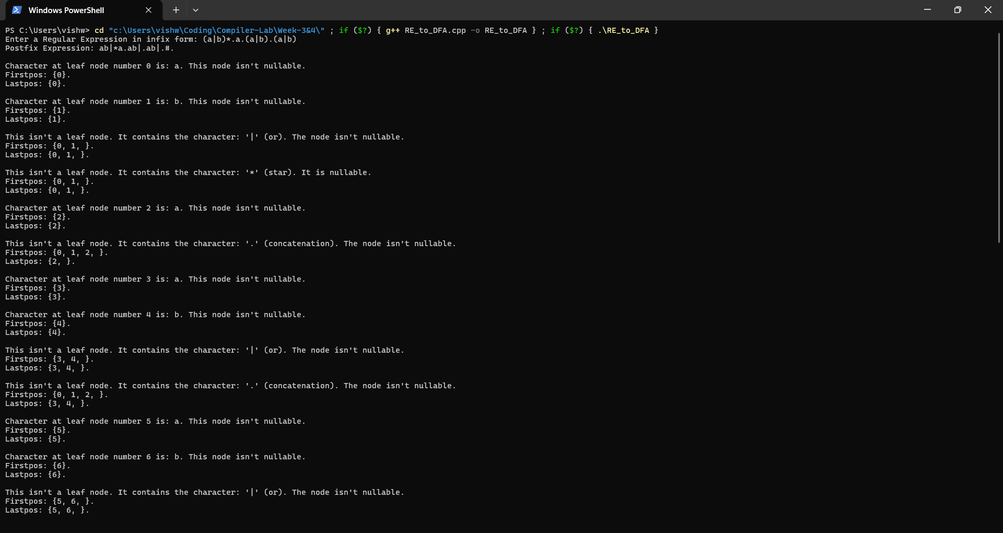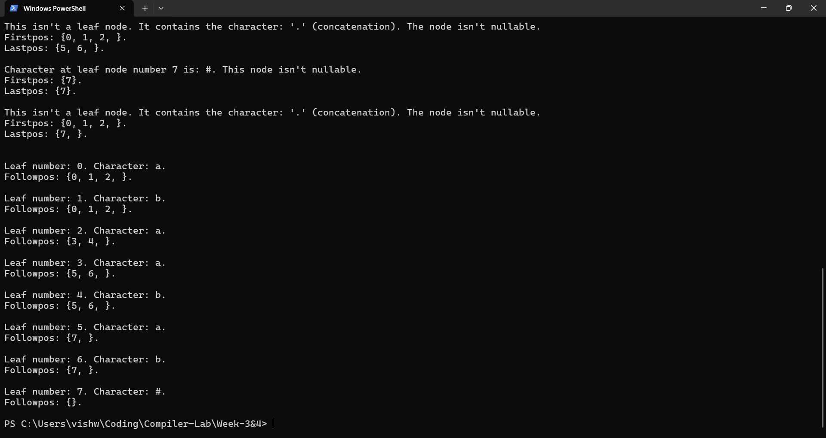
Enter a Regular Expression in infix form: (a|b)*.a.(a|b)*
Postfix Expression: ab|*a.ab|*.#.

Character at leaf node number 0 is: a. This node isn't nullable.
Firstpos: {0}.
Lastpos: {0}.

Character at leaf node number 1 is: b. This node isn't nullable.
Firstpos: {1}.
Lastpos: {1}.

This isn't a leaf node. It contains the character: '|' (or). The node isn't nullable.
Firstpos: {0, 1, }.
Lastpos: {0, 1, }.

This isn't a leaf node. It contains the character: '*' (star). It is nullable.
Firstpos: {0, 1, }.
Lastpos: {0, 1, }.

Character at leaf node number 2 is: a. This node isn't nullable.
Firstpos: {2}.
Lastpos: {2}.

This isn't a leaf node. It contains the character: '.' (concatenation). The node isn't nullable.
Firstpos: {0, 1, 2, }.
Lastpos: {2, }.

Character at leaf node number 3 is: a. This node isn't nullable.
Firstpos: {3}.
Lastpos: {3}.

Character at leaf node number 4 is: b. This node isn't nullable.
Firstpos: {4}.
Lastpos: {4}.

This isn't a leaf node. It contains the character: '|' (or). The node isn't nullable.
Firstpos: {3, 4, }.
Lastpos: {3, 4, }.

This isn't a leaf node. It contains the character: '*' (star). It is nullable.
Firstpos: {3, 4, }.
Lastpos: {3, 4, }.

This isn't a leaf node. It contains the character: '.' (concatenation). The node isn't nullable.
Firstpos: {0, 1, 2, }.
Lastpos: {2, 3, 4, }.

Character at leaf node number 5 is: #. This node isn't nullable.
Firstpos: {5}.
Lastpos: {5}.

This isn't a leaf node. It contains the character: '.' (concatenation). The node isn't nullable.
Firstpos: {0, 1, 2, }.
Lastpos: {5, }.

Leaf number: 0. Character: a.
Followpos: {0, 1, 2, }.

Leaf number: 1. Character: b.
Followpos: {0, 1, 2, }.

Leaf number: 2. Character: a.
Followpos: {3, 4, 5, }.

Leaf number: 3. Character: a.
Followpos: {3, 4, 5, }.

Leaf number: 4. Character: b.
Followpos: {3, 4, 5, }.

Leaf number: 5. Character: #.
Followpos: {}.
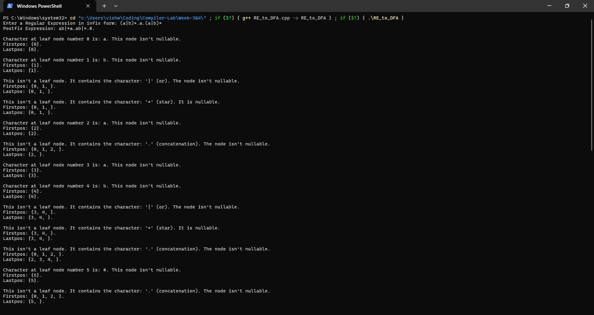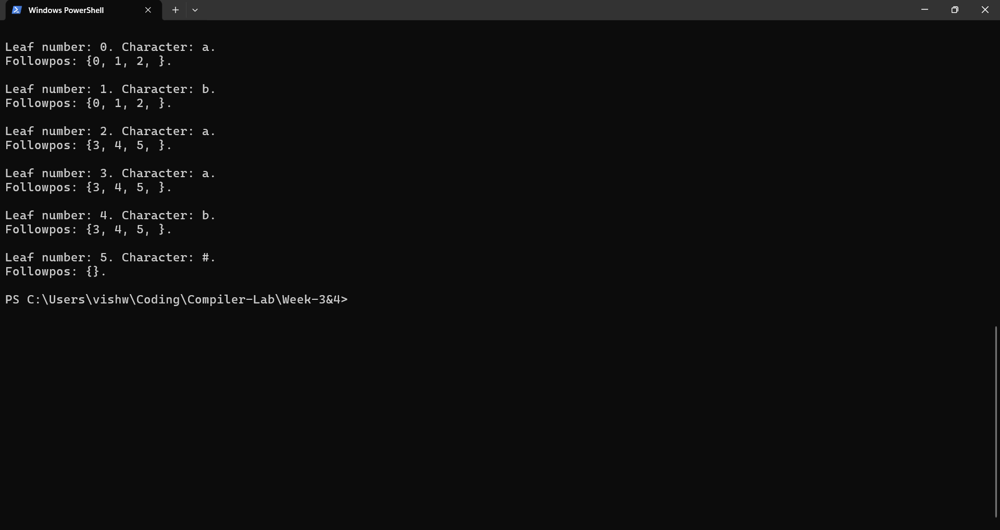
Enter a Regular Expression in infix form: (a|b)*|(a.c)*
Postfix Expression: ab|*ac.*|#.

Character at leaf node number 0 is: a. This node isn't nullable.
Firstpos: {0}.
Lastpos: {0}.

Character at leaf node number 1 is: b. This node isn't nullable.
Firstpos: {1}.
Lastpos: {1}.

This isn't a leaf node. It contains the character: '|' (or). The node isn't nullable.
Firstpos: {0, 1, }.
Lastpos: {0, 1, }.

This isn't a leaf node. It contains the character: '*' (star). It is nullable.
Firstpos: {0, 1, }.
Lastpos: {0, 1, }.

Character at leaf node number 2 is: a. This node isn't nullable.
Firstpos: {2}.
Lastpos: {2}.

Character at leaf node number 3 is: c. This node isn't nullable.
Firstpos: {3}.
Lastpos: {3}.

This isn't a leaf node. It contains the character: '.' (concatenation). The node isn't nullable.
Firstpos: {2, }.
Lastpos: {3, }.

This isn't a leaf node. It contains the character: '*' (star). It is nullable.
Firstpos: {2, }.
Lastpos: {3, }.

This isn't a leaf node. It contains the character: '|' (or). The node is nullable.
Firstpos: {0, 1, 2, }.
Lastpos: {0, 1, 3, }.

Character at leaf node number 4 is: #. This node isn't nullable.
Firstpos: {4}.
Lastpos: {4}.

This isn't a leaf node. It contains the character: '.' (concatenation). The node isn't nullable.
Firstpos: {0, 1, 2, 4, }.
Lastpos: {4, }.

Leaf number: 0. Character: a.
Followpos: {0, 1, 4, }.

Leaf number: 1. Character: b.
Followpos: {0, 1, 4, }.

Leaf number: 2. Character: a.
Followpos: {3, }.

Leaf number: 3. Character: c.
Followpos: {2, 4, }.

Leaf number: 4. Character: #.
Followpos: {}.
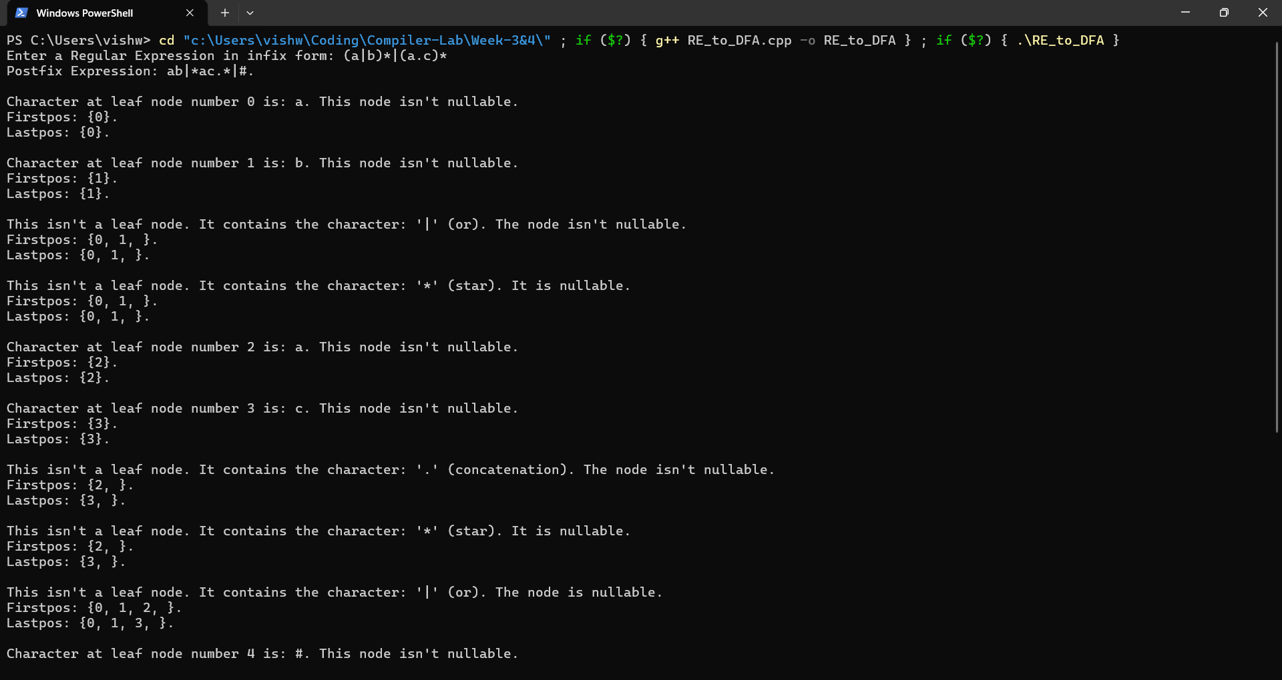
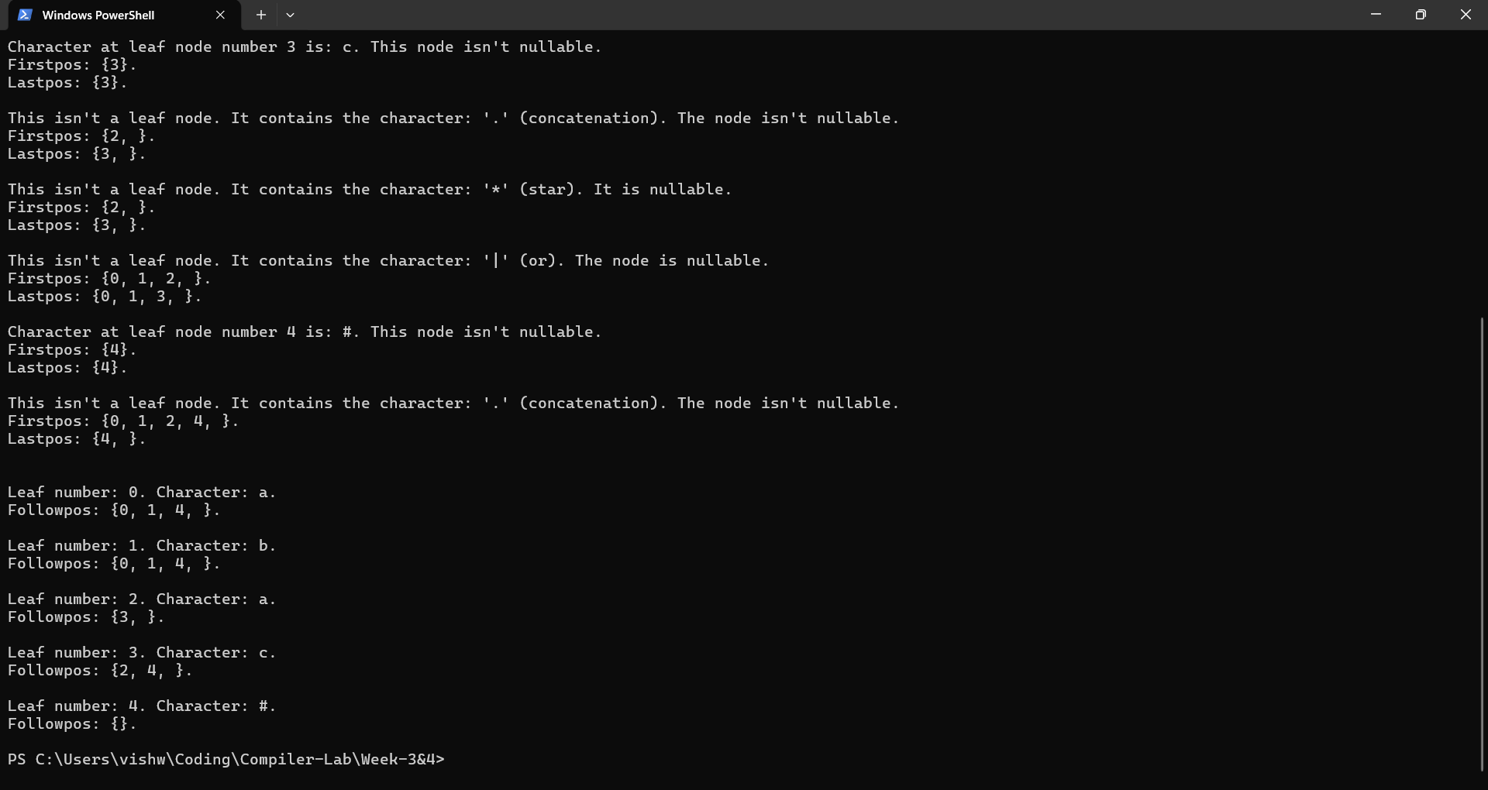

Result:
The C++ program to find Nullable(), Firstpos(), Lastpos(), and Followpos() for the given Regular Expressions was successfully run and the results were verified.

Compiler Design Lab
Date: 19-12-2025 | Name: S Vishwajith
Assignment No.: 4 | Register No.: 23BCE1145

Aim:
To write a C++ program that converts the regular expression (a|b)*a(a|b) to NFA with epsilon-transition and check whether the given string is accepted or rejected by the NFA.

Algorithm:
- For the regular expression (a|b)*a(a|b), construct a transition table for NFA with epsilon (null) transitions containing the current state, symbol for transition and the new state.
- Initiate states = {0} where 0 is the initial state and take the null closure of states in the variable and store it in the states variable itself.
- For each symbol ‘c’ in the string:
  - Take a new empty variable ‘next_states’ or clear it if it exists.
  - For each ‘st’ in states:
    - If there are any possible transitions, add them to ‘next_states’
  - Take the null closure of ‘next_state’.
  - Replace state with ‘next_state’.
- If the states set contains the final state number 3, then the given string is accepted. Else, the given string is rejected.

Code:
#include <iostream>
#include <string>
#include <set>
#include <vector>
#include <map>
using namespace std;

map<int, vector<pair<char, int>>> get_transition_table()
{
map<int, vector<pair<char, int>>> tt;

tt[0].push_back({'a', 0});
tt[0].push_back({'b', 0});
tt[0].push_back({'e', 1});
tt[1].push_back({'a', 2});
tt[2].push_back({'a', 3});
tt[2].push_back({'b', 3});

return tt;
}

int get_next_state(vector<pair<char, int>> transitions, char symbol)
{
for (auto &[c, i] : transitions)
{
if (c == symbol)
return i;
}
return -1;
}

void null_closure(set<int> &states, map<int, vector<pair<char, int>>> tt)
{
bool changed;
do
{
changed = false;
set<int> snapshot = states;
for (int s : snapshot)
{
int e = get_next_state(tt[s], 'e');
if (e != -1 && !states.count(e))
{
states.insert(e);
changed = true;
}
}
} while (changed);
}

int main()
{
string s;
cout << "Enter a string: ";
cin >> s;

map<int, vector<pair<char, int>>> tt = get_transition_table();
cout << endl
<< "Current State\tSymbol\tNew State" << endl;
for (auto &[old_state, transitions] : tt)
{
for (auto &[symbol, new_state] : transitions)
{
cout << old_state << "\t\t" << symbol << "\t\t" << new_state << endl;
}
}
cout << endl;

set<int> states = {0};
null_closure(states, tt);
for (char c : s)
{
set<int> next_states;
for (int st : states)
{
int ns = get_next_state(tt[st], c);
if (ns != -1)
next_states.insert(ns);
}

states = next_states;
null_closure(states, tt);
}

for (int i : states)
{
if (i == 3)
{
cout << "The given string is accepted." << endl;
return 0;
}
}

cout << "The given string is rejected." << endl;
return 0;
}

Inputs:
- aa
- ab
- abba

Outputs:
Enter a string: aa

Current State Symbol New State
0 a 0
0 b 0
0 e 1
1 a 2
2 a 3
2 b 3

The given string is accepted.
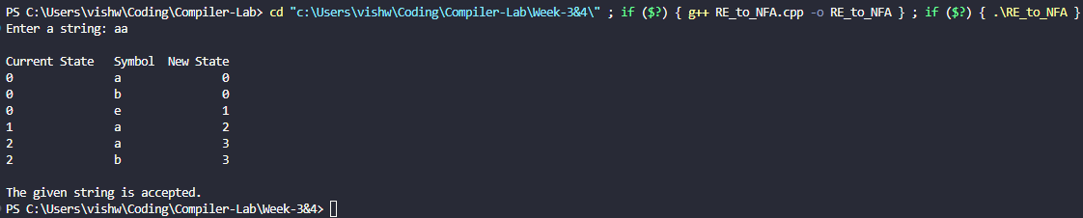
Enter a string: ab

Current State Symbol New State
0 a 0
0 b 0
0 e 1
1 a 2
2 a 3
2 b 3

The given string is accepted.
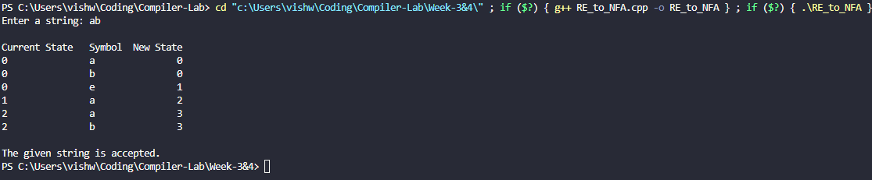
Enter a string: abba

Current State Symbol New State
0 a 0
0 b 0
0 e 1
1 a 2
2 a 3
2 b 3

The given string is rejected.
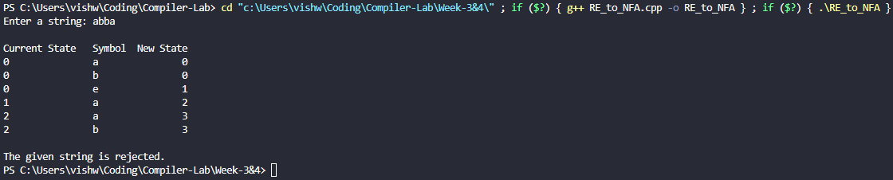

Result:
The C++ program to convert the regex (a|b)*a(a|b) into NFA with epsilon transitions and check whether the given string is accepted or not was successfully run and the results were verified.

Compiler Design Lab
Date: 9-1-2026 | Name: S Vishwajith
Assignment No.: 5 | Register No.: 23BCE1145

Aim:
To write a C++ program that parses the given LL (1) grammar: E->E+T/T; T->T*F/F; F->(E)/id; and prints the first(), follow(), parse table and the stack trace, and check if the string “(id+id)*id” is accepted by the grammar or not.

Algorithm:
- Eliminate left recursion present in the given grammar.
- Find first() for all non-terminals.
- Using first(), find follow() for all non-terminals.
- Using first() and follow(), construct the parse table.
- Using this parse table, check whether the string can be accepted or not, and print the trace for each step.

Code:
#include <iostream>
#include <vector>
#include <string>
#include <map>
#include <set>
#include <iomanip>
using namespace std;

vector<pair<char, string>> get_grammar()
{
return {
{'E', "TA"},
{'A', "+TA"},
{'A', "e"},
{'T', "FB"},
{'B', "*FB"},
{'B', "e"},
{'F', "(E)"},
{'F', "id"}};
}

map<char, set<string>> FIRST, FOLLOW;
map<char, map<string, string>> TABLE;

bool isNonTerminal(char c)
{
return c >= 'A' && c <= 'Z';
}

void computeFIRST(vector<pair<char, string>> &G)
{
bool changed = true;
while (changed)
{
changed = false;
for (auto &prod : G)
{
char A = prod.first;
string rhs = prod.second;

if (rhs == "e")
{
if (FIRST[A].insert("e").second)
changed = true;
continue;
}

for (int i = 0; i < rhs.length(); i++)
{
char X = rhs[i];

if (isNonTerminal(X))
{
for (auto t : FIRST[X])
if (t != "e")
if (FIRST[A].insert(t).second)
changed = true;

if (FIRST[X].count("e") == 0)
break;
}
else
{
if (X == 'i')
FIRST[A].insert("id");
else
FIRST[A].insert(string(1, X));
break;
}
}
}
}
}

void computeFOLLOW(vector<pair<char, string>> &G)
{
FOLLOW['E'].insert("$");

bool changed = true;
while (changed)
{
changed = false;
for (auto &prod : G)
{
char A = prod.first;
string rhs = prod.second;

for (int i = 0; i < rhs.length(); i++)
{
char B = rhs[i];
if (!isNonTerminal(B))
continue;

bool epsilonTrail = true;

for (int j = i + 1; j < rhs.length(); j++)
{
epsilonTrail = false;
char C = rhs[j];

if (isNonTerminal(C))
{
for (auto t : FIRST[C])
if (t != "e")
if (FOLLOW[B].insert(t).second)
changed = true;

if (FIRST[C].count("e"))
epsilonTrail = true;
else
break;
}
else
{
if (C == 'i')
FOLLOW[B].insert("id");
else
FOLLOW[B].insert(string(1, C));
break;
}
}

if (epsilonTrail || i == rhs.length() - 1)
for (auto t : FOLLOW[A])
if (FOLLOW[B].insert(t).second)
changed = true;
}
}
}
}

set<string> FIRST_of_string(string s)
{
set<string> result;
for (int i = 0; i < s.length(); i++)
{
char X = s[i];

if (isNonTerminal(X))
{
for (auto t : FIRST[X])
if (t != "e")
result.insert(t);
if (FIRST[X].count("e") == 0)
break;
}
else
{
if (X == 'i')
result.insert("id");
else
result.insert(string(1, X));
break;
}
}
return result;
}

void buildParsingTable(vector<pair<char, string>> &G)
{
for (auto &prod : G)
{
char A = prod.first;
string alpha = prod.second;

auto f = FIRST_of_string(alpha);

for (auto t : f)
TABLE[A][t] = alpha;

if (f.count("e"))
for (auto b : FOLLOW[A])
TABLE[A][b] = alpha;
}
}

vector<string> tokenize(string s)
{
vector<string> tokens;

for (int i = 0; i < s.length();)
{
if (i + 1 < s.length() && s.substr(i, 2) == "id")
{
tokens.push_back("id");
i += 2;
}
else
{
tokens.push_back(string(1, s[i]));
i++;
}
}
return tokens;
}

int parse(string input)
{
input += "$";

vector<string> stk = {"$", "E"};
int i = 0;

cout << left
<< setw(20) << "Stack"
<< setw(20) << "Input"
<< "Action" << endl;
cout << "----------------------------------------------------------" << endl;

while (true)
{
string stackStr;
for (auto &s : stk)
stackStr += s;

cout << left
<< setw(20) << stackStr
<< setw(20) << input.substr(i);

string X = stk.back();

if (X == "$" && input[i] == '$')
{
cout << "Accept\n";
return 0;
}

string a;
if (i + 1 < input.length() && input.substr(i, 2) == "id")
a = "id";
else
a = string(1, input[i]);

if (!isNonTerminal(X[0]))
{
if (X == a)
{
stk.pop_back();
i += (a == "id" ? 2 : 1);
cout << "Match " << a << "\n";
}
else
{
cout << "Error\n";
return 1;
}
}
else
{
if (TABLE[X[0]].count(a) == 0)
{
cout << "Error\n";
return 1;
}

stk.pop_back();
string prod = TABLE[X[0]][a];

if (prod != "e")
{
auto tokens = tokenize(prod);
for (int k = tokens.size() - 1; k >= 0; k--)
stk.push_back(tokens[k]);
}

cout << X << " --> " << prod << "\n";
}
}
}

int main()
{
auto grammar = get_grammar();

computeFIRST(grammar);
computeFOLLOW(grammar);
buildParsingTable(grammar);

cout << endl
<< "First():" << endl;
for (auto &p : FIRST)
{
cout << "first(" << p.first << ") = { ";
for (auto &x : p.second)
cout << x << " ";
cout << "}\n";
}

cout << endl
<< "Follow():" << endl;
for (auto &p : FOLLOW)
{
cout << "follow(" << p.first << ") = { ";
for (auto &x : p.second)
cout << x << " ";
cout << "}\n";
}

cout << endl
<< "Parsing Table:" << endl;
for (auto &r : TABLE)
for (auto &c : r.second)
cout << "map[" << r.first << "," << c.first << "] = " << r.first << " --> " << c.second << endl;

string input;
cout << endl
<< "Enter input string: ";
cin >> input;

int res = parse(input);
cout << endl
<< ((res == 0) ? "String is accepted." : "String is rejected.") << endl;
}

Input/Output:
First():
first(A) = { + e }
first(B) = { * e }
first(E) = { ( id }
first(F) = { ( id }
first(T) = { ( id }

Follow():
follow(A) = { $ ) }
follow(B) = { $ ) + }
follow(E) = { $ ) }
follow(F) = { $ ) * + }
follow(T) = { $ ) + }

Parsing Table:
map[A,$] = A --> e
map[A,)] = A --> e
map[A,+] = A --> +TA
map[A,e] = A --> e
map[B,$] = B --> e
map[B,)] = B --> e
map[B,*] = B --> *FB
map[B,+] = B --> e
map[B,e] = B --> e
map[E,(] = E --> TA
map[E,id] = E --> TA
map[F,(] = F --> (E)
map[F,id] = F --> id
map[T,(] = T --> FB
map[T,id] = T --> FB

Enter input string: (id+id)*id
Stack Input Action
----------------------------------------------------------
$E (id+id)*id$ E --> TA
$AT (id+id)*id$ T --> FB
$ABF (id+id)*id$ F --> (E)
$AB)E( (id+id)*id$ Match (
$AB)E id+id)*id$ E --> TA
$AB)AT id+id)*id$ T --> FB
$AB)ABF id+id)*id$ F --> id
$AB)ABid id+id)*id$ Match id
$AB)AB +id)*id$ B --> e
$AB)A +id)*id$ A --> +TA
$AB)AT+ +id)*id$ Match +
$AB)AT id)*id$ T --> FB
$AB)ABF id)*id$ F --> id
$AB)ABid id)*id$ Match id
$AB)AB )*id$ B --> e
$AB)A )*id$ A --> e
$AB) )*id$ Match )
$AB *id$ B --> *FB
$ABF* *id$ Match *
$ABF id$ F --> id
$ABid id$ Match id
$AB $ B --> e
$A $ A --> e
$ $ Accept

String is accepted.
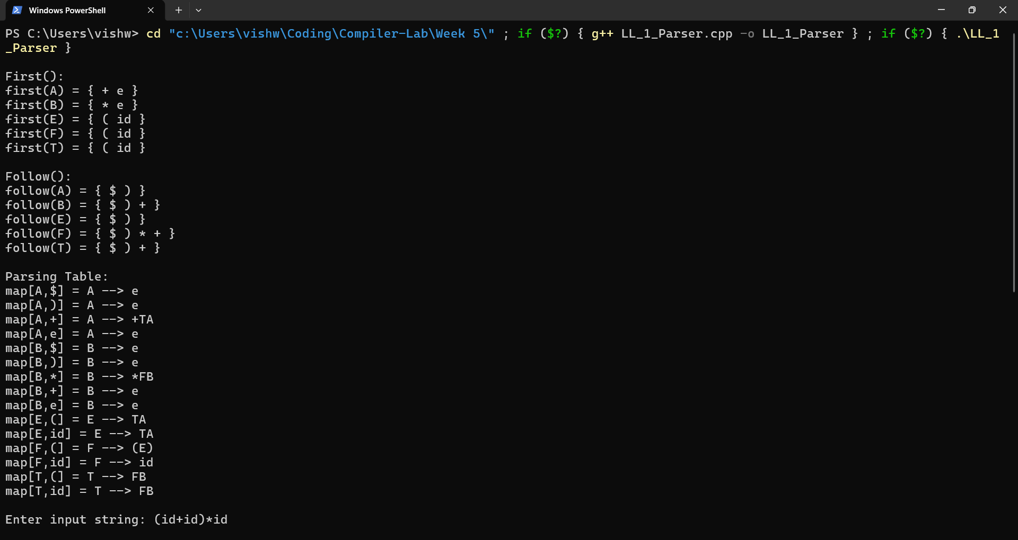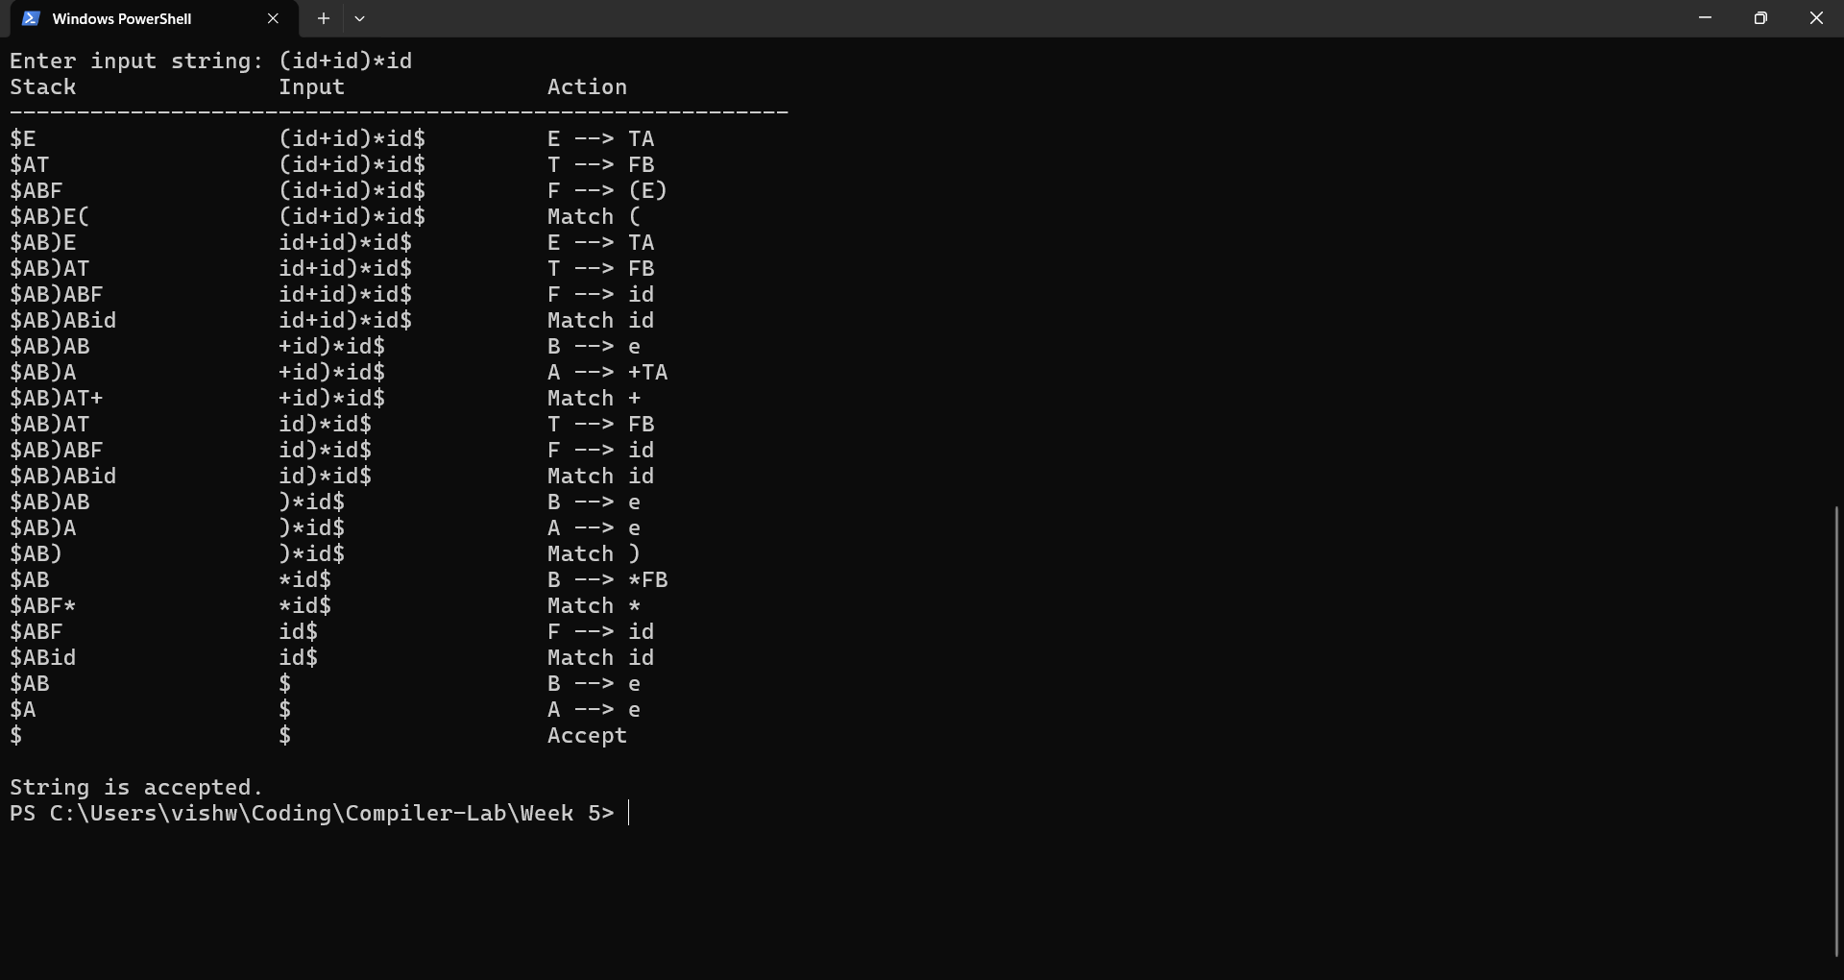

Result:
The C++ program that parses the given LL (1) grammar: E->E+T/T; T->T*F/F; F->(E)/id; and prints the first(), follow(), parse table and the stack trace, and check if the string “(id+id)*id” is accepted by the grammar or not was successfully run and the results were verified.

Compiler Design Lab
Date: 23-1-2026 | Name: S Vishwajith
Assignment No.: 5 | Register No.: 23BCE1145

Aim:
To write a C++ program to construct the Leading() and Trailing() for the given grammar.

Algorithm:
- Read the Grammar.
- For each non-terminal A, find Leading() by analysing each of its production.
  - If the non-terminal produces a terminal first, add the terminal to its Leading().
  - If it produces a non-terminal B first and then a terminal, add terminal to its Leading() and if B is not A, add Leading(B) to Leading(A)
- For each non-terminal A, find Trailing() by analysing each of its production.
  - If the non-terminal produces a terminal last, add the terminal to its Trailing().
  - If it produces a non-terminal B at the last and then a terminal, add terminal to its Trailing() and if B is not A, add Trailing(B) to Trailing(A).
- Display the Leading() and Trailing() of each non-terminal.

Code:
#include <iostream>
#include <string>
#include <vector>
#include <set>
#include <map>
#include <stack>
#include <limits>
using namespace std;

struct NonTerminal
{
char nt;
vector<string> rhs;
set<char> lead;
set<char> trail;
};

vector<struct NonTerminal> p;

bool isNonTerminal(char c)
{
for (struct NonTerminal temp_p : p)
{
if (temp_p.nt == c)
{
return true;
}
}
return false;
}

set<char> getLeading(char nt)
{
set<char> lead;
for (struct NonTerminal temp_p : p)
{
if (temp_p.nt == nt)
{
for (string s : temp_p.rhs)
{
if (!isNonTerminal(s[0]))
{
lead.insert(s[0]);
}
else if (s.length() > 1)
{
if (!isNonTerminal(s[1]))
{
lead.insert(s[1]);
}
if (s[0] != temp_p.nt)
{
for (char c : getLeading(s[0]))
{
lead.insert(c);
}
}
}
}
}
}
return lead;
}

set<char> getTrailing(char nt)
{
set<char> trail;
for (struct NonTerminal temp_p : p)
{
if (temp_p.nt == nt)
{
for (string s : temp_p.rhs)
{
if (!isNonTerminal(s[s.length() - 1]))
{
trail.insert(s[s.length() - 1]);
}
else if (s.length() > 1)
{
if (!isNonTerminal(s[s.length() - 2]))
{
trail.insert(s[s.length() - 2]);
}
if (s[s.length() - 1] != temp_p.nt)
{
for (char c : getTrailing(s[s.length() - 1]))
{
trail.insert(c);
}
}
}
}
}
}
return trail;
}

void createStruct(string s)
{
struct NonTerminal temp;
vector<string> temp_rhs;
int i = 0;
bool start_rhs = false;
string temp_r = "", temp_l = "";
while (i < s.length())
{
if (s[i] == ' ')
{
i++;
continue;
}
if (start_rhs)
{
if (s[i] != '|')
{
temp_r += s[i];
}
else
{
temp_rhs.push_back(temp_r);
temp_r = "";
}
}
else
{
if (s[i] == '-' && s[i + 1] == '>')
{
start_rhs = true;
i += 2;
}
else
temp_l += s[i];
}
i++;
}
temp_rhs.push_back(temp_r);
temp.nt = temp_l[0];
temp.rhs = temp_rhs;
p.push_back(temp);
}

int main()
{
int n;
cout << "Enter number of productions: ";
cin >> n;
cin.ignore(numeric_limits<streamsize>::max(), '\n');
vector<string> temp_prod;
string input;
for (int i = 0; i < n; i++)
{
cout << "Enter Production " << i + 1 << ": ";
getline(cin, input);
temp_prod.push_back(input);
}
for (int i = 0; i < n; i++)
{
// cout<<temp_prod[i]<<endl;
createStruct(temp_prod[i]);
}
cout << "Productions" << endl;
for (struct NonTerminal temp_p : p)
{
cout << temp_p.nt << " -> ";
for (int i = 0; i < temp_p.rhs.size(); i++)
{
cout << temp_p.rhs[i];
if (i != temp_p.rhs.size() - 1)
{
cout << '|';
}
}
cout << endl;
}
cout << "\nLeading:" << endl;
for (auto &temp_p : p)
{
temp_p.lead = getLeading(temp_p.nt);
cout << temp_p.nt << ":{ ";
for (char c : temp_p.lead)
{
cout << c << " ";
}
cout << "}" << endl;
}
cout << "\nTrailing:" << endl;
for (auto &temp_p : p)
{
temp_p.trail = getTrailing(temp_p.nt);
cout << temp_p.nt << ":{ ";
for (char c : temp_p.trail)
{
cout << c << " ";
}
cout << "}" << endl;
}
return 0;
}

Inputs:
- E -> EAE | (E) | id ; A -> + | - | * | /
- S -> (L) | a ; L -> L,S | S

Outputs:
1.
Enter number of productions: 2
Enter Production 1: E -> EAE | (E) | id
Enter Production 2: A -> + | - | * | /
Productions
E -> EAE|(E)|id
A -> +|-|*|/

Leading:
E:{ ( i }
A:{ * + - / }

Trailing:
E:{ ) d }
A:{ * + - / }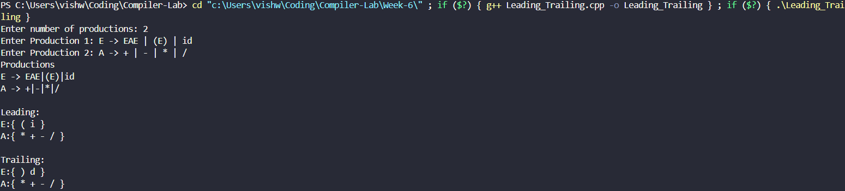
2.
Enter number of productions: 2
Enter Production 1: S -> (L) | a
Enter Production 2: L -> L,S | S
Productions
S -> (L)|a
L -> L,S|S

Leading:
S:{ ( a }
L:{ , }

Trailing:
S:{ ) a }
L:{ ) , a }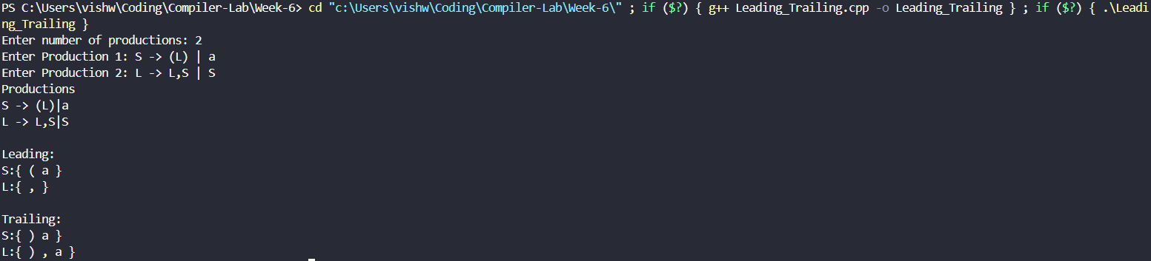

Result:
The C++ program to construct the Leading() and Trailing() for the given grammar was successfully run and the results were verified.

Compiler Design Lab
Date: 6-2-2026 | Name: S Vishwajith
Assignment No.: 7 | Register No.: 23BCE1145

Aim:
To write the given programs in LEX:
- Write a LEX program to count the number of characters in a given input.
- Write a LEX program to count the number of words in a sentence.
- Write a LEX program to count the number of lines in a file.
- Write a LEX program to count the number of vowels in the given input.
- Write a LEX program to convert all lowercase letters to uppercase.
- Write a LEX program to identify and count digits in the input.
- Write a LEX program to identify and count keywords and identifiers.
- Write a LEX program to recognize integers and floating-point numbers.
- Write a LEX program to count the number of operators and operands.
- Write a LEX program to remove single-line and multi-line comments from a C program.
- Write a LEX program to recognize relational and logical operators.
- Write a LEX program to count the number of uppercase and lowercase letters.
- Write a LEX program to identify valid and invalid identifiers.
- Write a LEX program to find and print all email IDs from a given text.
- Write a LEX program to perform lexical analysis of a C program.
- Write a LEX program to generate tokens for keywords, identifiers, constants, and operators.
- Write a LEX program to implement a symbol table.
- Write a LEX program to validate arithmetic expression.

Codes:
1.
/* Write a LEX program to count the number of characters in a given input. */

%{
#include <stdio.h>
int characters = 0;
%}

%%
. {characters++;}
\n {characters++;}
%%

int yywrap(){
return 1;
}

int main(){
printf("Input here: ");
yylex();
printf("The number of characters in the given input is: %d.\n", characters);
return 0;
}
2.
/* Write a LEX program to count the number of words in a sentence. */

%{
#include <stdio.h>
int words = 0;
%}

%%
[a-zA-z]+ {words++;}
[ \n\t]+ {}
. {}
%%

int yywrap(){
return 1;
}

int main(){
printf("Input here: ");
yylex();
printf("The number of words is: %d.\n", words);
return 0;
}
3.
/* Write a LEX program to count the number of lines in a file. */

%{
#include <stdio.h>
int lines = 0;
%}

%%
. {}
\n {lines++;}
%%

int yywrap() {
return 1;
}

int main() {
printf("Input here: ");
yylex();
printf("The number of lines is: %d.\n", lines);
return 0;
}
4.
/* Write a LEX program to count the number of vowels in the given input. */

%{
#include <stdio.h>
int vowels = 0;
%}

%%
[aeiouAEIOU] {vowels++;}
.|\n {}
%%

int yywrap() {
return 1;
}

int main(){
printf("Input here: ");
yylex();
printf("The number of vowels are: %d.\n", vowels);
return 0;
}
5.
/* Write a LEX program to convert all lowercase letters to uppercase. */
%{
#include <stdio.h>
#include <ctype.h>
%}

%%
[a-z] { yytext[0] = toupper(yytext[0]); ECHO; }
.|\n { ECHO; }
%%

int yywrap() {
return 1;
}

int main() {
printf("Input here: ");
fflush(stdout);
yylex();
return 0;
}
6.
/* Write a LEX program to identify and count digits in the input. */

%{
#include <stdio.h>
int digits = 0;
%}

%%
[0-9] {digits++;}
.|\n {}
%%

int yywrap() {
return 1;
}

int main() {
printf("Input here: ");
yylex();
printf("The number of digits is: %d.\n", digits);
return 0;
}
7.
/* Write a LEX program to identify and count keywords and identifiers. */

%{
#include <stdio.h>
#include <string.h>
int keywords = 0;
int identifiers = 0;
int is_keyword(char* token) {
char *keywords[] = {"auto", "break", "case", "char", "const", "continue",
"default", "do", "double", "else", "enum", "extern",
"float", "for", "goto", "if", "int", "long", "register",
"return", "short", "signed", "sizeof", "static", "struct",
"switch", "typedef", "union", "unsigned", "void", "volatile",
"while"};
int n = sizeof(keywords) / sizeof(char*);
for(int i = 0; i < n; i++) {
if(strcmp(token, keywords[i]) == 0) {
return 1;
}
}
return 0;
}
%}

identifier [a-zA-Z_][a-zA-Z0-9_]*
whitespace [ \t\n]+

%%
{identifier} {
if(is_keyword(yytext)) {
keywords++;
printf("KEYWORD: %s.\n", yytext);
}
else {
identifiers++;
printf("IDENTIFIER: %s.\n", yytext);
}
}
{whitespace} {}
. {}
%%

int yywrap() {
return 1;
}

int main() {
printf("Write code here:\n");
yylex();
printf("The number of keywords is: %d.\n", keywords);
printf("The number of identifiers is: %d.\n", identifiers);
}
8.
/* Write a LEX program to recognize integers and floating-point numbers. */

%{
#include <stdio.h>
%}

%%
[0-9]+[.][0-9]+ {printf("Floating point value.\n");}
[0-9]+ {printf("Integer.\n");}
.|\n {}
%%

int yywrap() {
return 1;
}

int main() {
printf("Input here:\n");
yylex();
return 0;
}
9.
/* Write a LEX program to count the number of operators and operands. */

%{
#include <stdio.h>
int operators = 0;
int operands = 0;
%}

operator "<<"|">>"|"&&"|"||"|"<="|">="|"=="|"++"|"--"|"+"|"-"|"*"|"/"|"%"|"<"|">"|"="|"&"|"|"|"^"
operand [a-zA-Z_][a-zA-Z0-9_]*
whitespace [ \t\n]+

%%
{operator} {operators++;}
{operand} {operands++;}
{whitespace} {}
. {}
%%

int yywrap() {
return 1;
}

int main() {
printf("Inputs here:\n");
yylex();
printf("Number of operands: %d.\n", operands);
printf("Number of operators: %d.\n", operators);
return 0;
}
10.
/* Write a LEX program to remove single-line and multi-line comments from a C program. */

%{
#include <stdio.h>
#include <string.h>
#define MAX 100000
char code[MAX];
int x = 0;
void add_text(const char *text) {
int len = strlen(text);
if (x + len < MAX) {
strcpy(&code[x], text);
x += len;
}
}
%}

%x SINGLE MULTI

%%
\"([^\\\"]|\\.)*\" {add_text(yytext);}
\'([^\\\']|\\.)*\' {add_text(yytext);}
"//" {BEGIN(SINGLE);}
"/*" {BEGIN(MULTI);}

<SINGLE>\n {BEGIN(INITIAL); add_text("\n");}
<SINGLE>. {}

<MULTI>"*/" {BEGIN(INITIAL);}
<MULTI>\n {add_text("\n");}
<MULTI>. {}

.|\n {add_text(yytext);}
%%

int yywrap() {
return 1;
}

int main() {
printf("Enter C Code:\n");
yylex();
printf("The C code without any comments is:\n\n%s\n", code);
return 0;
}
11.
/* Write a LEX program to recognize relational and logical operators. */

%{
#include <stdio.h>
%}

relational "<="|">="|"=="|"!="|"<"|">"
logical "&&"|"||"|"!"

%%
{relational} {printf("RELATIONAL OPERATOR: %s.\n", yytext);}
{logical} {printf("LOGICAL OPERATOR: %s.\n", yytext);}
.|\n {}
%%

int yywrap() {
return 1;
}

int main() {
printf("Inputs here:\n");
yylex();
return 0;
}
12.
/* Write a LEX program to count the number of uppercase and lowercase letters. */

%{
#include <stdio.h>
int upper = 0;
int lower = 0;
%}

%%
[a-z] {lower++;}
[A-Z] {upper++;}
.|\n {}
%%

int yywrap() {
return 1;
}

int main() {
printf("Input here:");
yylex();
printf("Number of uppercase letters is: %d.\n", upper);
printf("Number of lowercase letters is: %d.\n", lower);
return 0;
}
13.
/* Write a LEX program to identify valid and invalid identifiers. */

%{
#include <stdio.h>
#include <string.h>
const char *keywords[] = {
"int","float","char","double","if","else","while","for",
"return","void","break","continue","switch","case","default",
"do","struct","union","typedef","enum","const","unsigned",
"signed","extern","static","sizeof","long","short","goto"
};
int isKeyword(const char *word) {
int n = sizeof(keywords)/sizeof(keywords[0]);
for(int i = 0; i < n; i++) {
if(strcmp(word, keywords[i]) == 0)
return 1;
}
return 0;
}
%}

valid_id [a-zA-Z_][a-zA-Z0-9_]*
invalid_id [0-9][a-zA-Z0-9_]*

%%
{valid_id} {
if(isKeyword(yytext))
printf("%s : Keyword (not identifier)\n", yytext);
else
printf("%s : Valid Identifier\n", yytext);
}

{invalid_id} {printf("%s : Invalid Identifier\n", yytext);}

[ \t\n]+ {}

. {printf("%s : Invalid Identifier\n", yytext);}
%%

int yywrap() {
return 1;
}

int main() {
printf("Enter tokens:\n");
yylex();
return 0;
}
14.
/* Write a LEX program to find and print all email IDs from a given text. */

%{
#include <stdio.h>
%}

email [a-zA-Z0-9._%+-]+@[a-zA-Z0-9.-]+\.[a-zA-Z]{2,}

%%
{email} {printf("Email found: %s\n", yytext);}

.|\n {}
%%

int yywrap() {
return 1;
}

int main() {
printf("Inputs here:\n\n");
yylex();
return 0;
}
15.
/* Write a LEX program to perform lexical analysis of a C program. */

%{
#include <stdio.h>
#include <string.h>
%}

keyword int|float|char|double|if|else|while|for|return|void|break|continue
id [a-zA-Z_][a-zA-Z0-9_]*
number [0-9]+(\.[0-9]+)?
operator "=="|"!="|"<="|">="|"++"|"--"|"+"|"-"|"*"|"/"|"="|"<"|">"
delimiter [;(),{}]

%%
{keyword} {printf("Keyword: %s\n", yytext);}
{id} {printf("Identifier: %s\n", yytext);}
{number} {printf("Constant: %s\n", yytext);}
{operator} {printf("Operator: %s\n", yytext);}
{delimiter} {printf("Delimiter: %s\n", yytext);}
[ \t\n]+ {}
. {printf("Unknown: %s\n", yytext);}
%%

int yywrap(){
return 1;
}

int main(){
printf("Enter the C code here:\n");
yylex();
return 0;
}
16.
/* Write a LEX program to generate tokens for keywords, identifiers, constants, and operators. */

%{
#include <stdio.h>
%}

%%
int|float|char|double|if|else|while|for|return|void {printf("<KEYWORD, %s>\n", yytext);}
[a-zA-Z_][a-zA-Z0-9_]* {printf("<ID, %s>\n", yytext);}
[0-9]+(\.[0-9]+)? {printf("<CONST, %s>\n", yytext);}
"=="|"!="|"<="|">="|"+"|"-"|"*"|"/"|"=" {printf("<OP, %s>\n", yytext);}
[ \t\n]+ {}
. {printf("<INVALID, %s>\n", yytext);}
%%

int yywrap(){
return 1;
}

int main(){
printf("Enter the C code here:\n");
yylex();
return 0;
}
17.
/* Write a LEX program to implement a symbol table. */

%{
#include <stdio.h>
#include <string.h>
char symtab[100][50];
int count = 0;
int exists(char *s){
for(int i=0;i<count;i++)
if(strcmp(symtab[i],s)==0) return 1;
return 0;
}
%}

%%
int|float|char|double|if|else|while|for|return|void {}

[a-zA-Z_][a-zA-Z0-9_]* {
if(!exists(yytext)){
strcpy(symtab[count++], yytext);
printf("Inserted into Symbol Table: %s\n", yytext);
}
}

[ \t\n]+ ;
. ;
%%

int yywrap(){
return 1;
}

int main(){
printf("Enter the C code here:\n");
yylex();
printf("\nSymbol Table:\n");
for(int i=0;i<count;i++)
printf("%d. %s\n", i+1, symtab[i]);
return 0;
}
18.
/* Write a LEX program to validate arithmetic expression */

%{
#include <stdio.h>
int valid = 1;
int paren = 0;
%}

%%
[0-9]+ {}
[a-zA-Z_][a-zA-Z0-9_]* {}
"(" {paren++;}
")" {paren--;if(paren<0) valid=0;}
[+\-*/] {}
[ \t\n]+ {}
. {valid = 0;}
%%

int yywrap(){
return 1;
}

int main(){
printf("Enter expression:\n");
yylex();
if(valid && paren==0)
printf("Valid Arithmetic Expression\n");
else
printf("Invalid Arithmetic Expression\n");
return 0;
}

Inputs and Outputs:
1.
Executing task: cd "C:\Users\vishw\Coding\Compiler-Lab\Week-7"; flex Q1.l; gcc lex.yy.c; ./a.exe

Input here: Hello World!
^Z
The number of characters in the given input is: 13. 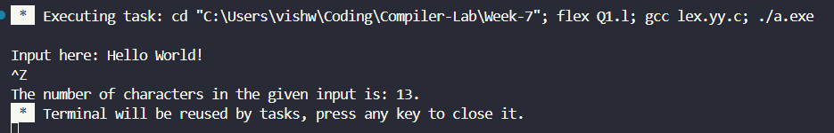
2.
Executing task: cd "C:\Users\vishw\Coding\Compiler-Lab\Week-7"; flex Q2.l; gcc lex.yy.c; ./a.exe

Input here: Hello world, this is compiler assignment.
^Z
The number of words is: 6. 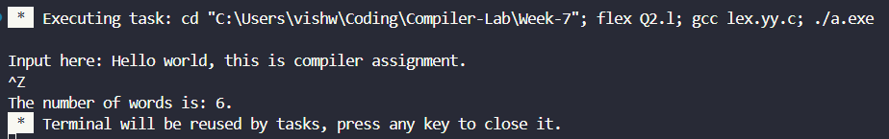
3.
Executing task: cd "C:\Users\vishw\Coding\Compiler-Lab\Week-7"; flex Q3.l; gcc lex.yy.c; ./a.exe

Input here: Hello
Bye
Compiler.
^Z
The number of lines is: 3. 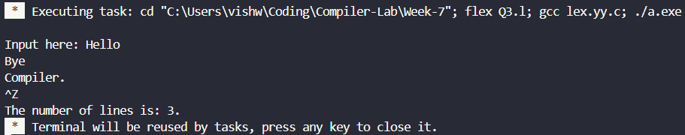
4.
Executing task: cd "C:\Users\vishw\Coding\Compiler-Lab\Week-7"; flex Q4.l; gcc lex.yy.c; ./a.exe

Input here: Hello World!
^Z
The number of vowels are: 3. 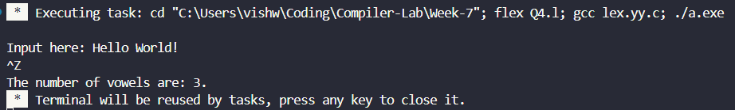

5.
Executing task: cd "C:\Users\vishw\Coding\Compiler-Lab\Week-7"; flex Q5.l; gcc lex.yy.c; ./a.exe

Input here: Hello world!
HELLO WORLD!
Bye.
BYE.
^Z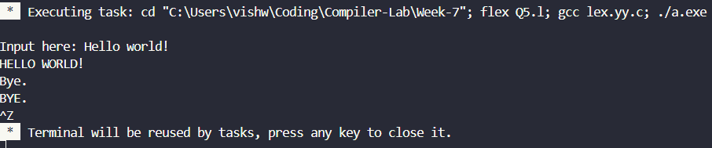
6.
Executing task: cd "C:\Users\vishw\Coding\Compiler-Lab\Week-7"; flex Q6.l; gcc lex.yy.c; ./a.exe

Input here: H3ll0 Fl4m3s!
^Z
The number of digits is: 4.
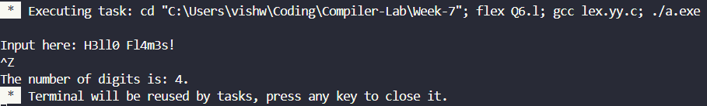
7.
Executing task: cd "C:\Users\vishw\Coding\Compiler-Lab\Week-7"; flex Q7.l; gcc lex.yy.c; ./a.exe

Write code here:
#include <stdio.h>
IDENTIFIER: include.
IDENTIFIER: stdio.
IDENTIFIER: h.
int main(){
KEYWORD: int.
IDENTIFIER: main.
int a = 6 + 7;
KEYWORD: int.
IDENTIFIER: a.
return 0;
KEYWORD: return.
}
^Z
The number of keywords is: 3.
The number of identifiers is: 5. 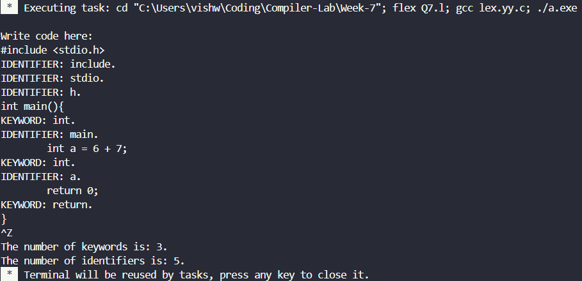
8.
Executing task: cd "C:\Users\vishw\Coding\Compiler-Lab\Week-7"; flex Q8.l; gcc lex.yy.c; ./a.exe

Input here:
11.11
Floating point value.
11
Integer.
^Z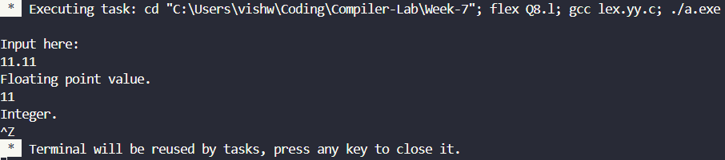
9.
Executing task: cd "C:\Users\vishw\Coding\Compiler-Lab\Week-7"; flex Q9.l; gcc lex.yy.c; ./a.exe

Inputs here:
a <<= b-- + ++c
^Z
Number of operands: 3.
Number of operators: 5. 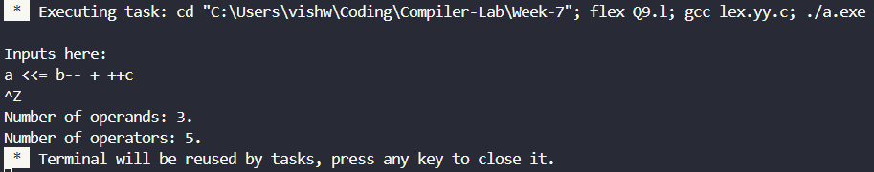
10.
Executing task: cd "C:\Users\vishw\Coding\Compiler-Lab\Week-7"; flex Q10.l; gcc lex.yy.c; ./a.exe

Enter C Code:
#include <stdio.h>
//Single line comment.
/* Multi
line
comment.
*/
int main(){
int a = 6 + 7;
return 0;
}
^Z
The C code without any comments is:

#include <stdio.h>

int main(){
int a = 6 + 7;
return 0;
}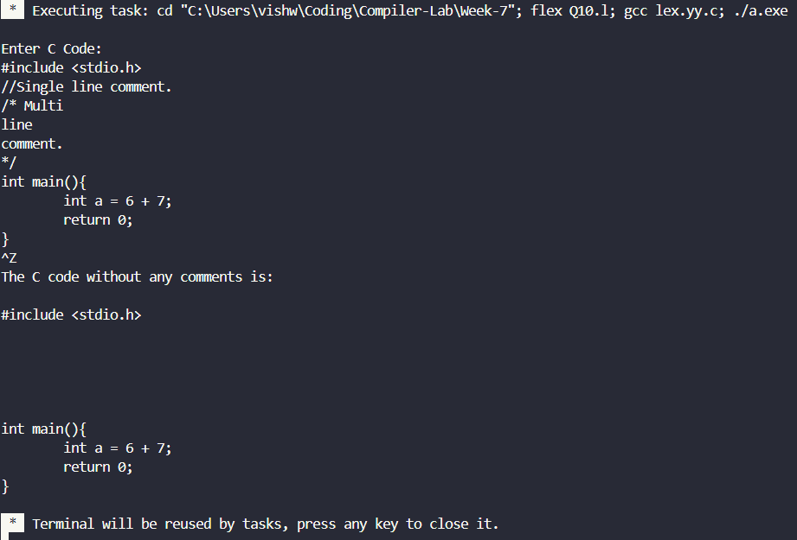
11.
Executing task: cd "C:\Users\vishw\Coding\Compiler-Lab\Week-7"; flex Q11.l; gcc lex.yy.c; ./a.exe

Inputs here:
<
RELATIONAL OPERATOR: <.
<=
RELATIONAL OPERATOR: <=.
&&
LOGICAL OPERATOR: &&.
&
||
LOGICAL OPERATOR: ||.
^Z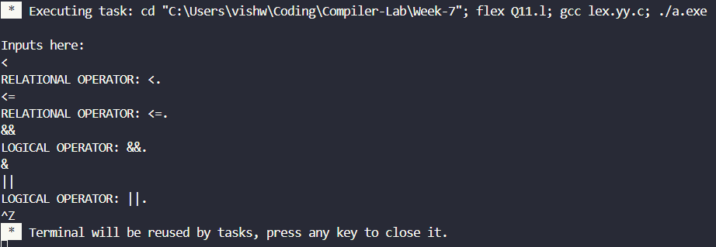
12.
Executing task: cd "C:\Users\vishw\Coding\Compiler-Lab\Week-7"; flex Q12.l; gcc lex.yy.c; ./a.exe

Input here: Hello World!
^Z
Number of uppercase letters is: 2.
Number of lowercase letters is: 8. 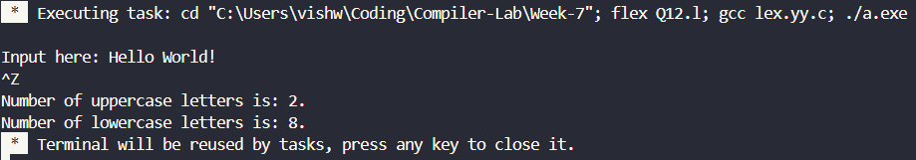
13.
Executing task: cd "C:\Users\vishw\Coding\Compiler-Lab\Week-7"; flex Q13.l; gcc lex.yy.c; ./a.exe

Enter tokens:
int sit
int : Keyword (not identifier)
sit : Valid Identifier
9ab-*bc
9ab : Invalid Identifier
- : Invalid Identifier
* : Invalid Identifier
bc : Valid Identifier
^Z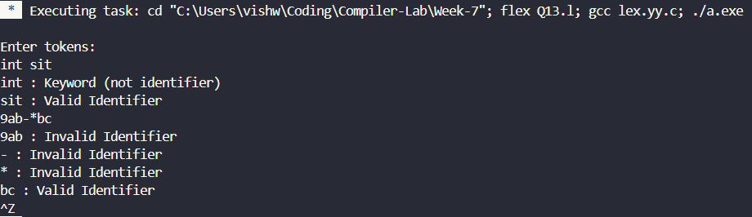
14.
Executing task: cd "C:\Users\vishw\Coding\Compiler-Lab\Week-7"; flex Q14.l; gcc lex.yy.c; ./a.exe

Inputs here:

ab
vishwajith.s2023@vitstudent.ac.in
Email found: vishwajith.s2023@vitstudent.ac.in
something@something.something
Email found: something@something.something
^Z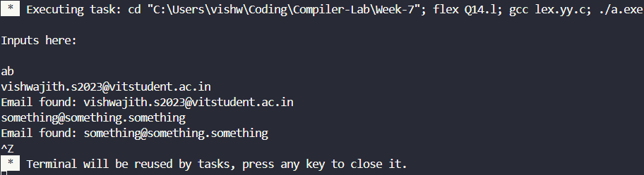
15.
Executing task: cd "C:\Users\vishw\Coding\Compiler-Lab\Week-7"; flex Q15.l; gcc lex.yy.c; ./a.exe

Enter the C code here:
#include <stdio.h>
Unknown: #
Identifier: include
Operator: <
Identifier: stdio
Unknown: .
Identifier: h
Operator: >
int main(){
Keyword: int
Identifier: main
Delimiter: (
Delimiter: )
Delimiter: {
int a = 6+7;
Keyword: int
Identifier: a
Operator: =
Constant: 6
Operator: +
Constant: 7
Delimiter: ;
return 0;
Keyword: return
Constant: 0
Delimiter: ;
}
Delimiter: }
^Z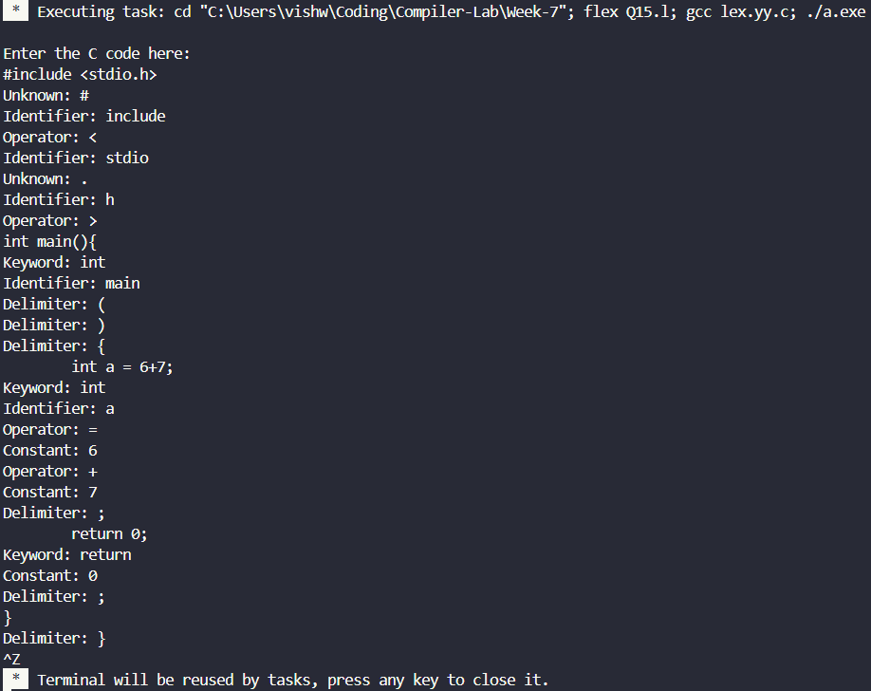
16.
Executing task: cd "C:\Users\vishw\Coding\Compiler-Lab\Week-7"; flex Q16.l; gcc lex.yy.c; ./a.exe

Enter the C code here:
int main(){
<KEYWORD, int>
<ID, main>
<INVALID, (>
<INVALID, )>
<INVALID, {>
return 0;
<KEYWORD, return>
<CONST, 0>
<INVALID, ;>
}
<INVALID, }>
^Z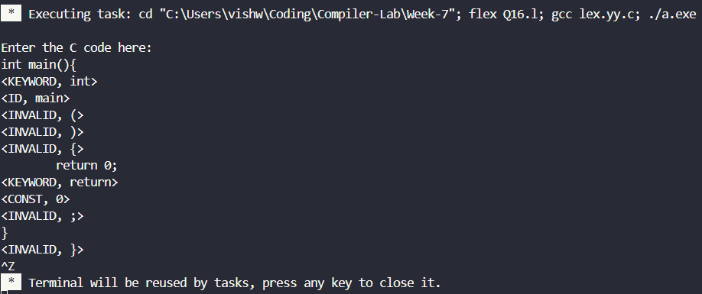
17.
Executing task: cd "C:\Users\vishw\Coding\Compiler-Lab\Week-7"; flex Q17.l; gcc lex.yy.c; ./a.exe

Enter the C code here:
int main(){
Inserted into Symbol Table: main
return 0;
}
^Z

Symbol Table:
1. main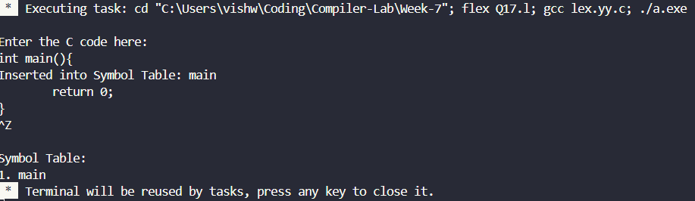
18.
Executing task: cd "C:\Users\vishw\Coding\Compiler-Lab\Week-7"; flex Q18.l; gcc lex.yy.c; ./a.exe

Enter expression:
a + (b - c) * d - ((e + f) / g)
^Z
Valid Arithmetic Expression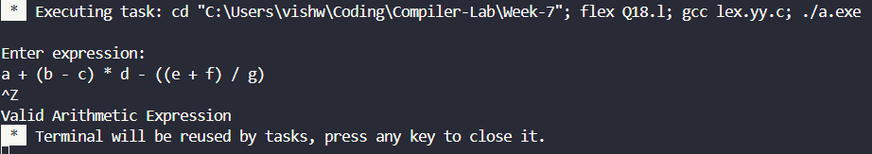

Result:
The LEX programs written for the given questions were successfully compiled and run.

Compiler Design Lab
Date: 13-2-2026 | Name: S Vishwajith
Assignment No.: 7 | Register No.: 23BCE1145

Aim:
To implement the SLR parser using C++.

Code:
#include <iostream>
#include <iomanip>
#include <vector>
#include <set>
#include <map>
using namespace std;

struct prod
{
int lhsIdx;
vector<pair<int, int>> rhsIdx; // nt/t, nt/tIdx - char
};
struct stackItem
{
int type; // 0-state, 1-NT, 2-T
int state;
int ntIdx;
int tIdx;
};

char startSym;
int startSymIdx;
set<char> terms, nterms;
vector<prod> prods;
vector<pair<int, int>> litems; // prodIdx, .pos - lr0 item
vector<vector<int>> lstates; // stateNo - vector(litemsIdx)
vector<vector<int>> closures; // ntIdx - vector(litemsIdx)
vector<int> cproc;
vector<int> fiproc, foproc;
vector<set<char>> first, follow; // ntIdx - set(first) and set(follow)
map<pair<int, pair<int, int>>, int> gotos; // stateNo, (nt/t nt/tIdx) -> stateNo
vector<vector<string>> table; // stateNo, t-ntIdx - Action
string input;
vector<stackItem> stack;

int findState(vector<int> v)
{
set<int> state(v.begin(), v.end());
for (int i = 0; i < lstates.size(); i++)
{
set<int> cstate(lstates[i].begin(), lstates[i].end());
if (state == cstate)
return i;
}
return -1;
}

int findLitem(pair<int, int> litem, vector<pair<int, int>> lritems)
{
for (int i = 0; i < lritems.size(); i++)
{
if (litem == lritems[i])
return i;
}
return -1;
}

int findInt(int i, vector<int> v)
{
for (int j = 0; j < v.size(); j++)
{
if (i == v[j])
return j;
}
return -1;
}

set<char> fillFirst(char t)
{
int ntIdx = distance(nterms.begin(), nterms.find(t));
if (fiproc[ntIdx])
return first[ntIdx];
fiproc[ntIdx] = 1;
for (prod p : prods)
{
if (p.lhsIdx == ntIdx)
{
int fnt = p.rhsIdx[0].first;
int fIdx = p.rhsIdx[0].second;
if (fnt)
first[ntIdx].insert(*next(terms.begin(), fIdx));
else
{
char tgt = *next(nterms.begin(), fIdx);
for (char c : fillFirst(tgt))
first[ntIdx].insert(c);
}
}
}
return first[ntIdx];
}

set<char> fillFollow(char t)
{
int ntIdx = distance(nterms.begin(), nterms.find(t));
if (foproc[ntIdx])
return follow[ntIdx];
foproc[ntIdx] = 1;
for (prod p : prods)
{
for (int i = 0; i < p.rhsIdx.size(); i++)
{
int fnt = p.rhsIdx[i].first;
int fntIdx = p.rhsIdx[i].second;
if (fnt == 0 && fntIdx == ntIdx)
{
if (i == p.rhsIdx.size() - 1)
{
char tgt = *next(nterms.begin(), p.lhsIdx);
for (char c : fillFollow(tgt))
follow[ntIdx].insert(c);
}
else
{
int fn = p.rhsIdx[i + 1].first;
int fnIdx = p.rhsIdx[i + 1].second;
if (fn)
follow[ntIdx].insert(*next(terms.begin(), fnIdx));
else
{
char tgt = *next(nterms.begin(), fnIdx);
for (char c : fillFirst(tgt))
follow[ntIdx].insert(c);
}
}
}
}
}

return follow[ntIdx];
}

vector<int> findClosure(int nt)
{
if (cproc[nt])
return closures[nt];
cproc[nt] = 1;
vector<int> litems;
for (int i = 0; i < prods.size(); i++)
{
if (prods[i].lhsIdx == nt)
{
litems.push_back(findLitem(pair<int, int>(i, 0), ::litems));
if (prods[i].rhsIdx[0].first == 0 &&
prods[i].rhsIdx[0].second != nt)
{
vector<int> vc = findClosure(prods[i].rhsIdx[0].second);
for (int i : vc)
{
if (findInt(i, litems) == -1)
litems.push_back(i);
}
}
}
}
closures[nt] = litems;
return litems;
}

void constructClosures()
{
for (int i = 0; i < prods.size(); i++)
litems.push_back(pair<int, int>(i, 0));
cproc = vector<int>(nterms.size(), 0);
closures = vector<vector<int>>(nterms.size());
for (int i = 0; i < nterms.size(); i++)
findClosure(i);
}

void printProd(prod pro, int i)
{
char l = *next(nterms.begin(), pro.lhsIdx);
if (l == 'Z')
cout << startSym << "'" << "->";
else
cout << l << "->";
int x = 0;
for (pair<int, int> ridx : pro.rhsIdx)
{
char c;
if (ridx.first == 0)
c = *next(nterms.begin(), ridx.second);
else
c = *next(terms.begin(), ridx.second);
if (x++ == i)
cout << ".";
cout << c;
}

if (i == pro.rhsIdx.size())
cout << ".";
cout << endl;
}

void findGoto(int lstateNo, char c)
{

int nt = 1;
if (nterms.count(c))
nt = 0;
int ntIdx;
if (nt == 0)
ntIdx = distance(nterms.begin(), nterms.find(c));
else
ntIdx = distance(terms.begin(), terms.find(c));
vector<int> lritems;
int found = 0;
for (int x : lstates[lstateNo])
{
pair<int, int> p = litems[x];
prod pr = prods[p.first];
int pos = p.second;
if (pr.rhsIdx.size() > pos)
{
if (pair<int, int>(nt, ntIdx) == pr.rhsIdx[pos])
{
found = 1;
pair<int, int> newitem(p.first, pos + 1);
int newIdx = findLitem(newitem, litems);
if (newIdx == -1)
{
litems.push_back(newitem);
lritems.push_back(litems.size() - 1);
}
else
lritems.push_back(newIdx);
if (pos + 1 < pr.rhsIdx.size())
{
pair<int, int> clositem = pr.rhsIdx[pos + 1];
if (clositem.first == 0)
{
vector<int> itemclos = closures[clositem.second];
for (int i : itemclos)
{
if (findInt(i, lritems) == -1)
lritems.push_back(i);
}
}
}
}
}
}
pair<int, int> nti(nt, ntIdx);
pair<int, pair<int, int>> gt(lstateNo, nti);
int gtstatenum = -1;
if (!found)
{
pair<pair<int, pair<int, int>>, int> val(gt, gtstatenum);
gotos.insert(val);
}
else if (findState(lritems) == -1)
{
lstates.push_back(lritems);
gtstatenum = lstates.size() - 1;
}
else
gtstatenum = findState(lritems);
pair<pair<int, pair<int, int>>, int> val(gt, gtstatenum);
gotos.insert(val);
}

void printGotos()
{
int x = 0;
int s = nterms.size() + terms.size() - 1;
for (pair<pair<int, pair<int, int>>, int> p : gotos)
{
int nt = p.first.second.first;
int ntIdx = p.first.second.second;
char ntc;
if (nt)
ntc = *next(terms.begin(), ntIdx);
else
ntc = *next(nterms.begin(), ntIdx);
int gst = p.second;
if (gst != -1)
cout << "goto(" << p.first.first << "," << ntc << "): " << gst << " | ";
else
cout << "goto(" << p.first.first << "," << ntc << "): - | ";
x = (x + 1) % s;
if (x == 0)
cout << endl;
}
}

void printClosures()
{
for (int i = 0; i < closures.size(); i++)
{
cout << *next(nterms.begin(), i) << ": " << endl;
for (int p : closures[i])
{
pair<int, int> pr = *next(litems.begin(), p);
prod pro = prods[pr.first];
printProd(pro, pr.second);
}
cout << endl;
}
}

void printStates()
{
for (int j = 0; j < lstates.size(); j++)
{
cout << "I" << j << endl;
for (int p : lstates[j])
{
pair<int, int> pr = *next(litems.begin(), p);
prod pro = prods[pr.first];
printProd(pro, pr.second);
}
cout << endl;
}
}

void printFollows()
{
for (int i = 0; i < follow.size(); i++)
{
char c = *next(nterms.begin(), i);
cout << c << ": {";
for (char x : follow[i])
cout << x << " ";
cout << "}" << endl;
}
cout << endl;
}

void fillTable()
{
for (pair<pair<int, pair<int, int>>, int> p : gotos)
{
int gst = p.second;
int sn = p.first.first;
int nt = p.first.second.first;
int ntIdx = p.first.second.second;
if (gst == -1)
continue;
if (nt)
table[sn][ntIdx] = "s" + to_string(gst);
else if (startSymIdx != ntIdx)
table[sn][ntIdx + terms.size()] = to_string(gst);
}
for (int i = 0; i < lstates.size(); i++)
{
for (int lritem : lstates[i])
{
int pos = litems[lritem].second;
int prodIdx = litems[lritem].first;
if (pos == prods[prodIdx].rhsIdx.size())
{
for (char c : terms)
{
int cIdx = distance(terms.begin(), terms.find(c));
if (follow[prods[prodIdx].lhsIdx].count(c))
{
string fstring;
if (prodIdx == 0)
fstring = "ACC";
else
fstring = "r" + to_string(prodIdx);
if (table[i][cIdx] == "-")
table[i][cIdx] = fstring;
}
}
}
}
}
}

void printTable()
{
cout << "SLR Parsing Table: " << endl;
int nnt = nterms.size() - 1;
int ntt = terms.size();
cout << setw(5) << "STATE"
<< setw(4) << "|"
<< setw(ntt * 5) << "ACTION"
<< setw(ntt * 5) << "|"
<< setw(nnt * 2) << "GOTO"
<< setw(nnt * 2) << "|" << endl;
cout << setw(5) << "-"
<< setw(4) << "|";
for (char c : terms)
cout << setw(5) << c << setw(5) << "|";
for (char c : nterms)
{
if (c != 'Z')
cout << setw(2) << c << setw(2) << "|";
}
cout << endl;
for (int i = 0; i < table.size(); i++)
{
cout << setw(5) << i << setw(4) << "|";
int j = 0;
for (; j < terms.size(); j++)
cout << setw(5) << table[i][j] << setw(5) << "|";
for (; j < table[i].size() - 1; j++)
cout << setw(2) << table[i][j] << setw(2) << "|";
cout << endl;
}
}

void printStack()
{
string out;
for (stackItem s : stack)
{
if (s.type == 0)
out += to_string(s.state);
else if (s.type == 1)
out += *next(nterms.begin(), s.ntIdx);
else if (s.type == 2)
out += *next(terms.begin(), s.tIdx);
}
cout << setw(10) << out << setw(10) << "|";
}

void parse(string in)
{
in = in + '$';
int i = 0;
int j = 0;
int acc = 0;
stackItem init;
init.type = 0;
init.state = 0;
stack.push_back(init);
cout << setw(10) << "STACK"
<< setw(10) << "|"
<< setw(10) << "INPUT"
<< setw(10) << "|"
<< setw(20) << "ACTION"
<< setw(20) << "|" << endl;
while (i < in.size() && acc == 0)
{
printStack();
cout << setw(10) << in.substr(i) << setw(10) << "|";
int tIdx = distance(terms.begin(), terms.find(in[i]));
string a = table[stack[j].state][tIdx];
if (a[0] == 's')
{
j += 2;
stackItem newItem;
newItem.type = 2;
newItem.tIdx = distance(terms.begin(), terms.find(in[i++]));
stack.push_back(newItem);
newItem.type = 0;
newItem.state = stoi(a.substr(1));
newItem.tIdx = -1;
stack.push_back(newItem);
cout << setw(20) << "SHIFT " + to_string(newItem.state)
<< setw(20) << "|" << endl;
}
else if (a[0] == 'A')
{
cout << setw(20) << "ACCEPT"
<< setw(20) << "|" << endl;
exit(0);
}
else if (a[0] == 'r')
{
int prodIdx = stoi(a.substr(1));
prod rprod = prods[prodIdx];
vector<pair<int, int>> rIdx;
int ntop = j - 2 * rprod.rhsIdx.size() + 1;
if (ntop < 0)
{
cout << setw(20) << "ERROR"
<< setw(20) << "|" << endl;
exit(0);
}
for (int x = ntop; x <= j; x += 2)
{
stackItem s1 = stack[x];
rIdx.push_back(
pair<int, int>(
s1.type - 1,
s1.type == 1 ? s1.ntIdx : s1.tIdx));
}
while (j >= ntop)
{
j--;
stack.pop_back();
}
if (rIdx == rprod.rhsIdx)
{
stackItem s2;
s2.type = 1;
s2.ntIdx = rprod.lhsIdx;
int gt = stoi(
table[stack[j].state][terms.size() + s2.ntIdx]);
stackItem s3;
s3.type = 0;
s3.state = gt;
stack.push_back(s2);
stack.push_back(s3);
j += 2;
char l = *next(nterms.begin(), rprod.lhsIdx);
string nout = string(1, l) + "->";
for (pair<int, int> ridx : rprod.rhsIdx)
{
char c;
if (ridx.first == 0)
c = *next(nterms.begin(), ridx.second);
else
c = *next(terms.begin(), ridx.second);
nout += c;
}
cout << setw(20) << "REDUCE " + nout
<< setw(20) << "|" << endl;
}
else
{
cout << setw(30) << "REDUCE FAILED"
<< setw(10) << "|" << endl;
cout << "Stack RHS: ";
for (pair<int, int> p : rIdx)
{
char c;
if (p.first == 0)
c = *next(nterms.begin(), p.second);
else
c = *next(terms.begin(), p.second);
cout << c << " ";
}
cout << endl
<< "Target RHS: ";
for (pair<int, int> p : rprod.rhsIdx)
{
char c;
if (p.first == 0)
c = *next(nterms.begin(), p.second);
else
c = *next(terms.begin(), p.second);
cout << c << " ";
}
exit(0);
}
}
else
{
cout << setw(20) << "ERROR"
<< setw(20) << "|" << endl;
exit(0);
}
}
}

int main()
{
int stlr = 0;
string in, t;
vector<pair<int, int>> v;
vector<prod> tempProds;
prod p;
cout << "Enter terminals seperated by comma: ";
cin >> in;
for (int i = 0; i < in.size(); i += 2)
terms.insert(in[i]);
cout << "Enter non-terminals seperated by comma: ";
cin >> in;
for (int i = 0; i < in.size(); i += 2)
nterms.insert(in[i]);
terms.insert('$');
cout << "Enter starting symbol: ";
cin >> startSym;
cout << "Enter productions seperated by |: ";
nterms.insert('Z');
startSymIdx = distance(nterms.begin(), nterms.find('Z'));
cin >> in;
for (int i = 0; i < in.size(); i++)
{
char c = in[i];
if (c == '|')
{
p.rhsIdx = v;
tempProds.push_back(p);
p.rhsIdx.clear();
v.clear();
stlr = 0;
}
else if (c == '-')
{
stlr = 1;
i++;
}
else if (stlr == 0)
p.lhsIdx = distance(nterms.begin(), nterms.find(c));
else if (terms.count(c))
v.push_back(
pair<int, int>(
1,
distance(terms.begin(), terms.find(c))));
else if (nterms.count(c))
v.push_back(
pair<int, int>(
0,
distance(nterms.begin(), nterms.find(c))));
else
cout << "ERROR";
}
cout << "Enter input string: ";
cin >> input;
p.rhsIdx = v;
tempProds.push_back(p);
p.rhsIdx.clear();
v.clear();
p.lhsIdx = distance(nterms.begin(), nterms.find('Z'));
v.push_back(
pair<int, int>(
0,
distance(nterms.begin(), nterms.find(startSym))));
p.rhsIdx = v;
prods.push_back(p);
for (prod pr : tempProds)
prods.push_back(pr);
cout << endl
<< "Augmented productions: " << endl;
for (int i = 0; i < prods.size(); i++)
{
cout << i << ". ";
printProd(prods[i], -1);
}
fiproc = vector<int>(nterms.size(), 0);
foproc = vector<int>(nterms.size(), 0);
first = vector<set<char>>(nterms.size());
follow = vector<set<char>>(nterms.size());
follow[startSymIdx].insert('$');
for (char c : nterms)
fillFollow(c);
constructClosures();
lstates.push_back(findClosure(startSymIdx));
for (int i = 0; i < lstates.size(); i++)
{
for (char c : terms)
{
if (c != '$')
findGoto(i, c);
}
for (char c : nterms)
{
if (c != 'Z')
findGoto(i, c);
}
}
cout << endl
<< "States: " << endl;
printStates();
cout << "Gotos: " << endl;
printGotos();
cout << endl
<< endl;
cout << "Follow(): " << endl;
printFollows();
table = vector<vector<string>>(
lstates.size(),
vector<string>(nterms.size() + terms.size(), "-"));
fillTable();
printTable();
cout << endl
<< "Parsing Input: " << endl;
parse(input);
}

// S->L=R|S->R|L->*R|L->id|R->L

Input and Output:
Input Grammar: (NT = {i , d , = , *}, T = {S, L, R}, P={ S->L=R | S->R | L->*R | L->id | R->L}, S = {S})
Input String: *d=id
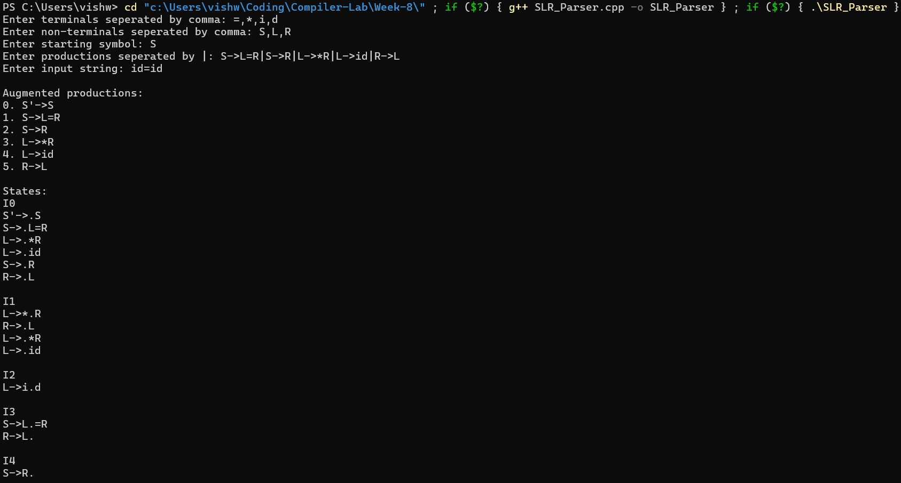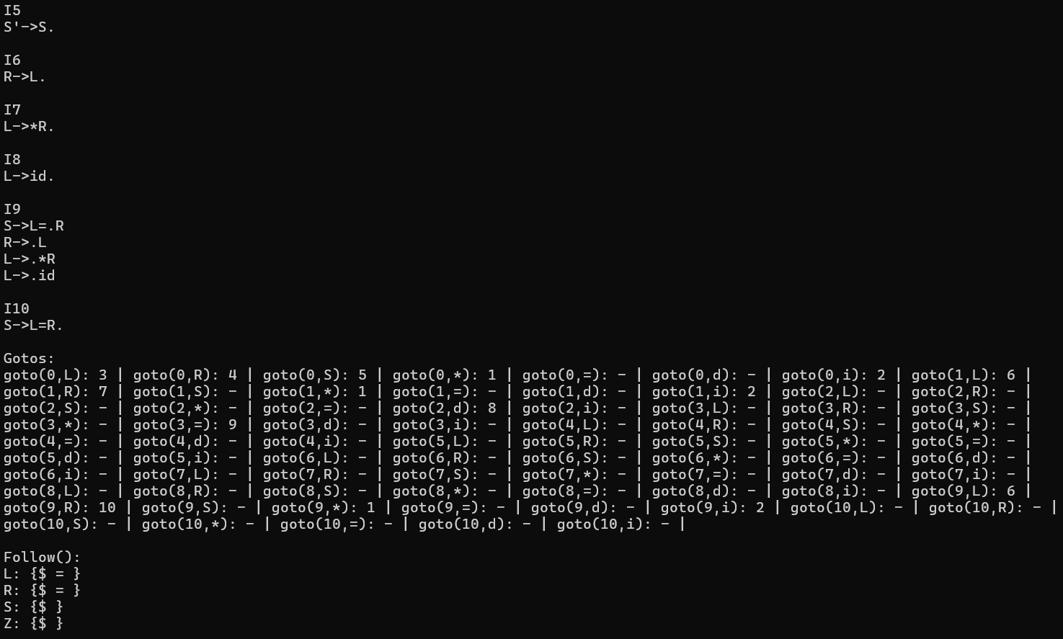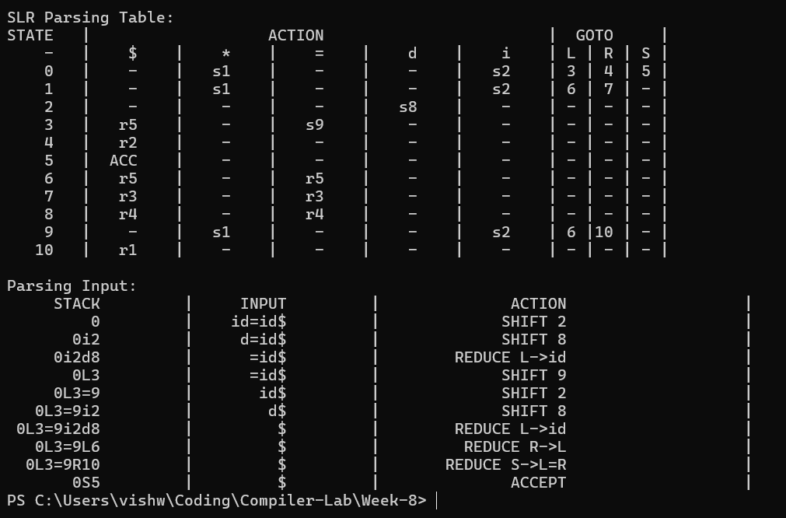

Result:
The SLR parser has been successfully written in C++ and executes as expected.

Compiler Design Lab
Date: 27-2-2026 | Name: S Vishwajith
Assignment No.: 8 | Register No.: 23BCE1145

Aim:
To implement a CLR parser using C++.

Code:
#include <iostream>
#include <vector>
#include <string>
#include <map>
#include <set>
#include <stack>
#include <algorithm>
#include <iomanip>
using namespace std;

vector<pair<string, vector<string>>> G = {
{"S'", {"S"}},
{"S", {"C", "C"}},
{"C", {"c", "C"}},
{"C", {"d"}},
};

const string INPUT = "ccdd";
set<string> NT, TM;
string AUG;

bool isNT(const string &s) { return NT.count(s) > 0; }

void deriveSymbols()
{
AUG = G[0].first;
for (auto &[l, r] : G)
NT.insert(l);
for (auto &[l, r] : G)
for (auto &s : r)
if (!NT.count(s))
TM.insert(s);
TM.insert("$");
}

map<string, set<string>> FIRST;

set<string> firstSeq(const vector<string> &v, int from = 0)
{
set<string> res;
if (from >= (int)v.size())
{
res.insert("eps");
return res;
}
for (int i = from; i < (int)v.size(); i++)
{
const string &s = v[i];
set<string> fi = TM.count(s) ? set<string>{s} : FIRST[s];
bool hasEps = fi.count("eps");
for (auto &x : fi)
if (x != "eps")
res.insert(x);
if (!hasEps)
return res;
}
res.insert("eps");
return res;
}

void computeFirst()
{
for (auto &n : NT)
FIRST[n] = {};
bool changed = true;
while (changed)
{
changed = false;
for (auto &[l, r] : G)
for (auto &x : firstSeq(r))
if (!FIRST[l].count(x))
{
FIRST[l].insert(x);
changed = true;
}
}
}

struct Item
{
int p, d;
string la;
bool operator<(const Item &o) const { return tie(p, d, la) < tie(o.p, o.d, o.la); }
bool operator==(const Item &o) const { return p == o.p && d == o.d && la == o.la; }
};
using ISet = set<Item>;

string itemStr(const Item &it)
{
auto &[lhs, rhs] = G[it.p];
string s = lhs + " ->";
for (int i = 0; i <= (int)rhs.size(); i++)
{
if (i == it.d)
s += " .";
if (i < (int)rhs.size())
s += " " + rhs[i];
}
s += " [" + it.la + "]";
return s;
}

ISet closure1(ISet s)
{
vector<Item> wl(s.begin(), s.end());
while (!wl.empty())
{
Item it = wl.back();
wl.pop_back();
auto &rhs = G[it.p].second;
if (it.d >= (int)rhs.size())
continue;
const string &B = rhs[it.d];
if (!isNT(B))
continue;
vector<string> beta(rhs.begin() + it.d + 1, rhs.end());
beta.push_back(it.la);
for (auto &b : firstSeq(beta))
{
if (b == "eps")
continue;
for (int i = 0; i < (int)G.size(); i++)
{
if (G[i].first != B)
continue;
Item ni{i, 0, b};
if (!s.count(ni))
{
s.insert(ni);
wl.push_back(ni);
}
}
}
}
return s;
}

ISet gotoSt(const ISet &s, const string &sym)
{
ISet kernel;
for (auto &it : s)
{
auto &rhs = G[it.p].second;
if (it.d < (int)rhs.size() && rhs[it.d] == sym)
kernel.insert({it.p, it.d + 1, it.la});
}
return kernel.empty() ? kernel : closure1(kernel);
}

vector<ISet> STATES;
map<pair<int, string>, int> TRANS;

void buildCollection()
{
STATES.push_back(closure1({{0, 0, "$"}}));
bool changed = true;
while (changed)
{
changed = false;
int n = (int)STATES.size();
for (int i = 0; i < n; i++)
{
set<string> syms;
for (auto &it : STATES[i])
{
auto &rhs = G[it.p].second;
if (it.d < (int)rhs.size())
syms.insert(rhs[it.d]);
}
for (auto &sym : syms)
{
ISet g = gotoSt(STATES[i], sym);
if (g.empty())
continue;
int idx = -1;
for (int j = 0; j < (int)STATES.size(); j++)
if (STATES[j] == g)
{
idx = j;
break;
}
if (idx == -1)
{
idx = (int)STATES.size();
STATES.push_back(g);
changed = true;
}
TRANS[{i, sym}] = idx;
}
}
}
}

map<int, map<string, string>> ACT;
map<int, map<string, int>> GOT;
vector<string> conflicts;

void buildTables()
{
for (int i = 0; i < (int)STATES.size(); i++)
{
for (auto &it : STATES[i])
{
auto &[lhs, rhs] = G[it.p];
if (it.d < (int)rhs.size())
{
const string &sym = rhs[it.d];
if (TM.count(sym) && sym != "$")
{
if (TRANS.count({i, sym}))
{
string act = "s" + to_string(TRANS[{i, sym}]);
if (ACT[i].count(sym) && ACT[i][sym] != act)
conflicts.push_back("State " + to_string(i) + " on '" + sym +
"': " + ACT[i][sym] + " vs " + act);
ACT[i][sym] = act;
}
}
else if (isNT(sym))
{
if (TRANS.count({i, sym}))
GOT[i][sym] = TRANS[{i, sym}];
}
}
else
{
if (lhs == AUG && it.la == "$")
{
ACT[i]["$"] = "acc";
}
else
{
string act = "r" + to_string(it.p);
if (ACT[i].count(it.la) && ACT[i][it.la] != act)
conflicts.push_back("State " + to_string(i) + " on '" + it.la +
"': " + ACT[i][it.la] + " vs " + act);
ACT[i][it.la] = act;
}
}
}
}
}

vector<int> colWidths(const vector<string> &hdr, const vector<vector<string>> &rows)
{
vector<int> w(hdr.size(), 0);
for (int i = 0; i < (int)hdr.size(); i++)
w[i] = (int)hdr[i].size();
for (auto &r : rows)
for (int i = 0; i < (int)r.size() && i < (int)w.size(); i++)
w[i] = max(w[i], (int)r[i].size());
return w;
}

void hline(const vector<int> &w, char fc = '-')
{
cout << "+";
for (auto x : w)
cout << string(x + 2, fc) << "+";
cout << "\n";
}

void printRow(const vector<int> &w, const vector<string> &cells)
{
cout << "|";
for (int i = 0; i < (int)cells.size(); i++)
{
string c = i < (int)cells.size() ? cells[i] : "";
cout << " " << left << setw(w[i]) << c << " |";
}
cout << "\n";
}

void printTable(const vector<string> &hdr, const vector<vector<string>> &rows)
{
auto w = colWidths(hdr, rows);
hline(w, '=');
printRow(w, hdr);
hline(w, '=');
for (auto &r : rows)
{
printRow(w, r);
hline(w, '-');
}
}

void sectionBanner(const string &title)
{
int n = (int)title.size() + 4;
cout << "\n"
<< string(n, '=') << "\n";
cout << "| " << title << " |\n";
cout << string(n, '=') << "\n\n";
}

void printGrammar()
{
sectionBanner("GRAMMAR (Augmented)");
for (int i = 0; i < (int)G.size(); i++)
{
cout << " (" << i << ") " << G[i].first << " -> ";
if (G[i].second.empty())
cout << "eps";
else
for (auto &s : G[i].second)
cout << s << " ";
cout << "\n";
}
}

void printFirstSets()
{
sectionBanner("FIRST SETS");
vector<string> ntVec;
for (auto &n : NT)
if (n != AUG)
ntVec.push_back(n);
sort(ntVec.begin(), ntVec.end());
for (auto &n : ntVec)
{
cout << " FIRST( " << n << " ) = { ";
bool first = true;
for (auto &x : FIRST[n])
{
if (!first)
cout << ", ";
cout << x;
first = false;
}
cout << " }\n";
}
}

void printStates()
{
sectionBanner("CANONICAL LR(1) ITEM SETS");
for (int i = 0; i < (int)STATES.size(); i++)
{
string hdr = " State I" + to_string(i) + " ";
cout << "\n"
<< hdr << string(max(0, 44 - (int)hdr.size()), '-') << "\n";
for (auto &it : STATES[i])
cout << " " << itemStr(it) << "\n";
bool any = false;
for (auto &[key, val] : TRANS)
if (key.first == i)
{
any = true;
break;
}
if (any)
{
cout << " " << string(36, '-') << "\n";
for (auto &[key, val] : TRANS)
if (key.first == i)
cout << " goto( " << key.second << " ) => I" << val << "\n";
}
}
}

void printParsingTable()
{
sectionBanner("CLR(1) PARSING TABLE");

vector<string> termCols, ntCols;
for (auto &t : TM)
if (t != "$")
termCols.push_back(t);
sort(termCols.begin(), termCols.end());
termCols.push_back("$");

for (auto &n : NT)
if (n != AUG)
ntCols.push_back(n);
sort(ntCols.begin(), ntCols.end());

vector<string> hdr = {"State"};
for (auto &t : termCols)
hdr.push_back(t);
for (auto &n : ntCols)
hdr.push_back(n);

vector<vector<string>> rows;
for (int i = 0; i < (int)STATES.size(); i++)
{
vector<string> row = {to_string(i)};
for (auto &t : termCols)
row.push_back(ACT[i].count(t) ? ACT[i][t] : "-");
for (auto &n : ntCols)
row.push_back(GOT[i].count(n) ? to_string(GOT[i][n]) : "-");
rows.push_back(row);
}

auto w = colWidths(hdr, rows);

int stateW = w[0];
int actionW = 0;
for (int i = 0; i < (int)termCols.size(); i++)
actionW += w[1 + i] + 3;
actionW -= 1;
int gotoW = 0;
for (int i = 0; i < (int)ntCols.size(); i++)
gotoW += w[1 + (int)termCols.size() + i] + 3;
gotoW -= 1;

cout << "+" << string(stateW + 2, '-')
<< "+" << string(actionW + 2, '-')
<< "+" << string(gotoW + 2, '-') << "+\n";
cout << "| " << left << setw(stateW) << "State"
<< " | " << left << setw(actionW) << "ACTION"
<< " | " << left << setw(gotoW) << "GOTO" << " |\n";

hline(w, '=');
printRow(w, hdr);
hline(w, '=');
for (auto &r : rows)
{
printRow(w, r);
hline(w, '-');
}

cout << "\n Legend:\n";
cout << " sN = shift to state N\n";
cout << " rN = reduce by production (N)\n";
cout << " acc = accept\n";
cout << " - = error / no entry\n";
cout << "\n Productions used in reduce actions:\n";
for (int i = 0; i < (int)G.size(); i++)
{
cout << " (" << i << ") " << G[i].first << " -> ";
if (G[i].second.empty())
cout << "eps";
else
for (auto &s : G[i].second)
cout << s << " ";
cout << "\n";
}
if (!conflicts.empty())
{
cout << "\n [!] CONFLICTS (grammar may not be CLR(1)):\n";
for (auto &c : conflicts)
cout << " " << c << "\n";
}
}

void parseInput()
{
sectionBanner("PARSING INPUT: \"" + INPUT + "\"");

string inp = INPUT + "$";
int ip = 0;

stack<int> stateStk;
stack<string> symStk;
stateStk.push(0);

auto stackStr = [&]() -> string
{
vector<int> v;
stack<int> tmp = stateStk;
while (!tmp.empty())
{
v.push_back(tmp.top());
tmp.pop();
}
reverse(v.begin(), v.end());
string s;
for (auto x : v)
s += to_string(x) + " ";
return s;
};

auto symStr = [&]() -> string
{
vector<string> v;
stack<string> tmp = symStk;
while (!tmp.empty())
{
v.push_back(tmp.top());
tmp.pop();
}
reverse(v.begin(), v.end());
string s = "$";
for (auto &x : v)
s += x;
return s;
};

vector<string> hdr = {"Step", "State Stack", "Symbol Stack", "Input", "Action"};
vector<vector<string>> rows;

int step = 0;
bool accepted = false;
bool errored = false;

while (true)
{
step++;
int state = stateStk.top();
string tok(1, inp[ip]);

if (!ACT[state].count(tok))
{
rows.push_back({to_string(step), stackStr(), symStr(), inp.substr(ip), "ERROR"});
errored = true;
break;
}

string act = ACT[state][tok];

if (act == "acc")
{
rows.push_back({to_string(step), stackStr(), symStr(), inp.substr(ip), "ACCEPT"});
accepted = true;
break;
}

if (act[0] == 's')
{
int ns = stoi(act.substr(1));
string desc = "Shift '" + tok + "' -> push s" + to_string(ns);
rows.push_back({to_string(step), stackStr(), symStr(), inp.substr(ip), desc});
stateStk.push(ns);
symStk.push(tok);
ip++;
}
else
{
int pid = stoi(act.substr(1));
auto &[lhs, rhs] = G[pid];
string prodStr = lhs + " ->";
for (auto &s : rhs)
prodStr += " " + s;
string desc = "Reduce by (" + to_string(pid) + ") " + prodStr;
rows.push_back({to_string(step), stackStr(), symStr(), inp.substr(ip), desc});
for (int i = 0; i < (int)rhs.size(); i++)
{
stateStk.pop();
symStk.pop();
}
int top = stateStk.top();
if (!GOT[top].count(lhs))
{
rows.push_back({to_string(step + 1), stackStr(), symStr(), inp.substr(ip), "GOTO ERROR"});
errored = true;
break;
}
stateStk.push(GOT[top][lhs]);
symStk.push(lhs);
}
}

printTable(hdr, rows);

cout << "\n";
if (accepted)
cout << " >> RESULT: \"" << INPUT << "\" is ACCEPTED by the grammar.\n\n";
else
cout << " >> RESULT: \"" << INPUT << "\" is REJECTED (syntax error at step "
<< step << ").\n\n";
}

int main()
{
deriveSymbols();
computeFirst();
buildCollection();
buildTables();

printGrammar();
printFirstSets();
printStates();
printParsingTable();
parseInput();

return 0;
}

Input and Output:
Input Grammar: (NT = {c , d}, T = {S, C }, P={ S -> CC, C -> cC, C -> d}, S = {S})
Input String: ccdd
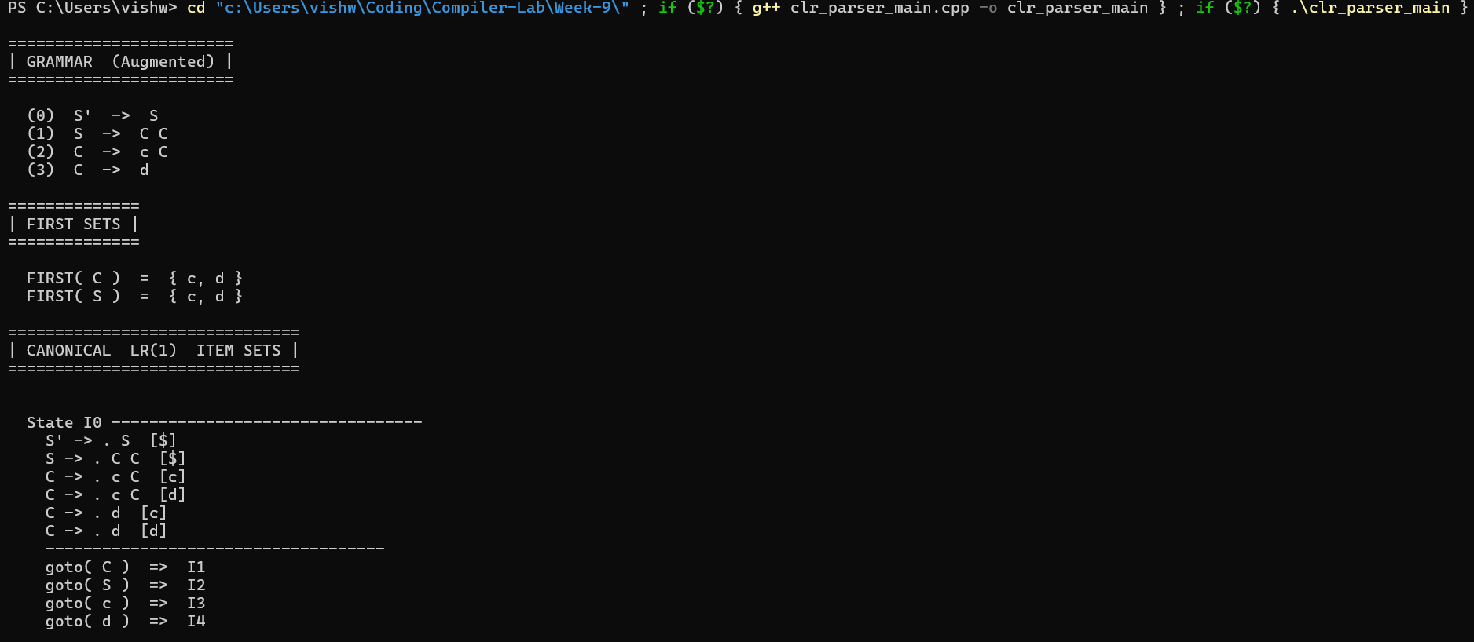
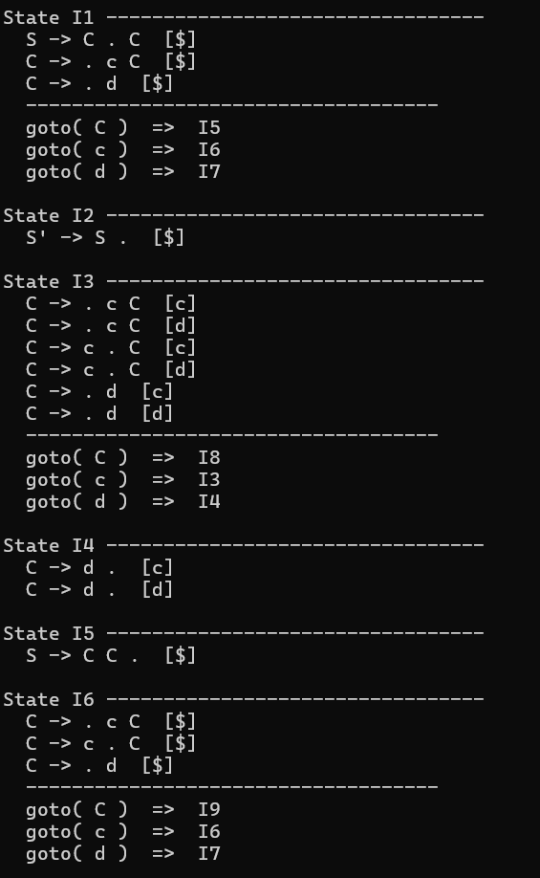
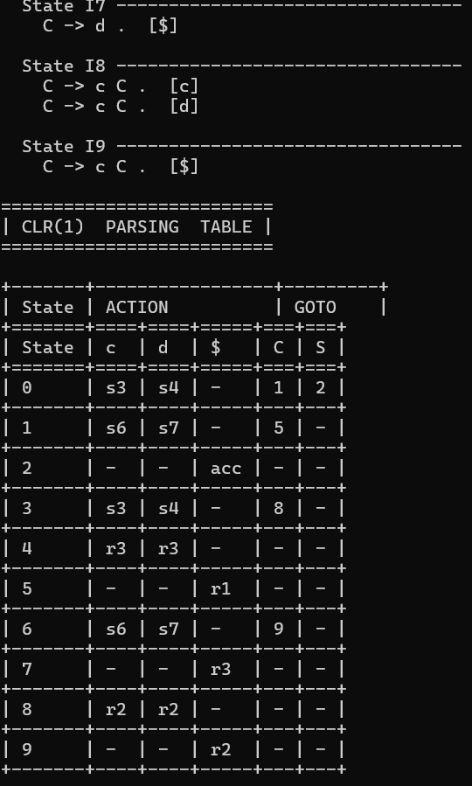
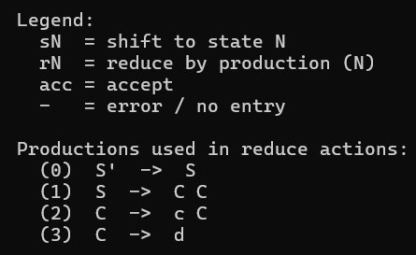
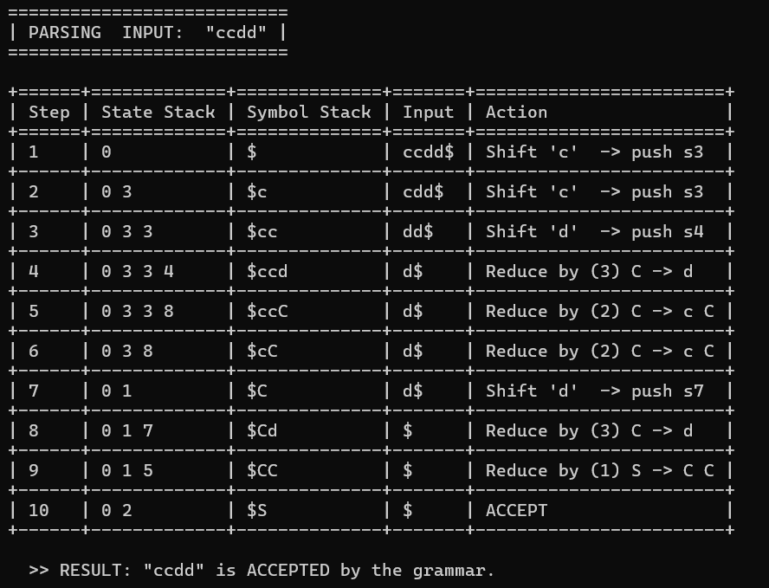

Result:
The CLR parser has been successfully written in C++ and executes as expected.

Compiler Design Lab
Date: 6-3-2026 | Name: S Vishwajith
Assignment No.: 9 | Register No.: 23BCE1145

Aim:
To implement a code to find Three Address code and it’s 3 data structures using C++.

Code:
#include <iostream>
#include <stack>
#include <vector>

using namespace std;
struct token
{
string c;
int type; // 0-id, 1-unary, 2-binary, 3-equals
};
struct statement
{
int temp; // 0-none, 1-arg1, 2-arg2, 3-arg1&&arg2
int eq;
string label;
string res;
string op;
string arg1;
string arg2;
};

vector<token> input;
vector<statement> tac;
int count = 0;
int ifcount = 0;

void to_tac()
{
stack<token> s;
stack<int> ifstack;
string lab = "";
int ind = 0;
for (token t : input)
{
ind++;
if (t.type == 0 && t.c == "if")
{
statement st;
st.op = "if True goto";
st.arg1 = s.top().c;
st.temp = 0;
st.eq = 2;
if (st.arg1[0] == 't' && st.arg1[1] <= '9' && st.arg1[1] >= '0')
st.temp = 1;
st.arg2 = "L" + to_string(ifcount);
lab = "L" + to_string(ifcount++);
st.res = "";
tac.push_back(st);
statement st1;
st1.eq = 3;
st1.temp = 0;
st1.op = "goto";
st1.arg1 = "L";
st1.arg2 = "";
st1.res = "";
tac.push_back(st1);
ifstack.push(tac.size() - 1);
}
else if (t.type == 0 && t.c == "else")
{
statement st1;
st1.eq = 3;
st1.temp = 0;
st1.op = "goto";
st1.arg1 = "L";
st1.arg2 = "";
st1.res = "";
tac.push_back(st1);
lab = "L" + to_string(ifcount);
tac[ifstack.top()].arg1 += to_string(ifcount++);
ifstack.pop();
ifstack.push(tac.size() - 1);
}
else if (t.type == 0 && t.c == "endif")
{
lab = "L" + to_string(ifcount);
if (ind == input.size())
{
statement st;
st.eq = 5;
st.label = "L" + to_string(ifcount);
tac.push_back(st);
while (!s.empty())
{
string lb = tac[ifstack.top()].arg1;
if (lb == "L")
tac[ifstack.top()].arg1 += to_string(ifcount);
s.pop();
}
}
}
else if (t.type == 0)
s.push(t);
else if (t.type == 1)
{
token arg = s.top();
s.pop();
statement st;
st.temp = 0;
st.eq = 0;
st.res = "t" + to_string(::count);
st.op = t.c;
st.arg1 = arg.c;
st.arg2 = "";
if (st.arg1[0] == 't' && st.arg1[1] <= '9' && st.arg1[1] >= '0')
st.temp = 1;
if (lab != "")
{
st.label = lab;
lab = "";
}
tac.push_back(st);
token n;
n.type = 0;
n.c = "t" + to_string(::count++);
s.push(n);
}
else if (t.type == 2)
{
token arg2 = s.top();
s.pop();
token arg1 = s.top();
s.pop();
statement st;
st.temp = 0;
st.eq = 0;
st.res = "t" + to_string(::count);
st.op = t.c;
st.arg1 = arg1.c;
st.arg2 = arg2.c;
if (st.arg1[0] == 't' && st.arg1[1] <= '9' && st.arg1[1] >= '0')
st.temp += 1;
if (st.arg2[0] == 't' && st.arg2[1] <= '9' && st.arg2[1] >= '0')
st.temp += 2;
if (lab != "")
{
st.label = lab;
lab = "";
}
tac.push_back(st);
token n;
n.type = 0;
n.c = "t" + to_string(::count++);
s.push(n);
}
else if (t.type == 3)
{
token arg1 = s.top();
s.pop();
token arg2 = s.top();
s.pop();
statement st;
st.arg1 = arg2.c;
st.op = "=";
st.arg2 = arg1.c;
st.eq = 1;
st.res = "";
if (lab != "")
{
st.label = lab;
lab = "";
}
tac.push_back(st);
}
}
}

int find_temp(string temp)
{
int i = 0;
for (statement s : tac)
{
if (s.res == temp || (s.arg1 == temp && s.eq == 1))
return i;
i++;
}
return -1;
}

void print_tac()
{
cout << endl
<< "Three Address Code: " << endl;
for (statement s : tac)
{
if (s.label == "")
cout << " ";
else
cout << s.label << ": ";
if (s.eq == 1)
cout << s.arg1 << " = " << s.arg2;
else if (s.eq == 2)
cout << "if " << s.arg1 << " True goto " << s.arg2;
else if (s.eq == 3)
cout << "goto " << s.arg1;
else if (s.eq == 5)
cout << " ";
else if (s.arg2 == "")
cout << s.res << " = " << s.op << " " << s.arg1;
else
cout << s.res << " = " << s.arg1 << " " << s.op << " " << s.arg2;
cout << endl;
}
}

void print_quad()
{
cout << "\nQuadruples: \n\n";
cout << "| OP | ARG1 | ARG2 | RES |" << endl;
cout << "-----------------------------------------------" << endl;
for (statement s : tac)
{
if (s.eq == 5)
continue;
string pad;
cout << '|';
string out = s.op;
pad = string(12 - out.size(), ' ');
cout << out << pad << '|';
out = s.arg1;
pad = string(10 - out.size(), ' ');
cout << out << pad << '|';
out = s.arg2;
pad = string(10 - out.size(), ' ');
cout << out << pad << '|';
out = s.res;
pad = string(10 - out.size(), ' ');
cout << out << pad << '|';
cout << endl;
}
}

void print_trip()
{
cout << "\nTriples: \n\n";
cout << "| INDEX | OP | ARG1 | ARG2 |" << endl;
cout << "-------------------------------------------------" << endl;
int i = 0;
for (statement s : tac)
{
if (s.eq == 5)
continue;
string pad;
string out;
cout << '|';
out = to_string(i);
pad = string(12 - out.size(), ' ');
cout << out << pad << '|';
out = s.op;
pad = string(12 - out.size(), ' ');
cout << out << pad << '|';
out = s.arg1;
if (out[0] == 't' && out.size() > 1)
out = '[' + to_string(find_temp(out)) + ']';
pad = string(10 - out.size(), ' ');
cout << out << pad << '|';
out = s.arg2;
if (out[0] == 't' && out.size() > 1)
out = '[' + to_string(find_temp(out)) + ']';
pad = string(10 - out.size(), ' ');
cout << out << pad << '|';
cout << endl;
i++;
}
}

void print_i_trip()
{
cout << "\nIndirect Triples: \n\n";
cout << "| ADDR | INDEX | | INDEX | OP | ARG1 | ARG2 |" << endl;
cout << "----------------------- -------------------------------------------------" << endl;
int i = 0;
int a = 31;
for (statement s : tac)
{
if (s.eq == 5)
continue;
string pad;
string out;
cout << '|';
out = to_string(a);
pad = string(8 - out.size(), ' ');
cout << out << pad << '|';
out = to_string(i);
pad = string(12 - out.size(), ' ');
cout << out << pad << '|';
cout << " |";
out = to_string(i);
pad = string(12 - out.size(), ' ');
cout << out << pad << '|';
out = s.op;
pad = string(12 - out.size(), ' ');
cout << out << pad << '|';
out = s.arg1;
if (out[0] == 't' && out.size() > 1)
out = '[' + to_string(a - i + find_temp(out)) + ']';
pad = string(10 - out.size(), ' ');
cout << out << pad << '|';
out = s.arg2;
if (out[0] == 't' && out.size() > 1)
out = '[' + to_string(a - i + find_temp(out)) + ']';
pad = string(10 - out.size(), ' ');
cout << out << pad << '|';
cout << endl;
i++;
a++;
}
}

int main()
{
string in, var;
int un = 0;
cin >> in;
cout << "INPUT: " << in << endl;
for (char c : in)
{
if (c == ',')
{
if (!var.empty())
{
token n;
n.type = 0;
n.c = var;
input.push_back(n);
var.clear();
}
un = 0;
}
else if (c == 'u')
{
un = 1;
var.push_back(c);
}
else if (c == '-' && un == 1)
{
token n;
n.type = 1;
n.c = '-';
input.push_back(n);
var.clear();
un = 0;
}
else if (c == '=')
{
token n;
n.type = 3;
n.c = '=';
input.push_back(n);
un = 0;
var.clear();
}
else if (('a' <= c && c <= 'z') || ('0' <= c && c <= '9') || ('A' <= c && c <= 'Z'))
{
var.push_back(c);
un = 0;
}
else if (c == '+' || c == '-' || c == '%' || c == '*' || c == '/' || c == '^' || c == '<')
{
token n;
n.type = 2;
n.c = c;
input.push_back(n);
var.clear();
un = 0;
}
}
if (!var.empty())
{
token n;
n.type = 0;
n.c = var;
input.push_back(n);
var.clear();
}

to_tac();
print_tac();
print_quad();
print_trip();
print_i_trip();
}

Inputs and Outputs:
Input 1: p = q * -r + q – r + (t * u + v * w)
Postfix: p,q,r,u-,*,q,+,r,-,t,u,*,v,w,*,+,+,=
Output:
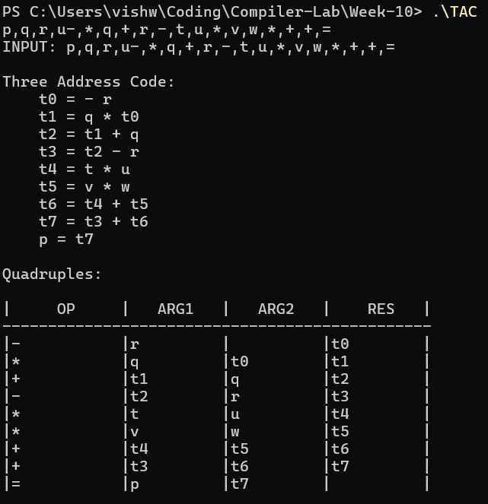
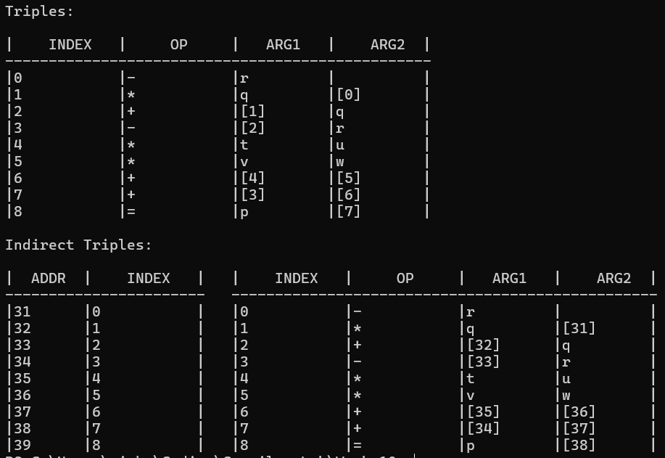
Input 2: x = (m+(n^o) / ((p-q)/(r+(n^o)) % s/t))
Postfix: x,m,n,o,^,p,q,-,r,n,o,^,+,/,s,t,/,%,/,=
Output:
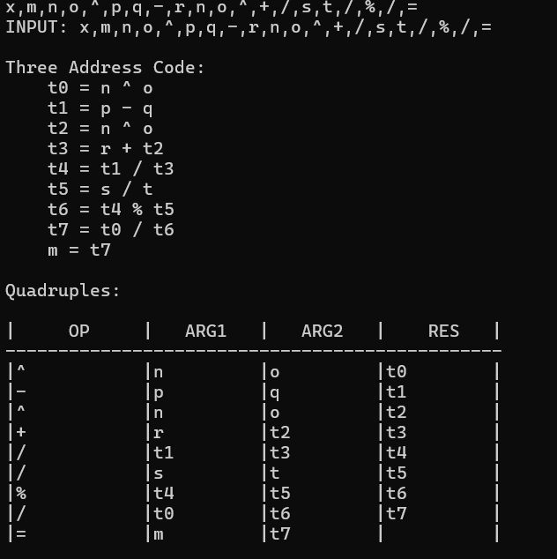
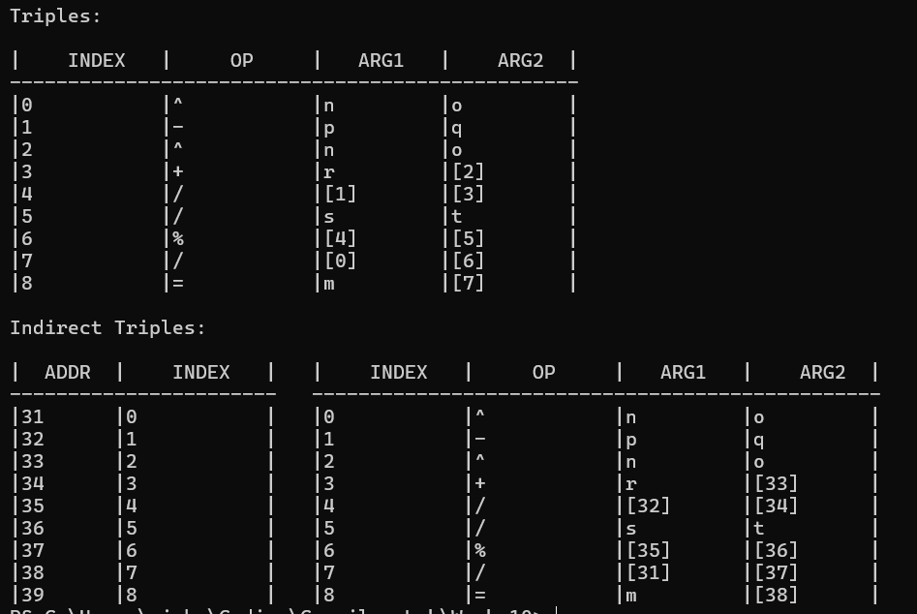
Input 3: if x<y, p=p+1 else q=q+1 endif
Postfix: x,y,<,if,p,p,1,+,=,else,q,q,1,+,=,endif
Output:
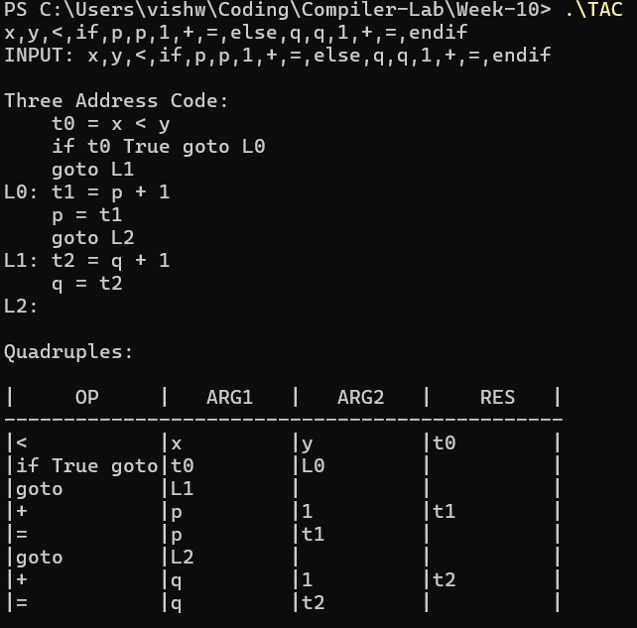
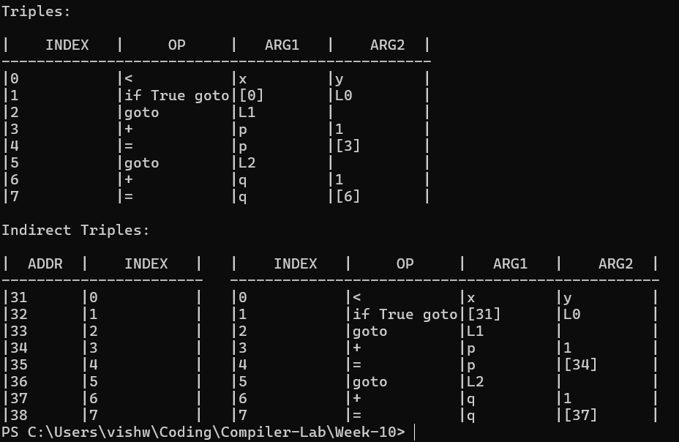

Result:
We have successfully implemented a C++ code to find Three Address Code and it’s 3 data structures (quadruple, triple, indirect triple).

Compiler Design Lab
Date: 13-3-2026 | Name: S Vishwajith
Assignment No.: 10 | Register No.: 23BCE1145

Aim:
To implement a code to find Three Address code and represent it in quadruples and triples using C++.

Code:
#include <iostream>
#include <fstream>
#include <sstream>
#include <string>
#include <vector>
#include <map>
#include <set>
#include <stack>
#include <iomanip>
#include <cstdlib>
using namespace std;

enum TokKind
{
T_ID,
T_NUM,
T_ASSIGN,
T_PLUS,
T_MINUS,
T_STAR,
T_SLASH,
T_LT,
T_GT,
T_LE,
T_GE,
T_EQ,
T_NEQ,
T_AND,
T_OR,
T_NOT,
T_LPAREN,
T_RPAREN,
T_LBRACKET,
T_RBRACKET,
T_LBRACE,
T_RBRACE,
T_SEMI,
T_COMMA,
T_IF,
T_ELSE,
T_WHILE,
T_FOR,
T_BREAK,
T_EOF
};

struct Token
{
TokKind kind;
string val;
int line;
};

class Lexer
{
string src;
size_t pos = 0;
int line = 1;

bool peek2(char a, char b) const
{
return pos + 1 < src.size() && src[pos] == a && src[pos + 1] == b;
}

void skipWS()
{
while (pos < src.size())
{
char c = src[pos];
if (c == '\n')
{
++line;
++pos;
}
else if (isspace((unsigned char)c))
{
++pos;
}
else if (peek2('/', '/'))
{
while (pos < src.size() && src[pos] != '\n')
++pos;
}
else
break;
}
}

static TokKind keyword(const string &s)
{
if (s == "if")
return T_IF;
if (s == "else")
return T_ELSE;
if (s == "while")
return T_WHILE;
if (s == "for")
return T_FOR;
if (s == "break")
return T_BREAK;
return T_ID;
}

public:
explicit Lexer(string source) : src(move(source)) {}

Token next()
{
skipWS();
if (pos >= src.size())
return {T_EOF, "", line};

char c = src[pos];

if (isdigit((unsigned char)c))
{
string num;
while (pos < src.size() && isdigit((unsigned char)src[pos]))
num += src[pos++];
return {T_NUM, num, line};
}

if (isalpha((unsigned char)c) || c == '_')
{
string id;
while (pos < src.size() &&
(isalnum((unsigned char)src[pos]) || src[pos] == '_'))
id += src[pos++];
return {keyword(id), id, line};
}

if (peek2('<', '='))
{
pos += 2;
return {T_LE, "<=", line};
}
if (peek2('>', '='))
{
pos += 2;
return {T_GE, ">=", line};
}
if (peek2('=', '='))
{
pos += 2;
return {T_EQ, "==", line};
}
if (peek2('!', '='))
{
pos += 2;
return {T_NEQ, "!=", line};
}
if (peek2('&', '&'))
{
pos += 2;
return {T_AND, "&&", line};
}
if (peek2('|', '|'))
{
pos += 2;
return {T_OR, "||", line};
}

++pos;
switch (c)
{
case '=':
return {T_ASSIGN, "=", line};
case '+':
return {T_PLUS, "+", line};
case '-':
return {T_MINUS, "-", line};
case '*':
return {T_STAR, "*", line};
case '/':
return {T_SLASH, "/", line};
case '<':
return {T_LT, "<", line};
case '>':
return {T_GT, ">", line};
case '!':
return {T_NOT, "!", line};
case '(':
return {T_LPAREN, "(", line};
case ')':
return {T_RPAREN, ")", line};
case '[':
return {T_LBRACKET, "[", line};
case ']':
return {T_RBRACKET, "]", line};
case '{':
return {T_LBRACE, "{", line};
case '}':
return {T_RBRACE, "}", line};
case ';':
return {T_SEMI, ";", line};
case ',':
return {T_COMMA, ",", line};
default:
cerr << "Unknown character '" << c
<< "' at line " << line << '\n';
return {T_EOF, "", line};
}
}

vector<Token> tokenise()
{
vector<Token> v;
Token t;
do
{
t = next();
v.push_back(t);
} while (t.kind != T_EOF);
return v;
}
};

struct Instr
{
string label;
string op, arg1, arg2, result;

string str() const
{
if (op == "goto")
return "goto " + result;
if (op == "if False")
return "if False " + arg1 + " goto " + result;
if (op == "=")
return result + " = " + arg1;
if (op == "[]r")
return result + " = " + arg1 + "[" + arg2 + "]";
if (op == "[]w")
return arg1 + "[" + arg2 + "] = " + result;
if (!arg2.empty())
return result + " = " + arg1 + " " + op + " " + arg2;
if (!arg1.empty())
return result + " = " + op + " " + arg1;
return op;
}
};

class CodeGen
{
vector<Token> toks;
size_t cur = 0;
vector<Instr> code;
int tempCnt = 0;
int labelCnt = 0;
stack<string> breakTarget; // innermost loop exit label

Token &peek() { return toks[cur]; }
bool at(TokKind k) { return peek().kind == k; }
Token consume() { return at(T_EOF) ? toks[cur] : toks[cur++]; }
bool match(TokKind k)
{
if (at(k))
{
consume();
return true;
}
return false;
}

void expect(TokKind k, const char *what)
{
if (!match(k))
{
cerr << "Parse error at line " << peek().line
<< ": expected " << what
<< ", got '" << peek().val << "'\n";
exit(1);
}
}

string freshTemp() { return "t" + to_string(++tempCnt); }
string freshLabel() { return "L" + to_string(++labelCnt); }

void emit(const string &op,
const string &a1 = "",
const string &a2 = "",
const string &res = "")
{
code.push_back({"", op, a1, a2, res});
}
void emitLabel(const string &lbl)
{
code.push_back({lbl, "label", "", "", ""});
}

string parseExpr() { return parseOr(); }

string parseOr()
{
string lhs = parseAnd();
while (at(T_OR))
{
consume();
string rhs = parseAnd();
string t = freshTemp();
emit("||", lhs, rhs, t);
lhs = t;
}
return lhs;
}

string parseAnd()
{
string lhs = parseRel();
while (at(T_AND))
{
consume();
string rhs = parseRel();
string t = freshTemp();
emit("&&", lhs, rhs, t);
lhs = t;
}
return lhs;
}

string parseRel()
{
string lhs = parseAdd();
for (;;)
{
string op;
switch (peek().kind)
{
case T_LT:
op = "<";
break;
case T_GT:
op = ">";
break;
case T_LE:
op = "<=";
break;
case T_GE:
op = ">=";
break;
case T_EQ:
op = "==";
break;
case T_NEQ:
op = "!=";
break;
default:
return lhs;
}
consume();
string rhs = parseAdd();
string t = freshTemp();
emit(op, lhs, rhs, t);
lhs = t;
}
}

string parseAdd()
{
string lhs = parseMul();
while (at(T_PLUS) || at(T_MINUS))
{
string op = consume().val;
string rhs = parseMul();
string t = freshTemp();
emit(op, lhs, rhs, t);
lhs = t;
}
return lhs;
}

string parseMul()
{
string lhs = parseUnary();
while (at(T_STAR) || at(T_SLASH))
{
string op = consume().val;
string rhs = parseUnary();
string t = freshTemp();
emit(op, lhs, rhs, t);
lhs = t;
}
return lhs;
}

string parseUnary()
{
if (at(T_MINUS))
{
consume();
string t = freshTemp();
emit("-", parsePrimary(), "", t);
return t;
}
if (at(T_NOT))
{
consume();
string t = freshTemp();
emit("!", parsePrimary(), "", t);
return t;
}
return parsePrimary();
}

string parsePrimary()
{
if (at(T_LPAREN))
{
consume();
string v = parseExpr();
expect(T_RPAREN, ")");
return v;
}
if (at(T_NUM))
return consume().val;

if (at(T_ID))
{
string name = consume().val;

if (at(T_LBRACKET))
{
consume();
string idx1 = parseExpr();
expect(T_RBRACKET, "]");

if (at(T_LBRACKET))
{
consume();
string idx2 = parseExpr();
expect(T_RBRACKET, "]");

string tRow = freshTemp();
string tOff = freshTemp();
string tVal = freshTemp();
emit("*", idx1, "cols", tRow);
emit("+", tRow, idx2, tOff);
emit("[]r", name, tOff, tVal);
return tVal;
}

string t = freshTemp();
emit("[]r", name, idx1, t);
return t;
}
return name;
}

cerr << "Unexpected token '" << peek().val
<< "' at line " << peek().line << '\n';
exit(1);
}

void parseBlock()
{
if (at(T_LBRACE))
{
consume();
while (!at(T_RBRACE) && !at(T_EOF))
parseStmt();
expect(T_RBRACE, "}");
}
else
{
parseStmt();
}
}

void parseIf()
{
consume();
expect(T_LPAREN, "(");
string cond = parseExpr();
expect(T_RPAREN, ")");

string lFalse = freshLabel();
string lEnd = freshLabel();

emit("if False", cond, "", lFalse);
parseBlock();

if (at(T_ELSE))
{
consume();
emit("goto", "", "", lEnd);
emitLabel(lFalse);
if (at(T_IF))
parseIf();
else
parseBlock();
emitLabel(lEnd);
}
else
{
emitLabel(lFalse);
}
}

void parseWhile()
{
consume();

string lStart = freshLabel();
string lEnd = freshLabel();

breakTarget.push(lEnd);

emitLabel(lStart);
expect(T_LPAREN, "(");
string cond = parseExpr();
expect(T_RPAREN, ")");

emit("if False", cond, "", lEnd);
parseBlock();
emit("goto", "", "", lStart);
emitLabel(lEnd);

breakTarget.pop();
}

void parseFor()
{
consume();
expect(T_LPAREN, "(");

if (!at(T_SEMI))
parseAssign();
expect(T_SEMI, ";");

string lCond = freshLabel();
string lBody = freshLabel();
string lIncr = freshLabel();
string lEnd = freshLabel();

breakTarget.push(lEnd);

emitLabel(lCond);

string cond = "1";
if (!at(T_SEMI))
cond = parseExpr();
expect(T_SEMI, ";");

emit("if False", cond, "", lEnd);
emit("goto", "", "", lBody);

size_t incrStart = cur;
{
int depth = 1;
while (cur < toks.size() && depth > 0)
{
if (toks[cur].kind == T_LPAREN)
++depth;
if (toks[cur].kind == T_RPAREN)
--depth;
++cur;
}
}

emitLabel(lBody);
parseBlock();

emitLabel(lIncr);
size_t afterBody = cur;
cur = incrStart;
if (!at(T_RPAREN))
parseAssign();
cur = afterBody;

emit("goto", "", "", lCond);
emitLabel(lEnd);

breakTarget.pop();
}

void parseAssign()
{
if (!at(T_ID))
{
parseExpr();
return;
}

string name = consume().val;

if (at(T_LBRACKET))
{
consume();
string idx1 = parseExpr();
expect(T_RBRACKET, "]");

if (at(T_LBRACKET))
{
consume();
string idx2 = parseExpr();
expect(T_RBRACKET, "]");
expect(T_ASSIGN, "=");
string rhs = parseExpr();

string tRow = freshTemp();
string tOff = freshTemp();
emit("*", idx1, "cols", tRow);
emit("+", tRow, idx2, tOff);
emit("[]w", name, tOff, rhs);
return;
}

expect(T_ASSIGN, "=");
string rhs = parseExpr();
emit("[]w", name, idx1, rhs);
return;
}

if (at(T_ASSIGN))
{
consume();
string rhs = parseExpr();
emit("=", rhs, "", name);
return;
}

--cur;
parseExpr();
}

void parseStmt()
{
switch (peek().kind)
{
case T_IF:
parseIf();
break;
case T_WHILE:
parseWhile();
break;
case T_FOR:
parseFor();
break;
case T_BREAK:
consume();
if (!breakTarget.empty())
emit("goto", "", "", breakTarget.top());
else
cerr << "Warning: 'break' outside loop at line "
<< peek().line << '\n';
match(T_SEMI);
break;
case T_LBRACE:
parseBlock();
break;
case T_SEMI:
consume();
break;
default:
parseAssign();
match(T_SEMI);
break;
}
}

public:
explicit CodeGen(vector<Token> tokens) : toks(move(tokens)) {}

void run()
{
while (!at(T_EOF))
parseStmt();
}

const vector<Instr> &instructions() const { return code; }
};

static string pad(const string &s, int w)
{
string r = s;
if ((int)r.size() > w)
r = r.substr(0, w);
while ((int)r.size() < w)
r += ' ';
return r;
}

static void hRule(int style, const vector<int> &widths)
{
const char *L[] = {"+", "+", "+"};
const char *M[] = {"+", "+", "+"};
const char *R[] = {"+", "+", "+"};
cout << L[style];
for (size_t i = 0; i < widths.size(); ++i)
{
for (int j = 0; j < widths[i] + 2; ++j)
cout << "-";
cout << (i + 1 < widths.size() ? M[style] : R[style]);
}
cout << '\n';
}

static void printTAC(const vector<Instr> &code)
{
cout << "\n+==============================================================+\n"
"| THREE-ADDRESS CODE (Labelled Form) |\n"
"+==============================================================+\n\n";

int seq = 0;
for (const auto &ins : code)
{
if (ins.op == "label")
{
if (seq > 0)
cout << '\n';
cout << ins.label << ":\n";
}
else
{
cout << " [" << setw(3) << setfill('0') << seq
<< setfill(' ') << "] " << ins.str() << '\n';
++seq;
}
}
cout << '\n';
}

static void printQuadruple(const vector<Instr> &code)
{
cout << "\n+==============================================================+\n"
"| QUADRUPLE TABLE |\n"
"+==============================================================+\n";

const int WI = 4, WO = 10, WA = 14, WB = 14, WR = 16;
hRule(0, {WI, WO, WA, WB, WR});
cout << "| " << pad("#", WI) << " | "
<< pad("Op", WO) << " | "
<< pad("Arg1", WA) << " | "
<< pad("Arg2", WB) << " | "
<< pad("Result", WR) << " |\n";
hRule(1, {WI, WO, WA, WB, WR});

int n = 0;
for (const auto &ins : code)
{
if (ins.op == "label")
continue;
cout << "| " << pad(to_string(n++), WI) << " | "
<< pad(ins.op, WO) << " | "
<< pad(ins.arg1, WA) << " | "
<< pad(ins.arg2, WB) << " | "
<< pad(ins.result, WR) << " |\n";
}
hRule(2, {WI, WO, WA, WB, WR});
cout << '\n';
}

struct Triple
{
string op, arg1, arg2;
};

static string resolveTriple(const string &arg,
const map<string, int> &t2i)
{
auto it = t2i.find(arg);
return (it != t2i.end()) ? "(" + to_string(it->second) + ")" : arg;
}

static void printTriple(const vector<Instr> &code)
{
cout << "\n+==============================================================+\n"
"| TRIPLE TABLE |\n"
"+==============================================================+\n";

vector<Triple> triples;
map<string, int> t2i;

for (const auto &ins : code)
{
if (ins.op == "label")
continue;

Triple tr;
tr.op = ins.op;

if (ins.op == "=")
{
tr.arg1 = resolveTriple(ins.arg1, t2i);
tr.arg2 = resolveTriple(ins.result, t2i);
}
else if (ins.op == "goto")
{
tr.arg1 = ins.result;
tr.arg2 = "";
}
else if (ins.op == "if False")
{
tr.arg1 = resolveTriple(ins.arg1, t2i);
tr.arg2 = ins.result;
}
else if (ins.op == "[]w")
{
tr.arg1 = ins.arg1 + "[" + resolveTriple(ins.arg2, t2i) + "]";
tr.arg2 = resolveTriple(ins.result, t2i);
}
else if (ins.arg2.empty() && !ins.arg1.empty())
{
tr.arg1 = resolveTriple(ins.arg1, t2i);
tr.arg2 = resolveTriple(ins.result, t2i);
}
else
{
tr.arg1 = resolveTriple(ins.arg1, t2i);
tr.arg2 = resolveTriple(ins.arg2, t2i);
}

int idx = (int)triples.size();
triples.push_back(tr);

if (!ins.result.empty() && ins.result[0] == 't' && isdigit((unsigned char)ins.result[1]))
t2i[ins.result] = idx;
}

const int WI = 4, WO = 10, WA = 18, WB = 18;
hRule(0, {WI, WO, WA, WB});
cout << "| " << pad("#", WI) << " | "
<< pad("Op", WO) << " | "
<< pad("Arg1", WA) << " | "
<< pad("Arg2", WB) << " |\n";
hRule(1, {WI, WO, WA, WB});

for (int i = 0; i < (int)triples.size(); ++i)
{
cout << "| " << pad(to_string(i), WI) << " | "
<< pad(triples[i].op, WO) << " | "
<< pad(triples[i].arg1, WA) << " | "
<< pad(triples[i].arg2, WB) << " |\n";
}
hRule(2, {WI, WO, WA, WB});
cout << '\n';
}

int main(int argc, char *argv[])
{
if (argc < 2)
{
cout << "Give the input file name next to the execution file." << endl;
return 1;
}

ifstream fin(argv[1]);
if (!fin)
{
cerr << "Error: cannot open '" << argv[1] << "'\n";
return 1;
}

string src((istreambuf_iterator<char>(fin)),
istreambuf_iterator<char>());

cout << "\nSource file : " << argv[1] << "\n";
cout << "--------------------------------------------------------------\n";
cout << src;
if (!src.empty() && src.back() != '\n')
cout << '\n';
cout << "--------------------------------------------------------------\n";

Lexer lex(src);
auto tokens = lex.tokenise();

CodeGen gen(move(tokens));
gen.run();
const auto &code = gen.instructions();

if (code.empty())
{
cerr << "\nNothing to generate -- check the input file for syntax errors.\n";
return 1;
}

printTAC(code);
printQuadruple(code);
printTriple(code);

return 0;
}

Inputs and Outputs:
Code 1:
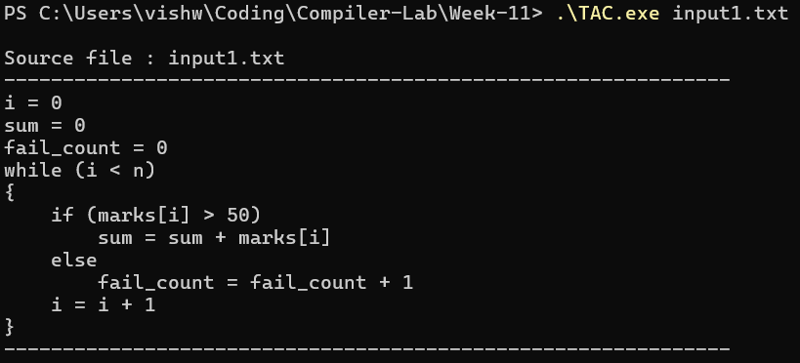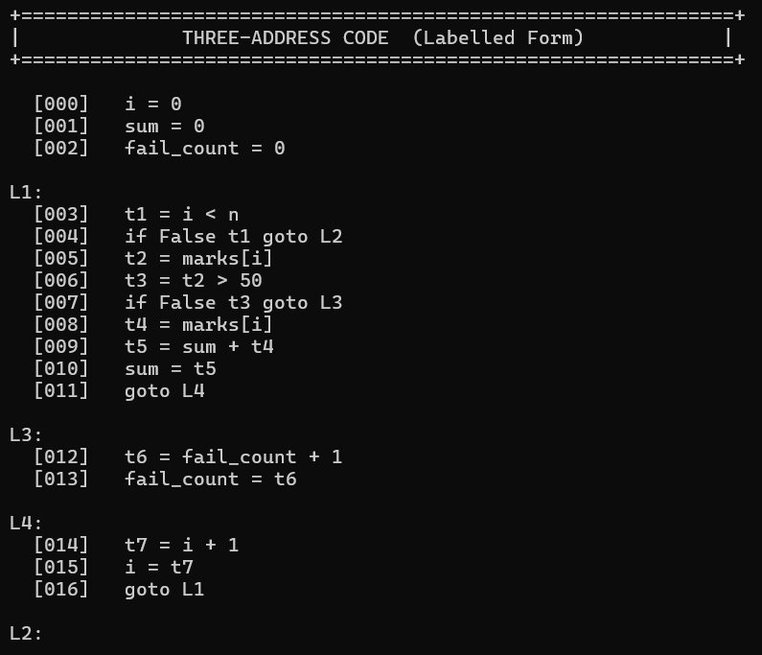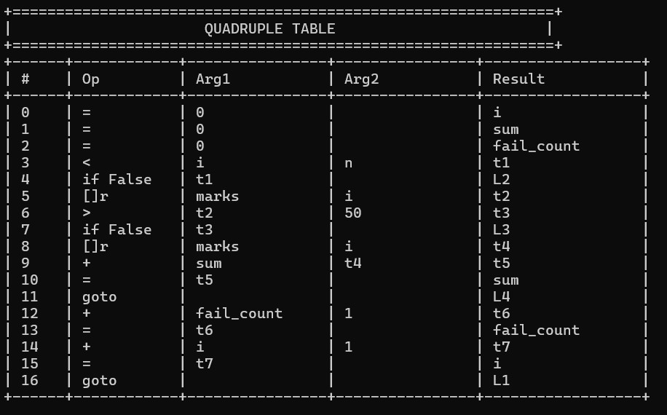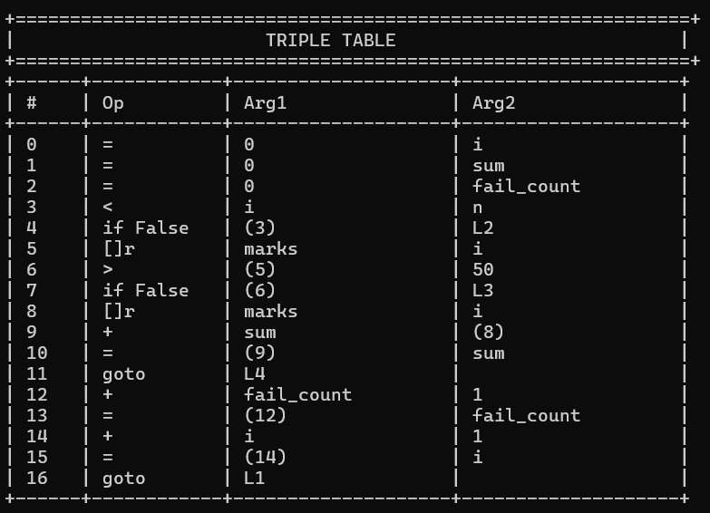

Code 2:
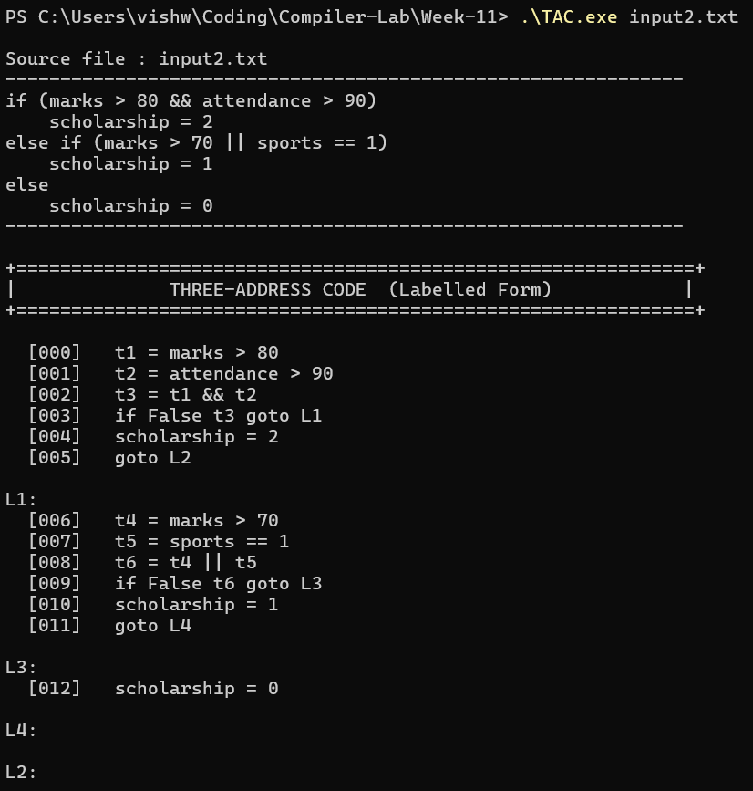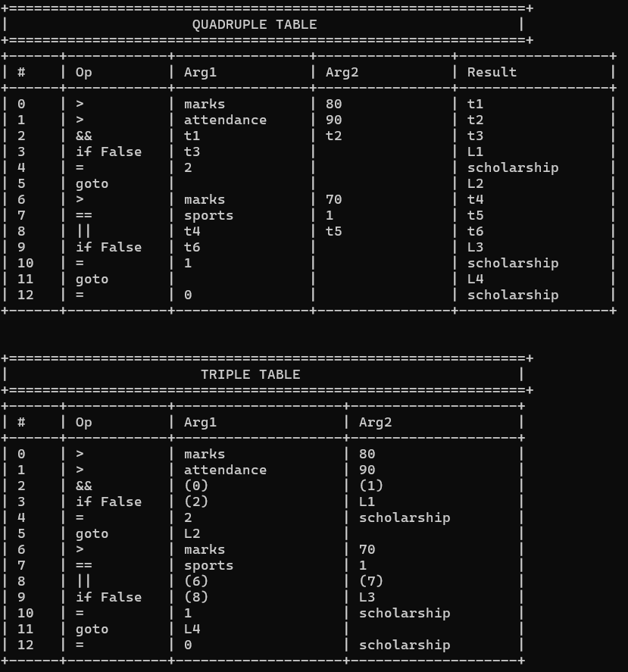

Code 3:
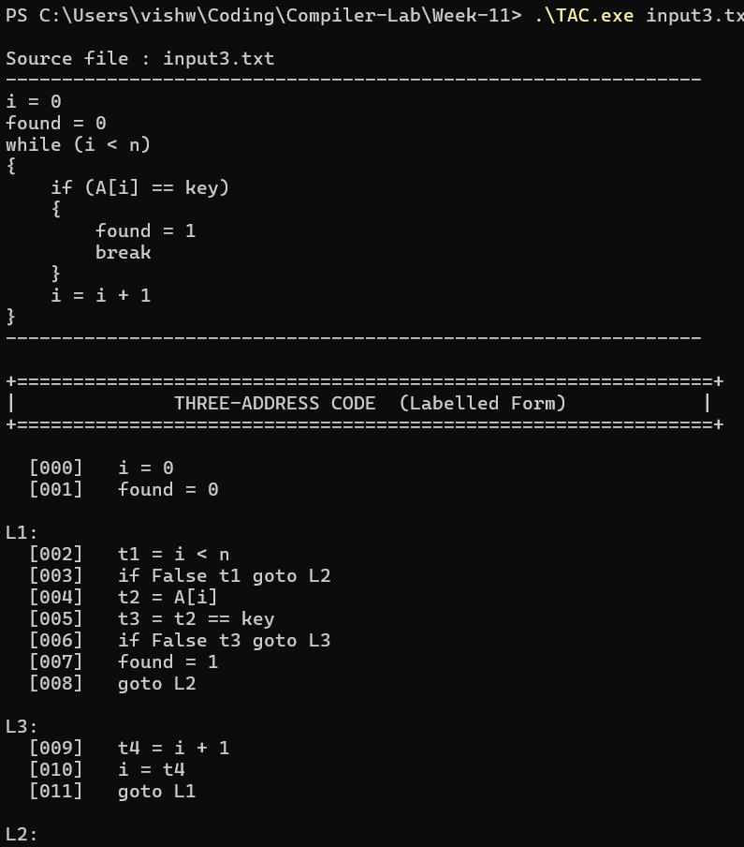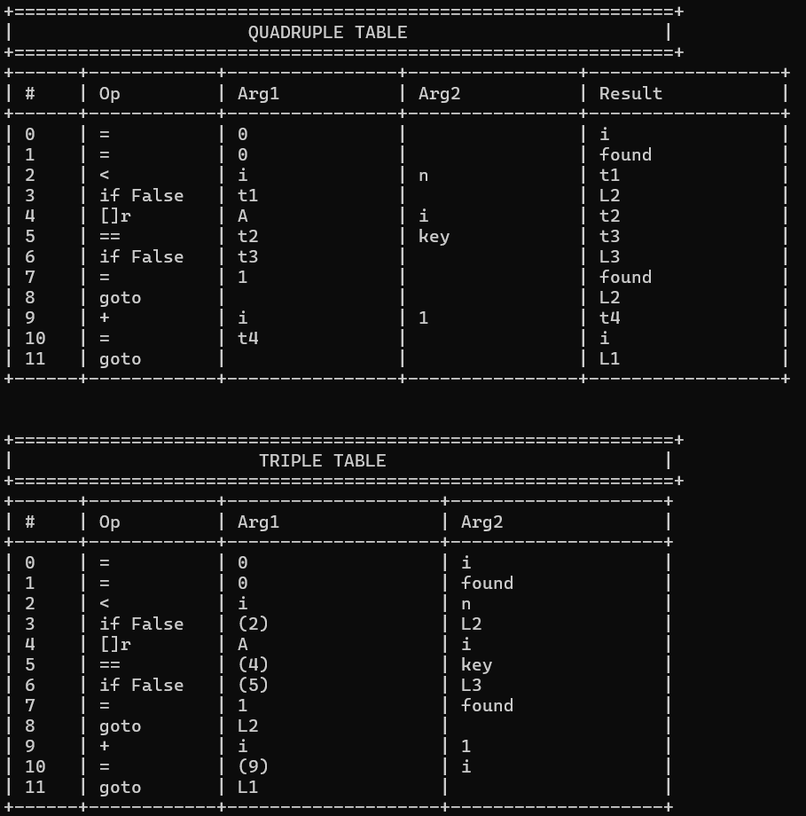

Result:
We have successfully implemented a C++ code to find Three Address Code and it’s data structures (quadruple, triple).

Compiler Design Lab

Date: 27-3-2026 Name: S Vishwajith
Assignment No.: 10 Register No.: 23BCE1145
Aim:
To reduce the given code using code optimization techniques (Constant folding, Variable propagation, Dead code elimination, code motion, common subexpression elimination, etc.).
Given code:
#include <iostream> using namespace std;

int main() { int a = 5, b = 10, c, d, i; int x = 2 * 3 * 4; int y = x; int z = y; int unused = a + b;
if (false) {
cout << "Hi welcome";

c = (a * b) + (a * b);
} for (i = 0; i < 5; i++) { d = a * b; int val = i * 2; cout << d + val << endl;
}
int result = (a * b) + (a * b) + (2 * 3 * 4);

cout << "Final: " << result << endl;

return 0;
}
Reduced Code:
#include <iostream> int main() {
for (int i = 0; i < 5; i++) std::cout << 50 + (i << 1) << "\n"; std::cout << "Final: " << 124 << "\n"; return 0;
}
Result:
The given code has been successfully reduced using the techniques, and the reduced code provides the same output as the given code.

