Compiler Design Lab
Date: 13-3-2026 | Name: S Vishwajith
Assignment No.: 10 | Register No.: 23BCE1145

Aim:
To implement a code to find Three Address code and represent it in quadruples and triples using C++.

Code:
#include <iostream>
#include <fstream>
#include <sstream>
#include <string>
#include <vector>
#include <map>
#include <set>
#include <stack>
#include <iomanip>
#include <cstdlib>
using namespace std;

enum TokKind
{
T_ID,
T_NUM,
T_ASSIGN,
T_PLUS,
T_MINUS,
T_STAR,
T_SLASH,
T_LT,
T_GT,
T_LE,
T_GE,
T_EQ,
T_NEQ,
T_AND,
T_OR,
T_NOT,
T_LPAREN,
T_RPAREN,
T_LBRACKET,
T_RBRACKET,
T_LBRACE,
T_RBRACE,
T_SEMI,
T_COMMA,
T_IF,
T_ELSE,
T_WHILE,
T_FOR,
T_BREAK,
T_EOF
};

struct Token
{
TokKind kind;
string val;
int line;
};

class Lexer
{
string src;
size_t pos = 0;
int line = 1;

bool peek2(char a, char b) const
{
return pos + 1 < src.size() && src[pos] == a && src[pos + 1] == b;
}

void skipWS()
{
while (pos < src.size())
{
char c = src[pos];
if (c == '\n')
{
++line;
++pos;
}
else if (isspace((unsigned char)c))
{
++pos;
}
else if (peek2('/', '/'))
{
while (pos < src.size() && src[pos] != '\n')
++pos;
}
else
break;
}
}

static TokKind keyword(const string &s)
{
if (s == "if")
return T_IF;
if (s == "else")
return T_ELSE;
if (s == "while")
return T_WHILE;
if (s == "for")
return T_FOR;
if (s == "break")
return T_BREAK;
return T_ID;
}

public:
explicit Lexer(string source) : src(move(source)) {}

Token next()
{
skipWS();
if (pos >= src.size())
return {T_EOF, "", line};

char c = src[pos];

if (isdigit((unsigned char)c))
{
string num;
while (pos < src.size() && isdigit((unsigned char)src[pos]))
num += src[pos++];
return {T_NUM, num, line};
}

if (isalpha((unsigned char)c) || c == '_')
{
string id;
while (pos < src.size() &&
(isalnum((unsigned char)src[pos]) || src[pos] == '_'))
id += src[pos++];
return {keyword(id), id, line};
}

if (peek2('<', '='))
{
pos += 2;
return {T_LE, "<=", line};
}
if (peek2('>', '='))
{
pos += 2;
return {T_GE, ">=", line};
}
if (peek2('=', '='))
{
pos += 2;
return {T_EQ, "==", line};
}
if (peek2('!', '='))
{
pos += 2;
return {T_NEQ, "!=", line};
}
if (peek2('&', '&'))
{
pos += 2;
return {T_AND, "&&", line};
}
if (peek2('|', '|'))
{
pos += 2;
return {T_OR, "||", line};
}

++pos;
switch (c)
{
case '=':
return {T_ASSIGN, "=", line};
case '+':
return {T_PLUS, "+", line};
case '-':
return {T_MINUS, "-", line};
case '*':
return {T_STAR, "*", line};
case '/':
return {T_SLASH, "/", line};
case '<':
return {T_LT, "<", line};
case '>':
return {T_GT, ">", line};
case '!':
return {T_NOT, "!", line};
case '(':
return {T_LPAREN, "(", line};
case ')':
return {T_RPAREN, ")", line};
case '[':
return {T_LBRACKET, "[", line};
case ']':
return {T_RBRACKET, "]", line};
case '{':
return {T_LBRACE, "{", line};
case '}':
return {T_RBRACE, "}", line};
case ';':
return {T_SEMI, ";", line};
case ',':
return {T_COMMA, ",", line};
default:
cerr << "Unknown character '" << c
<< "' at line " << line << '\n';
return {T_EOF, "", line};
}
}

vector<Token> tokenise()
{
vector<Token> v;
Token t;
do
{
t = next();
v.push_back(t);
} while (t.kind != T_EOF);
return v;
}
};

struct Instr
{
string label;
string op, arg1, arg2, result;

string str() const
{
if (op == "goto")
return "goto " + result;
if (op == "if False")
return "if False " + arg1 + " goto " + result;
if (op == "=")
return result + " = " + arg1;
if (op == "[]r")
return result + " = " + arg1 + "[" + arg2 + "]";
if (op == "[]w")
return arg1 + "[" + arg2 + "] = " + result;
if (!arg2.empty())
return result + " = " + arg1 + " " + op + " " + arg2;
if (!arg1.empty())
return result + " = " + op + " " + arg1;
return op;
}
};

class CodeGen
{
vector<Token> toks;
size_t cur = 0;
vector<Instr> code;
int tempCnt = 0;
int labelCnt = 0;
stack<string> breakTarget; // innermost loop exit label

Token &peek() { return toks[cur]; }
bool at(TokKind k) { return peek().kind == k; }
Token consume() { return at(T_EOF) ? toks[cur] : toks[cur++]; }
bool match(TokKind k)
{
if (at(k))
{
consume();
return true;
}
return false;
}

void expect(TokKind k, const char *what)
{
if (!match(k))
{
cerr << "Parse error at line " << peek().line
<< ": expected " << what
<< ", got '" << peek().val << "'\n";
exit(1);
}
}

string freshTemp() { return "t" + to_string(++tempCnt); }
string freshLabel() { return "L" + to_string(++labelCnt); }

void emit(const string &op,
const string &a1 = "",
const string &a2 = "",
const string &res = "")
{
code.push_back({"", op, a1, a2, res});
}
void emitLabel(const string &lbl)
{
code.push_back({lbl, "label", "", "", ""});
}

string parseExpr() { return parseOr(); }

string parseOr()
{
string lhs = parseAnd();
while (at(T_OR))
{
consume();
string rhs = parseAnd();
string t = freshTemp();
emit("||", lhs, rhs, t);
lhs = t;
}
return lhs;
}

string parseAnd()
{
string lhs = parseRel();
while (at(T_AND))
{
consume();
string rhs = parseRel();
string t = freshTemp();
emit("&&", lhs, rhs, t);
lhs = t;
}
return lhs;
}

string parseRel()
{
string lhs = parseAdd();
for (;;)
{
string op;
switch (peek().kind)
{
case T_LT:
op = "<";
break;
case T_GT:
op = ">";
break;
case T_LE:
op = "<=";
break;
case T_GE:
op = ">=";
break;
case T_EQ:
op = "==";
break;
case T_NEQ:
op = "!=";
break;
default:
return lhs;
}
consume();
string rhs = parseAdd();
string t = freshTemp();
emit(op, lhs, rhs, t);
lhs = t;
}
}

string parseAdd()
{
string lhs = parseMul();
while (at(T_PLUS) || at(T_MINUS))
{
string op = consume().val;
string rhs = parseMul();
string t = freshTemp();
emit(op, lhs, rhs, t);
lhs = t;
}
return lhs;
}

string parseMul()
{
string lhs = parseUnary();
while (at(T_STAR) || at(T_SLASH))
{
string op = consume().val;
string rhs = parseUnary();
string t = freshTemp();
emit(op, lhs, rhs, t);
lhs = t;
}
return lhs;
}

string parseUnary()
{
if (at(T_MINUS))
{
consume();
string t = freshTemp();
emit("-", parsePrimary(), "", t);
return t;
}
if (at(T_NOT))
{
consume();
string t = freshTemp();
emit("!", parsePrimary(), "", t);
return t;
}
return parsePrimary();
}

string parsePrimary()
{
if (at(T_LPAREN))
{
consume();
string v = parseExpr();
expect(T_RPAREN, ")");
return v;
}
if (at(T_NUM))
return consume().val;

if (at(T_ID))
{
string name = consume().val;

if (at(T_LBRACKET))
{
consume();
string idx1 = parseExpr();
expect(T_RBRACKET, "]");

if (at(T_LBRACKET))
{
consume();
string idx2 = parseExpr();
expect(T_RBRACKET, "]");

string tRow = freshTemp();
string tOff = freshTemp();
string tVal = freshTemp();
emit("*", idx1, "cols", tRow);
emit("+", tRow, idx2, tOff);
emit("[]r", name, tOff, tVal);
return tVal;
}

string t = freshTemp();
emit("[]r", name, idx1, t);
return t;
}
return name;
}

cerr << "Unexpected token '" << peek().val
<< "' at line " << peek().line << '\n';
exit(1);
}

void parseBlock()
{
if (at(T_LBRACE))
{
consume();
while (!at(T_RBRACE) && !at(T_EOF))
parseStmt();
expect(T_RBRACE, "}");
}
else
{
parseStmt();
}
}

void parseIf()
{
consume();
expect(T_LPAREN, "(");
string cond = parseExpr();
expect(T_RPAREN, ")");

string lFalse = freshLabel();
string lEnd = freshLabel();

emit("if False", cond, "", lFalse);
parseBlock();

if (at(T_ELSE))
{
consume();
emit("goto", "", "", lEnd);
emitLabel(lFalse);
if (at(T_IF))
parseIf();
else
parseBlock();
emitLabel(lEnd);
}
else
{
emitLabel(lFalse);
}
}

void parseWhile()
{
consume();

string lStart = freshLabel();
string lEnd = freshLabel();

breakTarget.push(lEnd);

emitLabel(lStart);
expect(T_LPAREN, "(");
string cond = parseExpr();
expect(T_RPAREN, ")");

emit("if False", cond, "", lEnd);
parseBlock();
emit("goto", "", "", lStart);
emitLabel(lEnd);

breakTarget.pop();
}

void parseFor()
{
consume();
expect(T_LPAREN, "(");

if (!at(T_SEMI))
parseAssign();
expect(T_SEMI, ";");

string lCond = freshLabel();
string lBody = freshLabel();
string lIncr = freshLabel();
string lEnd = freshLabel();

breakTarget.push(lEnd);

emitLabel(lCond);

string cond = "1";
if (!at(T_SEMI))
cond = parseExpr();
expect(T_SEMI, ";");

emit("if False", cond, "", lEnd);
emit("goto", "", "", lBody);

size_t incrStart = cur;
{
int depth = 1;
while (cur < toks.size() && depth > 0)
{
if (toks[cur].kind == T_LPAREN)
++depth;
if (toks[cur].kind == T_RPAREN)
--depth;
++cur;
}
}

emitLabel(lBody);
parseBlock();

emitLabel(lIncr);
size_t afterBody = cur;
cur = incrStart;
if (!at(T_RPAREN))
parseAssign();
cur = afterBody;

emit("goto", "", "", lCond);
emitLabel(lEnd);

breakTarget.pop();
}

void parseAssign()
{
if (!at(T_ID))
{
parseExpr();
return;
}

string name = consume().val;

if (at(T_LBRACKET))
{
consume();
string idx1 = parseExpr();
expect(T_RBRACKET, "]");

if (at(T_LBRACKET))
{
consume();
string idx2 = parseExpr();
expect(T_RBRACKET, "]");
expect(T_ASSIGN, "=");
string rhs = parseExpr();

string tRow = freshTemp();
string tOff = freshTemp();
emit("*", idx1, "cols", tRow);
emit("+", tRow, idx2, tOff);
emit("[]w", name, tOff, rhs);
return;
}

expect(T_ASSIGN, "=");
string rhs = parseExpr();
emit("[]w", name, idx1, rhs);
return;
}

if (at(T_ASSIGN))
{
consume();
string rhs = parseExpr();
emit("=", rhs, "", name);
return;
}

--cur;
parseExpr();
}

void parseStmt()
{
switch (peek().kind)
{
case T_IF:
parseIf();
break;
case T_WHILE:
parseWhile();
break;
case T_FOR:
parseFor();
break;
case T_BREAK:
consume();
if (!breakTarget.empty())
emit("goto", "", "", breakTarget.top());
else
cerr << "Warning: 'break' outside loop at line "
<< peek().line << '\n';
match(T_SEMI);
break;
case T_LBRACE:
parseBlock();
break;
case T_SEMI:
consume();
break;
default:
parseAssign();
match(T_SEMI);
break;
}
}

public:
explicit CodeGen(vector<Token> tokens) : toks(move(tokens)) {}

void run()
{
while (!at(T_EOF))
parseStmt();
}

const vector<Instr> &instructions() const { return code; }
};

static string pad(const string &s, int w)
{
string r = s;
if ((int)r.size() > w)
r = r.substr(0, w);
while ((int)r.size() < w)
r += ' ';
return r;
}

static void hRule(int style, const vector<int> &widths)
{
const char *L[] = {"+", "+", "+"};
const char *M[] = {"+", "+", "+"};
const char *R[] = {"+", "+", "+"};
cout << L[style];
for (size_t i = 0; i < widths.size(); ++i)
{
for (int j = 0; j < widths[i] + 2; ++j)
cout << "-";
cout << (i + 1 < widths.size() ? M[style] : R[style]);
}
cout << '\n';
}

static void printTAC(const vector<Instr> &code)
{
cout << "\n+==============================================================+\n"
"| THREE-ADDRESS CODE (Labelled Form) |\n"
"+==============================================================+\n\n";

int seq = 0;
for (const auto &ins : code)
{
if (ins.op == "label")
{
if (seq > 0)
cout << '\n';
cout << ins.label << ":\n";
}
else
{
cout << " [" << setw(3) << setfill('0') << seq
<< setfill(' ') << "] " << ins.str() << '\n';
++seq;
}
}
cout << '\n';
}

static void printQuadruple(const vector<Instr> &code)
{
cout << "\n+==============================================================+\n"
"| QUADRUPLE TABLE |\n"
"+==============================================================+\n";

const int WI = 4, WO = 10, WA = 14, WB = 14, WR = 16;
hRule(0, {WI, WO, WA, WB, WR});
cout << "| " << pad("#", WI) << " | "
<< pad("Op", WO) << " | "
<< pad("Arg1", WA) << " | "
<< pad("Arg2", WB) << " | "
<< pad("Result", WR) << " |\n";
hRule(1, {WI, WO, WA, WB, WR});

int n = 0;
for (const auto &ins : code)
{
if (ins.op == "label")
continue;
cout << "| " << pad(to_string(n++), WI) << " | "
<< pad(ins.op, WO) << " | "
<< pad(ins.arg1, WA) << " | "
<< pad(ins.arg2, WB) << " | "
<< pad(ins.result, WR) << " |\n";
}
hRule(2, {WI, WO, WA, WB, WR});
cout << '\n';
}

struct Triple
{
string op, arg1, arg2;
};

static string resolveTriple(const string &arg,
const map<string, int> &t2i)
{
auto it = t2i.find(arg);
return (it != t2i.end()) ? "(" + to_string(it->second) + ")" : arg;
}

static void printTriple(const vector<Instr> &code)
{
cout << "\n+==============================================================+\n"
"| TRIPLE TABLE |\n"
"+==============================================================+\n";

vector<Triple> triples;
map<string, int> t2i;

for (const auto &ins : code)
{
if (ins.op == "label")
continue;

Triple tr;
tr.op = ins.op;

if (ins.op == "=")
{
tr.arg1 = resolveTriple(ins.arg1, t2i);
tr.arg2 = resolveTriple(ins.result, t2i);
}
else if (ins.op == "goto")
{
tr.arg1 = ins.result;
tr.arg2 = "";
}
else if (ins.op == "if False")
{
tr.arg1 = resolveTriple(ins.arg1, t2i);
tr.arg2 = ins.result;
}
else if (ins.op == "[]w")
{
tr.arg1 = ins.arg1 + "[" + resolveTriple(ins.arg2, t2i) + "]";
tr.arg2 = resolveTriple(ins.result, t2i);
}
else if (ins.arg2.empty() && !ins.arg1.empty())
{
tr.arg1 = resolveTriple(ins.arg1, t2i);
tr.arg2 = resolveTriple(ins.result, t2i);
}
else
{
tr.arg1 = resolveTriple(ins.arg1, t2i);
tr.arg2 = resolveTriple(ins.arg2, t2i);
}

int idx = (int)triples.size();
triples.push_back(tr);

if (!ins.result.empty() && ins.result[0] == 't' && isdigit((unsigned char)ins.result[1]))
t2i[ins.result] = idx;
}

const int WI = 4, WO = 10, WA = 18, WB = 18;
hRule(0, {WI, WO, WA, WB});
cout << "| " << pad("#", WI) << " | "
<< pad("Op", WO) << " | "
<< pad("Arg1", WA) << " | "
<< pad("Arg2", WB) << " |\n";
hRule(1, {WI, WO, WA, WB});

for (int i = 0; i < (int)triples.size(); ++i)
{
cout << "| " << pad(to_string(i), WI) << " | "
<< pad(triples[i].op, WO) << " | "
<< pad(triples[i].arg1, WA) << " | "
<< pad(triples[i].arg2, WB) << " |\n";
}
hRule(2, {WI, WO, WA, WB});
cout << '\n';
}

int main(int argc, char *argv[])
{
if (argc < 2)
{
cout << "Give the input file name next to the execution file." << endl;
return 1;
}

ifstream fin(argv[1]);
if (!fin)
{
cerr << "Error: cannot open '" << argv[1] << "'\n";
return 1;
}

string src((istreambuf_iterator<char>(fin)),
istreambuf_iterator<char>());

cout << "\nSource file : " << argv[1] << "\n";
cout << "--------------------------------------------------------------\n";
cout << src;
if (!src.empty() && src.back() != '\n')
cout << '\n';
cout << "--------------------------------------------------------------\n";

Lexer lex(src);
auto tokens = lex.tokenise();

CodeGen gen(move(tokens));
gen.run();
const auto &code = gen.instructions();

if (code.empty())
{
cerr << "\nNothing to generate -- check the input file for syntax errors.\n";
return 1;
}

printTAC(code);
printQuadruple(code);
printTriple(code);

return 0;
}

Inputs and Outputs:
Code 1:
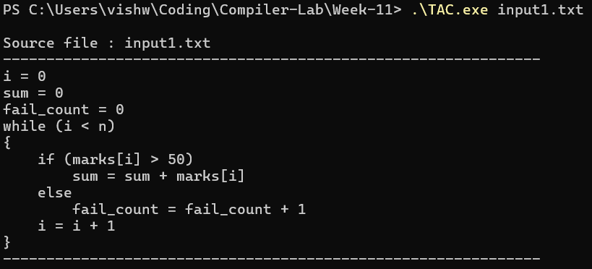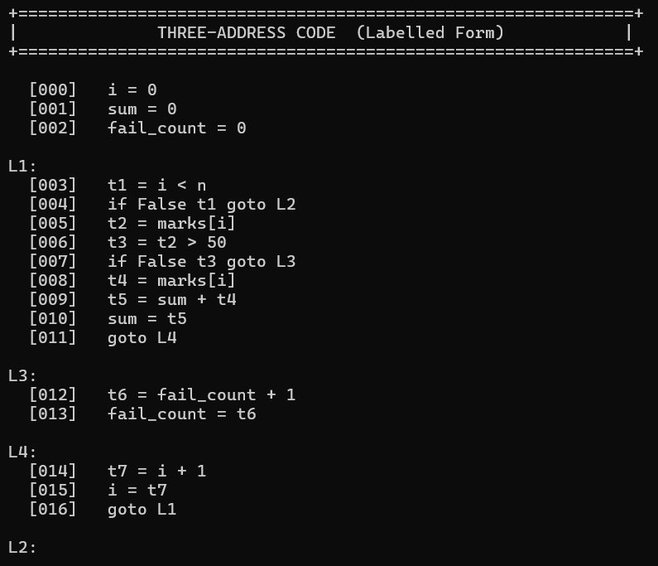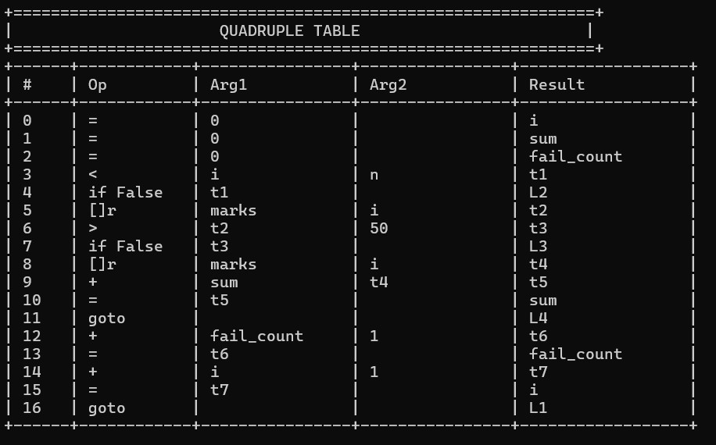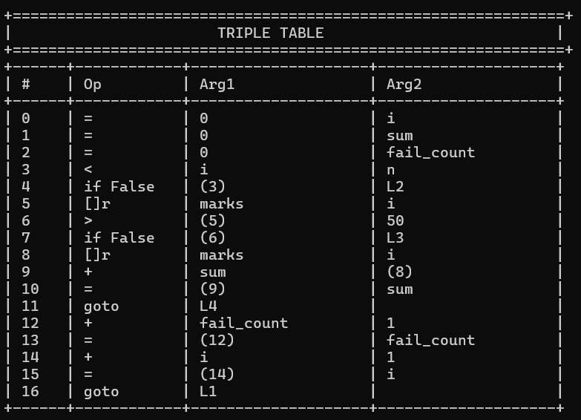

Code 2:
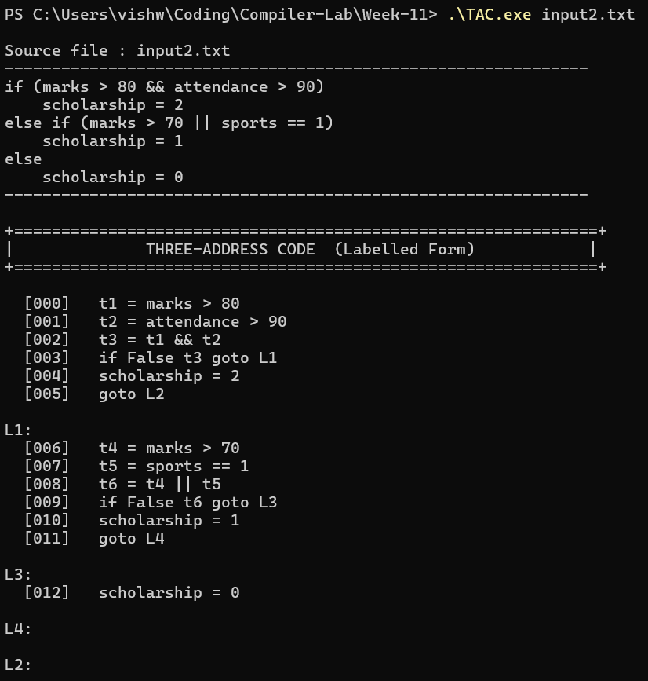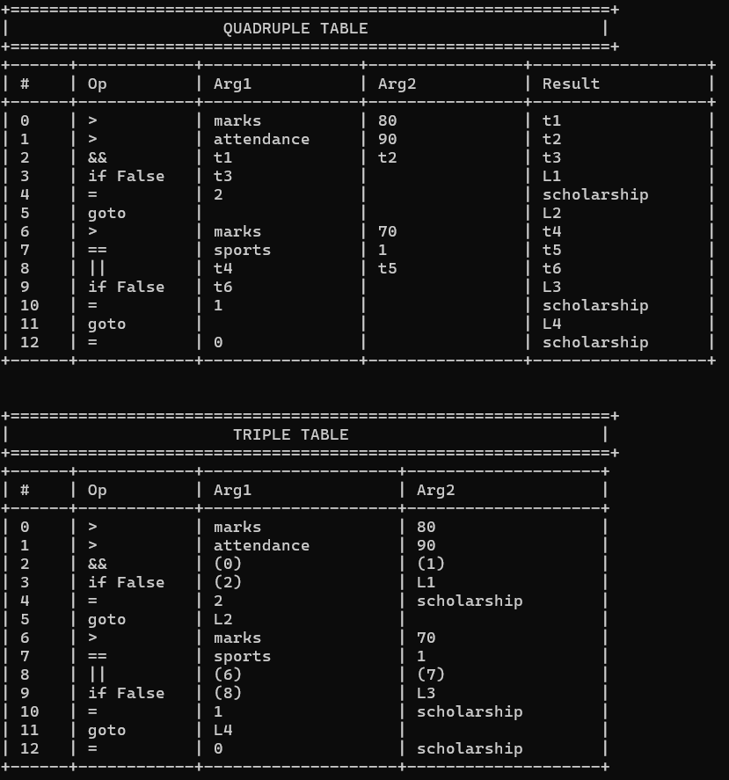

Code 3:
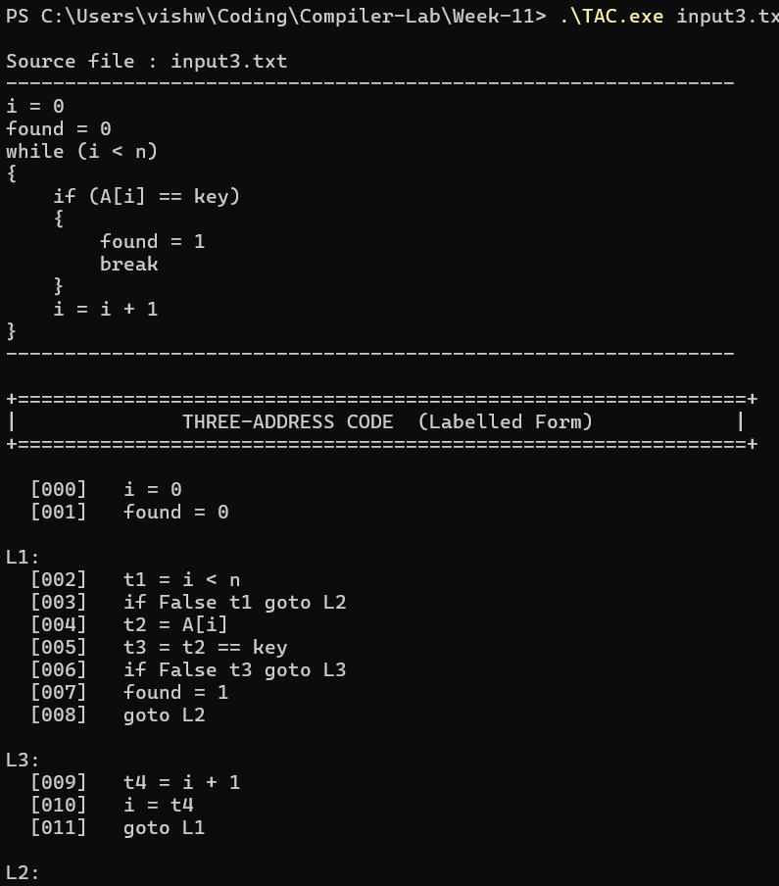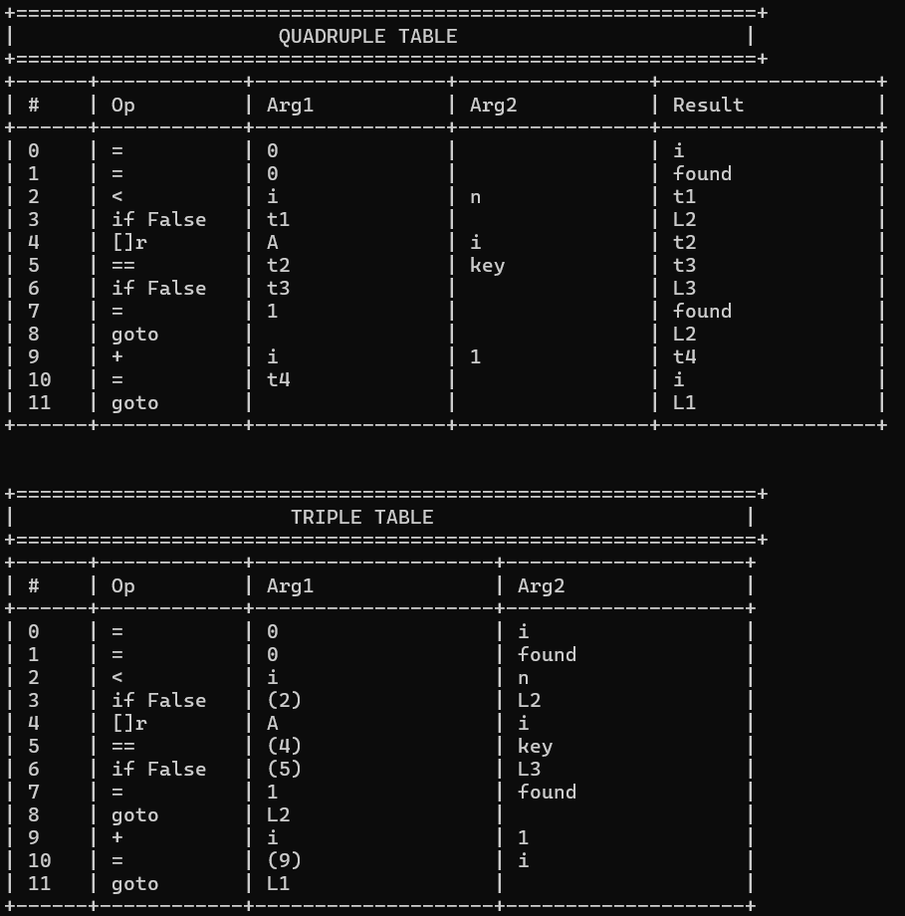

Result:
We have successfully implemented a C++ code to find Three Address Code and it’s data structures (quadruple, triple).

