Compiler Design Lab
Date: 6-3-2026 | Name: S Vishwajith
Assignment No.: 9 | Register No.: 23BCE1145

Aim:
To implement a code to find Three Address code and it’s 3 data structures using C++.

Code:
#include <iostream>
#include <stack>
#include <vector>

using namespace std;
struct token
{
string c;
int type; // 0-id, 1-unary, 2-binary, 3-equals
};
struct statement
{
int temp; // 0-none, 1-arg1, 2-arg2, 3-arg1&&arg2
int eq;
string label;
string res;
string op;
string arg1;
string arg2;
};

vector<token> input;
vector<statement> tac;
int count = 0;
int ifcount = 0;

void to_tac()
{
stack<token> s;
stack<int> ifstack;
string lab = "";
int ind = 0;
for (token t : input)
{
ind++;
if (t.type == 0 && t.c == "if")
{
statement st;
st.op = "if True goto";
st.arg1 = s.top().c;
st.temp = 0;
st.eq = 2;
if (st.arg1[0] == 't' && st.arg1[1] <= '9' && st.arg1[1] >= '0')
st.temp = 1;
st.arg2 = "L" + to_string(ifcount);
lab = "L" + to_string(ifcount++);
st.res = "";
tac.push_back(st);
statement st1;
st1.eq = 3;
st1.temp = 0;
st1.op = "goto";
st1.arg1 = "L";
st1.arg2 = "";
st1.res = "";
tac.push_back(st1);
ifstack.push(tac.size() - 1);
}
else if (t.type == 0 && t.c == "else")
{
statement st1;
st1.eq = 3;
st1.temp = 0;
st1.op = "goto";
st1.arg1 = "L";
st1.arg2 = "";
st1.res = "";
tac.push_back(st1);
lab = "L" + to_string(ifcount);
tac[ifstack.top()].arg1 += to_string(ifcount++);
ifstack.pop();
ifstack.push(tac.size() - 1);
}
else if (t.type == 0 && t.c == "endif")
{
lab = "L" + to_string(ifcount);
if (ind == input.size())
{
statement st;
st.eq = 5;
st.label = "L" + to_string(ifcount);
tac.push_back(st);
while (!s.empty())
{
string lb = tac[ifstack.top()].arg1;
if (lb == "L")
tac[ifstack.top()].arg1 += to_string(ifcount);
s.pop();
}
}
}
else if (t.type == 0)
s.push(t);
else if (t.type == 1)
{
token arg = s.top();
s.pop();
statement st;
st.temp = 0;
st.eq = 0;
st.res = "t" + to_string(::count);
st.op = t.c;
st.arg1 = arg.c;
st.arg2 = "";
if (st.arg1[0] == 't' && st.arg1[1] <= '9' && st.arg1[1] >= '0')
st.temp = 1;
if (lab != "")
{
st.label = lab;
lab = "";
}
tac.push_back(st);
token n;
n.type = 0;
n.c = "t" + to_string(::count++);
s.push(n);
}
else if (t.type == 2)
{
token arg2 = s.top();
s.pop();
token arg1 = s.top();
s.pop();
statement st;
st.temp = 0;
st.eq = 0;
st.res = "t" + to_string(::count);
st.op = t.c;
st.arg1 = arg1.c;
st.arg2 = arg2.c;
if (st.arg1[0] == 't' && st.arg1[1] <= '9' && st.arg1[1] >= '0')
st.temp += 1;
if (st.arg2[0] == 't' && st.arg2[1] <= '9' && st.arg2[1] >= '0')
st.temp += 2;
if (lab != "")
{
st.label = lab;
lab = "";
}
tac.push_back(st);
token n;
n.type = 0;
n.c = "t" + to_string(::count++);
s.push(n);
}
else if (t.type == 3)
{
token arg1 = s.top();
s.pop();
token arg2 = s.top();
s.pop();
statement st;
st.arg1 = arg2.c;
st.op = "=";
st.arg2 = arg1.c;
st.eq = 1;
st.res = "";
if (lab != "")
{
st.label = lab;
lab = "";
}
tac.push_back(st);
}
}
}

int find_temp(string temp)
{
int i = 0;
for (statement s : tac)
{
if (s.res == temp || (s.arg1 == temp && s.eq == 1))
return i;
i++;
}
return -1;
}

void print_tac()
{
cout << endl
<< "Three Address Code: " << endl;
for (statement s : tac)
{
if (s.label == "")
cout << " ";
else
cout << s.label << ": ";
if (s.eq == 1)
cout << s.arg1 << " = " << s.arg2;
else if (s.eq == 2)
cout << "if " << s.arg1 << " True goto " << s.arg2;
else if (s.eq == 3)
cout << "goto " << s.arg1;
else if (s.eq == 5)
cout << " ";
else if (s.arg2 == "")
cout << s.res << " = " << s.op << " " << s.arg1;
else
cout << s.res << " = " << s.arg1 << " " << s.op << " " << s.arg2;
cout << endl;
}
}

void print_quad()
{
cout << "\nQuadruples: \n\n";
cout << "| OP | ARG1 | ARG2 | RES |" << endl;
cout << "-----------------------------------------------" << endl;
for (statement s : tac)
{
if (s.eq == 5)
continue;
string pad;
cout << '|';
string out = s.op;
pad = string(12 - out.size(), ' ');
cout << out << pad << '|';
out = s.arg1;
pad = string(10 - out.size(), ' ');
cout << out << pad << '|';
out = s.arg2;
pad = string(10 - out.size(), ' ');
cout << out << pad << '|';
out = s.res;
pad = string(10 - out.size(), ' ');
cout << out << pad << '|';
cout << endl;
}
}

void print_trip()
{
cout << "\nTriples: \n\n";
cout << "| INDEX | OP | ARG1 | ARG2 |" << endl;
cout << "-------------------------------------------------" << endl;
int i = 0;
for (statement s : tac)
{
if (s.eq == 5)
continue;
string pad;
string out;
cout << '|';
out = to_string(i);
pad = string(12 - out.size(), ' ');
cout << out << pad << '|';
out = s.op;
pad = string(12 - out.size(), ' ');
cout << out << pad << '|';
out = s.arg1;
if (out[0] == 't' && out.size() > 1)
out = '[' + to_string(find_temp(out)) + ']';
pad = string(10 - out.size(), ' ');
cout << out << pad << '|';
out = s.arg2;
if (out[0] == 't' && out.size() > 1)
out = '[' + to_string(find_temp(out)) + ']';
pad = string(10 - out.size(), ' ');
cout << out << pad << '|';
cout << endl;
i++;
}
}

void print_i_trip()
{
cout << "\nIndirect Triples: \n\n";
cout << "| ADDR | INDEX | | INDEX | OP | ARG1 | ARG2 |" << endl;
cout << "----------------------- -------------------------------------------------" << endl;
int i = 0;
int a = 31;
for (statement s : tac)
{
if (s.eq == 5)
continue;
string pad;
string out;
cout << '|';
out = to_string(a);
pad = string(8 - out.size(), ' ');
cout << out << pad << '|';
out = to_string(i);
pad = string(12 - out.size(), ' ');
cout << out << pad << '|';
cout << " |";
out = to_string(i);
pad = string(12 - out.size(), ' ');
cout << out << pad << '|';
out = s.op;
pad = string(12 - out.size(), ' ');
cout << out << pad << '|';
out = s.arg1;
if (out[0] == 't' && out.size() > 1)
out = '[' + to_string(a - i + find_temp(out)) + ']';
pad = string(10 - out.size(), ' ');
cout << out << pad << '|';
out = s.arg2;
if (out[0] == 't' && out.size() > 1)
out = '[' + to_string(a - i + find_temp(out)) + ']';
pad = string(10 - out.size(), ' ');
cout << out << pad << '|';
cout << endl;
i++;
a++;
}
}

int main()
{
string in, var;
int un = 0;
cin >> in;
cout << "INPUT: " << in << endl;
for (char c : in)
{
if (c == ',')
{
if (!var.empty())
{
token n;
n.type = 0;
n.c = var;
input.push_back(n);
var.clear();
}
un = 0;
}
else if (c == 'u')
{
un = 1;
var.push_back(c);
}
else if (c == '-' && un == 1)
{
token n;
n.type = 1;
n.c = '-';
input.push_back(n);
var.clear();
un = 0;
}
else if (c == '=')
{
token n;
n.type = 3;
n.c = '=';
input.push_back(n);
un = 0;
var.clear();
}
else if (('a' <= c && c <= 'z') || ('0' <= c && c <= '9') || ('A' <= c && c <= 'Z'))
{
var.push_back(c);
un = 0;
}
else if (c == '+' || c == '-' || c == '%' || c == '*' || c == '/' || c == '^' || c == '<')
{
token n;
n.type = 2;
n.c = c;
input.push_back(n);
var.clear();
un = 0;
}
}
if (!var.empty())
{
token n;
n.type = 0;
n.c = var;
input.push_back(n);
var.clear();
}

to_tac();
print_tac();
print_quad();
print_trip();
print_i_trip();
}

Inputs and Outputs:
Input 1: p = q * -r + q – r + (t * u + v * w)
Postfix: p,q,r,u-,*,q,+,r,-,t,u,*,v,w,*,+,+,=
Output:
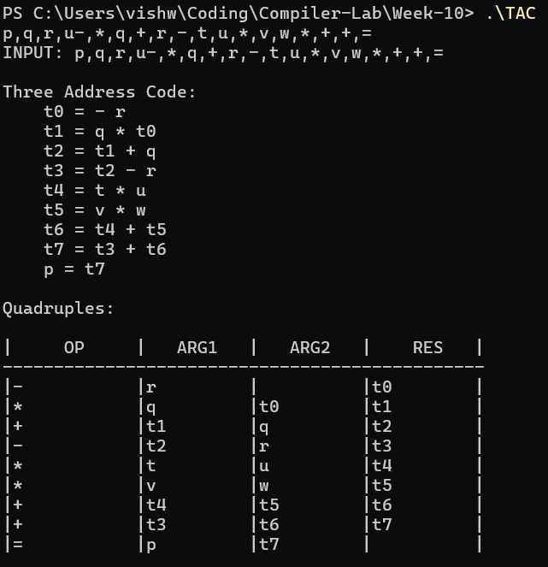
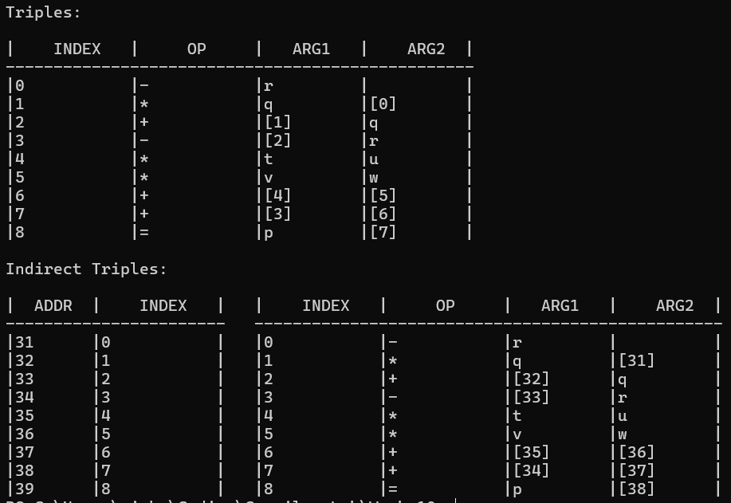
Input 2: x = (m+(n^o) / ((p-q)/(r+(n^o)) % s/t))
Postfix: x,m,n,o,^,p,q,-,r,n,o,^,+,/,s,t,/,%,/,=
Output:
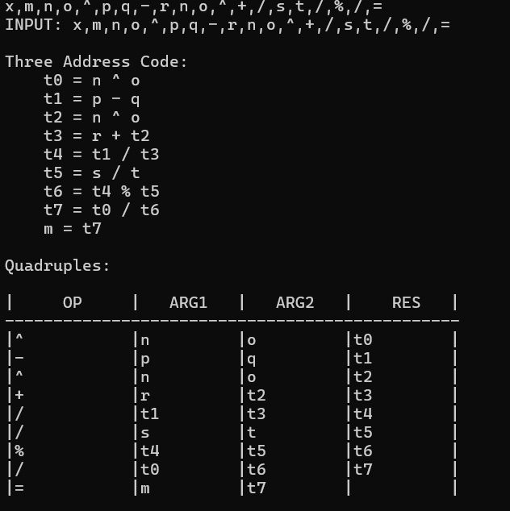
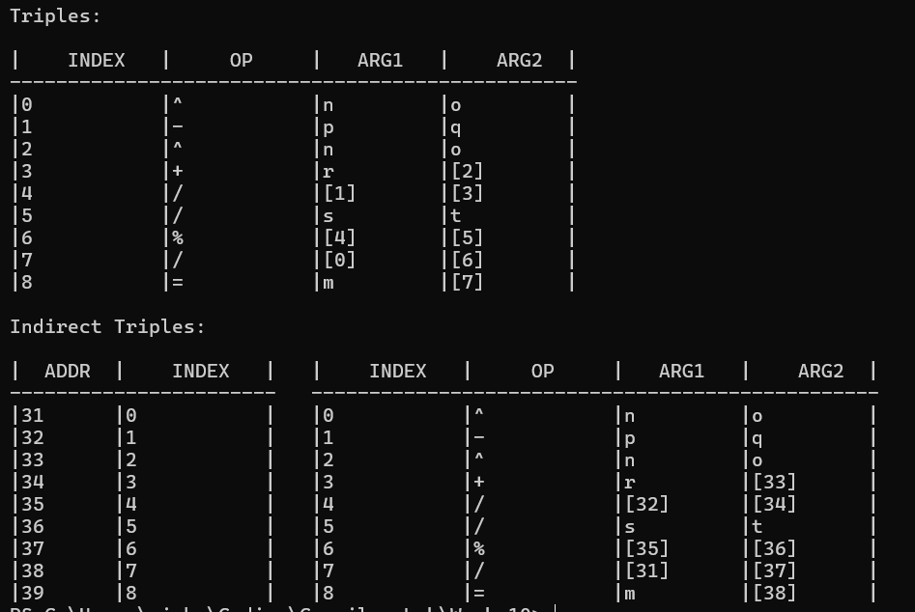
Input 3: if x<y, p=p+1 else q=q+1 endif
Postfix: x,y,<,if,p,p,1,+,=,else,q,q,1,+,=,endif
Output:
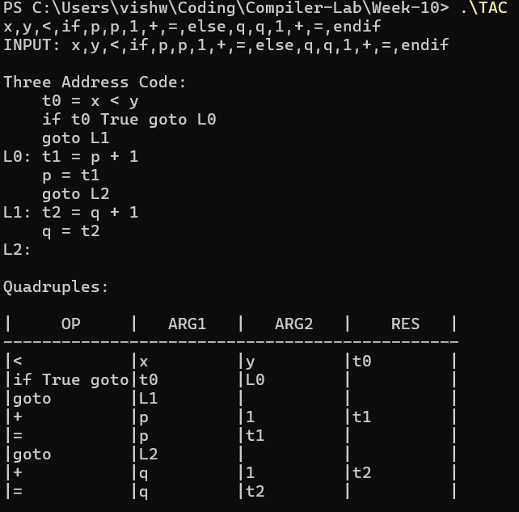
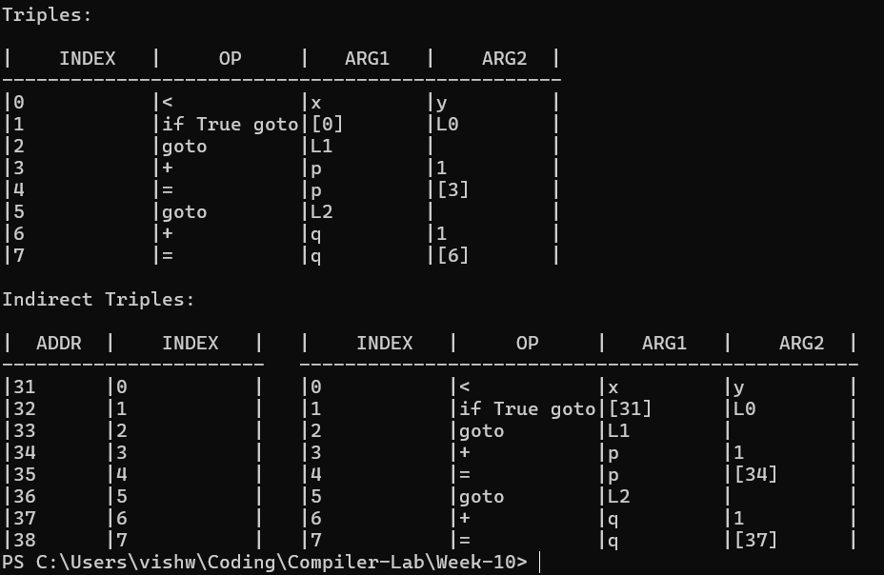

Result:
We have successfully implemented a C++ code to find Three Address Code and it’s 3 data structures (quadruple, triple, indirect triple).

