Compiler Design Lab
Date: 27-2-2026 | Name: S Vishwajith
Assignment No.: 8 | Register No.: 23BCE1145

Aim:
To implement a CLR parser using C++.

Code:
#include <iostream>
#include <vector>
#include <string>
#include <map>
#include <set>
#include <stack>
#include <algorithm>
#include <iomanip>
using namespace std;

vector<pair<string, vector<string>>> G = {
{"S'", {"S"}},
{"S", {"C", "C"}},
{"C", {"c", "C"}},
{"C", {"d"}},
};

const string INPUT = "ccdd";
set<string> NT, TM;
string AUG;

bool isNT(const string &s) { return NT.count(s) > 0; }

void deriveSymbols()
{
AUG = G[0].first;
for (auto &[l, r] : G)
NT.insert(l);
for (auto &[l, r] : G)
for (auto &s : r)
if (!NT.count(s))
TM.insert(s);
TM.insert("$");
}

map<string, set<string>> FIRST;

set<string> firstSeq(const vector<string> &v, int from = 0)
{
set<string> res;
if (from >= (int)v.size())
{
res.insert("eps");
return res;
}
for (int i = from; i < (int)v.size(); i++)
{
const string &s = v[i];
set<string> fi = TM.count(s) ? set<string>{s} : FIRST[s];
bool hasEps = fi.count("eps");
for (auto &x : fi)
if (x != "eps")
res.insert(x);
if (!hasEps)
return res;
}
res.insert("eps");
return res;
}

void computeFirst()
{
for (auto &n : NT)
FIRST[n] = {};
bool changed = true;
while (changed)
{
changed = false;
for (auto &[l, r] : G)
for (auto &x : firstSeq(r))
if (!FIRST[l].count(x))
{
FIRST[l].insert(x);
changed = true;
}
}
}

struct Item
{
int p, d;
string la;
bool operator<(const Item &o) const { return tie(p, d, la) < tie(o.p, o.d, o.la); }
bool operator==(const Item &o) const { return p == o.p && d == o.d && la == o.la; }
};
using ISet = set<Item>;

string itemStr(const Item &it)
{
auto &[lhs, rhs] = G[it.p];
string s = lhs + " ->";
for (int i = 0; i <= (int)rhs.size(); i++)
{
if (i == it.d)
s += " .";
if (i < (int)rhs.size())
s += " " + rhs[i];
}
s += " [" + it.la + "]";
return s;
}

ISet closure1(ISet s)
{
vector<Item> wl(s.begin(), s.end());
while (!wl.empty())
{
Item it = wl.back();
wl.pop_back();
auto &rhs = G[it.p].second;
if (it.d >= (int)rhs.size())
continue;
const string &B = rhs[it.d];
if (!isNT(B))
continue;
vector<string> beta(rhs.begin() + it.d + 1, rhs.end());
beta.push_back(it.la);
for (auto &b : firstSeq(beta))
{
if (b == "eps")
continue;
for (int i = 0; i < (int)G.size(); i++)
{
if (G[i].first != B)
continue;
Item ni{i, 0, b};
if (!s.count(ni))
{
s.insert(ni);
wl.push_back(ni);
}
}
}
}
return s;
}

ISet gotoSt(const ISet &s, const string &sym)
{
ISet kernel;
for (auto &it : s)
{
auto &rhs = G[it.p].second;
if (it.d < (int)rhs.size() && rhs[it.d] == sym)
kernel.insert({it.p, it.d + 1, it.la});
}
return kernel.empty() ? kernel : closure1(kernel);
}

vector<ISet> STATES;
map<pair<int, string>, int> TRANS;

void buildCollection()
{
STATES.push_back(closure1({{0, 0, "$"}}));
bool changed = true;
while (changed)
{
changed = false;
int n = (int)STATES.size();
for (int i = 0; i < n; i++)
{
set<string> syms;
for (auto &it : STATES[i])
{
auto &rhs = G[it.p].second;
if (it.d < (int)rhs.size())
syms.insert(rhs[it.d]);
}
for (auto &sym : syms)
{
ISet g = gotoSt(STATES[i], sym);
if (g.empty())
continue;
int idx = -1;
for (int j = 0; j < (int)STATES.size(); j++)
if (STATES[j] == g)
{
idx = j;
break;
}
if (idx == -1)
{
idx = (int)STATES.size();
STATES.push_back(g);
changed = true;
}
TRANS[{i, sym}] = idx;
}
}
}
}

map<int, map<string, string>> ACT;
map<int, map<string, int>> GOT;
vector<string> conflicts;

void buildTables()
{
for (int i = 0; i < (int)STATES.size(); i++)
{
for (auto &it : STATES[i])
{
auto &[lhs, rhs] = G[it.p];
if (it.d < (int)rhs.size())
{
const string &sym = rhs[it.d];
if (TM.count(sym) && sym != "$")
{
if (TRANS.count({i, sym}))
{
string act = "s" + to_string(TRANS[{i, sym}]);
if (ACT[i].count(sym) && ACT[i][sym] != act)
conflicts.push_back("State " + to_string(i) + " on '" + sym +
"': " + ACT[i][sym] + " vs " + act);
ACT[i][sym] = act;
}
}
else if (isNT(sym))
{
if (TRANS.count({i, sym}))
GOT[i][sym] = TRANS[{i, sym}];
}
}
else
{
if (lhs == AUG && it.la == "$")
{
ACT[i]["$"] = "acc";
}
else
{
string act = "r" + to_string(it.p);
if (ACT[i].count(it.la) && ACT[i][it.la] != act)
conflicts.push_back("State " + to_string(i) + " on '" + it.la +
"': " + ACT[i][it.la] + " vs " + act);
ACT[i][it.la] = act;
}
}
}
}
}

vector<int> colWidths(const vector<string> &hdr, const vector<vector<string>> &rows)
{
vector<int> w(hdr.size(), 0);
for (int i = 0; i < (int)hdr.size(); i++)
w[i] = (int)hdr[i].size();
for (auto &r : rows)
for (int i = 0; i < (int)r.size() && i < (int)w.size(); i++)
w[i] = max(w[i], (int)r[i].size());
return w;
}

void hline(const vector<int> &w, char fc = '-')
{
cout << "+";
for (auto x : w)
cout << string(x + 2, fc) << "+";
cout << "\n";
}

void printRow(const vector<int> &w, const vector<string> &cells)
{
cout << "|";
for (int i = 0; i < (int)cells.size(); i++)
{
string c = i < (int)cells.size() ? cells[i] : "";
cout << " " << left << setw(w[i]) << c << " |";
}
cout << "\n";
}

void printTable(const vector<string> &hdr, const vector<vector<string>> &rows)
{
auto w = colWidths(hdr, rows);
hline(w, '=');
printRow(w, hdr);
hline(w, '=');
for (auto &r : rows)
{
printRow(w, r);
hline(w, '-');
}
}

void sectionBanner(const string &title)
{
int n = (int)title.size() + 4;
cout << "\n"
<< string(n, '=') << "\n";
cout << "| " << title << " |\n";
cout << string(n, '=') << "\n\n";
}

void printGrammar()
{
sectionBanner("GRAMMAR (Augmented)");
for (int i = 0; i < (int)G.size(); i++)
{
cout << " (" << i << ") " << G[i].first << " -> ";
if (G[i].second.empty())
cout << "eps";
else
for (auto &s : G[i].second)
cout << s << " ";
cout << "\n";
}
}

void printFirstSets()
{
sectionBanner("FIRST SETS");
vector<string> ntVec;
for (auto &n : NT)
if (n != AUG)
ntVec.push_back(n);
sort(ntVec.begin(), ntVec.end());
for (auto &n : ntVec)
{
cout << " FIRST( " << n << " ) = { ";
bool first = true;
for (auto &x : FIRST[n])
{
if (!first)
cout << ", ";
cout << x;
first = false;
}
cout << " }\n";
}
}

void printStates()
{
sectionBanner("CANONICAL LR(1) ITEM SETS");
for (int i = 0; i < (int)STATES.size(); i++)
{
string hdr = " State I" + to_string(i) + " ";
cout << "\n"
<< hdr << string(max(0, 44 - (int)hdr.size()), '-') << "\n";
for (auto &it : STATES[i])
cout << " " << itemStr(it) << "\n";
bool any = false;
for (auto &[key, val] : TRANS)
if (key.first == i)
{
any = true;
break;
}
if (any)
{
cout << " " << string(36, '-') << "\n";
for (auto &[key, val] : TRANS)
if (key.first == i)
cout << " goto( " << key.second << " ) => I" << val << "\n";
}
}
}

void printParsingTable()
{
sectionBanner("CLR(1) PARSING TABLE");

vector<string> termCols, ntCols;
for (auto &t : TM)
if (t != "$")
termCols.push_back(t);
sort(termCols.begin(), termCols.end());
termCols.push_back("$");

for (auto &n : NT)
if (n != AUG)
ntCols.push_back(n);
sort(ntCols.begin(), ntCols.end());

vector<string> hdr = {"State"};
for (auto &t : termCols)
hdr.push_back(t);
for (auto &n : ntCols)
hdr.push_back(n);

vector<vector<string>> rows;
for (int i = 0; i < (int)STATES.size(); i++)
{
vector<string> row = {to_string(i)};
for (auto &t : termCols)
row.push_back(ACT[i].count(t) ? ACT[i][t] : "-");
for (auto &n : ntCols)
row.push_back(GOT[i].count(n) ? to_string(GOT[i][n]) : "-");
rows.push_back(row);
}

auto w = colWidths(hdr, rows);

int stateW = w[0];
int actionW = 0;
for (int i = 0; i < (int)termCols.size(); i++)
actionW += w[1 + i] + 3;
actionW -= 1;
int gotoW = 0;
for (int i = 0; i < (int)ntCols.size(); i++)
gotoW += w[1 + (int)termCols.size() + i] + 3;
gotoW -= 1;

cout << "+" << string(stateW + 2, '-')
<< "+" << string(actionW + 2, '-')
<< "+" << string(gotoW + 2, '-') << "+\n";
cout << "| " << left << setw(stateW) << "State"
<< " | " << left << setw(actionW) << "ACTION"
<< " | " << left << setw(gotoW) << "GOTO" << " |\n";

hline(w, '=');
printRow(w, hdr);
hline(w, '=');
for (auto &r : rows)
{
printRow(w, r);
hline(w, '-');
}

cout << "\n Legend:\n";
cout << " sN = shift to state N\n";
cout << " rN = reduce by production (N)\n";
cout << " acc = accept\n";
cout << " - = error / no entry\n";
cout << "\n Productions used in reduce actions:\n";
for (int i = 0; i < (int)G.size(); i++)
{
cout << " (" << i << ") " << G[i].first << " -> ";
if (G[i].second.empty())
cout << "eps";
else
for (auto &s : G[i].second)
cout << s << " ";
cout << "\n";
}
if (!conflicts.empty())
{
cout << "\n [!] CONFLICTS (grammar may not be CLR(1)):\n";
for (auto &c : conflicts)
cout << " " << c << "\n";
}
}

void parseInput()
{
sectionBanner("PARSING INPUT: \"" + INPUT + "\"");

string inp = INPUT + "$";
int ip = 0;

stack<int> stateStk;
stack<string> symStk;
stateStk.push(0);

auto stackStr = [&]() -> string
{
vector<int> v;
stack<int> tmp = stateStk;
while (!tmp.empty())
{
v.push_back(tmp.top());
tmp.pop();
}
reverse(v.begin(), v.end());
string s;
for (auto x : v)
s += to_string(x) + " ";
return s;
};

auto symStr = [&]() -> string
{
vector<string> v;
stack<string> tmp = symStk;
while (!tmp.empty())
{
v.push_back(tmp.top());
tmp.pop();
}
reverse(v.begin(), v.end());
string s = "$";
for (auto &x : v)
s += x;
return s;
};

vector<string> hdr = {"Step", "State Stack", "Symbol Stack", "Input", "Action"};
vector<vector<string>> rows;

int step = 0;
bool accepted = false;
bool errored = false;

while (true)
{
step++;
int state = stateStk.top();
string tok(1, inp[ip]);

if (!ACT[state].count(tok))
{
rows.push_back({to_string(step), stackStr(), symStr(), inp.substr(ip), "ERROR"});
errored = true;
break;
}

string act = ACT[state][tok];

if (act == "acc")
{
rows.push_back({to_string(step), stackStr(), symStr(), inp.substr(ip), "ACCEPT"});
accepted = true;
break;
}

if (act[0] == 's')
{
int ns = stoi(act.substr(1));
string desc = "Shift '" + tok + "' -> push s" + to_string(ns);
rows.push_back({to_string(step), stackStr(), symStr(), inp.substr(ip), desc});
stateStk.push(ns);
symStk.push(tok);
ip++;
}
else
{
int pid = stoi(act.substr(1));
auto &[lhs, rhs] = G[pid];
string prodStr = lhs + " ->";
for (auto &s : rhs)
prodStr += " " + s;
string desc = "Reduce by (" + to_string(pid) + ") " + prodStr;
rows.push_back({to_string(step), stackStr(), symStr(), inp.substr(ip), desc});
for (int i = 0; i < (int)rhs.size(); i++)
{
stateStk.pop();
symStk.pop();
}
int top = stateStk.top();
if (!GOT[top].count(lhs))
{
rows.push_back({to_string(step + 1), stackStr(), symStr(), inp.substr(ip), "GOTO ERROR"});
errored = true;
break;
}
stateStk.push(GOT[top][lhs]);
symStk.push(lhs);
}
}

printTable(hdr, rows);

cout << "\n";
if (accepted)
cout << " >> RESULT: \"" << INPUT << "\" is ACCEPTED by the grammar.\n\n";
else
cout << " >> RESULT: \"" << INPUT << "\" is REJECTED (syntax error at step "
<< step << ").\n\n";
}

int main()
{
deriveSymbols();
computeFirst();
buildCollection();
buildTables();

printGrammar();
printFirstSets();
printStates();
printParsingTable();
parseInput();

return 0;
}

Input and Output:
Input Grammar: (NT = {c , d}, T = {S, C }, P={ S -> CC, C -> cC, C -> d}, S = {S})
Input String: ccdd
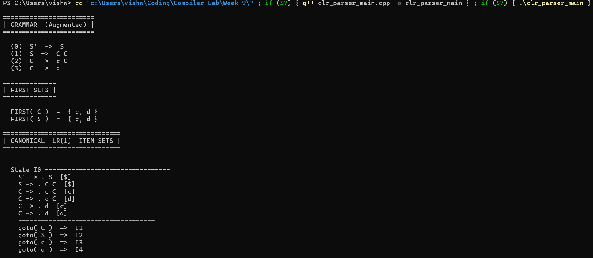
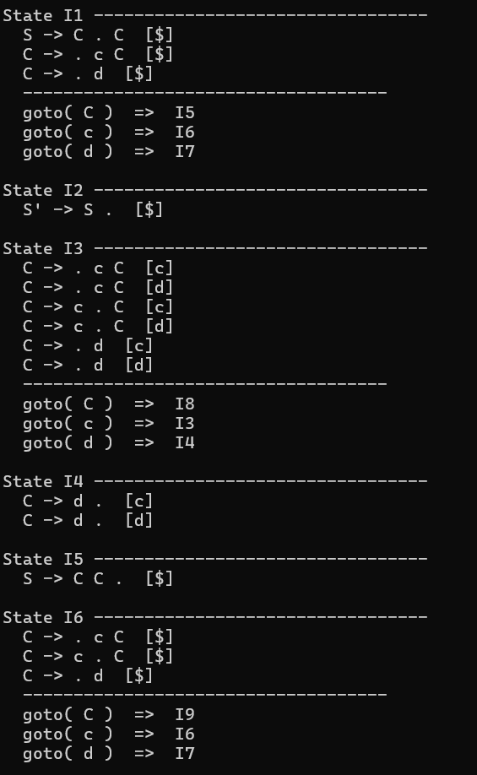
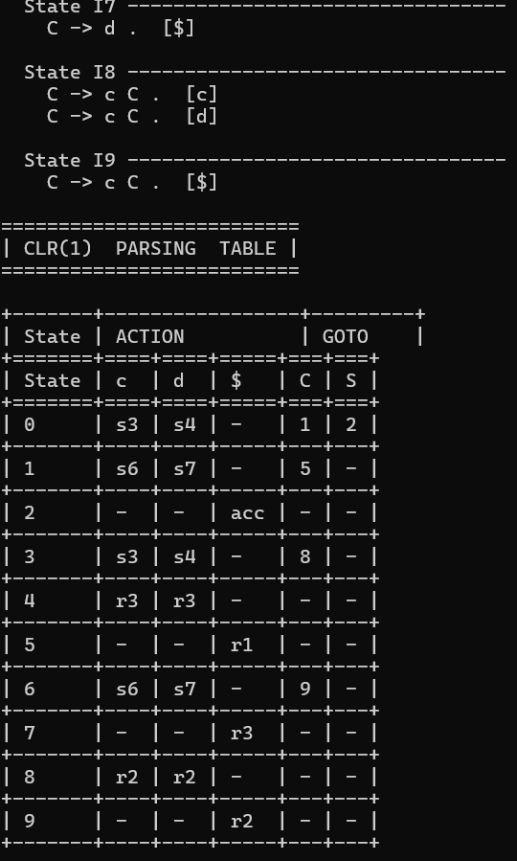
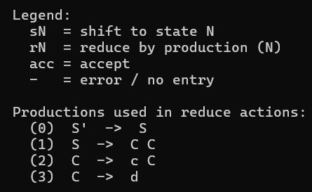
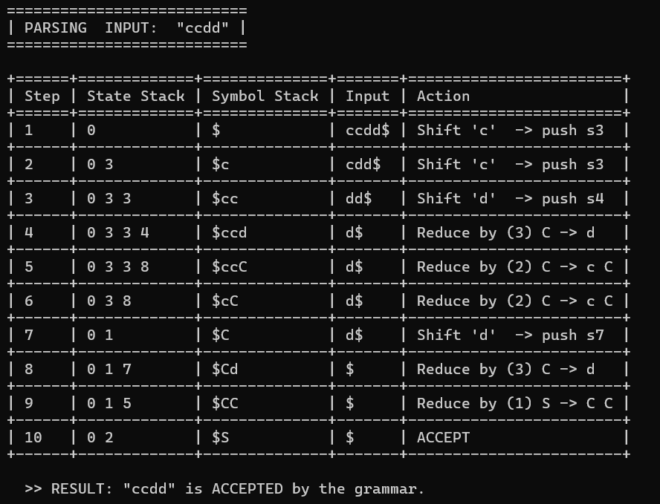

Result:
The CLR parser has been successfully written in C++ and executes as expected.

