Lab Assignment
Name | S Vishwajith
Registration Number | 23BCE1145
Subject | Compiler Design
Assignment Number | 1

Aim:
To write a C++ program LA.cpp that acts as a lexical analyser to read a C++ source file Factorial.cpp containing a factorial program. The program should identify tokens such as keywords, identifiers, operators, constants, and symbols. It should then print each token with its type and value.

Algorithm:
- Open the source file Factorial.cpp in read mode.
- Repeat until End of File (EOF) is reached:
  - Read each word (separated with a blank space) from the file.
  - If the word has a special symbol, split it into 3 (before, special symbol, and after) and print each part as a token.
  - Check if the word is a keyword, operator or a special symbol and print accordingly.
  - If it’s none of them, then the word is an identifier and print it accordingly.
- Close the file after reading.

Codes:

Factorial.cpp:
#include <iostream>
using namespace std;
int factorial(int n)
{
if (n <= 1)
return 1;
return n * factorial(n - 1);
}
int main()
{
int n;
cin >> n;
cout << factorial(n) << endl;
return 0;
}

LA.cpp:
#include <fstream>
#include <iostream>
#include <string>
#include <sstream>
#include <algorithm>
#include <vector>
using namespace std;
vector<string> keywords = {"include", "using", "namespace", "int", "if", "return"};
vector<string> operators = {"<", ">", "=", "-", ">>", "<<"};
vector<string> special_symbols = {"(", ")", ";", "{", "}", "#"};
bool hasPunctuator(string word)
{
for (const auto &spec : special_symbols)
{
if (word.find(spec) != string::npos)
{
return true;
}
}
return false;
}
void printToken(string word)
{
if (word.length() > 1 && hasPunctuator(word))
{
for (const auto &spec : special_symbols)
{
size_t pos;
while ((pos = word.find(spec)) != string::npos)
{
string beforePunct = word.substr(0, pos);
if (!beforePunct.empty())
{
printToken(beforePunct);
}
cout << "Type: SPECIAL SYMBOL, Value: " << spec << endl;
word = word.substr(pos + spec.length());
}
}
if (!word.empty())
{
printToken(word);
}
return;
}
if (word.find("<") != string::npos && word.find(">") != string::npos && word.length() > 1)
{
cout << "Type: OPERATOR, Value: <" << endl;
word.erase(remove(word.begin(), word.end(), '<'), word.end());
word.erase(remove(word.begin(), word.end(), '>'), word.end());
printToken(word);
cout << "Type: OPERATOR, Value: >" << endl;
return;
}
auto itk = find(keywords.begin(), keywords.end(), word);
auto ito = find(operators.begin(), operators.end(), word);
auto itp = find(special_symbols.begin(), special_symbols.end(), word);
if (itk != keywords.end())
{
cout << "Type: KEYWORD, Value: " << word << endl;
}
else if (ito != operators.end())
{
cout << "Type: OPERATOR, Value: " << word << endl;
}
else if (itp != special_symbols.end())
{
cout << "Type: PUNCTUATOR, Value: " << word << endl;
}
else
{
cout << "Type: IDENTIFIER, Value: " << word << endl;
}
}
int main()
{
ifstream inputFile("Factorial.cpp");
if (!inputFile.is_open())
{
cerr << "Error: Could not open the file 'Factorial.cpp'" << endl;
return 1;
}
string word;
while (inputFile >> word)
{
printToken(word);
}
inputFile.close();
return 0;
}

Output:
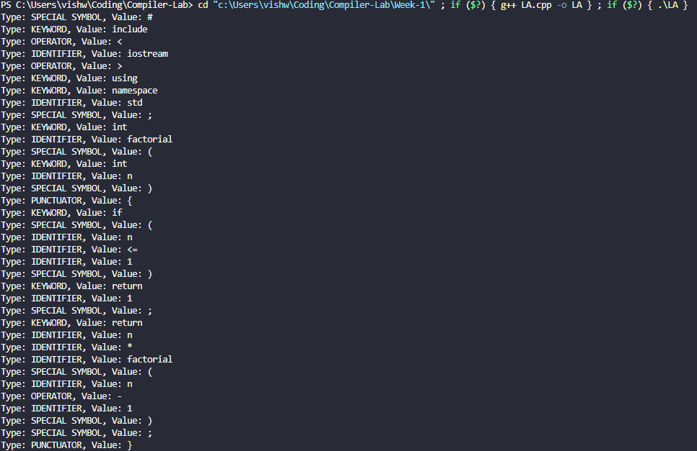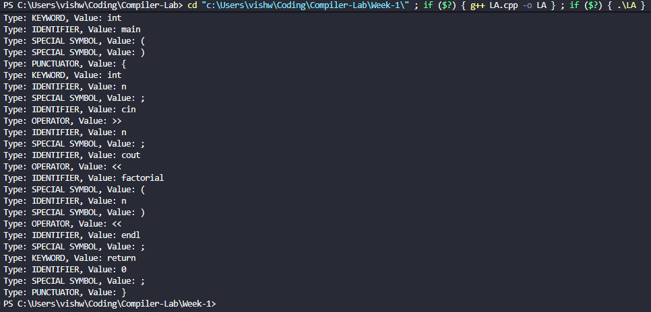
Type: SPECIAL SYMBOL, Value: #
Type: KEYWORD, Value: include
Type: OPERATOR, Value: <
Type: IDENTIFIER, Value: iostream
Type: OPERATOR, Value: >
Type: KEYWORD, Value: using
Type: KEYWORD, Value: namespace
Type: IDENTIFIER, Value: std
Type: SPECIAL SYMBOL, Value: ;
Type: KEYWORD, Value: int
Type: IDENTIFIER, Value: factorial
Type: SPECIAL SYMBOL, Value: (
Type: KEYWORD, Value: int
Type: IDENTIFIER, Value: n
Type: SPECIAL SYMBOL, Value: )
Type: PUNCTUATOR, Value: {
Type: KEYWORD, Value: if
Type: SPECIAL SYMBOL, Value: (
Type: IDENTIFIER, Value: n
Type: IDENTIFIER, Value: <=
Type: IDENTIFIER, Value: 1
Type: SPECIAL SYMBOL, Value: )
Type: KEYWORD, Value: return
Type: IDENTIFIER, Value: 1
Type: SPECIAL SYMBOL, Value: ;
Type: KEYWORD, Value: return
Type: IDENTIFIER, Value: n
Type: IDENTIFIER, Value: *
Type: IDENTIFIER, Value: factorial
Type: SPECIAL SYMBOL, Value: (
Type: IDENTIFIER, Value: n
Type: OPERATOR, Value: -
Type: IDENTIFIER, Value: 1
Type: SPECIAL SYMBOL, Value: )
Type: SPECIAL SYMBOL, Value: ;
Type: PUNCTUATOR, Value: }
Type: KEYWORD, Value: int
Type: IDENTIFIER, Value: main
Type: SPECIAL SYMBOL, Value: (
Type: SPECIAL SYMBOL, Value: )
Type: PUNCTUATOR, Value: {
Type: KEYWORD, Value: int
Type: IDENTIFIER, Value: n
Type: SPECIAL SYMBOL, Value: ;
Type: IDENTIFIER, Value: cin
Type: OPERATOR, Value: >>
Type: IDENTIFIER, Value: n
Type: SPECIAL SYMBOL, Value: ;
Type: IDENTIFIER, Value: cout
Type: OPERATOR, Value: <<
Type: IDENTIFIER, Value: factorial
Type: SPECIAL SYMBOL, Value: (
Type: IDENTIFIER, Value: n
Type: SPECIAL SYMBOL, Value: )
Type: OPERATOR, Value: <<
Type: IDENTIFIER, Value: endl
Type: SPECIAL SYMBOL, Value: ;
Type: KEYWORD, Value: return
Type: IDENTIFIER, Value: 0
Type: SPECIAL SYMBOL, Value: ;
Type: PUNCTUATOR, Value: }

Result:
The C++ program to perform lexical analysis of a factorial program was successfully run and the results were verified.

