Compiler Design Lab
Date: 13-2-2026 | Name: S Vishwajith
Assignment No.: 7 | Register No.: 23BCE1145

Aim:
To implement the SLR parser using C++.

Code:
#include <iostream>
#include <iomanip>
#include <vector>
#include <set>
#include <map>
using namespace std;

struct prod
{
int lhsIdx;
vector<pair<int, int>> rhsIdx; // nt/t, nt/tIdx - char
};
struct stackItem
{
int type; // 0-state, 1-NT, 2-T
int state;
int ntIdx;
int tIdx;
};

char startSym;
int startSymIdx;
set<char> terms, nterms;
vector<prod> prods;
vector<pair<int, int>> litems; // prodIdx, .pos - lr0 item
vector<vector<int>> lstates; // stateNo - vector(litemsIdx)
vector<vector<int>> closures; // ntIdx - vector(litemsIdx)
vector<int> cproc;
vector<int> fiproc, foproc;
vector<set<char>> first, follow; // ntIdx - set(first) and set(follow)
map<pair<int, pair<int, int>>, int> gotos; // stateNo, (nt/t nt/tIdx) -> stateNo
vector<vector<string>> table; // stateNo, t-ntIdx - Action
string input;
vector<stackItem> stack;

int findState(vector<int> v)
{
set<int> state(v.begin(), v.end());
for (int i = 0; i < lstates.size(); i++)
{
set<int> cstate(lstates[i].begin(), lstates[i].end());
if (state == cstate)
return i;
}
return -1;
}

int findLitem(pair<int, int> litem, vector<pair<int, int>> lritems)
{
for (int i = 0; i < lritems.size(); i++)
{
if (litem == lritems[i])
return i;
}
return -1;
}

int findInt(int i, vector<int> v)
{
for (int j = 0; j < v.size(); j++)
{
if (i == v[j])
return j;
}
return -1;
}

set<char> fillFirst(char t)
{
int ntIdx = distance(nterms.begin(), nterms.find(t));
if (fiproc[ntIdx])
return first[ntIdx];
fiproc[ntIdx] = 1;
for (prod p : prods)
{
if (p.lhsIdx == ntIdx)
{
int fnt = p.rhsIdx[0].first;
int fIdx = p.rhsIdx[0].second;
if (fnt)
first[ntIdx].insert(*next(terms.begin(), fIdx));
else
{
char tgt = *next(nterms.begin(), fIdx);
for (char c : fillFirst(tgt))
first[ntIdx].insert(c);
}
}
}
return first[ntIdx];
}

set<char> fillFollow(char t)
{
int ntIdx = distance(nterms.begin(), nterms.find(t));
if (foproc[ntIdx])
return follow[ntIdx];
foproc[ntIdx] = 1;
for (prod p : prods)
{
for (int i = 0; i < p.rhsIdx.size(); i++)
{
int fnt = p.rhsIdx[i].first;
int fntIdx = p.rhsIdx[i].second;
if (fnt == 0 && fntIdx == ntIdx)
{
if (i == p.rhsIdx.size() - 1)
{
char tgt = *next(nterms.begin(), p.lhsIdx);
for (char c : fillFollow(tgt))
follow[ntIdx].insert(c);
}
else
{
int fn = p.rhsIdx[i + 1].first;
int fnIdx = p.rhsIdx[i + 1].second;
if (fn)
follow[ntIdx].insert(*next(terms.begin(), fnIdx));
else
{
char tgt = *next(nterms.begin(), fnIdx);
for (char c : fillFirst(tgt))
follow[ntIdx].insert(c);
}
}
}
}
}

return follow[ntIdx];
}

vector<int> findClosure(int nt)
{
if (cproc[nt])
return closures[nt];
cproc[nt] = 1;
vector<int> litems;
for (int i = 0; i < prods.size(); i++)
{
if (prods[i].lhsIdx == nt)
{
litems.push_back(findLitem(pair<int, int>(i, 0), ::litems));
if (prods[i].rhsIdx[0].first == 0 &&
prods[i].rhsIdx[0].second != nt)
{
vector<int> vc = findClosure(prods[i].rhsIdx[0].second);
for (int i : vc)
{
if (findInt(i, litems) == -1)
litems.push_back(i);
}
}
}
}
closures[nt] = litems;
return litems;
}

void constructClosures()
{
for (int i = 0; i < prods.size(); i++)
litems.push_back(pair<int, int>(i, 0));
cproc = vector<int>(nterms.size(), 0);
closures = vector<vector<int>>(nterms.size());
for (int i = 0; i < nterms.size(); i++)
findClosure(i);
}

void printProd(prod pro, int i)
{
char l = *next(nterms.begin(), pro.lhsIdx);
if (l == 'Z')
cout << startSym << "'" << "->";
else
cout << l << "->";
int x = 0;
for (pair<int, int> ridx : pro.rhsIdx)
{
char c;
if (ridx.first == 0)
c = *next(nterms.begin(), ridx.second);
else
c = *next(terms.begin(), ridx.second);
if (x++ == i)
cout << ".";
cout << c;
}

if (i == pro.rhsIdx.size())
cout << ".";
cout << endl;
}

void findGoto(int lstateNo, char c)
{

int nt = 1;
if (nterms.count(c))
nt = 0;
int ntIdx;
if (nt == 0)
ntIdx = distance(nterms.begin(), nterms.find(c));
else
ntIdx = distance(terms.begin(), terms.find(c));
vector<int> lritems;
int found = 0;
for (int x : lstates[lstateNo])
{
pair<int, int> p = litems[x];
prod pr = prods[p.first];
int pos = p.second;
if (pr.rhsIdx.size() > pos)
{
if (pair<int, int>(nt, ntIdx) == pr.rhsIdx[pos])
{
found = 1;
pair<int, int> newitem(p.first, pos + 1);
int newIdx = findLitem(newitem, litems);
if (newIdx == -1)
{
litems.push_back(newitem);
lritems.push_back(litems.size() - 1);
}
else
lritems.push_back(newIdx);
if (pos + 1 < pr.rhsIdx.size())
{
pair<int, int> clositem = pr.rhsIdx[pos + 1];
if (clositem.first == 0)
{
vector<int> itemclos = closures[clositem.second];
for (int i : itemclos)
{
if (findInt(i, lritems) == -1)
lritems.push_back(i);
}
}
}
}
}
}
pair<int, int> nti(nt, ntIdx);
pair<int, pair<int, int>> gt(lstateNo, nti);
int gtstatenum = -1;
if (!found)
{
pair<pair<int, pair<int, int>>, int> val(gt, gtstatenum);
gotos.insert(val);
}
else if (findState(lritems) == -1)
{
lstates.push_back(lritems);
gtstatenum = lstates.size() - 1;
}
else
gtstatenum = findState(lritems);
pair<pair<int, pair<int, int>>, int> val(gt, gtstatenum);
gotos.insert(val);
}

void printGotos()
{
int x = 0;
int s = nterms.size() + terms.size() - 1;
for (pair<pair<int, pair<int, int>>, int> p : gotos)
{
int nt = p.first.second.first;
int ntIdx = p.first.second.second;
char ntc;
if (nt)
ntc = *next(terms.begin(), ntIdx);
else
ntc = *next(nterms.begin(), ntIdx);
int gst = p.second;
if (gst != -1)
cout << "goto(" << p.first.first << "," << ntc << "): " << gst << " | ";
else
cout << "goto(" << p.first.first << "," << ntc << "): - | ";
x = (x + 1) % s;
if (x == 0)
cout << endl;
}
}

void printClosures()
{
for (int i = 0; i < closures.size(); i++)
{
cout << *next(nterms.begin(), i) << ": " << endl;
for (int p : closures[i])
{
pair<int, int> pr = *next(litems.begin(), p);
prod pro = prods[pr.first];
printProd(pro, pr.second);
}
cout << endl;
}
}

void printStates()
{
for (int j = 0; j < lstates.size(); j++)
{
cout << "I" << j << endl;
for (int p : lstates[j])
{
pair<int, int> pr = *next(litems.begin(), p);
prod pro = prods[pr.first];
printProd(pro, pr.second);
}
cout << endl;
}
}

void printFollows()
{
for (int i = 0; i < follow.size(); i++)
{
char c = *next(nterms.begin(), i);
cout << c << ": {";
for (char x : follow[i])
cout << x << " ";
cout << "}" << endl;
}
cout << endl;
}

void fillTable()
{
for (pair<pair<int, pair<int, int>>, int> p : gotos)
{
int gst = p.second;
int sn = p.first.first;
int nt = p.first.second.first;
int ntIdx = p.first.second.second;
if (gst == -1)
continue;
if (nt)
table[sn][ntIdx] = "s" + to_string(gst);
else if (startSymIdx != ntIdx)
table[sn][ntIdx + terms.size()] = to_string(gst);
}
for (int i = 0; i < lstates.size(); i++)
{
for (int lritem : lstates[i])
{
int pos = litems[lritem].second;
int prodIdx = litems[lritem].first;
if (pos == prods[prodIdx].rhsIdx.size())
{
for (char c : terms)
{
int cIdx = distance(terms.begin(), terms.find(c));
if (follow[prods[prodIdx].lhsIdx].count(c))
{
string fstring;
if (prodIdx == 0)
fstring = "ACC";
else
fstring = "r" + to_string(prodIdx);
if (table[i][cIdx] == "-")
table[i][cIdx] = fstring;
}
}
}
}
}
}

void printTable()
{
cout << "SLR Parsing Table: " << endl;
int nnt = nterms.size() - 1;
int ntt = terms.size();
cout << setw(5) << "STATE"
<< setw(4) << "|"
<< setw(ntt * 5) << "ACTION"
<< setw(ntt * 5) << "|"
<< setw(nnt * 2) << "GOTO"
<< setw(nnt * 2) << "|" << endl;
cout << setw(5) << "-"
<< setw(4) << "|";
for (char c : terms)
cout << setw(5) << c << setw(5) << "|";
for (char c : nterms)
{
if (c != 'Z')
cout << setw(2) << c << setw(2) << "|";
}
cout << endl;
for (int i = 0; i < table.size(); i++)
{
cout << setw(5) << i << setw(4) << "|";
int j = 0;
for (; j < terms.size(); j++)
cout << setw(5) << table[i][j] << setw(5) << "|";
for (; j < table[i].size() - 1; j++)
cout << setw(2) << table[i][j] << setw(2) << "|";
cout << endl;
}
}

void printStack()
{
string out;
for (stackItem s : stack)
{
if (s.type == 0)
out += to_string(s.state);
else if (s.type == 1)
out += *next(nterms.begin(), s.ntIdx);
else if (s.type == 2)
out += *next(terms.begin(), s.tIdx);
}
cout << setw(10) << out << setw(10) << "|";
}

void parse(string in)
{
in = in + '$';
int i = 0;
int j = 0;
int acc = 0;
stackItem init;
init.type = 0;
init.state = 0;
stack.push_back(init);
cout << setw(10) << "STACK"
<< setw(10) << "|"
<< setw(10) << "INPUT"
<< setw(10) << "|"
<< setw(20) << "ACTION"
<< setw(20) << "|" << endl;
while (i < in.size() && acc == 0)
{
printStack();
cout << setw(10) << in.substr(i) << setw(10) << "|";
int tIdx = distance(terms.begin(), terms.find(in[i]));
string a = table[stack[j].state][tIdx];
if (a[0] == 's')
{
j += 2;
stackItem newItem;
newItem.type = 2;
newItem.tIdx = distance(terms.begin(), terms.find(in[i++]));
stack.push_back(newItem);
newItem.type = 0;
newItem.state = stoi(a.substr(1));
newItem.tIdx = -1;
stack.push_back(newItem);
cout << setw(20) << "SHIFT " + to_string(newItem.state)
<< setw(20) << "|" << endl;
}
else if (a[0] == 'A')
{
cout << setw(20) << "ACCEPT"
<< setw(20) << "|" << endl;
exit(0);
}
else if (a[0] == 'r')
{
int prodIdx = stoi(a.substr(1));
prod rprod = prods[prodIdx];
vector<pair<int, int>> rIdx;
int ntop = j - 2 * rprod.rhsIdx.size() + 1;
if (ntop < 0)
{
cout << setw(20) << "ERROR"
<< setw(20) << "|" << endl;
exit(0);
}
for (int x = ntop; x <= j; x += 2)
{
stackItem s1 = stack[x];
rIdx.push_back(
pair<int, int>(
s1.type - 1,
s1.type == 1 ? s1.ntIdx : s1.tIdx));
}
while (j >= ntop)
{
j--;
stack.pop_back();
}
if (rIdx == rprod.rhsIdx)
{
stackItem s2;
s2.type = 1;
s2.ntIdx = rprod.lhsIdx;
int gt = stoi(
table[stack[j].state][terms.size() + s2.ntIdx]);
stackItem s3;
s3.type = 0;
s3.state = gt;
stack.push_back(s2);
stack.push_back(s3);
j += 2;
char l = *next(nterms.begin(), rprod.lhsIdx);
string nout = string(1, l) + "->";
for (pair<int, int> ridx : rprod.rhsIdx)
{
char c;
if (ridx.first == 0)
c = *next(nterms.begin(), ridx.second);
else
c = *next(terms.begin(), ridx.second);
nout += c;
}
cout << setw(20) << "REDUCE " + nout
<< setw(20) << "|" << endl;
}
else
{
cout << setw(30) << "REDUCE FAILED"
<< setw(10) << "|" << endl;
cout << "Stack RHS: ";
for (pair<int, int> p : rIdx)
{
char c;
if (p.first == 0)
c = *next(nterms.begin(), p.second);
else
c = *next(terms.begin(), p.second);
cout << c << " ";
}
cout << endl
<< "Target RHS: ";
for (pair<int, int> p : rprod.rhsIdx)
{
char c;
if (p.first == 0)
c = *next(nterms.begin(), p.second);
else
c = *next(terms.begin(), p.second);
cout << c << " ";
}
exit(0);
}
}
else
{
cout << setw(20) << "ERROR"
<< setw(20) << "|" << endl;
exit(0);
}
}
}

int main()
{
int stlr = 0;
string in, t;
vector<pair<int, int>> v;
vector<prod> tempProds;
prod p;
cout << "Enter terminals seperated by comma: ";
cin >> in;
for (int i = 0; i < in.size(); i += 2)
terms.insert(in[i]);
cout << "Enter non-terminals seperated by comma: ";
cin >> in;
for (int i = 0; i < in.size(); i += 2)
nterms.insert(in[i]);
terms.insert('$');
cout << "Enter starting symbol: ";
cin >> startSym;
cout << "Enter productions seperated by |: ";
nterms.insert('Z');
startSymIdx = distance(nterms.begin(), nterms.find('Z'));
cin >> in;
for (int i = 0; i < in.size(); i++)
{
char c = in[i];
if (c == '|')
{
p.rhsIdx = v;
tempProds.push_back(p);
p.rhsIdx.clear();
v.clear();
stlr = 0;
}
else if (c == '-')
{
stlr = 1;
i++;
}
else if (stlr == 0)
p.lhsIdx = distance(nterms.begin(), nterms.find(c));
else if (terms.count(c))
v.push_back(
pair<int, int>(
1,
distance(terms.begin(), terms.find(c))));
else if (nterms.count(c))
v.push_back(
pair<int, int>(
0,
distance(nterms.begin(), nterms.find(c))));
else
cout << "ERROR";
}
cout << "Enter input string: ";
cin >> input;
p.rhsIdx = v;
tempProds.push_back(p);
p.rhsIdx.clear();
v.clear();
p.lhsIdx = distance(nterms.begin(), nterms.find('Z'));
v.push_back(
pair<int, int>(
0,
distance(nterms.begin(), nterms.find(startSym))));
p.rhsIdx = v;
prods.push_back(p);
for (prod pr : tempProds)
prods.push_back(pr);
cout << endl
<< "Augmented productions: " << endl;
for (int i = 0; i < prods.size(); i++)
{
cout << i << ". ";
printProd(prods[i], -1);
}
fiproc = vector<int>(nterms.size(), 0);
foproc = vector<int>(nterms.size(), 0);
first = vector<set<char>>(nterms.size());
follow = vector<set<char>>(nterms.size());
follow[startSymIdx].insert('$');
for (char c : nterms)
fillFollow(c);
constructClosures();
lstates.push_back(findClosure(startSymIdx));
for (int i = 0; i < lstates.size(); i++)
{
for (char c : terms)
{
if (c != '$')
findGoto(i, c);
}
for (char c : nterms)
{
if (c != 'Z')
findGoto(i, c);
}
}
cout << endl
<< "States: " << endl;
printStates();
cout << "Gotos: " << endl;
printGotos();
cout << endl
<< endl;
cout << "Follow(): " << endl;
printFollows();
table = vector<vector<string>>(
lstates.size(),
vector<string>(nterms.size() + terms.size(), "-"));
fillTable();
printTable();
cout << endl
<< "Parsing Input: " << endl;
parse(input);
}

// S->L=R|S->R|L->*R|L->id|R->L

Input and Output:
Input Grammar: (NT = {i , d , = , *}, T = {S, L, R}, P={ S->L=R | S->R | L->*R | L->id | R->L}, S = {S})
Input String: *d=id
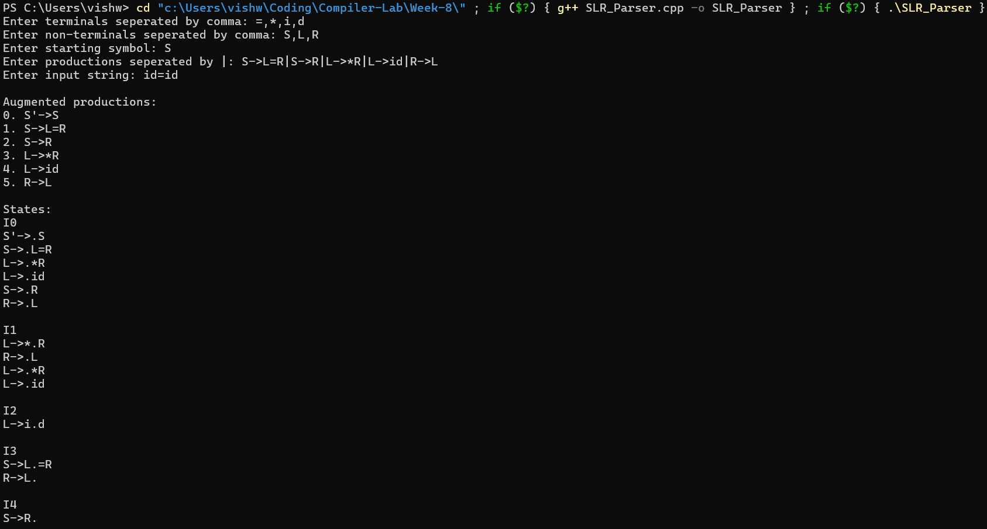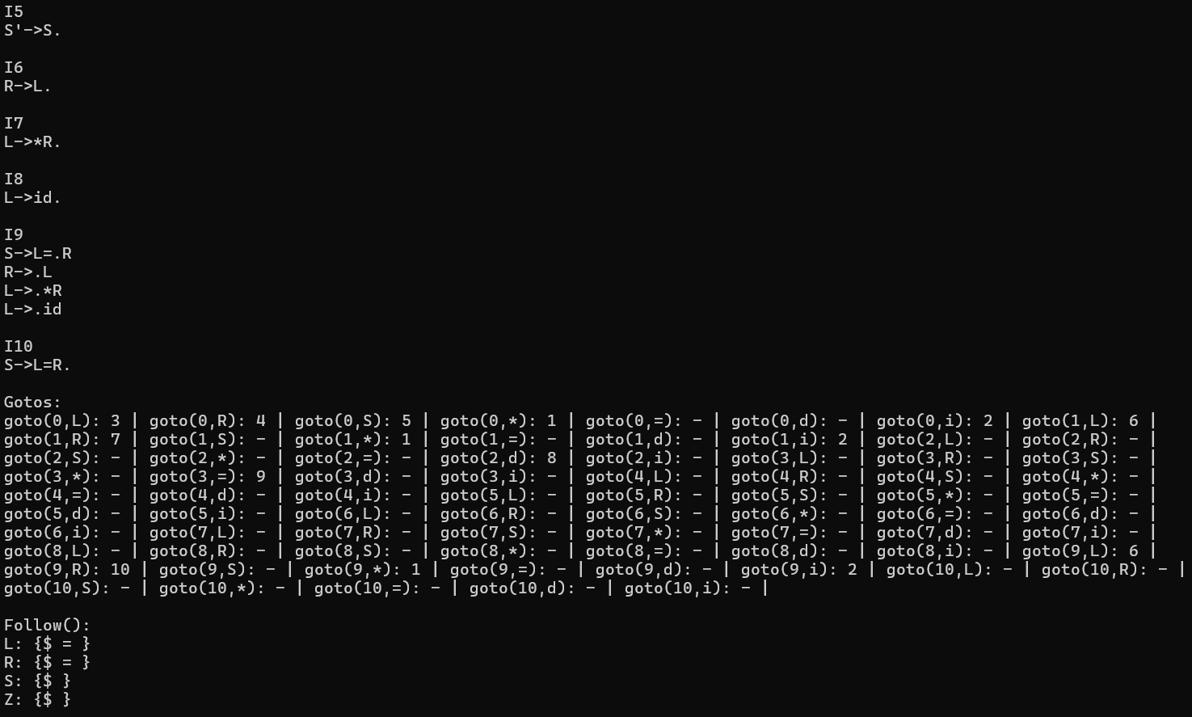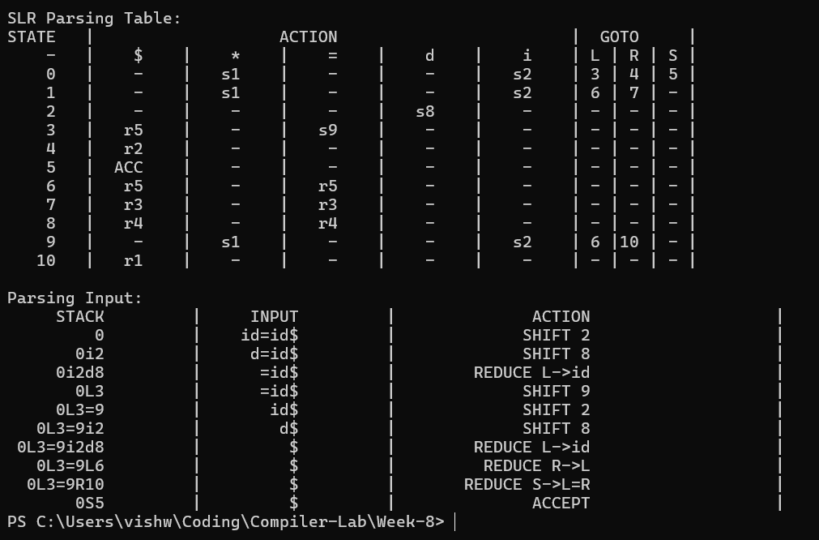

Result:
The SLR parser has been successfully written in C++ and executes as expected.

