Lab Assignment
Name | S Vishwajith
Registration Number | 23BCE1145
Subject | Compiler Design
Assignment Number | 2

Question 1:
Write a regex to check if a string contains only alphabets.

Code:
// A C++ program to write a regex to check if a string contains only alphabets.
#include <iostream>
#include <regex>
using namespace std;

int main()
{
string str;
cout << "Enter a string: ";
cin >> str;

regex pattern("^[A-Za-z]+$");

if (regex_match(str, pattern))
{
cout << "The string contains only alphabets." << endl;
}
else
{
cout << "The string contains characters other than alphabets." << endl;
}

return 0;
}

Output:
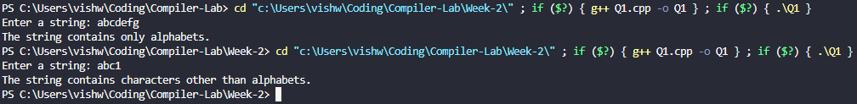

Question 2:
Write a regex to validate a 10-digit Indian mobile number starting with
digits 6 to 9.

Code:
// A C++ code to write a regex to validate a 10-digit Indian mobile number starting with digits 6 to 9.
#include <iostream>
#include <regex>
using namespace std;

int main()
{
string mobileNo;
cout << "Enter a 10-digit Indian mobile number: ";
cin >> mobileNo;
regex pattern("^[6-9][0-9]{9}$");
if (regex_match(mobileNo, pattern))
{
cout << "The mobile number is valid." << endl;
}
else
{
cout << "The mobile number is invalid." << endl;
}
}

Output:
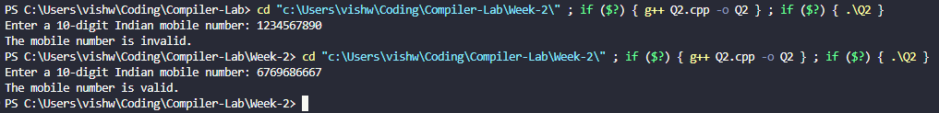

Question 3:
Write a regex to validate an email address.

Code:
// A C++ program to write a regex to validate an email address.
#include <iostream>
#include <regex>
using namespace std;

int main()
{
string emailAddresss;
cout << "Enter an email address: ";
cin >> emailAddresss;

regex ep("^([a-zA-Z]+)([a-zA-Z0-9_.-]*)@([a-zA-Z0-9.-]+)\\.([a-zA-Z]{2,5})$");

if (regex_match(emailAddresss, ep))
{
cout << "This is a valid email address." << endl;
}
else
{
cout << "This is an invalid email address." << endl;
}
return 0;
}

Output:
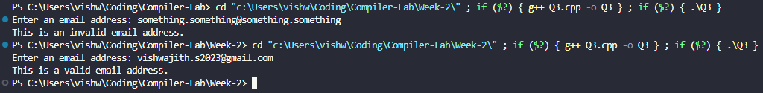

Question 4:
Write a regex to validate dates in DD-MM-YYYY format.

Code:
// A C++ program to write a regex to validate dates in DD-MM-YYYY format.
#include <iostream>
#include <regex>
using namespace std;

int main()
{
string date;
cout << "Enter a date in the format \"DD-MM-YYYY\": ";
cin >> date;

regex dp("^[0-3][0-9]\\-[0-1][0-9]\\-[0-9]{4}$");

if (regex_match(date, dp))
{
cout << "The given date matches the given format." << endl;
}
else
{
cout << "The given date doesn't match the given format." << endl;
}
return 0;
}

Output:
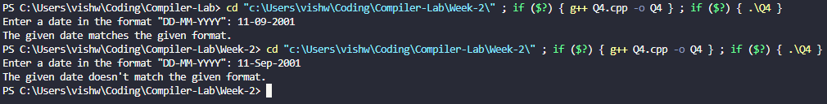

Question 5:
Write a C++ program to check whether the string is accepted or not – the
string must contain exactly two occurrences of ‘a’.

Code:
// A C++ program to check whether the string is accepted or not – the string must contain exactly two occurrences of 'a'.
#include <iostream>
#include <regex>
using namespace std;

int main()
{
string s;
cout << "Enter a string: ";
cin >> s;

regex sp("^[a]{2}$");
if (regex_match(s, sp))
{
cout << "The string has exactly 2 occurrences of a." << endl;
}
else
{
cout << "The string doesn't have exactly 2 occurrences of a." << endl;
}
return 0;
}

Output:
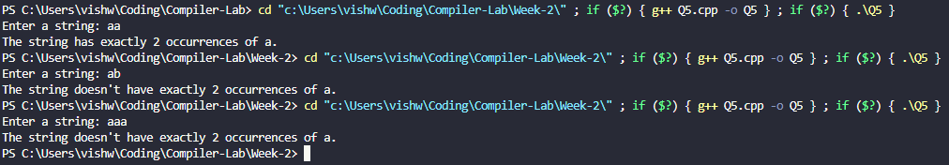

Question 6:
Write a C++ program to check whether the string is accepted or not – the
string should be of even length and contain only a and b.

Code:
// A C++ program to check whether the string is accepted or not – the string should be of even length and contain only a and b.
#include <iostream>
#include <regex>
using namespace std;

int main()
{
string s;
cout << "Enter a string: ";
cin >> s;

regex sp("^[a|b]+$");
if (regex_match(s, sp) && s.size() % 2 == 0)
{
cout << "The string is of even length and contains only a and b." << endl;
}
else
{
cout << "The string doesn't satisfy one or more of the given conditions." << endl;
}
return 0;
}

Output:
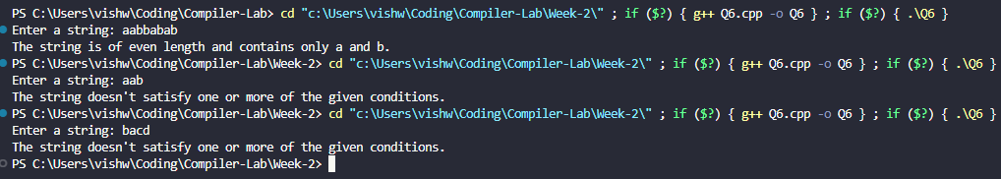

Question 7:
Write a C++ program to check whether the string is accepted or not – the
string should begin and end with the same character.

Code:
// A C++ program to check whether the string is accepted or not – the string should begin and end with the same character.
#include <iostream>
using namespace std;

int main()
{
string s;
cout << "Enter a string: ";
cin >> s;
if (s[0] == s[s.size() - 1])
{
cout << "The first and last characters are the same." << endl;
}
else
{
cout << "The first and last characters are not the same." << endl;
}
return 0;
}

Output:
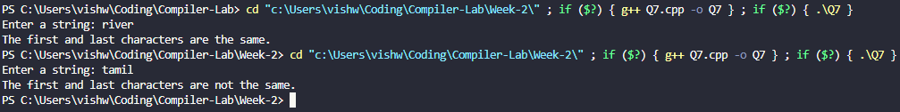

Question 8:
Write a C++ program to check whether the string is accepted or not – the
string must end with “abb”.

Code:
// A C++ program to check whether the string is accepted or not – the string must end with “abb”.
#include <iostream>
using namespace std;

int main()
{
string s;
cout << "Enter a string: ";
cin >> s;
if (s.size() >= 3 && s.substr(s.size() - 3) == "abb")
{
cout << "The string ends with \"abb\"." << endl;
}
else
{
cout << "The string does not end with \"abb\"." << endl;
}
return 0;
}

Output:
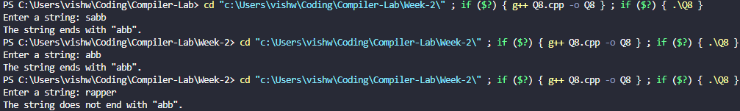

Question 9:
Write a C++ program to check whether the string is accepted or not – the
string must contain no consecutive repeating characters.

Code:
// A C++ program to check whether the string is accepted or not – the string must contain no consecutive repeating characters.
#include <iostream>
using namespace std;

int main()
{
string s;
cout << "Enter a string: ";
cin >> s;
bool flag = true;
for (int i = 0; i < s.size() - 1; i++)
{
if (s[i] == s[i + 1])
{
flag = false;
break;
}
}
if (flag)
{
cout << "There are no consecutive repeating characters." << endl;
}
else
{
cout << "There are consecutive repeating characters." << endl;
}
return 0;
}

Output:
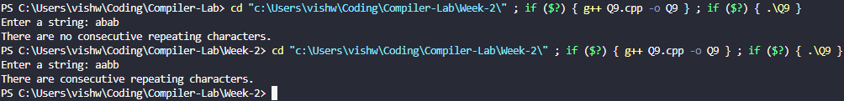

Question 10:
Write a C++ program to check whether the string is accepted or not – the string must contain both substrings “ab” and “ba” at least once, in any order.

Code:
// a C++ program to check whether the string is accepted or not – the string must contain both substrings “ab” and “ba” at least once, in any order.
#include <iostream>
#include <regex>
using namespace std;

int main()
{
string s;
cout << "Enter a string: ";
cin >> s;

regex sp1("ab"), sp2("ba");

if (regex_search(s, sp1) && regex_search(s, sp2))
{
cout << "The string contains both \"ab\" and \"ba\"." << endl;
}
else
{
cout << "The string doesn't contain either \"ab\" or \"ba\"." << endl;
}
return 0;
}

Output:
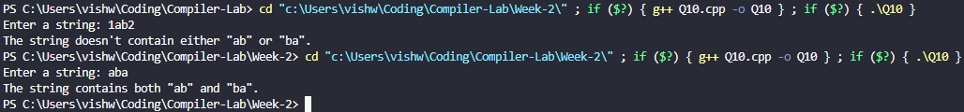

Question 11:
Write a C++ program to check whether the string is accepted or not – the string length must be a prime number, and the string must contain only 0s and 1s.

Code:
// A C++ program to check whether the string is accepted or not – the string length must be a prime number, and the string must contain only 0s and 1s.
#include <iostream>
#include <regex>
#include <math.h>
using namespace std;

bool isPrime(int n)
{
if (n <= 1)
{
return false;
}
for (int i = 2; i <= sqrt(n); i++)
{
if (n % i == 0)
{
return false;
}
}
return true;
}

int main()
{
string s;
cout << "Enter a string: ";
cin >> s;

regex sp("^[0|1]+$");
if (regex_match(s, sp) && isPrime(s.size()))
{
cout << "The string is of prime number length and contains only 0 and 1." << endl;
}
else
{
cout << "The string doesn't satisfy one or more of the given conditions." << endl;
}
return 0;
}

Output:
