Connect 4 using Minimax and Alpha-Beta Pruning

Team Details
- S Vishwajith - 23BCE1145
- N Vignesh - 23BCE1156
- S V Sriram - 23BEEE1110

Abstract
This project implements the classic Connect 4 board game with an integrated Artificial Intelligence (AI) opponent based on the Minimax algorithm with Alpha–Beta pruning. The primary goal is to design an interactive and visually engaging two-player environment where a human player can compete against a computer-controlled AI that intelligently evaluates future board states to determine optimal moves. The system is developed using the Pygame framework for interface and animation rendering. The AI’s difficulty can be adjusted by changing the search depth, offering a scalable challenge. The game efficiently manages user input, game physics, and board evaluation while maintaining smooth animations and realistic piece drops. The outcome is a responsive, intelligent, and enjoyable strategy game illustrating fundamental AI decision-making techniques.

Introduction
Connect 4 is a turn-based two-player game where participants alternately drop colored discs into a vertically suspended grid, aiming to align four discs horizontally, vertically, or diagonally before the opponent. The game provides an excellent platform for demonstrating adversarial search algorithms and game tree evaluations in artificial intelligence. The motivation behind this project is to create a visually engaging version of Connect 4 with realistic animation and competitive AI that adapts to varying difficulty levels. Unlike random-move or rule-based bots, the AI here uses Minimax decision-making enhanced by Alpha–Beta pruning, allowing efficient exploration of game states within reasonable computation time. The project also demonstrates how game physics, heuristic scoring, and graphical user interfaces (GUI) integrate within a unified application.

Objectives
- Create a game AI for Connect-4 that can determine and execute the most optimal moves that maximize its chances of winning while minimizing the chances of the opponent, using intelligent search algorithms such as the Minimax algorithm and Alpha-Beta pruning.
- The AI should be able to adjust the search depth of the algorithm to allow different difficulty levels ranging from lower depths for easier levels to higher depths for more challenging gameplay.
- The AI should play consistently at different levels.

Motivation
The motivation behind developing this project stems from the desire to explore how classical Artificial Intelligence techniques can emulate human strategic thinking in games. Connect 4, though simple in its rules, has a surprisingly complex search space that makes it an excellent candidate for experimenting with heuristic evaluation and adversarial algorithms.
The project serves as a learning platform to understand how AI can anticipate human actions, counter strategies, and optimize its decisions under computational constraints. Moreover, the interactive and visual nature of the game makes it an engaging way to demonstrate the real-world applications of algorithms like Minimax and Alpha–Beta pruning, which are also foundational in fields like robotics, autonomous systems, and decision support tools.
By implementing a scalable AI opponent with adjustable difficulty, the project aims to strike a balance between entertainment and educational value, helping learners visualize how search depth and heuristics directly influence AI performance.

Project Background
Connect 4 is a well-known strategy game that has been extensively studied in computer science due to its finite yet large state space. The game was first solved in 1988, revealing that the first player can always force a win with perfect play.
From an AI perspective, it offers a controlled environment to test decision-making algorithms without the complexity of massive state spaces like Chess or Go. The Minimax algorithm forms the foundation of game-playing AI, evaluating possible moves by simulating both player and opponent turns recursively. However, the computational cost of exploring all possible game states can grow exponentially.
To address this, Alpha-Beta pruning optimizes the Minimax process by pruning branches that cannot affect the final decision, effectively reducing the computation time while preserving correctness.
This project implements these techniques in Python using Pygame to demonstrate how intelligent agents can make near-optimal decisions in a limited timeframe while providing a polished and interactive user experience.

System Design
The system follows a modular, event-driven design with clear separation of concerns:
- User Interface Module: Handles input events, rendering of menus, and color/difficulty selection.
- Game Logic Module: Controls turn management, coin physics, and board updates.
- AI Decision Module: Executes Minimax algorithm with Alpha–Beta pruning to simulate intelligent move choices.
- Evaluation Module: Analyzes the board state for possible wins, draws, or valid positions.
- Visualization Module: Renders animations, text, and overlays to communicate the game state.

System Architecture Diagram
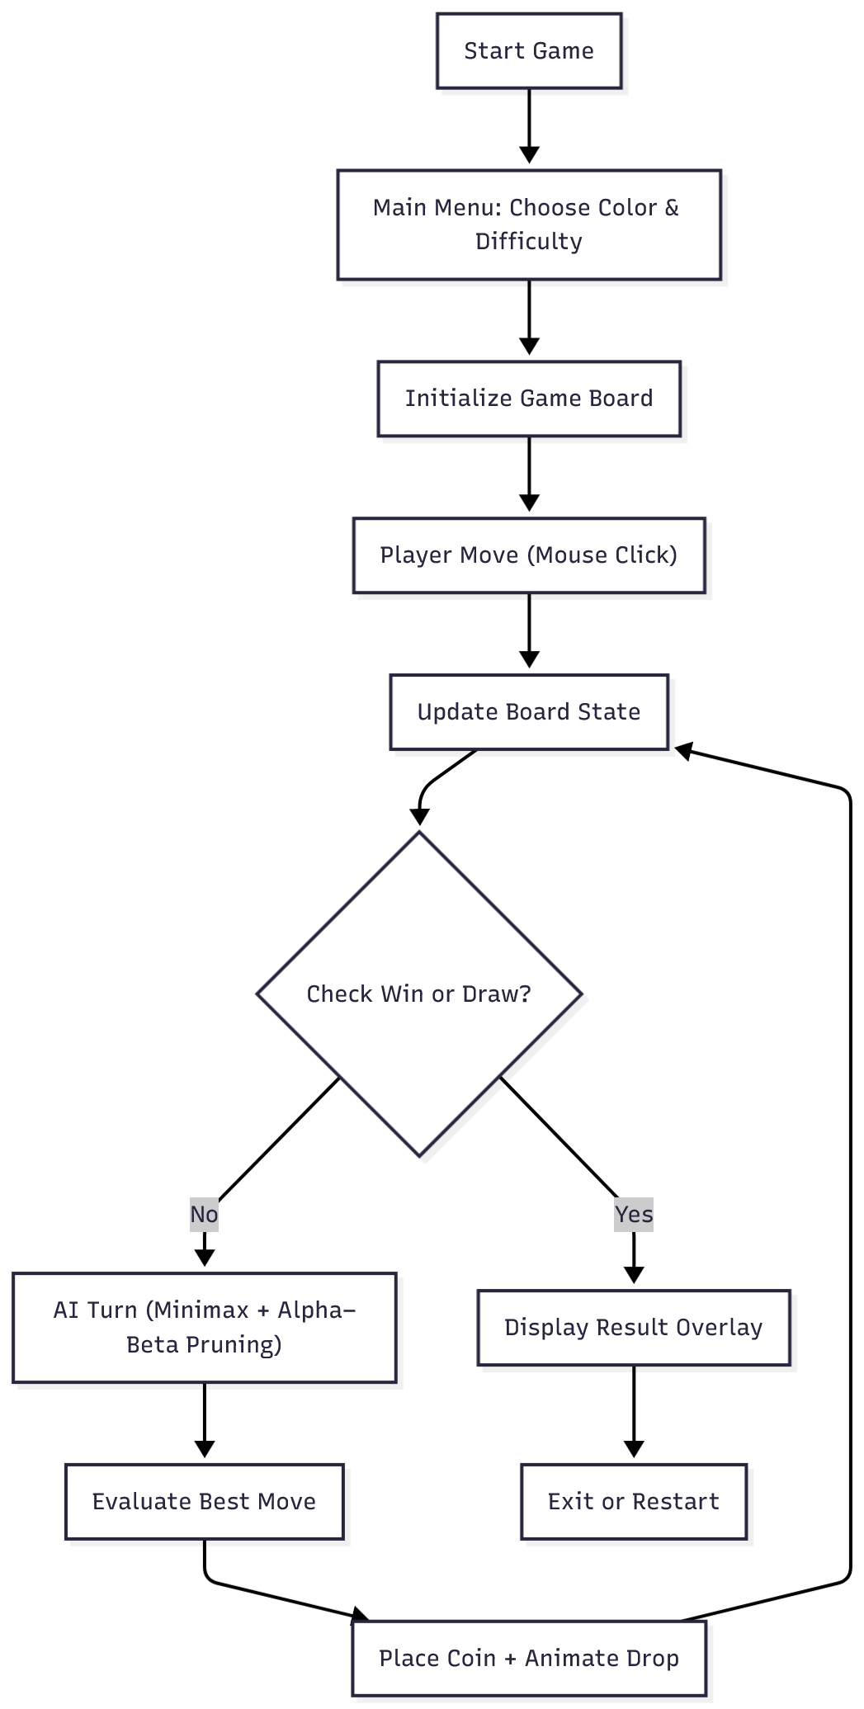

Workflow
- User Input:
  - Player selects a column to drop a disc via the GUI (pygame).
- Game State Update:
  - The move is validated, and the board state is updated accordingly.
- AI Decision-Making:
  - Minimax with Alpha-Beta pruning algorithm is triggered to evaluate possible future moves.
  - The evaluation function scores each possible board configuration.
  - Best move is selected based on maximizing AI’s winning chances while minimizing the opponent’s chances.
- Move Execution:
  - AI drops its disc in the chosen column, and the board is updated.
- Game Status Check:
  - The system checks for win/loss/draw conditions.
  - If the game continues, control passes back to the player.
- Difficulty Adjustment:
  - Depending on difficulty setting, the AI uses a higher depth.
- Output:
  - Updated board is displayed on GUI.
  - Game continues until terminal state is reached (win, loss, or draw).

Minimax Algorithm Flow Diagram
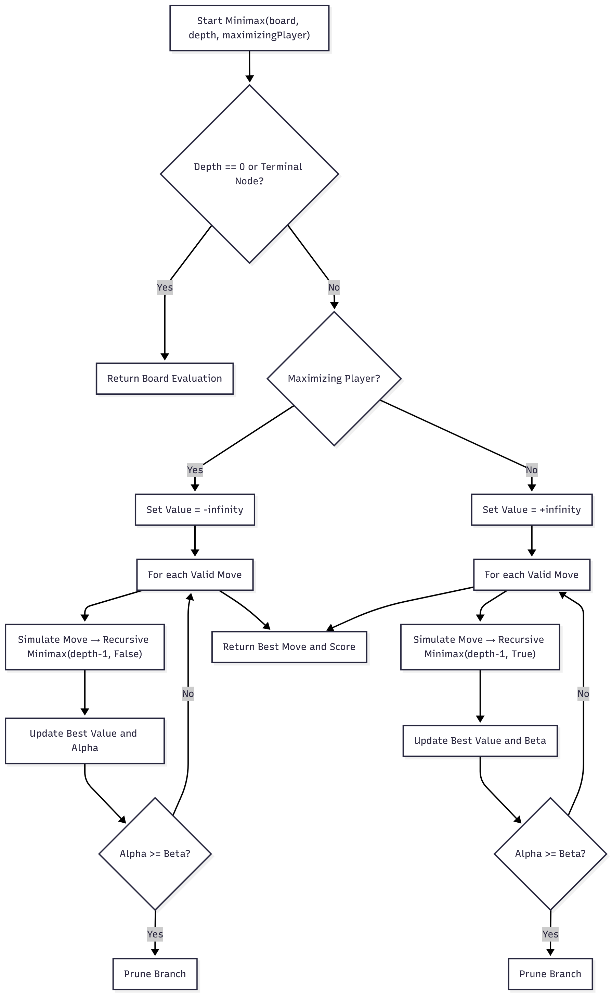

Algorithm
The artificial intelligence component of the system is built around the Minimax algorithm enhanced with Alpha-Beta pruning. The algorithm is implemented as a recursive function minimax(board, depth, alpha, beta, maximizingPlayer) that explores future board states and selects the optimal move for the AI player.
- Initialization:
  - The current board state is passed as a 2D list (board), representing the grid configuration.
  - depth defines the current search level, decreasing with each recursive call.
  - alpha and beta are initialized as −infinity and +infinity, representing the best scores that the maximizer and minimizer can guarantee, respectively.
  - maximizingPlayer is a Boolean flag indicating whether the AI (True) or the human player (False) is making the current move.
- Terminal State Check:
The algorithm first checks whether the current state is a terminal node, i.e., a win, loss, or draw, or if the maximum search depth has been reached.
  - If so, the function returns a heuristic score generated by score_position(board, piece) which evaluates the advantage for the AI player.
  - Winning states are assigned high positive scores, losing states negative scores, and draws neutral (zero) scores.
- Maximizing Player (AI Turn):
When maximizingPlayer is True, the algorithm simulates all valid moves by placing the AI’s piece (AI_PIECE) into each possible column:
  - For each move, the function recursively calls itself, toggling the player and reducing depth.
  - The maximum score among all possible moves is chosen as the AI’s best outcome.
  - Alpha-Beta pruning ensures branches that cannot yield a better score than beta are not explored further.

- Minimizing Player (Human’s turn):
When maximizingPlayer is False, the same process occurs but in the opposite direction:
  - The minimizing player aims to reduce the AI’s advantage by choosing the move with the lowest score.
  - The algorithm updates beta and prunes branches where the minimizer already found a better option.
- Heuristic Evaluation (score_position):
  - The scoring function evaluates the board using weighted windows (groups of four consecutive cells) horizontally, vertically, and diagonally.
  - For each window:
    - +100 points if it contains 4 AI pieces (win).
    - +5 points for 3 AI pieces and 1 empty space.
    - −4 points for 3 opponent pieces and 1 empty space.
  - Central columns are weighted higher since they offer more possible connections.
- Move Selection:
  - After evaluating all columns, the function returns a tuple (best_col, best_score) representing the optimal move and its expected utility.
  - The AI then executes this move using drop_piece(board, row, best_col, AI_PIECE).
- Outcome:
  - By recursively simulating possible outcomes, the AI predicts how each move will affect future game states and selects the move that maximizes its chance of winning while minimizing the opponent’s opportunities.
  - Alpha-Beta pruning significantly reduces redundant calculations, allowing deeper searches and faster response times.

Implementation
- Language: Python 3
- Libraries: Pygame (for graphics, UI, event handling)
- AI Algorithm: Minimax with Alpha–Beta pruning
- Data Structures: 2D Lists for board representation, Recursion for AI tree search
- Graphics: PNG assets for coins, dynamic rendering for board, overlays, and text
The user interface provides interactive buttons for colour and difficulty selection, smooth hover effects, and a clean layout. Game physics simulate gravity for realistic coin drops, and AI decisions are computed dynamically based on search depth.

Related Works
Research on artificial intelligence for two-player adversarial board games such as Connect-4 has largely focused on decision-making algorithms that simulate rational strategic play. The Minimax algorithm remains the cornerstone of such implementations. Minimax systematically explores possible future game states, assuming that both players play optimally—one maximizing its own advantage while the other minimizes it. This approach ensures that the AI can plan several moves ahead and anticipate countermoves. However, Minimax on its own is computationally expensive, as the search tree expands exponentially with depth, making it impractical for real-time play in larger or complex domains (Russell & Norvig, 2021).
To address this limitation, Alpha-Beta pruning has been widely integrated with Minimax. Alpha-Beta pruning reduces the number of nodes evaluated by eliminating branches that will not affect the final decision. This optimization allows for deeper searches within the same computational constraints, thus enabling stronger gameplay strategies (Knuth & Moore, 1975). Studies have shown that with proper move ordering, Alpha-Beta pruning can reduce the effective branching factor dramatically, which is particularly beneficial for games like Connect-4 where branching is relatively high (Allis, 1988). The main drawback of this approach is its reliance on efficient evaluation functions, as the pruning process may overlook promising branches if heuristics are poorly designed.
Beyond Minimax and Alpha-Beta pruning, research has also explored heuristic-based evaluation functions tailored for Connect-4. Such heuristics assign scores to board states based on the number of potential winning lines, threats, or blocked moves. For example, a position with three aligned discs and an open slot for the fourth is scored highly, while positions that block an opponent’s winning chance are also prioritized (Kocsis & Szepesvári, 2006). While heuristic evaluation enhances decision quality at shallow depths, it remains susceptible to short-sightedness, particularly when long-term strategies outweigh immediate tactical gains.
More recent advances have investigated Monte Carlo Tree Search (MCTS), which relies on random simulations to estimate the value of moves instead of exhaustive search. Although MCTS has been highly successful in games like Go, studies indicate that it performs less consistently in smaller, deterministic games like Connect-4 compared to well-optimized Minimax with Alpha-Beta pruning (Cazenave, 2009). MCTS excels in domains with large search spaces and uncertain outcomes but is not as efficient in domains where exhaustive adversarial search remains tractable.
Open-source implementations of Connect-4 AI further demonstrate the practical utility of these algorithms. For instance, many Python-based projects combine Minimax with Alpha-Beta pruning and custom heuristics to balance performance with play strength. Such implementations reveal the trade-off between search depth and computation time, highlighting the importance of adjustable difficulty levels. By tuning depth, developers can cater to both novice and expert players, aligning well with educational and recreational objectives.
In summary, existing literature underscores that Minimax with Alpha-Beta pruning remains the most efficient and reliable approach for Connect-4 AI. While heuristics are necessary to guide decision-making, their quality directly impacts gameplay performance. More advanced methods such as MCTS are less effective for this game due to the manageable complexity of Connect-4. The strengths of the established techniques lie in their proven robustness and efficiency, while their limitations revolve around computational scalability and heuristic dependence. This review indicates that a hybrid approach—Minimax with Alpha-Beta pruning supported by domain-specific heuristics—offers the most promising framework for building a competitive yet efficient Connect-4 AI system.

6. Results

Experimental Setup
Before running the experiments, ensure the following software and libraries are installed on your system:
System Requirements
- Python: 3.8 or higher
- Operating System: Windows / macOS / Linux
- Hardware: Minimum 4 GB RAM, Dual-Core Processor
Required Python Libraries
The following dependencies are required for running the Connect 4 AI game and performance experiments:
Library | Purpose
pygame | For game graphics and user interface
math | Used in Minimax evaluation and calculations
random | To randomize initial moves and selections
copy | To duplicate board states safely during recursive calls
time | To measure execution time for experiments
matplotlib | To visualize results with performance graphs
csv | To store and export performance data
sys | For system-level operations like quitting the game

Project Files:
File | Description
Home.py | Main menu and UI to select color and difficulty
Board.py | Manages game board rendering and player interactions
Minimax.py | Implements Minimax Algorithm with Alpha-Beta Pruning
Winning_Move.py | Contains functions to check horizontal, vertical, and diagonal wins
Draw.py | Handles valid move checks and draw conditions
connect4_experiment_fixed.py | Script for performance analysis (execution time, node count, and pruning efficiency)

Graphs:
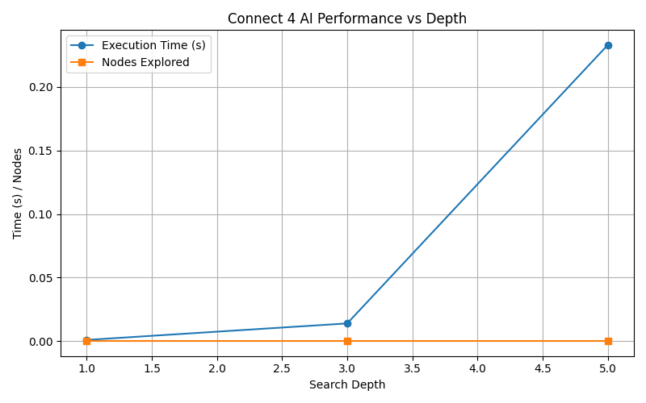

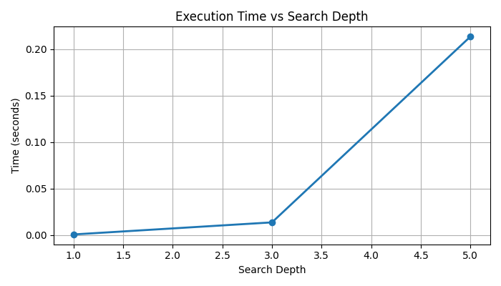

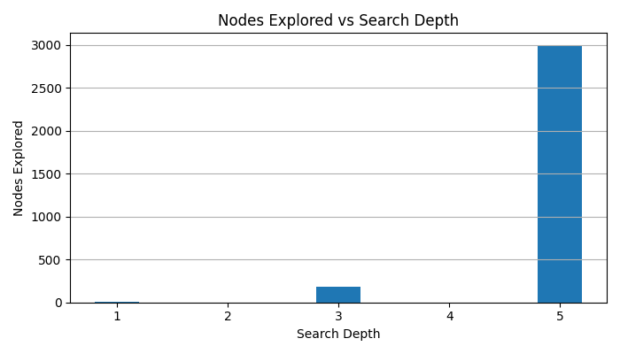

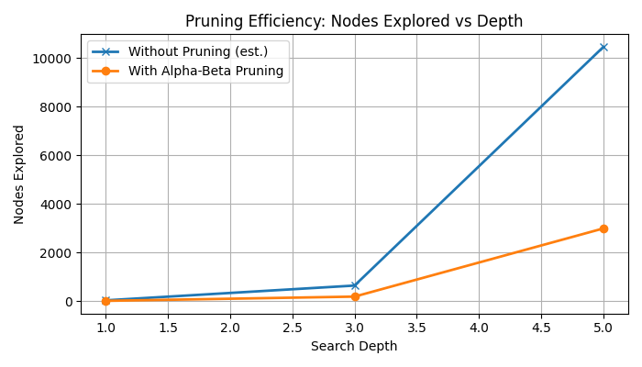

7. Discussion

Challenges faced
- Balancing Difficulty
One of the main challenges was creating a noticeable difference between difficulty levels. Early versions showed minimal variation in AI performance across depths because the heuristic function and pruning were not fine-tuned. Adjusting the heuristic weights (such as center control and potential 3-in-a-row patterns) was necessary to make each difficulty level feel distinct.
- Computational Cost
As the search depth increased, the computation time grew exponentially. Although Alpha-Beta Pruning reduced the number of explored nodes significantly, deeper searches (especially depth 5 and beyond) still required noticeable processing time, occasionally causing small delays in move generation.
- Heuristic Optimization
Designing an effective heuristic that balances offensive and defensive play was a challenge. The AI needed to evaluate not just its own potential wins but also the player’s threats, which required refining the scoring mechanism multiple times.

Limitations
1. Limited Complexity of the Game
While Connect 4 is more complex than Tic Tac Toe, it still has a finite and fully observable state space. This makes it possible for the AI to predict all future outcomes at high depths, reducing the challenge once players understand its strategy.
2. Lack of Adaptivity
The AI follows a fixed heuristic function and does not learn or adapt based on previous games. It cannot analyze player tendencies or alter its strategy dynamically, unlike machine learning–based agents.
3. Predictability at High Depths
At higher difficulty levels, the AI becomes nearly deterministic. Since Alpha-Beta Pruning always leads the AI to the same optimal move sequence, gameplay may feel repetitive after multiple rounds.
4. Performance Trade-offs
Although pruning improves efficiency, there is still a trade-off between decision speed and accuracy. Very high depths could provide better play quality but are impractical for real-time gameplay due to longer computation times.

8. Conclusion

Contributions
Vignesh – Focused on developing and implementing the AI system for Connect 4. This stage involved designing the 6×7 grid structure, managing game logic such as valid move detection, turn management, and win/draw conditions, as well as integrating the AI opponent using the minimax algorithm. The AI was designed to evaluate board positions and make optimal moves based on predictive analysis. By the end of this phase, the foundational version of Connect 4 was fully functional and playable against an intelligent AI opponent.
Vishwajith – Concentrated on building the base user interface and implementing the winning move logic. He developed the grid layout and interactive elements that allowed players to place tokens intuitively within the columns. In addition, he ensured that the system accurately detected horizontal, vertical, and diagonal wins, as well as handled draw conditions effectively. His work established a stable and responsive interaction layer that connected the core game mechanics with the player experience.
Sriram – Focused on enhancing and upgrading the user interface, refining the visuals and improving the overall user experience. He redesigned the layout with improved graphics, animations, and smoother transitions, making the gameplay more engaging and visually appealing. Sriram also optimized the interface for better performance and responsiveness across different devices. His contributions gave the final version of Connect 4 AI a polished and professional look, ensuring an enjoyable experience for players.

Future scope

1. Adaptive Learning with Reinforcement Learning
Future versions of the AI could implement reinforcement learning techniques (like Q-learning or Deep Q-Networks) to allow the AI to learn optimal strategies through repeated self-play rather than relying solely on manually designed heuristics.
2. Dynamic Depth Adjustment
Introducing a time-based or difficulty-adaptive depth control could improve gameplay smoothness. For example, the AI could adjust its search depth based on available computation time, game state complexity, or user performance.
3. Improved Heuristic Evaluation
The current heuristic focuses on pattern recognition (e.g., 2-in-a-row or 3-in-a-row). Future enhancements could integrate probabilistic scoring or Monte Carlo simulations to better handle mid-game uncertainty and optimize moves more intelligently.
4. Integration with Neural Networks
Neural networks could be trained to approximate the board evaluation function, enabling more nuanced decision-making and better generalization to unseen board configurations.
5. Multiplayer and Online Play
Extending the game to support human-vs-human matches over a network or through online multiplayer would enhance engagement and introduce real-world competitive play.
6. Visualization and Analytics Dashboard
A performance dashboard showing search depth, node count, evaluation scores, and move times during gameplay could provide deeper insights into AI behavior and help in algorithmic analysis.
.

References
- Russell, S., & Norvig, P. (2021). Artificial Intelligence: A Modern Approach (4th ed.). Pearson.
- Knuth, D. E., & Moore, R. W. (1975). An analysis of alpha-beta pruning. Artificial Intelligence, 6(4), 293–326.
- Allis, L. V. (1988). A knowledge-based approach of Connect-Four. Vrije Universiteit Amsterdam.
- Kocsis, L., & Szepesvári, C. (2006). Bandit based Monte-Carlo planning. European Conference on Machine Learning (ECML), 282–293.
- Cazenave, T. (2009). Monte-Carlo Tree Search and Rapid Action Value Estimation in Computer Go. IEEE Transactions on Computational Intelligence and AI in Games, 1(1), 68–72.

