Course Title: Cryptography and Network Security Lab | Course Code: BCSE309P
Faculty: Prof. Karthika V | Slot: L43+L44
Regno: 23BCE1145 | Name: S Vishwajith

Ex 1 – 1A, 1B and 1C Combined

EX1A – Classical Cryptographic Techniques

Code (Caesar Cipher):

Sender:
import java.util.*;
import java.io.*;
import java.net.*;
public class Caesar_Sender {
private Socket socket = null;
private DataInputStream input = null;
private DataOutputStream output = null;
private Scanner sc = null;
public Caesar_Sender(String address, int port) {
try {
socket = new Socket(address, port);
System.out.println("Client is connected!");
input = new DataInputStream(socket.getInputStream());
output = new DataOutputStream(socket.getOutputStream());
sc = new Scanner(System.in);
} catch (UnknownHostException u) {
System.out.println(u);
} catch (IOException i) {
System.out.println(i);
}
}
String caesarEncrypt(String pt, int k) {
StringBuilder ct = new StringBuilder();
for (char c : pt.toCharArray()) {
if (Character.isUpperCase(c)) {
int ch = (int) c - 'A';
ch = (ch + k) % 26;
char cs = (char) (ch + 65);
ct.append(cs);
} else if (Character.isLowerCase(c)) {
int ch = (int) c - 'a';
ch = (ch + k) % 26;
char cs = (char) (ch + 97);
ct.append(cs);
} else {
ct.append(c);
}
}
return ct.toString();
}
public void Work() {
try {
System.out.print("Enter the message: ");
String[] ips = sc.nextLine().trim().split("\\s+");
System.out.print("Enter the key: ");
int k = sc.nextInt();
Vector<String> ct = new Vector<>();
for (String word : ips) {
ct.add(caesarEncrypt(word, k));
}
String cts = String.join(" ", ct);
System.out.println("The encrypted text is: " + cts);
output.writeInt(k);
output.writeUTF(cts);
System.out.println(input.readUTF());
input.close();
output.close();
sc.close();
} catch (IOException i) {
System.out.println(i);
}
}
public static void main(String[] args) {
Caesar_Sender cc = new Caesar_Sender("127.0.0.1", 5431);
cc.Work();
}
}

Receiver:
import java.util.*;
import java.io.*;
import java.net.*;
public class Caesar_Receiver {
private ServerSocket server = null;
private Socket socket = null;
private DataInputStream input = null;
private DataOutputStream output = null;
public Caesar_Receiver(int port) {
try {
server = new ServerSocket(port);
socket = server.accept();
System.out.println("Client is connected!\n");
input = new DataInputStream(socket.getInputStream());
output = new DataOutputStream(socket.getOutputStream());
} catch (UnknownHostException u) {
System.out.println(u);
} catch (IOException i) {
System.out.println(i);
}
}
String caesarDecrypt(String ct, int k) {
StringBuilder pt = new StringBuilder();
for (char c : ct.toCharArray()) {
if (Character.isUpperCase(c)) {
int ch = (int) c - 'A';
ch = (ch - k) % 26;
if (ch < 0) {
ch += 26;
}
char cs = (char) (ch + 65);
pt.append(cs);
} else if (Character.isLowerCase(c)) {
int ch = (int) c - 'a';
ch = (ch - k) % 26;
if (ch < 0) {
ch += 26;
}
char cs = (char) (ch + 97);
pt.append(cs);
} else {
pt.append(c);
}
}
return pt.toString();
}
public void Work() {
try {
int k = input.readInt();
String ip = input.readUTF();
String[] ips = ip.trim().split("\\s+");
Vector<String> ct = new Vector<>();
for (String word : ips) {
ct.add(caesarDecrypt(word, k));
}
System.out.println("The received encrypted text is: " + ip);
System.out.println("The received key is: " + k);
String cts = String.join(" ", ct);
System.out.println("The decrypted text is: " + cts);
output.writeUTF("Success from receiver!");
input.close();
output.close();
} catch (IOException i) {
System.out.println(i);
}
}
public static void main(String[] args) {
Caesar_Receiver cs = new Caesar_Receiver(5431);
cs.Work();
}
}

Output (Caesar Cipher):

Sender:
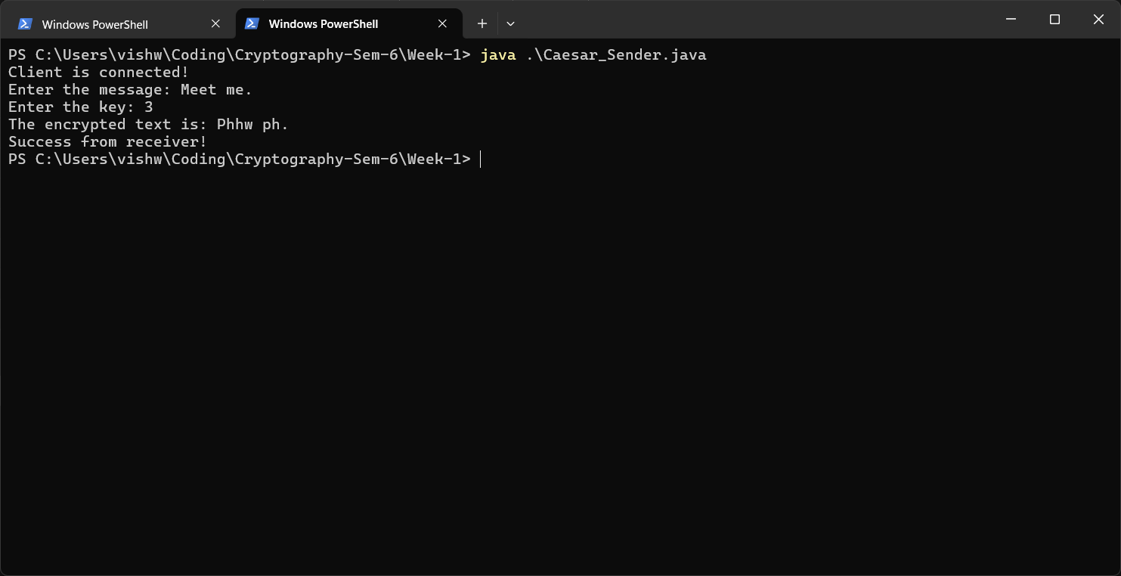

Receiver:
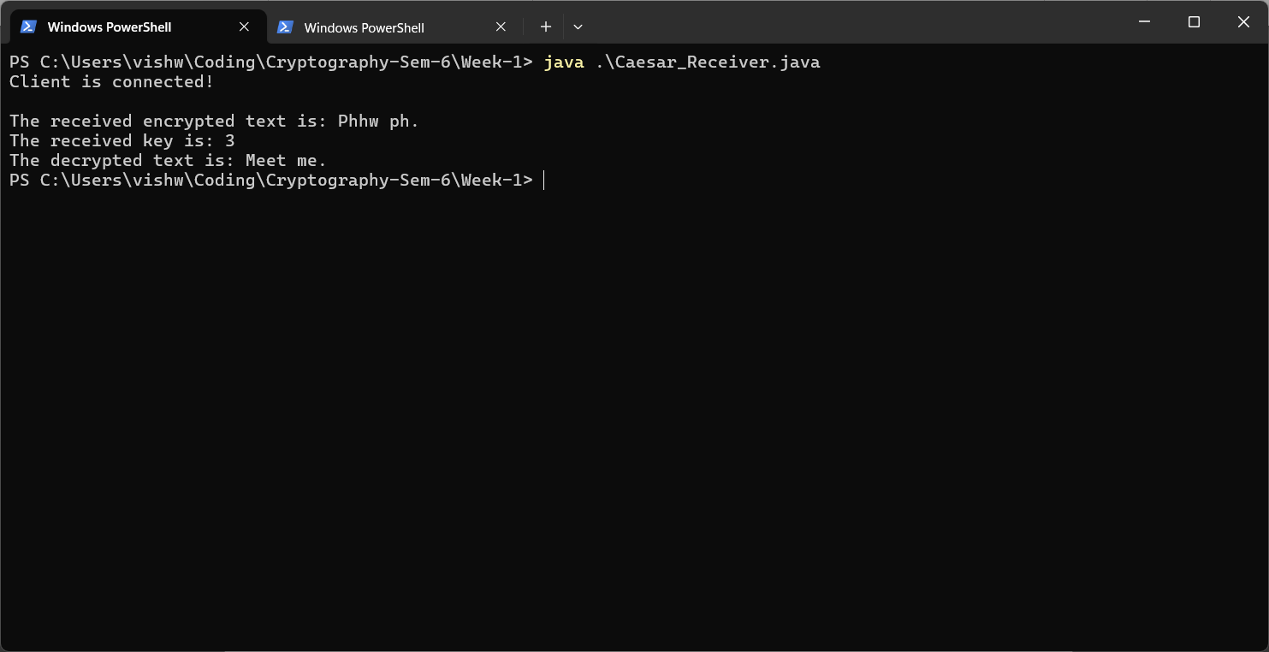

Code (Vigenère Cipher):

Sender:
import java.util.*;
import java.io.*;
import java.net.*;

public class Vignere_Sender {
private Socket socket = null;
private DataInputStream input = null;
private DataOutputStream output = null;
private Scanner sc = null;
int pos = 0;

public Vignere_Sender(String address, int port) {
try {
socket = new Socket(address, port);
System.out.println("Client is connected!");
input = new DataInputStream(socket.getInputStream());
output = new DataOutputStream(socket.getOutputStream());
sc = new Scanner(System.in);
} catch (UnknownHostException u) {
System.out.println(u);
} catch (IOException i) {
System.out.println(i);
}
}

String vignereEncrpyt(String pt, String k) {
StringBuilder ct = new StringBuilder();
int klen = k.length();

for (char c : pt.toCharArray()) {
char keyChar = k.charAt(pos);
int shift;
if (Character.isUpperCase(keyChar)) {
shift = keyChar - 'A';
} else {
shift = keyChar - 'a';
}

if (Character.isUpperCase(c)) {
int ch = (int) c - 'A';
ch = (ch + shift) % 26;
char cs = (char) (ch + 65);
ct.append(cs);
pos = (pos + 1) % klen;
} else if (Character.isLowerCase(c)) {
int ch = (int) c - 'a';
ch = (ch + shift) % 26;
char cs = (char) (ch + 97);
ct.append(cs);
pos = (pos + 1) % klen;
} else {
ct.append(c);
}
}

return ct.toString();
}

public void Work() {
try {
System.out.print("Enter the message: ");
String[] ips = sc.nextLine().trim().split("\\s+");
System.out.print("Enter the key: ");
String k = sc.next().trim();
Vector<String> ct = new Vector<>();
for (String word : ips) {
ct.add(vignereEncrpyt(word, k));
}
String cts = String.join(" ", ct);
System.out.println("The encrypted text is: " + cts);
output.writeUTF(k);
output.writeUTF(cts);
System.out.println(input.readUTF());
input.close();
output.close();
sc.close();
} catch (IOException i) {
System.out.println(i);
}
}

public static void main(String[] args) {
Vignere_Sender vs = new Vignere_Sender("127.0.0.1", 5431);
vs.Work();
}
}

Receiver:
import java.util.*;
import java.io.*;
import java.net.*;

public class Vignere_Receiver {
private ServerSocket server = null;
private Socket socket = null;
private DataInputStream input = null;
private DataOutputStream output = null;
int pos = 0;

public Vignere_Receiver(int port) {
try {
server = new ServerSocket(port);
socket = server.accept();
System.out.println("Client is connected!\n");
input = new DataInputStream(socket.getInputStream());
output = new DataOutputStream(socket.getOutputStream());
} catch (UnknownHostException u) {
System.out.println(u);
} catch (IOException i) {
System.out.println(i);
}
}

String vignereDecrypt(String ct, String k) {
StringBuilder pt = new StringBuilder();
int klen = k.length();

for (char c : ct.toCharArray()) {
char keyChar = k.charAt(pos);
int shift;
if (Character.isUpperCase(keyChar)) {
shift = keyChar - 'A';
} else {
shift = keyChar - 'a';
}

if (Character.isUpperCase(c)) {
int ch = (int) c - 'A';
ch = (ch - shift) % 26;
if (ch < 0) {
ch += 26;
}
char vr = (char) (ch + 65);
pt.append(vr);
pos = (pos + 1) % klen;
} else if (Character.isLowerCase(c)) {
int ch = (int) c - 'a';
ch = (ch - shift) % 26;
if (ch < 0) {
ch += 26;
}
char vr = (char) (ch + 97);
pt.append(vr);
pos = (pos + 1) % klen;
} else {
pt.append(c);
}
}

return pt.toString();
}

public void Work() {
try {
String k = input.readUTF();
String ip = input.readUTF();
String[] ips = ip.trim().split("\\s+");
Vector<String> ct = new Vector<>();
for (String word : ips) {
ct.add(vignereDecrypt(word, k));
}
System.out.println("The received encrypted text is: " + ip);
System.out.println("The received key is: " + k);
String cts = String.join(" ", ct);
System.out.println("The decrypted text is: " + cts);
output.writeUTF("Success from receiver!");
input.close();
output.close();
} catch (IOException i) {
System.out.println(i);
}
}

public static void main(String[] args) {
Vignere_Receiver vr = new Vignere_Receiver(5431);
vr.Work();
}
}

Output (Vigenère Cipher):

Sender:
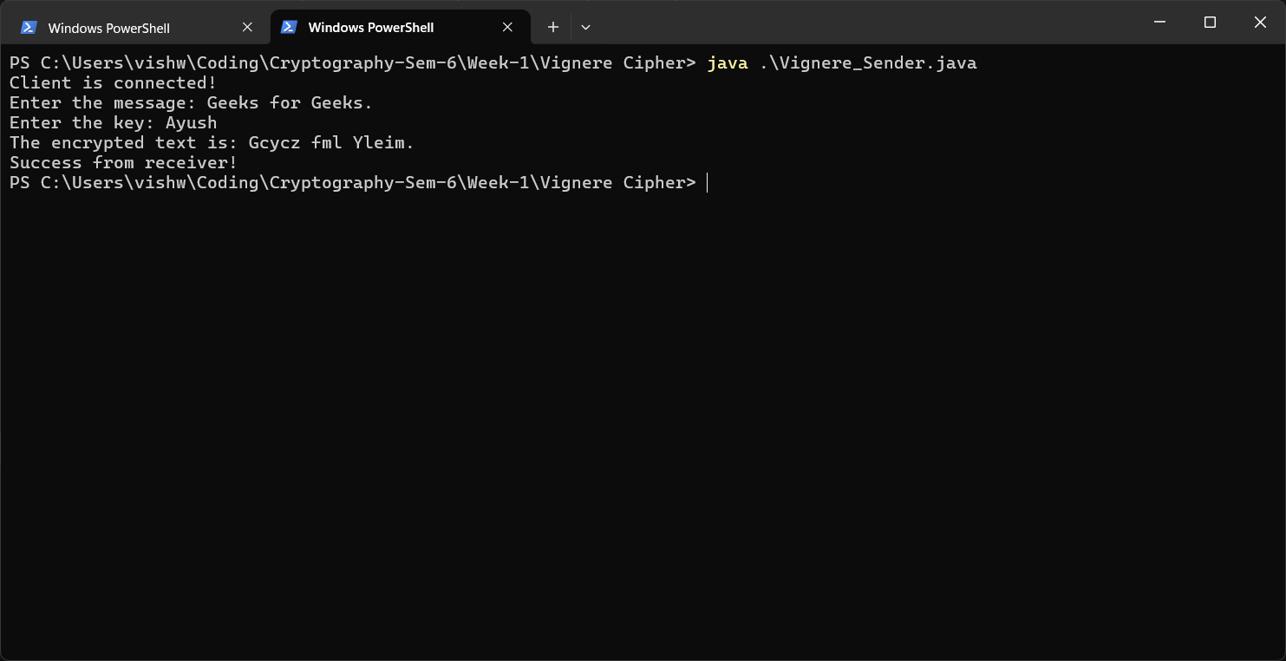

Receiver:
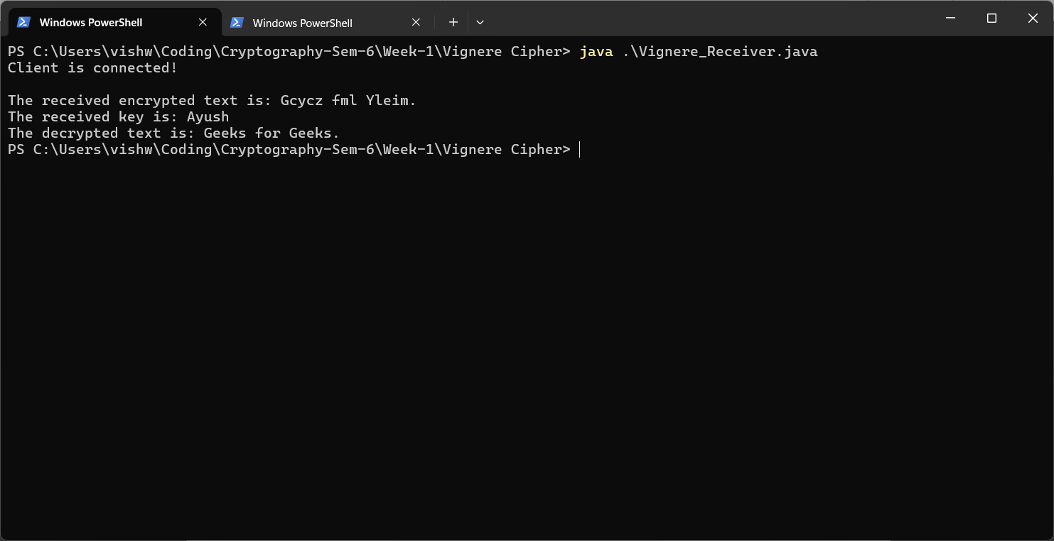

Code (Vernam Cipher):

Sender:
import java.util.*;
import java.io.*;
import java.net.*;

public class Vernam_Sender {
private Socket socket = null;
private DataInputStream input = null;
private DataOutputStream output = null;
private Scanner sc = null;
int pos = 0;

public Vernam_Sender(String address, int port) {
try {
socket = new Socket(address, port);
System.out.println("Client is connected!");
input = new DataInputStream(socket.getInputStream());
output = new DataOutputStream(socket.getOutputStream());
sc = new Scanner(System.in);
} catch (UnknownHostException u) {
System.out.println(u);
} catch (IOException i) {
System.out.println(i);
}
}

String vernamEncrypt(String pt, String k) {
StringBuilder ct = new StringBuilder();
for (int i = 0; i < pt.length(); i++) {
char pChar = pt.charAt(i);
char kChar = k.charAt(i);
int pc, kc;
if (Character.isUpperCase(pChar)) {
pc = (int) pChar - 'A';
} else {
pc = (int) pChar - 'a';
}
if (Character.isUpperCase(kChar)) {
kc = (int) kChar - 'A';
} else {
kc = (int) kChar - 'a';
}
int cc = (pc ^ kc);
if (Character.isUpperCase(pChar)) {
char cChar = (char) (cc + 'A');
ct.append(cChar);
} else {
char cChar = (char) (cc + 'a');
ct.append(cChar);
}
}
return ct.toString();
}

public void Work() {
try {
System.out.print("Enter the message: ");
String ips = sc.next().trim();
System.out.print("Enter the key: ");
String k = sc.next().trim();
String cts = vernamEncrypt(ips, k);
System.out.println("The encrypted text is: " + cts);
output.writeUTF(k);
output.writeUTF(cts);
System.out.println(input.readUTF());
input.close();
output.close();
sc.close();
} catch (IOException i) {
System.out.println(i);
}
}

public static void main(String[] args) {
Vernam_Sender vs = new Vernam_Sender("127.0.0.1", 5431);
vs.Work();
}
}

Receiver:
import java.io.*;
import java.net.*;

public class Vernam_Receiver {
private ServerSocket server = null;
private Socket socket = null;
private DataInputStream input = null;
private DataOutputStream output = null;
int pos = 0;

public Vernam_Receiver(int port) {
try {
server = new ServerSocket(port);
socket = server.accept();
System.out.println("Client is connected!\n");
input = new DataInputStream(socket.getInputStream());
output = new DataOutputStream(socket.getOutputStream());
} catch (UnknownHostException u) {
System.out.println(u);
} catch (IOException i) {
System.out.println(i);
}
}

String vernamDecrypt(String ct, String k) {
StringBuilder pt = new StringBuilder();
for (int i = 0; i < ct.length(); i++) {
char cChar = ct.charAt(i);
char kChar = k.charAt(i);
int cc, kc;
if (Character.isUpperCase(cChar)) {
cc = (int) cChar - 'A';
} else {
cc = (int) cChar - 'a';
}
if (Character.isUpperCase(kChar)) {
kc = (int) kChar - 'A';
} else {
kc = (int) kChar - 'a';
}
int pc = (cc ^ kc);
if (Character.isUpperCase(cChar)) {
char pChar = (char) (pc + 'A');
pt.append(pChar);
} else {
char pChar = (char) (pc + 'a');
pt.append(pChar);
}
}
return pt.toString();
}

public void Work() {
try {
String k = input.readUTF();
String ip = input.readUTF();
String cts = vernamDecrypt(ip, k);
System.out.println("The received encrypted text is: " + ip);
System.out.println("The received key is: " + k);
System.out.println("The decrypted text is: " + cts);
output.writeUTF("Success from receiver!");
input.close();
output.close();
} catch (IOException i) {
System.out.println(i);
}
}

public static void main(String[] args) {
Vernam_Receiver vr = new Vernam_Receiver(5431);
vr.Work();
}
}

Output (Vernam Cipher):

Sender:
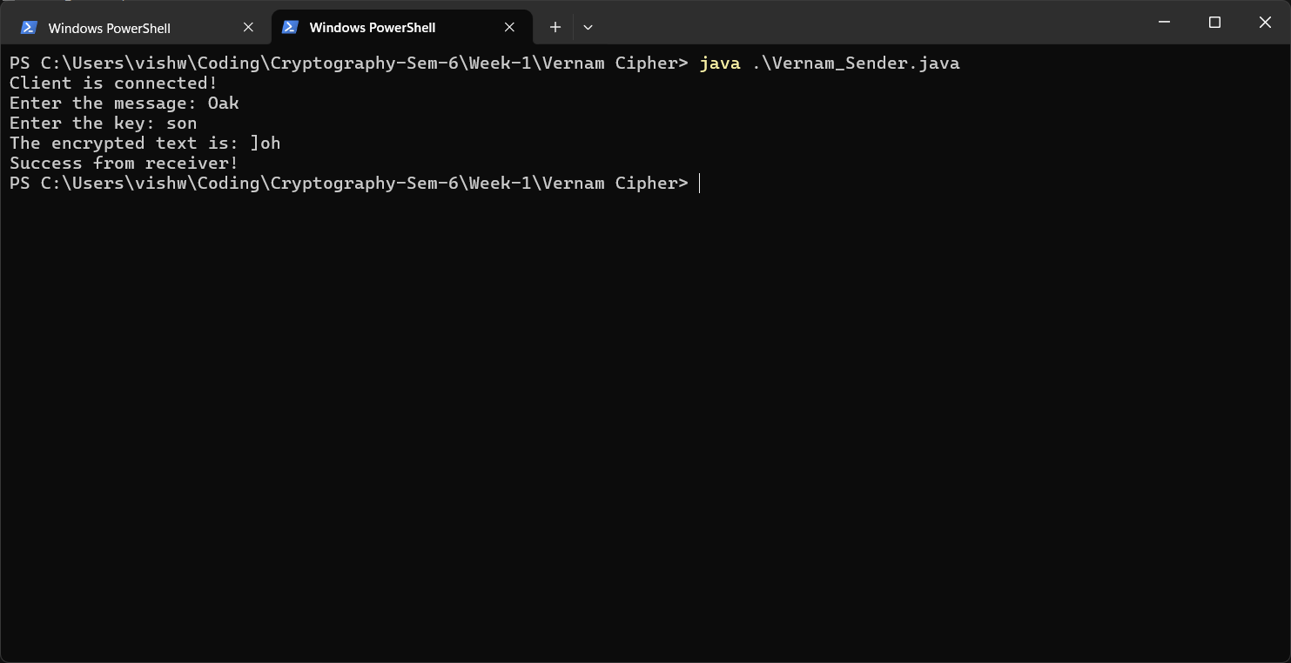

Receiver:
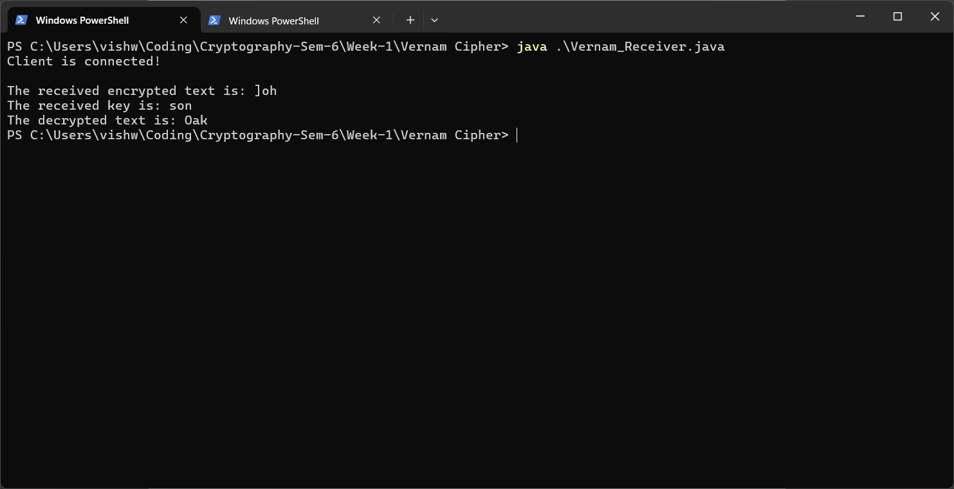

Ex1B - Playfair and Hill Cipher

Playfair Cipher:

Code:

Sender:
import socket

def create_diagram(pt):
diagram = []
i = 0
while i < len(pt):
a = pt[i]
if i + 1 < len(pt):
b = pt[i + 1]
if a == b:
diagram.append(a + 'x')
i += 1
else:
diagram.append(a + b)
i += 2
else:
diagram.append(a + 'x')
i += 1
return diagram

def create_key_matrix(key):
key = key.replace("j", "i")
key_matrix = []
used_chars = set()
row = 0
col = 0
temp = []
for char in key:
if char not in used_chars and char.isalpha():
used_chars.add(char)
temp.append(char)
col += 1
if col == 5:
key_matrix.append(temp)
temp = []
row += 1
col = 0
for i in range(ord('a'), ord('z') + 1):
char = chr(i)
if char == 'j':
continue
if char not in used_chars:
used_chars.add(char)
temp.append(char)
col += 1
if col == 5:
key_matrix.append(temp)
temp = []
row += 1
col = 0
return key_matrix

def get_cipher(diagram, key_matrix):
cipher_text = ""
for pair in diagram:
row1, col1, row2, col2 = -1, -1, -1, -1
for r in range(5):
for c in range(5):
if key_matrix[r][c] == pair[0]:
row1, col1 = r, c
if key_matrix[r][c] == pair[1]:
row2, col2 = r, c
if row1 == row2:
cipher_text += key_matrix[row1][(col1 + 1) % 5]
cipher_text += key_matrix[row2][(col2 + 1) % 5]
elif col1 == col2:
cipher_text += key_matrix[(row1 + 1) % 5][col1]
cipher_text += key_matrix[(row2 + 1) % 5][col2]
else:
cipher_text += key_matrix[row1][col2]
cipher_text += key_matrix[row2][col1]
return cipher_text

print("Playfair Cipher Sender initialized.")
pt = input("Enter the plaintext: ").lower()
if(len(pt) == 0):
print("No plaintext provided. Exiting.")
exit()
key = input("Enter the key: ").lower()
if(len(key) == 0):
print("No key provided. Exiting.")
exit()

diagram = create_diagram(pt)
diagram_text = ''.join(diagram)
print("Diagram created:", diagram_text)
key_matrix = create_key_matrix(key)
print("Key matrix created:")
for row in key_matrix:
print(row)
cipher_text = get_cipher(diagram, key_matrix)
print("Ciphertext generated:", cipher_text)

s = socket.socket()
s.connect(('127.0.0.1', 5067))
s.send(cipher_text.encode().ljust(1024, b'\0'))
s.send(key.encode().ljust(1024, b'\0'))
print("Ciphertext and key sent to the receiver.")
s.close()

Receiver:
import socket

def create_key_matrix(key):
key = key.replace("j", "i")
key_matrix = []
used_chars = set()
row = 0
col = 0
temp = []
for char in key:
if char not in used_chars and char.isalpha():
used_chars.add(char)
temp.append(char)
col += 1
if col == 5:
key_matrix.append(temp)
temp = []
row += 1
col = 0
for i in range(ord('a'), ord('z') + 1):
char = chr(i)
if char == 'j':
continue
if char not in used_chars:
used_chars.add(char)
temp.append(char)
col += 1
if col == 5:
key_matrix.append(temp)
temp = []
row += 1
col = 0
return key_matrix

def get_plain_text(cipher, key_matrix):
plain_text = ""
for i in range(0, len(cipher), 2):
pair = cipher[i:i+2]
row1, col1, row2, col2 = -1, -1, -1, -1
for r in range(5):
for c in range(5):
if key_matrix[r][c] == pair[0]:
row1, col1 = r, c
if key_matrix[r][c] == pair[1]:
row2, col2 = r, c
if row1 == row2:
plain_text += key_matrix[row1][(col1 - 1) % 5]
plain_text += key_matrix[row2][(col2 - 1) % 5]
elif col1 == col2:
plain_text += key_matrix[(row1 - 1) % 5][col1]
plain_text += key_matrix[(row2 - 1) % 5][col2]
else:
plain_text += key_matrix[row1][col2]
plain_text += key_matrix[row2][col1]
return plain_text

server = socket.socket()
server.bind(('127.0.0.1', 5067))
server.listen(1)
print("Playfair Cipher Receiver initialized and listening for sender.")
conn, addr = server.accept()
print(f"Connection established with {addr}.")

cipher = conn.recv(1024).decode().rstrip('\0')
key = conn.recv(1024).decode().rstrip('\0')
print("Ciphertext received:", cipher)
print("Key received:", key)
key_matrix = create_key_matrix(key)
print("Plain text reconstructed:", get_plain_text(cipher, key_matrix))

conn.close()
server.close()

Output:

Sender:
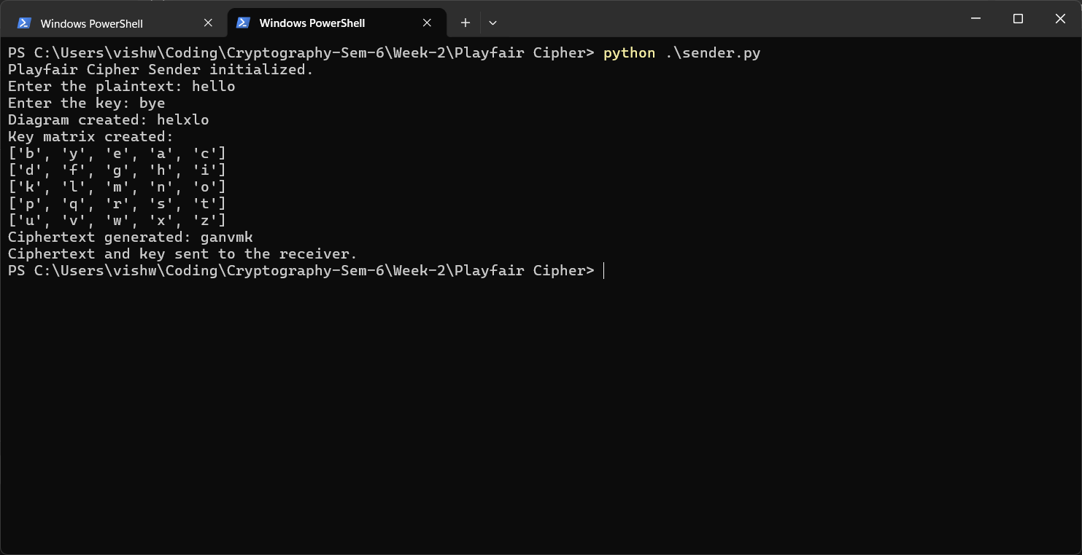

Receiver:
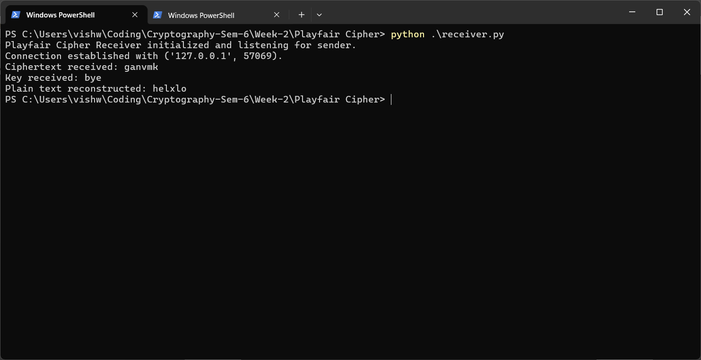

Hill Cipher:

Code:

Sender:
import socket
import numpy as np

def create_key_matrix(key_char_matrix):
key_matrix = [[ord(char) - ord('a') for char in row] for row in key_char_matrix]
return np.matrix(key_matrix, dtype=int)

def create_pt_matrix(pt, n):
pt_matrix = []
for i in range(0, len(pt), n):
row = [ord(char) - ord('a') for char in pt[i:i+n]]
pt_matrix.append(row)
return np.matrix(pt_matrix, dtype=int)

def get_cipher_text(ct_matrix):
ct = ''
for row in ct_matrix:
for num in row.tolist()[0]:
ct += chr(num + ord('a'))
return ct

def get_key_text(key_char_matrix):
key = ''
for row in key_char_matrix:
for char in row:
key += char
return key

print("Hill Cipher Sender initialized.")
n = int(input("Enter the size of the key matrix (n x n): "))
pt = input(f"Enter the plaintext: ").lower()
key_char_matrix = [list(input(f"Enter row {i+1} of the key matrix (space-separated integers and length must be {n}): ").lower()) for i in range(n)]
key_matrix = create_key_matrix(key_char_matrix)
key_text = get_key_text(key_char_matrix)
print("Key Matrix:")
for row in key_matrix:
print(row)
print(f"Key Text: {key_text}")

pt_matrix = create_pt_matrix(pt, n)
print("Plaintext Matrix:")
for row in pt_matrix:
print(row)

ct_matrix = (pt_matrix @ key_matrix) % 26
print("Ciphertext Matrix:")
for row in ct_matrix:
print(row)

ct = get_cipher_text(ct_matrix)
print(f"Ciphertext: {ct}")

s = socket.socket()
s.connect(('127.0.0.1', 5069))
s.send(ct.encode().ljust(1024, b'\0'))
s.send(str(n).encode().ljust(1024, b'\0'))
s.send(key_text.encode().ljust(1024, b'\0'))
print("Ciphertext, key size, and key text sent to receiver.")
s.close()

Receiver:
import socket
import numpy as np

def create_key_matrix(key_text, n):
key_matrix = []
index = 0
for i in range(n):
row = []
for j in range(n):
row.append(ord(key_text[index]) - ord('a'))
index += 1
key_matrix.append(row)
return np.matrix(key_matrix, dtype=int)

def create_ct_matrix(ct, n):
ct_matrix = []
for i in range(0, len(ct), n):
row = [ord(char) - ord('a') for char in ct[i:i+n]]
ct_matrix.append(row)
return np.matrix(ct_matrix, dtype=int)

def get_key_matrix_adjugate(key_matrix):
n = key_matrix.shape[0]
adjugate = np.zeros((n, n), dtype=int)
for i in range(n):
for j in range(n):
minor = np.delete(np.delete(key_matrix, i, axis=0), j, axis=1)
cofactor = int(round(np.linalg.det(minor))) * ((-1) ** (i + j))
adjugate[j][i] = cofactor % 26
return np.asmatrix(adjugate)

def get_plain_text(pt_matrix):
pt = ''
for row in pt_matrix:
for num in row.tolist()[0]:
pt += chr(num + ord('a'))
return pt

server = socket.socket()
server.bind(('127.0.0.1', 5069))
server.listen(1)
print("Hill Cipher Receiver initialized and listening for sender.")

conn, addr = server.accept()
print(f"Connection established with sender at {addr}.")
ct = conn.recv(1024).decode().rstrip('\0')
n = int(conn.recv(1024).decode().rstrip('\0'))
key_text = conn.recv(1024).decode().rstrip('\0')

print(f"Received Ciphertext: {ct}")
print(f"Received Key Size: {n}")
print(f"Received Key Text: {key_text}")

key_matrix = create_key_matrix(key_text, n)
print("Key Matrix:")
for row in key_matrix:
print(row)

ct_matrix = create_ct_matrix(ct, n)
print("Ciphertext Matrix:")
for row in ct_matrix:
print(row)

det = int(round(np.linalg.det(key_matrix))) % 26
det_inverse = pow(det, -1, 26)
print(f"Determinant: {det}")
print(f"Determinant Inverse: {det_inverse}")

key_matrix_inverse = (det_inverse * get_key_matrix_adjugate(key_matrix)) % 26
print("Inverse Key Matrix:")
for row in key_matrix_inverse:
print(row)

pt_matrix = (ct_matrix @ key_matrix_inverse) % 26
print("Plaintext Matrix:")
for row in pt_matrix:
print(row)

pt = get_plain_text(pt_matrix)
print(f"Decrypted Plaintext: {pt}")

conn.close()
server.close()

Output:

Sender:
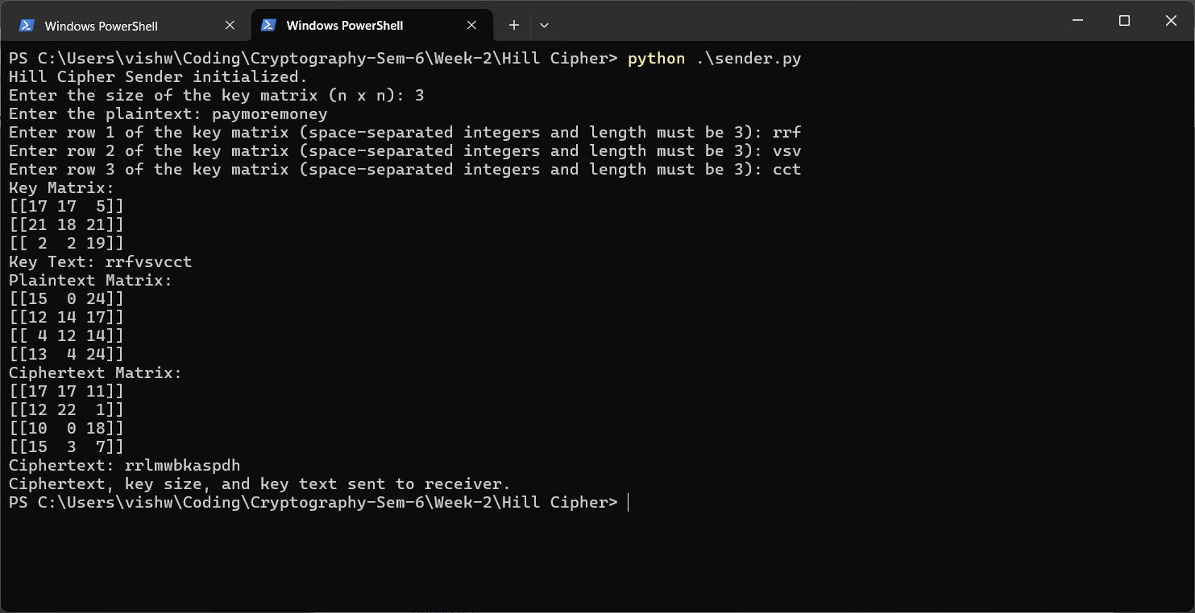

Receiver:
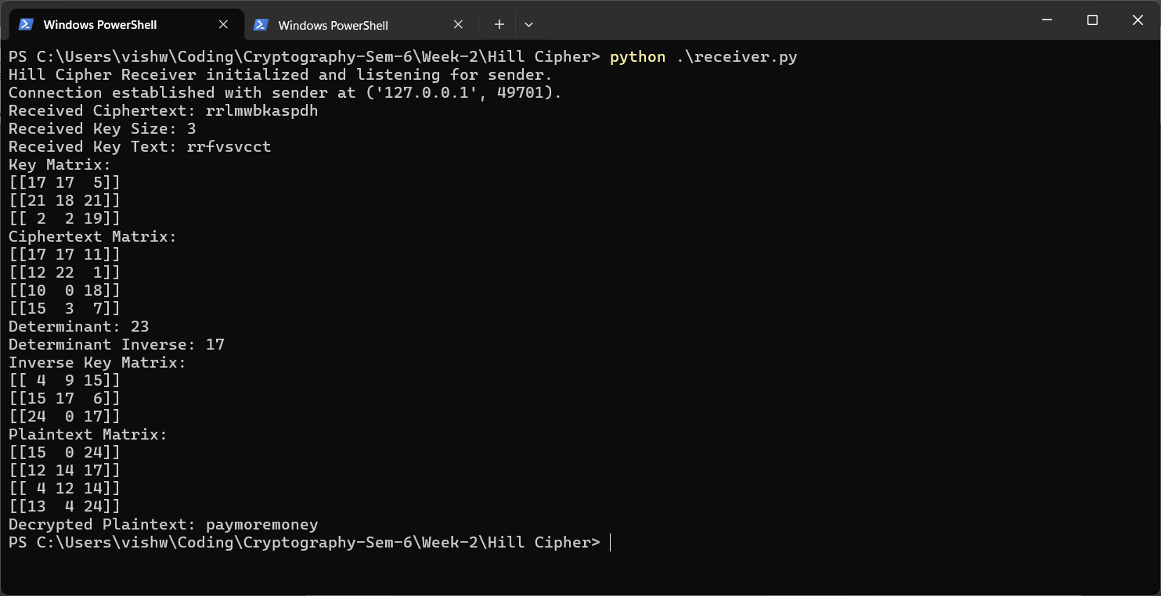

Ex 1C – Transposition Cryptographic Algorithms

Rail Fence Cipher:

Code:

Sender:
import socket

print("Rail Fence Cipher Sender Initialized.")
pt = input("Enter the text to be encoded: ")
d = int(input("Enter the depth: "))

ar = [[None for i in range(len(pt))] for j in range(d)]
row, col = 0,0
direction = 1

for i in pt:
ar[row][col] = i
col += 1
row += direction
if row == 0 or row == d-1:
direction *= -1

print("\nThe intermediate matrix is:")
for i in ar:
for j in i:
if j == None:
print("-", end=" ")
else:
print(j, end=" ")
print()
print()

ct = ""
for i in ar:
for j in i:
if j != None:
ct += j

print("The Cipher Text is: " + ct)

s = socket.socket()
s.connect(('127.0.0.1', 12345))
s.send(ct.encode().ljust(1024, b'\0'))
s.send(str(d).encode().ljust(1024, b'\0'))
print("Cipher text and the depth are sent successfully.")
s.close()

Receiver:
import socket

server = socket.socket()
server.bind(('127.0.0.1', 12345))
server.listen(1)
print("Rail Fence Cipher Receiver initialized and listening for sender.")

conn, addr = server.accept()
print(f"Connection established with sender at {addr}.")
ct = conn.recv(1024).decode().rstrip('\0')
d = int(conn.recv(1024).decode().rstrip('\0'))

print(f"Received Cipher Text is: {ct}.")
print(f"Received depth is: {d}.")

row, col = 0,0
direction = 1
ar1 = [[None for i in range(len(ct))] for j in range(d)]
for i in ct:
ar1[row][col] = '*'
col += 1
row += direction
if row == 0 or row == d-1:
direction *= -1

index = 0
for i in range(d):
for j in range(len(ct)):
if index < len(ct) and ar1[i][j] == '*':
ar1[i][j] = ct[index]
index += 1

print("The intermediate matrix is:")
for i in ar1:
for j in i:
if j == None:
print("-", end=" ")
else:
print(j, end=" ")
print()
print()

row, col = 0,0
direction = 1
pt1 = ""
while len(pt1) < len(ct):
pt1 += ar1[row][col]
col += 1
row += direction
if row == 0 or row == d-1:
direction *= -1
print("The plaintext is: " + pt1)

conn.close()
server.close()

Output:

Sender: 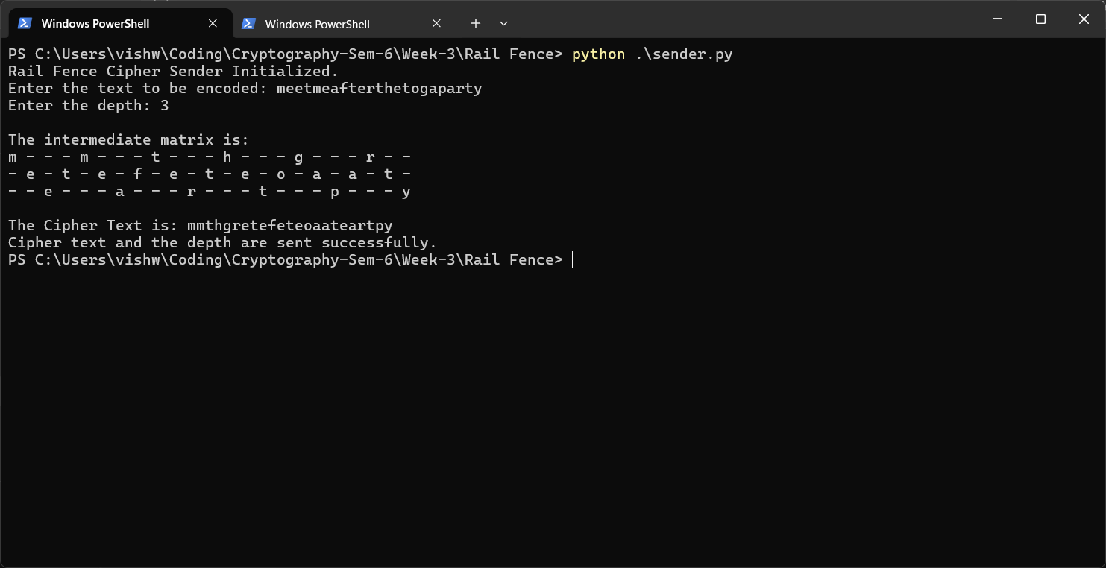

Receiver: 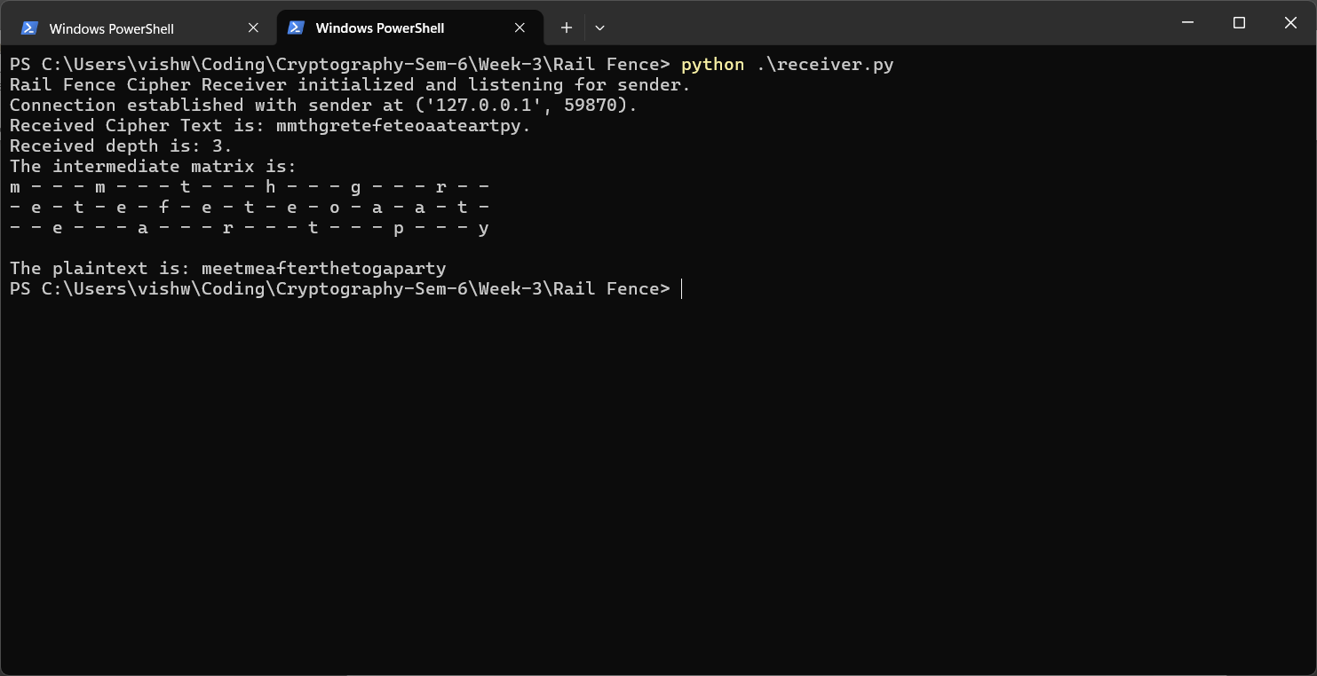

Row Column Transposition Cipher:

Code:

Sender:
import pickle
import socket

print("Row Column Cipher Sender Initialized.")
pt = input("Enter the plaintext: ")
pt_len = len(pt)
key = input("Enter the permutation: ").split(" ")
key = [int(i) for i in key]
key_data = pickle.dumps(key)

if max(key) != len(key) or min(key) != 1:
print("The given permutation is invalid.")
exit(1)

if len(pt) % len(key) != 0:
pad = len(key) - (pt_len % len(key))
pt += '*'*pad

mat = [[None for i in range(len(key))] for j in range(len(pt)//len(key))]
index = 0
for i in range(len(pt)//len(key)):
for j in range(len(key)):
if index < len(pt):
mat[i][j] = pt[index]
index += 1
print("\nThe intermediate matrix is:")
for i in mat:
for j in i:
print(j, end=" ")
print()
print()

d = dict()
for i in range(len(key)):
d[key[i]] = ""
for j in range(len(pt)//len(key)):
d[key[i]] += mat[j][i]

ct = ""
for i in sorted(d.keys()):
ct += d[i]
print(f"The Cipher Text is: \"{ct}\".")

s = socket.socket()
s.connect(('127.0.0.1', 5096))
s.send(ct.encode().ljust(1024, b'\0'))
s.send(key_data.ljust(1024, b'\0'))
s.send(str(pt_len).encode().ljust(1024, b'\0'))
print("The Ciphertext, permutation and the original plain text length have been sent successfully.")
s.close()

Receiver:
import socket
import pickle

server = socket.socket()
server.bind(('127.0.0.1', 5096))
server.listen(1)
print("Row Column Cipher Receiver initialized and listening for sender.")

conn, addr = server.accept()
print(f"Connection established with sender at {addr}.")
ct = conn.recv(1024).decode().rstrip('\0')
print(f"The Cipher Text is: {ct}.")
key = pickle.loads(conn.recv(1024).rstrip(b'\0'))
pt_len = int(conn.recv(1024).decode().rstrip('\0'))
print(f"The permutation is: {key}")

conn.close()
server.close()

d = dict()
gap = len(ct)//len(key)
for i in range(1, len(key)+1):
d[i] = ct[(i-1)*gap : i*gap]

mat = [[None for i in range(len(key))] for j in range(gap)]
for i in range(len(key)):
block = d[key[i]]
for j in range(gap):
mat[j][i] = block[j]
print("\nThe intermediate matrix is:")
pt = ""
for i in mat:
for j in i:
print(j, end=" ")
pt += j
print()
print()

print(f"The Plain Text with padding is: \"{pt}\".")
pt = pt[:pt_len]
print(f"The Plain Text without padding is: \"{pt}\".")

Output:

Sender:
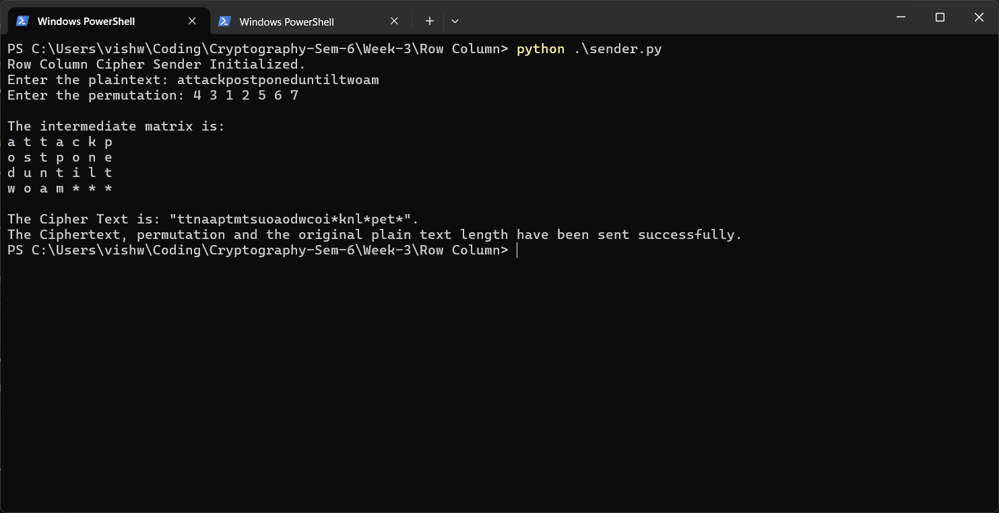

Receiver:
