Course Title: Cryptography and Network Security Lab | Course Code: BCSE309P
Faculty: Prof. Karthika V | Slot: L43+L44
Regno: 23BCE1145 | Name: S Vishwajith

Ex1b - Playfair and Hill Cipher

Playfair Cipher:

Code:

Sender:
import socket

def create_diagram(pt):
diagram = []
i = 0
while i < len(pt):
a = pt[i]
if i + 1 < len(pt):
b = pt[i + 1]
if a == b:
diagram.append(a + 'x')
i += 1
else:
diagram.append(a + b)
i += 2
else:
diagram.append(a + 'x')
i += 1
return diagram

def create_key_matrix(key):
key = key.replace("j", "i")
key_matrix = []
used_chars = set()
row = 0
col = 0
temp = []
for char in key:
if char not in used_chars and char.isalpha():
used_chars.add(char)
temp.append(char)
col += 1
if col == 5:
key_matrix.append(temp)
temp = []
row += 1
col = 0
for i in range(ord('a'), ord('z') + 1):
char = chr(i)
if char == 'j':
continue
if char not in used_chars:
used_chars.add(char)
temp.append(char)
col += 1
if col == 5:
key_matrix.append(temp)
temp = []
row += 1
col = 0
return key_matrix

def get_cipher(diagram, key_matrix):
cipher_text = ""
for pair in diagram:
row1, col1, row2, col2 = -1, -1, -1, -1
for r in range(5):
for c in range(5):
if key_matrix[r][c] == pair[0]:
row1, col1 = r, c
if key_matrix[r][c] == pair[1]:
row2, col2 = r, c
if row1 == row2:
cipher_text += key_matrix[row1][(col1 + 1) % 5]
cipher_text += key_matrix[row2][(col2 + 1) % 5]
elif col1 == col2:
cipher_text += key_matrix[(row1 + 1) % 5][col1]
cipher_text += key_matrix[(row2 + 1) % 5][col2]
else:
cipher_text += key_matrix[row1][col2]
cipher_text += key_matrix[row2][col1]
return cipher_text

print("Playfair Cipher Sender initialized.")
pt = input("Enter the plaintext: ").lower()
if(len(pt) == 0):
print("No plaintext provided. Exiting.")
exit()
key = input("Enter the key: ").lower()
if(len(key) == 0):
print("No key provided. Exiting.")
exit()

diagram = create_diagram(pt)
diagram_text = ''.join(diagram)
print("Diagram created:", diagram_text)
key_matrix = create_key_matrix(key)
print("Key matrix created:")
for row in key_matrix:
print(row)
cipher_text = get_cipher(diagram, key_matrix)
print("Ciphertext generated:", cipher_text)

s = socket.socket()
s.connect(('127.0.0.1', 5067))
s.send(cipher_text.encode().ljust(1024, b'\0'))
s.send(key.encode().ljust(1024, b'\0'))
print("Ciphertext and key sent to the receiver.")
s.close()

Receiver:
import socket

def create_key_matrix(key):
key = key.replace("j", "i")
key_matrix = []
used_chars = set()
row = 0
col = 0
temp = []
for char in key:
if char not in used_chars and char.isalpha():
used_chars.add(char)
temp.append(char)
col += 1
if col == 5:
key_matrix.append(temp)
temp = []
row += 1
col = 0
for i in range(ord('a'), ord('z') + 1):
char = chr(i)
if char == 'j':
continue
if char not in used_chars:
used_chars.add(char)
temp.append(char)
col += 1
if col == 5:
key_matrix.append(temp)
temp = []
row += 1
col = 0
return key_matrix

def get_plain_text(cipher, key_matrix):
plain_text = ""
for i in range(0, len(cipher), 2):
pair = cipher[i:i+2]
row1, col1, row2, col2 = -1, -1, -1, -1
for r in range(5):
for c in range(5):
if key_matrix[r][c] == pair[0]:
row1, col1 = r, c
if key_matrix[r][c] == pair[1]:
row2, col2 = r, c
if row1 == row2:
plain_text += key_matrix[row1][(col1 - 1) % 5]
plain_text += key_matrix[row2][(col2 - 1) % 5]
elif col1 == col2:
plain_text += key_matrix[(row1 - 1) % 5][col1]
plain_text += key_matrix[(row2 - 1) % 5][col2]
else:
plain_text += key_matrix[row1][col2]
plain_text += key_matrix[row2][col1]
return plain_text

server = socket.socket()
server.bind(('127.0.0.1', 5067))
server.listen(1)
print("Playfair Cipher Receiver initialized and listening for sender.")
conn, addr = server.accept()
print(f"Connection established with {addr}.")

cipher = conn.recv(1024).decode().rstrip('\0')
key = conn.recv(1024).decode().rstrip('\0')
print("Ciphertext received:", cipher)
print("Key received:", key)
key_matrix = create_key_matrix(key)
print("Plain text reconstructed:", get_plain_text(cipher, key_matrix))

conn.close()
server.close()

Output:

Sender:
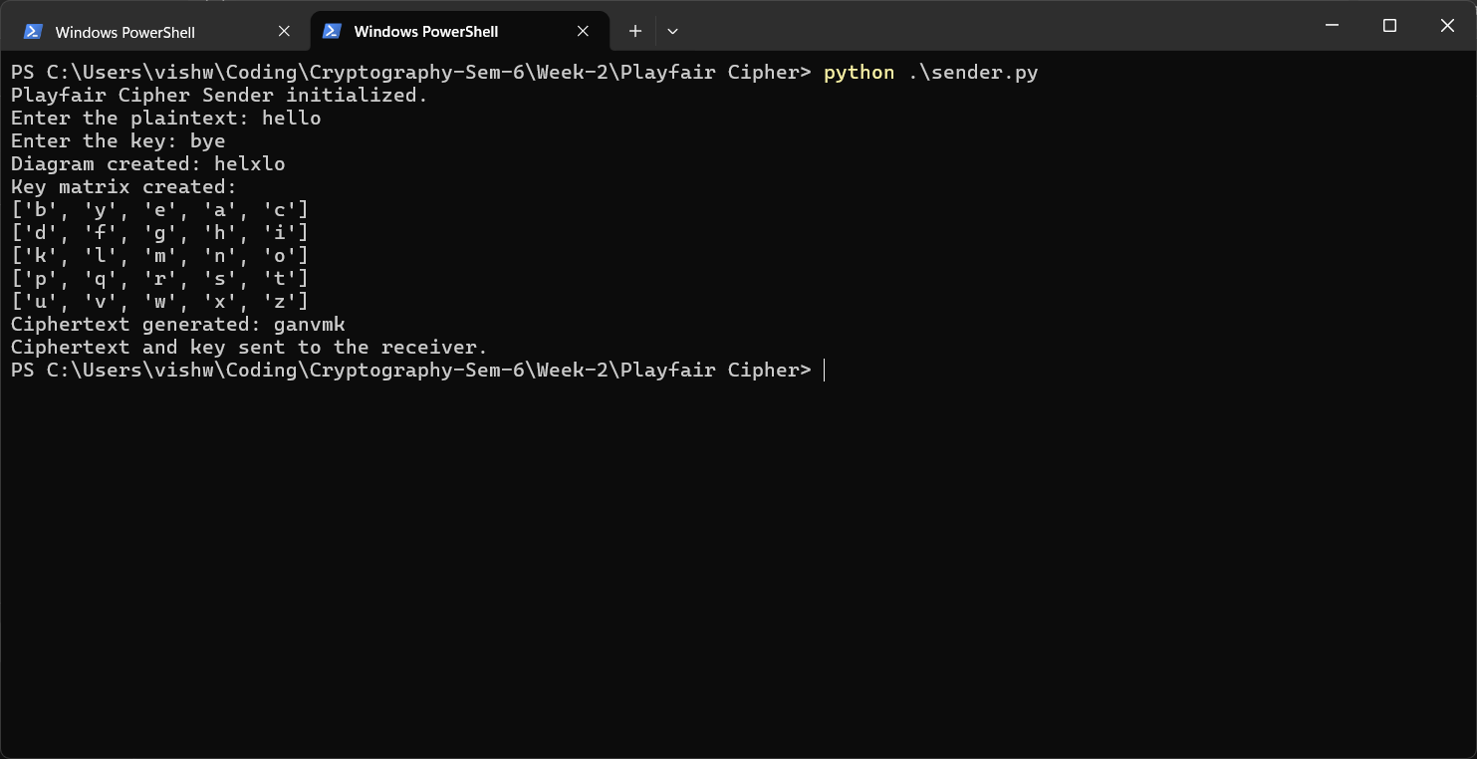

Receiver:
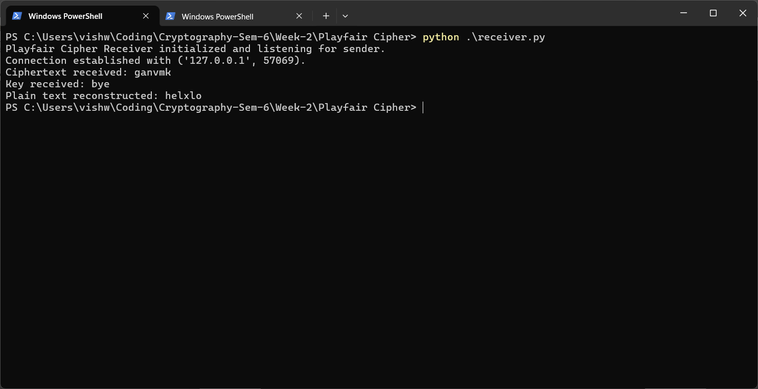

Hill Cipher:

Code:

Sender:
import socket
import numpy as np

def create_key_matrix(key_char_matrix):
key_matrix = [[ord(char) - ord('a') for char in row] for row in key_char_matrix]
return np.matrix(key_matrix, dtype=int)

def create_pt_matrix(pt, n):
pt_matrix = []
for i in range(0, len(pt), n):
row = [ord(char) - ord('a') for char in pt[i:i+n]]
pt_matrix.append(row)
return np.matrix(pt_matrix, dtype=int)

def get_cipher_text(ct_matrix):
ct = ''
for row in ct_matrix:
for num in row.tolist()[0]:
ct += chr(num + ord('a'))
return ct

def get_key_text(key_char_matrix):
key = ''
for row in key_char_matrix:
for char in row:
key += char
return key

print("Hill Cipher Sender initialized.")
n = int(input("Enter the size of the key matrix (n x n): "))
pt = input(f"Enter the plaintext: ").lower()
key_char_matrix = [list(input(f"Enter row {i+1} of the key matrix (space-separated integers and length must be {n}): ").lower()) for i in range(n)]
key_matrix = create_key_matrix(key_char_matrix)
key_text = get_key_text(key_char_matrix)
print("Key Matrix:")
for row in key_matrix:
print(row)
print(f"Key Text: {key_text}")

pt_matrix = create_pt_matrix(pt, n)
print("Plaintext Matrix:")
for row in pt_matrix:
print(row)

ct_matrix = (pt_matrix @ key_matrix) % 26
print("Ciphertext Matrix:")
for row in ct_matrix:
print(row)

ct = get_cipher_text(ct_matrix)
print(f"Ciphertext: {ct}")

s = socket.socket()
s.connect(('127.0.0.1', 5069))
s.send(ct.encode().ljust(1024, b'\0'))
s.send(str(n).encode().ljust(1024, b'\0'))
s.send(key_text.encode().ljust(1024, b'\0'))
print("Ciphertext, key size, and key text sent to receiver.")
s.close()

Receiver:
import socket
import numpy as np

def create_key_matrix(key_text, n):
key_matrix = []
index = 0
for i in range(n):
row = []
for j in range(n):
row.append(ord(key_text[index]) - ord('a'))
index += 1
key_matrix.append(row)
return np.matrix(key_matrix, dtype=int)

def create_ct_matrix(ct, n):
ct_matrix = []
for i in range(0, len(ct), n):
row = [ord(char) - ord('a') for char in ct[i:i+n]]
ct_matrix.append(row)
return np.matrix(ct_matrix, dtype=int)

def get_key_matrix_adjugate(key_matrix):
n = key_matrix.shape[0]
adjugate = np.zeros((n, n), dtype=int)
for i in range(n):
for j in range(n):
minor = np.delete(np.delete(key_matrix, i, axis=0), j, axis=1)
cofactor = int(round(np.linalg.det(minor))) * ((-1) ** (i + j))
adjugate[j][i] = cofactor % 26
return np.asmatrix(adjugate)

def get_plain_text(pt_matrix):
pt = ''
for row in pt_matrix:
for num in row.tolist()[0]:
pt += chr(num + ord('a'))
return pt

server = socket.socket()
server.bind(('127.0.0.1', 5069))
server.listen(1)
print("Hill Cipher Receiver initialized and listening for sender.")

conn, addr = server.accept()
print(f"Connection established with sender at {addr}.")
ct = conn.recv(1024).decode().rstrip('\0')
n = int(conn.recv(1024).decode().rstrip('\0'))
key_text = conn.recv(1024).decode().rstrip('\0')

print(f"Received Ciphertext: {ct}")
print(f"Received Key Size: {n}")
print(f"Received Key Text: {key_text}")

key_matrix = create_key_matrix(key_text, n)
print("Key Matrix:")
for row in key_matrix:
print(row)

ct_matrix = create_ct_matrix(ct, n)
print("Ciphertext Matrix:")
for row in ct_matrix:
print(row)

det = int(round(np.linalg.det(key_matrix))) % 26
det_inverse = pow(det, -1, 26)
print(f"Determinant: {det}")
print(f"Determinant Inverse: {det_inverse}")

key_matrix_inverse = (det_inverse * get_key_matrix_adjugate(key_matrix)) % 26
print("Inverse Key Matrix:")
for row in key_matrix_inverse:
print(row)

pt_matrix = (ct_matrix @ key_matrix_inverse) % 26
print("Plaintext Matrix:")
for row in pt_matrix:
print(row)

pt = get_plain_text(pt_matrix)
print(f"Decrypted Plaintext: {pt}")

conn.close()
server.close()

Output:

Sender:
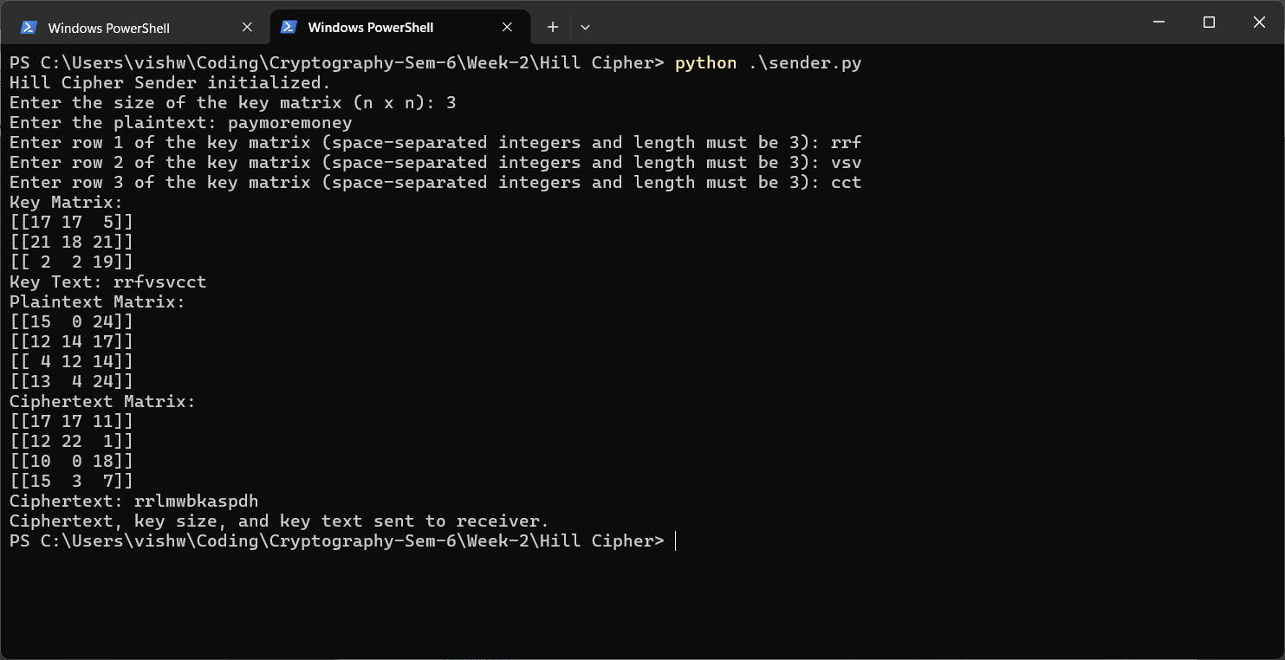

Receiver:
