Course Title: Cryptography and Network Security Lab | Course Code: BCSE309P
Faculty: Prof. Karthika V | Slot: L43 + L44
Regno: 23BCE1145 | Name: S Vishwajith

EX8 – SHA 512

Code:
import copy

Buffers = [
0x6A09E667F3BCC908, 0xBB67AE8584CAA73B, 0x3C6EF372FE94F82B, 0xA54FF53A5F1D36F1,
0x510E527FADE682D1, 0x9B05688C2B3E6C1F, 0x1F83D9ABFB41BD6B, 0x5BE0CD19137E2179
]

Keys = [
0x428A2F98D728AE22, 0x7137449123EF65CD, 0xB5C0FBCFEC4D3B2F, 0xE9B5DBA58189DBBC,
0x3956C25BF348B538, 0x59F111F1B605D019, 0x923F82A4AF194F9B, 0xAB1C5ED5DA6D8118,
0xD807AA98A3030242, 0x12835B0145706FBE, 0x243185BE4EE4B28C, 0x550C7DC3D5FFB4E2,
0x72BE5D74F27B896F, 0x80DEB1FE3B1696B1, 0x9BDC06A725C71235, 0xC19BF174CF692694,
0xE49B69C19EF14AD2, 0xEFBE4786384F25E3, 0x0FC19DC68B8CD5B5, 0x240CA1CC77AC9C65,
0x2DE92C6F592B0275, 0x4A7484AA6EA6E483, 0x5CB0A9DCBD41FBD4, 0x76F988DA831153B5,
0x983E5152EE66DFAB, 0xA831C66D2DB43210, 0xB00327C898FB213F, 0xBF597FC7BEEF0EE4,
0xC6E00BF33DA88FC2, 0xD5A79147930AA725, 0x06CA6351E003826F, 0x142929670A0E6E70,
0x27B70A8546D22FFC, 0x2E1B21385C26C926, 0x4D2C6DFC5AC42AED, 0x53380D139D95B3DF,
0x650A73548BAF63DE, 0x766A0ABB3C77B2A8, 0x81C2C92E47EDAEE6, 0x92722C851482353B,
0xA2BFE8A14CF10364, 0xA81A664BBC423001, 0xC24B8B70D0F89791, 0xC76C51A30654BE30,
0xD192E819D6EF5218, 0xD69906245565A910, 0xF40E35855771202A, 0x106AA07032BBD1B8,
0x19A4C116B8D2D0C8, 0x1E376C085141AB53, 0x2748774CDF8EEB99, 0x34B0BCB5E19B48A8,
0x391C0CB3C5C95A63, 0x4ED8AA4AE3418ACB, 0x5B9CCA4F7763E373, 0x682E6FF3D6B2B8A3,
0x748F82EE5DEFB2FC, 0x78A5636F43172F60, 0x84C87814A1F0AB72, 0x8CC702081A6439EC,
0x90BEFFFA23631E28, 0xA4506CEBDE82BDE9, 0xBEF9A3F7B2C67915, 0xC67178F2E372532B,
0xCA273ECEEA26619C, 0xD186B8C721C0C207, 0xEADA7DD6CDE0EB1E, 0xF57D4F7FEE6ED178,
0x06F067AA72176FBA, 0x0A637DC5A2C898A6, 0x113F9804BEF90DAE, 0x1B710B35131C471B,
0x28DB77F523047D84, 0x32CAAB7B40C72493, 0x3C9EBE0A15C9BEBC, 0x431D67C49C100D4C,
0x4CC5D4BECB3E42B6, 0x597F299CFC657E2A, 0x5FCB6FAB3AD6FAEC, 0x6C44198C4A475817,
]

state = copy.deepcopy(Buffers)

def convert_hex_to_int(h):
if(h==''): return 0
else: return int(h,16)

def number_of_blocks(l):
n = (-l-1-128)%1024
if(n==0): n=1024
return((l+128+n+1)//1024, n)

def rotate_right(w,n):
w=bin(w)[2:].rjust(64,'0')
w=w[-n:]+w[:-n]
return int(w,2)

def shift_512(w,n):
nums=[(1,8,7),(19,61,6)]
x=nums[n]
w=convert_hex_to_int(w)
return (rotate_right(w,x[0]) ^ rotate_right(w,x[1]) ^ w>>x[2])

def sigma(w,n):
nums=[(28,34,39),(14,18,41)]
x=nums[n]
return (rotate_right(w,x[0]) ^ rotate_right(w,x[1]) ^ rotate_right(w,x[2]))

def ch(e,f,g):
return (e & f) ^ ((e ^ (2**64-1)) & g)

def maj(a,b,c):
return (a & b) ^ (b & c) ^ (c & a)

def generate_words(msg):
w = []
for i in range(16):
w.append(msg[16*i:16*i+16])
for i in range(16,80):
nw = ((shift_512(w[i-2],1)+shift_512(w[i-15],0)+convert_hex_to_int(w[i-16])+convert_hex_to_int(w[i-7]))%(2**64))
w.append(hex(nw)[2:])
return w

def sha(msg):
[a,b,c,d,e,f,g,h]=state
words = generate_words(hex(msg)[2:].rjust(256,'0'))
for r in range(80):
t1 = (h+ch(e,f,g)+sigma(e,1)+convert_hex_to_int(words[r])+Keys[r])%(2**64)
t2 = (sigma(a,0)+maj(a,b,c))%(2**64)
nh = g
ng = f
nf = e
ne = (d+t1)%(2**64)
nd = c
nc = b
nb = a
na = (t1+t2)%(2**64)
a,b,c,d,e,f,g,h = na,nb,nc,nd,ne,nf,ng,nh
string_output = "0x"
for x in [a,b,c,d,e,f,g,h]:
string_output+=hex(x)[2:].rjust(16,'0')
print(f"Round {r+1}: {string_output}")
bufs = [a,b,c,d,e,f,g,h]
string_output = "0x"
for i in range(8):
state[i] = (state[i] + bufs[i])%(2**64)
string_output+=hex(state[i])[2:].rjust(16,'0')
print(f"Hash value: {string_output}")

s = input("Enter the string here: ")
h = s.encode('ascii').hex()
l = 4*len(h)
print(f"\nInput bits: {l}")
h = (convert_hex_to_int(h)<<1) + 1
nblocks, npadding = number_of_blocks(l)
h = (h<<(npadding+128))+(l)
print(f"Number of blocks: {nblocks}")
print("Input blocks: 0x",end="")

blocks = []
for i in range(nblocks):
blocks.append(convert_hex_to_int(hex(h)[2+256*i:258+256*i].rjust(256,'0')))
print(hex(h)[2+256*i:258+256*i].rjust(256,'0'), end=" ")
print('\n')

for block in blocks: sha(block)

string_output = "0x"
for i in range(8):
string_output+=hex(state[i])[2:].rjust(16,'0')
print(f"Final Hash: {string_output}")

Output:

Test Case 1:
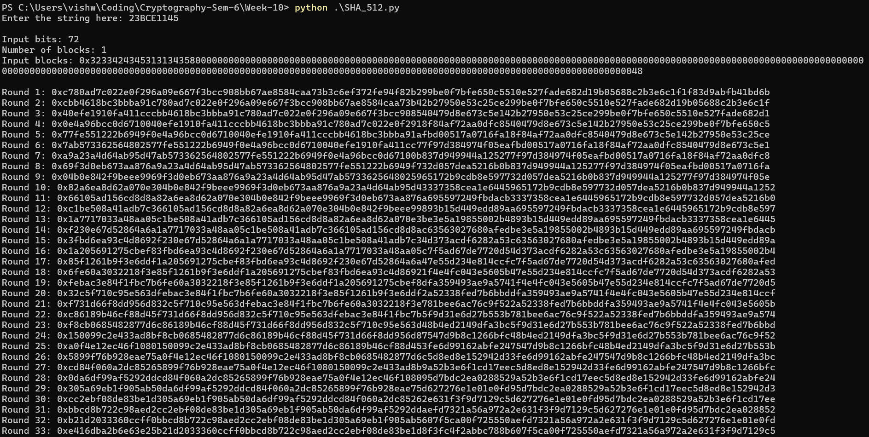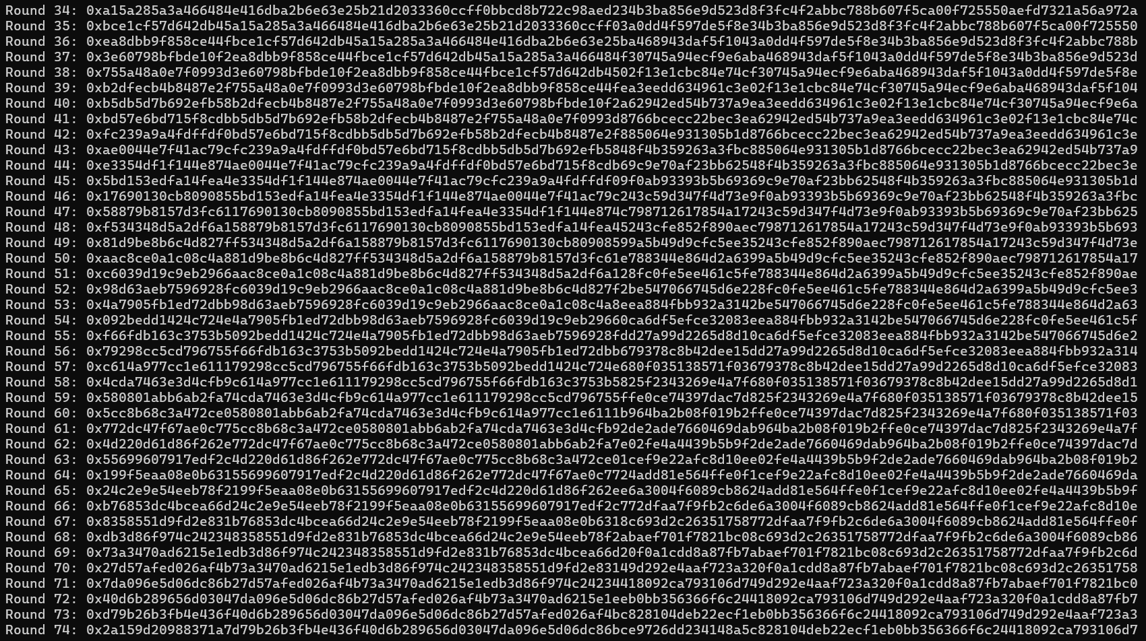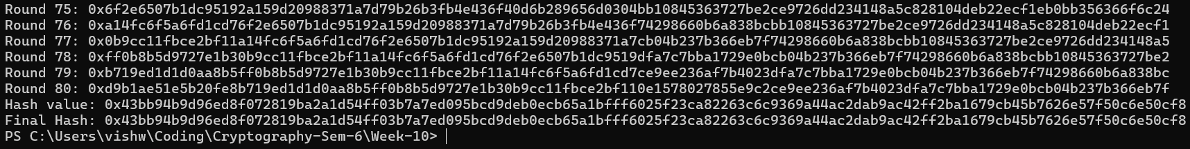

Test Case 2:
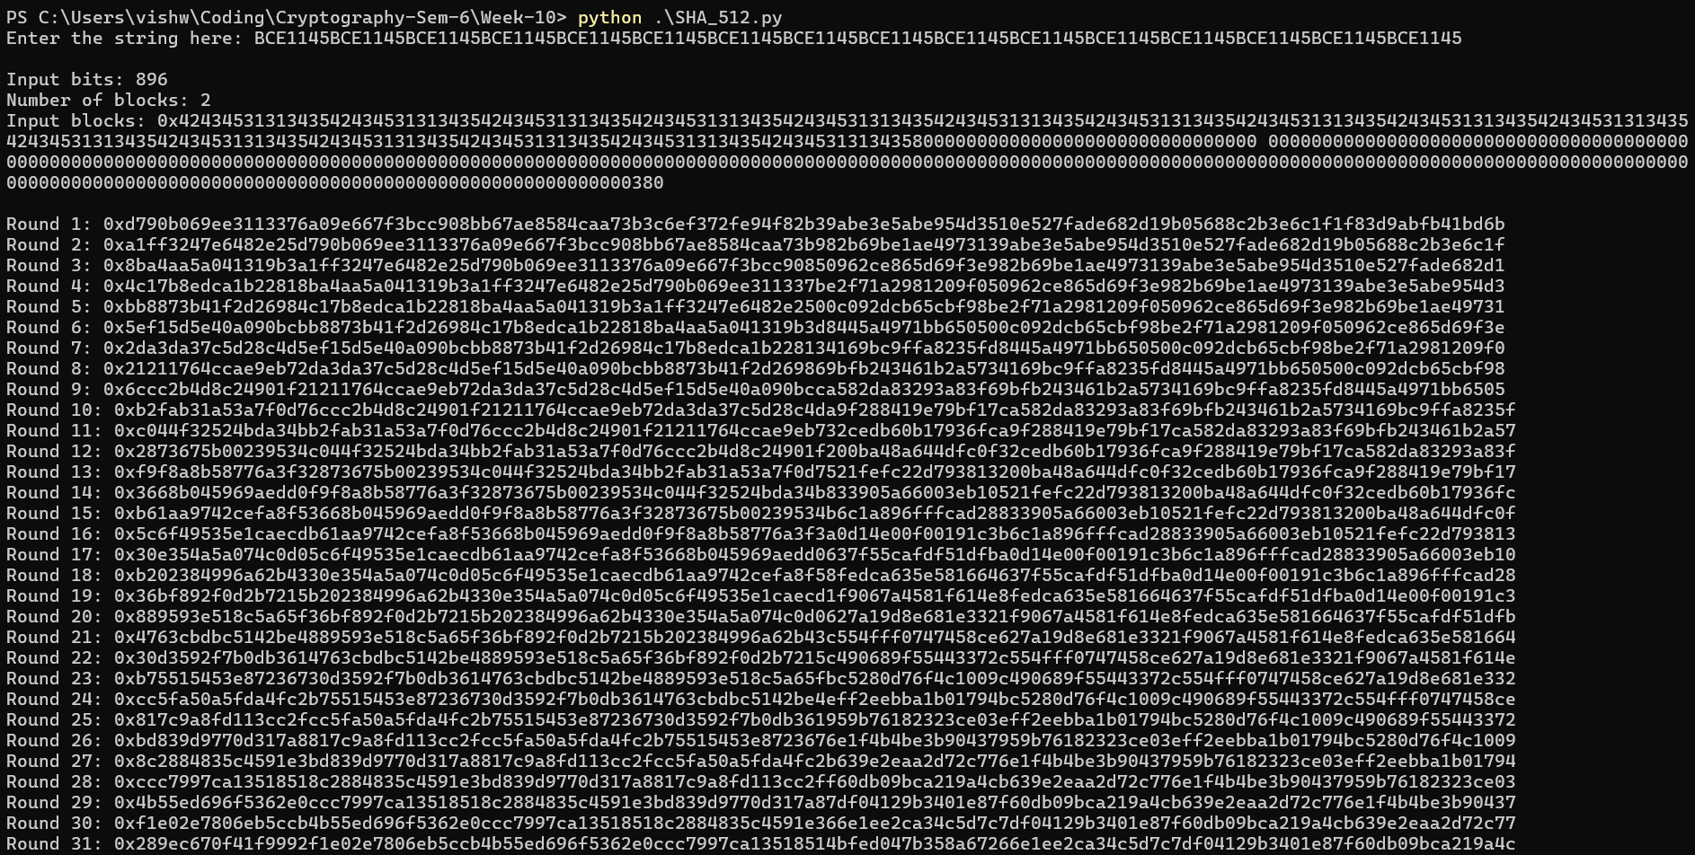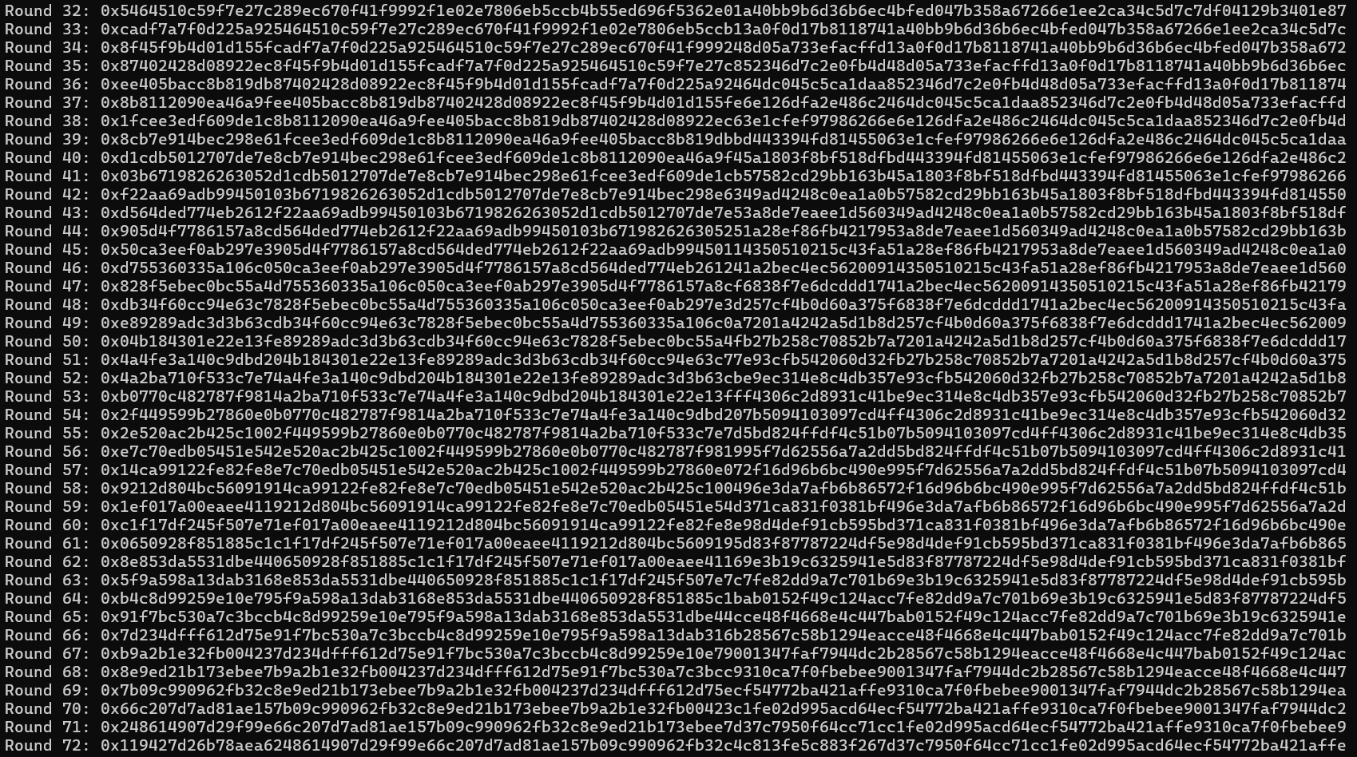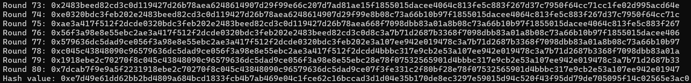
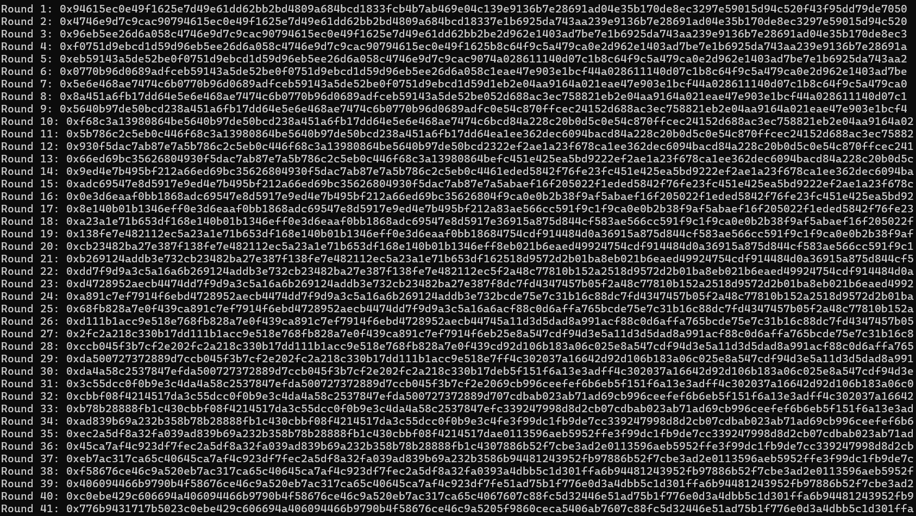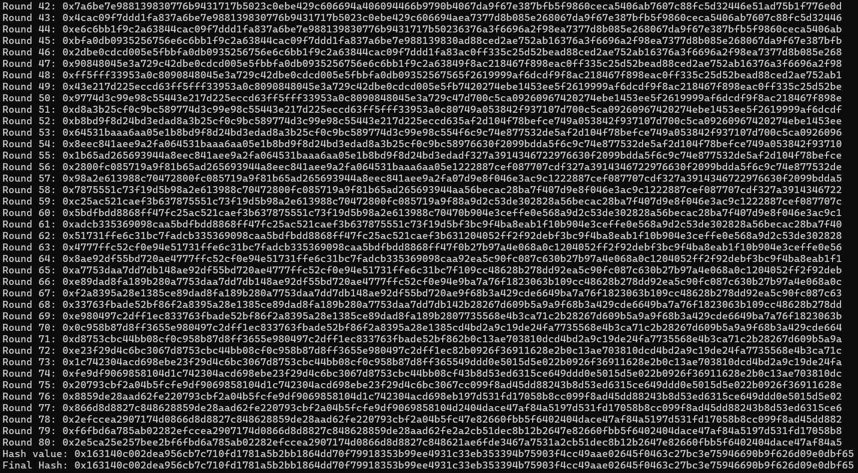

Test Case 3:
