Course Title: Cryptography and Network Security Lab | Course Code: BCSE309P
Faculty: Prof. Karthika V | Slot: L43 + L44
Regno: 23BCE1145 | Name: S Vishwajith

Week 1 – Caesar Cipher

Code:

Sender:
import java.util.*;
import java.io.*;
import java.net.*;
public class Caesar_Sender {
private Socket socket = null;
private DataInputStream input = null;
private DataOutputStream output = null;
private Scanner sc = null;
public Caesar_Sender(String address, int port) {
try {
socket = new Socket(address, port);
System.out.println("Client is connected!");
input = new DataInputStream(socket.getInputStream());
output = new DataOutputStream(socket.getOutputStream());
sc = new Scanner(System.in);
} catch (UnknownHostException u) {
System.out.println(u);
} catch (IOException i) {
System.out.println(i);
}
}
String caesarEncrypt(String pt, int k) {
StringBuilder ct = new StringBuilder();
for (char c : pt.toCharArray()) {
if (Character.isUpperCase(c)) {
int ch = (int) c - 'A';
ch = (ch + k) % 26;
char cs = (char) (ch + 65);
ct.append(cs);
} else if (Character.isLowerCase(c)) {
int ch = (int) c - 'a';
ch = (ch + k) % 26;
char cs = (char) (ch + 97);
ct.append(cs);
} else {
ct.append(c);
}
}
return ct.toString();
}
public void Work() {
try {
System.out.print("Enter the message: ");
String[] ips = sc.nextLine().trim().split("\\s+");
System.out.print("Enter the key: ");
int k = sc.nextInt();
Vector<String> ct = new Vector<>();
for (String word : ips) {
ct.add(caesarEncrypt(word, k));
}
String cts = String.join(" ", ct);
System.out.println("The encrypted text is: " + cts);
output.writeInt(k);
output.writeUTF(cts);
System.out.println(input.readUTF());
input.close();
output.close();
sc.close();
} catch (IOException i) {
System.out.println(i);
}
}
public static void main(String[] args) {
Caesar_Sender cc = new Caesar_Sender("127.0.0.1", 5431);
cc.Work();
}
}

Receiver:
import java.util.*;
import java.io.*;
import java.net.*;
public class Caesar_Receiver {
private ServerSocket server = null;
private Socket socket = null;
private DataInputStream input = null;
private DataOutputStream output = null;
public Caesar_Receiver(int port) {
try {
server = new ServerSocket(port);
socket = server.accept();
System.out.println("Client is connected!\n");
input = new DataInputStream(socket.getInputStream());
output = new DataOutputStream(socket.getOutputStream());
} catch (UnknownHostException u) {
System.out.println(u);
} catch (IOException i) {
System.out.println(i);
}
}
String caesarDecrypt(String ct, int k) {
StringBuilder pt = new StringBuilder();
for (char c : ct.toCharArray()) {
if (Character.isUpperCase(c)) {
int ch = (int) c - 'A';
ch = (ch - k) % 26;
if (ch < 0) {
ch += 26;
}
char cs = (char) (ch + 65);
pt.append(cs);
} else if (Character.isLowerCase(c)) {
int ch = (int) c - 'a';
ch = (ch - k) % 26;
if (ch < 0) {
ch += 26;
}
char cs = (char) (ch + 97);
pt.append(cs);
} else {
pt.append(c);
}
}
return pt.toString();
}
public void Work() {
try {
int k = input.readInt();
String ip = input.readUTF();
String[] ips = ip.trim().split("\\s+");
Vector<String> ct = new Vector<>();
for (String word : ips) {
ct.add(caesarDecrypt(word, k));
}
System.out.println("The received encrypted text is: " + ip);
System.out.println("The received key is: " + k);
String cts = String.join(" ", ct);
System.out.println("The decrypted text is: " + cts);
output.writeUTF("Success from receiver!");
input.close();
output.close();
} catch (IOException i) {
System.out.println(i);
}
}
public static void main(String[] args) {
Caesar_Receiver cs = new Caesar_Receiver(5431);
cs.Work();
}
}

Output:

Sender:
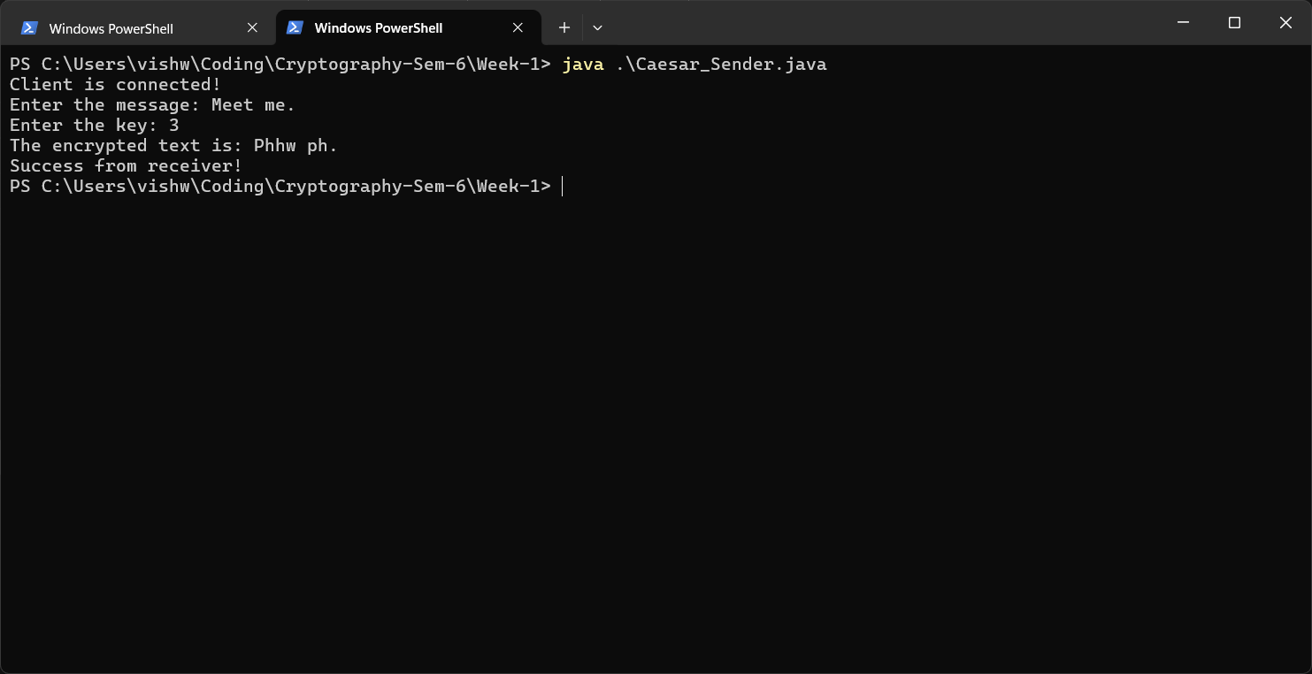

Receiver:
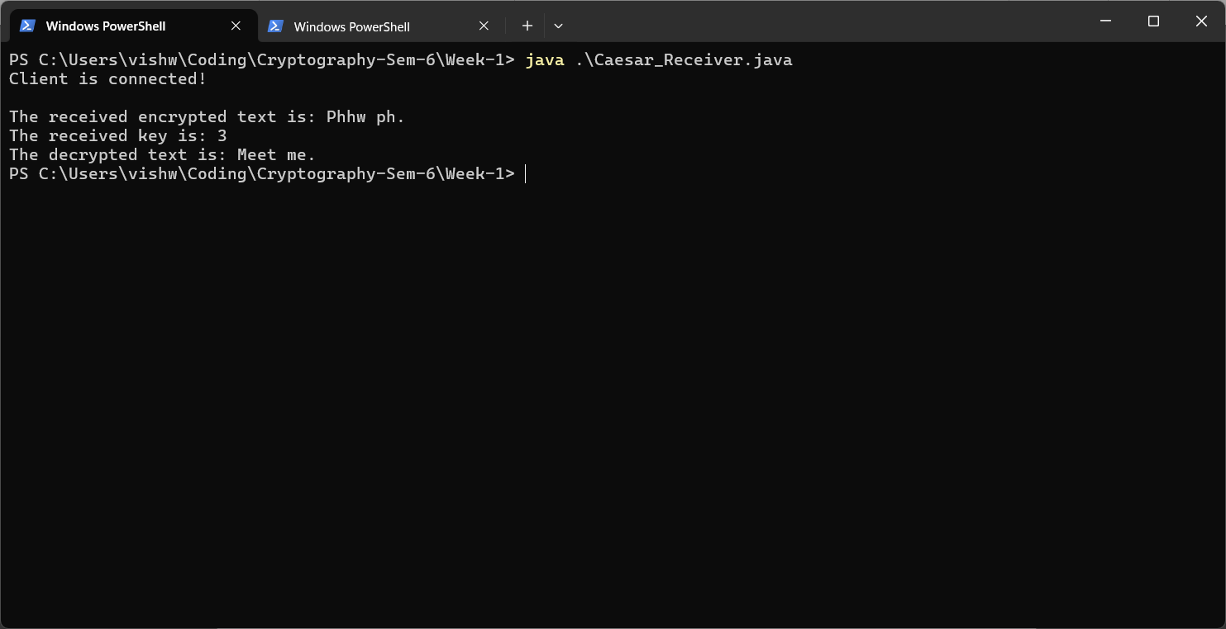
File name
Ex1a _REGNO_NAME.pdf

