Lost and Found Item Tracker
  - Done By: S. Vishwajith 23BCE1145

Integration testing
The following tests were conducted:
- Login button must be rendered when the Employee has logged out.
- Logout button must be rendered when the Employee has logged in.
- To render buttons for item, finder and claimer in the Home Page.
- To show “No finders found” on the finders’ subpage if the list of finders is empty.
- To call the API to fetch finders when the user clicks on the finder button.
- To call the function responsible for maintaining the state of the variable that stores the view of the Home Page (item, finder, claimer).
- To check if the FinderCard component renders the details of the finder perfectly in a card-like format.
- To check if the FinderCard component shows the edit and delete buttons only when the employee has logged in.
- To check if the delete button of the FinderCard component calls the function responsible for deleting the respective finder.
- To check if the ItemCard component renders the details of the finder perfectly in a card-like format.
- To check if the ItemCard component shows the edit and delete buttons only when the employee has logged in.
- To check if the delete button of the ItemCard component calls the function responsible for deleting the respective item.
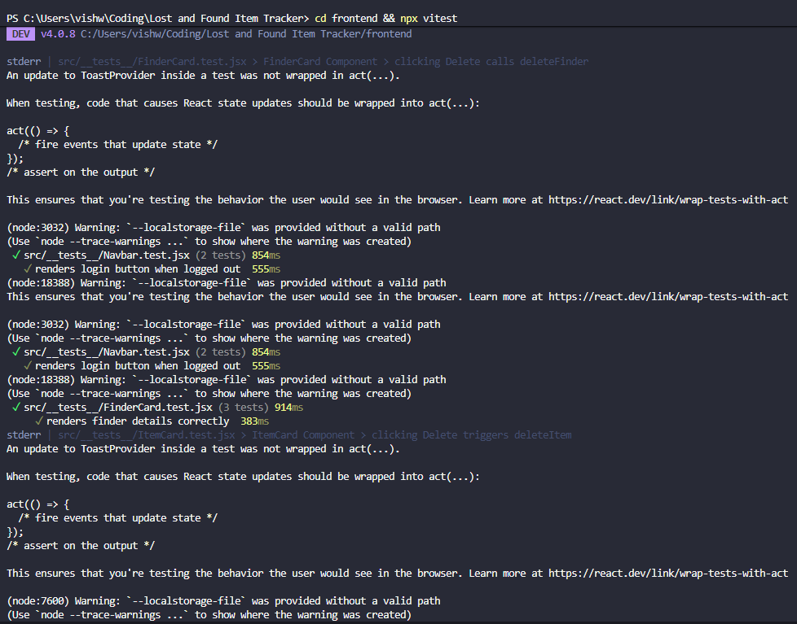
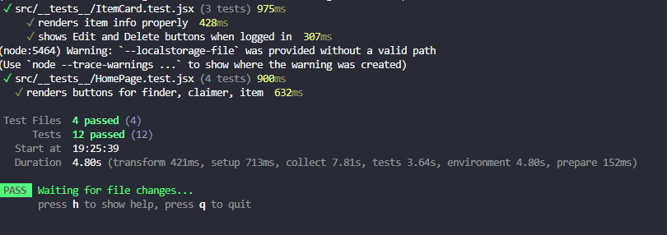

Version Management
Version Management of this project was handled using the open-source version control tool “git”. The commit tree is as follows:
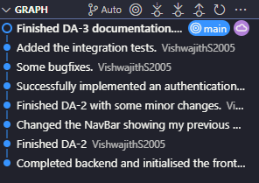

Developed Functionalities

Homepage for viewers:
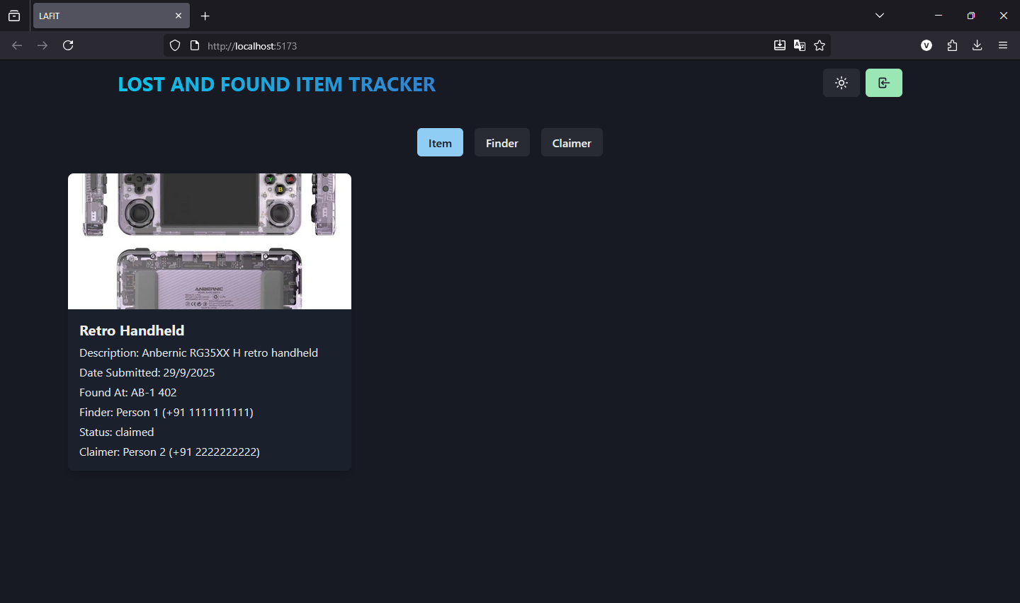
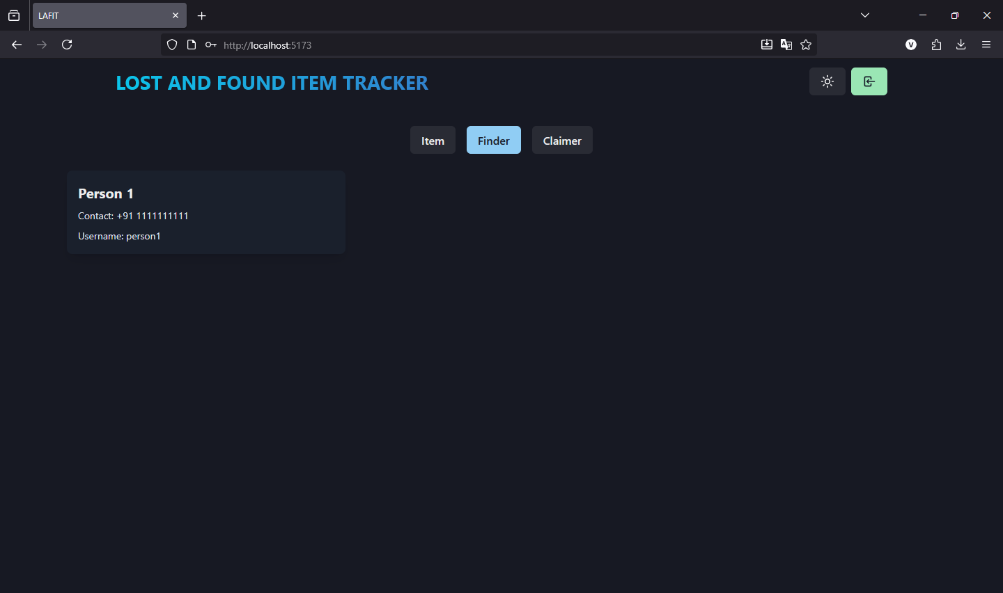
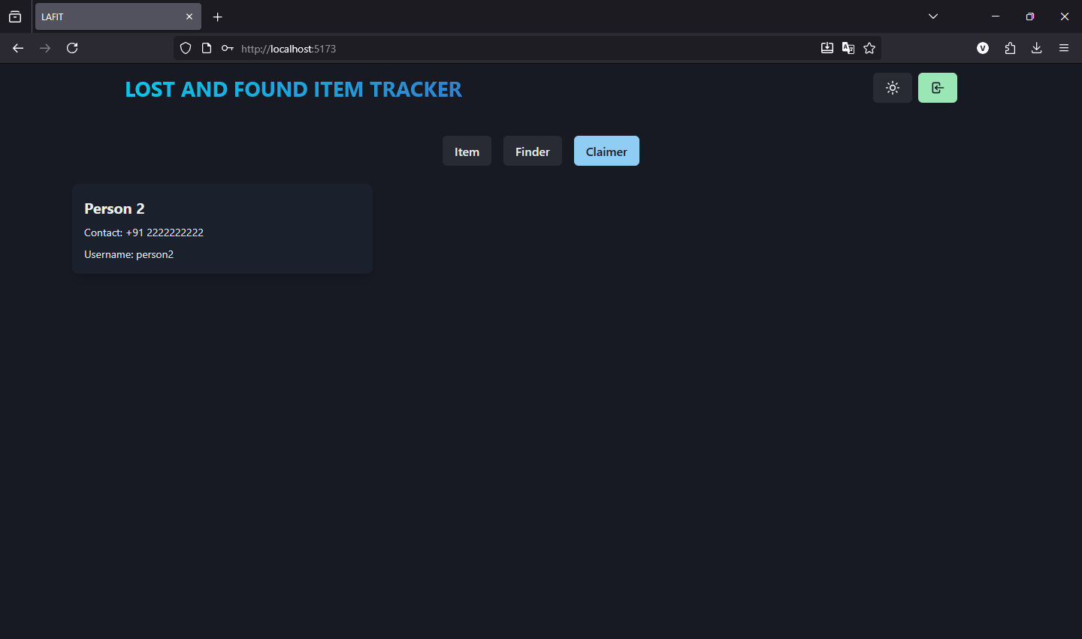

Light mode and Dark mode:
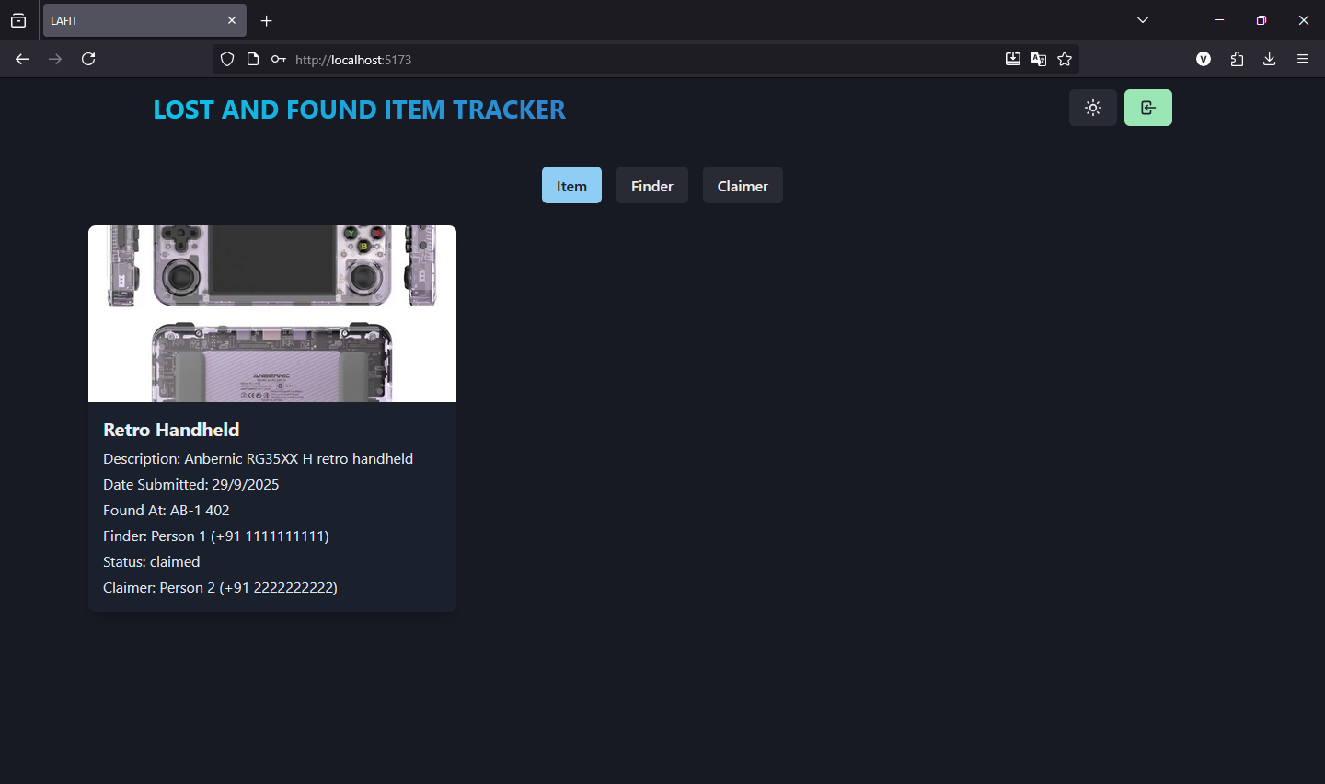
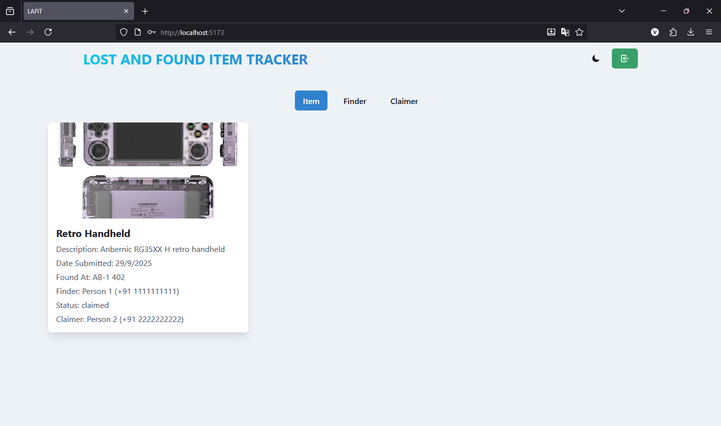

Login/Logout:
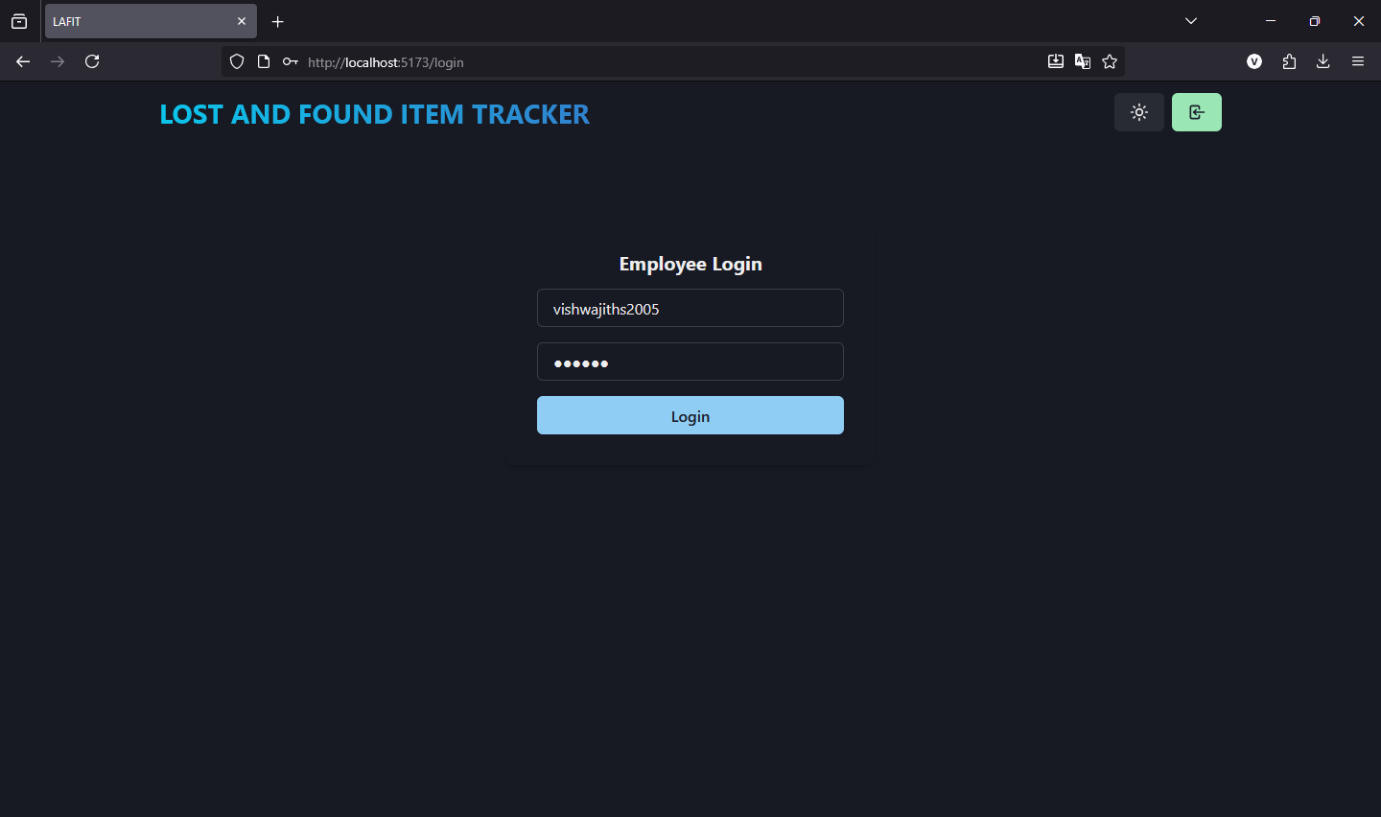
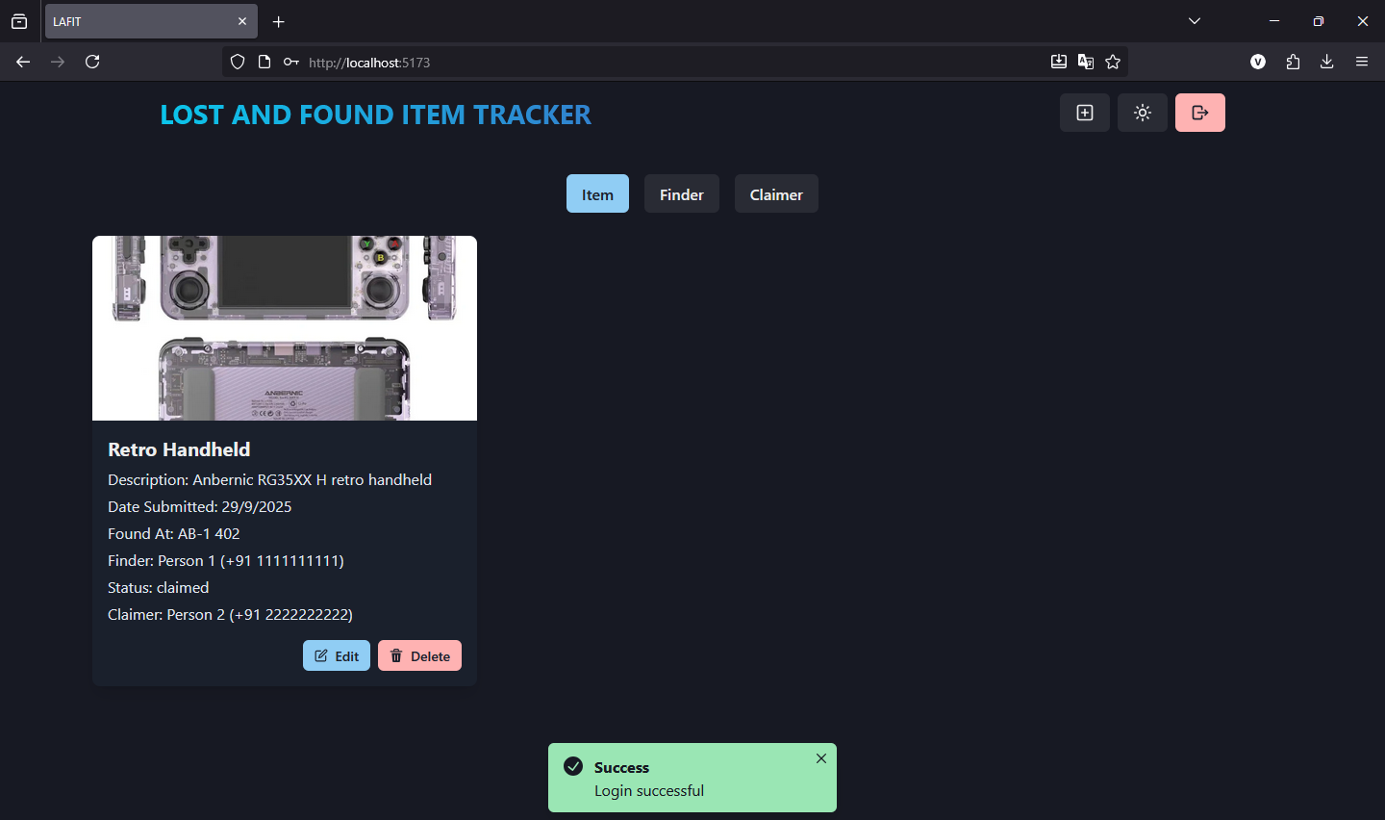
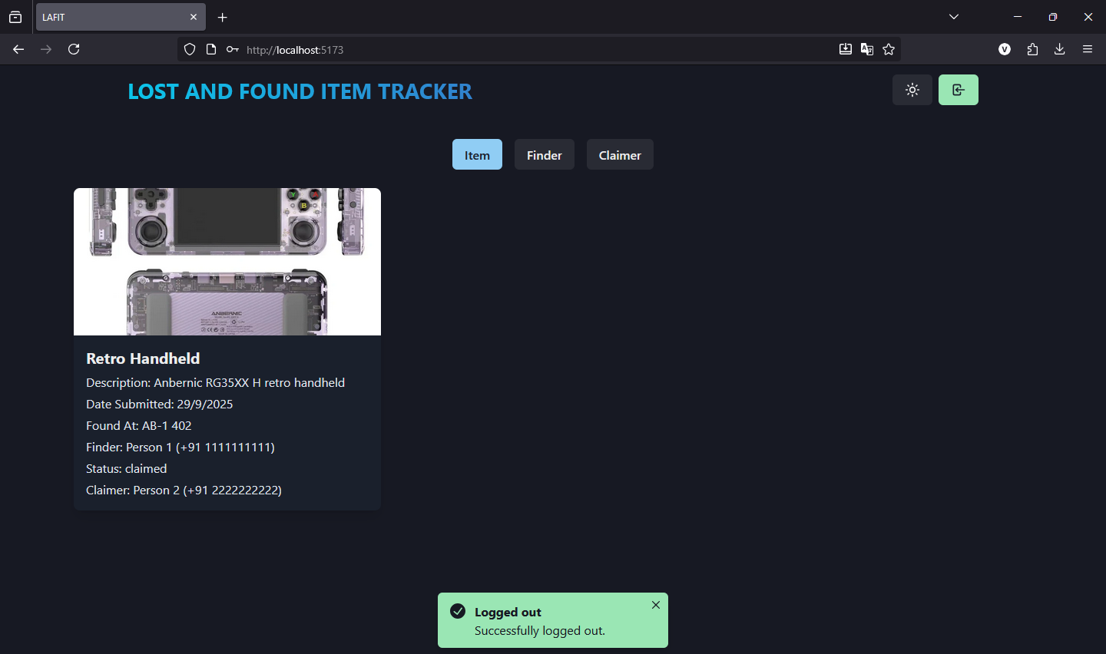

Homepage for Employees:
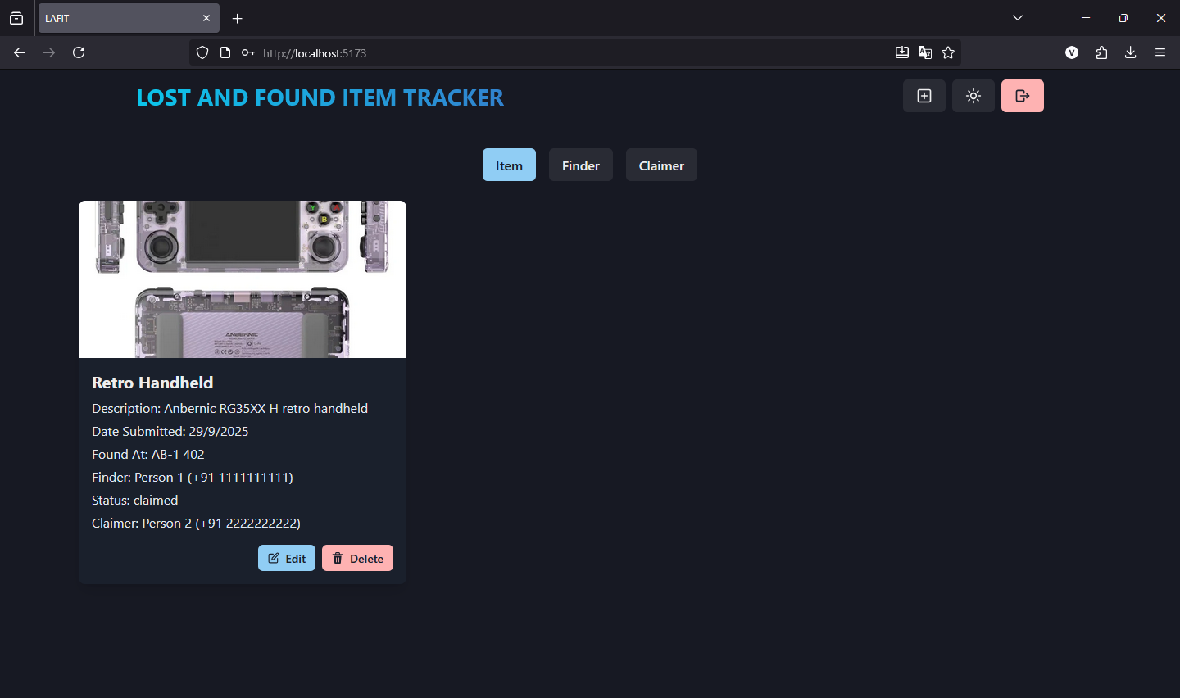
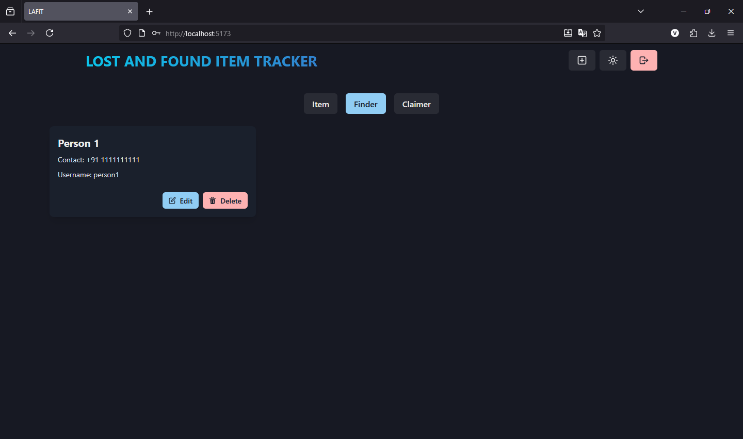
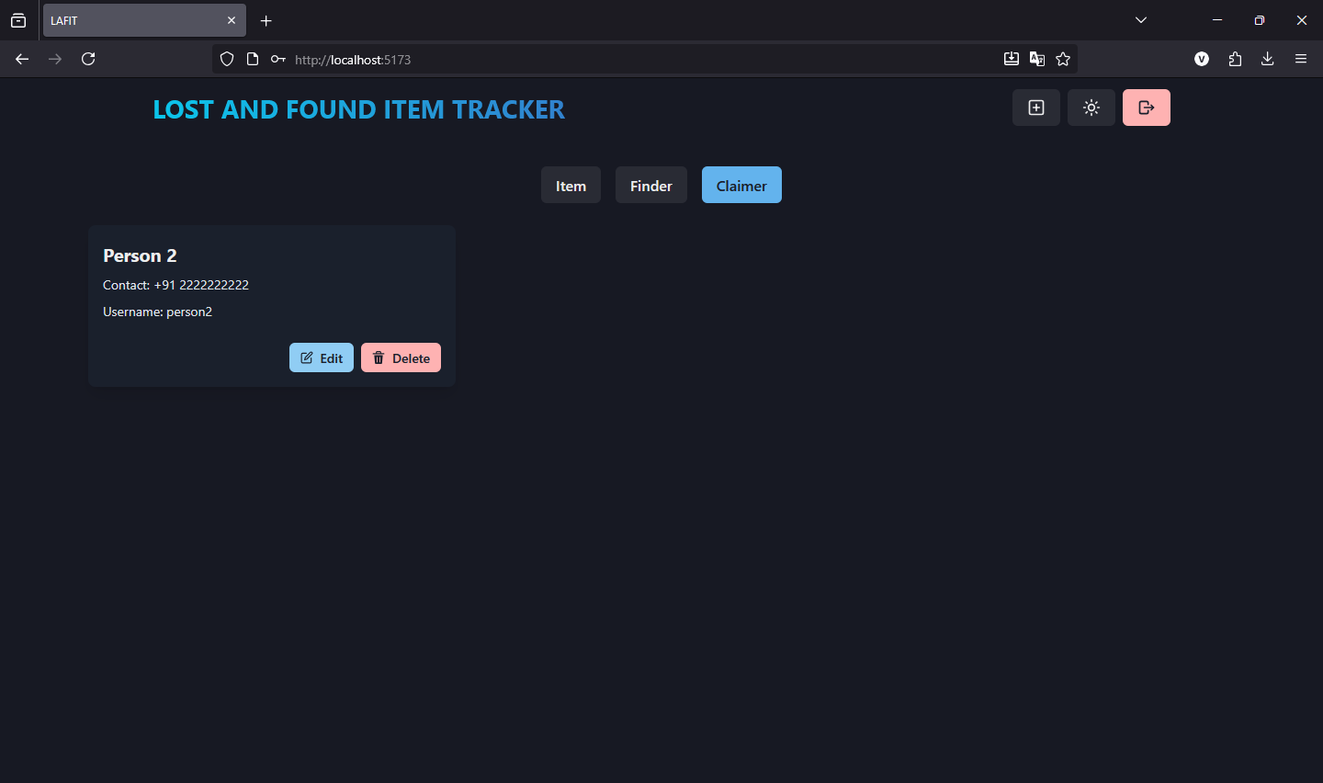

Create Pages for Item, Finder and Claimer to add new Items, Finders and Claimers:
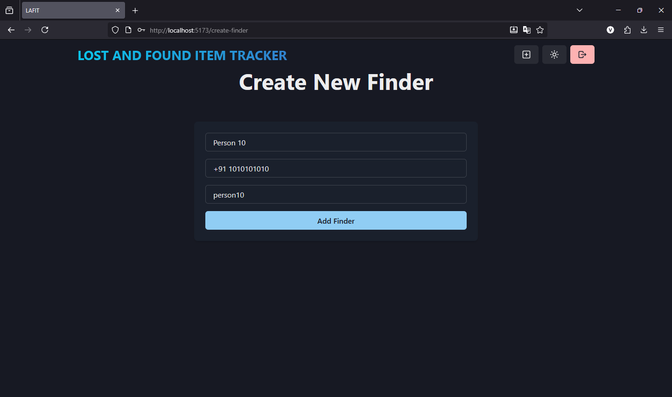
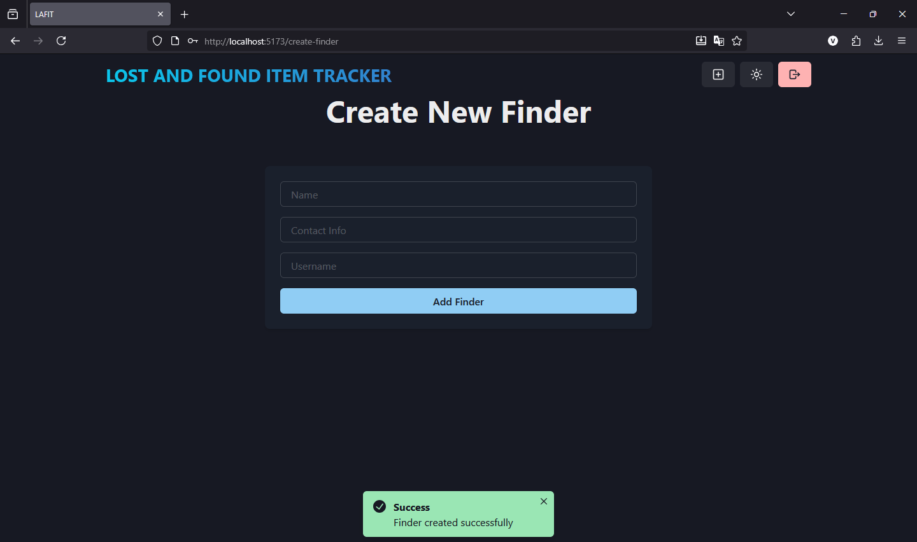
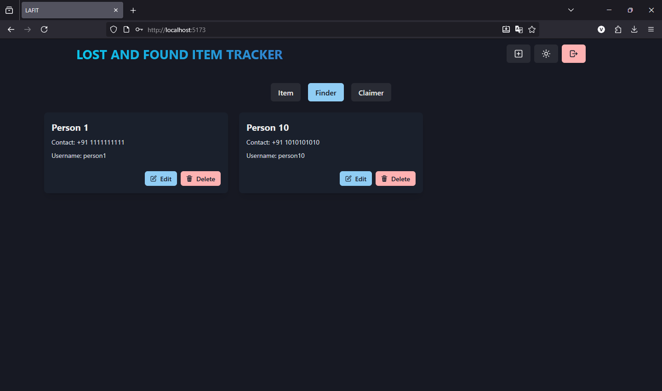
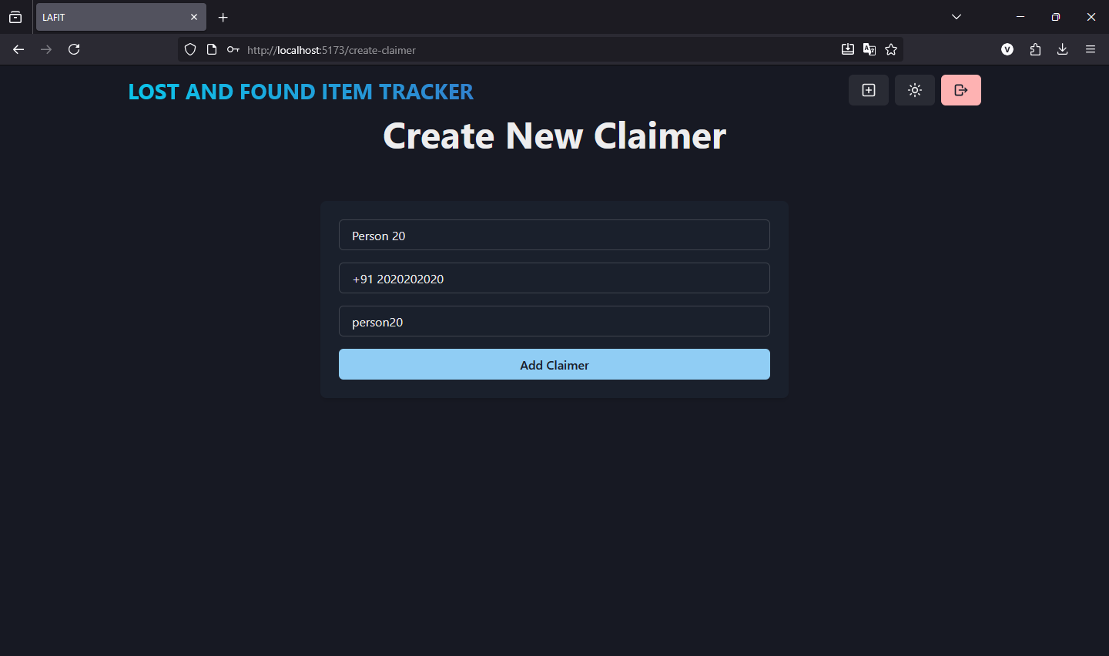
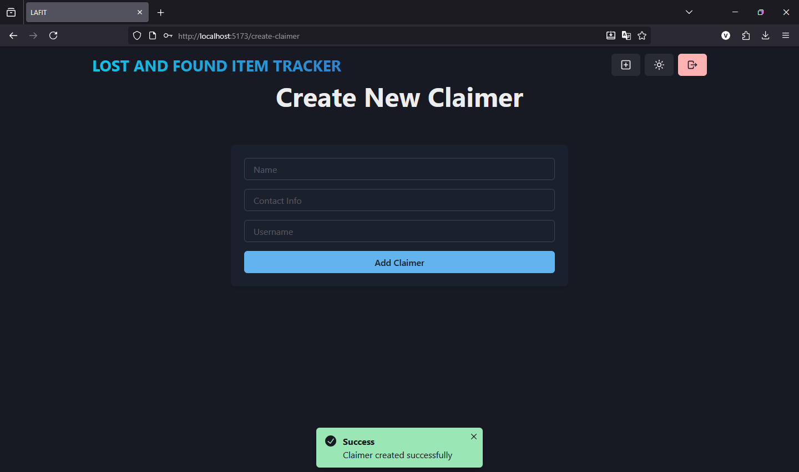
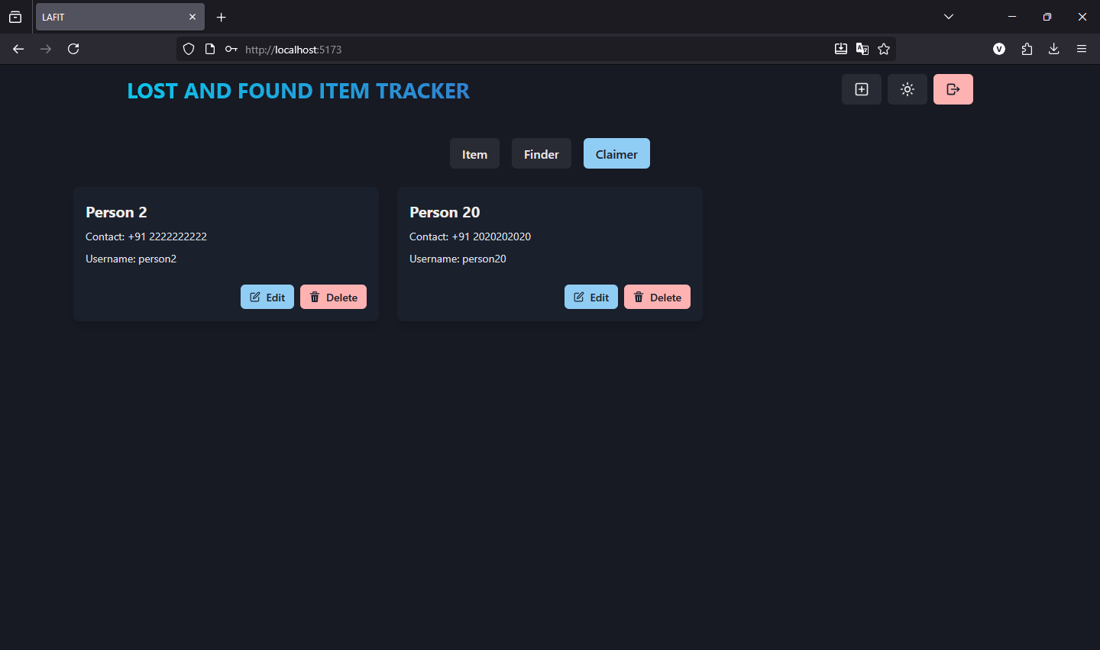
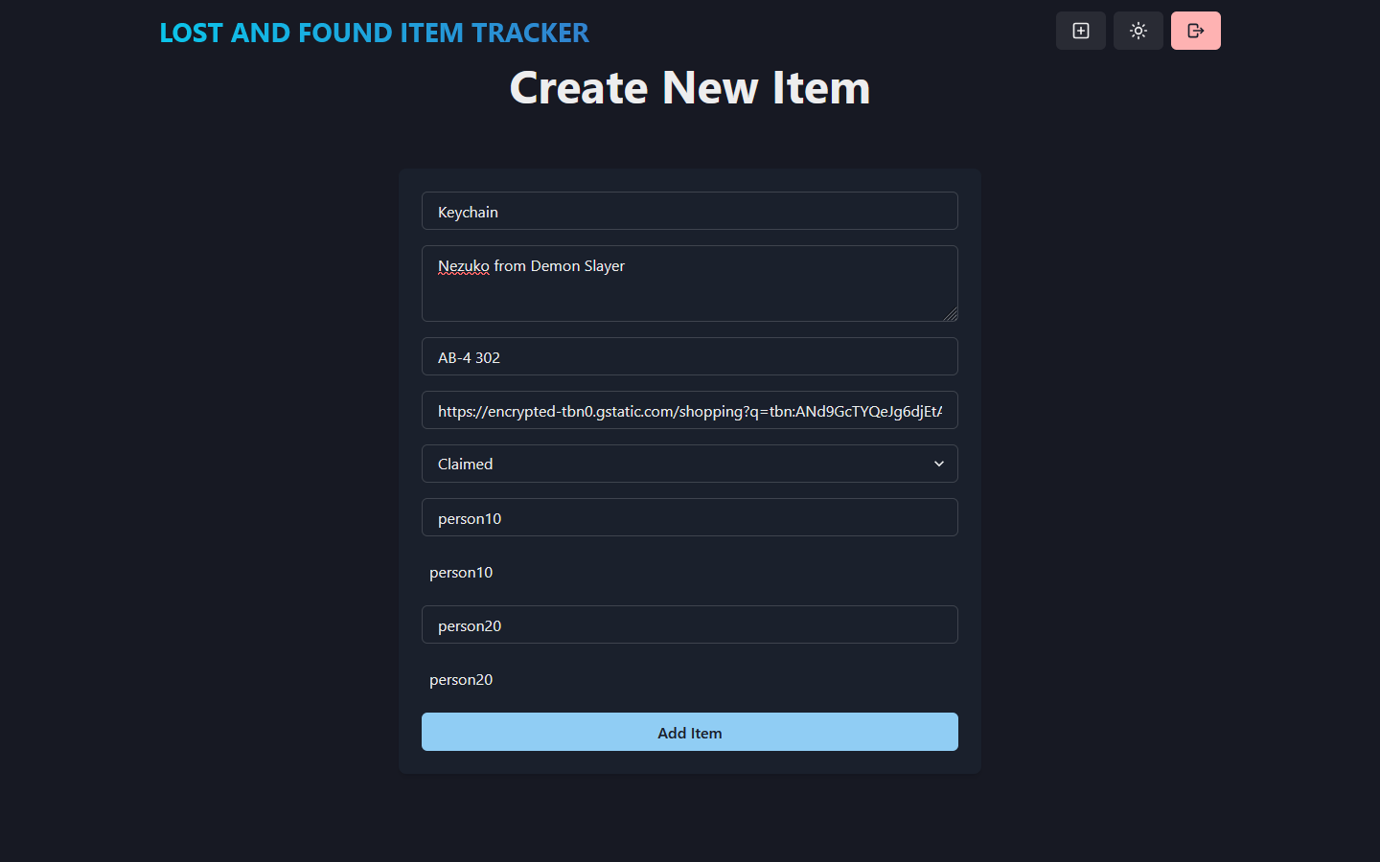
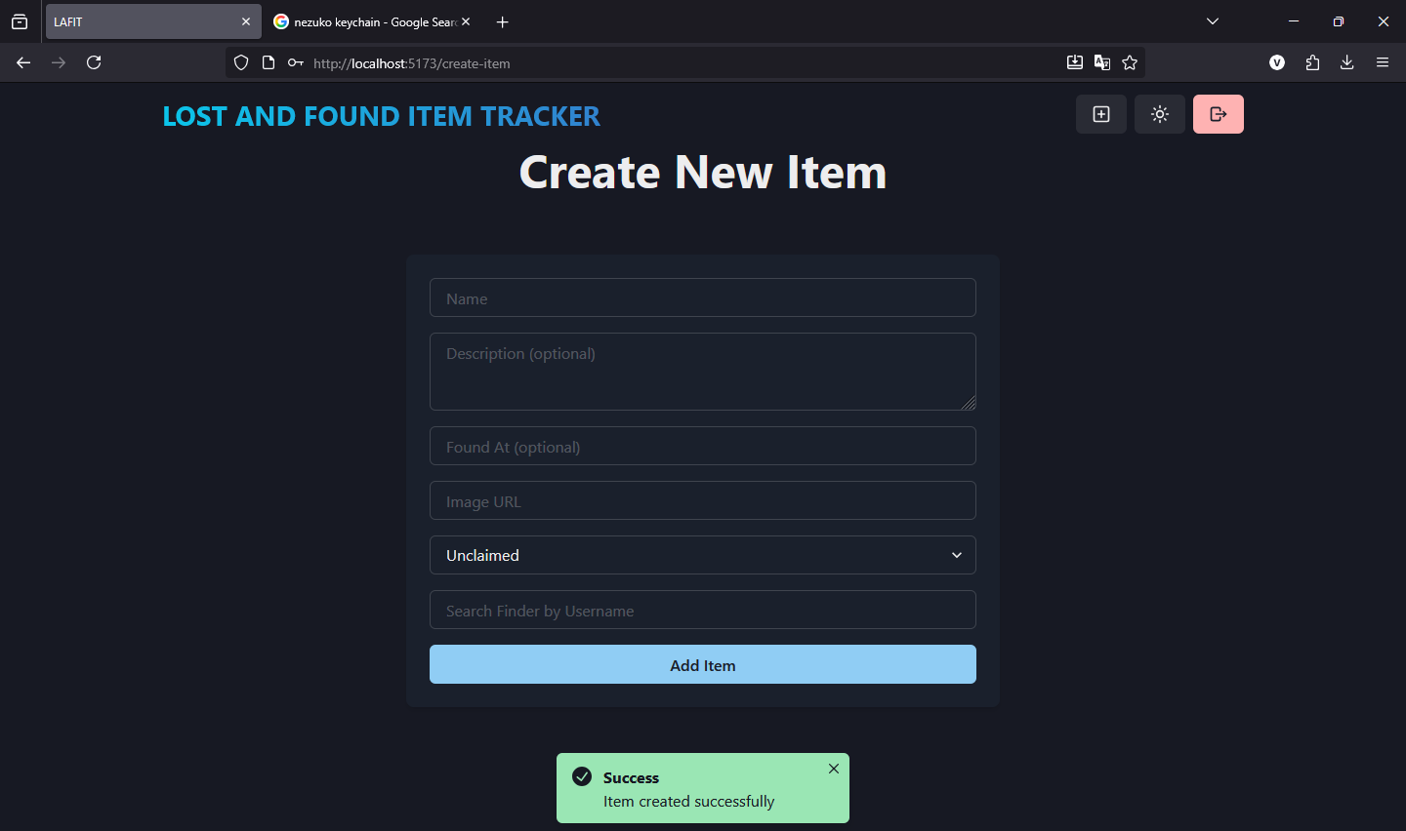
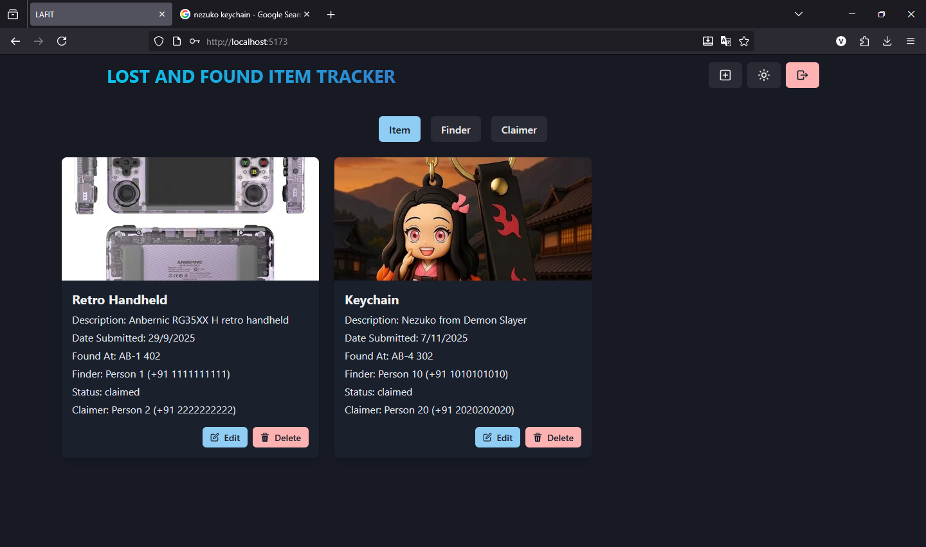

Editing of Items, Finders and Claimers:
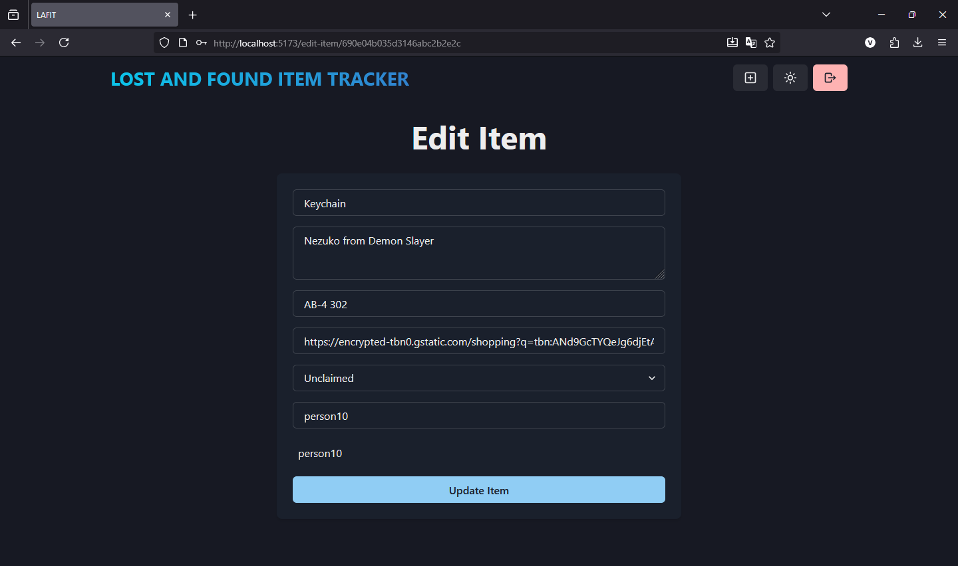
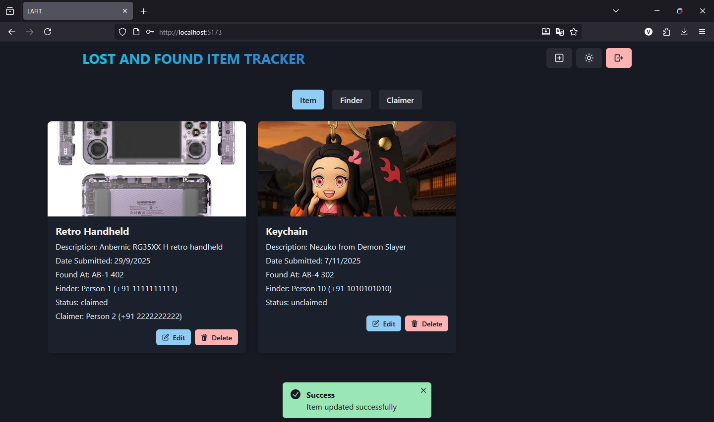
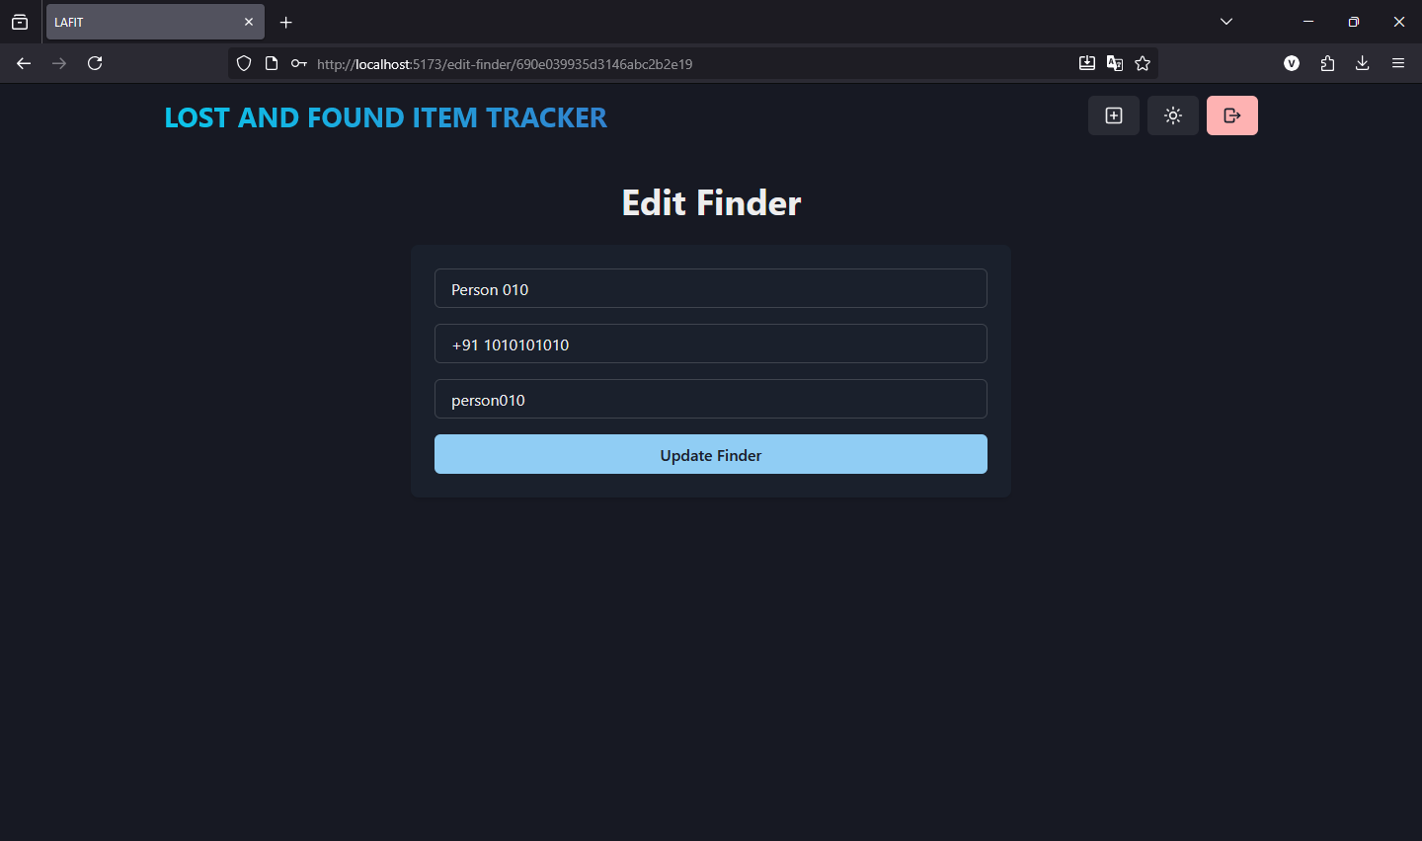
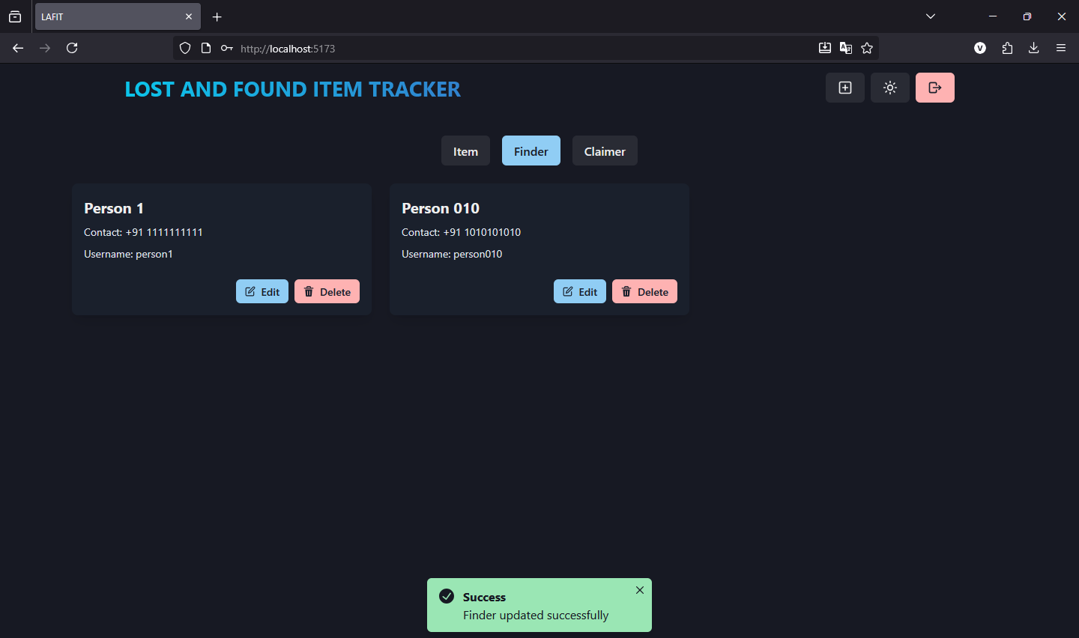
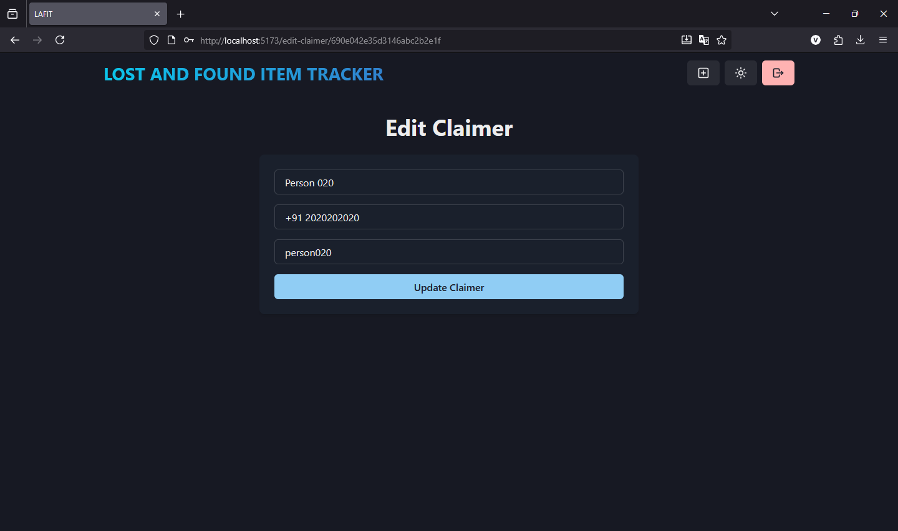
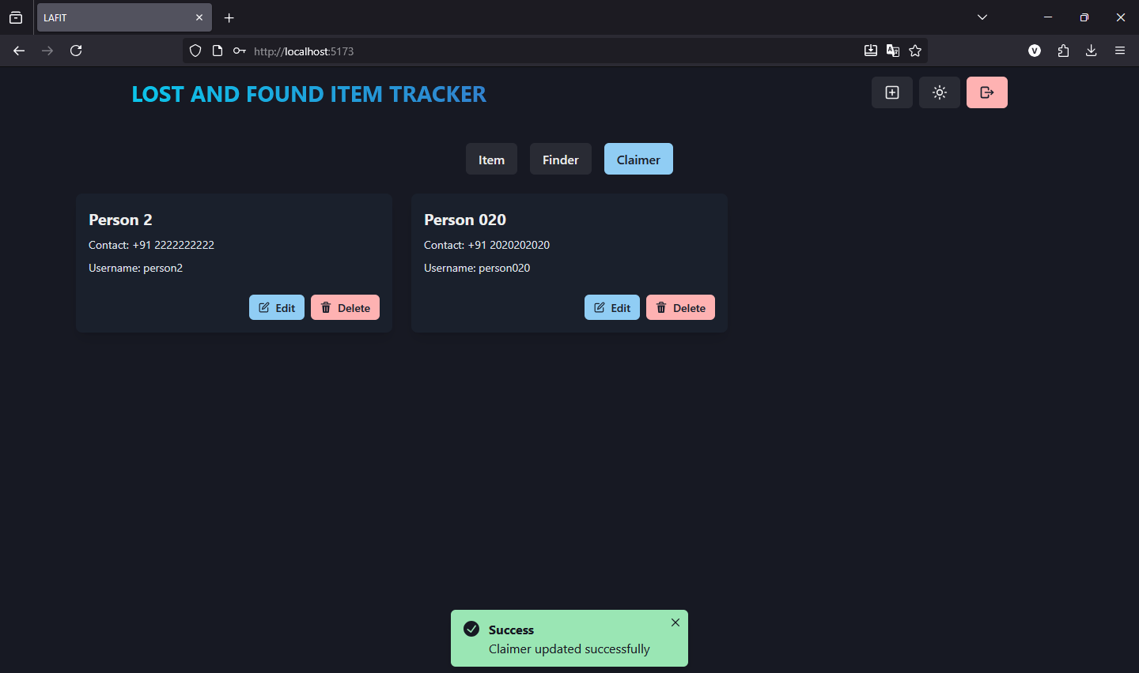
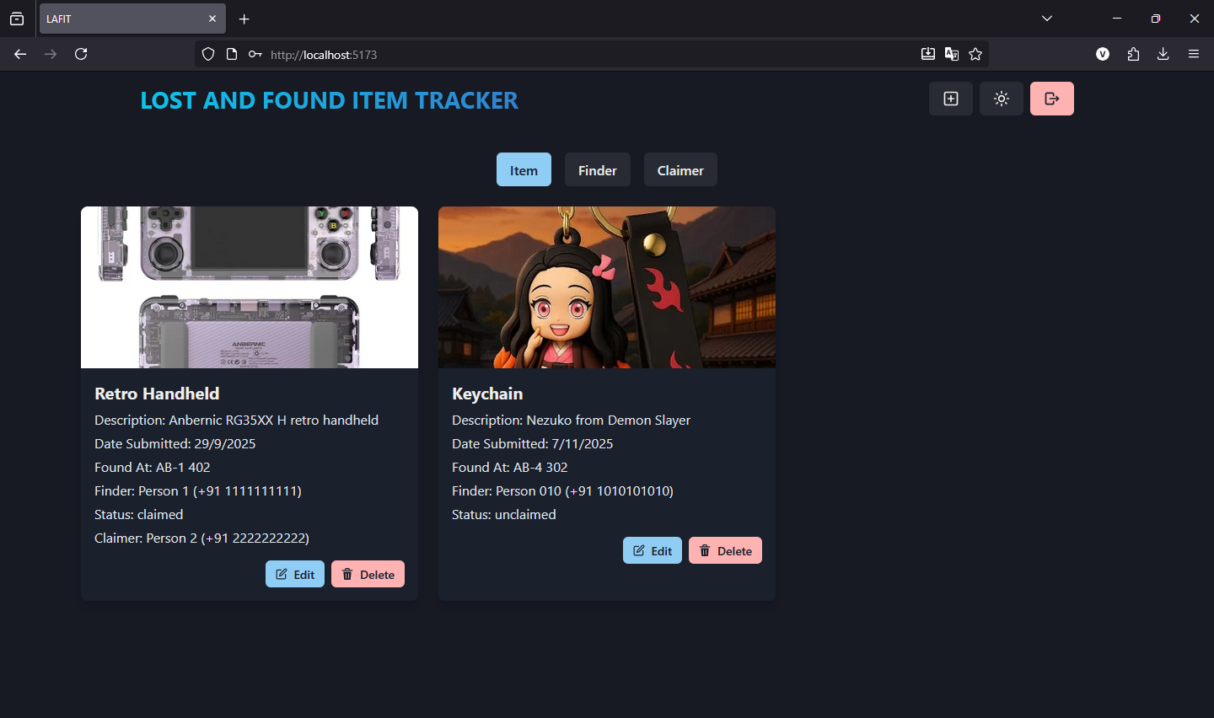

Deletion of Items, Finders and Claimers:
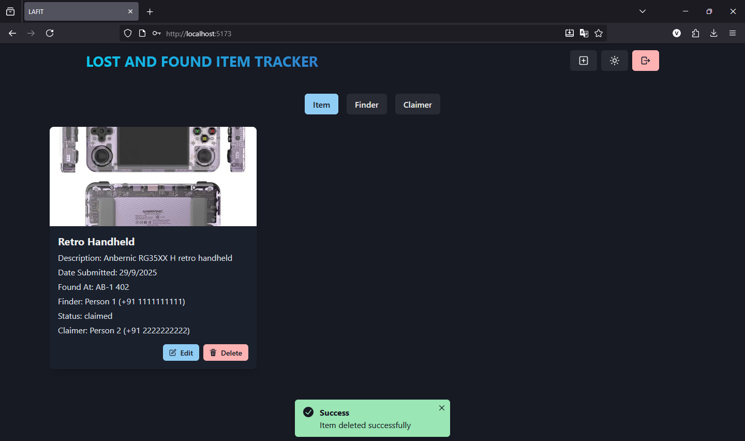
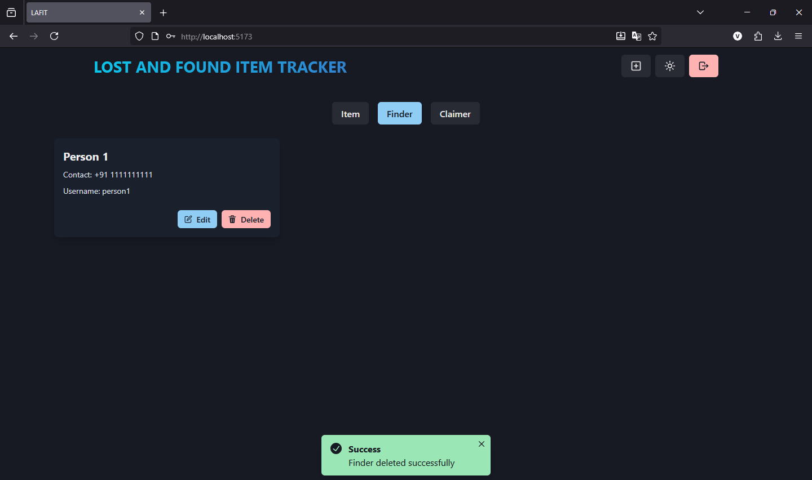
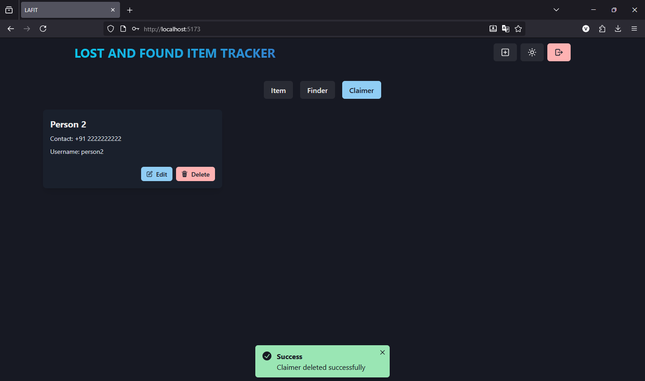

Tools and Technologies Used
- Frontend - ReactJS
- Backend - NodeJS
- APIs - ExpressJS
- Database - MongoDB
- IDE - VSCode
- Version Control - Git
- Repository - GitHub

