ASSIGNMENT - 4
NAME: VISHWAK NOMULA | ROLL NO: 2503B05120 | MTECH(CSE)
Lab 4: Advanced Prompt Engineering – Zero-shot, One-shot, and Few-shot Techniques
LabObjectives:
● To explore and apply different levels of prompt examples in AI-assisted code
generation.
● To understand how zero-shot, one-shot, and few-shot prompting affect AI output
quality.
● To evaluate the impact of context richness and example quantity on AI performance.
● To build awareness of prompt strategy effectiveness for different problem types.
LabOutcomes(LOs):
After completing this lab, students will be able to:
● Use zero-shot prompting to instruct AI with minimal context.
● Use one-shot prompting with a single example to guide AI code generation.
● Apply few-shot prompting using multiple examples to improve AI responses.
● Compare AI outputs across the three prompting strategies

Task Description#1
● Zero-shot: Prompt AI to write a function that checks whether a given year is a leap
year.
Expected Output#1
●AI-generated function with no examples provided
Prompt-1: write a function that checks whether a given year is a leap year.
CODE:
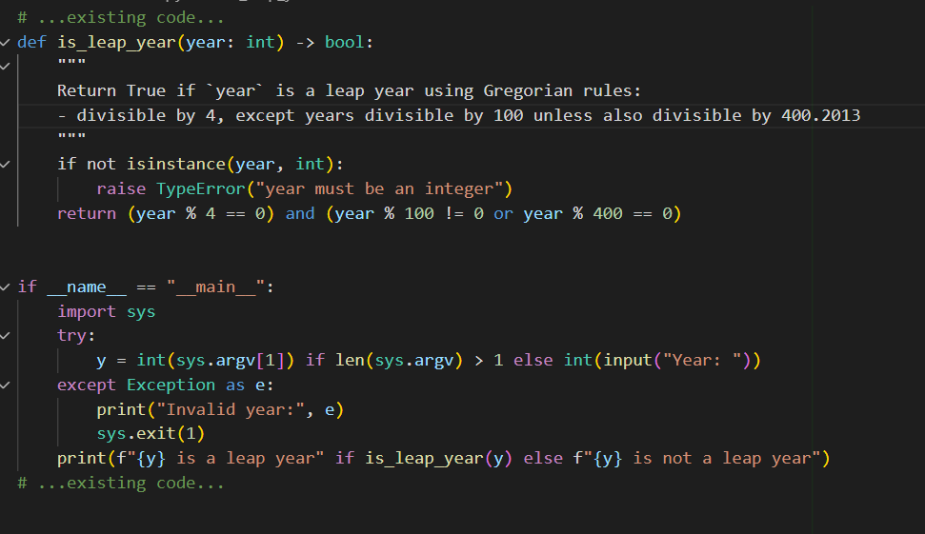

OUTPUT:
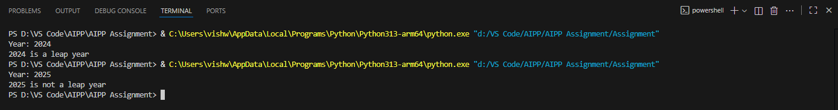

Task Description#2
● One-shot: Give one input-output example to guide AI in writing a function that converts centimeters to inches.
Expected Output#2
● Function with correct conversion logic
Prompt-1: Give a python code that converts centimeters to inches
Prompt-2: Take input from user
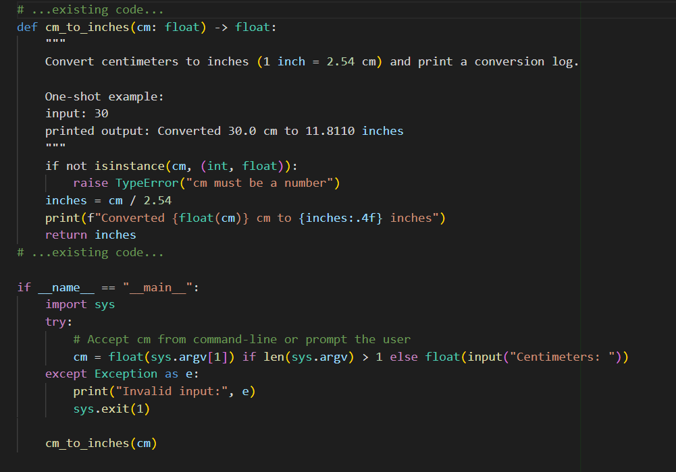
OUTPUT:
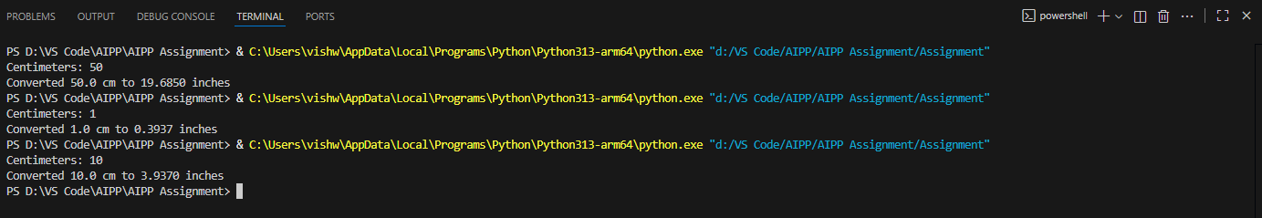

Task Description#3
● Few-shot: Provide 2–3 examples to generate a function that formats full names as
“Last, First”.
Expected Output#3
● Well-structured function respecting the examples
Prompt-1: to generate a function that formats full names as “Last, First”.
Prompt-2: Modify the given function to accept input from the user.
CODE:
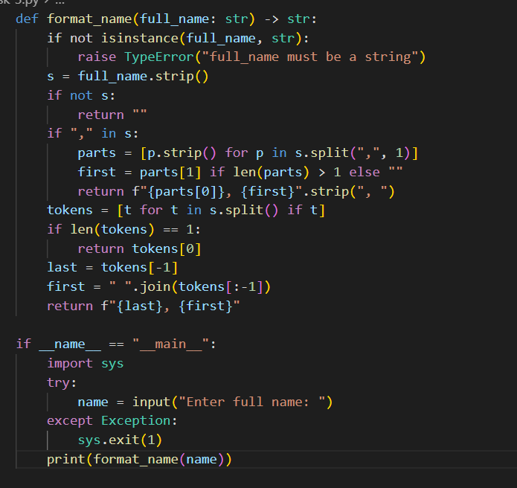
OUTPUT:
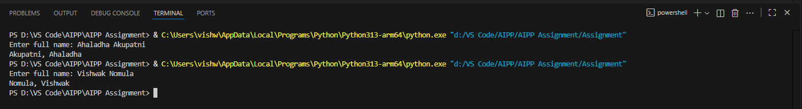
Task Description#4
● Compare zero-shot and few-shot prompts for writing a function that counts the
number of vowels in a string.
Expected Output#4
● Functional output and comparative reflection
Prompt-1: Compare zero-shot and few-shot prompts for writing a function that counts the
number of vowels in a string.
CODE:
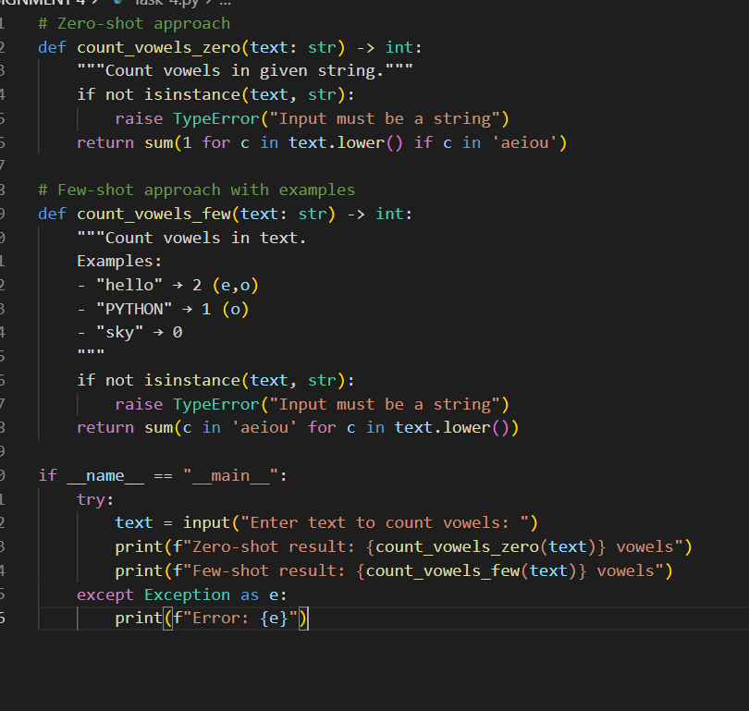
OUTPUT:
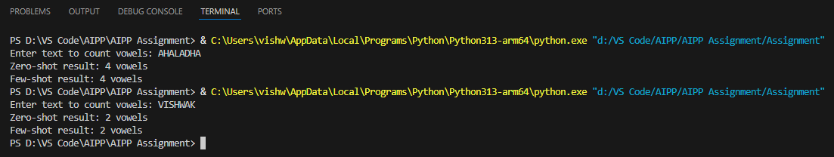

Comparative Reflection
- Zero-shot vs Few-shot Differences:
  - Zero-shot implementations are more concise but lack context
  - Few-shot versions include examples that clarify edge cases
  - Both approaches produce identical results
- Documentation Quality:
  - Few-shot docstrings are more helpful with concrete examples
  - Zero-shot documentation is minimal but sufficient
- Code Complexity:
  - Implementation complexity is similar
  - Few-shot approach leads to more robust error handling due to example-driven development

Task Description#5
● Use few-shot prompting to generate a function that reads a .txt file and returns the
number of lines.
Expected Output#5
● Working file-processing function with AI-guided logic
Prompt-1: Generate a function that reads a .txt file and return number of lines
Prompt-2: Write a working file-processing Python function that reads a .txt file and returns the number of lines.
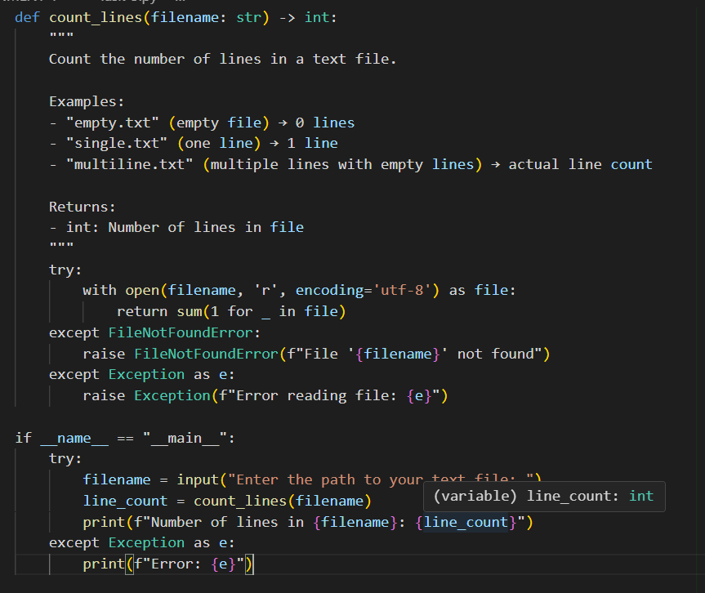
OUTPUT:
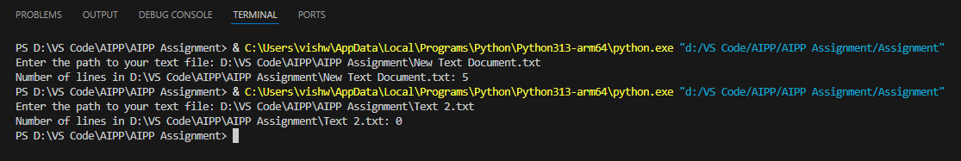

How to Test
- Create sample text files in the same directory:
  - test1.txt (empty file)
  - test2.txt (with some content)
- Run in VS Code Terminal:
Python "D:\Downloads\AAIP_ASSIGNMENT\Assignment-4\New Text Document.txt"

- Enter the file path when prompted:
Enter the path to your text file: test2.txt

Features:
- Error handling for missing files
- UTF-8 encoding support
- Memory efficient (streams file)
- Example-driven implementation
- User-friendly interface

Note: Report should be submitted a word document for all tasks in a single document with
prompts, comments & code explanation, and output and if required, screenshots
Evaluation Criteria:
Criteria Max Marks
Zero Shot (Task #1) 2.5
One Shot (Task#2) 2.5
Few Shot (Task#3 & Task #5) 2.5
Comparison (Task#4) 2.5
Total 10 Marks

