1. Title of the project
Adaptive Ransomware Detection System: A Hierarchical Automata Approach

2. Team members list
- Gudivada Vishwak Sai (24BYB0053)
- Kankanala Havish Kumar (24BYB0057)

3. Aim of the project
The aim of this project is to build a deterministic, behaviour-based Intrusion Detection System (IDS) that identifies zero-day ransomware attacks (like WannaCry). By modelling malicious behavioral sequences as Formal Languages, the system aims to catch threats based on what they do (e.g., rapid file renaming, port scanning) rather than relying on easily bypassed static file hashes.

4. Modules description
The system is divided into three core modules:
- Engine 1 (File System DFA): Monitors local I/O logs for encryption patterns and access anomalies (e.g., rapid_rename, encrypt_call).
- Engine 2 (Network DFA): Monitors inbound/outbound traffic for anomalous C2 callbacks and lateral movement attempts (e.g., port_scan_445, smb_exploit).
- Product Automaton Supervisor: A fusion module that evaluates the Cartesian Product of the two parallel machines. It only triggers a global system alarm when both individual engines reach their respective Compromised trap states simultaneously.

5. Related TOC / Computer Architecture TOPICS in your work
- Deterministic Finite Automata (DFA): Used as the core logic engines to parse system log tokens symbol-by-symbol.
- Regular Languages: Used to mathematically define the sequence of ransomware behaviors.
- Closure Properties (Cartesian Product of Automata): Used to fuse the two parallel DFAs into a single Product Automaton to eliminate false positives.
- Trap States: Used to represent the "COMPROMISED" system state where the machine loops infinitely and halts the attack.

6. Importance features or highlights of your project
- Zero False Positives: Because the transition function is mathematically deterministic (Q×Σ→Q), there is no ambiguity.
- Real-time Parsing: Achieves O(n) time complexity by utilizing hardcoded transition maps, allowing it to process logs instantly.
- Behaviour over Identity: Defeats polymorphic malware that easily bypasses traditional hash-based antivirus software.

7. Coding
Below is the core implementation of our transition functions (mapped using Python dictionaries to simulate the DFA transitions):
# File System DFA - Transition Table
self.file_transitions = {
'SAFE': {'read': 'SAFE', 'write': 'SAFE', 'rapid_rename': 'SUSPICIOUS'},
'SUSPICIOUS': {'read': 'SAFE', 'encrypt_call': 'COMPROMISED'},
'COMPROMISED': {'read': 'COMPROMISED', 'rapid_rename': 'COMPROMISED', 'ANY': 'COMPROMISED'}
}

# Network DFA - Transition Table
self.net_transitions = {
'SAFE': {'dns_query': 'SAFE', 'http_get': 'SAFE', 'port_scan_445': 'SUSPICIOUS'},
'SUSPICIOUS': {'http_get': 'SAFE', 'smb_exploit': 'COMPROMISED'},
'COMPROMISED': {'dns_query': 'COMPROMISED', 'smb_exploit': 'COMPROMISED', 'ANY': 'COMPROMISED'}
}

Here is the GitHub Link for the codes attached :

8. Share your recorded video link
Video Presentation Link:
https://drive.google.com/drive/folders/1aGleQyANYEOcCc0DJA4SZiUW28oVHhVq?usp=sharing

9. Advantages
- Eliminates the guesswork and false alarms found in probabilistic AI/ML security models.
- Highly lightweight and requires minimal computational overhead, making it suitable for endpoint deployment.
- Mathematically guarantees detection if the malware follows the defined operational language.

10. Drawback and possible measures to be followed in future
- Drawback: DFAs lack stack memory. They process regular languages efficiently but cannot interpret deeply nested structures or matched brackets (e.g., highly obfuscated, layered PowerShell scripts).
- Future Measure: Upgrade the engine to a Pushdown Automaton (PDA). By defining malware syntax as Context-Free Grammars (CFG) in Chomsky Normal Form (CNF), the system will gain the memory required for Deep Packet Inspection.

11. Screenshots during the RUN mode

system_logs.txt image :
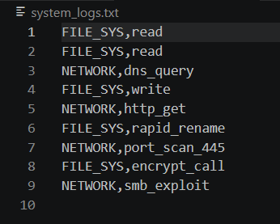

Main code output:
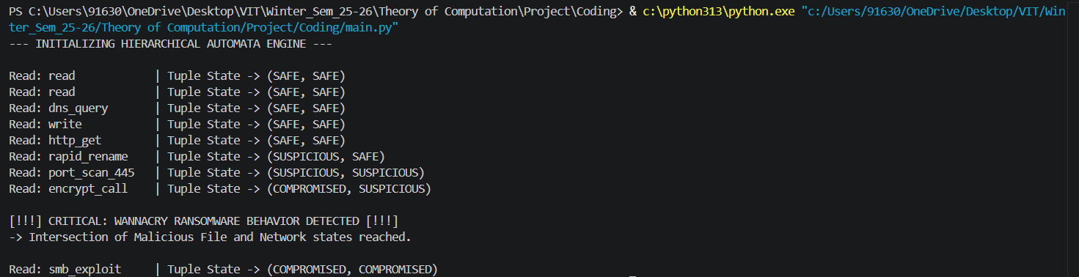

Partial Compromise:
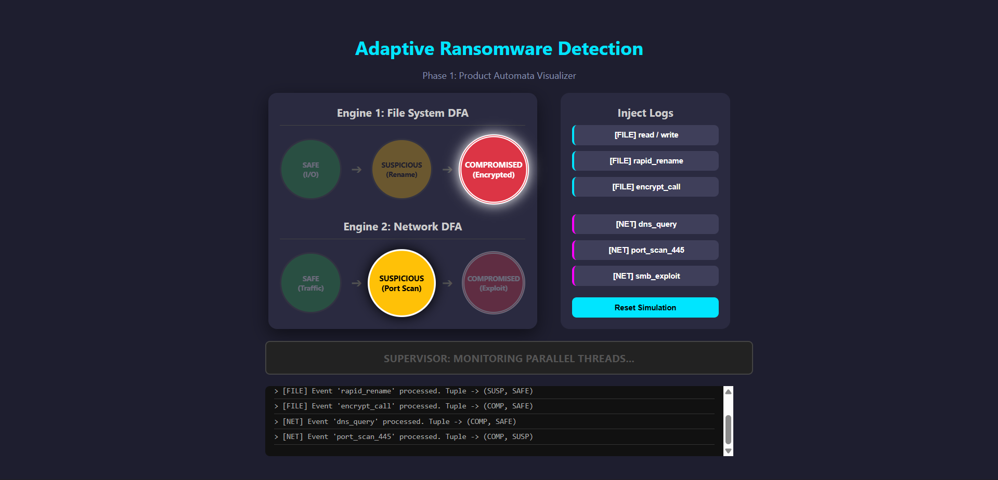
Intersection Compromise:
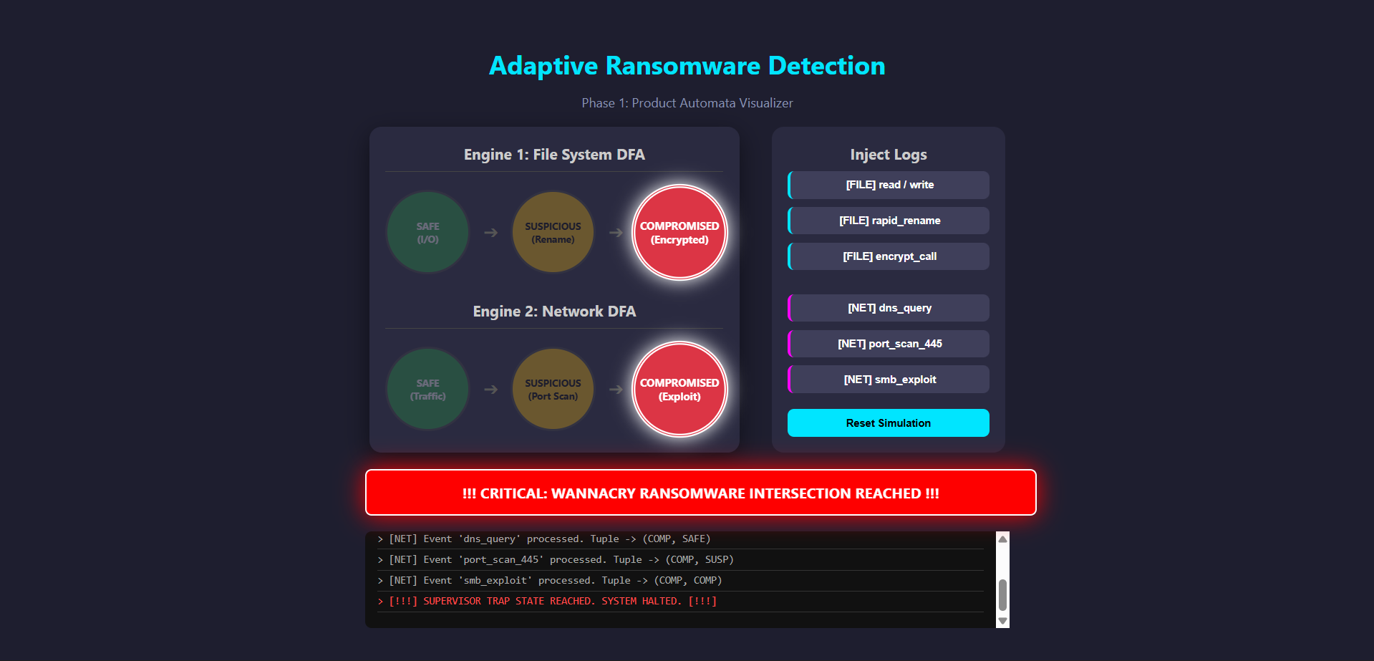

12. Societal measure or usage from the end-user’s' side
For the end-user, this system operates invisibly in the background as an endpoint security agent. It protects everyday users, hospitals, and corporations from devastating ransomware extortion by stopping the encryption process mid-execution. It requires no technical input from the user, offering passive, mathematically secure protection.

13. Future work
As detailed in the drawbacks, future work involves advancing the computational model up the Chomsky Hierarchy. Moving from Regular Languages to Context-Free Languages using Pushdown Automata will allow the system to detect highly complex, layered cyber threats that attempt to hide within nested network traffic.

14. Conclusion
By bridging abstract mathematical models with practical cybersecurity, we have demonstrated that Automata Theory provides a robust framework for modern Intrusion Detection. Utilizing parallel DFAs and Product Automata construction proves that formal languages can effectively identify and isolate zero-day malware behaviour where traditional static analysis fails.

---------------------------------------------------------------------------------------------------------
This project is submitted to Dr. Raghavan R.
- School of Computer Science Engineering and Information Systems (SCORE)

========================== End of Document =======================

