VELLORE INSTITUTE OF TECHNOLOGY
School of Computer Science Engineering and Information Systems
BCSE302L Database Systems
Course Project
BOM-Track
A Database for Hardware Bills of Materials, Part Stock and Board Builds
Review I: Problem Analysis and Database Design
Submitted by | : Gudivada Vishwak Sai
Register Number | : 24BYB0053
Implementation | : PostgreSQL 16 (SQL, PL/pgSQL), Python
Faculty | : Dr. Thanga Mariappan L.

Contents
1. Introduction and Problem Statement
2. Objectives, Users and Scope
3. Requirement Analysis
4. ER Diagram
5. Relational Schema
6. Design Notes

1. Introduction and Problem Statement
Every PCB I design in KiCad (A free PCB Designing Software) ends with a bill of materials (BOM) exported as a CSV file. For my 8051-based handheld game board, uGameBox, that file has 28 lines. Each line groups several components under one value and footprint, for example "R1-R8,R10" for nine 1k resistors.
The CSV is fine as a parts list, but it cannot answer the questions that come up when I actually want to build the board:
- How much will one board cost, using current supplier prices?
- Which parts do I already have, and which ones do I still need to buy?
- If I want to build three boards, what is the shortfall for each part?
- Which parts are shared between my different boards, so I can buy them together?
Right now, these answers are worked out by hand in a spreadsheet, and they go out of date as soon as a price changes or parts get used. The file also has some data problems. The Refs column stores a list of designators inside one cell. The Qty column is a count that can be computed from that list. The Value column is sometimes a real value ("10k") and sometimes just a label: the nine identical 6 mm push buttons appear as nine separate lines because they are named BTN0 to BTN7 and RESET.
BOM-Track stores this information in a relational database. Only the basic facts are stored (which part sits at which position on which board, what price a supplier quoted, how many parts came in or went out). Totals such as board cost, stock on hand, shortfall and build readiness are calculated by SQL views and PL/pgSQL functions whenever they are asked for, so they are never stale and never typed in by hand.

2. Objectives, Users and Scope

2.1 Objectives
- Import a KiCad BOM CSV into normalized tables, with one row per placed component.
- Keep a single catalogue of parts so that the same physical part is stored only once, even when it is used on many boards.
- Record supplier price quotes and stock movements as dated facts.
- Plan and record builds of a board, including how many units are built.
- Calculate cost, stock on hand, shortfall and build readiness in the database itself.
- Use constraints and triggers so that invalid data (negative stock, a build finishing before it started) is rejected by the database.

2.2 Users
This is a single-user system. I use it in three roles:
Role | What the role does in the system
Designer | Imports BOM files from KiCad, corrects part details, adds new boards.
Purchaser | Adds suppliers, records price quotes, records parts that are bought.
Builder | Plans a build, checks whether stock is enough, marks the build as complete.

2.3 Scope
In scope | Out of scope
BOM import from KiCad CSV exports | Schematic and PCB layout data
Parts catalogue and categories | Placing orders with suppliers automatically
Supplier price quotes (with date) | Multiple users, logins and permissions
Stock ledger (purchases, adjustments) | Live price feeds from supplier APIs
Build planning and completion | Accounting, invoices and taxes
Cost, shortfall and readiness reports; Python front end

3. Requirement Analysis

3.1 Source Data
The starting data is the real BOM export of uGameBox (AT89S52 microcontroller, 16x2 LCD, eight LEDs, nine push buttons, buzzer, SW-420 vibration sensor, L7805 regulator). A few lines from the file, unchanged:
Refs | Value | Footprint (shortened) | Qty
R1-R8,R10 | 1k | R_Axial_DIN0207_L6.3mm... | 9
C1,C6,C7 | 100nF | C_Disc_D5.0mm_W2.5mm_P5.00mm | 3
D1-D8 | LED | LED_D5.0mm | 8
SW1 | BTN0 | SW_PUSH_6mm | 1
SW9 | RESET | SW_PUSH_6mm | 1
U1 | AT89S52 | DIP-40_W15.24mm_Socket | 1

The file has 28 lines covering 49 placed components. I checked that the Qty of every line matches the number of designators it lists. The importer expands each line into one row per designator. The same importer can load the BOM of any other KiCad project, so the database is designed for many boards, not just one.

3.2 Functional Requirements
ID | Requirement
FR1 | Import a KiCad BOM CSV: expand designator ranges such as "R1-R8,R10" into one placement each, and link each placement to a part.
FR2 | Maintain a parts catalogue grouped into categories (resistor, capacitor, LED, IC and so on). Identical parts must not be duplicated.
FR3 | Maintain boards (name, revision, source) and the list of placements on each board.
FR4 | Record suppliers and dated price quotes for parts.
FR5 | Record stock movements: purchases (linked to a supplier) and manual adjustments.
FR6 | Plan a build of N units of a board and mark it complete.
FR7 | Report: BOM per board, cost per board, stock on hand, shortfall for a build, parts shared across boards.
FR8 | Reject invalid operations: negative stock, completing a build without enough stock, invalid dates, non-positive prices.

3.3 Entities and Attributes
Entity | Attributes | Meaning
CATEGORY | category_id, name | Type of part (Resistor, LED, ...)
PART | part_id, category_id, value_text, footprint, description | One distinct physical part that can be bought
BOARD | board_id, name, revision, source, created_on | A PCB design, e.g. uGameBox rev 1
PLACEMENT | placement_id, board_id, part_id, ref_designator, label | One component position on a board (R3, SW5, ...)
SUPPLIER | supplier_id, name, website | A shop or distributor
PRICE_QUOTE | quote_id, part_id, supplier_id, unit_price, currency, captured_at | Price seen for a part at a given time
BUILD | build_id, board_id, units, started_on, completed_on | One assembly run of a board
STOCK_MOVEMENT | movement_id, part_id, supplier_id, qty_delta, movement_type, moved_at | Parts coming in (purchase) or a correction (adjustment)

4. ER Diagram
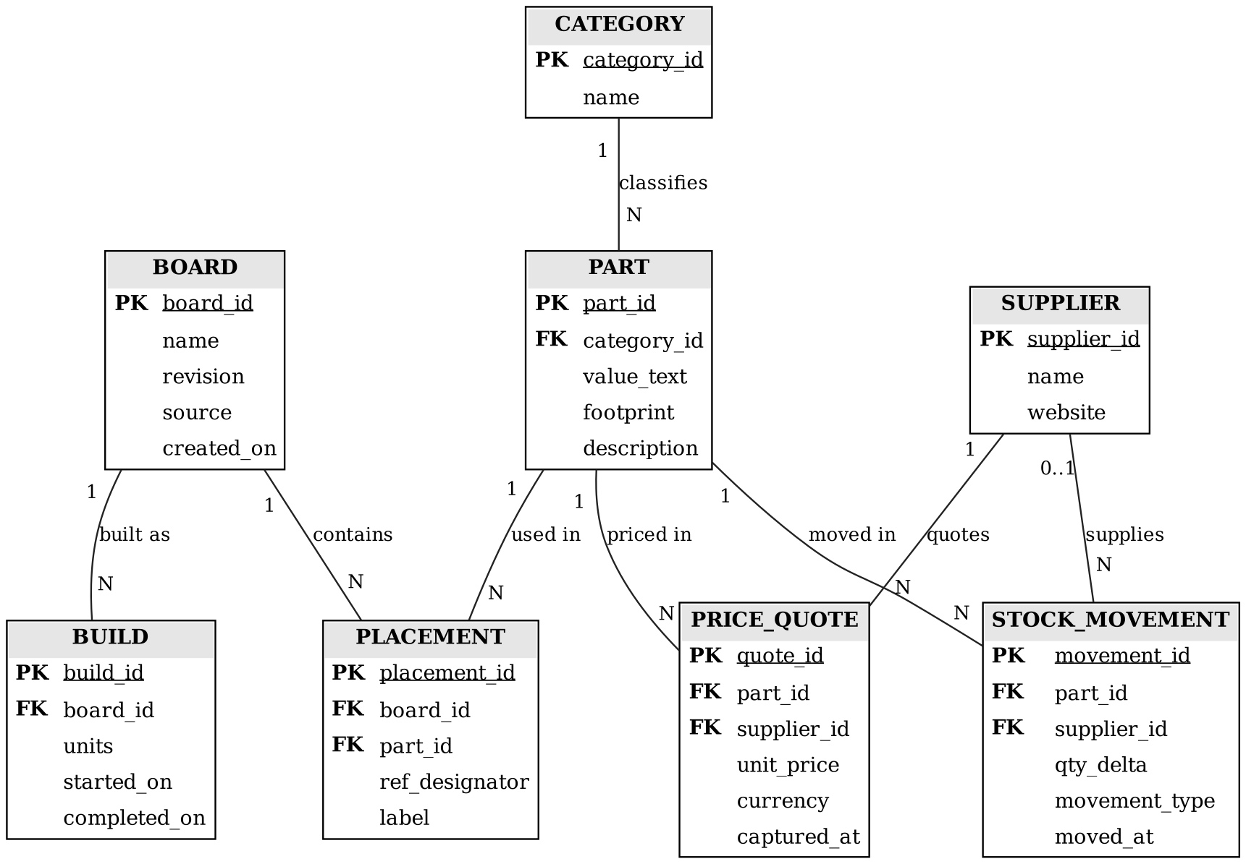
Figure 1. ER diagram of BOM-Track (PK = primary key, FK = foreign key)

4.1 Relationships and Cardinality
Relationship | Cardinality | Explanation
CATEGORY classifies PART | 1 : N | Every part belongs to exactly one category.
PART used in PLACEMENT | 1 : N | A part can be placed many times; a placement uses one part.
BOARD contains PLACEMENT | 1 : N | A board has many placements; a placement is on one board.
BOARD and PART | M : N | Resolved through PLACEMENT, which also carries ref_designator and label.
BOARD built as BUILD | 1 : N | The same board can be built many times.
PART priced in PRICE_QUOTE | 1 : N | A part can have many quotes over time.
SUPPLIER quotes PRICE_QUOTE | 1 : N | PART and SUPPLIER are M : N through PRICE_QUOTE.
PART moved in STOCK_MOVEMENT | 1 : N | Each stock movement is for one part.
SUPPLIER supplies STOCK_MOVEMENT | 0..1 : N | A purchase names a supplier; an adjustment does not.

Participation: every PART must have a CATEGORY and every PLACEMENT must have both a BOARD and a PART (total participation on the N side). A BOARD may exist with no BUILD yet, and a PART may exist with no quotes or stock movements (partial participation).

5. Relational Schema
Primary keys are underlined, foreign keys are marked with *.
CATEGORY ( category_id, name )
PART ( part_id, category_id*, value_text, footprint, description )
BOARD ( board_id, name, revision, source, created_on )
PLACEMENT ( placement_id, board_id*, part_id*, ref_designator, label )
SUPPLIER ( supplier_id, name, website )
PRICE_QUOTE ( quote_id, part_id*, supplier_id*, unit_price, currency, captured_at )
BUILD ( build_id, board_id*, units, started_on, completed_on )
STOCK_MOVEMENT ( movement_id, part_id*, supplier_id*, qty_delta, movement_type, moved_at )

5.1 Keys and Constraints
Table | Foreign keys | Other constraints
CATEGORY | none | name NOT NULL UNIQUE
PART | category_id -> CATEGORY | value_text, footprint NOT NULL; UNIQUE(category_id, value_text, footprint)
BOARD | none | name, revision NOT NULL; UNIQUE(name, revision); created_on DEFAULT CURRENT_DATE
PLACEMENT | board_id -> BOARD (ON DELETE CASCADE); part_id -> PART | ref_designator NOT NULL; UNIQUE(board_id, ref_designator)
SUPPLIER | none | name NOT NULL UNIQUE
PRICE_QUOTE | part_id -> PART; supplier_id -> SUPPLIER | CHECK (unit_price > 0); currency DEFAULT 'INR'; captured_at DEFAULT now()
BUILD | board_id -> BOARD | units DEFAULT 1, CHECK (units > 0); started_on NOT NULL; CHECK (completed_on >= started_on)
STOCK_MOVEMENT | part_id -> PART; supplier_id -> SUPPLIER (nullable) | CHECK (qty_delta <> 0); movement_type IN ('PURCHASE','ADJUSTMENT'); a PURCHASE must have qty_delta > 0 and a supplier

6. Design Notes

6.1 What is stored and what is calculated
The CSV mixes stored facts with numbers that can be worked out from them. In BOM-Track, anything that can be calculated is not stored:
Value | Calculated from
Quantity of a part on a board | COUNT of PLACEMENT rows for that board and part (replaces the CSV Qty column)
Stock on hand | SUM of qty_delta in STOCK_MOVEMENT, minus parts used by completed builds (units x placements)
Board cost | Quantity of each part x its latest PRICE_QUOTE, added up
Shortfall for a build | Parts needed for the build minus stock on hand, when positive
Build status | From the dates: no completed_on means in progress, otherwise completed

Because of this, each fact has one home. There is no stock column that could disagree with the movement history, and no status column that could disagree with the build dates.

6.2 Normalization
The CSV is not in 1NF because the Refs column holds a list. Splitting it into one PLACEMENT row per designator fixes this. Separating PART from PLACEMENT removes repeated part data: the nine push buttons become one PART row and nine PLACEMENT rows, and each placement keeps its own label (BTN0, RESET, ...).
Table | Functional dependencies | Normal form
PART | part_id -> category_id, value_text, footprint, description; (category_id, value_text, footprint) -> part_id | BCNF
PLACEMENT | placement_id -> all; (board_id, ref_designator) -> placement_id, part_id, label | BCNF
PRICE_QUOTE | quote_id -> part_id, supplier_id, unit_price, currency, captured_at | BCNF
STOCK_MOVEMENT | movement_id -> part_id, supplier_id, qty_delta, movement_type, moved_at | BCNF
CATEGORY, BOARD, SUPPLIER, BUILD | Surrogate key -> all attributes; natural keys are declared UNIQUE | BCNF

In every table, each determinant is a candidate key, so there are no partial or transitive dependencies.

