MAJOR PROJECT - EVIDENCE REVIEW
OphthalmicAI
Current Results, Evidence Gaps, and Execution Plan
A structured handoff for paper preparation and application deployment
Prepared for | Prepared by | Review date
Major Project Supervisor / Professor | Vishwam Modi | 18 July 2026

Document status: Working evidence report. Numerical results are preserved from executed notebook outputs; simulated plots are explicitly excluded from scientific claims.

1. Executive Summary
Current evidence: The project has credible internal-validation evidence for diabetic retinopathy severity grading, glaucoma classification, cataract classification, and five segmentation targets. The deployed application is intentionally limited to DR grading and DR-related segmentation; glaucoma and cataract are research-only transfer-learning experiments. The evidence is not yet sufficient to claim independent test performance or clinical validation.

Component | Best available result | Evidence status | Immediate action
DR severity | QWK 0.8912; accuracy 81.3%; n=550 | Internal validation | Export row-level predictions and create an untouched test set
Glaucoma | AUC 0.9565; accuracy 88%; n=313 | Internal validation | Export final probabilities and final confusion matrix
Cataract | AUC 0.9959; accuracy 95.9%; n=317 | Internal validation | External validation and leakage audit
Segmentation | OD strongest; MA weakest | Pixel-level reports | Add Dice/IoU per image, HE report, confidence intervals
Deployment | Video updated; frontend/backend builds pass | Locally verified | Publish backend, set frontend URL, run public smoke test

Recommended paper posture
- Describe all reported classification figures as internal validation results, not final test results.
- Use QWK as the primary endpoint for ordinal DR grading, supported by macro-F1 and per-class recall.
- Use Dice/IoU and lesion sensitivity as the principal segmentation endpoints; do not lead with pixel accuracy.
- Do not include the simulated loss or simulated training-QWK curves in the paper.
- Present glaucoma and cataract as secondary DR-pretrained transfer-learning studies, not as deployed features.

2. Evidence Sources Reviewed
Source | What it contributes | Reliability for paper
transfer-learning-eye (1).ipynb | Executed training logs, validation reports, DR/cataract confusion matrices | Primary computational evidence
results-eye-disease-screening.ipynb | Dataset EDA and manually assembled training curve | EDA usable; simulated curves not usable
Results/*.txt | Pixel-level reports for EX, MA, OD and SE | Usable as preliminary segmentation evidence
Results screenshots | Fundus image, ground-truth mask and predicted-mask examples | Qualitative evidence
DR.docx / DR.pdf | Method, dataset and literature narrative | Background/method drafting source
OpthV7_Vishwam.pdf | Final thesis methods, claimed results, qualitative figures and discussion | Reference source requiring numerical reconciliation
Application source | Actual runtime models, synthetic confidence behavior, DCA fallback | Deployment and integrity audit

3. Experimental Design Reconstructed from the Notebooks
Stage | Dataset and split | Model/training | Evaluation
Foundation pre-training | EyePACS 2015; 35,108 cleaned images; stratified 90/10 image-level split; seed 42 | EfficientNet-B3 regression; 300x300; SmoothL1; AdamW 3e-4; 10 epochs | Validation loss, accuracy, macro-F1 and QWK
DR fine-tuning | APTOS 2019 train.csv; stratified 85/15 image-level split; seed 42; validation n=550 | 5-epoch frozen-head warm-up, then 20 full-network epochs; TTA horizontal flip | Five-class report, confusion matrix and QWK
Glaucoma | 1,074 normal + 1,007 glaucoma; stratified 85/15 image split; validation n=313 | EfficientNet-B3 foundation; 10 frozen-head + 15 fine-tuning epochs | AUC and threshold-0.5 classification report
Cataract | 1,074 normal + 1,038 cataract; stratified 85/15 image split; validation n=317 | EfficientNet-B3 foundation; 10 frozen-head + 15 fine-tuning epochs | AUC, threshold-0.5 report and confusion matrix

Critical design limitation: The same validation partitions were repeatedly used for epoch selection and final reporting. No untouched independent test cohort is present in the notebooks. Final paper claims therefore require a locked test set or external cohort.

4. Diabetic Retinopathy Severity Classification
The final EfficientNet-B3 regression model converts a continuous output to ICDR grades 0-4 using fixed thresholds at 0.5, 1.5, 2.5 and 3.5. The best validation QWK was 0.8912 after full fine-tuning.
Class | Precision | Recall | F1-score | Support
No DR | 0.99 | 0.98 | 0.98 | 271
Mild | 0.51 | 0.36 | 0.42 | 56
Moderate | 0.70 | 0.91 | 0.79 | 150
Severe | 0.41 | 0.38 | 0.39 | 29
Proliferative | 0.71 | 0.34 | 0.46 | 44
Macro average | 0.66 | 0.59 | 0.61 | 550
Weighted average | 0.81 | 0.81 | 0.80 | 550

Interpretation: Agreement is strong overall, but sensitivity is low for Mild (0.36), Severe (0.38) and Proliferative DR (0.34). The model often collapses adjacent grades toward Moderate. This pattern is compatible with good ordinal QWK but insufficient per-class sensitivity for a screening claim.

5. Glaucoma Classification
Training state | AUC | Accuracy | Glaucoma recall | Conclusion
Frozen-head best | 0.7483 | 0.52 | 0.00 | Degenerate threshold behavior: all cases classified as Normal
Fully fine-tuned best | 0.9565 | 0.88 | 0.87 | Large and clinically meaningful improvement after unfreezing

Class | Precision | Recall | F1-score | Support
Normal | 0.88 | 0.89 | 0.88 | 162
Glaucoma | 0.88 | 0.87 | 0.87 | 151
Macro average | 0.88 | 0.88 | 0.88 | 313
Weighted average | 0.88 | 0.88 | 0.88 | 313

Missing artifact: The notebook contains a confusion matrix for the failed frozen-head stage, but no final fine-tuned confusion matrix or row-level probabilities. The final paper should use a regenerated matrix from the saved best checkpoint.

6. Cataract Classification
Class | Precision | Recall | F1-score | Support
Normal | 0.99 | 0.93 | 0.96 | 161
Cataract | 0.93 | 0.99 | 0.96 | 156
Macro average | 0.96 | 0.96 | 0.96 | 317
Weighted average | 0.96 | 0.96 | 0.96 | 317

The best reported validation AUC was 0.9959. The confusion matrix contains 150 true negatives, 154 true positives, 11 false positives and 2 false negatives, corresponding to 304/317 correct predictions (95.9%).
Interpretive caution: The very high AUC requires confirmation on an external dataset and a patient-level split. Image-level splitting can allow correlated images from the same patient or acquisition source to appear in both training and validation.

7. Dataset Distribution and Imbalance
Reconciliation required: The EDA notebook reports APTOS n=2,930 and EyePACS n=35,126, while the training notebook uses an APTOS validation support consistent with the full 3,662-image training set and reports EyePACS n=35,108. The final manuscript must state one traceable dataset version and flow diagram.

8. Segmentation Results
Available reports are pixel-level binary classification summaries. For a binary mask, the positive-class F1 score is equivalent to the Dice coefficient. IoU below is derived from the reported precision and recall and should be regenerated directly from per-image masks.
Target | Precision | Sensitivity | Dice/F1 | Derived IoU | Positive pixels
Optic Disc (OD) | 0.9033 | 0.8725 | 0.8876 | 0.7980 | 75,350
Hard Exudate (EX) | 0.5547 | 0.5634 | 0.5590 | 0.3879 | 65,847
Soft Exudate (SE) | 0.7589 | 0.2933 | 0.4231 | 0.2683 | 15,996
Microaneurysm (MA) | 0.2602 | 0.1039 | 0.1485 | 0.0802 | 5,235
Hemorrhage (HE) | Not provided | Not provided | Not provided | Not provided | Not provided

Main segmentation finding: Optic-disc localization is comparatively strong. Small-lesion detection remains the primary weakness: MA sensitivity is 10.4% and SE sensitivity is 29.3%. Background-dominated accuracy above 99% is not an appropriate headline metric.

- Required: per-image Dice, IoU, precision, sensitivity and specificity for OD, EX, SE, MA and HE.
- Required: lesion-level sensitivity and false positives per image for MA, HE, EX and SE.
- Required: threshold sweep, precision-recall curve and AUPRC from probability masks.
- Required: bootstrap 95% confidence intervals and best/median/worst qualitative cases.
Saved segmentation screenshots
The screenshots below demonstrate that ground-truth/predicted-mask panels and genuine training histories exist. They are useful qualitative evidence, but the printed aggregate scores must be regenerated from image-level masks because several displayed Dice, IoU and F1 values use inconsistent averaging or calculation conventions.
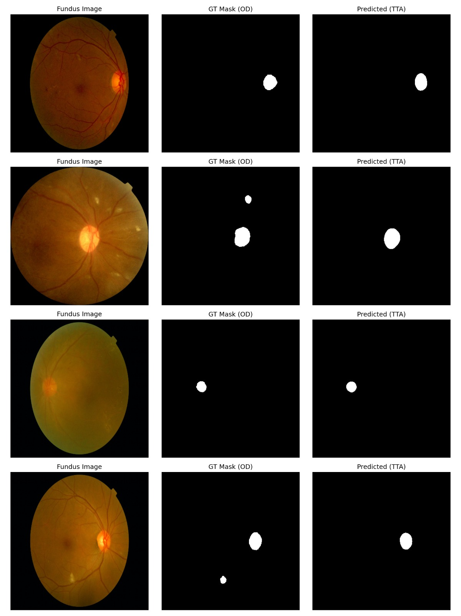
Figure 4. Optic-disc examples: fundus image, ground-truth mask and predicted mask.
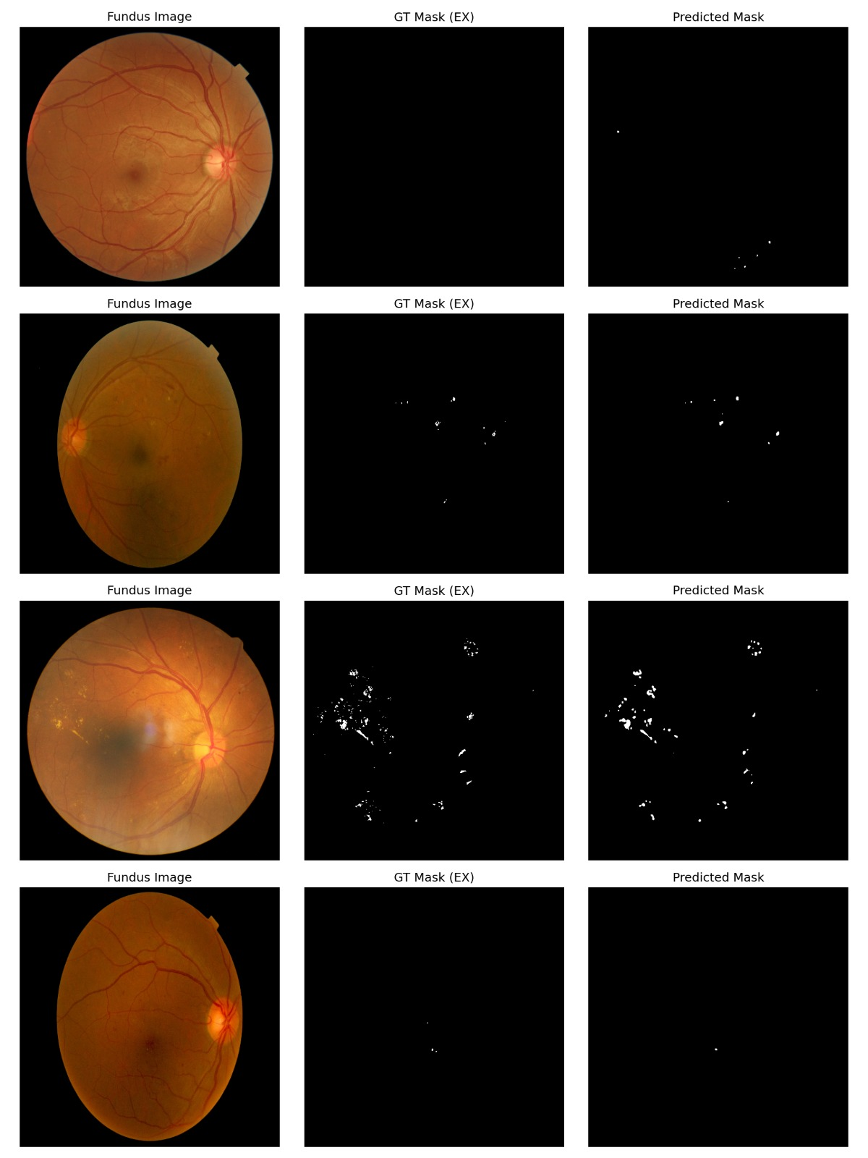
Figure 5. Lesion-segmentation examples showing sparse ground-truth and predicted masks.
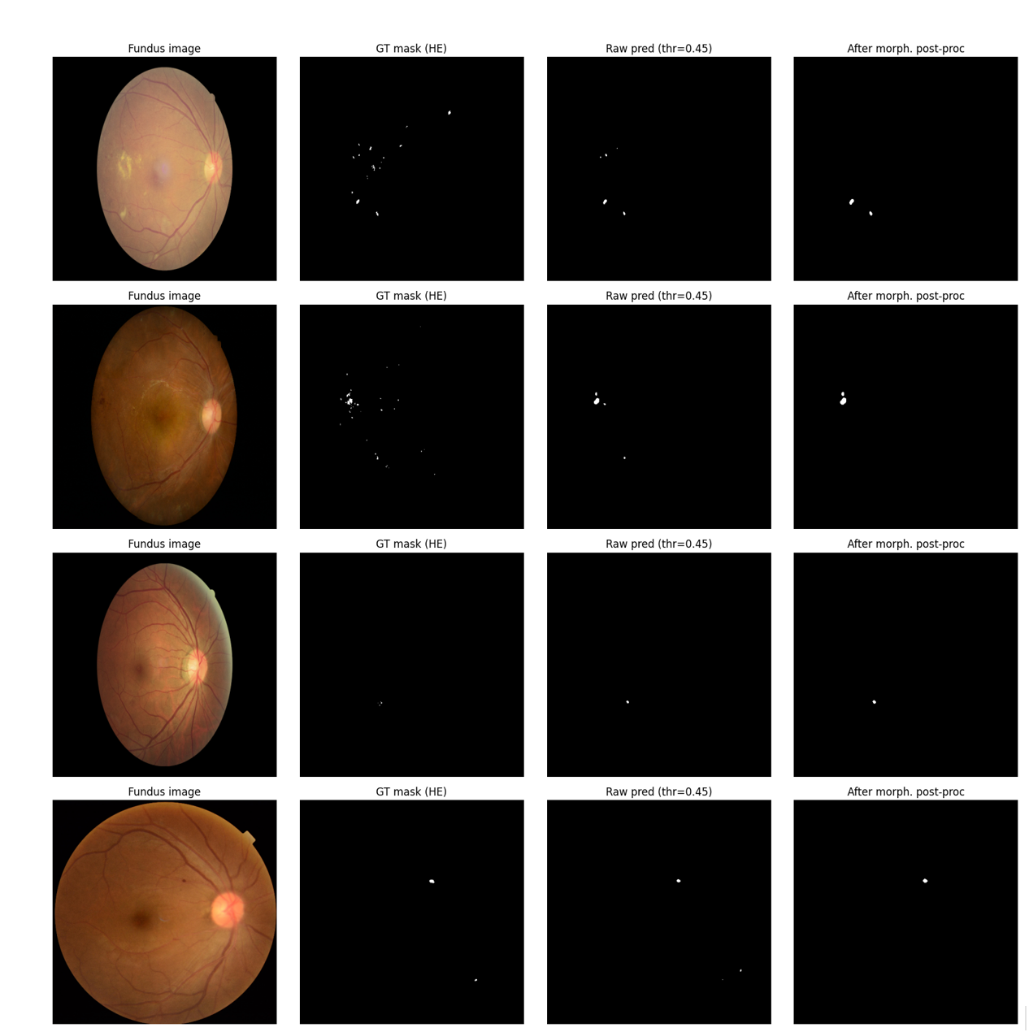
Figure 6. Hemorrhage segmentation examples with ground truth, raw prediction and post-processed output.

9. Thesis-to-Notebook Numerical Reconciliation
Result | Thesis statement | Executed notebook / screenshot | Publication action
DR QWK | 0.912 in section 5.1; 0.89 in section 5.3 | Best validation QWK 0.8912 | Use regenerated image-level result; explain evaluation set
DR accuracy | 81.4% | Classification report rounds to 0.81 | Compute exact numerator/denominator from predictions
Optic disc Dice | 0.964 in narrative; 0.89 in Table 5.1 | Screenshot approximately 0.8895 | Rerun checkpoint on explicit manifest
Hard exudate Dice | 0.863 in narrative; 0.43 in Table 5.1 | Separate screenshots/reports disagree | Rerun and document averaging rule
Grad-CAM agreement | 91.3% on 104 images | No annotation-level file located | Attach scoring rubric, raters and per-image ratings
DME engine | Sensitivity 0.887; specificity 0.923; F1 0.893 | No supporting prediction table located | Attach label and prediction cohort
DCA | Positive benefit across 0.10-0.80 | Application contains synthetic fallback | Regenerate exclusively from real cohort probabilities

Publication rule: Do not select the highest value among conflicting sources. The authoritative result is the value recomputed from an explicit checkpoint, manifest, labels and saved image-level outputs.

10. Evidence Integrity and Paper-Risk Audit
Issue | Why it matters | Required correction | Priority
Simulated training curves | Training QWK and loss values were generated with random numbers | Exclude from paper; export genuine epoch history | Critical
No untouched test cohort | Validation was used for checkpoint selection and reporting | Create a locked test split or external validation cohort | Critical
Image-level splitting | Left/right eyes or repeated patients may cross partitions | Split by patient identifier where available | Critical
EyePACS validation augmentation | The same random transform is used for training and validation in stage 1 | Use deterministic validation transforms and rerun | High
Inconsistent dataset totals | EDA and training notebooks reference different CSV versions | Add a dataset flow table with exclusions | High
Incomplete glaucoma artifacts | Final probabilities and confusion matrix are missing | Run inference from the best fine-tuned checkpoint and export | High
Missing HE segmentation report | One deployed lesion model has no quantitative evidence | Evaluate and export HE metrics | High
Synthetic app confidence | Live API generates confidence from severity plus random noise | Replace with calibrated model-derived uncertainty or label as unavailable | Critical
Synthetic DCA fallback | The API returns a fallback curve when no cohort is configured | Deploy a real validation cohort or disable DCA in production | Critical

11. Results That Can Be Produced Immediately
Output | Can be produced now? | Source / constraint
Current results narrative and tables | Yes | Executed notebook text and segmentation reports
DR and cataract confusion-matrix figures | Yes | Embedded notebook outputs
Per-class classification interpretation | Yes | Classification reports
Approximate derived IoU for four masks | Yes, provisional | Derived from aggregate precision/recall
ROC and precision-recall curves | Code prepared | Run the supplied Kaggle evaluation notebook
95% confidence intervals for all metrics | Partially | Accuracy CI possible; full metric CIs need predictions
Calibration and Brier score | Not yet | Need probabilities
Referable DR binary analysis | Not yet | Need true/predicted rows or full confusion matrix aggregation rule
External validation | Not yet | Need a locked external dataset and inference export
Per-image segmentation distributions | Not yet | Need one row per image per target

12. Exact Kaggle Export Package Required
Create one folder named paper_results_export and download it as a ZIP. The following files provide enough information to regenerate nearly all publication figures and statistical analyses.
File | Minimum columns/content | Purpose
dr_predictions.csv | image_id, patient_id, dataset, true_grade, raw_score, predicted_grade | QWK, confusion matrix, referable DR, confidence intervals
glaucoma_predictions.csv | image_id, patient_id, true_label, probability, predicted_label | ROC, PR, threshold selection, calibration
cataract_predictions.csv | image_id, patient_id, true_label, probability, predicted_label | ROC, PR, threshold selection, calibration
training_history.csv | phase, epoch, train_loss, val_loss, accuracy, macro_f1, qwk/auc, learning_rate | Authentic convergence curves
segmentation_metrics.csv | image_id, target, threshold, dice, iou, precision, sensitivity, specificity, gt_pixels, pred_pixels | Per-lesion distributions and confidence intervals
segmentation_thresholds.csv | target, threshold, dice, precision, recall, auprc | Threshold justification
dataset_manifest.csv | image_id, patient_id, dataset, split, label, included, exclusion_reason | Reproducibility and leakage audit
run_config.json | Seed, versions, hardware, model, optimizer, loss, transforms, batch size | Methods and reproducibility

13. Complete Kaggle Evaluation Package
A complete Kaggle notebook has been prepared as OphthalmicAI_Kaggle_Publication_Evaluation.ipynb. After its path block is configured, it exports the source tables, figures, qualitative panels, consolidated Excel workbook and ZIP package required for paper preparation.
# Final outputs created by the supplied notebook
/kaggle/working/OphthalmicAI_publication_results.zip
/kaggle/working/publication_results/OphthalmicAI_publication_results.xlsx
# The ZIP contains:
tables/ # image-level predictions, metrics, CIs and curve coordinates
figures/ # 300-dpi confusion matrices, ROC/PR, calibration and DCA
examples/ # qualitative Grad-CAM and segmentation evidence

Do not reconstruct history: Append genuine metric values to a history list inside each training epoch. Do not infer or simulate loss values after training.

14. Deployment Work Started
Item | Status | Result
Walkthrough video | Completed locally | Fallback and deployment variable updated to YouTube video opcj0hZPnxU
Backend container | Build and health check passed | AIEngine and five segmentation checkpoints load; /api/health returns status ok
Container footprint | Reduced | Unused classification checkpoints and frontend excluded from backend image
Frontend production variables | Prepared | Example backend URL and updated YouTube embed variable
Render blueprint | Improved | Health endpoint configured and video variable updated
GitHub | Connected | Codex authenticated as VishwamModi; publication branch/PR pending local Git tooling
Production publication | Pending host authorization | Backend host and frontend host must be authorized and linked

Runtime architecture: The current API loads the DR severity model and five segmentation models. This is the intended deployment scope. Cataract and glaucoma remain separate DR-pretrained research experiments and must not be described as live application capabilities.

Deployment sequence
- Publish the Docker backend to a CPU-capable ML host and verify /api/health.
- Set database and Gemini secrets in the hosting dashboard; never commit them.
- Set NEXT_PUBLIC_API_BASE_URL in the frontend host to the live backend URL.
- Build and publish the Next.js frontend.
- Run signup, login, image upload, analysis, segmentation, report and chat smoke tests.
- Replace synthetic confidence and synthetic DCA fallback before presenting the deployment as research evidence.

15. Recommended Paper Results Structure
- Dataset flow, class distributions and split protocol.
- Primary DR severity outcome: QWK with confidence interval.
- Per-class DR precision, recall and F1, followed by the confusion matrix.
- Secondary transfer-learning experiments: glaucoma and cataract ROC-AUC, sensitivity, specificity and calibration.
- Segmentation Dice/IoU by lesion, with per-image distributions.
- Ablation: frozen head versus full fine-tuning, preprocessing and TTA.
- External validation and subgroup analysis where metadata permits.
- Qualitative Grad-CAM and segmentation successes/failures.
- Computational efficiency and deployment characteristics.
- Limitations, data leakage controls and intended-use boundaries.

16. Execution Checklist
Priority | Action | Deliverable | Completion criterion
P0 | Rerun/export genuine epoch history | training_history.csv | No simulated values
P0 | Create locked patient-level test split | dataset_manifest.csv | No patient overlap
P0 | Export row-level predictions | Three prediction CSVs | All rows include probabilities/raw scores
P0 | Evaluate HE segmentation | HE report + per-image metrics | Same protocol as other targets
P1 | Regenerate all statistical figures | Paper-ready PNG/SVG figures | Traceable to exported data
P1 | Add bootstrap confidence intervals | Results table with 95% CIs | Fixed seed and documented method
P1 | Publish and smoke-test app | Public frontend and backend URLs | Core workflows pass
P2 | External validation | Independent cohort table | Predefined protocol, no retraining
P2 | Preserve research/deployment boundary | Scope statement in paper and app | Glaucoma/cataract remain research-only

17. Suggested Wording for the Current Result
Draft: On an internal stratified APTOS validation subset of 550 images, the EfficientNet-B3 ordinal regression model achieved a quadratic weighted kappa of 0.8912 and an accuracy of 81.3%. Performance was strongest for No DR (F1=0.98) and Moderate DR (F1=0.79), while recall remained limited for Mild (0.36), Severe (0.38), and Proliferative DR (0.34). These findings require confirmation using an untouched patient-level test cohort.

Appendix A. Current Numerical Evidence
Foundation EyePACS stage: the best QWK recorded during the 10 epochs was 0.7245 at epoch 5. Epoch 10 achieved validation loss 0.1732, accuracy 0.7884, macro-F1 0.5140 and QWK 0.7204.
DR APTOS stage: QWK increased from 0.6915 in the first warm-up epoch to 0.8912 in the final fine-tuning epoch.
Glaucoma stage: AUC increased from 0.7483 in the frozen-head stage to 0.9565 after full fine-tuning.
Cataract stage: AUC increased from 0.9297 in the best frozen-head epoch to 0.9959 after full fine-tuning.

Appendix B. Scope Statement
This report is an engineering and research evidence audit. The deployed system is limited to DR severity grading and DR-related segmentation. Glaucoma and cataract results are secondary transfer-learning experiments based on a DR-pretrained backbone and are not deployed capabilities. This report does not establish clinical safety, diagnostic efficacy, regulatory clearance or suitability for patient care. All model results should be interpreted within the datasets, splits and notebook procedures documented above.

