EXP.NO: 2

Write JavaScript Programme to validate thefollowing fields of the HTML Registration page.

DATE: 06/02/2025

AIM:
To write JavaScript code to validate user input in a registration form. The validation will
ensure that the data entered by the user meets specific criteria for each field. This will help in
maintaining data integrity and prevent invalid submissions.

5

ALGORITHM:
1. Input:
• The user fills in the following fields: First Name, Password, E-mail, Mobile
Number, Last Name, and Address.
2. Validation Steps:
1. Validate First Name:
o Check if the first name contains only alphabets.
o Ensure the length of the First Name is at least 6 characters.
o If any of these conditions fail, display an error message indicating the required
input.
2. Validate Password:
o Check if the password is at least 6 characters long.
o If it is less than 6 characters, display an error message.
3. Validate E-mail:
o Use a regular expression to check if the email follows the standard pattern:
name@domain.com.
o Ensure that the email contains no invalid characters and matches the required
pattern.
o If it doesn&#39;t match, display an error message indicating an invalid email
format.

4. Validate Mobile Number:
o Check if the mobile number contains exactly 10 digits.
o Ensure there are no alphabets or special characters.
o If the number is invalid, display an error message indicating the correct
format.
5. Validate Last Name:
o Ensure the Last Name field is not empty.
o If it is empty, display an error message.
6. Validate Address:
o Ensure the Address field is not empty.
o If it is empty, display an error message.

CODE:
<<!DOCTYPE html>
<html>
<head>
<title>Photography Portfolio + Registration</title>

<!-- CSS -->
<style>
body {
font-family: Arial;
margin: 0;
background: linear-gradient(to right, #e6f7ff, #ffffff);
}

header {
background: #333;
color: white;
padding: 15px;
text-align: center;
}

nav a {
color: white;
margin: 10px;
text-decoration: none;
}

section {
padding: 20px;
text-align: center;
}

.gallery img {
width: 200px;
margin: 10px;
border-radius: 10px;
transition: 0.3s;
}

.gallery img:hover {
transform: scale(1.1);
}

iframe {
border: 2px solid black;
margin: 20px;
}

form {
background: white;
padding: 20px;
width: 300px;
margin: auto;
border-radius: 10px;
box-shadow: 0 0 10px gray;
}

input, textarea {
width: 100%;
padding: 8px;
margin: 5px 0;
}

button {
background: #333;
color: white;
padding: 10px;
border: none;
width: 100%;
}
</style>

<!-- JavaScript Validation -->
<script>
function validateForm() {

let fname = document.forms["regForm"]["fname"].value;
let lname = document.forms["regForm"]["lname"].value;
let password = document.forms["regForm"]["password"].value;
let email = document.forms["regForm"]["email"].value;
let mobile = document.forms["regForm"]["mobile"].value;
let address = document.forms["regForm"]["address"].value;

let namePattern = /^[A-Za-z]+$/;
let emailPattern = /^[^ ]+@[^ ]+\.[a-z]{2,3}$/;
let mobilePattern = /^[0-9]{10}$/;

if (!namePattern.test(fname) || fname.length < 6) {
alert("First Name must be alphabets & min 6 characters");
return false;
}

if (password.length < 6) {
alert("Password must be at least 6 characters");
return false;
}

if (!emailPattern.test(email)) {
alert("Invalid Email format");
return false;
}

if (!mobilePattern.test(mobile)) {
alert("Mobile must be exactly 10 digits");
return false;
}

if (lname == "") {
alert("Last Name cannot be empty");
return false;
}

if (address == "") {
alert("Address cannot be empty");
return false;
}

alert("Registration Successful!");
return true;
}
</script>
</head>

<body>

<header>
<h1>📸 My Photography Portfolio</h1>
<nav>
<a href="#gallery">Gallery</a>
<a href="#map">Locations</a>
<a href="#register">Register</a>
</nav>
</header>

<section>
<h2>Welcome</h2>
<p>Explore my best photography work across Chennai.</p>
</section>

<!-- Gallery -->
<section id="gallery" class="gallery">
<h2>Gallery</h2>
<img src="k21.jpg">
<img src="k22.jpg">
<img src="k23.jpg">
</section>

<!-- Map -->
<section id="map">
<h2>Photography Locations</h2>

<img src="chennai_map.jpg" usemap="#chennai" width="600">

<map name="chennai">
<area shape="rect" coords="50,100,150,200"
href="https://en.wikipedia.org/wiki/Marina_Beach" target="_blank">

<area shape="circle" coords="250,150,50"
href="https://en.wikipedia.org/wiki/Besant_Nagar" target="_blank">

<area shape="rect" coords="350,200,450,300"
href="https://en.wikipedia.org/wiki/T._Nagar" target="_blank">
</map>

<h3>Live Map</h3>

<iframe src="https://www.google.com/maps?q=Chennai&output=embed"
width="600" height="400"></iframe>
</section>

<!-- Registration Form -->
<section id="register">
<h2>Register</h2>

<form name="regForm" onsubmit="return validateForm()">

First Name:
<input type="text" name="fname">

Last Name:
<input type="text" name="lname">

Password:
<input type="password" name="password">

Email:
<input type="text" name="email">

Mobile Number:
<input type="text" name="mobile">

Address:
<textarea name="address"></textarea>

<button type="submit">Register</button>

</form>
</section>

<!-- Contact -->
<section>
<h2>Contact</h2>
<p>Email: photographer@email.com</p>

<a href="https://instagram.com" target="_blank">Instagram</a> |
<a href="https://facebook.com" target="_blank">Facebook</a>
</section>

</body>
</html>

OUTPUT:
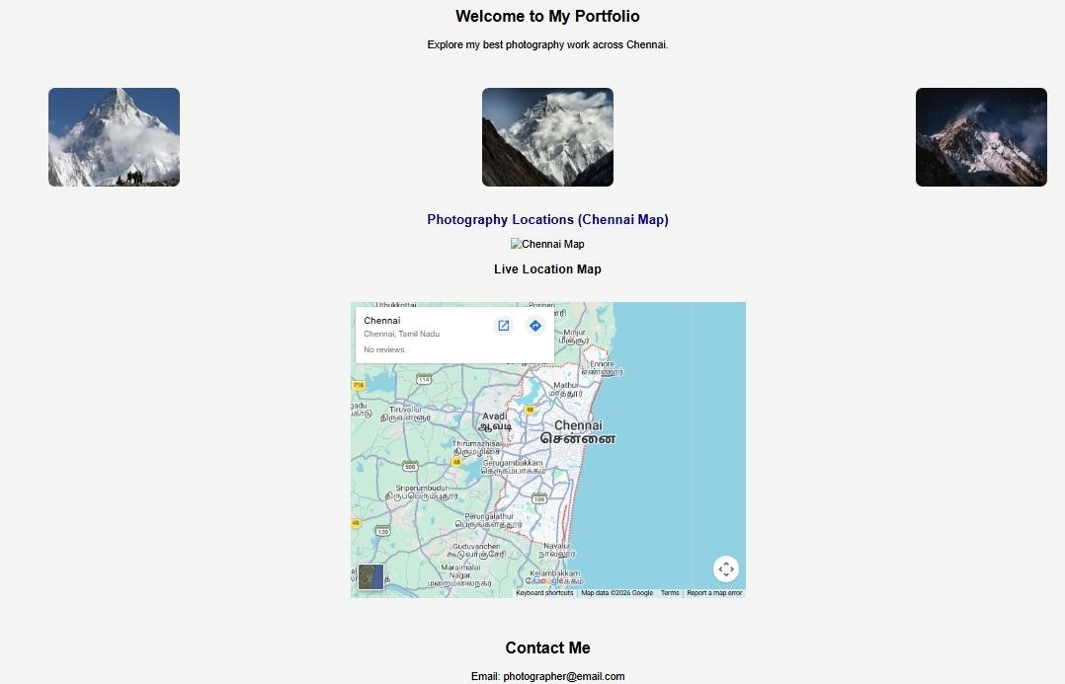

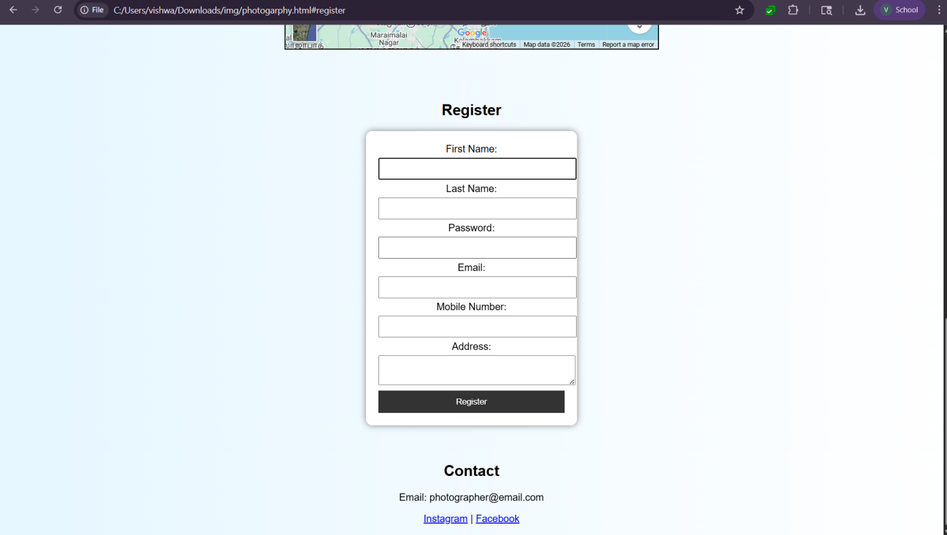

RESULT:
html page with form is created and is validated using javascript

