EXP.NO: 1 | Web Page Creation using HTML
DATE: 29/01/2025

AIM:
To create a web page that embeds a map with hotspots, frames, and links. The web page should be designed using HTML, incorporating embedded, external, and inline CSS for styling. This exercise aims to enhance understanding of integrating multimedia elements like maps, creating interactive hotspots, and organizing content using frames while applying different CSS techniques for styling.
ALGORITHM:
Create the HTML structure:
- Set up the basic HTML document with <!DOCTYPE html>, <html>, <head>, and <body> tags.
- In the <head>, link the external CSS file (<link> tag), define the title, and include any metadata.
- In the <body>, create the necessary elements:
- Frames: Use the <frameset> tag to create a frame layout (for older browsers, use <iframe> instead).
- Map: Use the <img> tag to display a map.
- Hotspots: Create clickable regions using the <map> and <area> tags.
- Links: Add hyperlinks (<a>) to navigate to different parts of the page or external sites.
●
Create CSS Styles:
- External CSS: In a separate file, define styles such as colors, fonts, and layout for the entire page.
- Inline CSS: Use the style attribute within specific tags to apply styles (e.g., in <div> or <p> tags).
- Embedded CSS: Inside the <style> tag in the <head>, define styles for specific elements like the map, frames, and text.
Map with Hotspots:
- Use the <map> tag to create an image map.
- Define the <area> tag for each hotspot, specifying the coordinates (e.g., coords="x,y,x2,y2") for clickable areas on the map.
Frames:
- Use the <iframe> tag for embedding external content like a map or another webpage, with attributes such as src for the URL, width, and height.
Add Links:
- Inside the <body>, use the <a> tag to create links for navigation (for example, to link to specific parts of the page or external sites).
Test the Page:
- Test the webpage to check the functionality of frames, hotspots, and links. Ensure that the map hotspots are clickable and the linked content displays correctly.
- Ensure that the styles are applied properly using inline, embedded, and external CSS.
CODE:
<!DOCTYPE html>
<html>
<head>
<title>Photography Portfolio</title>

<!-- External CSS -->
<link rel="stylesheet" href="styles.css">

<!-- Embedded CSS -->
<style> iframe { border: 2px solid black; margin: 20px;
}

.map-section { text-align: center; margin-top: 20px;
}

.hotspot-title { color: darkblue; font-size: 20px;
}
</style>
</head>

<body>

<header>
<h1>My Photography Portfolio</h1>
<nav>
<a href="#gallery">Gallery</a>
<a href="#map">Photo Locations</a>
<a href="#contact">Contact</a>
</nav>
</header>

<!-- Inline CSS Example -->
<div style="text-align:center; padding:20px;">
<h2>Welcome to My Portfolio</h2> <p>Explore my best photography work across Chennai.</p>
</div>

<!-- Gallery Section -->
<section id="gallery" class="gallery">
<img src="k2 p1.jpg" alt="Photo 1">
<img src="k2 p2.jpg" alt="Photo 2"> <img src="k2 p3.jpg" alt="Photo 3">
</section>
<!-- Map with Hotspots -->
<section id="map" class="map-section">
<h2 class="hotspot-title">Photography Locations (Chennai Map)</h2>

<!-- Image Map -->
<img src="chennai_map.jpg" usemap="#chennai" alt="Chennai Map" width="600">

<map name="chennai">
<!-- Marina Beach -->
<area shape="rect" coords="50,100,150,200" href="https://en.wikipedia.org/wiki/Marina_Beach" target="_blank" alt="Marina Beach">

<!-- Besant Nagar -->
<area shape="circle" coords="250,150,50" href="https://en.wikipedia.org/wiki/Besant_Nagar" target="_blank" alt="Besant Nagar">

<!-- T Nagar -->
<area shape="rect" coords="350,200,450,300" href="https://en.wikipedia.org/wiki/T._Nagar" target="_blank" alt="T Nagar">
</map>

<!-- Google Map (iframe) -->
<h3>Live Location Map</h3>

<iframe
src="https://www.google.com/maps/embed?pb=!1m18!1m12!1m3!1d248756.0788588270 4!2d80.20867324999999!3d13.04752545!2m3!1f0!2f0!3f0!3m2!1i1024!2i768!4f13.1!3m3! 1m2!1s0x3a5265ea4f7d3361%3A0x6e61a70b6863d433!2sChennai%2C%20Tamil%20Nadu!5 e0!3m2!1sen!2sin!4v1773736073178!5m2!1sen!2sin" width="600" height="450" style="border:0;" allowfullscreen="" loading="lazy" referrerpolicy="no-referrer-when-downgrade"></iframe>

</section>

<!-- Links Section -->
<section id="contact" style="text-align:center; padding:20px;">
<h2>Contact Me</h2>
<p>Email: photographer@email.com</p>

<a href="https://instagram.com" target="_blank">Instagram</a> |
<a href="https://facebook.com" target="_blank">Facebook</a>
</section>

</body>
</html>

OUTPUT:
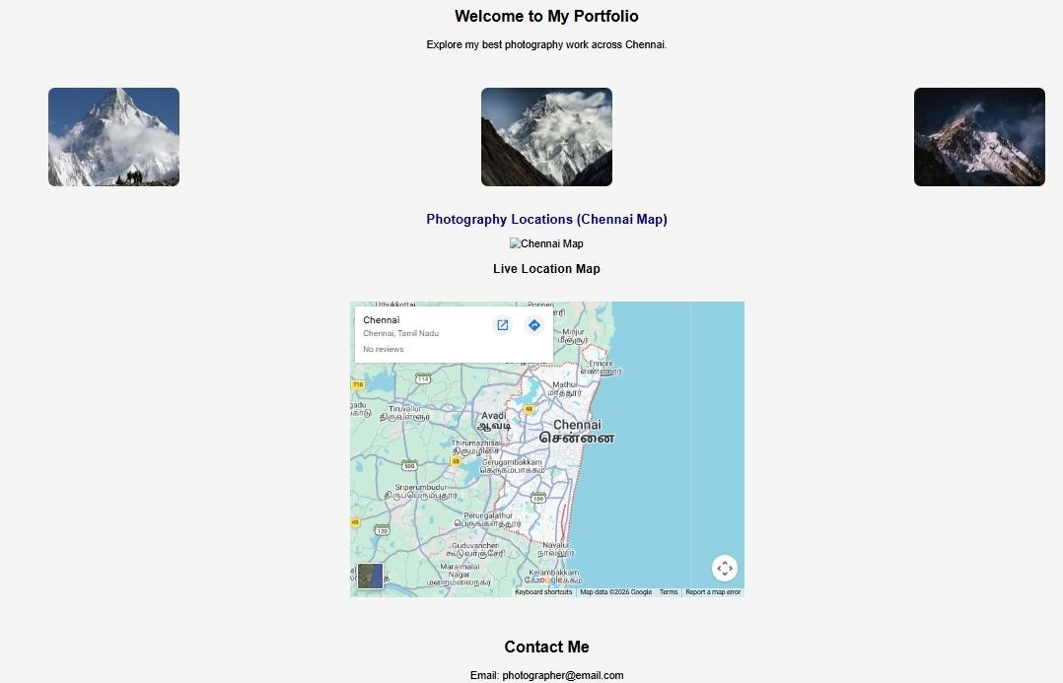

RESULT:
Html Page is created with embedded Chennai map along with hot spot, frames & links.

