Write a Servlet to demonstrate the difference between HTTP GET and POST
methods by creating a form and handling requests accordingly.

AIM
To create a web application demonstrating the difference between HTTP GET and POST methods. The application includes a secure login gateway leading to a weather dashboard where users can search for city data and submit weather reports.

ALGORITHM
- Input: User provides login credentials; once authenticated, they input city names for searching or weather feedback for submission.

Form Handling:
  - Create index.html using a POST form for secure login.
  - Create a dashboard with a GET form for city searches and a POST form for reporting conditions.

Servlet Processing:
  - LoginServlet: Authenticates credentials and redirects the user upon success.
  - WeatherServlet: Overrides doGet() to process searches via URL parameters and doPost()
to process report submissions via the request body.
- Deployment: Compile the Servlets and deploy to a container like Apache Tomcat. Use
@WebServlet annotations or web.xml for URL mapping.
- Output: Display processed results (City search result or submission confirmation) back to the browser.

SOURCE CODE

User Interface (index.html)
<html>
<head>
<title>Music Streaming Login</title>
<style>
body {
font-family: Arial;
background: linear-gradient(135deg, #1db954, #191414);
margin: 0;
color: white;
}
.container {
width: 380px;
margin: 120px auto;
padding: 30px;
background: #121212;
border-radius: 15px;
box-shadow: 0 0 20px rgba(0,0,0,0.6);
text-align: center;
animation: fadeIn 1s ease-in-out;
}
h2 {
color: #1db954;
}
input {
width: 90%;
padding: 12px;
margin: 10px 0;
border-radius: 6px;
border: none;
outline: none;
}
button {
width: 95%;
padding: 12px;
margin-top: 10px;
border: none;
border-radius: 25px;
background: #1db954;
color: white;
font-weight: bold;
cursor: pointer;
transition: 0.3s;
}
button:hover {
background: #1ed760;
transform: scale(1.05);
}
@keyframes fadeIn {
from { opacity: 0; transform: translateY(20px); }
to { opacity: 1; transform: translateY(0); }
}
.popup {
position: fixed;
top: 20px;
right: 20px;
background: #1db954;
padding: 15px 25px;
border-radius: 8px;
display: none;
animation: slideIn 0.5s forwards;
}
@keyframes slideIn {
from { right: -200px; opacity: 0; }
to { right: 20px; opacity: 1; }
}
</style>
<script>
function loginSuccess(form, methodType) {
event.preventDefault();
// Show popup
document.getElementById("popup").style.display = "block";
// Redirect after 1.5 sec
setTimeout(function() {
form.method = methodType;
form.submit();
}, 1500);
return false;
}
</script>
</head>
<body>
<div class="container">
<h2>Music Streaming Login</h2>
<form action="music" onsubmit="return loginSuccess(this, 'get')">
<input type="text" name="name" placeholder="Enter Name" required>
<input type="email" name="email" placeholder="Enter Email" required>
<button type="submit">Login with GET</button>
</form>
<br>
<form action="music" onsubmit="return loginSuccess(this, 'post')">
<input type="text" name="name" placeholder="Enter Name" required>
<input type="email" name="email" placeholder="Enter Email" required>
<button type="submit">Login with POST</button>
</form>
<div id="popup" class="popup">
Login Successful
</div>
</body>
</html>

Controller Servlet (LoginServlet.java)
import java.io.*;
import javax.servlet.*;
import javax.servlet.http.*;
import javax.servlet.annotation.WebServlet;
@WebServlet("/music")
public class MusicServlet extends HttpServlet {
private static final long serialVersionUID = 1L;
protected void doGet(HttpServletRequest request, HttpServletResponse response)
throws ServletException, IOException {
response.setContentType("text/html");
PrintWriter out = response.getWriter();
String name = request.getParameter("name");
String email = request.getParameter("email");
out.println("<html><body style='margin:0;font-family:Arial;background:linear-gradient(135deg,#1db954,#191414);color:white;'>");
out.println("<div style='width:400px;margin:120px auto;padding:30px;background:#121212;border-radius:15px;box-shadow:0 0 20px rgba(0,0,0,0.6);text-align:center;'>");
out.println("<h2 style='color:#1db954;'>Welcome</h2>");
out.println("<p><b>Name:</b> " + name + "</p>");
out.println("<p><b>Email:</b> " + email + "</p>");
out.println("<p style='color:red;'>GET Method (Visible in URL)</p>");
out.println("<br><a href='index.html'>");
out.println("<button style='padding:10px 20px;background:#1db954;border:none;border-radius:25px;color:white;'>Go Back</button>");
out.println("</a>");
out.println("</div></body></html>");
}
protected void doPost(HttpServletRequest request, HttpServletResponse response)
throws ServletException, IOException {
response.setContentType("text/html");
PrintWriter out = response.getWriter();
String name = request.getParameter("name");
String email = request.getParameter("email");
out.println("<html><body style='margin:0;font-family:Arial;background:linear-gradient(135deg,#1db954,#191414);color:white;'>");
out.println("<div style='width:400px;margin:120px auto;padding:30px;background:#121212;border-radius:15px;box-shadow:0 0 20px rgba(0,0,0,0.6);text-align:center;'>");
out.println("<h2 style='color:#1db954;'>Welcome</h2>");
out.println("<p><b>Name:</b> " + name + "</p>");
out.println("<p><b>Email:</b> " + email + "</p>");
out.println("<p style='color:lightgreen;'>POST Method (Secure)</p>");
out.println("<br><a href='index.html'>");
out.println("<button style='padding:10px 20px;background:#1db954;border:none;border-radius:25px;color:white;'>Go Back</button>");
out.println("</a>");
out.println("</div></body></html>");
}
}
Web.xml
<web-app>
<!-- Welcome file (VERY IMPORTANT) -->
<welcome-file-list>
<welcome-file>index.html</welcome-file>
</welcome-file-list>
</web-app>

OUTPUT :

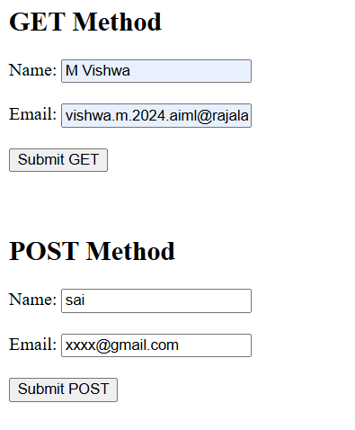
Get method:

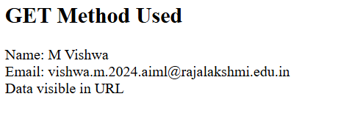

Post Method:

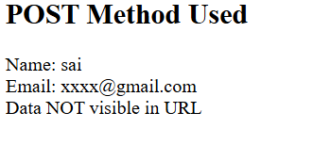

RESULT:
A Servlet-based weather application was successfully created to demonstrate the differences between HTTP GET and POST methods. The GET method was utilized for data retrieval, while POST ensured secure data transmission for authentication and user reports.

