EDGE INTELLIGENCE
LAB - 9

25MML0039
VISHWA M
NUMBER PLATE DETECTION PROJECT
1. System Overview
The backend of the Number Plate Detection system is built using Spring Boot with Java, following the MVC (Model-View-Controller) architecture. The backend and frontend communicate through REST APIs, which act as entry points for all client requests. When a user captures or uploads a vehicle image, it is sent to the backend through an upload API. The controller layer then validates the request and forwards it to the service layer for further processing.
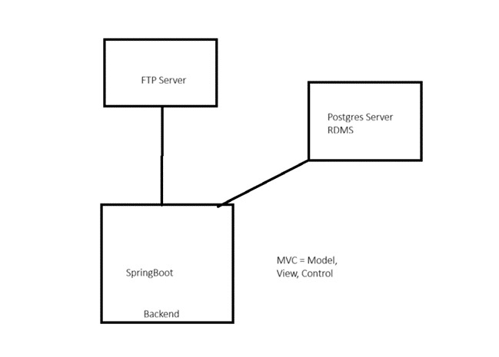

2. API Layer — Spring Boot Controller
Spring Boot exposes RESTful API endpoints to handle incoming requests from the frontend. The Controller layer is the first point of contact and is responsible for receiving the uploaded image, validating the request, and routing it to the service layer.

Flow:
Client (Frontend) | → | POST /upload | → | Controller | → | Service Layer

The controller performs the following checks before passing the request forward:
- File format validation
- File size check
- Request parameter verification

3. Service Layer Processing
The Service class handles the core business logic of the system. Once a validated image request is received, the service layer executes the following operations in sequence:

- Validate the uploaded image
- Generate metadata such as timestamp and filename
- Verify that FTP connection and database services are active
- Transfer the image to the FTP server
- Trigger the number plate detection model
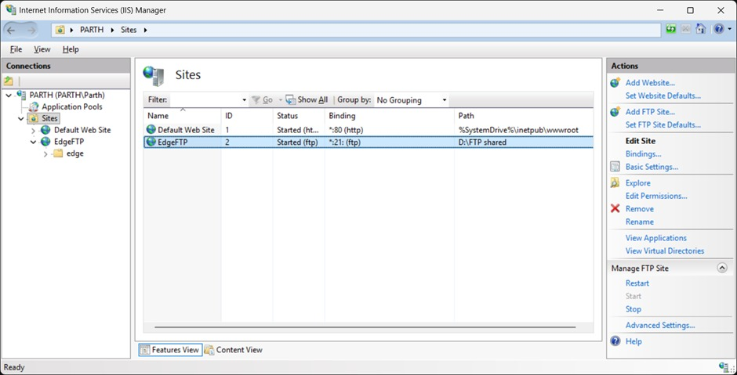
- Store the detection results and logs in the database

4. Image Storage — FTP Server
After validation, the uploaded image is transferred to a centralized FTP server. This design choice reduces the load on the application server and ensures that images are stored securely and remain accessible for further processing by the detection model.

Flow:
Service Layer | → | FTP Connection | → | Image Uploaded | → | Stored Centrally

The following details are stored along with each uploaded image:
- Image file name
- Upload timestamp
- File path on the FTP server
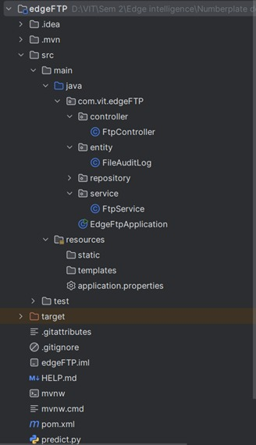

5. Number Plate Detection — ML Model and OCR
Once the image is successfully stored in the FTP server, the detection pipeline is triggered. The machine learning model loads the image, processes it to identify the number plate region, and generates a bounding box around the plate area. Optical Character Recognition (OCR) is then applied to extract the alphanumeric characters from the detected region.

Detection pipeline:
Load Image | → | Run ML Model | → | Bounding Box | → | OCR | → | Plate Text

Sample output: KL07AB1234
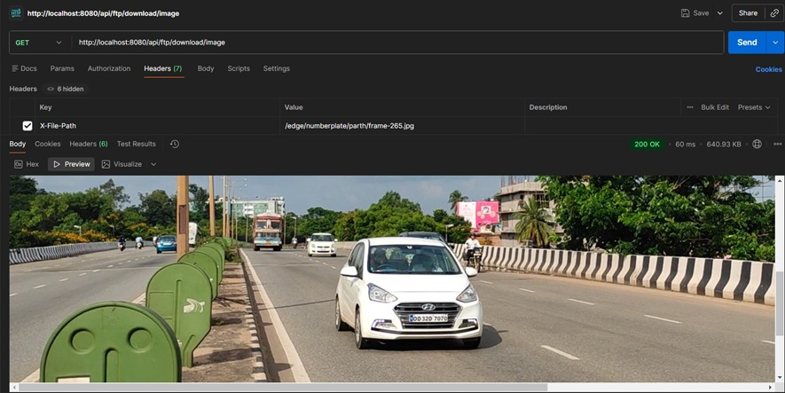

6. Database Storage — PostgreSQL
All detection results and system logs are stored in a PostgreSQL relational database. The backend uses Hibernate ORM to manage database interactions and handle SQL operations efficiently. The following information is recorded for every processed request:

Field | Description
filename | Name of the uploaded image file
upload_time | Timestamp of the upload
detected_plate | Extracted number plate text
processing_status | Success or Failure
server_logs | System activity logs
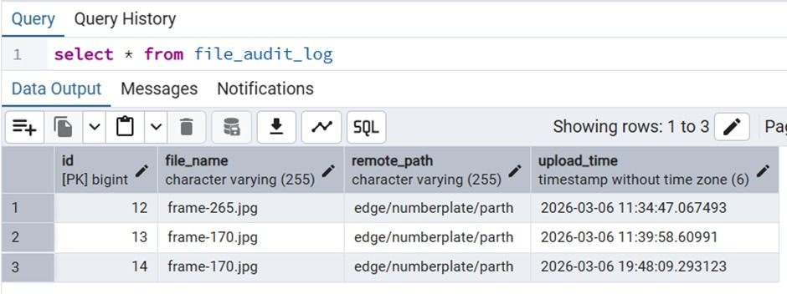
7. Logging and Monitoring
A logging system is implemented to track and monitor all activities at each stage of the processing pipeline. Logs are generated for key events and are used for debugging and system monitoring.

Logged events include:
- API request received
- Image successfully uploaded to FTP server
- Detection model triggered
- Detection status — completed or failed
- Error details for troubleshooting

Sample log entries:
Image uploaded successfully
Detection completed
Plate detected: KL07AB1234

8. Parallel Processing — Multiple Users
Spring Boot supports automatic multithreading, which allows the system to handle multiple image upload requests simultaneously. Each incoming request is processed in its own independent thread, ensuring that no user experiences delays even during peak usage.

Flow:
User 1: Upload | → | User 2: Upload | → | User 3: Upload | → | Processed in Parallel

9. Response to Client
After the detection process is complete, the backend returns a structured JSON response to the frontend containing the filename, detected plate number, processing status, and upload timestamp.

{
"filename" : "vehicle1.jpg",
"plate_number" : "KL07AB1234",
"status" : "success",
"upload_time" : "2026-03-06 10:21:30"
}

10. System Architecture Overview
The overall backend architecture connects all components in a structured flow. The frontend sends image requests through the REST API, which are handled by the Controller and Service layers. The Service layer interacts with the FTP server for image storage, triggers the detection model, and stores all results in the PostgreSQL database. The final output is returned to the frontend as a JSON response.

Architecture flow:
Frontend / Camera | → | REST API (Spring Boot) | → | Controller Layer | → | Service Layer

FTP Server | → | Detection Model (AI/ML) | → | PostgreSQL Database | → | Response to Client

11. Deployment
The complete backend application is packaged as an executable JAR file, making it straightforward to deploy and run across different environments. The application is launched using a single Java command as shown below:

java -jar number-plate-detection.jar

Once the application starts successfully, the following services are initialized:
- Spring Boot server initializes and becomes active
- Database connection to PostgreSQL is established
- FTP server connection is configured and verified
- All REST API endpoints are activated and ready to receive requests

Summary
The Number Plate Detection backend is built on a scalable and efficient architecture that integrates Spring Boot, an FTP server for image storage, a PostgreSQL database for logging, and a machine learning model for plate detection. The system supports concurrent users through Spring Boot's automatic multithreading and is easily deployable as a JAR file. Together, these components provide a reliable and efficient solution for real-time vehicle number plate detection.

