

DEPARTMENT OF COMPUTER SCIENCE AND ENGINEERING

OPERATING SYSTEMS - CS235AI

PINTos-ThreadManagement

REPORT

Submitted by

Vishwanath Ganesh Bhat 1RV22CS235

Computer Science and Engineering 2023-2024
Table of Contents:

- Abstract
- Introduction
- Starting with PintOS
- Methodology
- System call/Functions
- Output
- Conclusion

Abstract:

Pintos, an educational operating system, provides a platform for understanding core operating system concepts, including thread management. Thread management in Pintos encompasses thread creation, synchronization, and scheduling. This abstract delves into the essential aspects of thread management within Pintos.

Thread creation in Pintos involves utilizing the thread_create function, which accepts a function pointer to the thread's entry point and any necessary arguments. Synchronization is achieved through primitives such as semaphores, locks, and condition variables, enabling threads to coordinate their actions and access shared resources safely. Pintos implements a priority-based scheduling algorithm where threads with higher priorities are executed before those with lower priorities, with the ability to set thread priorities using the thread_set_priority function.

Understanding thread management in Pintos provides valuable insights into fundamental operating system concepts, enabling students to grasp the intricacies of concurrent programming, synchronization mechanisms, and scheduling algorithms. Through practical implementation and experimentation within the Pintos environment, students gain hands-on experience in developing and analyzing thread-based applications, laying a solid foundation for further exploration in operating systems and concurrent programming paradigms.

Introduction:
Welcome to Pintos, an operating system framework designed for the 80x86 architecture. Pintos provides foundational support for kernel threads, user program execution, and a file system, albeit in a simplified manner. Throughout the course of your engagement with Pintos projects, you and your team will have the opportunity to enhance and expand upon these core functionalities, including the integration of a virtual memory system.
While Pintos theoretically possesses the capability to operate on standard IBM-compatible PCs, practical considerations necessitate the use of a system simulator. This simulator faithfully emulates an 80x86 CPU and its associated peripheral devices with sufficient accuracy to support unmodified operating systems and software. Within our instructional environment, simulators such as Bochs and QEMU are employed within a Linux Docker container. Additionally, Pintos has been rigorously tested with VMware Player, offering versatility in deployment environments.

Installing PintOS:

Install docker on your machine
Clone the source code onto your directory

git clone https://github.com/Vishwanath-Bhat/PINTOS-Thread-Management

As the next step, build the source code supplied for the first project. First, run the docker container with a mount of your source: (The Docker Image was created by Prof. TheirrySans University of Toloronto)

$ docker run --platform linux/amd64 --rm --name pintos -it -v "$(pwd):/pintos" thierrysans/pintos bash

Once in the Docker container, you should build the utils directory (first time only):

$ cd /pintos/src/utils
$ make

Then, let us build the Pintos kernel inside the docker container:
$ cd /pintos/src/threads
$ make

This will create a build directory under threads, populate it with a Makefile and a few subdirectories, and then build the kernel inside. The entire build should take less than 30 seconds.

Then run a test to check whether the OS has been installed properly:
$ docker run --platform linux/amd64 --rm --name pintos -w /pintos/src/threads/build thierrysans/pintos pintos -q run alarm-zero
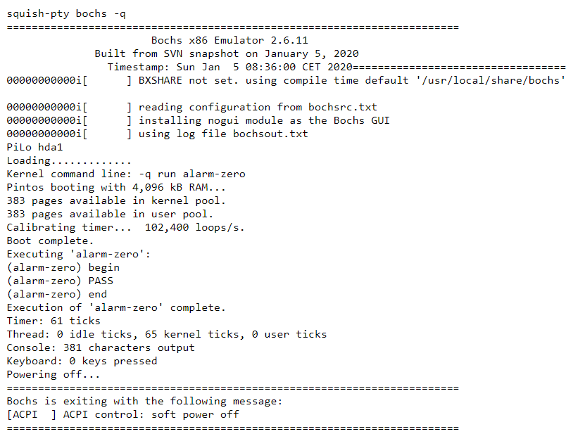

Methodology:

We will be using GDB debugging tool to debug the kernel.o object file so as to see the procedure of thread creation and switching and termination.

Debugging tools:
- dumplist &all_list thread allelem – gives list of all the threads that are currently running
- bt – backtracing the program
- c – continuing
- display – display contents
- b – set breakpoints

Step 1: Running the program

Run the test case alarm-single which basically creates N threads and puts them to sleep using the GDB tool with bochs/QEMU simulator

pintos -v -k -T 60 --bochs --gdb -- -q run alarm-single

Now as the gdb port has been established, open a new shell and connect to the gdb port:

pintos-gdb kernel.o
debugpintos

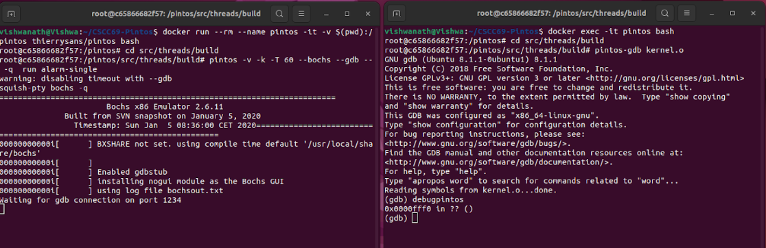

Step 2: ADDING BREAKING POINTS

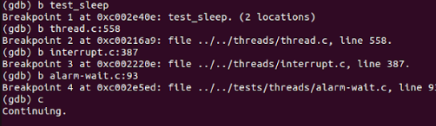

Breakpoint 1: test_sleep
Invokes thread_create function in thread.c file of pintos

Breakpoint 2: schedule();
Shows the current running thread and prev and next thread, and if no thread availabe results in interrupt(trap to os)

Breakpoint 3: intr_handler();
If no thread is ready to yield which results in trap intr_handler() in interrupt.c is invoked which in turn invokes timer.c indicating timer interrupt

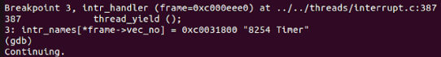

Breakpoint 4: thread_create();
It is invoked when there is a creation of thread.

Step 3 : KEEP CONTINUE UNTIL BREAKPOINT 4 IS HIT:

After series of continue progress in first terminal:
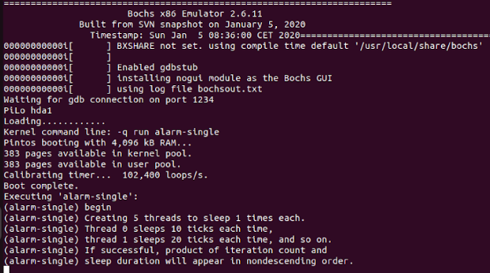

Functions/System calls :

- Thread_create();
In Pintos, thread_create is a function used to create a new thread. This function is provided by the Pintos thread library and allows developers to spawn a new thread with a specified function as its entry point and optional arguments.
- name: A descriptive name for the thread, which can be useful for debugging purposes.
- priority: The priority of the new thread. Pintos uses priority-based scheduling, where higher priority threads are scheduled to run before lower priority threads.
- function: A pointer to the function that the new thread will execute.
- aux: An optional pointer to additional data that can be passed to the thread function.
When thread_create is called, it creates a new thread and adds it to the list of threads ready to run. The newly created thread will start executing the specified function with the provided arguments. The function returns the thread identifier (tid_t) of the newly created thread.
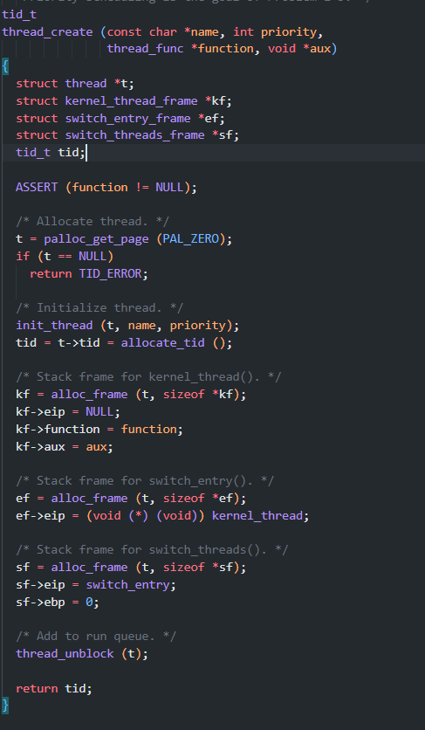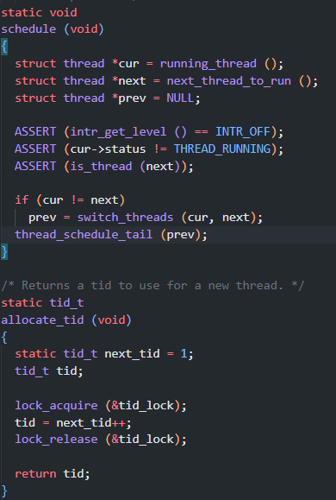

- schedule();

In Pintos, the schedule() function is responsible for selecting the next thread to run on the CPU. This function is a central component of the thread scheduler and is typically called in various contexts, such as when a thread voluntarily yields the CPU (thread_yield()) or when a higher-priority thread becomes ready to run.
The schedule() function follows a priority-based scheduling algorithm, where threads with higher priorities are given precedence over threads with lower priorities. The steps involved in the schedule() function typically include:
- Selecting the Next Thread
- Context Switching
- Execution
- Preemption
- Blocking and Unblocking

- get_next_thread_to_run() is a hypothetical function that selects the next thread to run based on the priority-based scheduling algorithm.
- thread_switch(next_thread) is a hypothetical function that performs the context switch from the current thread to the next thread.

- Thread_yield();

In Pintos, the thread_yield() function is used to voluntarily relinquish the CPU by the currently running thread, allowing another thread of equal or higher priority to be scheduled for execution. This function is often employed in situations where a thread wishes to give other threads an opportunity to run, thereby promoting fairness and preventing starvation.
The thread_yield() function typically involves the following steps:
- Checking for Higher-Priority Threads
- Context Switching
- Execution

- intr_context() checks if the function is being called from an interrupt context.
- intr_disable() disables interrupts to ensure atomicity of the operation.
- thread_highest_priority() retrieves the priority of the highest-priority thread in the ready queue.
- thread_yield_to_higher_priority() is a hypothetical function that performs the actual context switch to yield to a higher-priority thread.

Output:

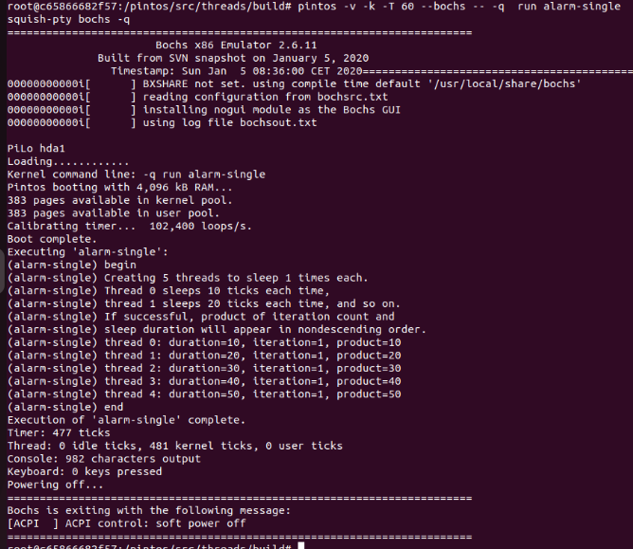

Thread Creation and Switching:

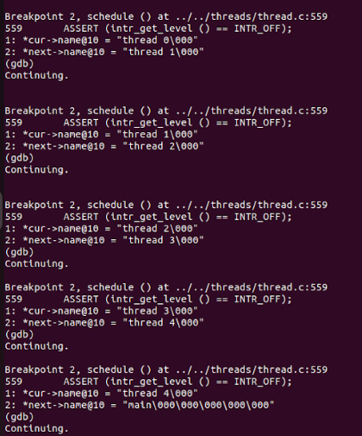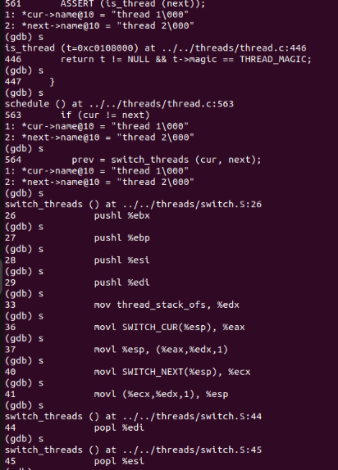
Conclusion:

In conclusion, Pintos thread management offers a comprehensive framework for understanding and implementing core operating system concepts related to concurrency, synchronization, and scheduling. Through its support for kernel threads, user program execution, and simplified file system operations, Pintos provides a practical environment for students to explore the intricacies of thread management.
The priority-based scheduling algorithm employed in Pintos ensures that threads with higher priorities are given precedence, promoting fairness and responsiveness in multitasking environments. Additionally, synchronization primitives such as semaphores and locks facilitate coordination among threads, enabling safe access to shared resources.
By integrating a virtual memory system and providing support for system simulation, Pintos enriches the learning experience, allowing students to gain hands-on experience with operating system development in a controlled environment.
Overall, Pintos thread management serves as a foundational component in the educational journey of students studying operating systems, equipping them with essential skills and insights into concurrent programming and scheduling algorithms. Through experimentation and exploration within the Pintos environment, students are empowered to tackle real-world operating system challenges with confidence and proficiency.

