Transfer Learning for an Automated Detection System of Fractures in Patients with Maxillofacial Trauma
In this project author is using CNN (convolution neural network) to predict SKULL fracture. To train CNN author is using CT SCAN images and this images are not available in huge numbers so author is applying Transfer Learning mechanism with Pretrained RESNET50 as this algorithm already trained on non-medical images and will have massive amount of features so we can include fewer CT SCAN images in this RESNET model to trained our own Fracture detection model. By adding transfer learning concept we can increase prediction accuracy and avoid model over-fitting problem which may rises due to less amount of dataset images.
To implement this project we have designed following modules
- Upload Skull-Fracture Dataset: using this module we will upload SKULL fracture CT-SCAN images to application
- Preprocess Dataset: using this module we will read all CT-SCAN images and then resize to equal size and then normalize all pixel values and then split dataset into train and test where application used 80% images dataset from training and 20% dataset for testing
- Train Resnet50 CNN Model: using this module we will train RESNET50 transfer learning with CNN by using above train and test data and then build a prediction model
- Accuracy Graph: using this module we will plot RESNET50 transfer learning CNN accuracy and loss graph
- Predict Fracture from Test Image: using this module we will upload test image and then CNN will predict weather image is FRACTURE or NON_FRACTURE
To implement this project we have used below images
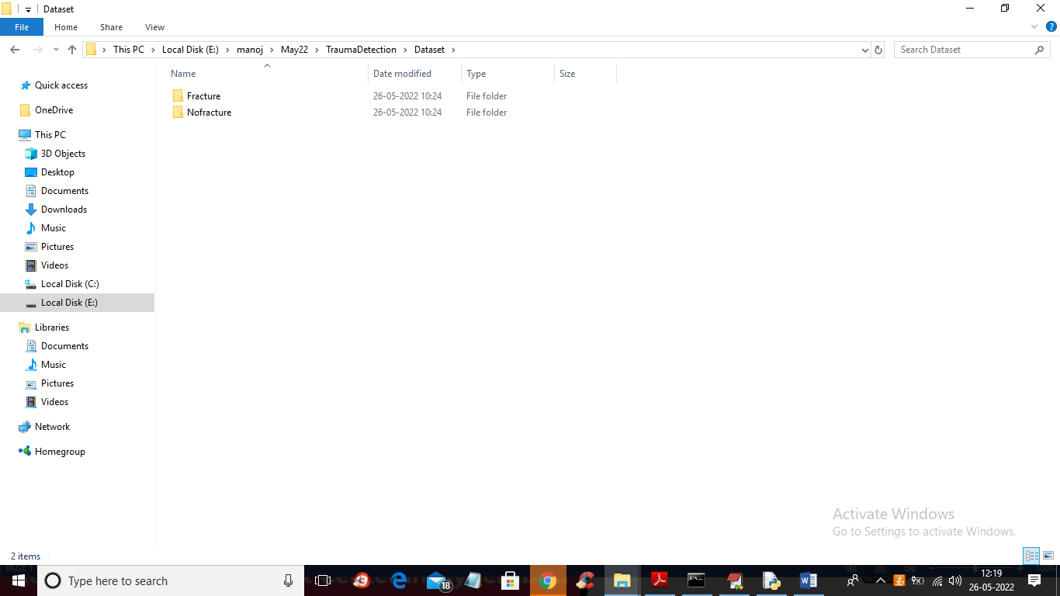
In above screen we have two folder for fracture and non-fracture and just go inside any folder to view images
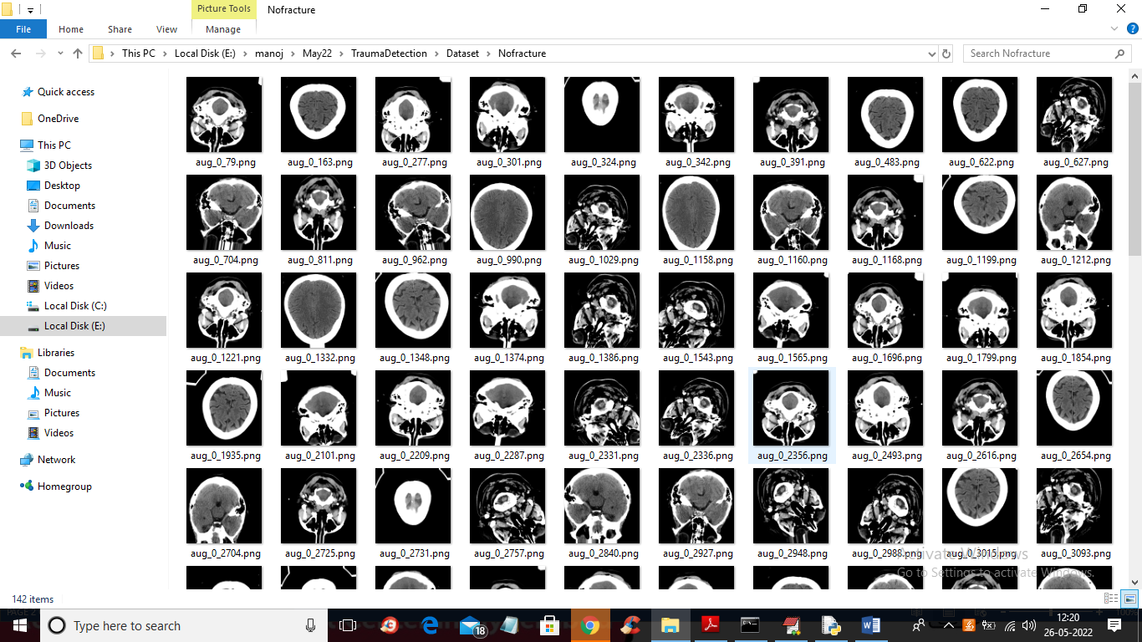
In above screen we can see SKULL CT-SCAN images and will use above images to train CNN.
Below code showing RESNET50 transfer learning
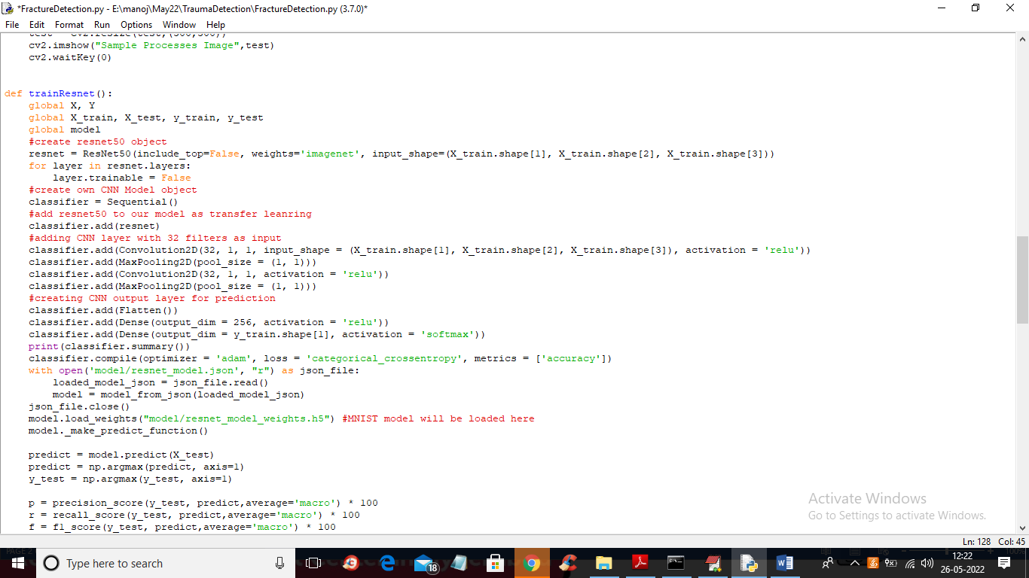
In above screen read red colour comments to know transfer learning with our own model
SCREEN SHOTS
To run project double click on ‘run.bat’ file to get below screen
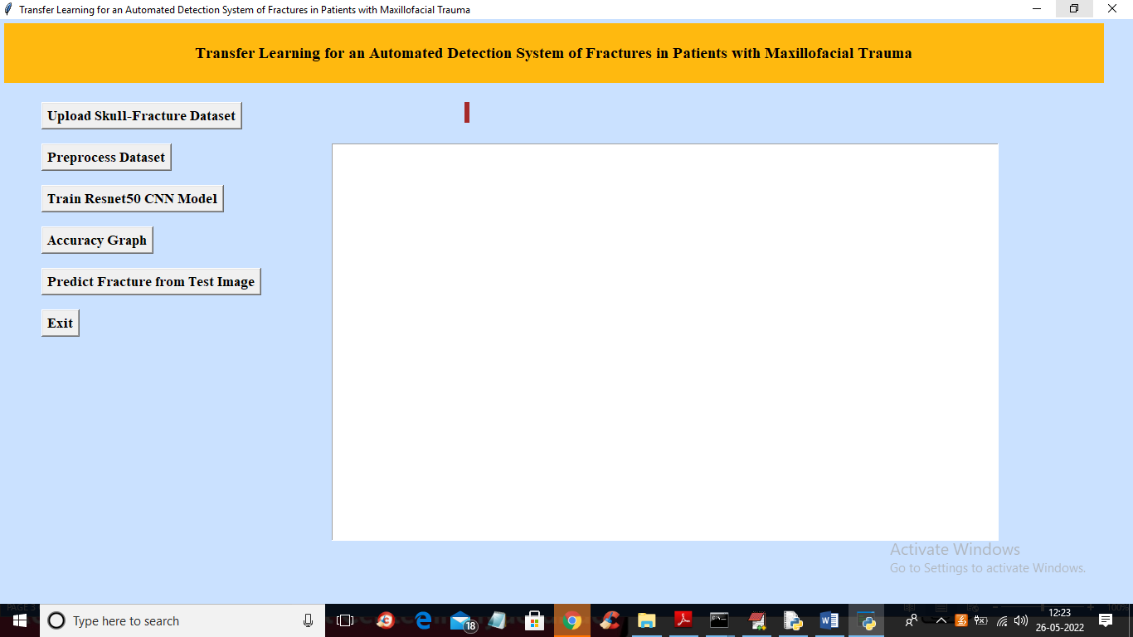
In above screen click on ‘Upload Skull Fracture Dataset’ button to upload dataset to application and get below output
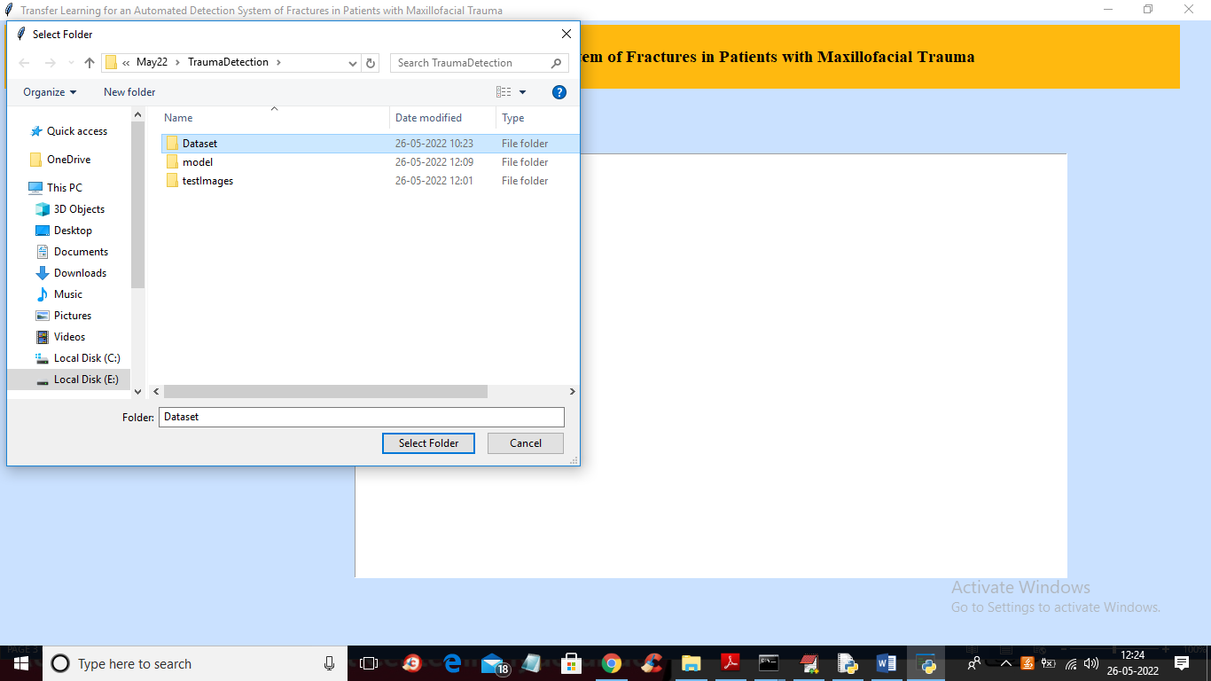
In above screen selecting and uploading ‘Dataset’ folder and then click on ‘Select Folder’ button to load dataset and get below output
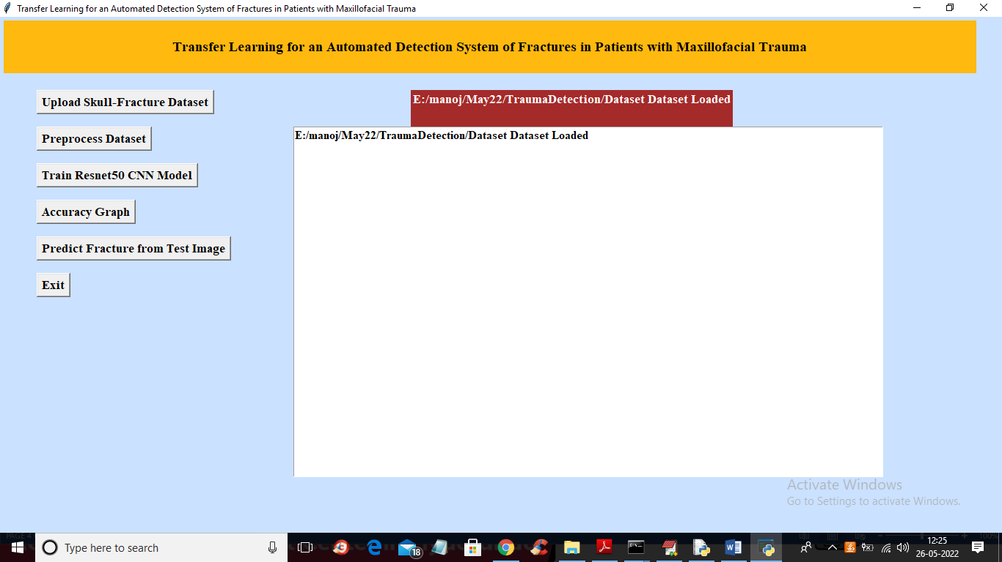
In above screen dataset loaded and now click on ‘Preprocess Dataset’ button to read all images and normalize them
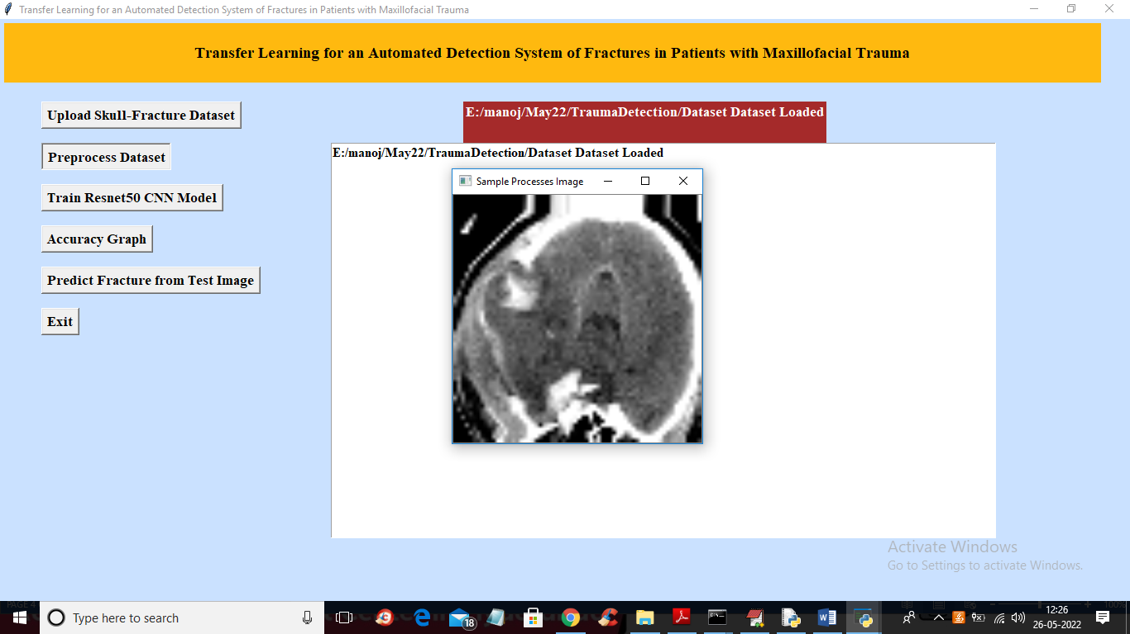
In above screen showing one processed image to check all images are loaded properly and now close above image to get below output
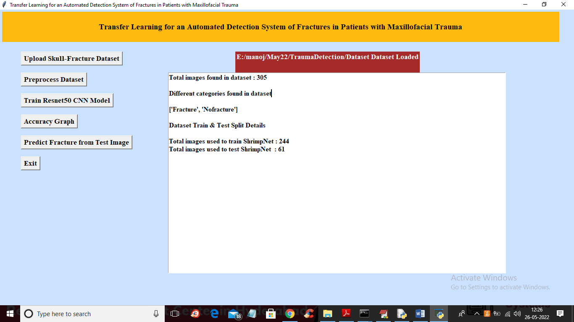
In above screen dataset contains total 305 images and application using 244 images for training and 61 images for testing and now click on ‘Train Resnet50 CNN Model’ button to train Resnet50 transfer learning with CNN and get below output
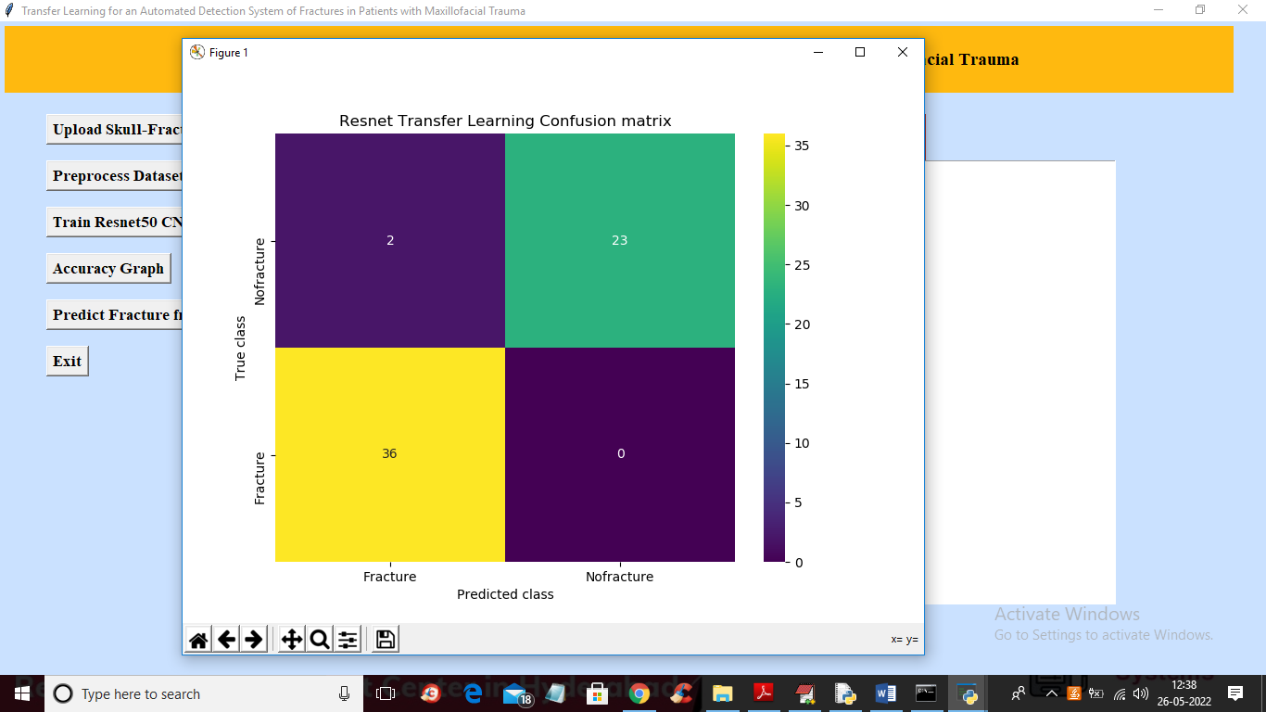
In above confusion matrix graph x-axis represents PREDICTED CLASSES and y-axis represents TRUE classes and in above screen we can see CNN predicted 36 classes correctly as FRCATURED and only 2 classes are incorrectly predicted and all 23 non-fractured images are correctly predicted. Now close above graph to get below output
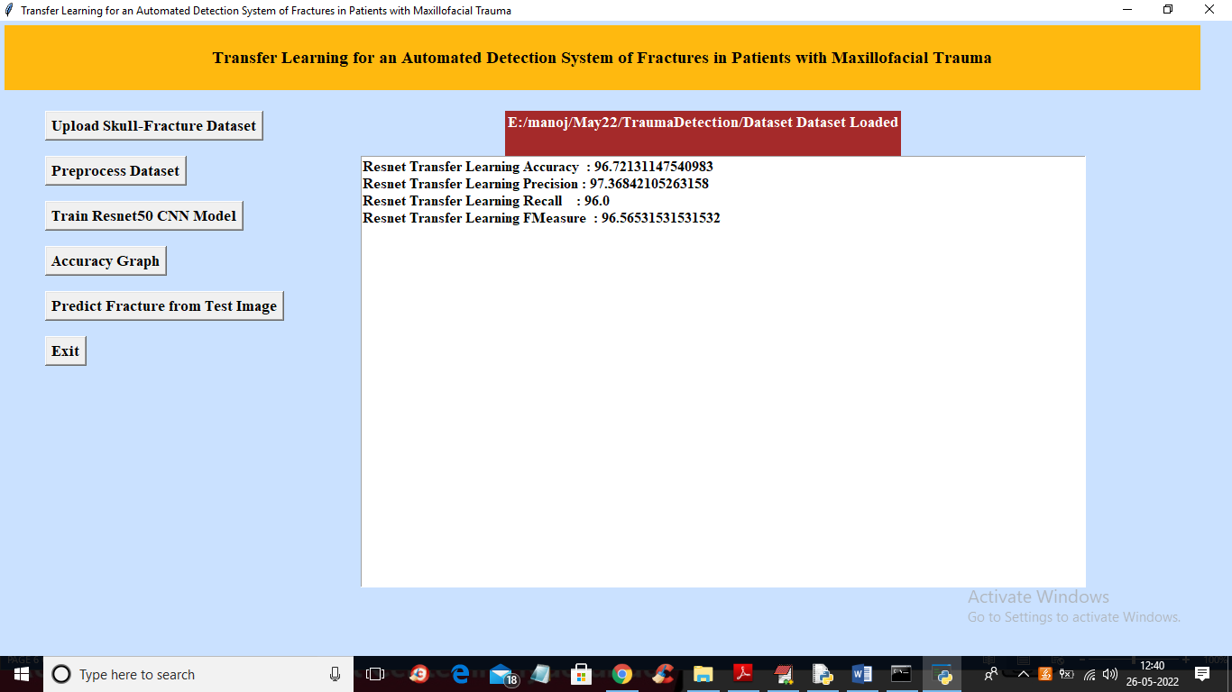
In above screen with RESNET50 transfer learning CNN we got 96% accuracy and now click on ‘Accuracy Graph’ button to get below graph
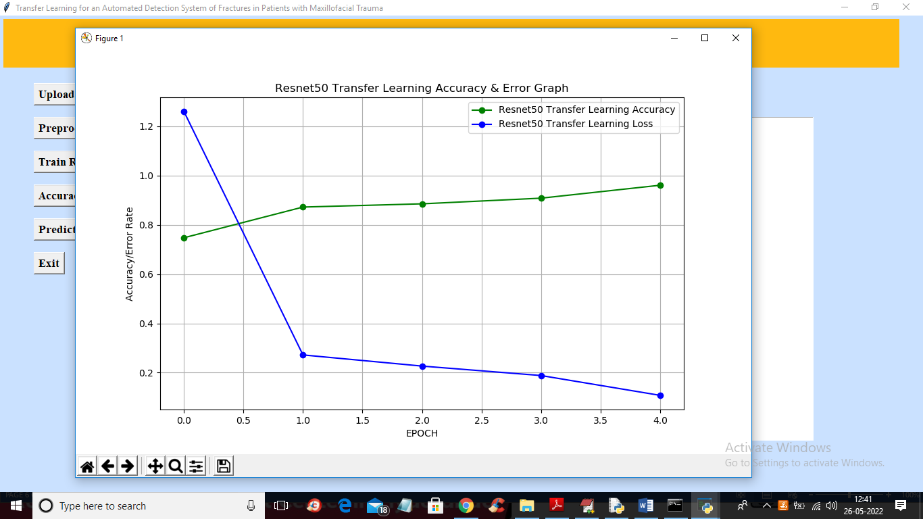
In above graph x-axis represents training EPOCH and y-axis represents accuracy and loss values and in above graph green line represents accuracy and blue line represents LOSS and in above graph we can see with each increasing epoch accuracy got increase and LOSS got decrease. Now close above graph and then click on ‘Predict Fracture from Test Image’ button to upload test image and get predicted output
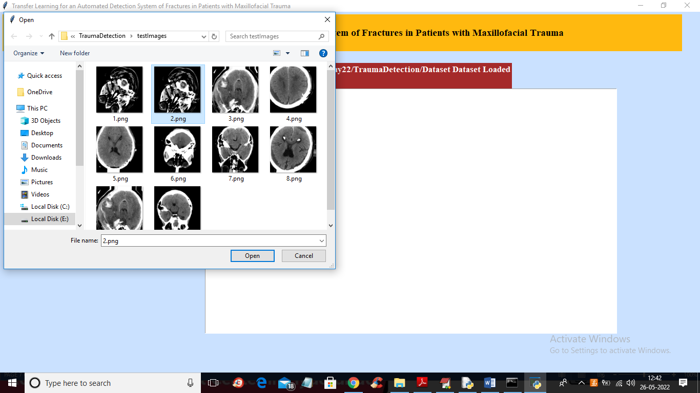
In above screen selecting and uploading 2.png and then click ‘Open’ button to get below output
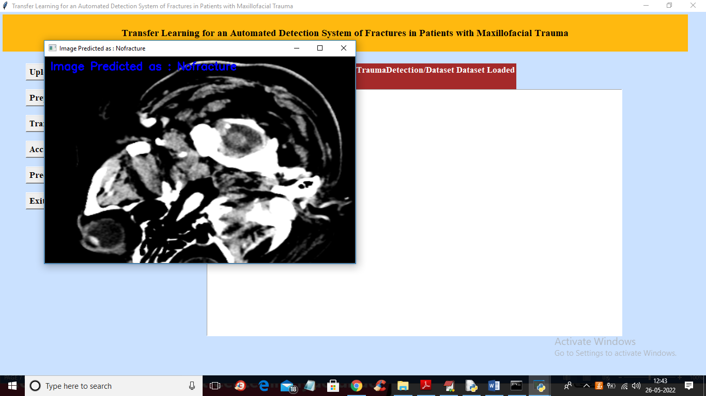
In above screen in blue colour text we can see image predicted as ‘No Fracture’ and now test another image
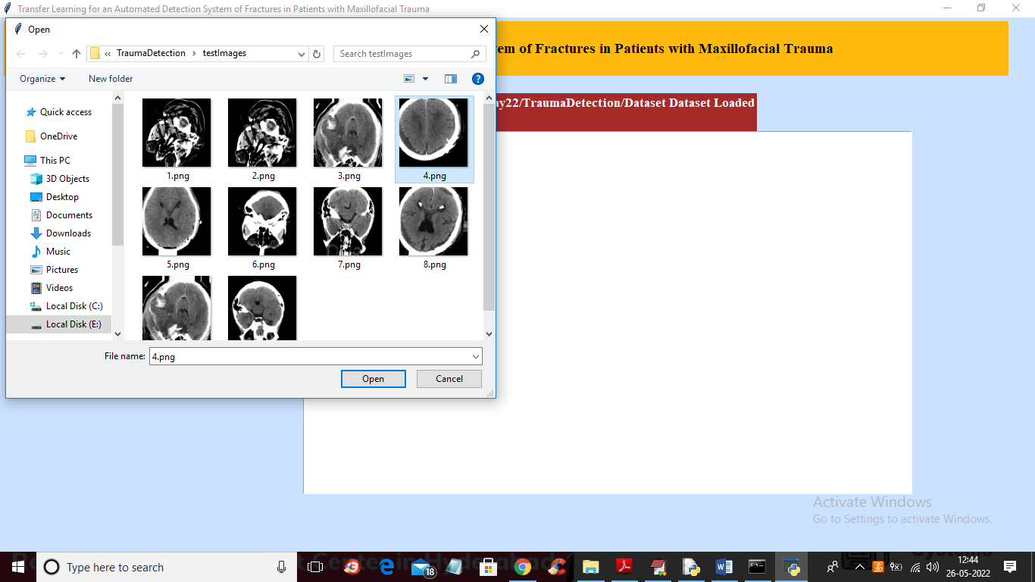
In above screen uploading 4.png and below is the output
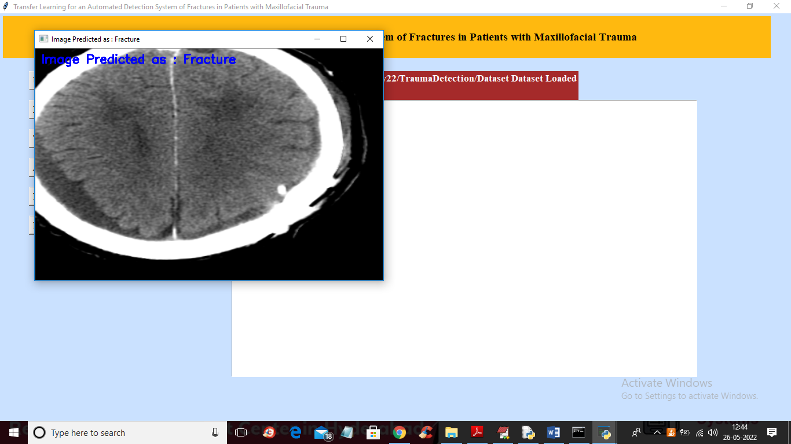
In above image Fracture is predicted and similarly you can upload and test other images

