**Dashboard with charts:**

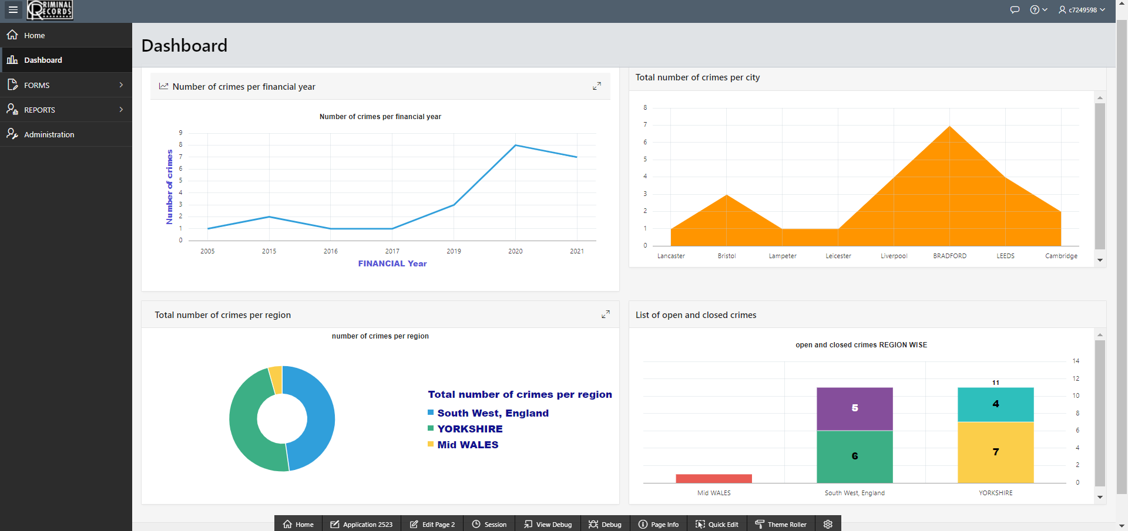

## **Chart 1: Line graph**

**Number of crimes per financial year**

SELECT YEAR AS FINANCIAL_YEAR, COUNT(*) AS NUMBER_OF_CRIMES

FROM

(

select EXTRACT(YEAR FROM reported_date) YEAR, CRIME_ID ,LOCATION_ID, POLICE_ID, REPORTED_DATE, CRIME_STATUS

FROM

crime_register

)

WHERE YEAR BETWEEN 2001 AND 2021 GROUP BY YEAR ORDER BY YEAR ASC;

## **Chart 2: Area graph**

**Total number of crimes per city**

select city_name, count(crime_id) as number_of_crimes

from

(select crime_id, REPORTED_DATE, CRIME_STATUS, CLOSED_DATE, CITY_NAME, REGION_NAME from crime_register cr, location l, region r where cr.location_id = l.location_id and l.region_id = r.region_id)

group by city_name;

## **chart3: Donut chart**

Total number of crimes per region

select count(*) as number_of_crimes ,region_name

from

(select crime_id, REPORTED_DATE, CRIME_STATUS, CLOSED_DATE, CITY_NAME, REGION_NAME from crime_register cr, location l, region r where cr.location_id = l.location_id and l.region_id = r.region_id)

group by

region_name

## **chart4: Bar charts**

**List of open and closed crimes**

SELECT * from (

SELECT REGION_NAME, CRIME_STATUS

FROM

crime_report_view

)

pivot

(

Count (CRIME_STATUS)

for CRIME_STATUS in ('open' as "Open",'closed' as "Closed")

)

order by REGION_NAME;