# **ERD**

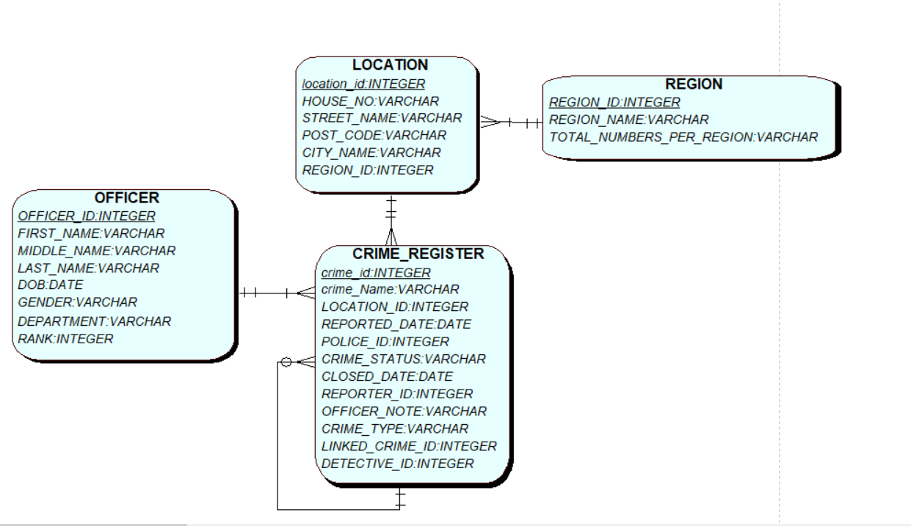

# **Creating the application in Apex**

The application creation wizard is used in which a dashboard and 2 empty pages are added with the name reports and forms

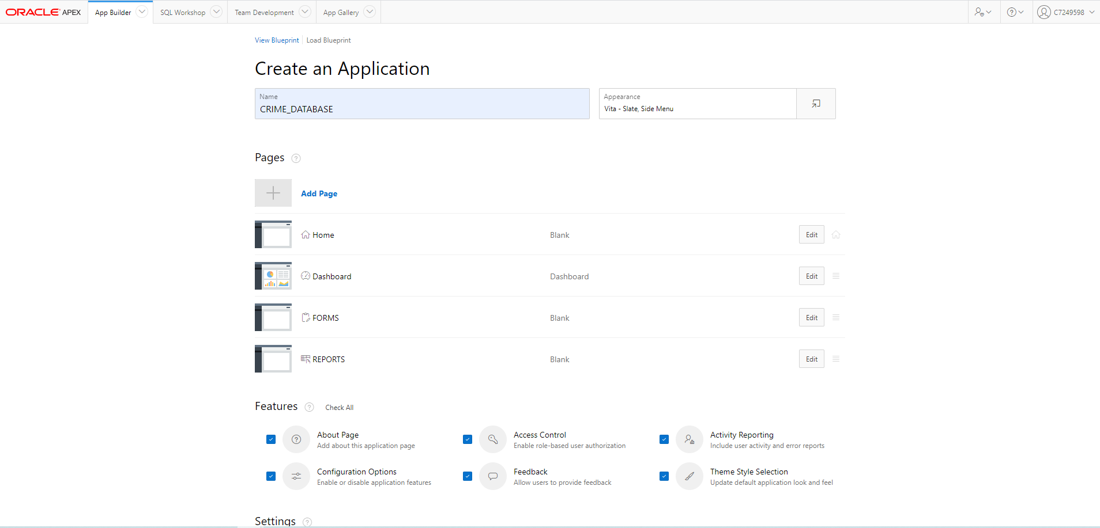

# **Home page:**

# 

# **Master-Detail Form:**

## **Master (OFFICER TABLE)**

#### **Officer attributes Actions Needed**

Officer_id will be populated by a sequence through a trigger

First name validation (alpha numeric, not null)

Middle Name validation (alpha numeric)

Last name validation (alpha numeric, not null)

DOB validation (age > 18)

Gender radio group (male, female), validation (Not Null)

Department radio group (investigation, law enforcement),

validation (Not Null),

dynamic Action: if department = law enforcement show rank

Rank radio group (constable, Inspector, superintendent),

Validation (Not null when department = law enforcement)

## **Validations:**

**First name**: Item is not null, Item is alphanumeric

**Middle name**: Item is alphanumeric

**Last name**: Item is not null, Item is alphanumeric

**DOB**: PL\SQL expression :P6_DOB <= SYSDATE-6570

Age > 18 years = 18*368 days = 6570, Item is not null

**GENDER**: Item is not null

**Department**: Item is not null

**Rank**: Item is not null when department = law enforcement,

*Server-side Condition* (Item! = value)

P6_DEPARTMENT != Investigation

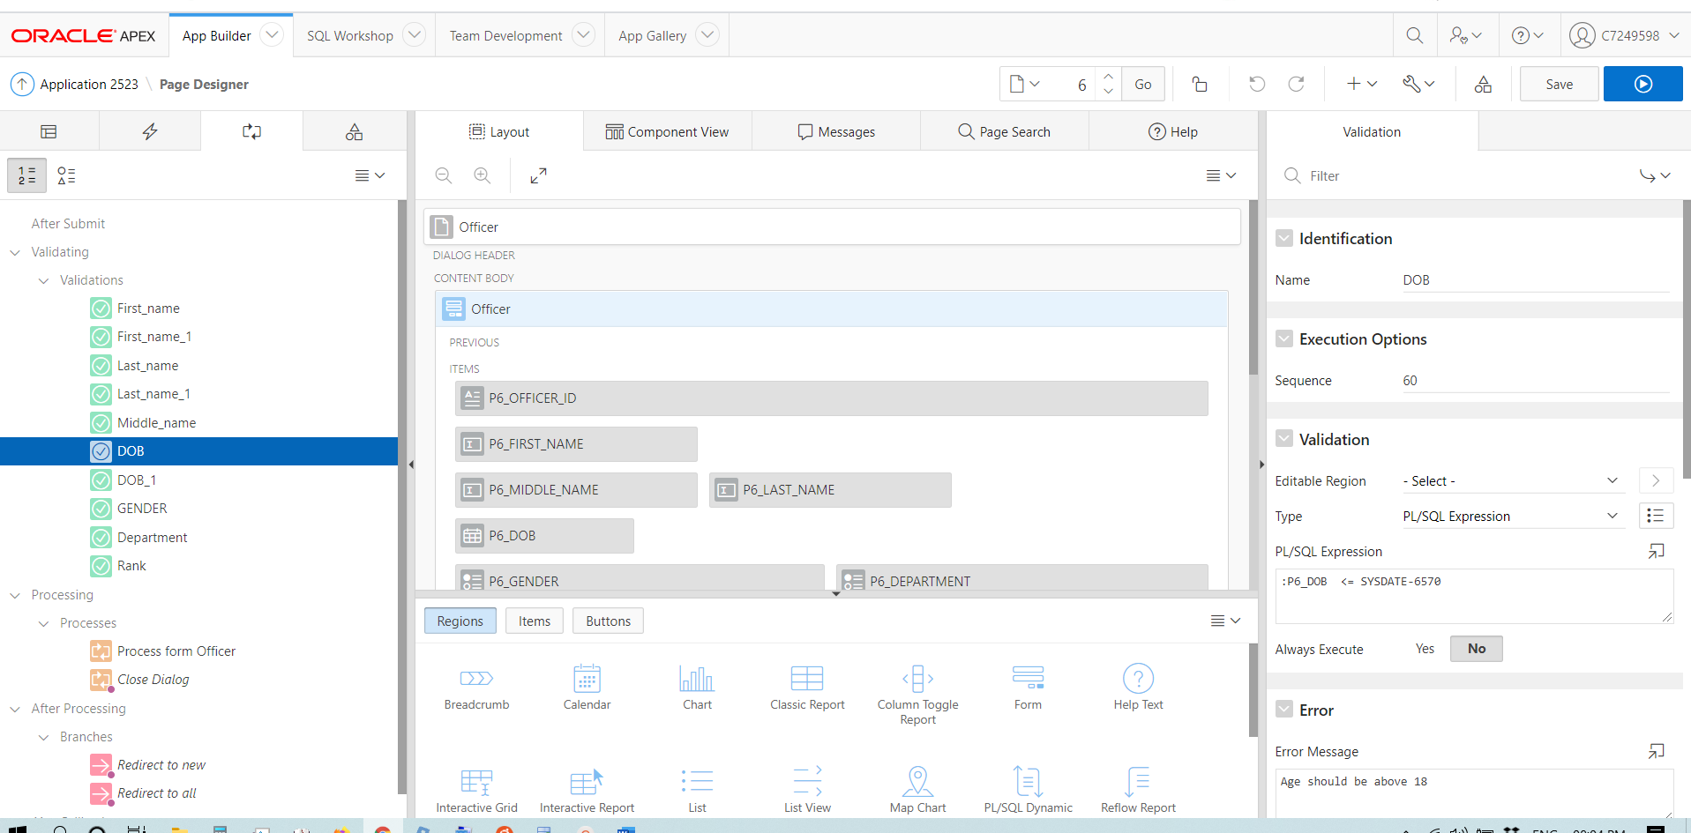

## **Messages due to validation errors. (Master Table)**

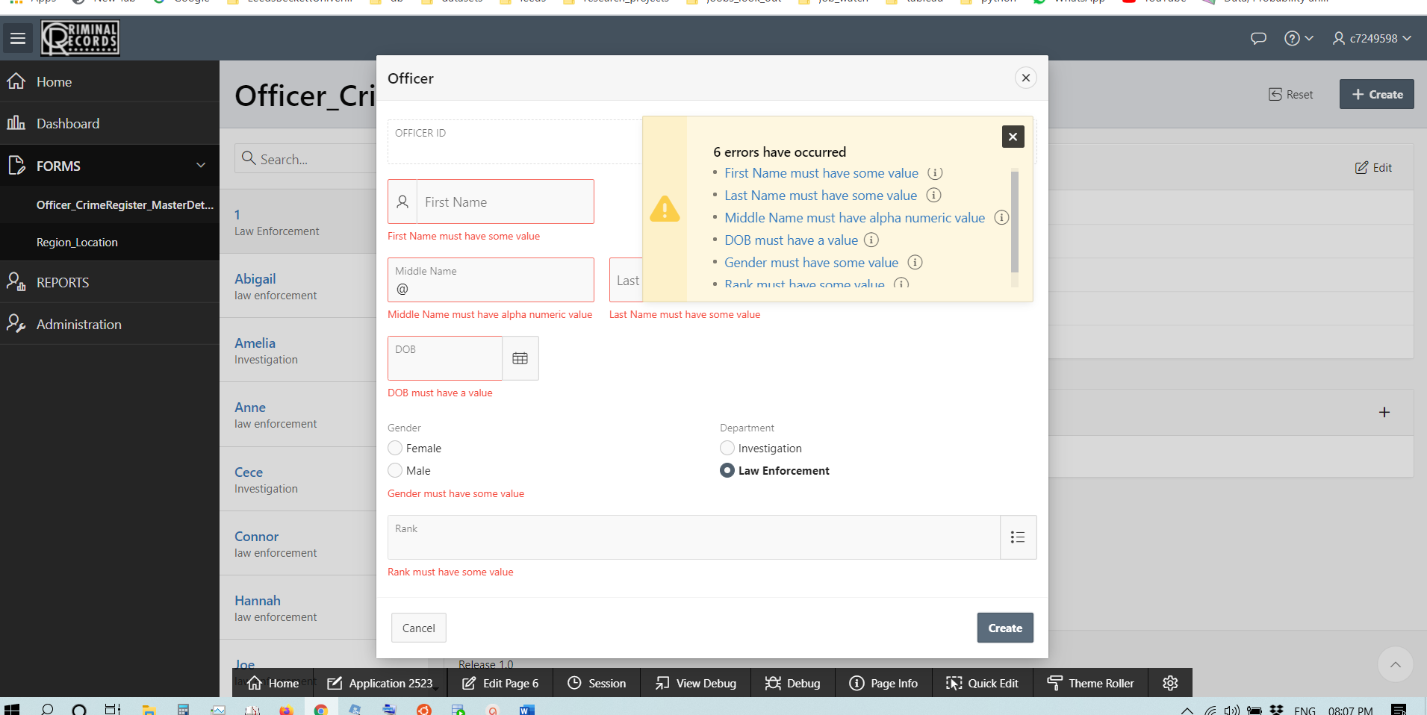

## **List of Values (Master Table)**

### **Static LOV for officer rank:**

Officer rank 1,2,3 corresponds to constable, Inspector and Superintendent

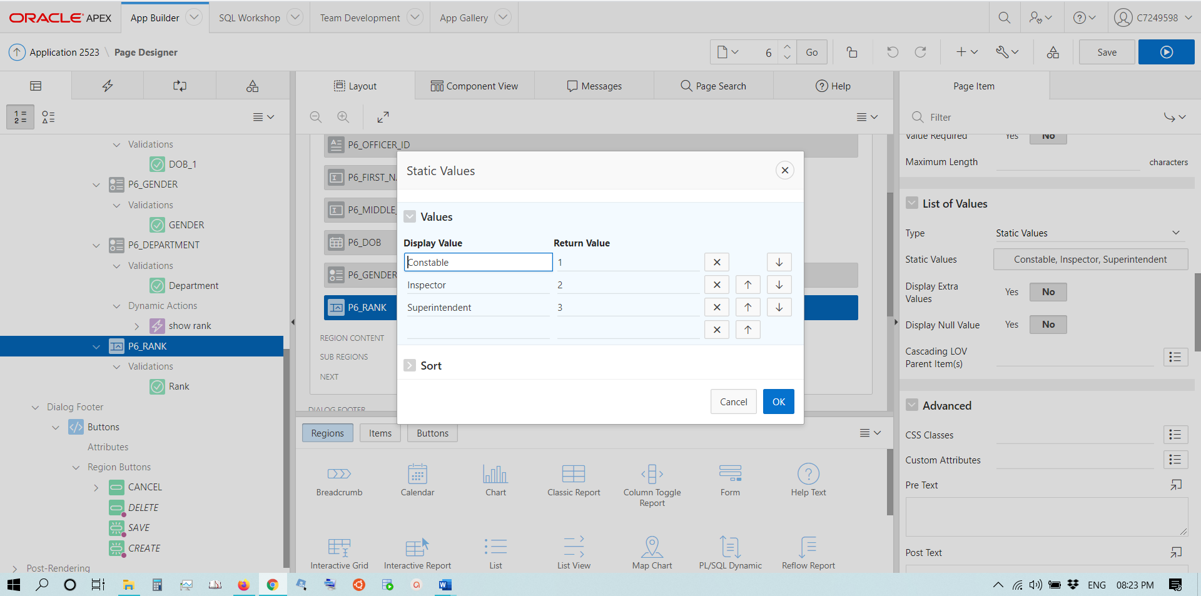

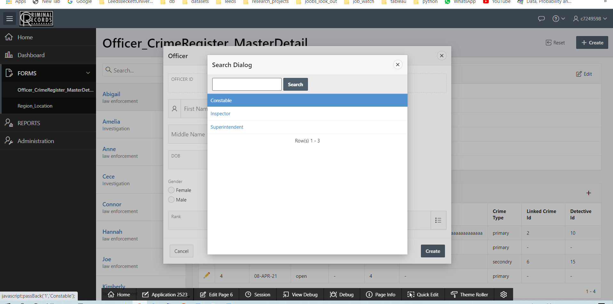

* Gender and Department attributes are populated through radio buttons as they eliminate out of range errors, impose check constraints. LOV’s are not required for these attributes.

## **Dynamic Actions (Master Table)**

* When department is selected as Law Enforcement through a radio button on the client side then officer rank is expected. A dynamic action will show the rank with an LOV to select

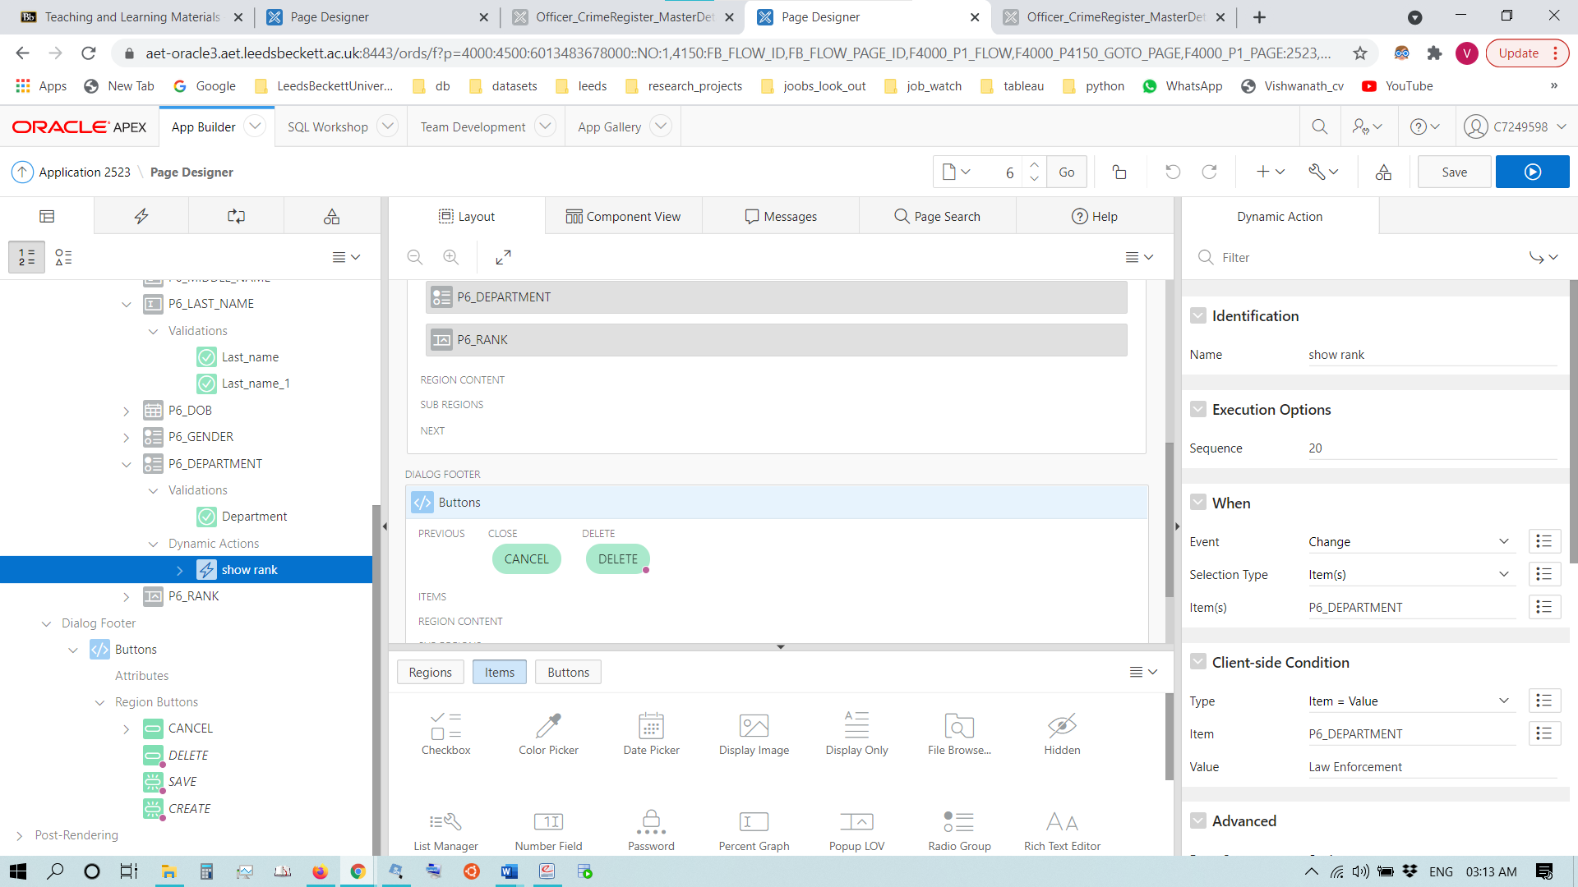

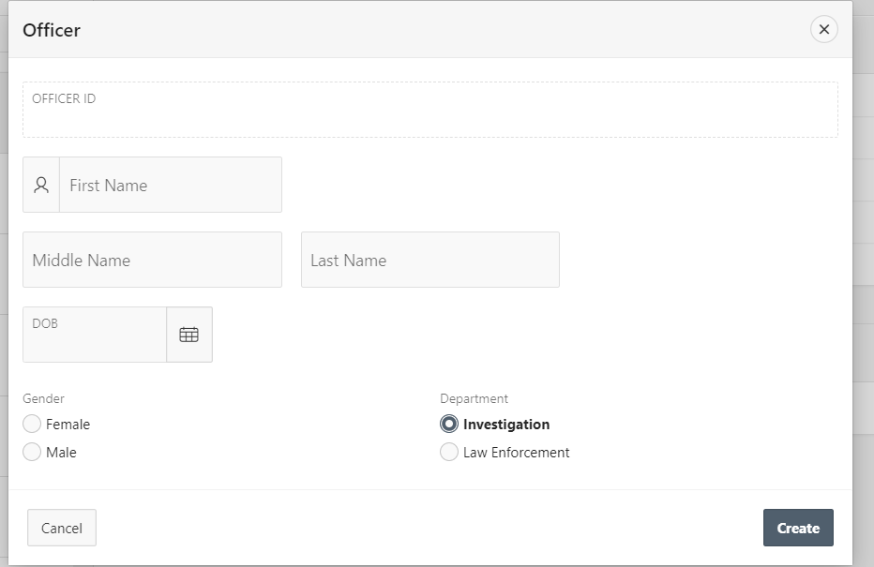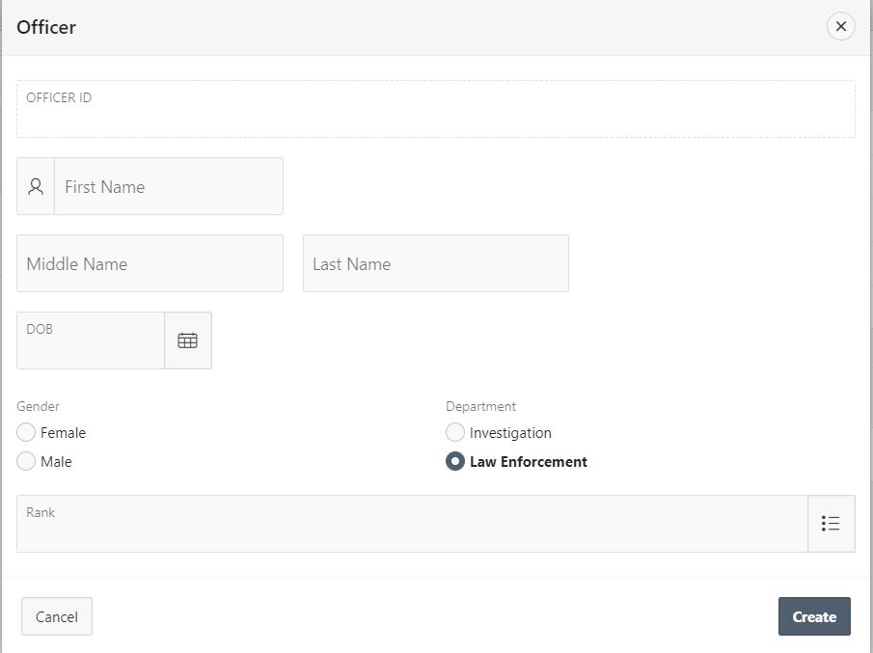

## **Detail (CRIME_REGISTER TABLE)**

### **Crime register:**

**Officer attributes Actions Needed**

Crime id populated using a sequence by a trigger

Location dynamic LOV (showing H.NO, address, city), validation (not null)

Reported_date Not null, validation (reported date can’t be a future date)

Police_id validation (not null, integer), LOV

Crime status Radio group (open, closed),

dynamic action (if closed show the closed date)

Reporter id LOV, validation (Not null)

Officer note validation (not null)

Crime_type radio Group (primary, secondary) or a static LOV

Closed date

Linked_crime_id

Detectice_id LOV with null

## **Validations**

### **Reported date**

* :P7_REPORTED_DATE <= sysdate

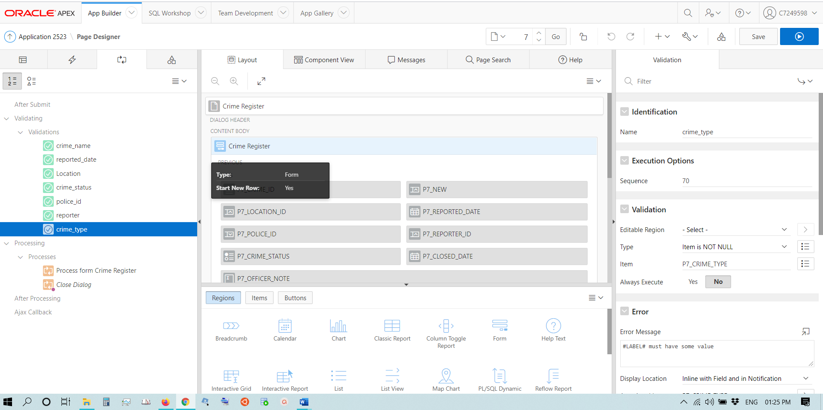

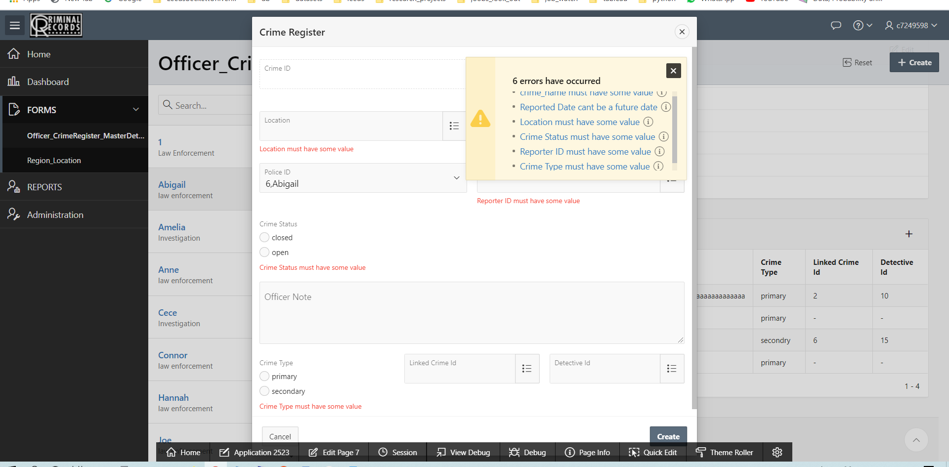

## **List of Values (Detail table)**

* For location a dynamic LOV is used that will display the location details like House number, street, city and region. The search dialogue box can be used search for a city or region etc.

SELECT HOUSE_NO|| ' , '|| STREET_NAME || ' , '|| POST_CODE || ' , '|| CITY_NAME AS display_value, LOCATION_ID as return_value

from LOCATION

order by HOUSE_NO, STREET_NAME, CITY_NAME , POST_CODE;

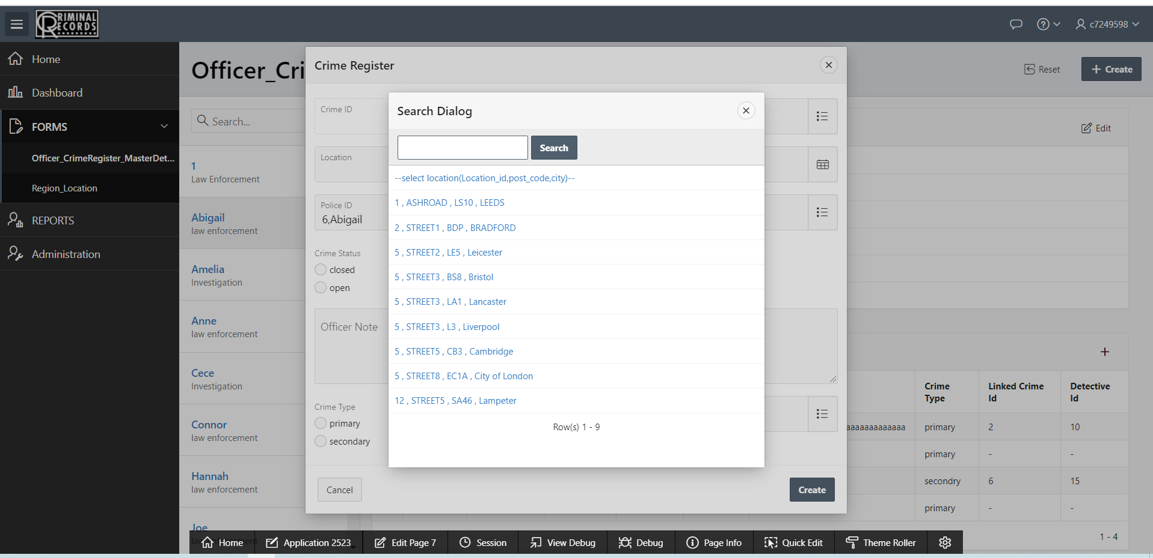

### **POLICE_ID dynamic LOV:**

select OFFICER_ID || ',' ||FIRST_NAME as display_value, OFFICER_ID as return_value

from officer

where DEPARTMENT = 'law enforcement'

order by OFFICER_ID;

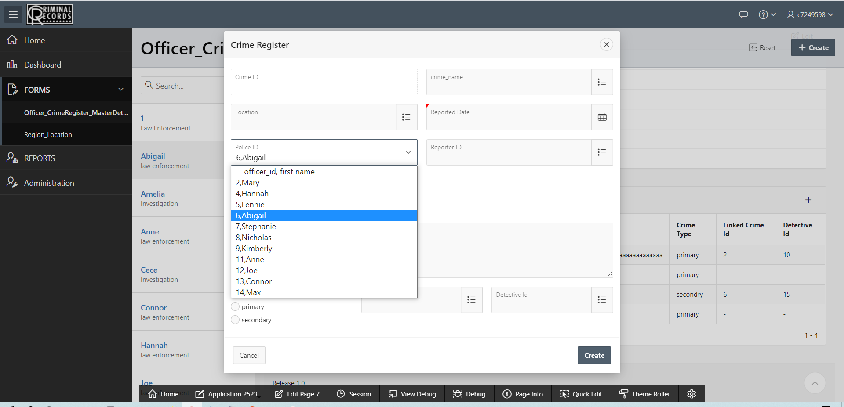

**Dynamic Actions**

* If crime status is chosen as ‘closed’ from the Radio group (open, closed) then a dynamic action should show the user the closed date.

