# **Reports**

The following view is created to use it with a pivot table

**VIEW:**

CREATE VIEW crime_report_view AS

SELECT CRIME_ID, CRIME_NAME, REPORTED_DATE, CLOSED_DATE, CRIME_STATUS, CRIME_TYPE, OFFICER_NOTE,

HOUSE_NO, STREET_NAME, POST_CODE, CITY_NAME, REGION_NAME,

FIRST_NAME, MIDDLE_NAME, LAST_NAME, DOB, GENDER, DEPARTMENT,RANK

FROM CRIME_REGISTER, LOCATION, REGION, OFFICER

where CRIME_REGISTER.LOCATION_ID = LOCATION.LOCATION_ID and

CRIME_REGISTER.POLICE_ID = OFFICER.OFFICER_ID and

LOCATION.REGION_ID = REGION.REGION_ID;

**Report1:**

* **Total number of open and closed crimes per city using a pivot, a count function, order by**

SELECT * from (

SELECT CITY_NAME, CRIME_STATUS

FROM

crime_report_view

)

pivot

(

Count (CRIME_STATUS)

for CRIME_STATUS in ('OPEN' as "Open",'CLOSED' as "Closed")

)

order by CITY_NAME;

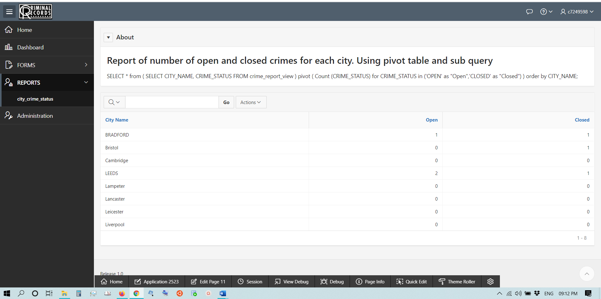

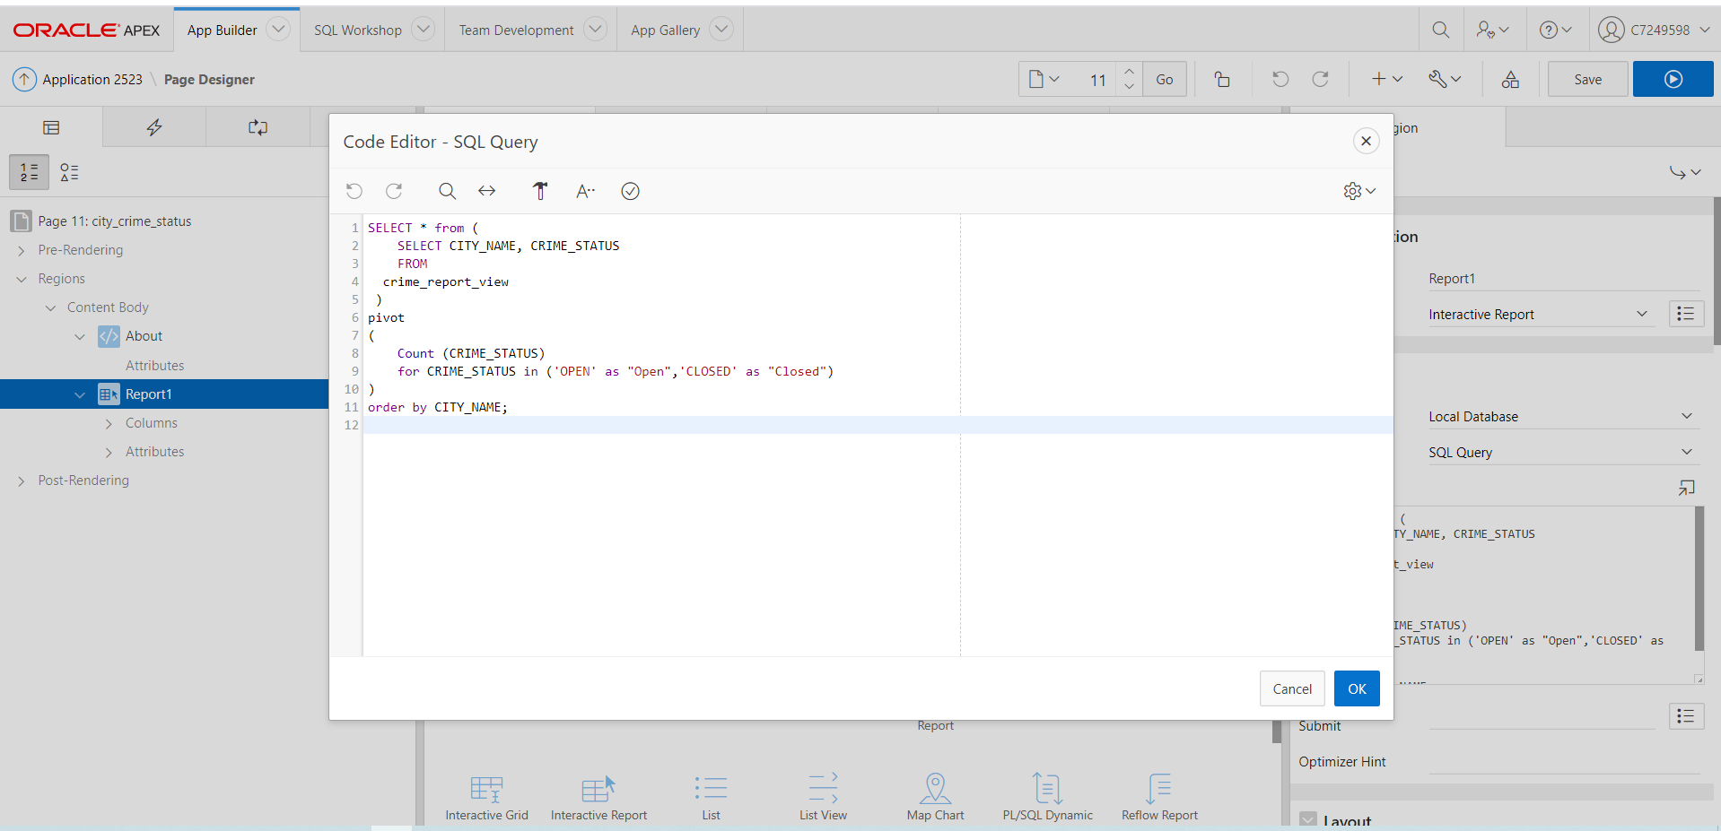

**Report2:**

* **Number of crimes per financial year between the years 2001 to 2021 using sub query, Extract function, Between, group by and order by.**

SELECT YEAR AS FINANCIAL_YEAR, COUNT(*) AS NUMBER_OF_CRIMES

FROM

(

select EXTRACT(YEAR FROM reported_date) YEAR, CRIME_ID ,LOCATION_ID, POLICE_ID, REPORTED_DATE, CRIME_STATUS

FROM

crime_register

)

WHERE YEAR BETWEEN 2001 AND 2021 GROUP BY YEAR ORDER BY YEAR ASC;

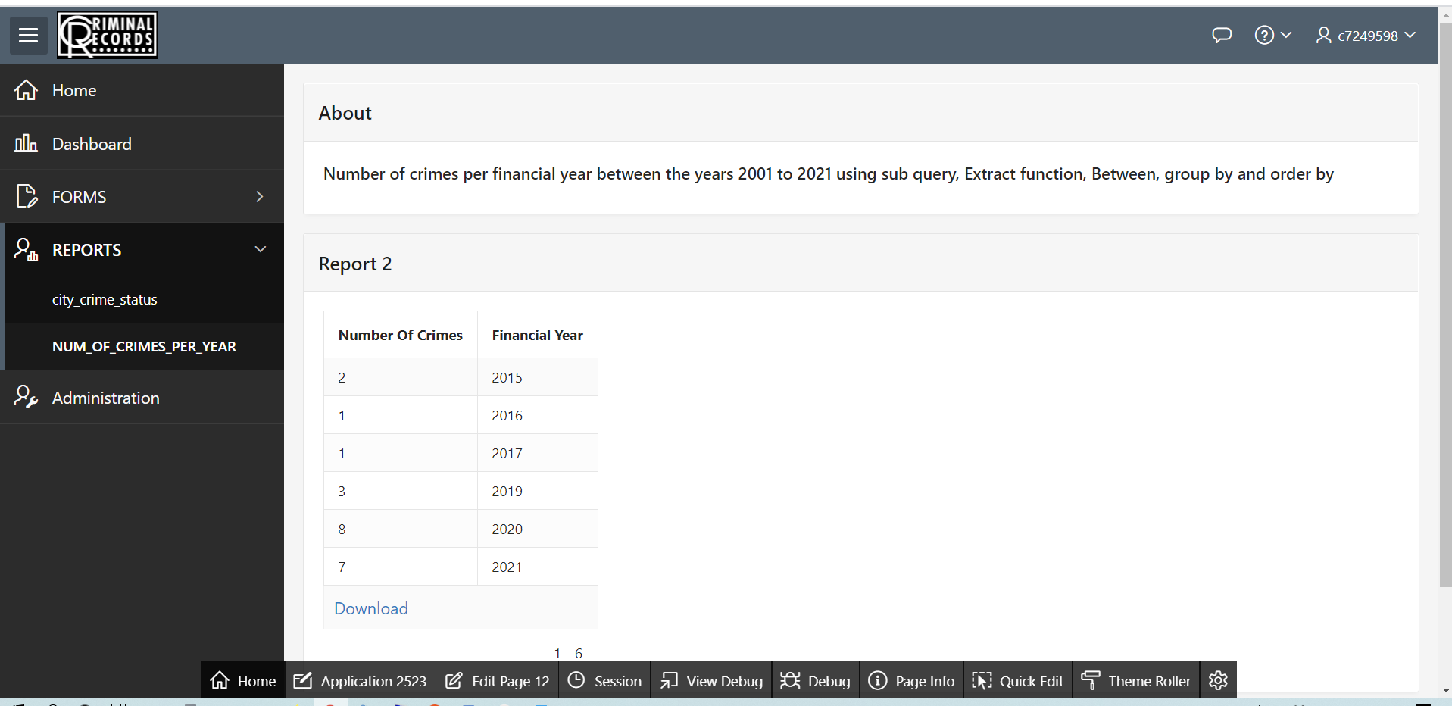

**Report3:**

### **Number of crimes per region using subqueries, table joins, count, group by order by**

SELECT region_name, crime_numbers_per_region

FROM

(

SELECT COUNT(*) as crime_numbers_per_region, region_name

From

(

SELECT cr.crime_id, l.location_id,r.region_id, region_name

FROM

crime_register cr, location l, Region r where cr.location_id = l.location_id and l.region_id = r.region_id

)

GROUP BY region_name

) ORDER BY region_name;

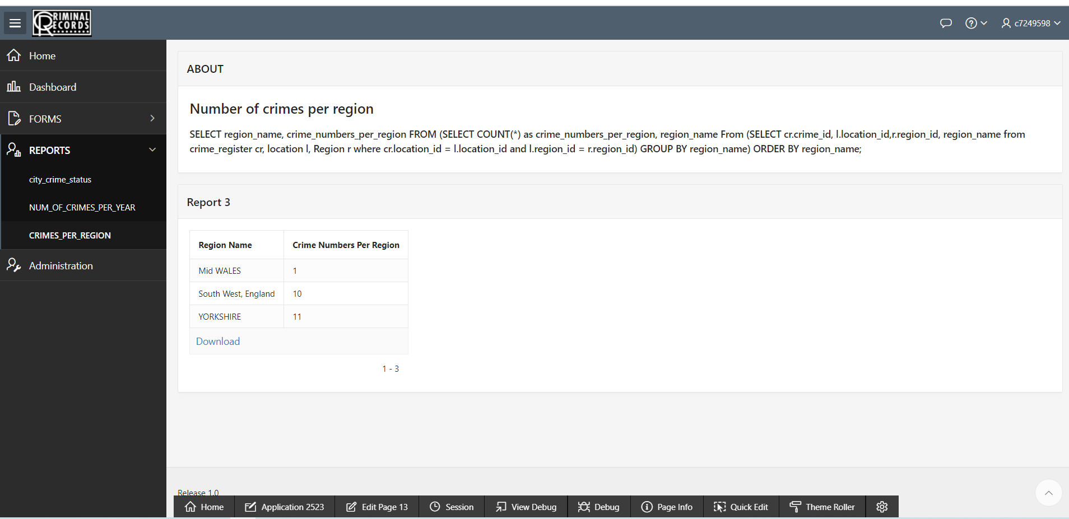

**Report4:**

**Region where number of crime is maximum using MAX, count, table joins and subqueries**

SELECT region_name as region_with_max_crimes, CRIME_NUMBERS_PER_REGION as number_of_crimes FROM (SELECT region_name, crime_numbers_per_region FROM

(SELECT count(*) as crime_numbers_per_region, region_name

From

(SELECT cr.crime_id, l.location_id,r.region_id, region_name from crime_register cr, location l, Region r where cr.location_id = l.location_id and l.region_id = r.region_id)

GROUP BY region_name) order by region_name)

WHERE

CRIME_NUMBERS_PER_REGION =(SELECT Max(CRIME_NUMBERS_PER_REGION)

FROM

(select region_name, crime_numbers_per_region FROM

(select count(*) as crime_numbers_per_region, region_name

From

(select cr.crime_id, l.location_id,r.region_id, region_name from crime_register cr, location l, Region r where cr.location_id = l.location_id and l.region_id = r.region_id)

GROUP BY region_name))

)

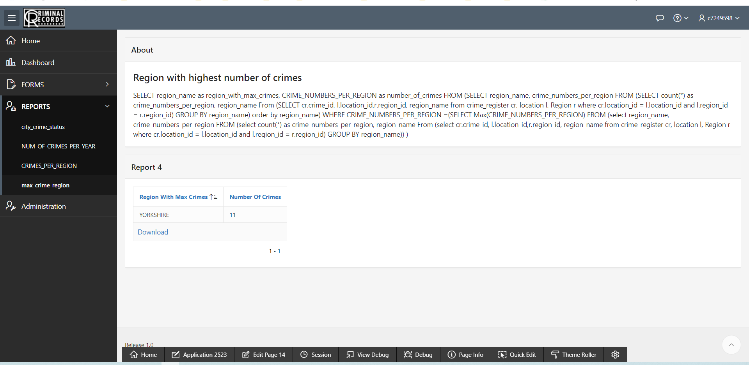

**Report5:**

**List of cities where crime numbers is more than the average number of crimes using table joins, count(), Having, AVG(), group by.**

SELECT l.city_name FROM crime_register c, location l WHERE c.location_id = l.location_id

GROUP BY l.city_name

HAVING COUNT(*) > (SELECT AVG(COUNT(*)) FROM crime_register GROUP BY location_id)

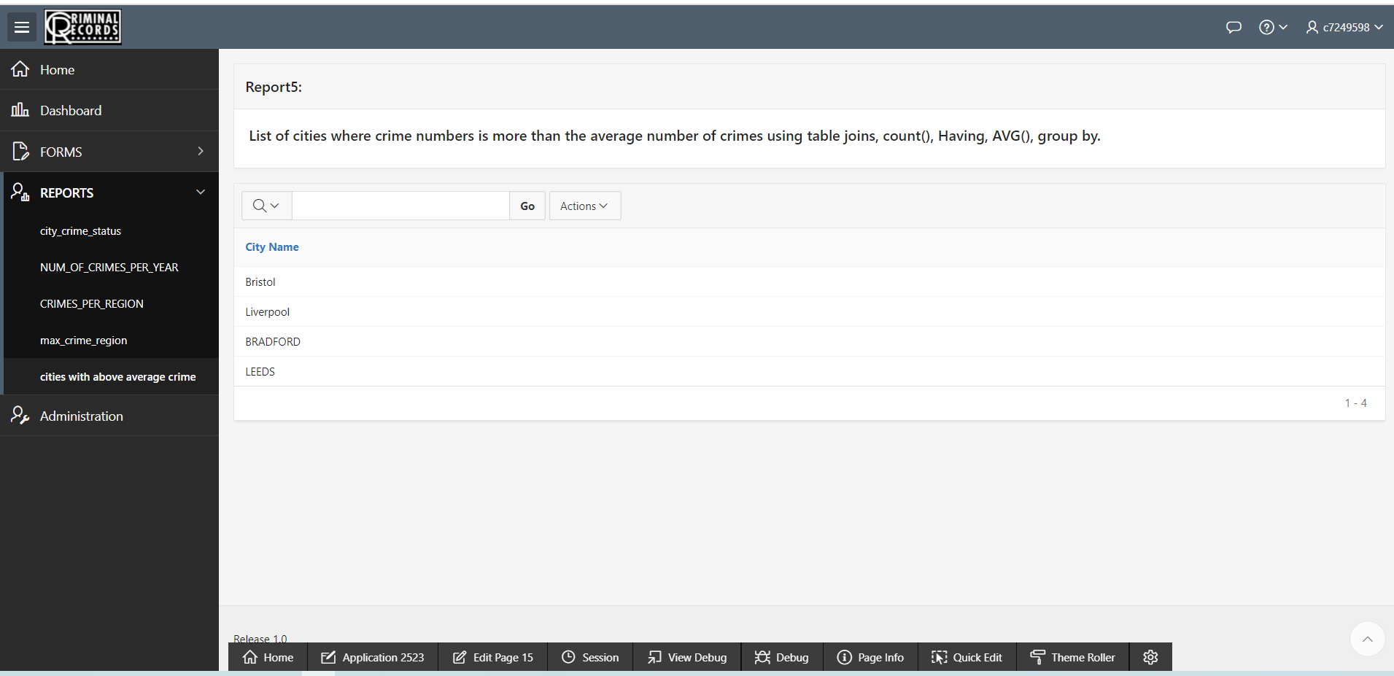

**Report6:**

### **list of crimes that remained unsolved for more than 2 years and the detective who is assigned with the case**

SELECT CRIME_ID, CITY_NAME, o.first_name ||''||o.middle_name||' '||o.last_name AS DETECTIVE, FLOOR((SYSDATE-REPORTED_DATE)/365) AS NUM_OF_YEARS FROM CRIME_REGISTER cr, OFFICER o, LOCATION L WHERE cr.detective_id = o.officer_id AND CRIME_STATUS = 'open' AND DEPARTMENT = 'Investigation' AND FLOOR((SYSDATE-REPORTED_DATE)/365) >2 AND L.location_id = cr.location_id;

