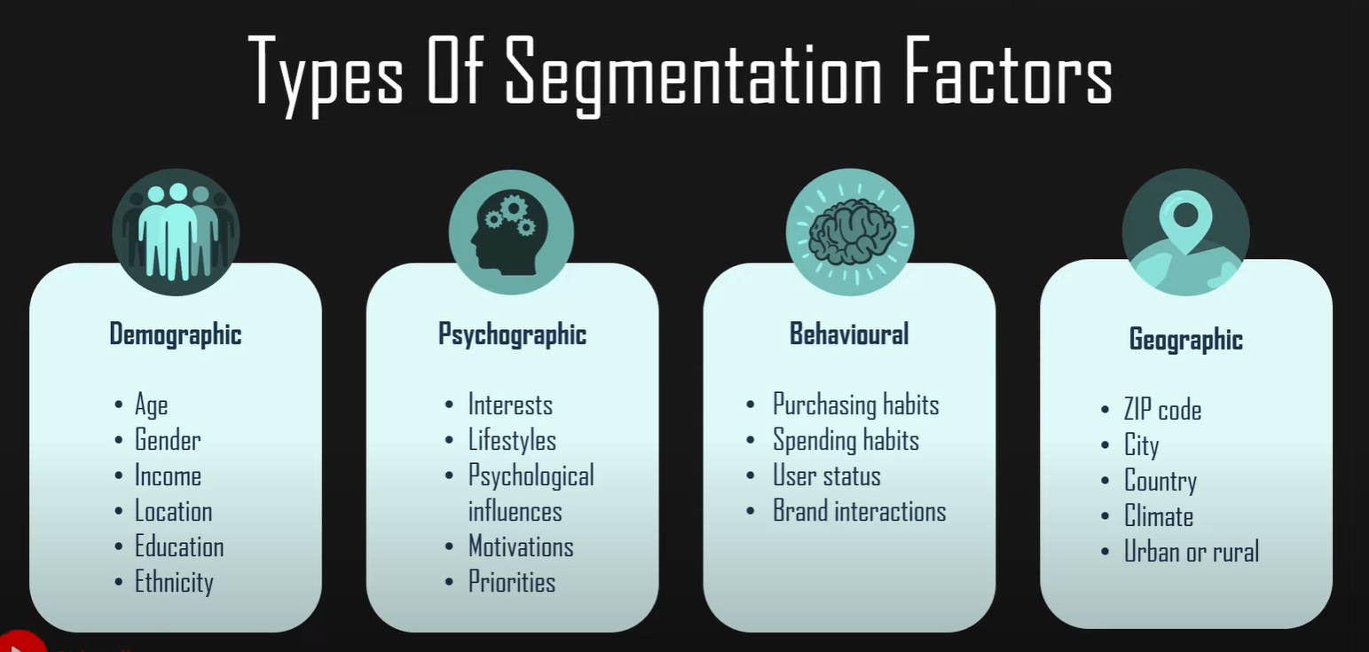

**## To do**

1) obtain most frequent customers by grouping transaction id by customer id through count (frequent buyers)

2) define list_price - standard_cost  as profitability

3) Identify high value customers for approved orders profit(summed after grouping the dataset through customer_id) vs customer_id

4) which brand has high profitability

5) customer segmentation(Demographic, Geographic, psychographic, Behavioural)

6) Trgeting (segmentsize, Expected growth , competitors offering)

7) Association analysis