Create a file and commit it
Add a line to the file ( DO nOT Commit it )
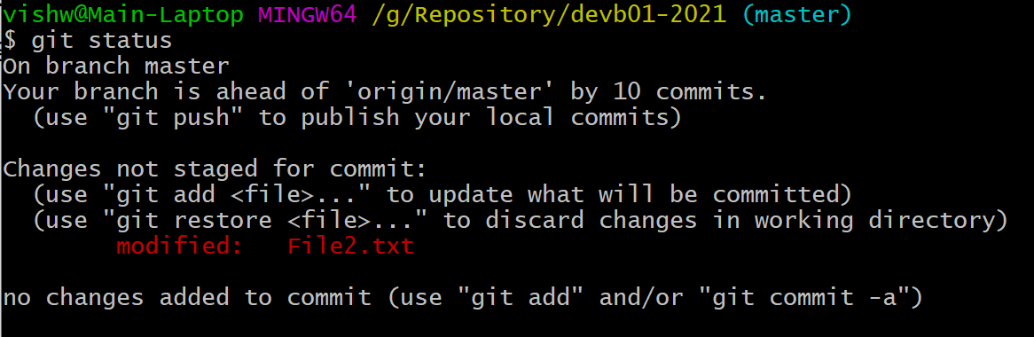
Run “git stash”
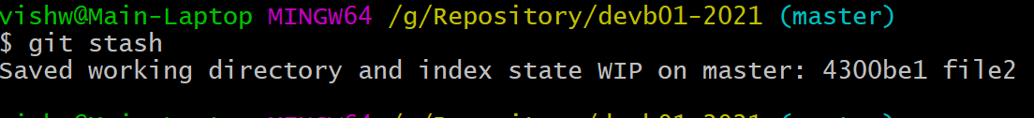
Run “git status” – this
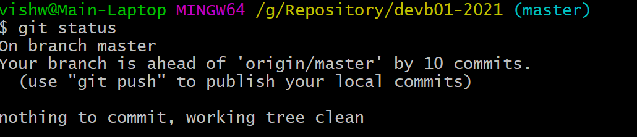

Running “git stash list” would list all the stashed messages
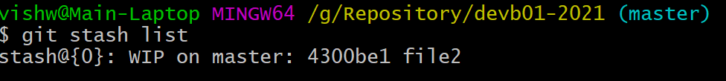

Now lets add –3rd line to the file
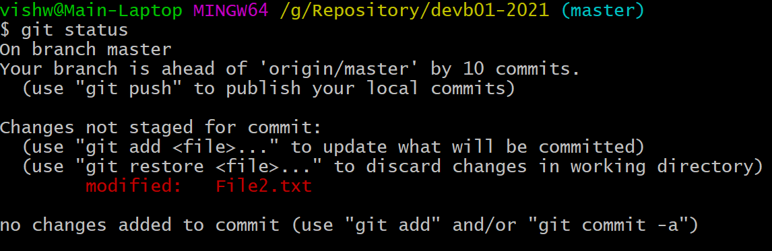
And then stash it again

Git stash list again
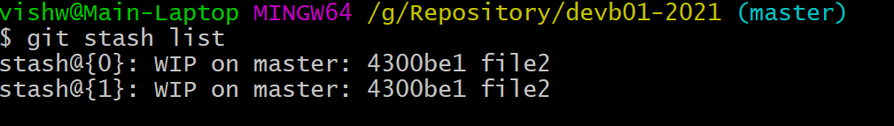
There are 2 stashed messages. Here the last stashed would be marked with index value of “0”.

Lets now stash with some message
Add 4th line in the file (do not Commit it)
But stash it
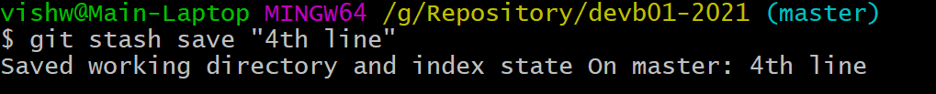
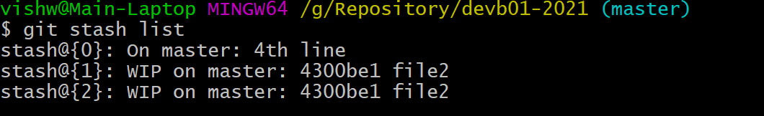
Now lets get the information from the stash back to the working directory.

In This case, we will get the specific stash
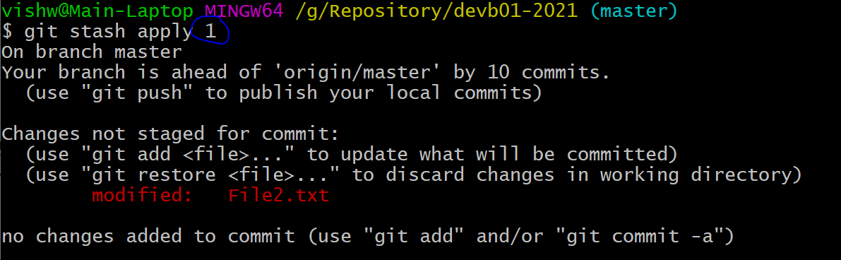
So instead of taking the first index value “0”, we are taking ‘1”.
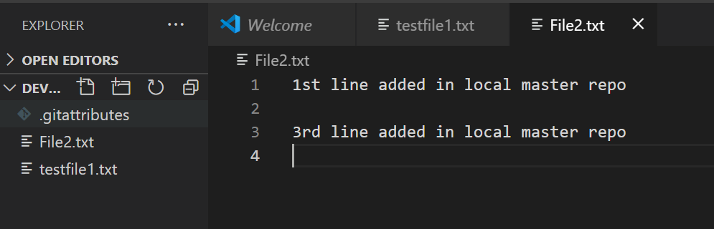
The copy of the stash message still remains in the stash
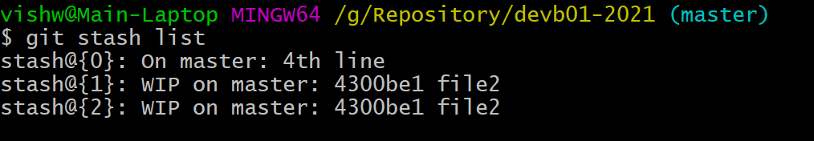
We could a commit this
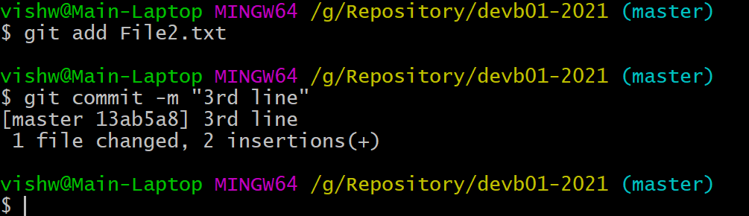

Now lets stash the index “2”.

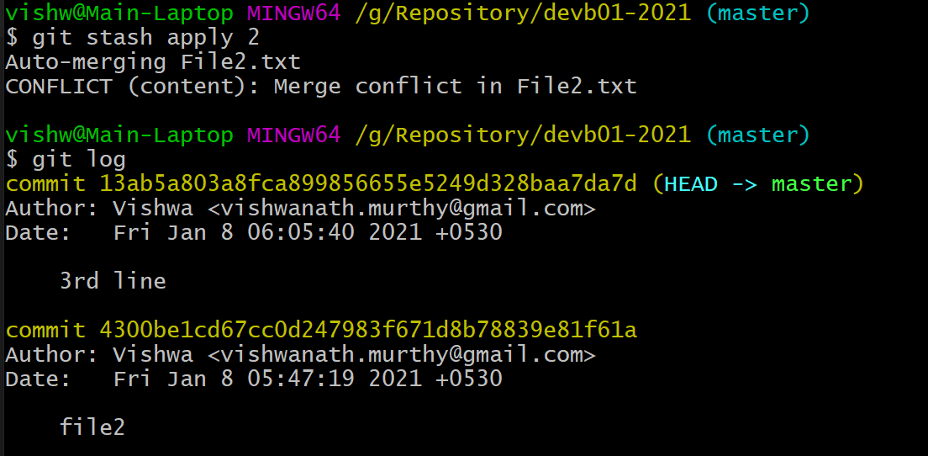
There would be an merge conflict, and it has to be cleared, bcz stash “2” has “4300be1c” commit as the ref .
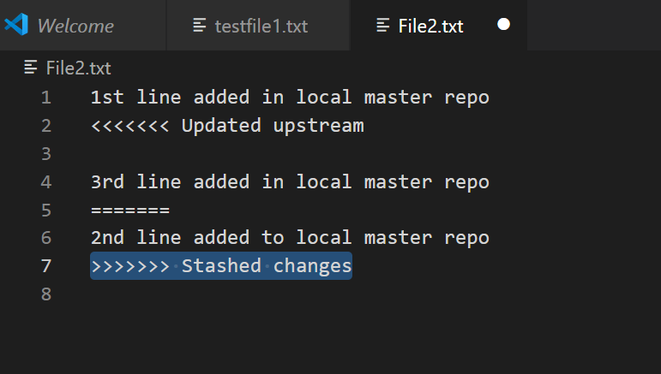
Clean up the code.
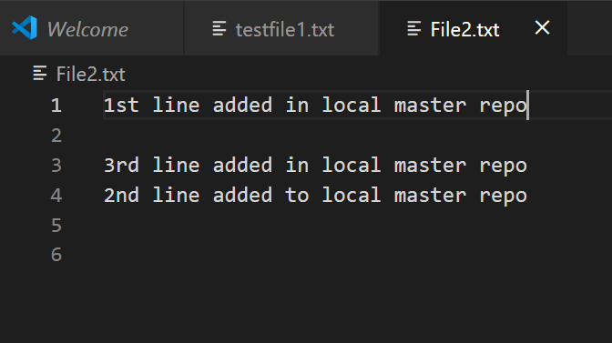
And commit it
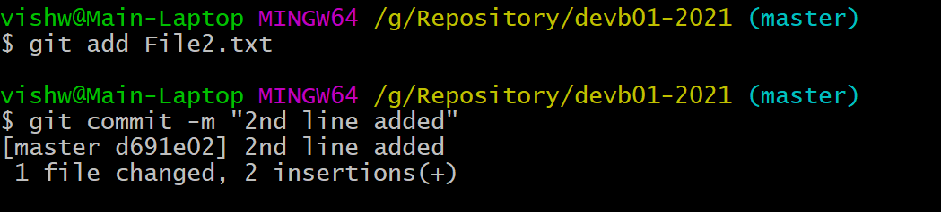

Git stash show
This would show the details of file
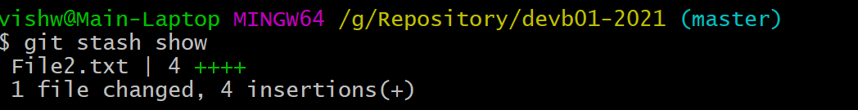
“git stash show -p 1”
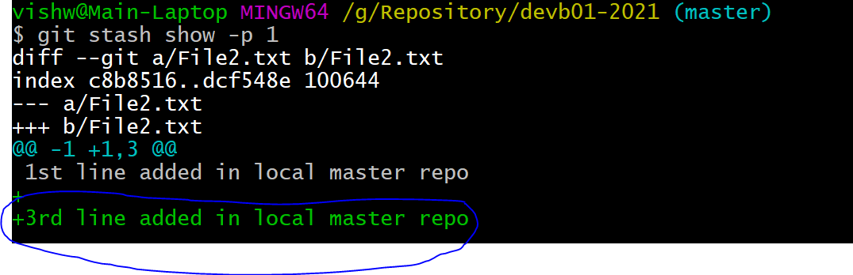
Showing the changes

Now lets clean the stash
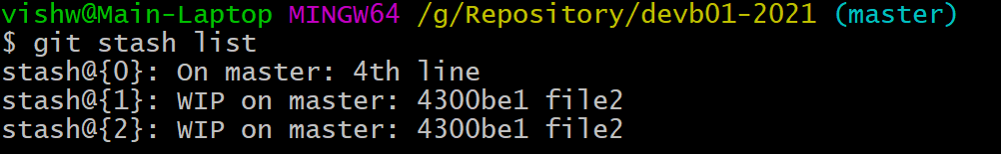
Lets remove the “1” stash
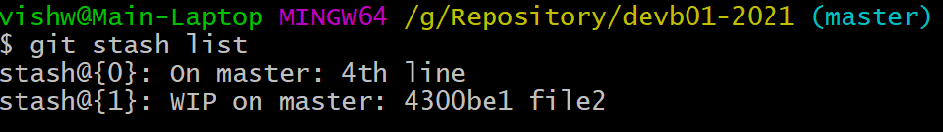
Even though we hve removed “1” now the index 2 is moved to “1”.
