- Create an VM with inbound traffic allowed for SSH and HTTP on the Security group.
- Allow only SSH inbound on the NACL.
- Once the HTTP service is up on the VM.
- Allow HTTP inbound on the NACL
Note:--
For http service, below are the commands
Sudo su
Yum install httpd
Service httpd start

Solution:
- Create a VPC
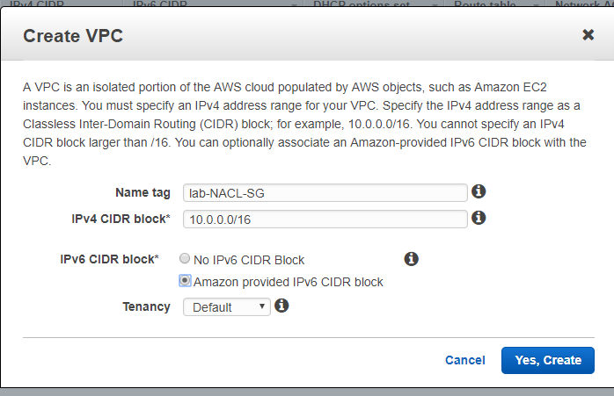
- Create 2 Subnets
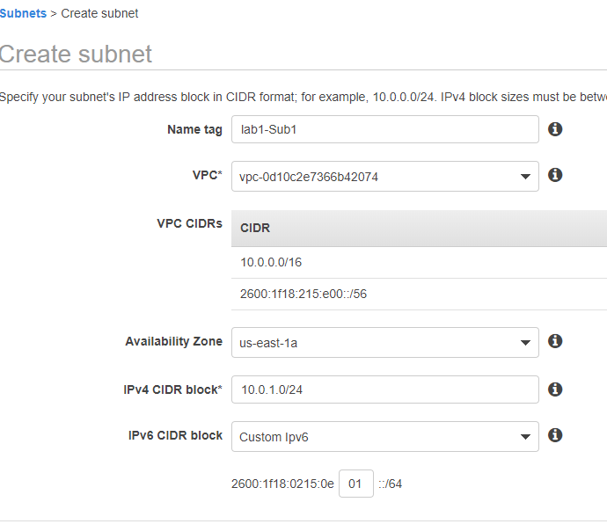
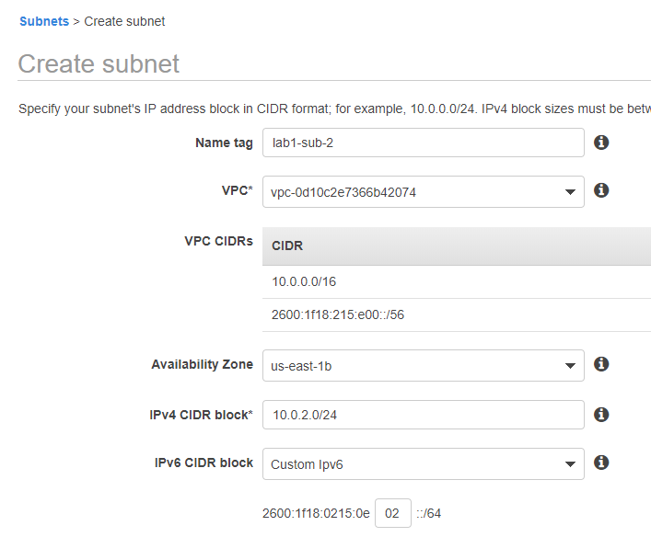
- Create an Internet Gateway
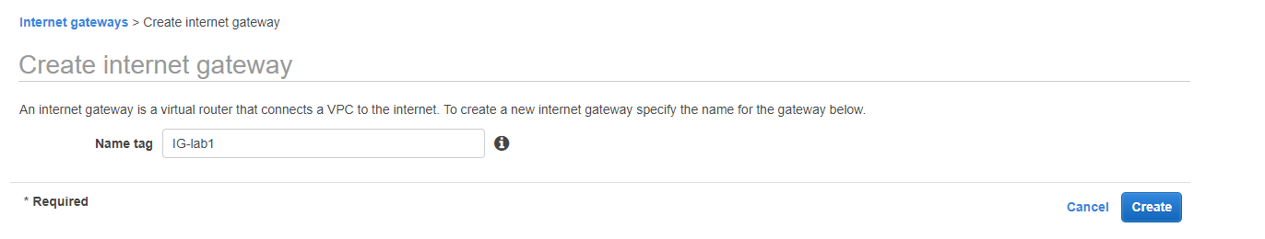
  - Attach the Internet Gateway to VPC
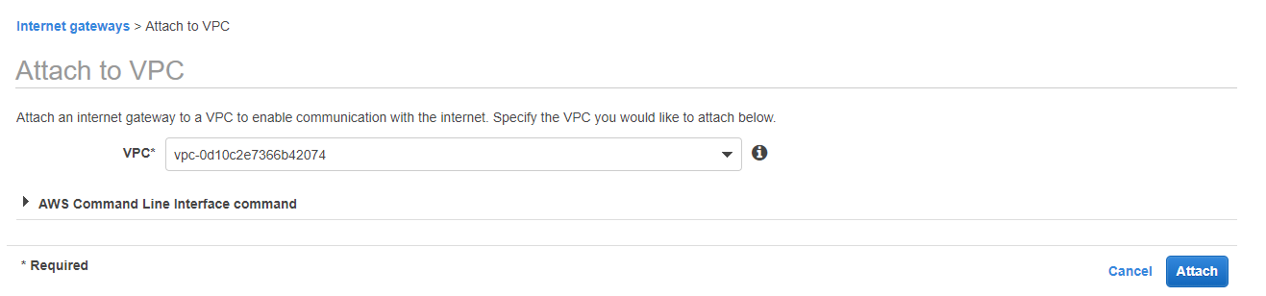
- Update Routing Table –
  - Add “0.0.0.0/0” to the default Routing Table for Ipv4.
  - Add “::/0” to the default Routing Table for Ipv6.

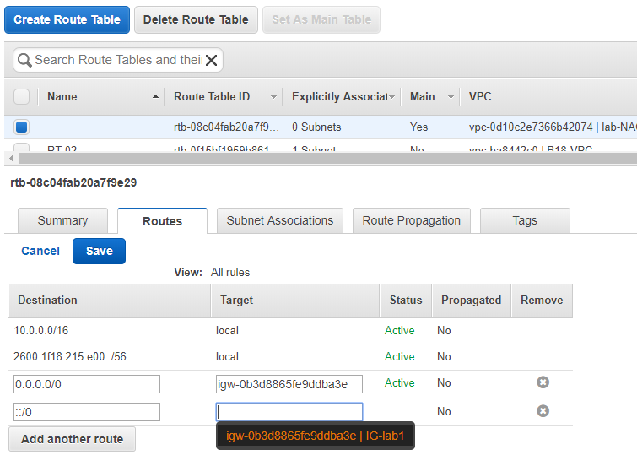
- Create Security Group.
  - DONOT USE THE DEFAULT SECURITY GROUP.
Default Security Group is, OUTBOUND all Allow
And Inbound allow only itself, means Block ALL inbound.
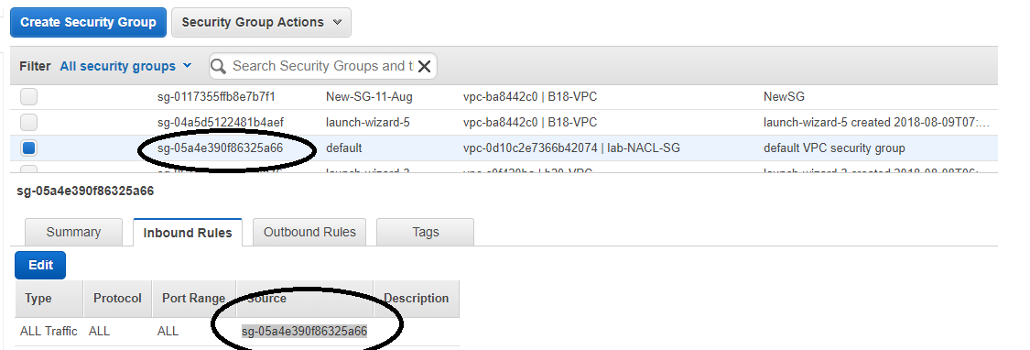
  - Create a new Security Group
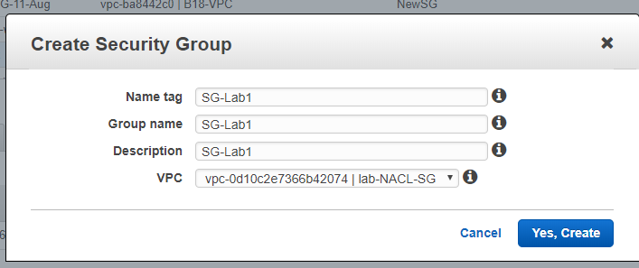
  - Add rules accordingly.
By default Outbound ALL TRAFFIC is allowed
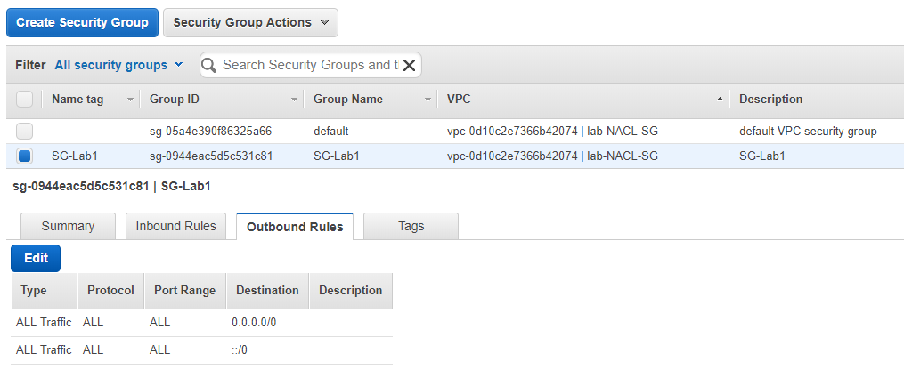
Inbound, allow only SSH and HTTP.
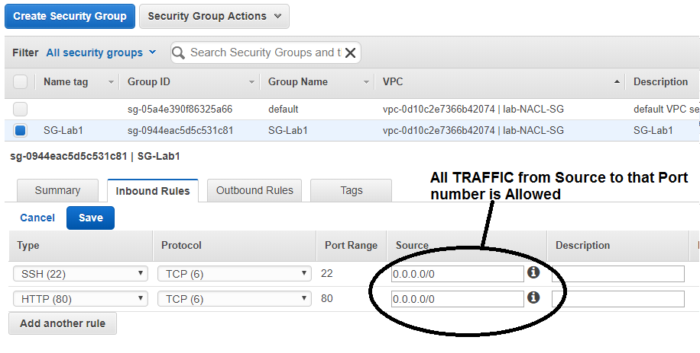

- Create Network Access Control List.
We WOULD be using the DEFAULT NACL created by VPC.
  - By default, ALL outbound and Inbound Traffic is Allowed

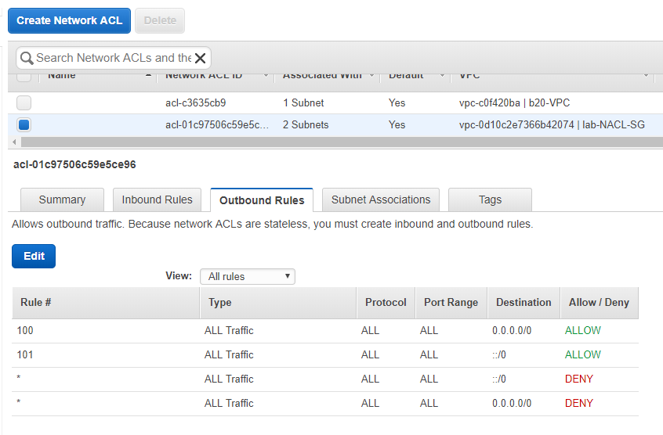
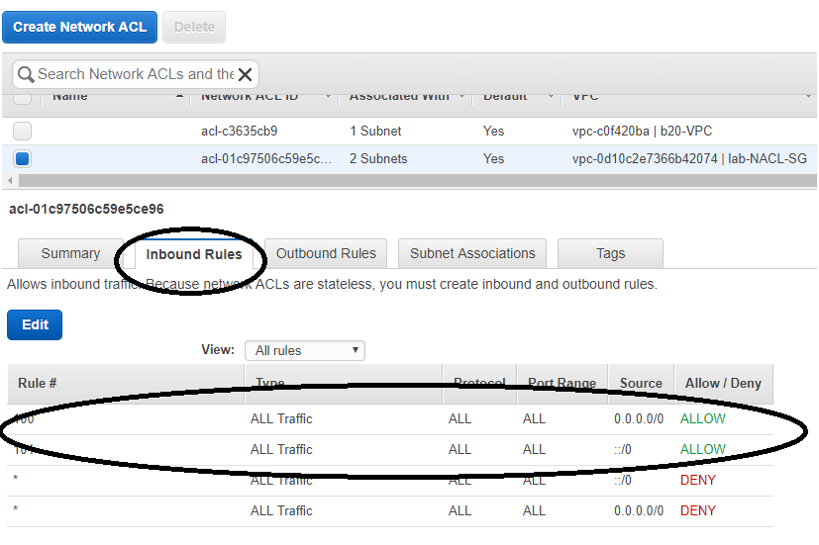

  - All the subnets are ASSOCIATED to the DEFAULT NACL
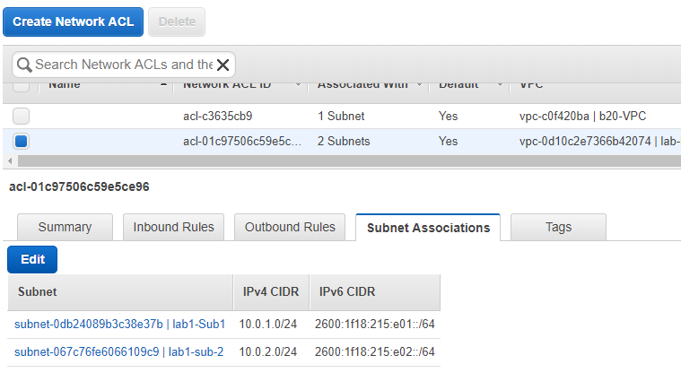
  - Add the NACL rules to the INBOUND as mentioned. – Allow only SSH.
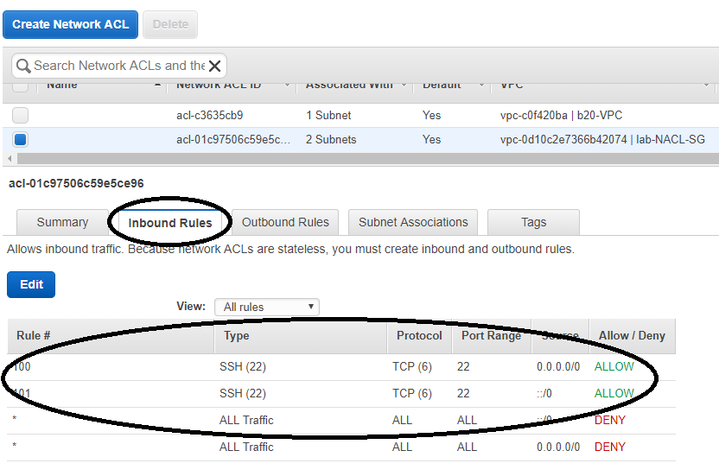

- Create an EC2 instance in Subnet -1 with Public IPV6 and IPv4.
From CLI.
aws ec2 run-instances --image-id ami-b70554c8 --count 1 --instance-type t2.micro --key-name b16-key1 --security-group-ids sg-0944eac5d5c531c81 --subnet-id subnet-0db24089b3c38e37b
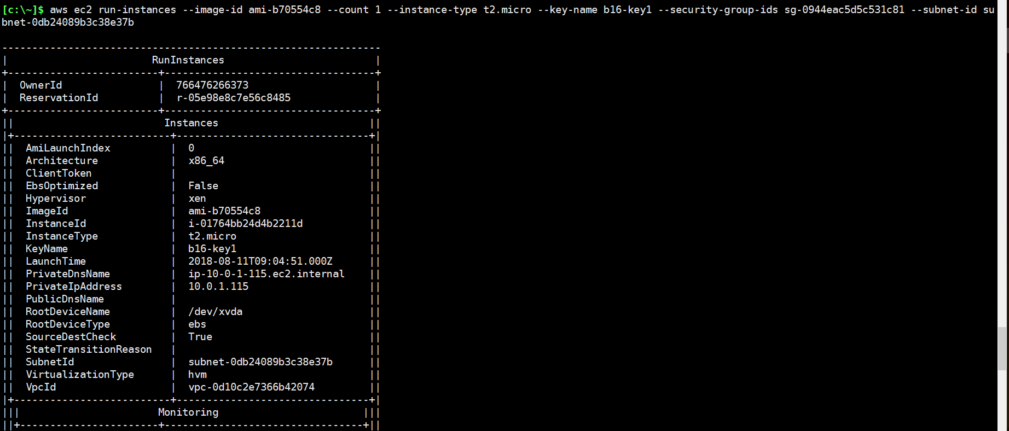

  - After creation of the EC2, login and try the below command
sudo su
yum install httpd

This would FAIL as “inbound” http is BLOCKED on NACL.

All ALLOW TRAFFIC INBOUND for installation on NACL.

Then install the httpd.

yum install httpd
service httpd start.

Now again in the NACL , allow only SSH and HTTP.

You should be able to access the “http://<public ip on ec2> page.

