Lab – Scenario – S3 – Glacier -- 02

- Create an S3 bucket with Versioning enabled, which would be the “DATA” bucket
  - NO Internet access to the Bucket
- Upload a file “Twice” in an internal of “2 Min”.
  - For the First time upload of the file
    - Make the file public.
    - Keep the storage Class as “Standard-IA”
    - Select Encryption as ‘AWS S3 Key”
  - For the second time upload
    - Make the file public.
    - Keep the storage Class as “Standard”
    - Select Encryption as ‘None”
- Create an “Replication” within your Friend’s Account number for the “Data” bucket.
  - Make sure your Frnd has created the Bucket in an Different Region.
  - Also the below should be copied under the “Bucket Policy” of your Frnds Bucket (on the another region)
{
"Version":"2008-10-17",
"Id":"",
"Statement":[
{
"Sid":"Stmt123",
"Effect":"Allow",
"Principal":{
"AWS":"arn:aws:iam::AWS-ID-Account-A:root"
},
"Action":["s3:ReplicateObject", "s3:ReplicateDelete"],
"Resource":"arn:aws:s3:::destination-bucket/*"
}
]
}
AWS-ID-Account-A your account.
destination-bucket your bucket.
As this policy needs to be configured on your frnds Account .
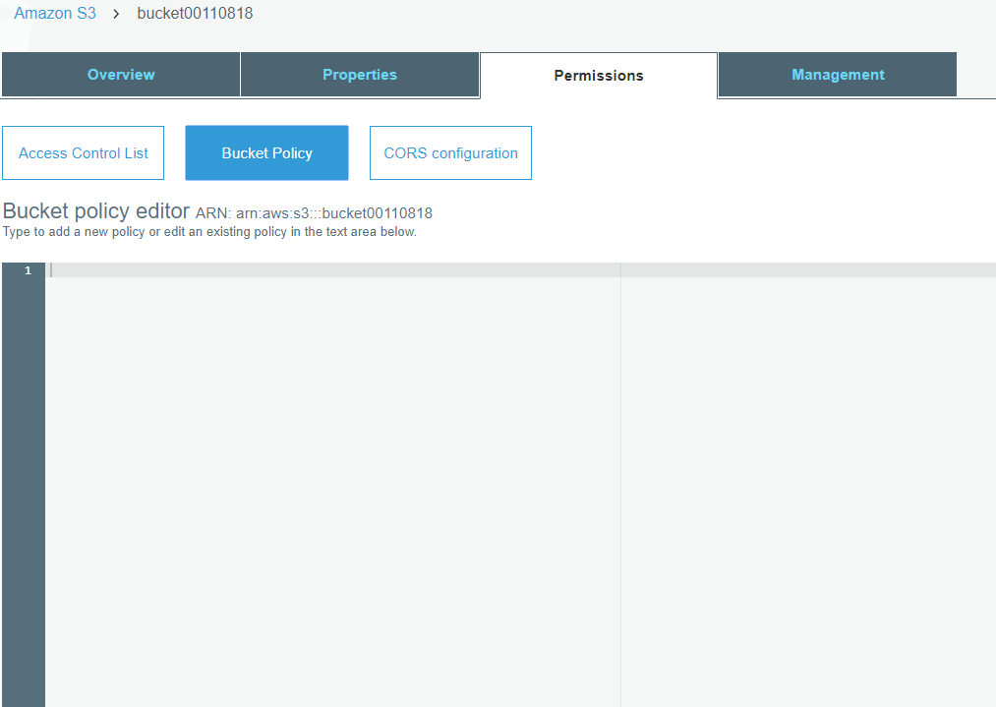
Recommended name’s of the Bucket.
<bucketname>data

Output:
- Check after 1 hr whether data is replicated.
- Delete the file in the source bucket, it should delete in the destination bucket as well.

