Lab manual – LB, AS, SG, NACL

Objective of this LAB.
This Lab Scenario would cover the topics of Load Balancing, AutoScaling, Security Group, NACL, Cloud Watch, EBS.

Diagram
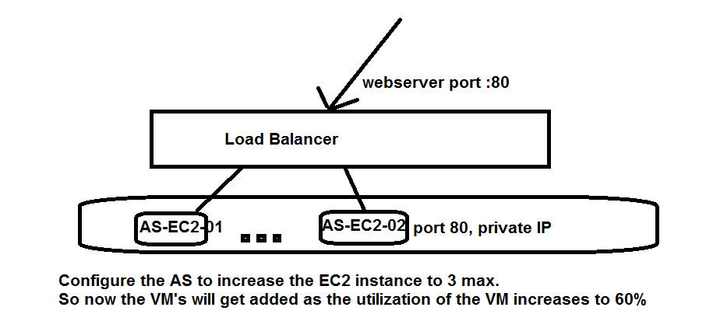

Steps
- Create the VPC with Internet Gateway
- Create RDS “MYSQL” and configure the DB and Table.
- Create an EC2 instance and install and configure webserver on it.
- Create image of the above EC2 instance and then Terminate the above instance.
- Create Application LoadBalancer.
- Create Autoscaling
- Test the web application

- Create the VPC with Internet Gateway

- Use: -- 192.168.0.0/20 , 60 IP’s per Network and 5 Networks.
- Make sure Internet Gateway is created and Routing Table is Updated.
- Enable “DNS Hostname” on the VPC
- All the Subnet should have IPV4 and IPV6 enabled.

