Lab manual – LB

Objective of this LAB.
This Lab Manual would cover the topics of Load Balancing, .

Diagram
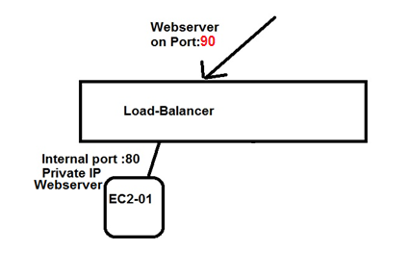

Configuration Steps.
- Create an EC2 instance with Webserver enabled.
  - Create an Security Group with SSH and HTTP allowed
  - Use the above Security Group created to create a EC2 instance
  - Run the below command to enable webserver on the EC2 instance
    - sudo yum install httpd
    - sudo service httpd start
    - sudo chkconfig httpd on
    - sudo vi /var/www/html/index.html
press “I”
type “This is a TEST server ONE” (message)
Press “esc”
Type “:wq” ( lowercase)
Output: -- You should be able to open the webpage and get the above message with the public ip of EC2 instance
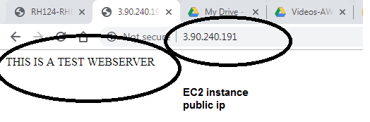

- Create an Load balancer with Target Group.
  - Create an Load Balancer with “Internet Facing”
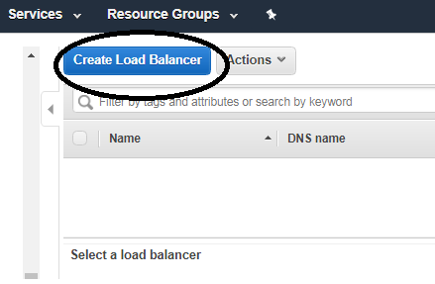
Click on “Create Load Balancer”
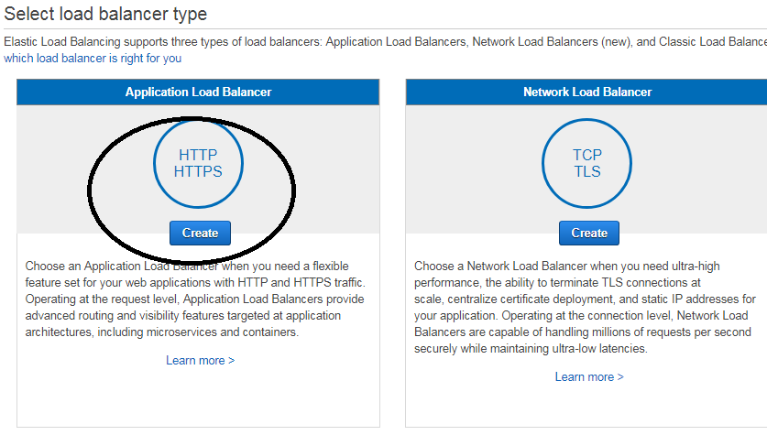
Click on “Create” for application load balancer.
  - Assign the External port number , eg: --port 80 for people to access your page.

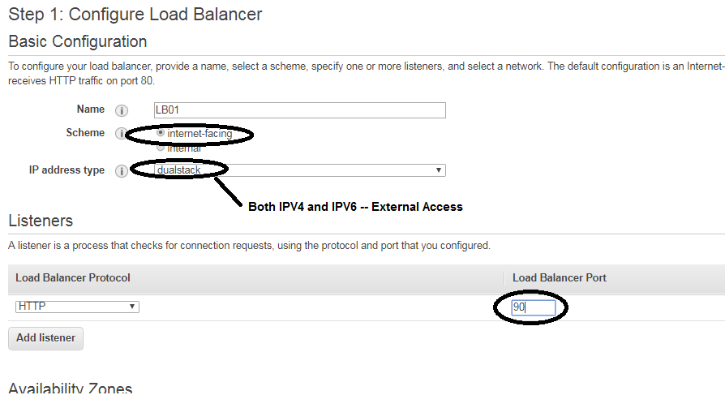

  - Assign the VPC for which this Loadbalancer would be used, in our case, the above created same VPC.
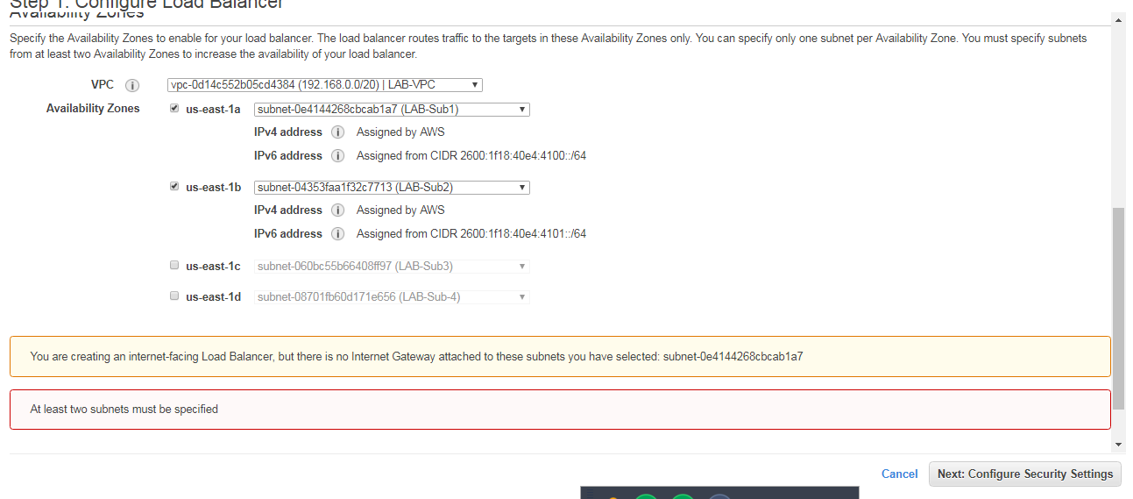
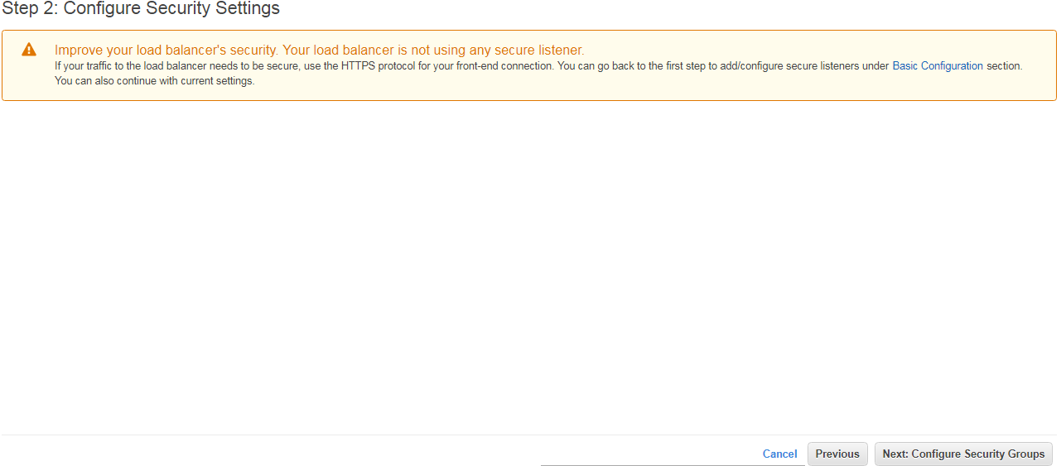
The Warning is because we have selected “HTTP”.

  - Assign a security group to the FRONT end of the Load Balancer
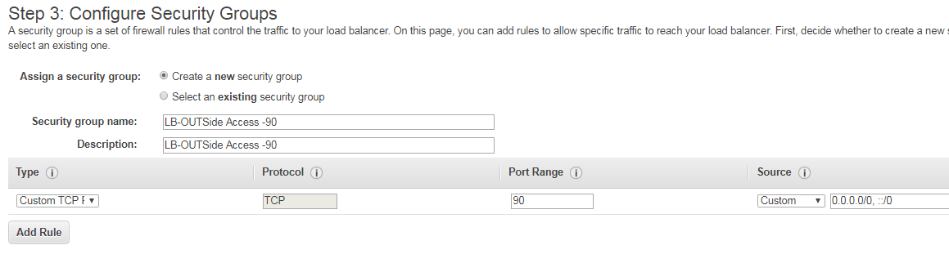
This is the Front end part,
Click on “Next: Configure Routing”

  - Give a name to the Target Group
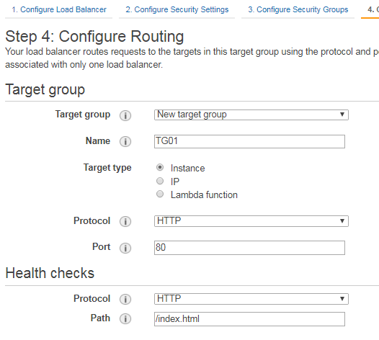
Configure the Routing Target, this is to tell the Load Balancer what port in the backend should it be talking to the EC2 instance.
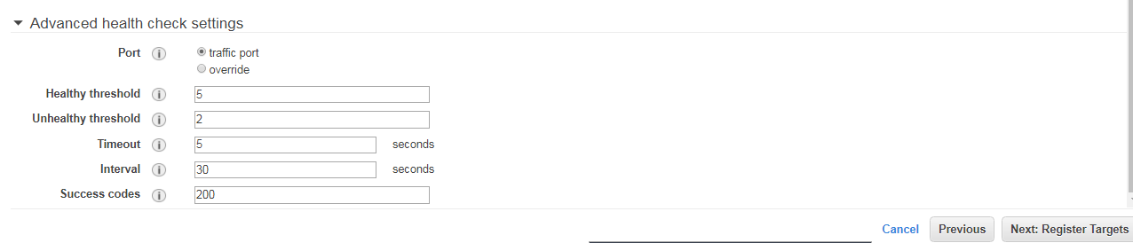
Click on “Next:Register Targets”

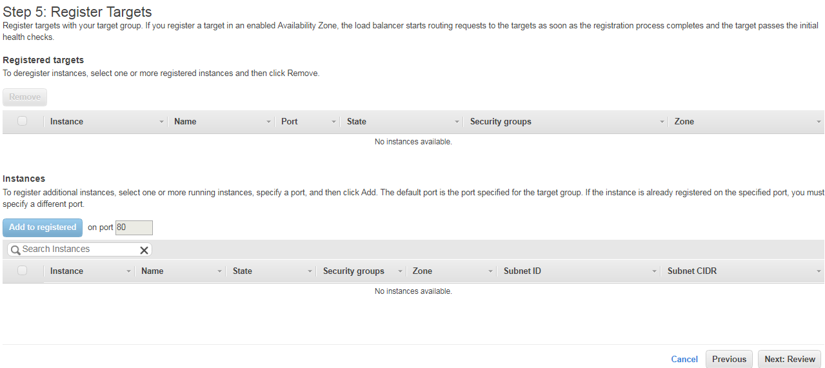
Click “Next: Review”
Note: -- The EC2 addition at this stage is NOT compulsory.

  - Add and Register the TWO instance that has been created.
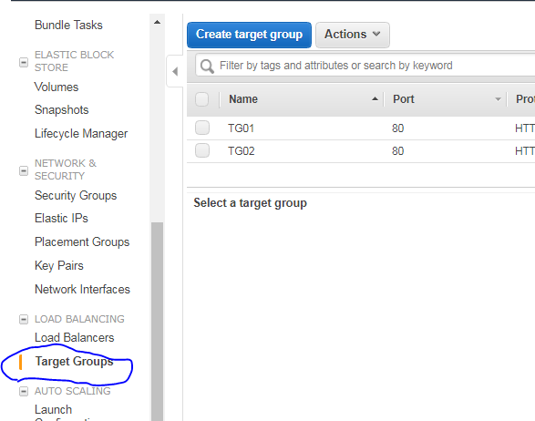
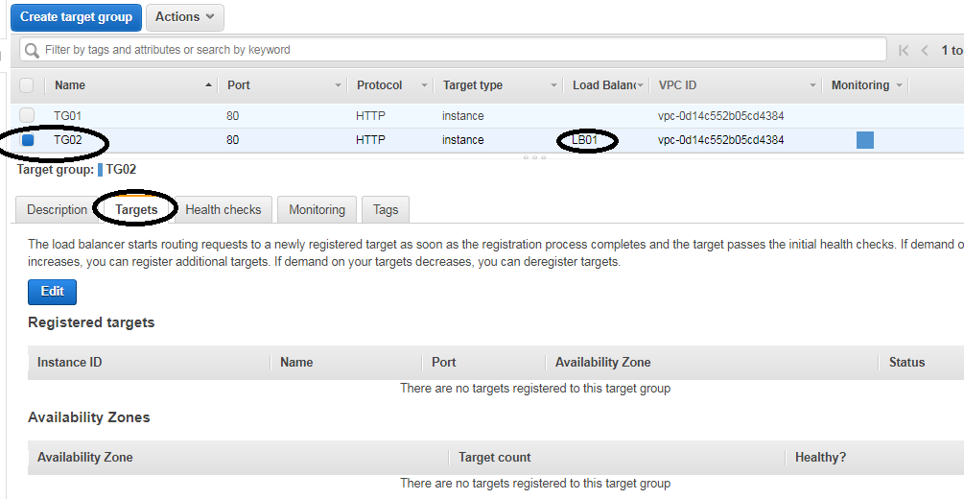
Click on “EDIT”
Add the listed EC2 instance and click SAVE.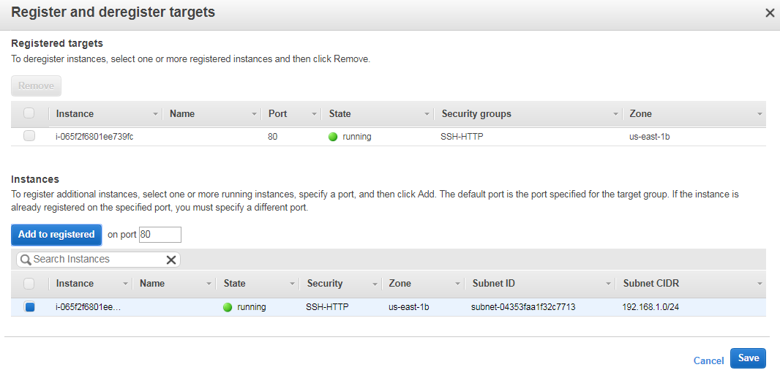

The Target group will put the instance in the “Initial” phase.
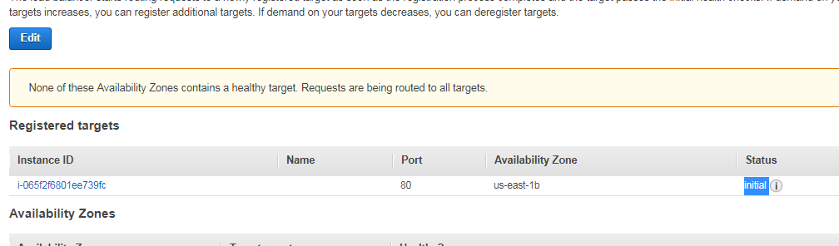
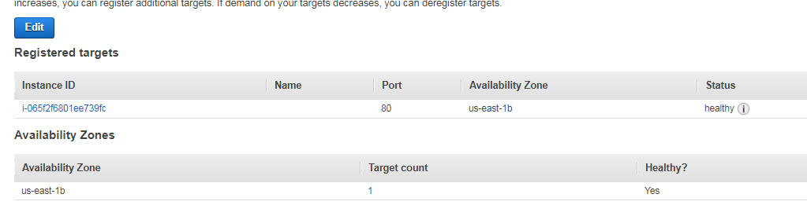
This shows the machine is healthy for access

Output: -- Under the Load balancer that you have created, you would find “DNS” name.

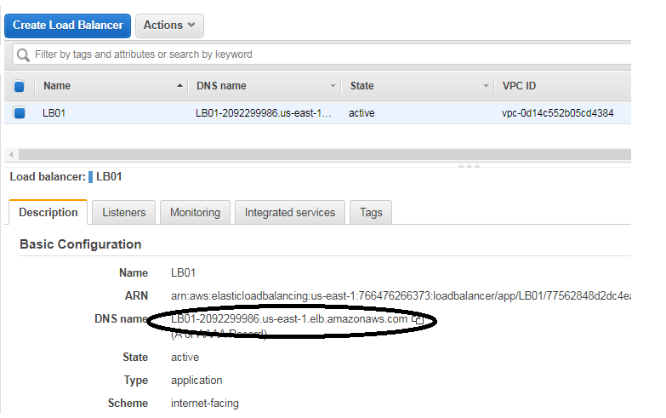
Copy that name and paste it on the Webpage.
