Lab manual – Autoscaling

Objective of this LAB.
This Lab manual would cover the setup of Autoscaling for a custom AMI.

Steps
- Create the Launch Configuration
- Create Autoscaling group

- Create the Launch Configuration
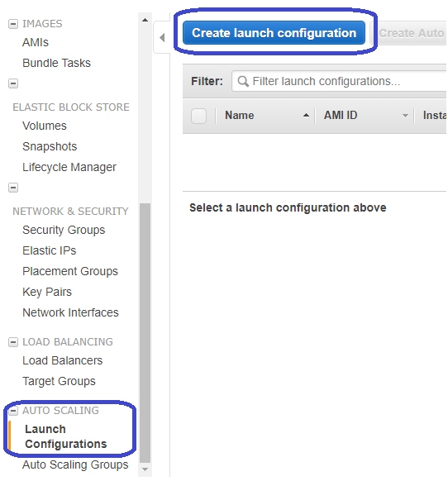
Click on “Create Launch Configuration”

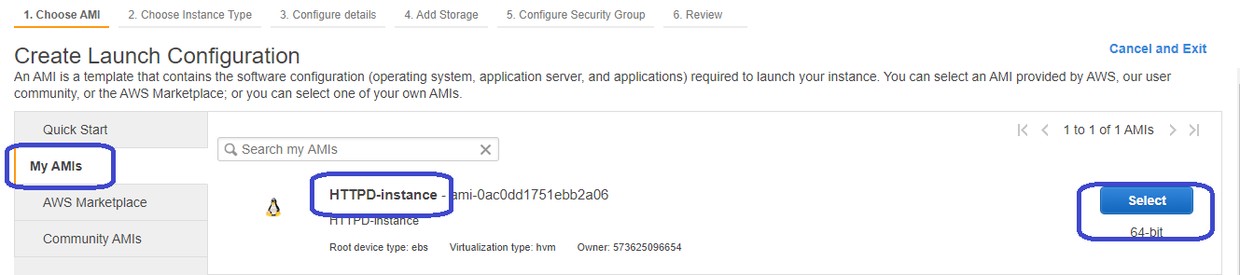
Select the custom image. This image is pre built with “HTTPD” service and use case is we want this webserver to be spined up when the utilization goes high automatically.
Click on Select
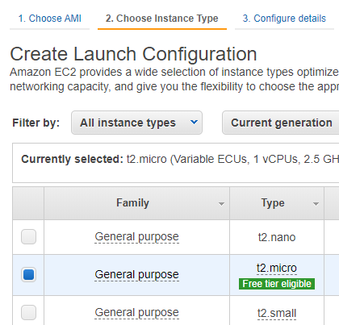 Select the instance type
Click on Next
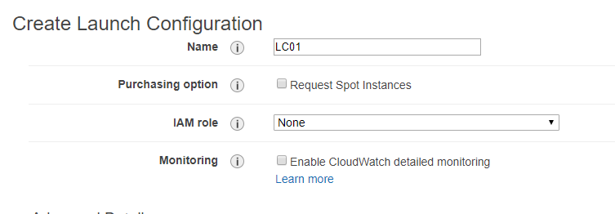
Part1
We could also select “Spot Instance” . So which means this would be one of the best way to save money for the test and development Env.

Also, we could enable detailed monitoring if the application needs some insight into and to be monitored.
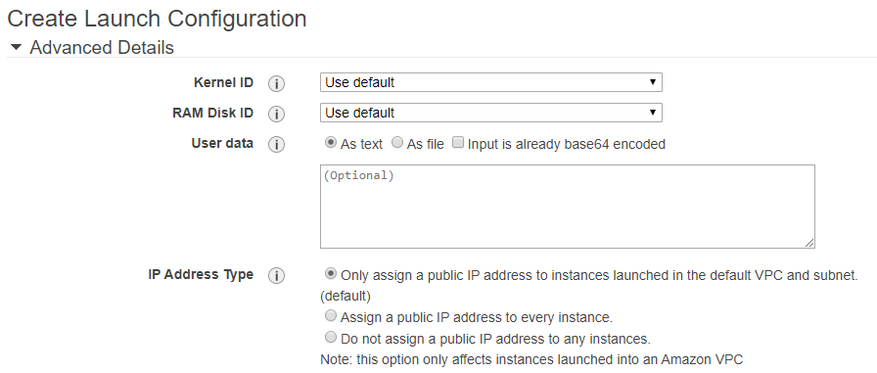
Part2
Userdata We could put some more “Bootstrap” commands if required during the Launch Config, for this Autoscaling group.

IP Address Type Best practice, DO NOT assign public ip.
But for the LAB purpose, assign the public ip (2nd option), so that we can login to the EC2 instance and increase the CPU utilization.

Click Next

Lets keep the storage simple and
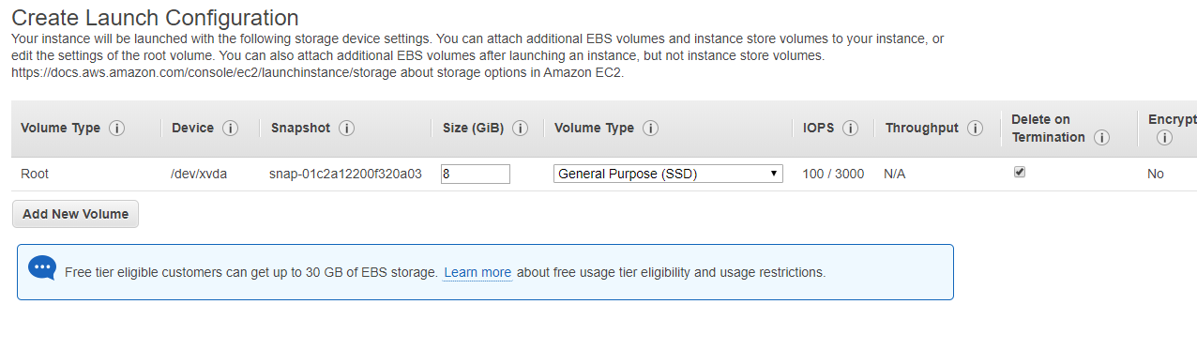
Click Next

Select the appropriate Security Group
CAUTION: you should be selecting the same VPC, that you plan to spin the EC2 instance in.
Note: -- if using Load Balancer, even there the same VPC to be used, so that its all synched up.
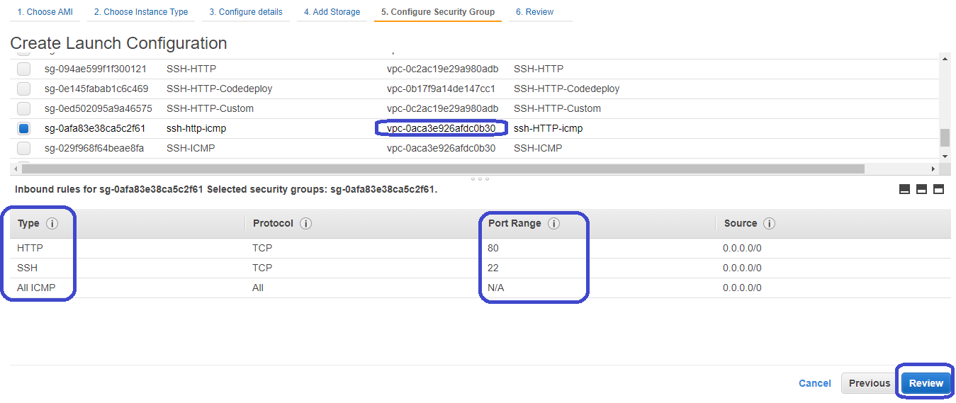
Click on Review
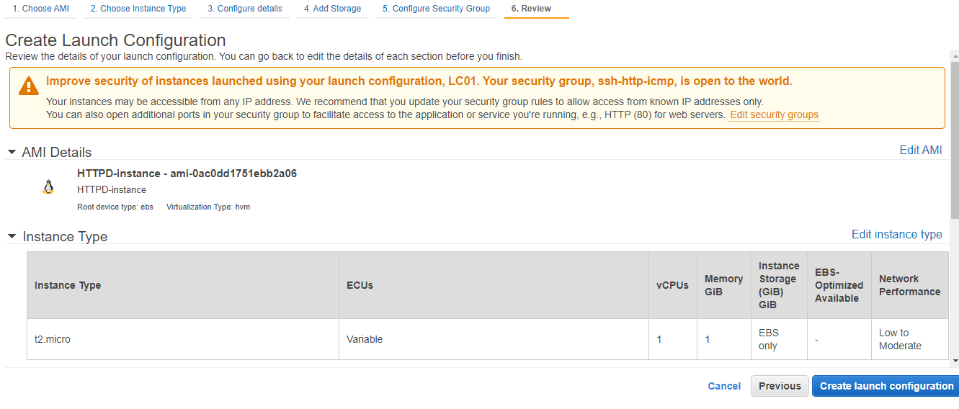
Review it and click Create Launch Config
Select the “Key Pair” and Click “Create launch Config”
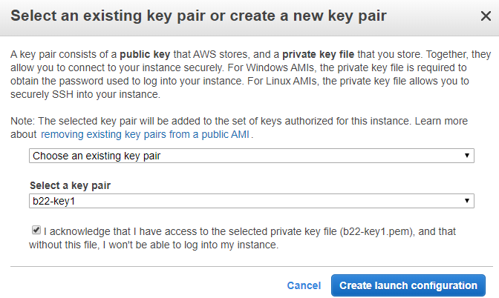
This would just create the Launch config, in other terms Template for EC2 config
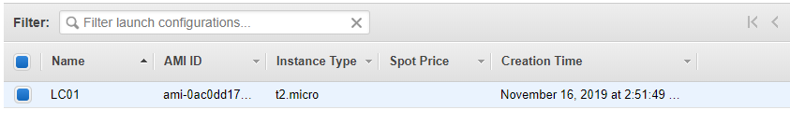
- Create Autoscaling group
This is to create the number of machine and do scaling based on the condition we have specified.
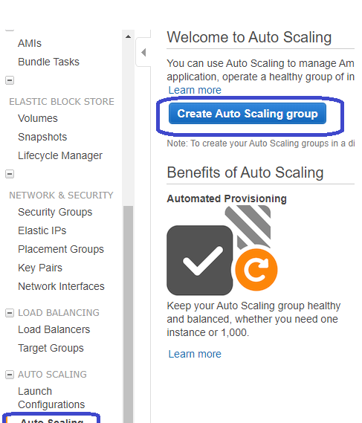
Click on “Create Auto Scaling Group”

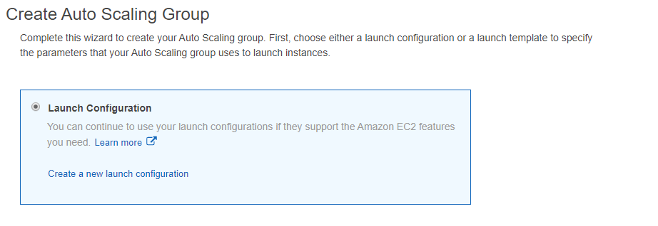

Select “Launch Configuration”
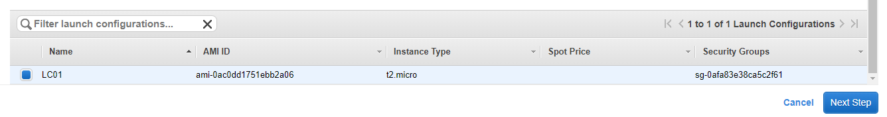
Click on Next
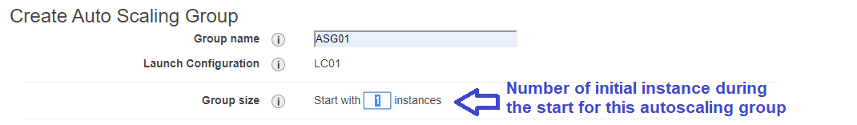
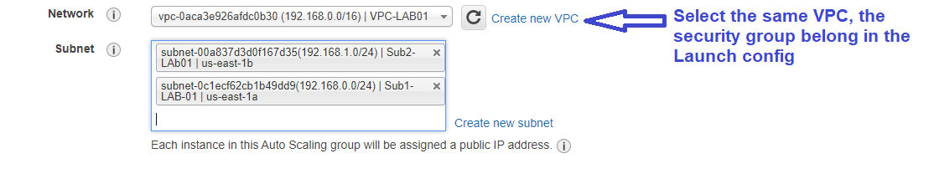
Also, select the subnets in which EC2 instance needs to be spine up.

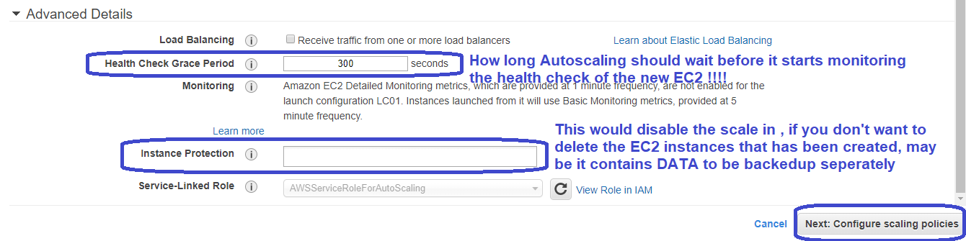

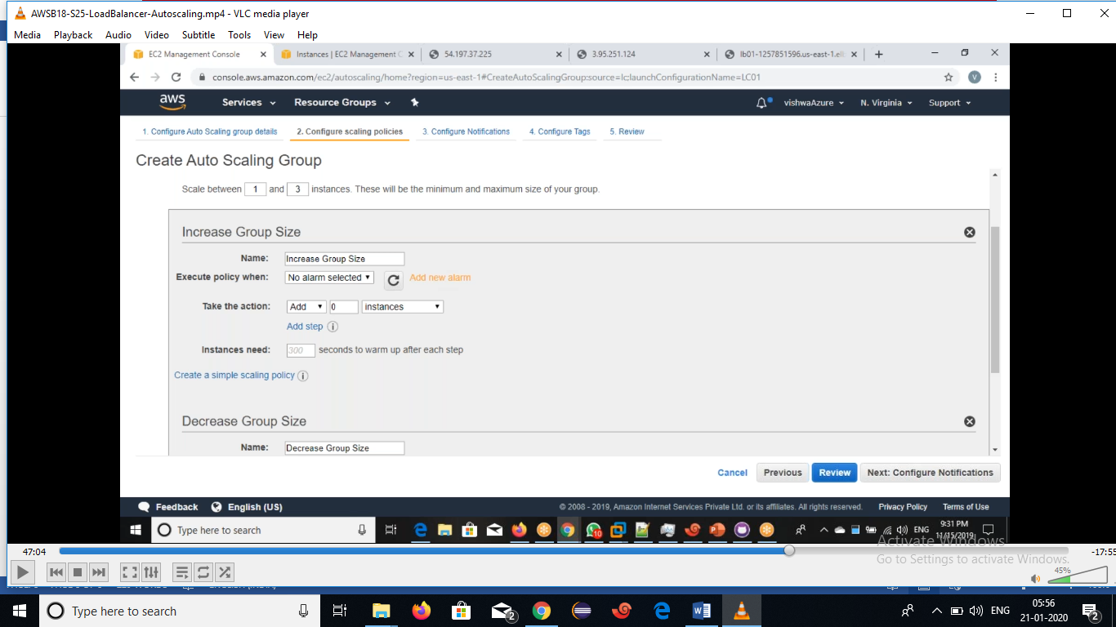
Next let’s configure the number of machines that can be scaled upto

- Set an increase and decrease group size .
- Set an Alarms.
- Scale between1 &3 instances. These will be the minimum and maximum size of your group.
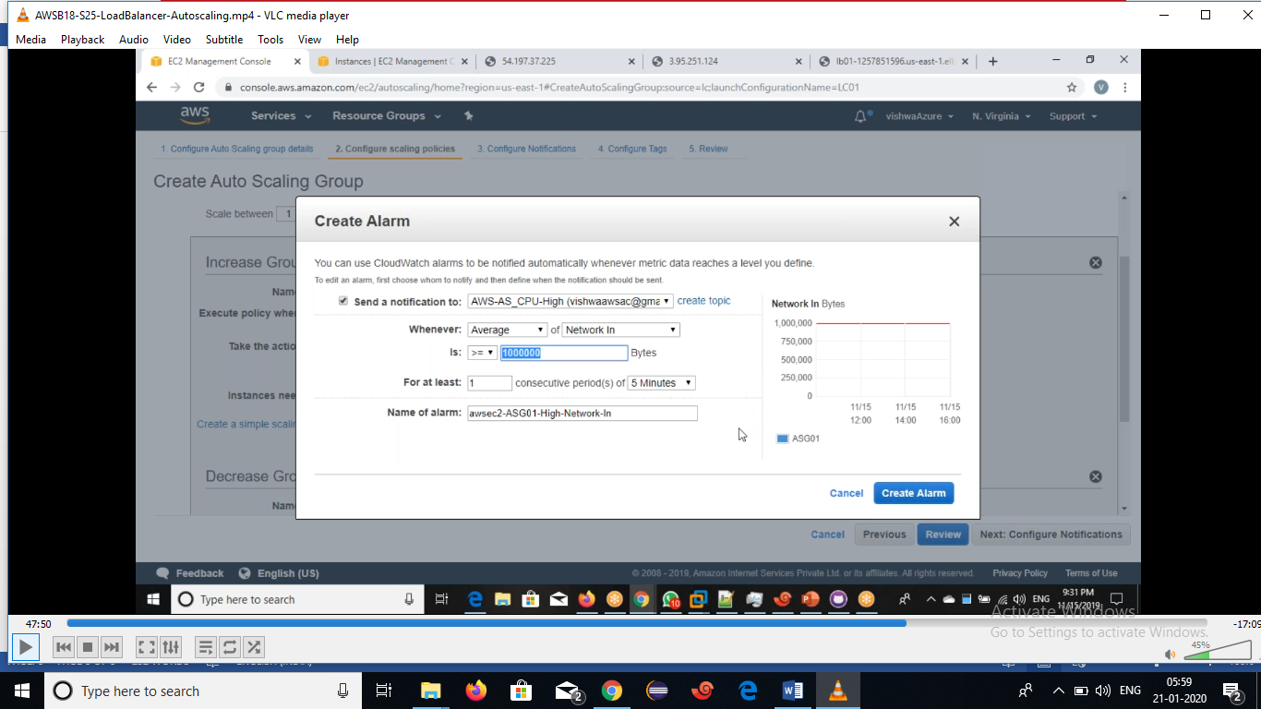
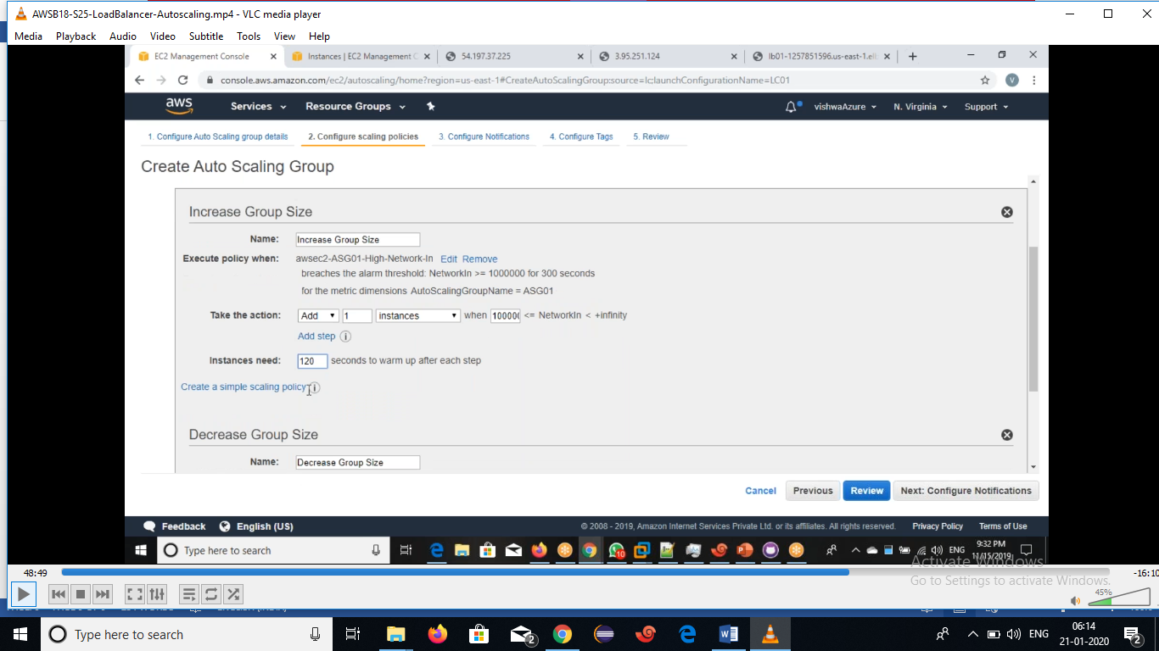

- Click on configure notification.
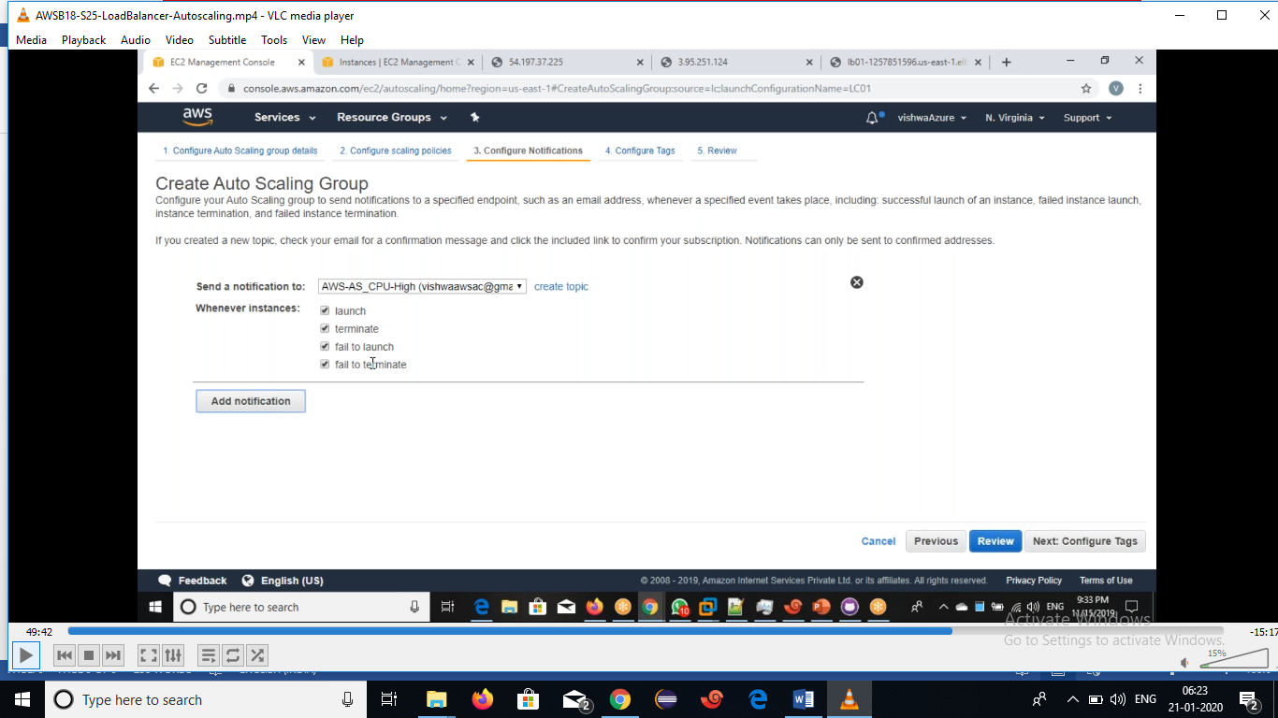
- Click on configure tags.
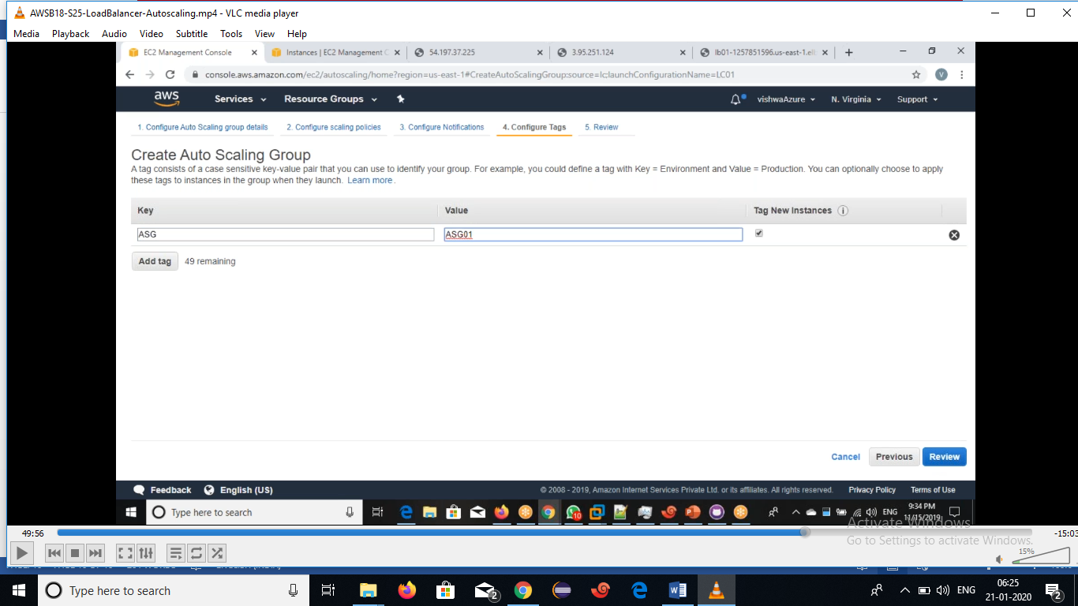
- Click on Review.
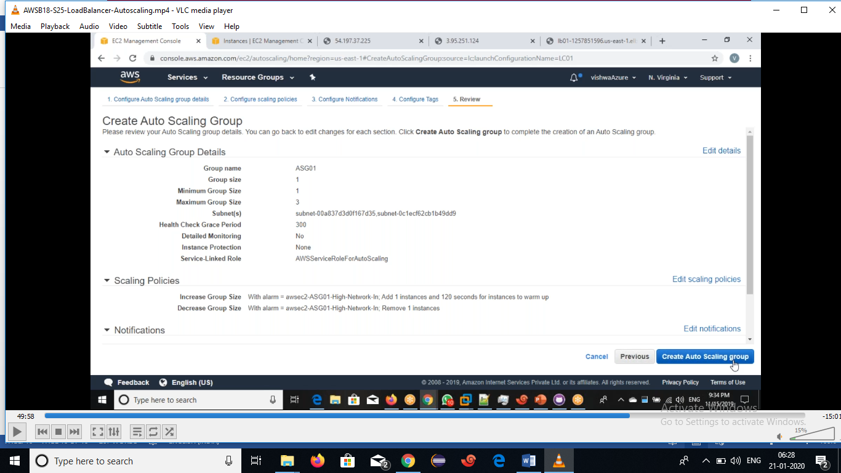
- Click on CreateAutoScalling group.

