LAB – LoadBalancer with Autoscaling
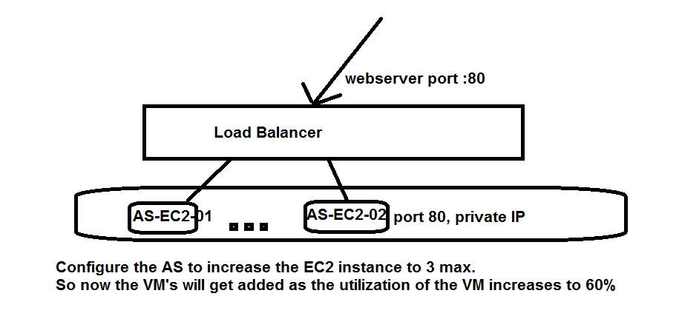

- Setup your Network
- Create an custom AMI with Webserver installed and ready
- Create an Launch Template
- Create an Autoscaling Group
- Create an Loadbalancer with Target Group
- Attach the Autoscaling to LoadBalancer

Configuration Steps.
- Create an VPC with “2” subnets in TWO different Availability Zone.
  - Create VPC
  - Create 2 Subnets ( only IPv6 should be enabled and IPV4 public IP should be disabled)
  - Create Internet Gateway
  - Update the Routing Table.
  - Create an Security Group with SSH and HTTP, ICMP inbound allowed.
  - Create an Network ACL on both Subnets with SSH and HTTP, ICMP inbound Allowed
  - Outbound in both SG and NACL ALL Traffic Allowed.

- Create an EC2 instance with Webserver enabled.
  - Create an Security Group with SSH and HTTP allowed
  - Create First EC2 instance on First Subnet
  - Use the above Security Group created
  - Run the below command to enable webserver on the EC2 instance
    - sudo su
    - yum install httpd
    - service httpd start
    - chkconfig httpd on
    - vi /var/www/html/index.html
press “i”
type “This is a TEST server ONE” (message)
Press “esc”
Type “:wq” ( lowercase)
Output: -- You should be able to open the webpage and get the above message with the public ip of EC2 instance

  - Shutdown the Instance, either from the AWS Console or from Linux (init 0)
  - Create an “Image” from the instance (after shutdown)
  - Make sure custom AMI is “Available”
  - Delete the instance that was created.

- Create an Autoscaling Launch Configuration.
  - Select the Custom AMI
  - T2.micro
  - Select the same Security Group.
  - Protect the initial Instance that would be created in Austoscaling Group.
- Create an Autoscaling Group.
  - Assign the Same VPC with both the subnets selected.
  - Assign the scaling policy
    - Max number of VM’s -- 3
    - If CPU above 60% -- Send an Alert and Increase the VM by 1
    - If CPU below 25% -- Send an Alert and Decrease the VM by 1
    - Enable Notifications

Output: -- You should be able to open the webpage and get the above message with the public ip of EC2 instance
- Create an Load balancer with Target Group.
  - Create an Load Balancer with “Internet Facing”
  - Assign the External port number , eg: --port 80 for people to access your page.
  - Assign the VPC for which this Loadbalancer would be used, in our case, the above created same VPC.
  - Assign both the subnets to the Loadbalancer.
  - Give a name to the Target Group
  - Configure the Routing Target, this is to tell the Load Balancer what port in the backend should it be talking to the EC2 instance.
  - On the Autoscaling Group , Add the ‘LB Target Group”.
Output: -- Under the Loadbalancer that you hve created, you would find “DNS” name.
Copy that name and paste it on the Webpage.
If you refresh the page multiple time, it should show both the pages from each EC2 instance alternatively.

