Objective
- Manifest file
- Deploy app using Deployment option
- Display and Validate Deployment
- Expose it to the external world
- Test – POD Failures
- Test – Scale up
- Test – Scale down

Assumption:
- We are using ‘NodePort”

- Manifest file
  - Deployment-file
- ---
- apiVersion: apps/v1
- kind: Deployment
- metadata:
- name: deploy1
- spec:
- replicas: 2
- selector:
- matchLabels:
- app: vclapp
- template:
- metadata:
- labels:
- app: vclapp
- spec:
- containers:
- - name: myapp
- image: nginx

- ports:
- - containerPort: 80

Save the file as “deployment.yaml”

  - service-port
- ---
- apiVersion: v1
- kind: Service
- metadata:
- name: node-port
- spec:
- type: NodePort
- ports:
- - port: 88
- targetPort: 80
- nodePort: 30303
- selector:
- app: vclapp

Save the file as “service.yaml”

- Folder structure looks like
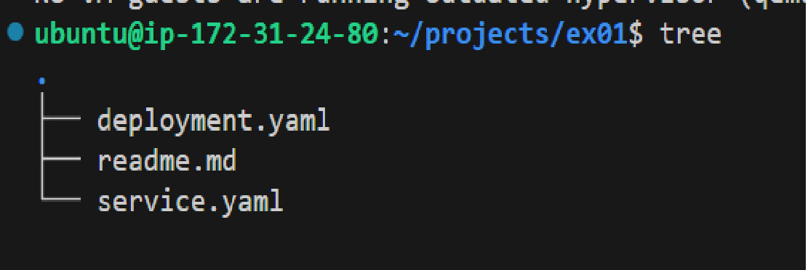

- Deploy app using Deployment
$ kubectl apply -f deployment.yaml
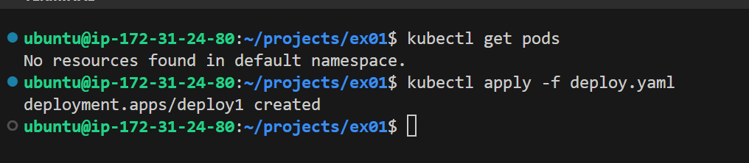

$ kubectl get pods
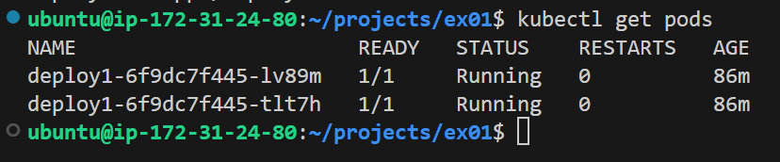

- Display and Validate deployment inside minikube
Login to the minikube Vm, and run
projects/ex01$ minikube ssh
$ docker ps | grep nginx
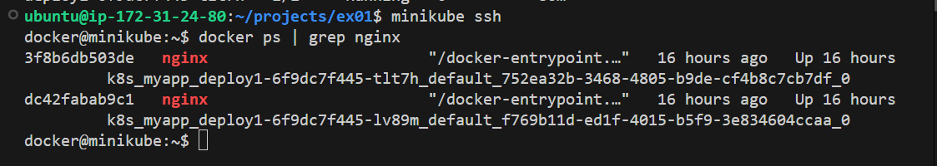

Check each PODS
$ kubectl describe pods/deploy1-6f9dc7f445-lv89m
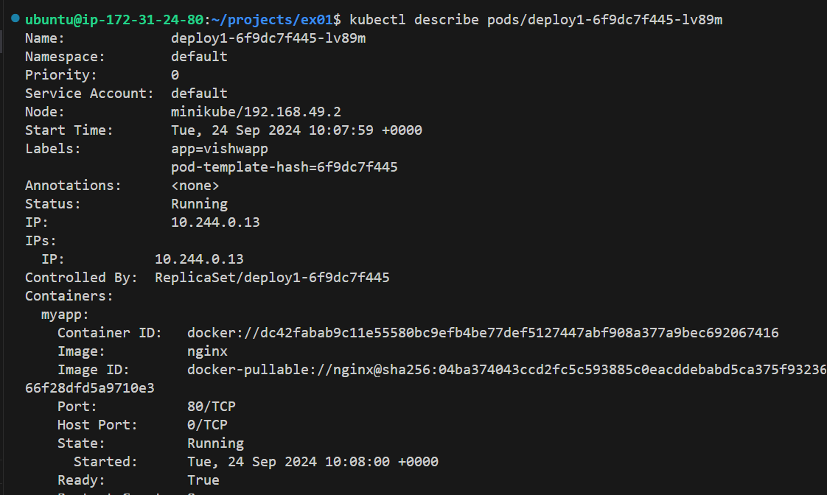

$ kubectl describe pods/deploy1-6f9dc7f445-tlt7h
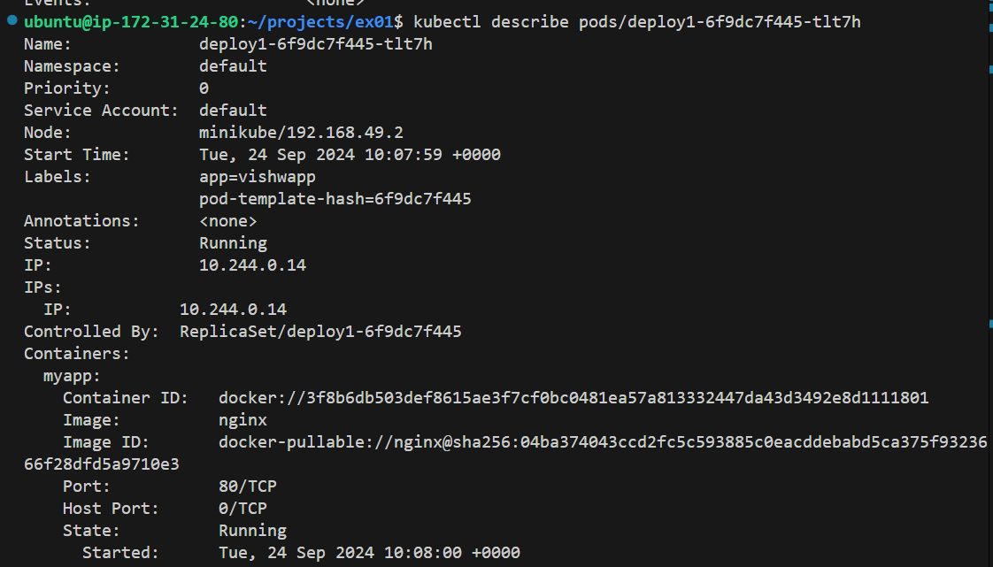
- Expose it to the external world ( Here the external world for the pod is minikube. Refe below diagram
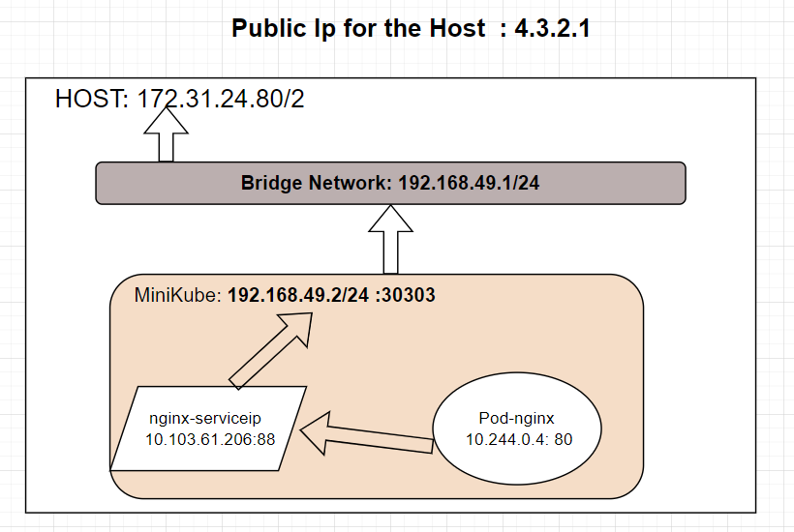
$ kubectl apply -f service.yaml

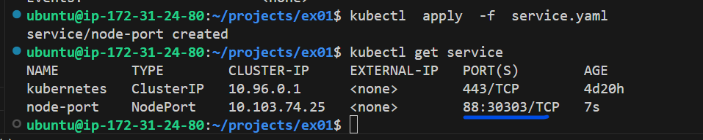

Here the pod is exposed to external world on port “30303”

$ kubectl describe services/node-port
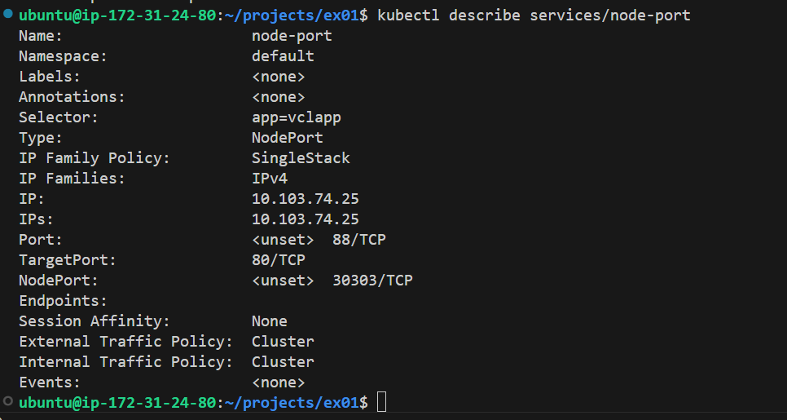

This clearly shows that the service has created the LOADBALANCER.
The endpoint points to all the 3 PODS and
The external port is working on “32150”

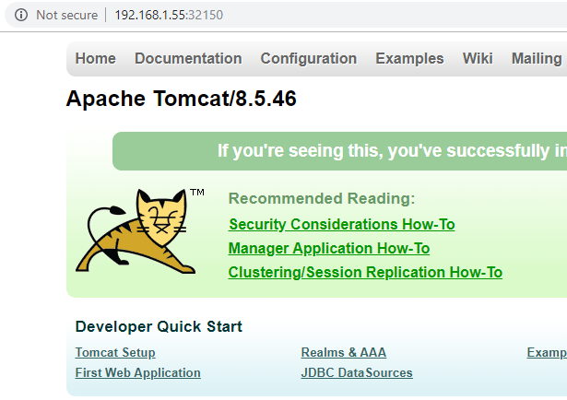

- Test – POD Failures
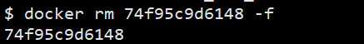
We just removed a container.

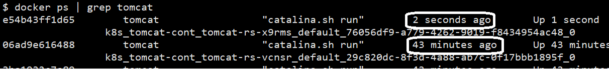

The container is back with no time.
This is the work of the Kubernetes.

- Test – Scale up
Change the replicas in the YAML file and save it.

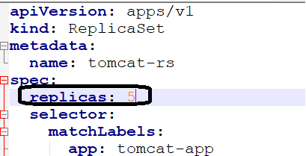

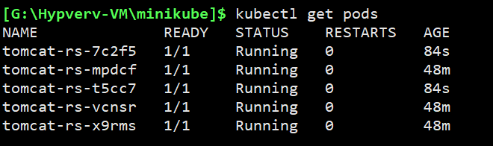

$ kubectl describe services/replica-nodeport

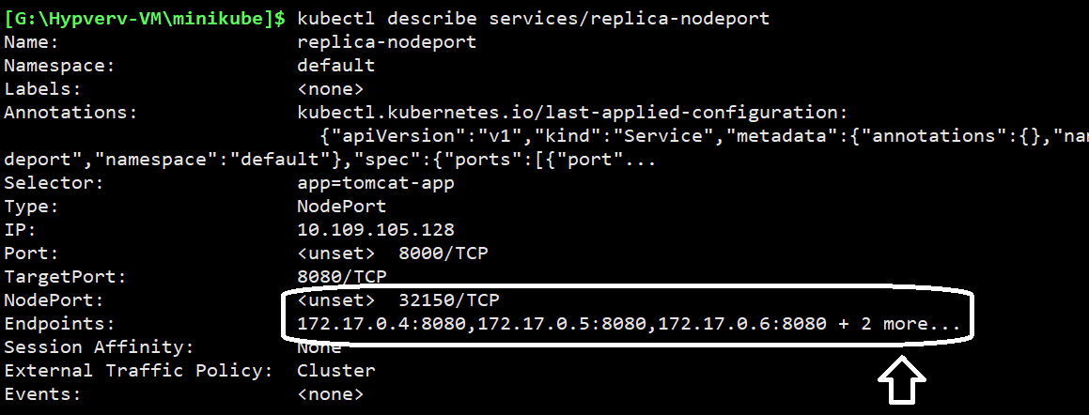
- Test – Scale down
Change the replicas in the YAML file and save it.
