Objective
- Manifest file
- Deploy app using replicaset
- Display and Validate ReplicaSet
- Expose it to the external world
- Test – POD Failures
- Test – Scale up
- Test – Scale down

- Manifest file
  - ReplicaSet-pod
apiVersion: apps/v1
kind: ReplicaSet
metadata:
name: tomcat-rs
spec:
replicas: 3
selector:
matchLabels:
app: tomcat-app
matchExpressions:
- {key: tier, operator: In, values: [frontend]}
template:
metadata:
name: tomcat-pod
labels:
app: tomcat-app
tier: frontend
spec:
containers:
- name: tomcat-cont
image: tomcat
ports:
- containerPort: 8080

Save the file as “Replicaset-pod.yaml”

  - ReplicaSet-node-port
apiVersion: v1
kind: Service
metadata:
name: replica-nodeport
spec:
type: NodePort
ports:
- port: 8000
targetPort: 8080
selector:
app: tomcat-app

Save the file as “Replicaset-node-port.yaml”

- Deploy app using ReplicaSet
$ kubectl apply -f ReplicaSet-pod.yaml

$ kubectl get pods
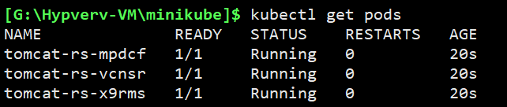
- Display and Validate ReplicaSet
Login to the minikube Vm, and run
$ docker ps | grep tomcat
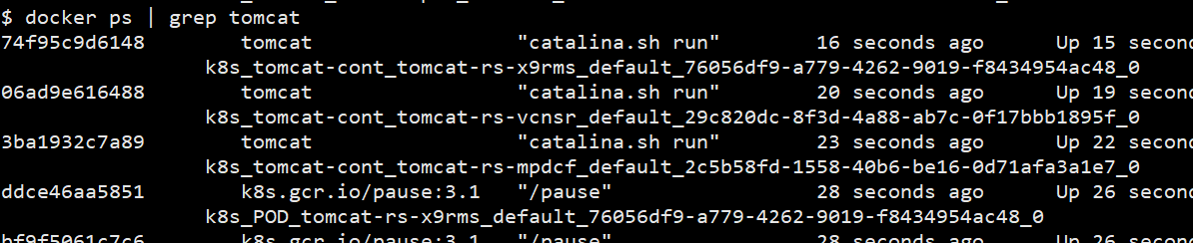

Check each PODS
$ kubectl describe pods/tomcat-rs-mpdcf
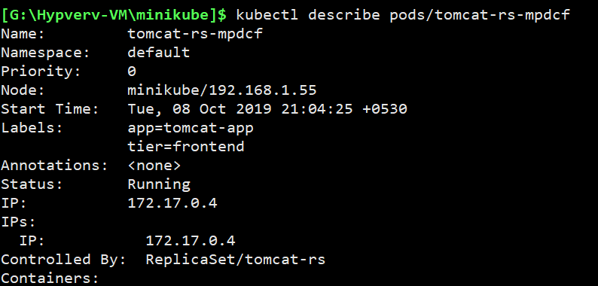

$ kubectl describe pods/tomcat-rs-vcnsr
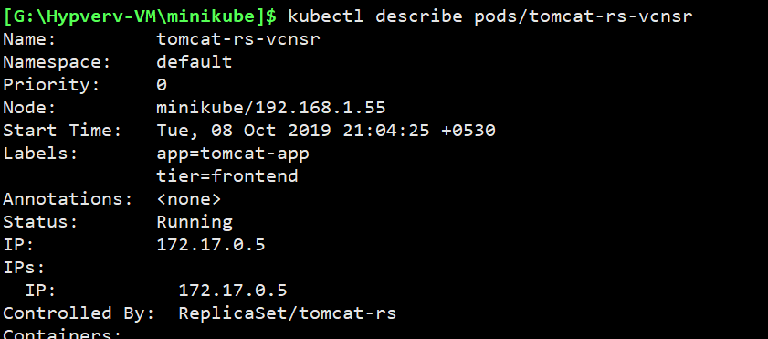

$ kubectl describe pods/tomcat-rs-x9rms
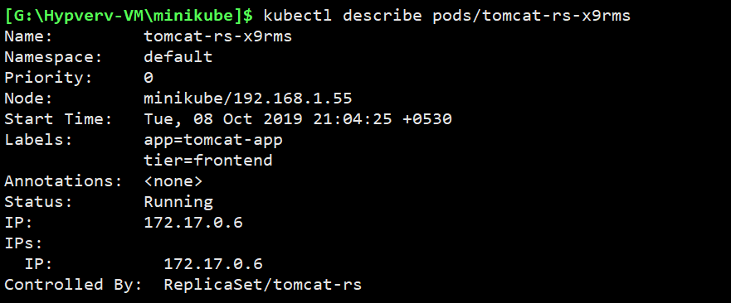

- Expose it to the external world
$ kubectl apply -f ReplicaSet-node-port.yaml

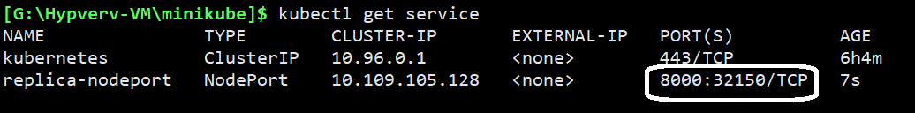

$ kubectl describe services/replica-nodeport
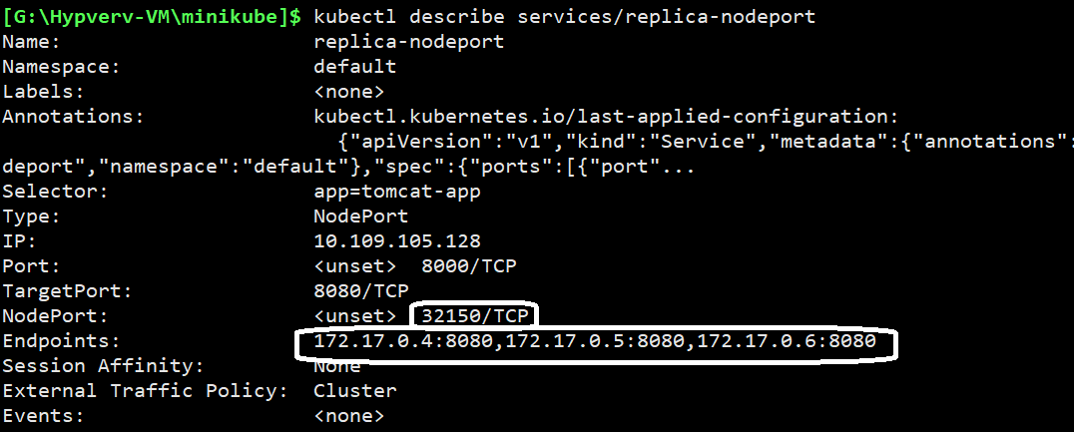

This clearly shows that the service has created the LOADBALANCER.
The endpoint points to all the 3 PODS and
The external port is working on “32150”

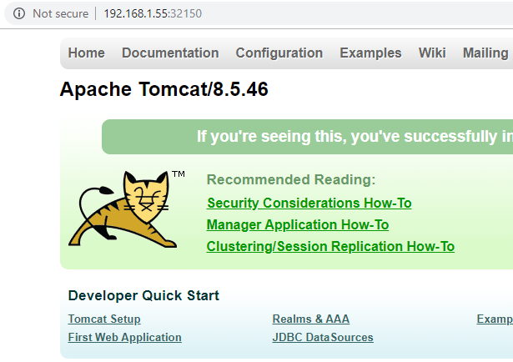

- Test – POD Failures
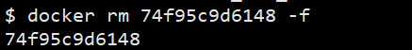
We just removed a container.

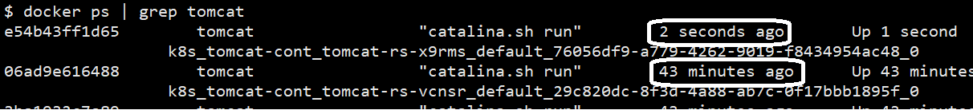

The container is back with no time.
This is the work of the Kubernetes.

- Test – Scale up
Change the replicas in the YAML file and save it.

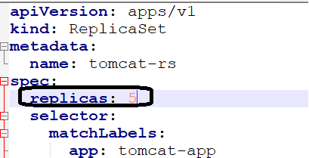

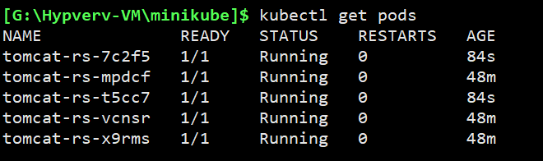

$ kubectl describe services/replica-nodeport

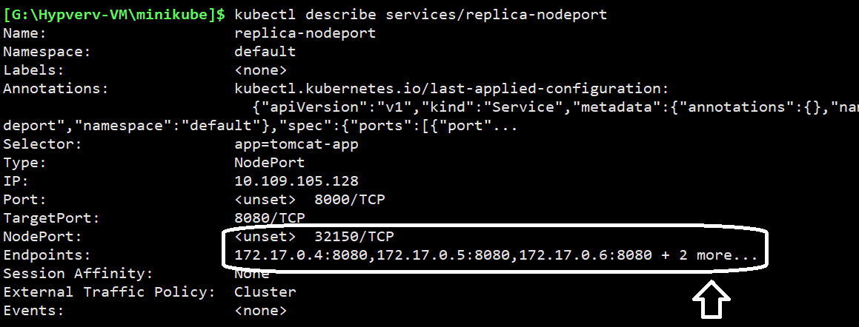
- Test – Scale down
Change the replicas in the YAML file and save it.
