Objective of the LAB.
To deploy “http” service on 2 EC2 instance from CodeDeploy and also copy an test page to the EC2 instance.
Result:
We should have an web service running on the EC2 and we should be able to access it via the EC2 instance public IP.
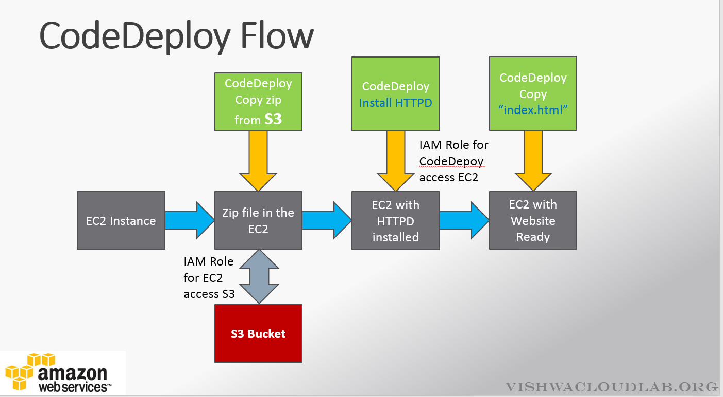
www.vishwacloudlab.com

Lab-Setups – CodeDeploy
- Create IAM Policy & Role for EC2 to access S3
  - Provide – S3 – get and list Permission for the EC2 instance. -- EC2-codedeploy
Example for the name , You can have same name for Role and Policy,eg: -- EC2-codedeploy
- Create Ec2 instance with “EC2-codedeploy” Roles attached to it and install the Codedeploy agent along with it (Bootstrap option)
- Upload the “Sample-linuz.zip” into S3 bucket and give “Public” access
- Create IAM Policy & Role for CodeDeploy to Access EC2 instance
Create Roles ,eg: -- and CodeDeploy
- Create an CodeDeploy deployment and deploy the code.
- Update the index.html file in the “.zip” file, and change “Congratulations” Edit the “appsepc” file. Remove all the lines from “hooks” and save it.

Step 1. Policy Creation
- IAM Policy -- EC2-codedeploy for EC2 to access S3
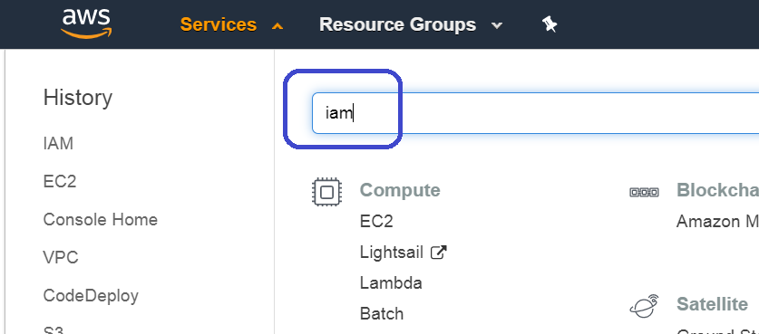
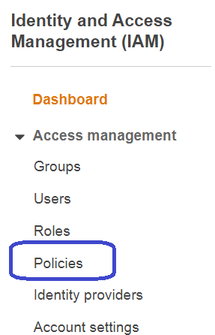

Click on “Policies”

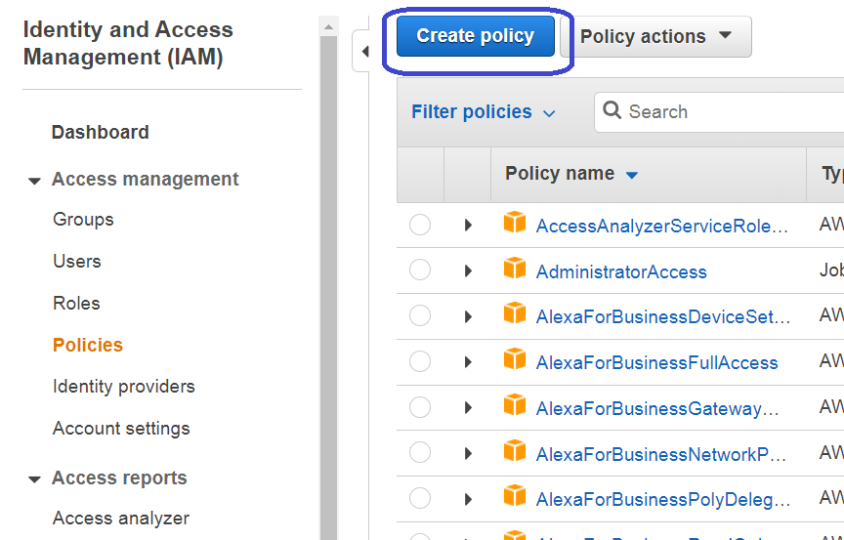
Click on “Create Policy” to create an custom policy.

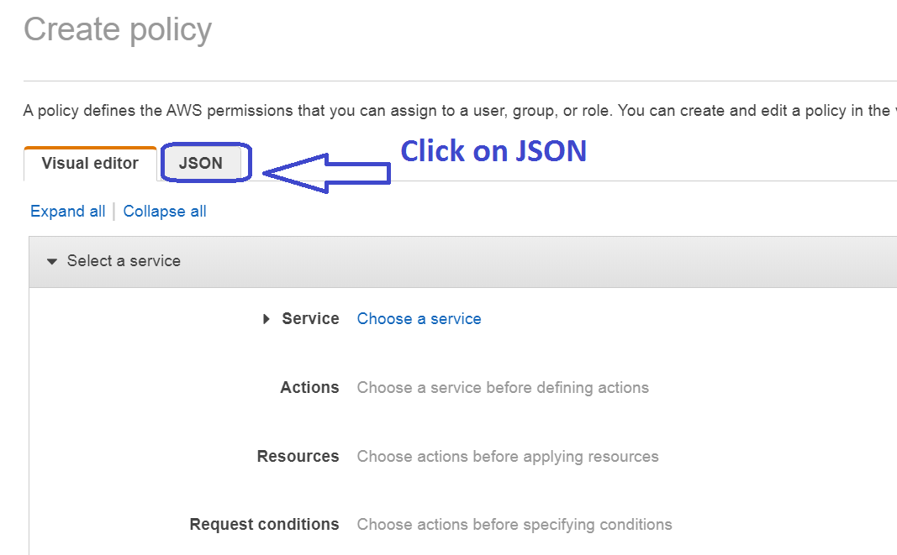

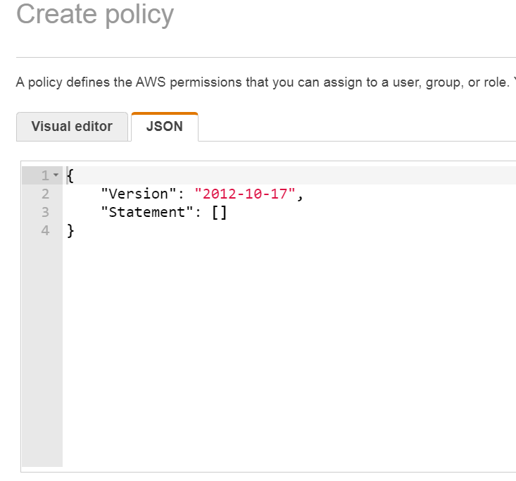
Copy the below json content into the policy and save it.

{
"Version": "2012-10-17",
"Statement": [
{
"Action": [
"s3:Get*",
"s3:List*"
],
"Effect": "Allow",
"Resource": "*"
}
]
}

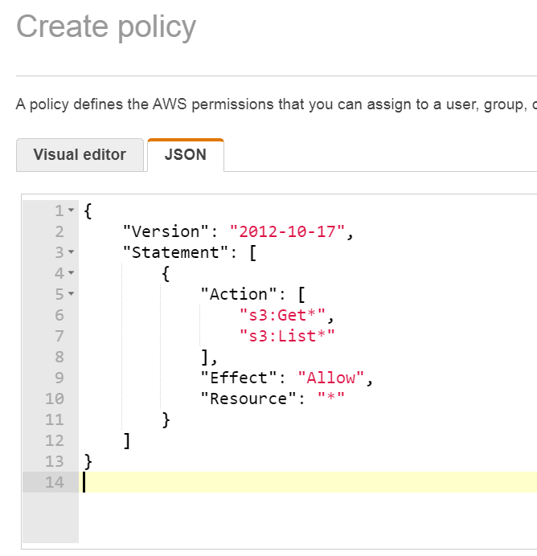

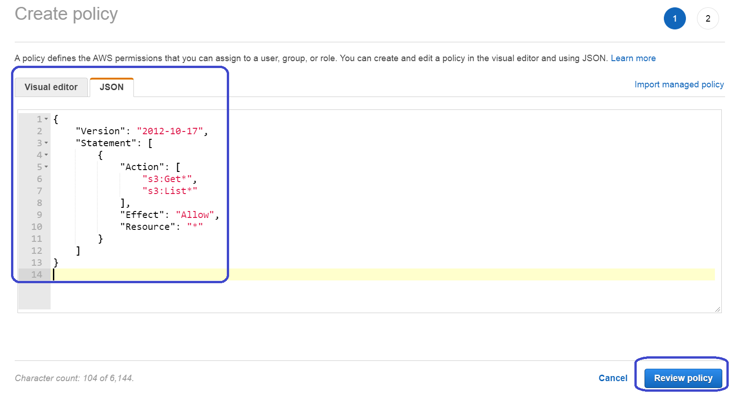
Click on “Review Policy”
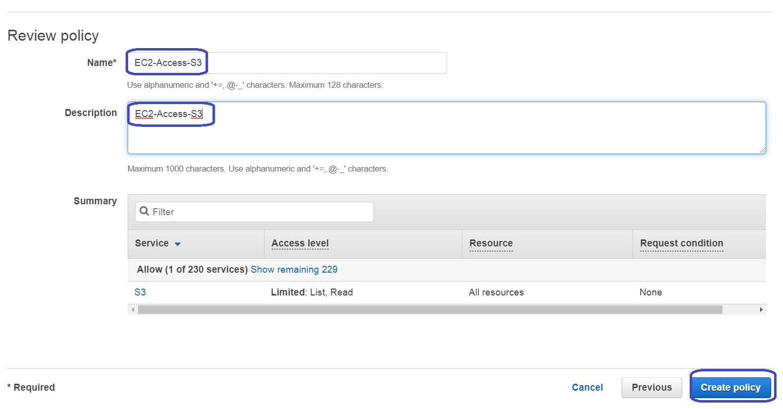

- IAM Role for EC2 Access the S3
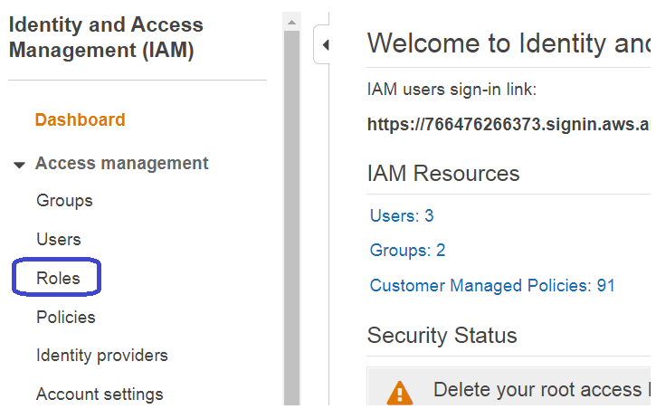
Click on “Roles”
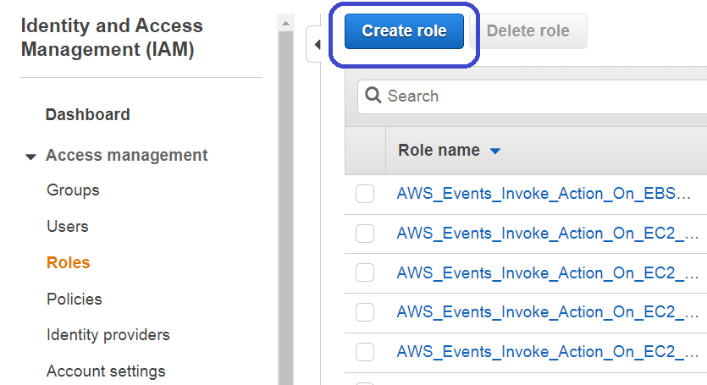

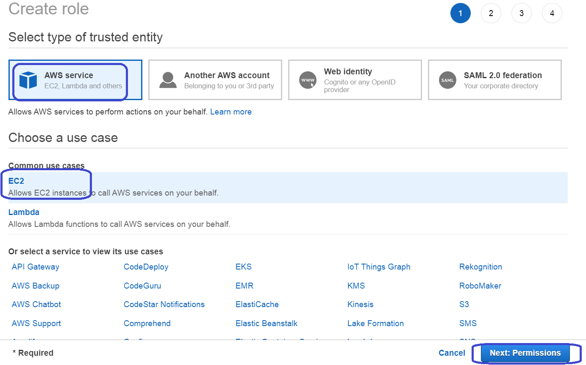
www.vishwacloudlab.com
Click on “Next:Permissions”.
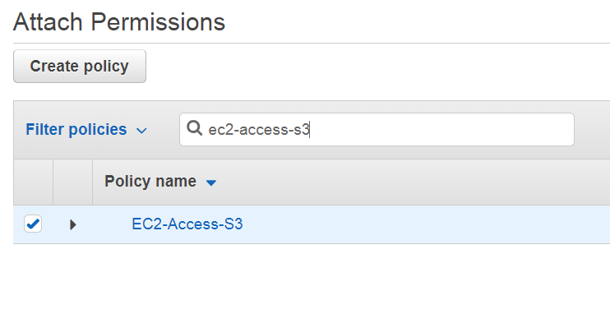
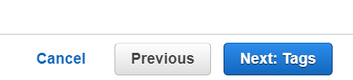
Click on “next”.

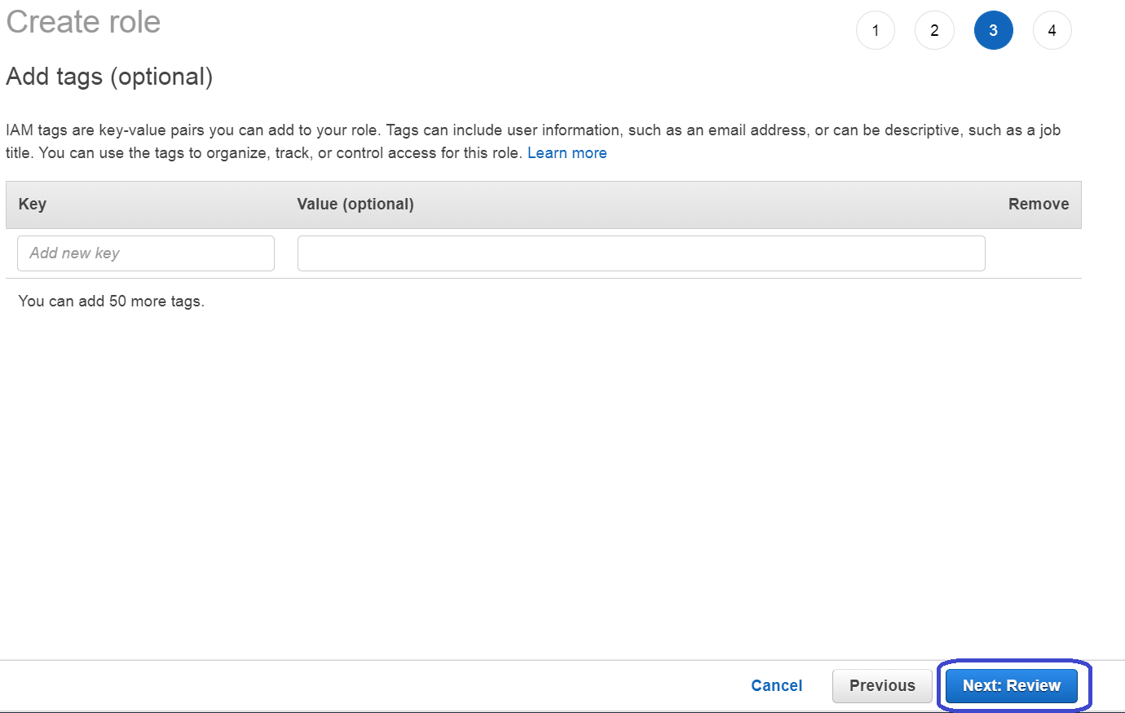
Click on “Review”
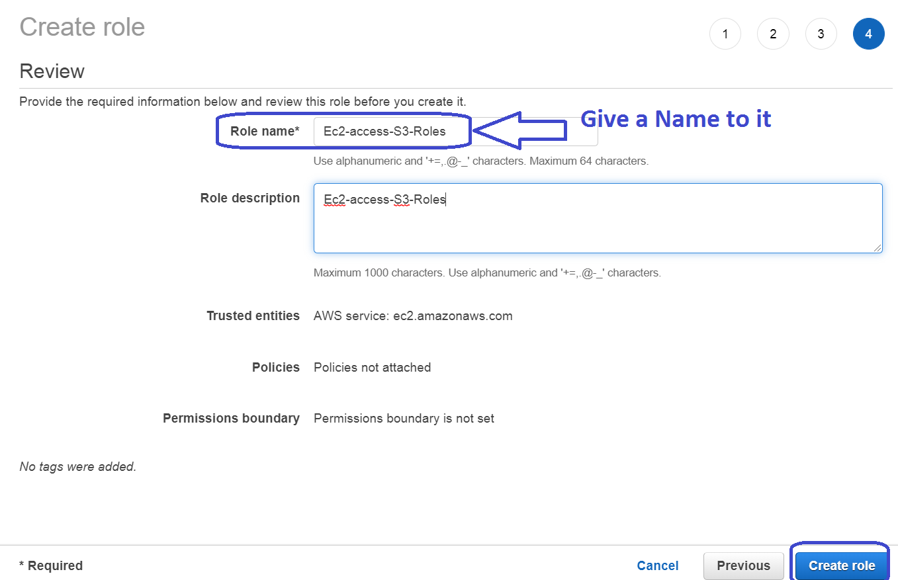
Click on “Create Role”

Step 2. Create EC2 instance
Create 2 Instance with the Above IAM role that was created for EC2 “EC2-codedeploy”

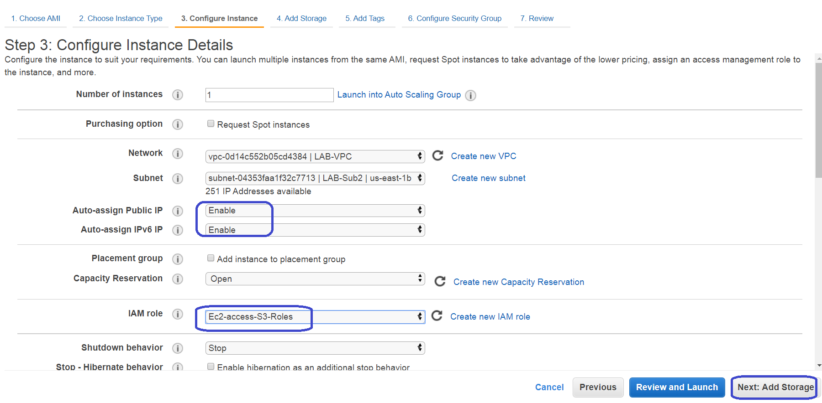
www.vishwacloudlab.com
Select the IAM roles while creating the EC2 instance.

Under the Advance option copy the Below command along with it
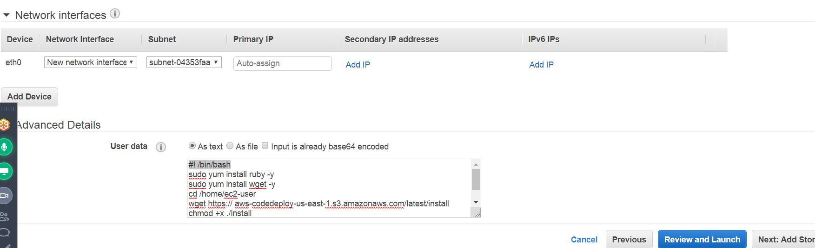
www.vishwacloudlab.com
#!/bin/bash
sudo yum install ruby -y
sudo yum install wget -y
cd /home/ec2-user
wget https://aws-codedeploy-us-east-1.s3.amazonaws.com/latest/install
chmod +x ./install
sudo ./install auto
These above codes needs to be copied under the advance section in the “userdata”, which would automatically install the Codedeploy agent and its called as “Bootstrapping”

The heighted portion in the http link could be replaced with the below code, based on the region selected.

Resource Kit Bucket Names by Region
This table lists the names of bucket-name replacements required for some procedures in the guide. These are the names of the Amazon S3 buckets that contain the AWS CodeDeploy Resource Kit files.
Region name | bucket-name replacement | Region identifier
US East (Ohio) | aws-codedeploy-us-east-2 | us-east-2
US East (N. Virginia) | aws-codedeploy-us-east-1 | us-east-1
US West (N. California) | aws-codedeploy-us-west-1 | us-west-1
US West (Oregon) | aws-codedeploy-us-west-2 | us-west-2
Canada (Central) | aws-codedeploy-ca-central-1 | ca-central-1
EU (Ireland) | aws-codedeploy-eu-west-1 | eu-west-1
EU (London) | aws-codedeploy-eu-west-2 | eu-west-2
EU (Paris) | aws-codedeploy-eu-west-3 | eu-west-3
EU (Frankfurt) | aws-codedeploy-eu-central-1 | eu-central-1
Asia Pacific (Tokyo) | aws-codedeploy-ap-northeast-1 | ap-northeast-1
Asia Pacific (Seoul) | aws-codedeploy-ap-northeast-2 | ap-northeast-2
Asia Pacific (Singapore) | aws-codedeploy-ap-southeast-1 | ap-southeast-1
Asia Pacific (Sydney) | aws-codedeploy-ap-southeast-2 | ap-southeast-2
Asia Pacific (Mumbai) | aws-codedeploy-ap-south-1 | ap-south-1
South America (São Paulo) | aws-codedeploy-sa-east-1 | sa-east-1

- Click next on the “Add storage”
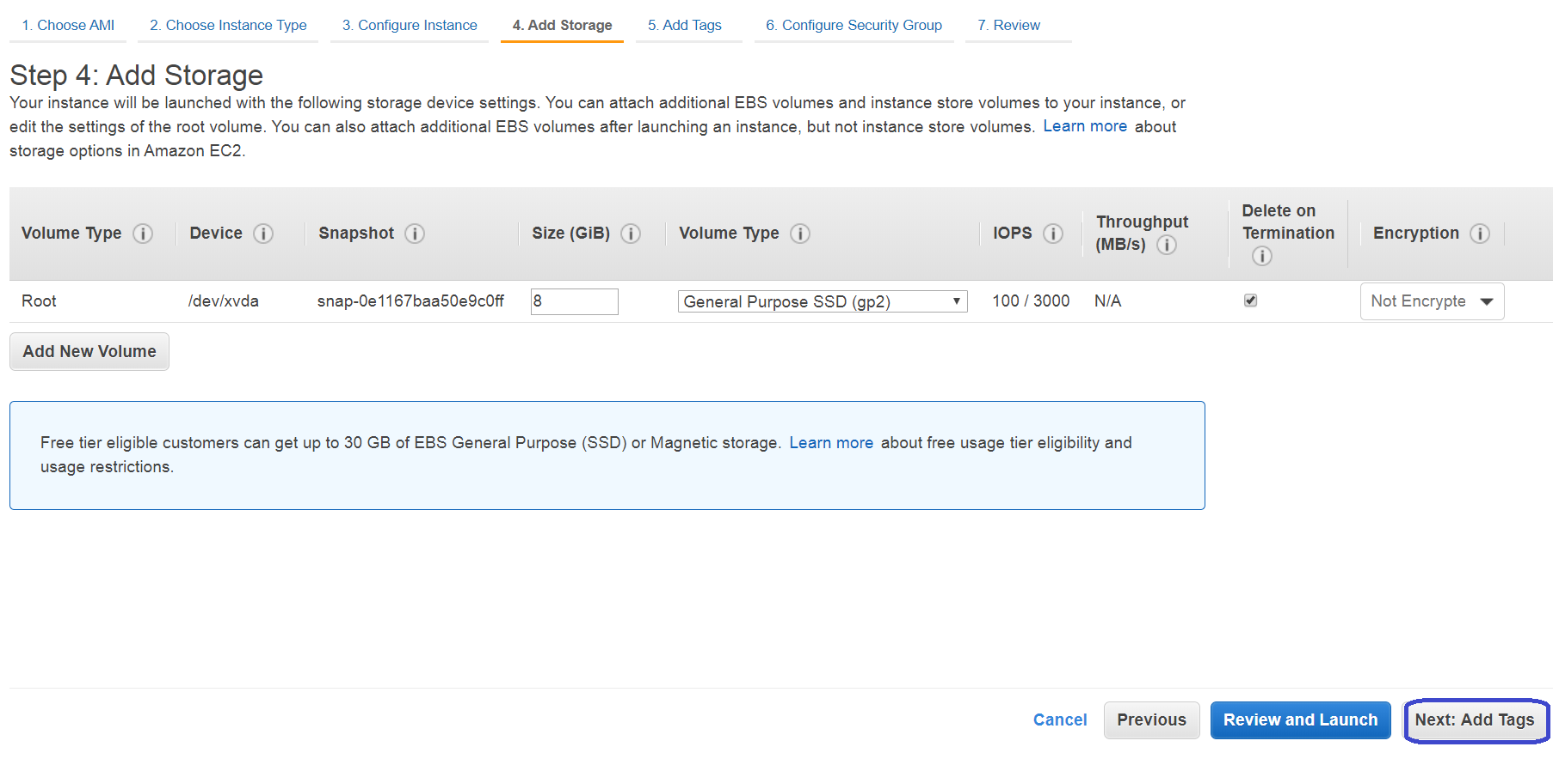
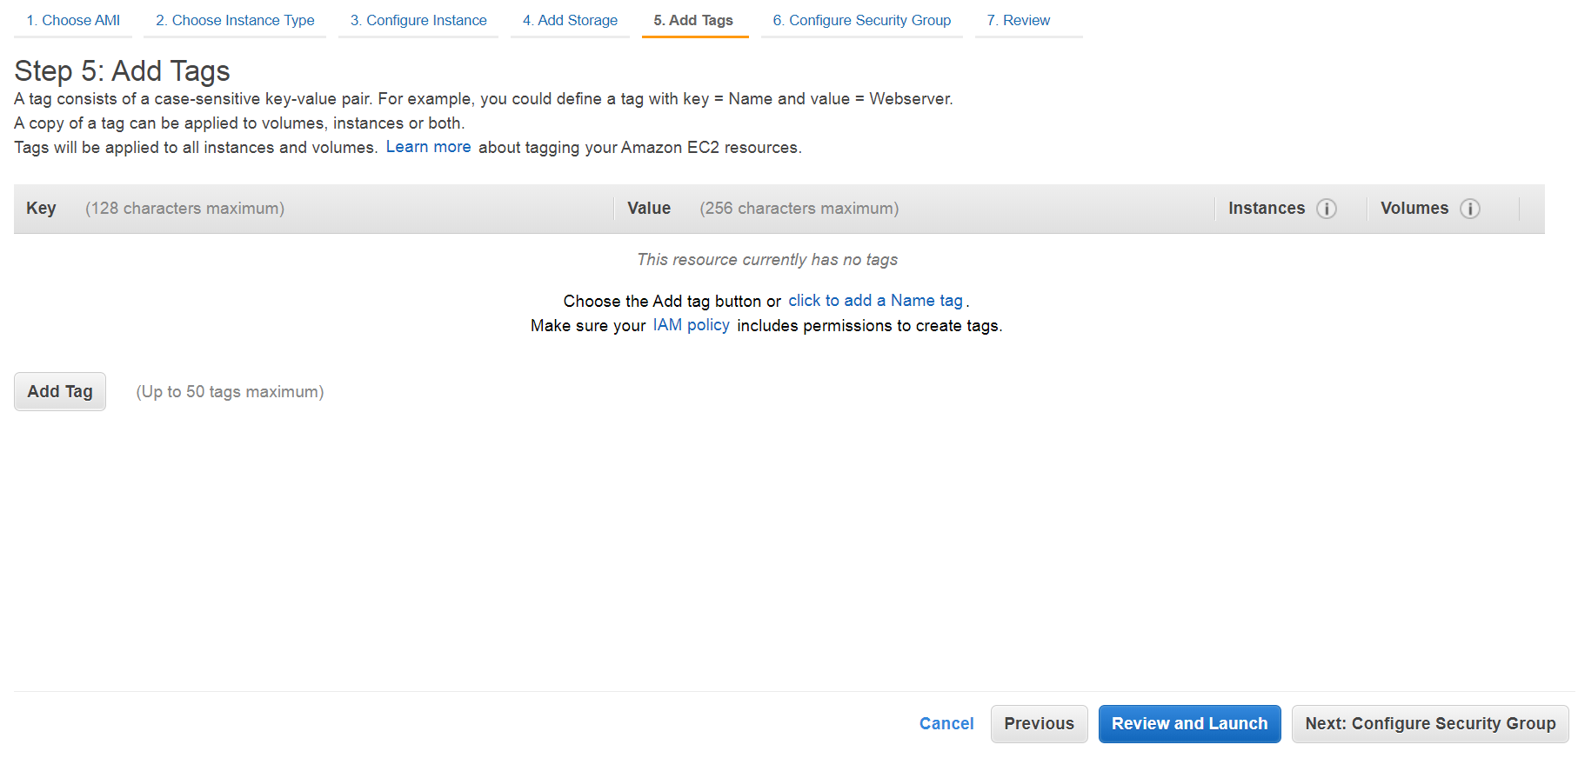
Click on “next”

- With Security Group allowing -- SSH and HTTP traffic
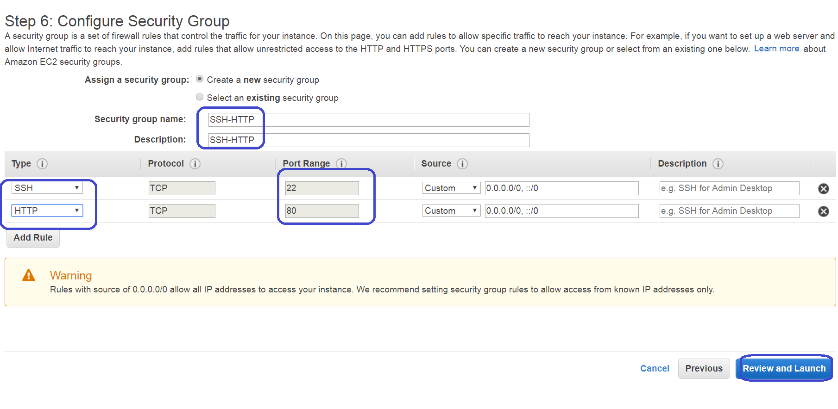
Click on “review and launch”
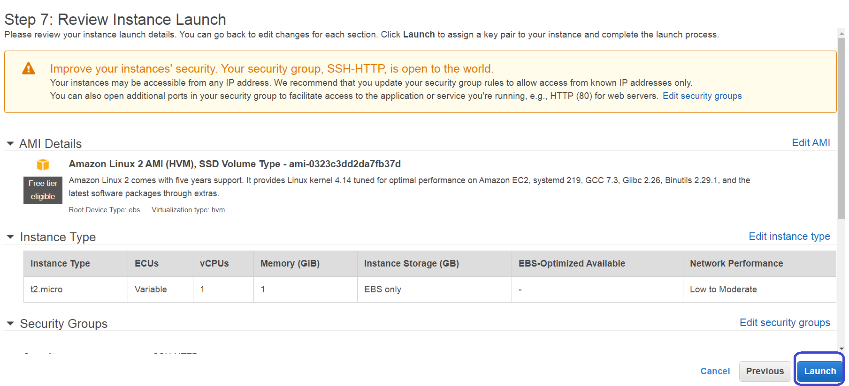
Click on “Launch”
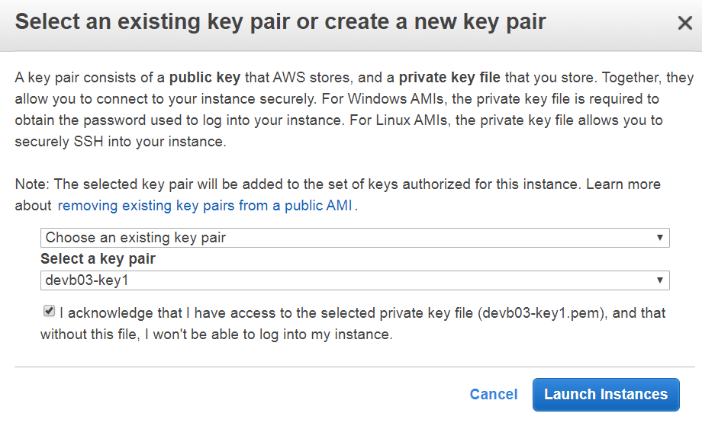
We would need a key to login to the ec2 instance later.
Here the key is already created and the “.pem” file is already downloaded on the system.
Click on “launch”.

For more info, on creating the EC2 and how to login, refer to the “EC2-instance creation” and “Login to EC2 via xshell and putty” document.

- After the EC2 instance is up, check if the codedeploy agent service is running with the below command.
# service codedeploy-agent status.
Output:
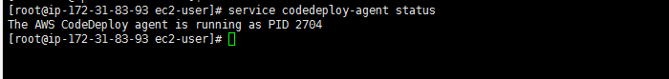
www.vishwacloudlab.com

Step 3.
Upload the “Sample-linuz.zip” into S3 bucket and give “Public” access.
The bucket needs to have "Versioning" ENABLED.
The file is available in the Google drive https://drive.google.com/drive/u/1/folders/18wNY2GTIcS3vCufomVo9If5B59P5l8nS

Step 4: Create IAM Role and Policy for CodeDeploy
- IAM Policy -- Codedeploy to access EC2 instance.
Eg:-- “Codedeploy”
{
"Version": "2012-10-17",
"Statement": [
{
"Sid": "VisualEditor0",
"Effect": "Allow",
"Action": [
"ec2:*"
],
"Resource": "*"
}
]
}
IAM Role for “CodeDeploy”
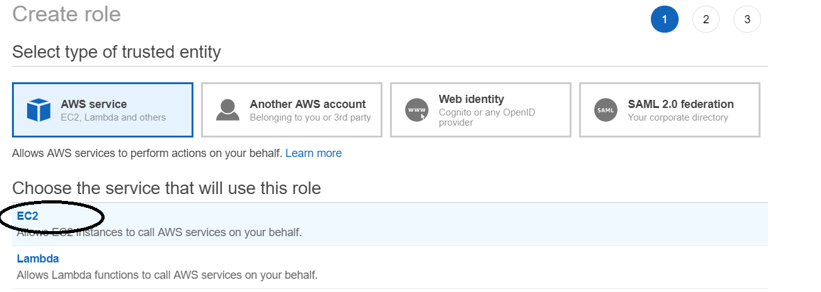
www.vishwacloudlab.com
Then attach the above Codedeploy Policy to this IAM role
Add the below trust relationship on the CodeDeploy Role
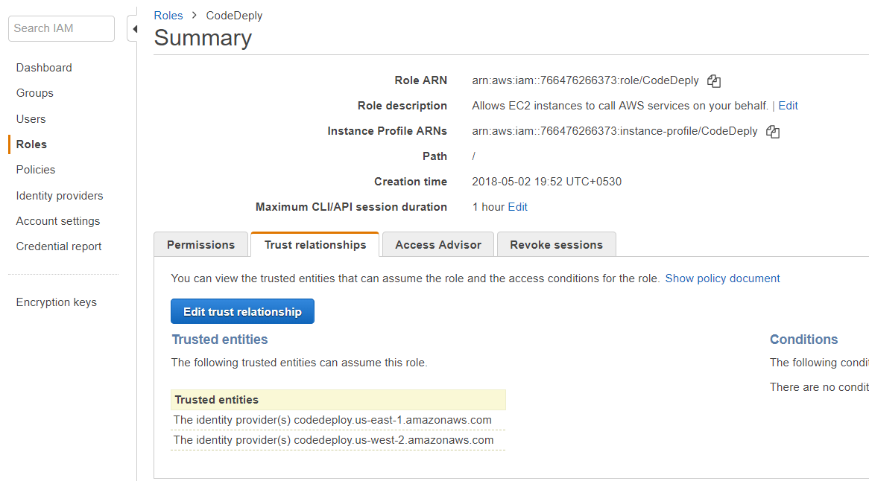
www.vishwacloudlab.com
Click on “Edit trust relationship”
{
"Version": "2012-10-17",
"Statement": [
{
"Sid": "",
"Effect": "Allow",
"Principal": {
"Service": [
"codedeploy.us-east-1.amazonaws.com",
"codedeploy.us-west-2.amazonaws.com"
]
},
"Action": "sts:AssumeRole"
}
]
}

Step 5: Create an CodeDeploy deployment and deploy the code.

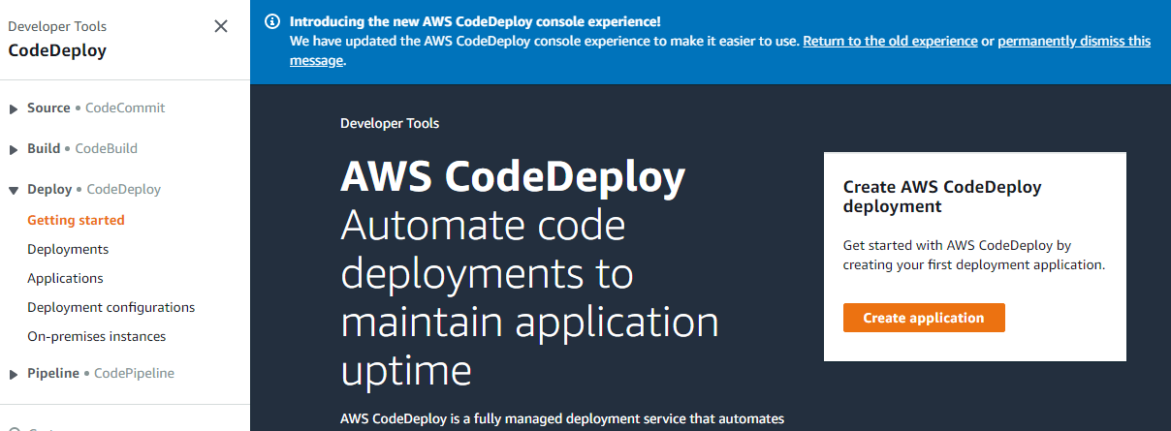
www.vishwacloudlab.com
Click on “Create Application”

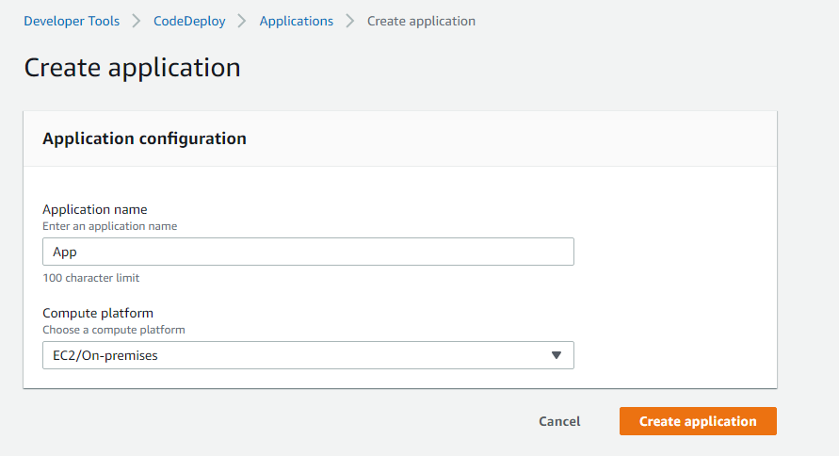
www.vishwacloudlab.com
Click on “create Application”

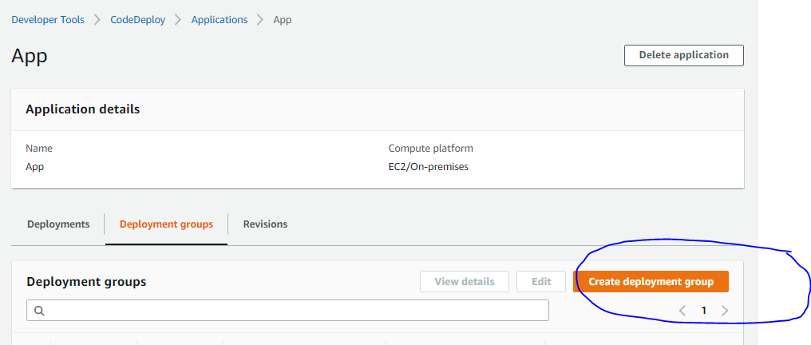
www.vishwacloudlab.com
Click on “Create deployment group”
Note: -- Make sure you have a tag attached to your EC2 instance.
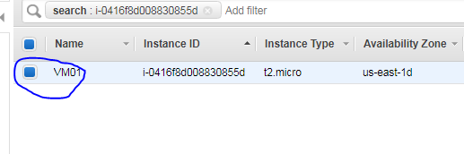
- Create a Deployment Group
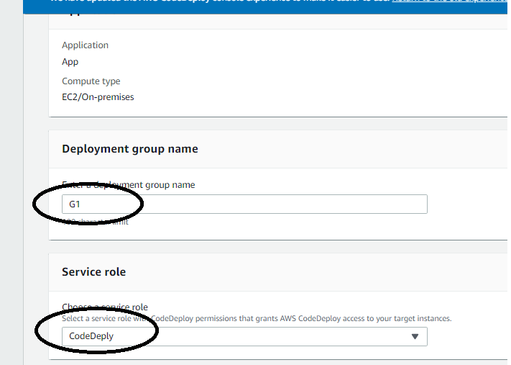
www.vishwacloudlab.com
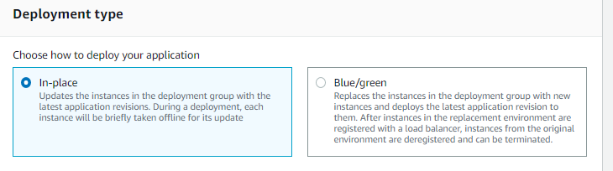
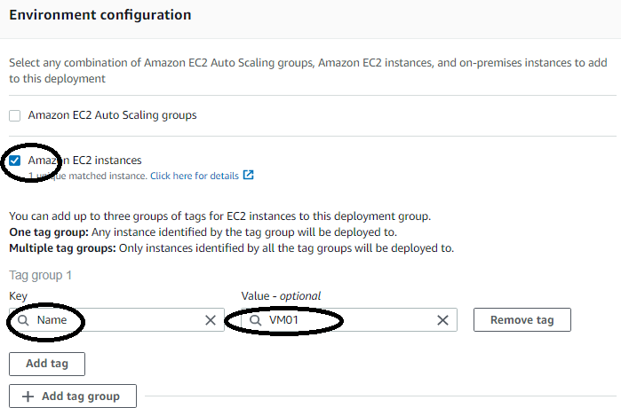
www.vishwacloudlab.com
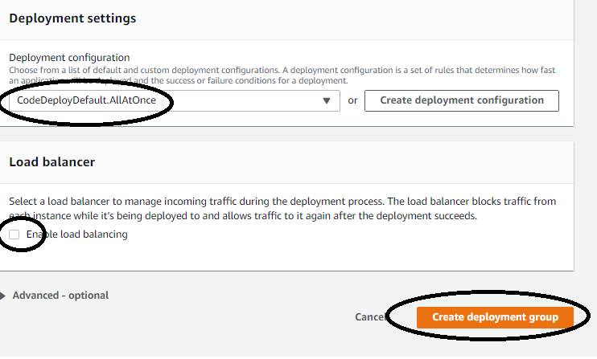
www.vishwacloudlab.com
Output:
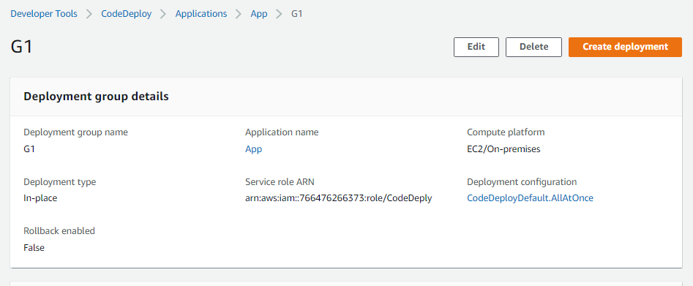
www.vishwacloudlab.com

- Create Deployment
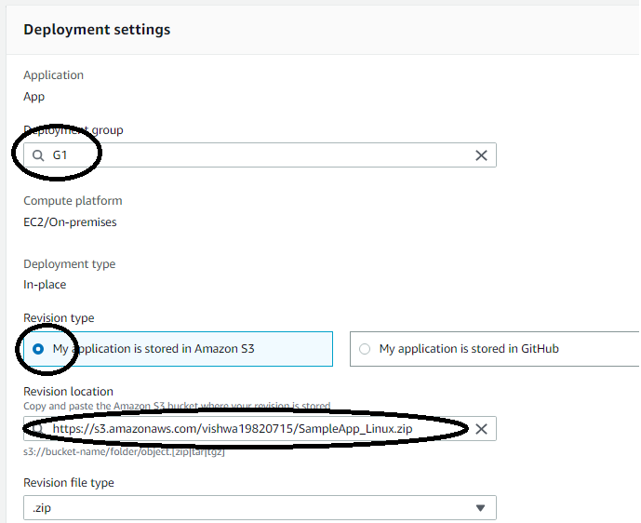
www.vishwacloudlab.com
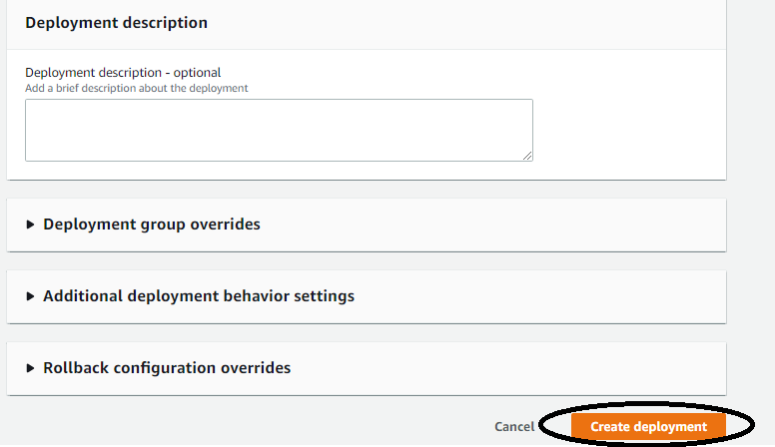
www.vishwacloudlab.com
Click on “Create Deployment”

Output:
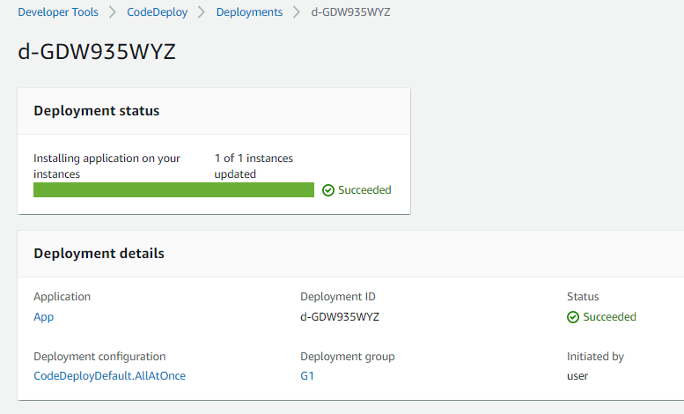
www.vishwacloudlab.com
This show that the deployment is successful.
Now lets try to access the webpage with public ip of the EC2 instance.
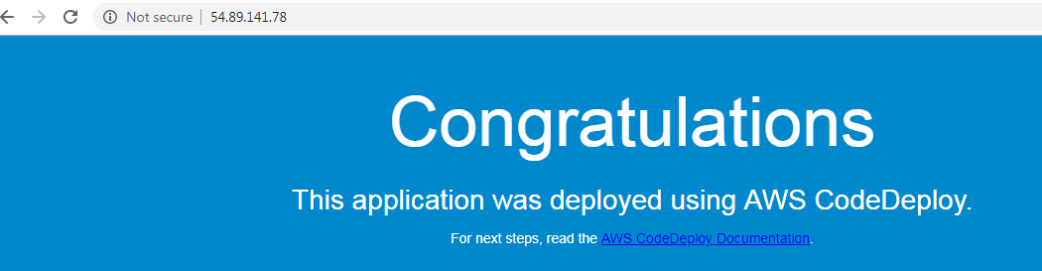
www.vishwacloudlab.com

Step 6: Update the Deploy with new content Download the Zip file on your laptop, uncompress it to a folder.
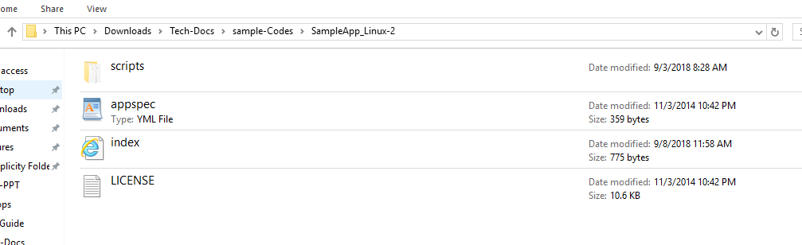
www.vishwacloudlab.com
Remove the “Scripts” folder.
Edit the appspec file as below. Remove all other lines.
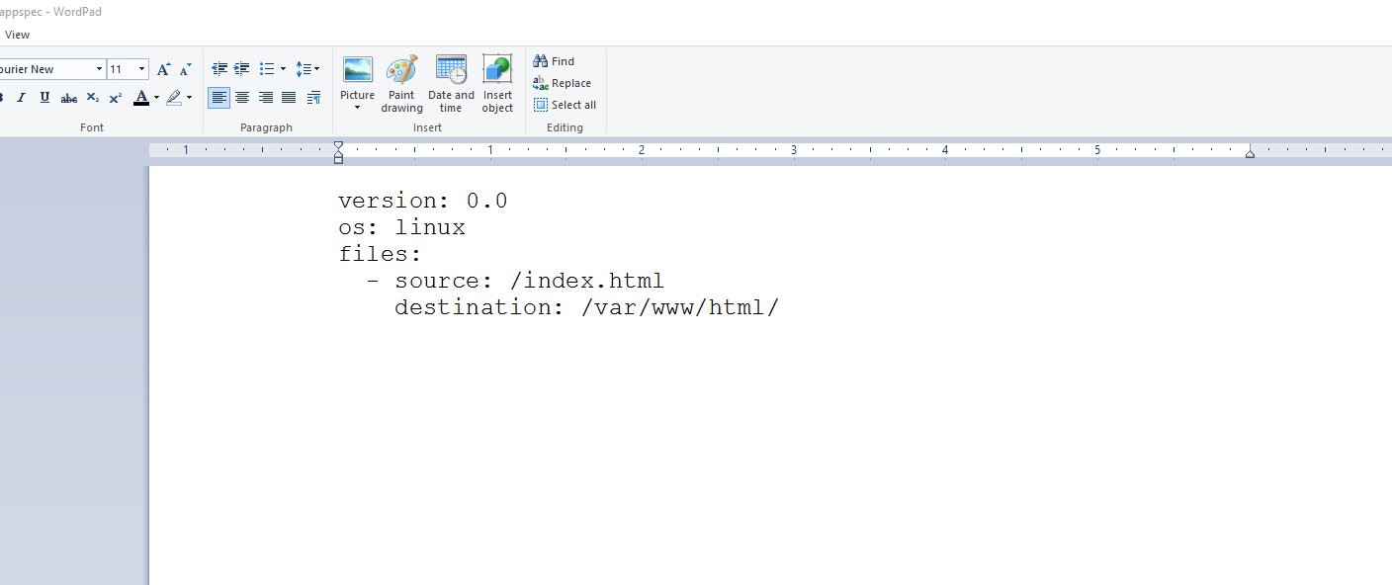
www.vishwacloudlab.com

Now edit the “index.html” file. And add some content as below. And save it.
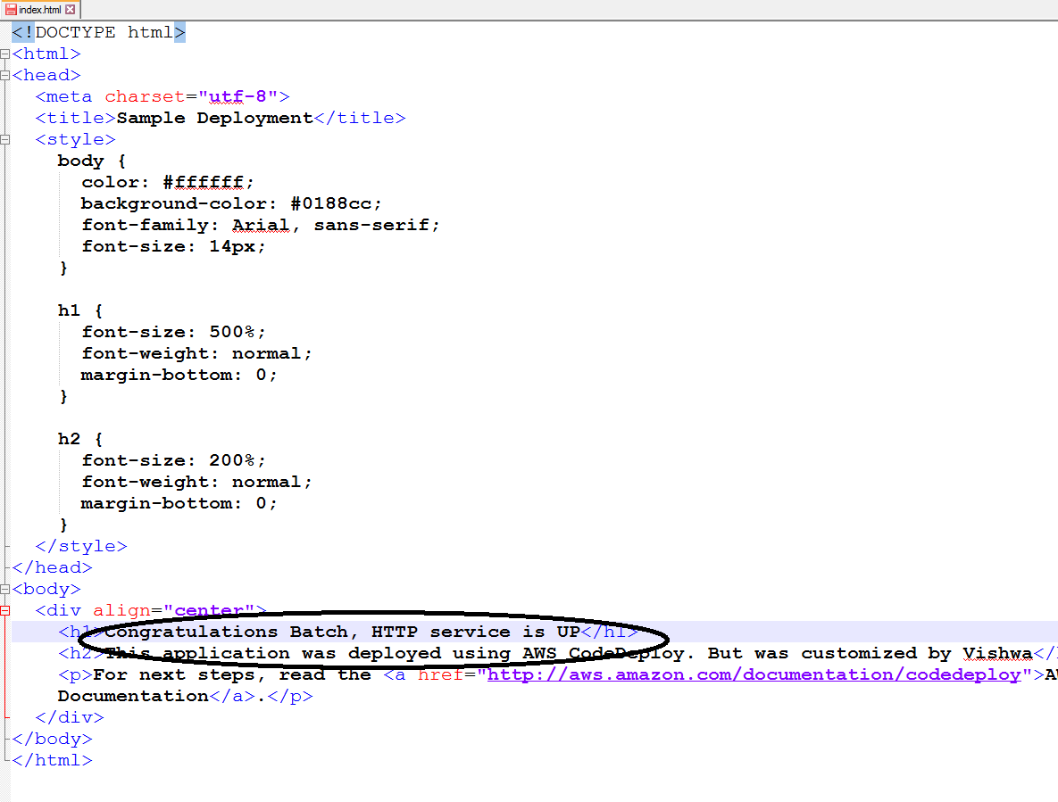
www.vishwacloudlab.com

Now zip the file as shown. Select only the FILES and zip and NOT the folder itself, as CODEDEPLOY would be looking for “appsepc” file in the zip parent folder.

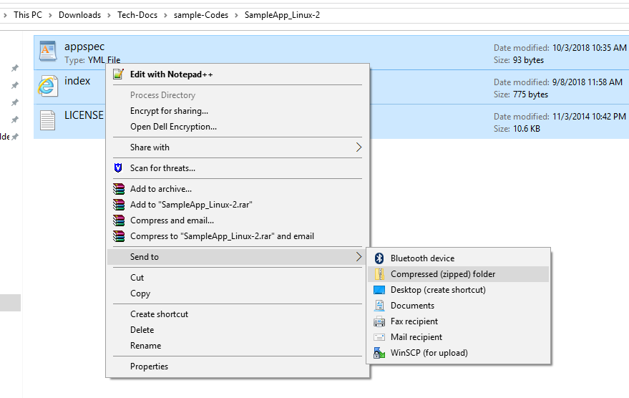
www.vishwacloudlab.com
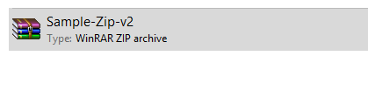
Now upload this Sample-zip-v2 to S3, and make it public.
Update the same Deployment Group with “new Revision” with new S3 link.

