Objective of the LAB.
To deploy “http” service on 2 EC2 instance from CodeDeploy and also copy an test page to the EC2 instance.
Result:
We should have an web service running on the EC2 and we should be able to access it via the EC2 instance public IP.

Lab-Setups – CodeDeploy
- Create IAM Policy & Role for EC2 to access S3
  - Provide – S3 – get and list Permission for the EC2 instance. -- EC2-codedeploy
Example for the name , You can have same name for Role and Policy,eg: -- EC2-codedeploy
- Create Ec2 instance with “EC2-codedeploy” Roles attached to it and install the Codedeploy agent along with it (Bootstrap option)
- Upload the “Sample-linuz.zip” into S3 bucket and give “Public” access
- Create IAM Policy & Role for CodeDeploy to Access EC2 instance
Create Roles ,eg: -- and CodeDeploy
- Create an CodeDeploy deployment code.
- Create an ‘New Deploy” and point to the S3 location of the Sample-linux.zip file
- Update the index.html file in the “.zip” file, and change “Congratulations” Edit the “appsepc” file. Remove all the lines from “hooks” and save it.

Step 1. Policy Creation
- IAM Policy -- EC2-codedeploy for EC2 to access S3
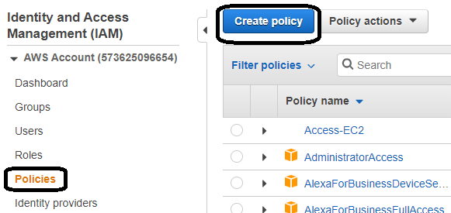

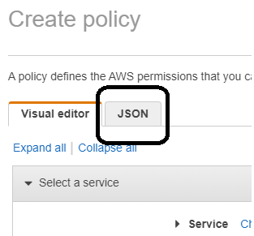

Copy paste the below IAM policy in the JSON window.

{
"Version": "2012-10-17",
"Statement": [
{
"Action": [
"s3:Get*",
"s3:List*"
],
"Effect": "Allow",
"Resource": "*"
}
]
}
Save the policy as “ec2-s3”

- IAM Role for EC2-access-s3
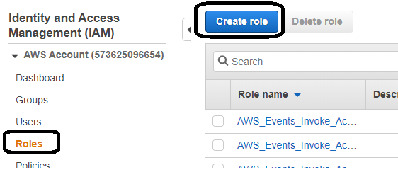
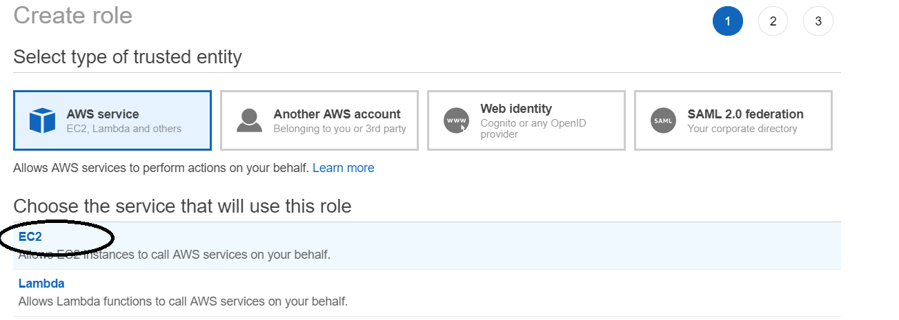
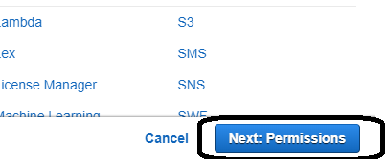
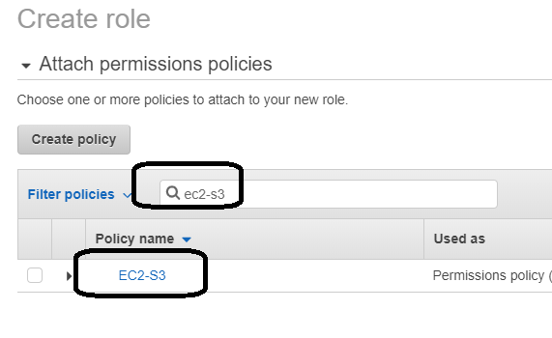
Then attach the policy “EC2-s3”
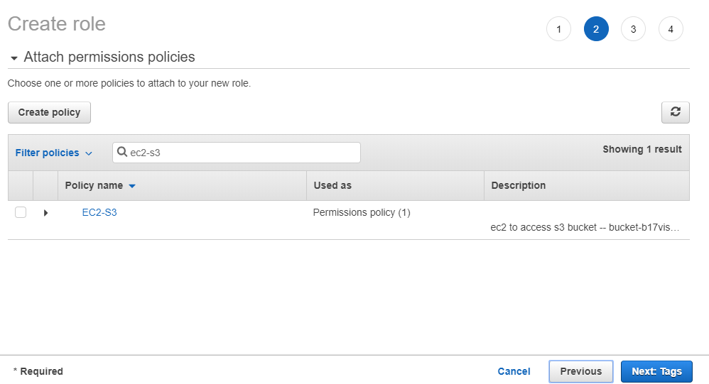
Click on “Next”.
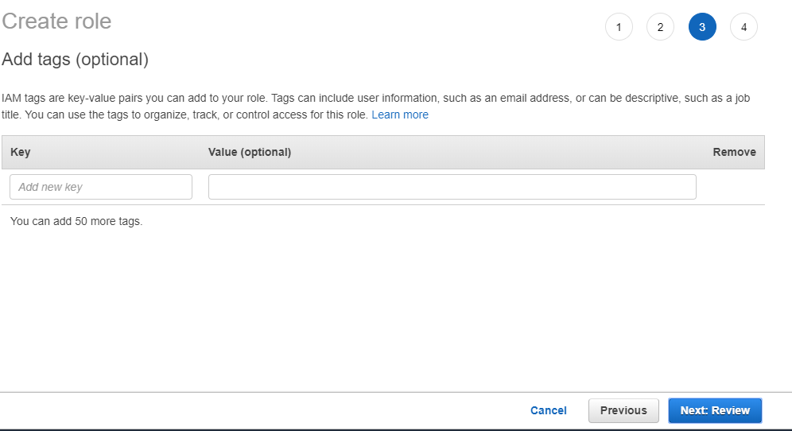
Click on “next”
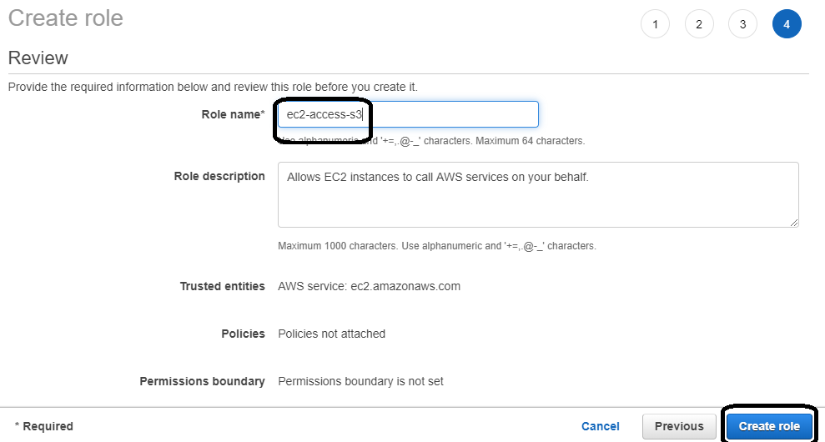
Put the role as “ec2-access-s3” and click on “create role”
Step 2. Create EC2 instance
Create 2 Instance with the Above IAM role that was created for EC2 “EC2-codedeploy”

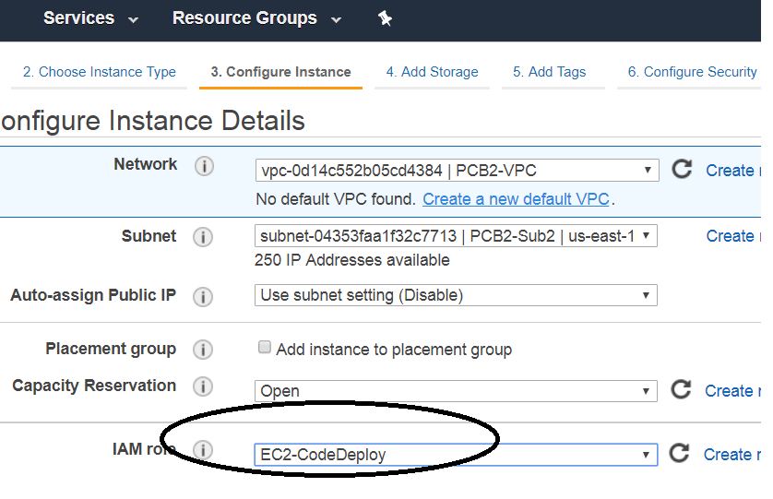

Under the Advance option copy the Below command along with it
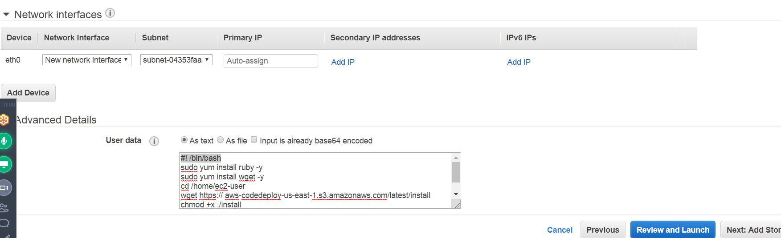
#!/bin/bash
sudo yum install ruby -y
sudo yum install wget -y
cd /home/ec2-user
wget https://aws-codedeploy-us-east-1.s3.amazonaws.com/latest/install
chmod +x ./install
sudo ./install auto
This would automatically install the Codedeploy agent and its called as “Bootstrapping”
Note: -- Make sure to use the right region link.

- With Security Group allowing -- SSH and HTTP traffic
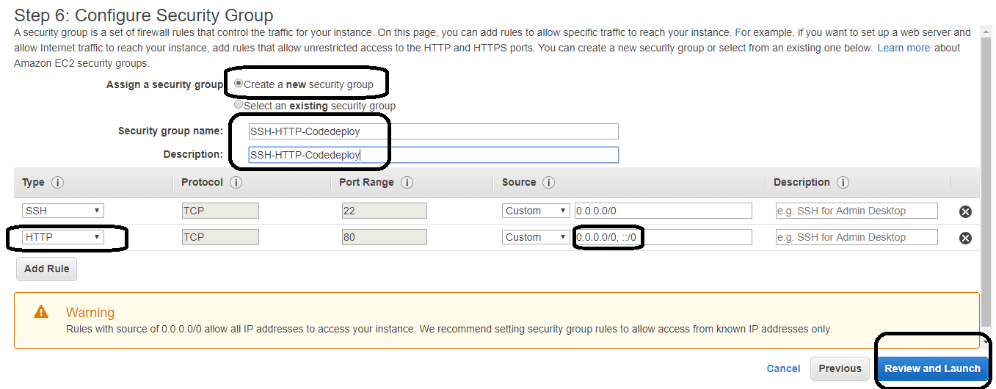

- After the EC2 instance is up, check if the codedeploy agent service is running with the below command.
# service codedeploy-agent status
Output:
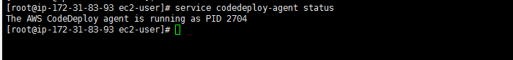

Resource Kit Bucket Names by Region
This table lists the names of bucket-name replacements required for some procedures in the guide. These are the names of the Amazon S3 buckets that contain the AWS CodeDeploy Resource Kit files.
Region name | bucket-name replacement | Region identifier
US East (Ohio) | aws-codedeploy-us-east-2 | us-east-2
US East (N. Virginia) | aws-codedeploy-us-east-1 | us-east-1
US West (N. California) | aws-codedeploy-us-west-1 | us-west-1
US West (Oregon) | aws-codedeploy-us-west-2 | us-west-2
Canada (Central) | aws-codedeploy-ca-central-1 | ca-central-1
EU (Ireland) | aws-codedeploy-eu-west-1 | eu-west-1
EU (London) | aws-codedeploy-eu-west-2 | eu-west-2
EU (Paris) | aws-codedeploy-eu-west-3 | eu-west-3
EU (Frankfurt) | aws-codedeploy-eu-central-1 | eu-central-1
Asia Pacific (Tokyo) | aws-codedeploy-ap-northeast-1 | ap-northeast-1
Asia Pacific (Seoul) | aws-codedeploy-ap-northeast-2 | ap-northeast-2
Asia Pacific (Singapore) | aws-codedeploy-ap-southeast-1 | ap-southeast-1
Asia Pacific (Sydney) | aws-codedeploy-ap-southeast-2 | ap-southeast-2
Asia Pacific (Mumbai) | aws-codedeploy-ap-south-1 | ap-south-1
South America (São Paulo) | aws-codedeploy-sa-east-1 | sa-east-1

Step 3.
Upload the “Sample-linux.zip” into S3 bucket. ( Its not compulsory to have public access)
The bucket needs to have "Versioning" ENABLED.

Step 4: Create IAM Role and Policy for CodeDeploy
- IAM Policy -- Codedeploy to access EC2 instance.
Eg:-- “Codedeploy”
{
"Version": "2012-10-17",
"Statement": [
{
"Sid": "VisualEditor0",
"Effect": "Allow",
"Action": [
"ec2:*"
],
"Resource": "*"
}
]
}
IAM Role for “CodeDeploy”

Then attach the above Codedeploy Policy to this IAM role
Add the below trust relationship on the CodeDeploy Role
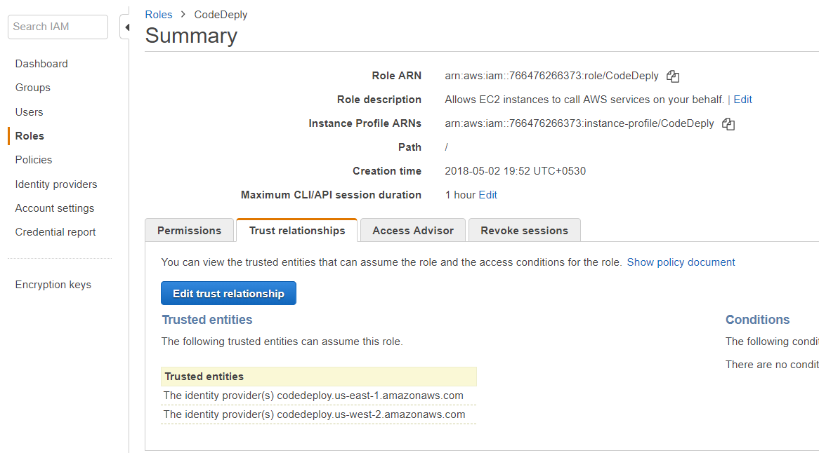
Click on “Edit trust relationship”
{
"Version": "2012-10-17",
"Statement": [
{
"Sid": "",
"Effect": "Allow",
"Principal": {
"Service": [
"codedeploy.amazonaws.com"
]
},
"Action": "sts:AssumeRole"
}
]
}

Step 5: Create an CodeDeploy deployment code.

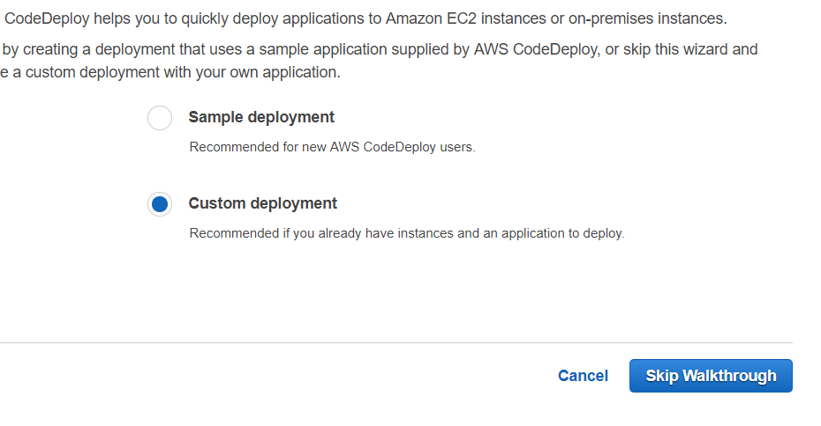
- 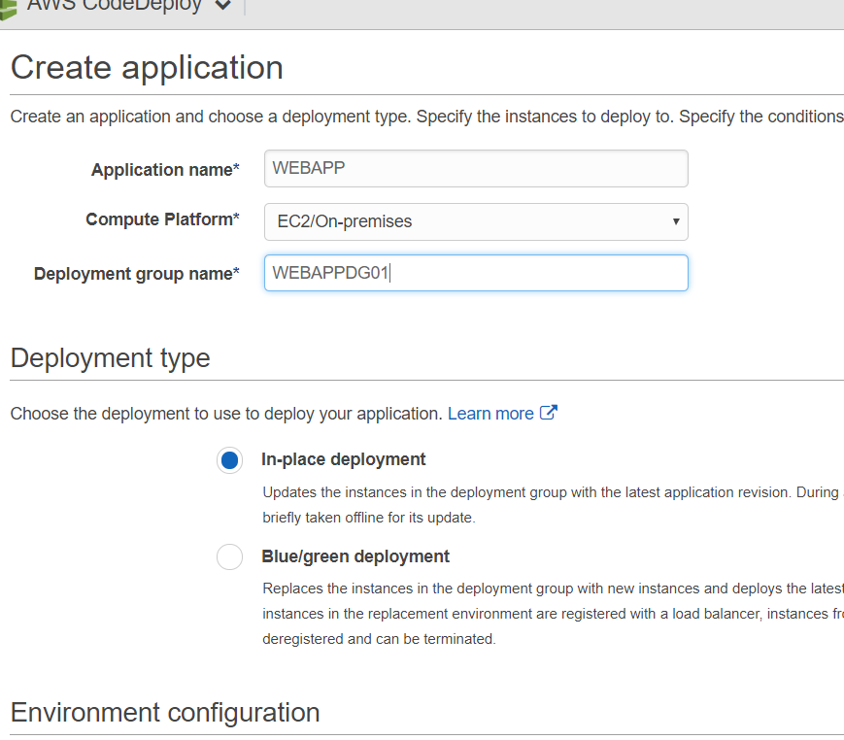
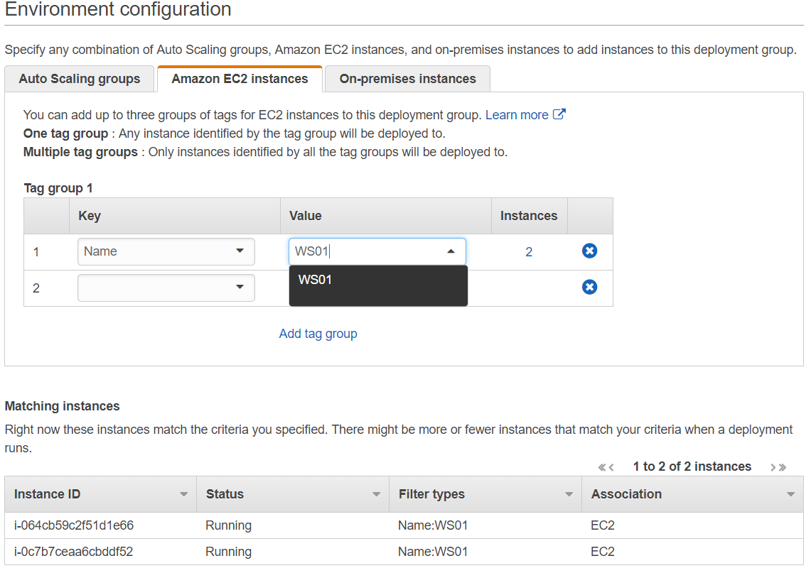
Note: -- EC2 instance type min “t2.medium”
- 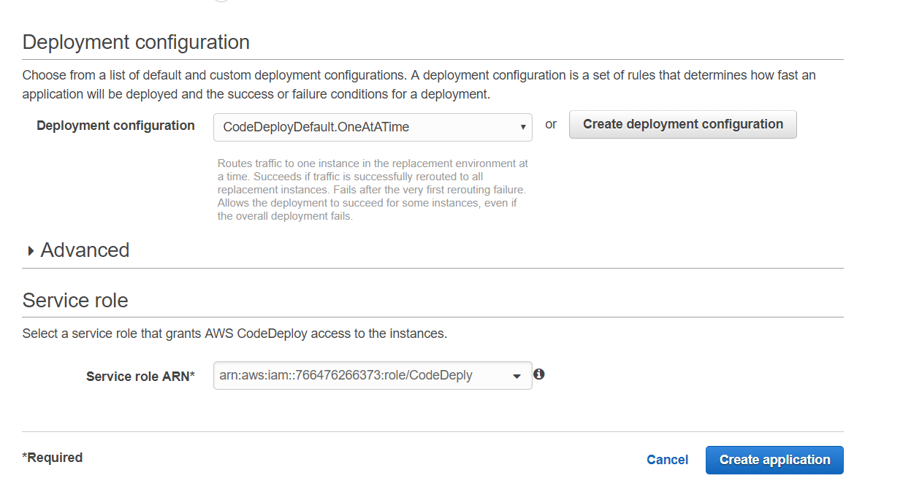
Successfully Application Deployment Group has been created.

Step 6: Create an ‘New Deploy” and point to the S3 location of the Sample-linux.zip file

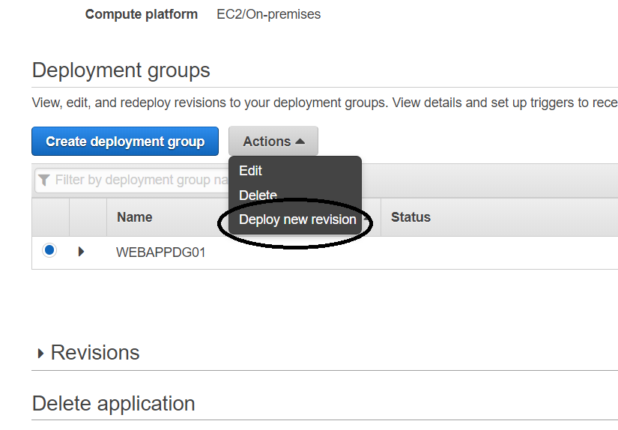
Click on “deploy new revision”on the above screen
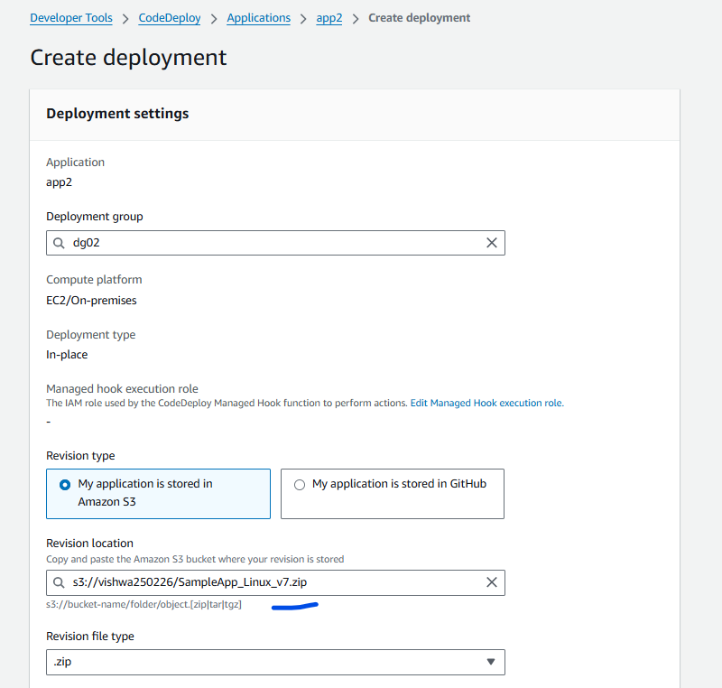
Copy the “S3 zip file link” to locate the zip file as above.
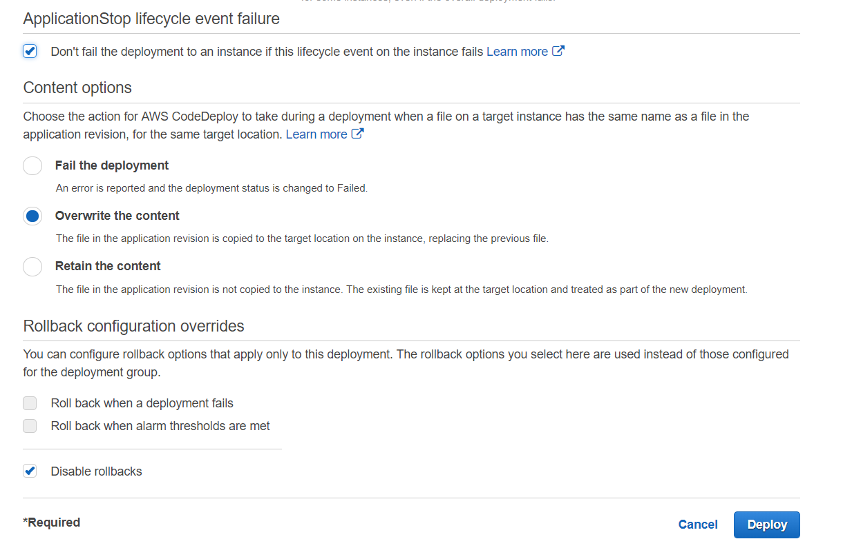
Select “Overwrite the content” if content found in the EC2 instance.
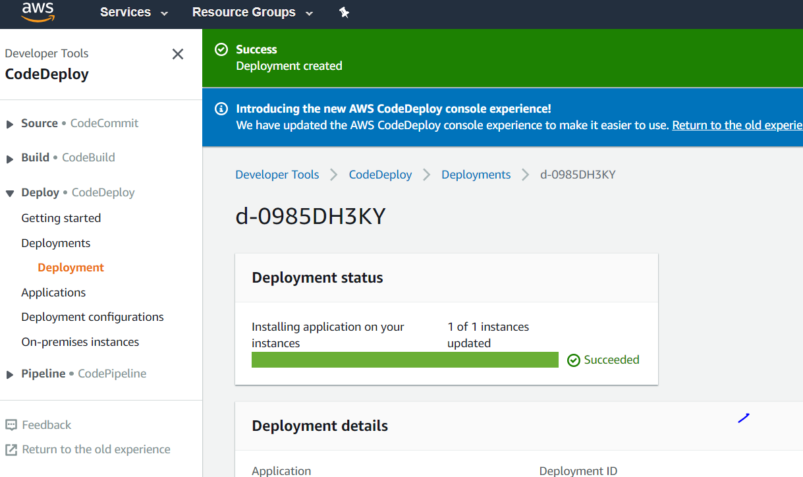
The Above screen would take upto 5 min as there are 2 instance in this example.

Step 7: Update the Deploy with new content Download the Zip file on your laptop, uncompress it to a folder.
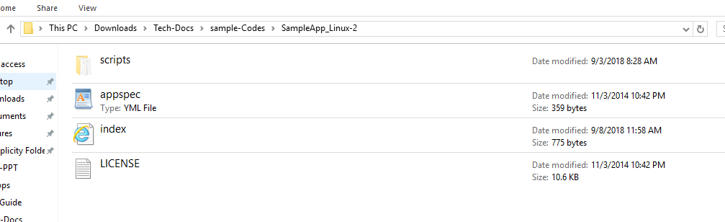
Remove the “Scripts” folder.
Edit the appspec file as below. Remove all other lines.
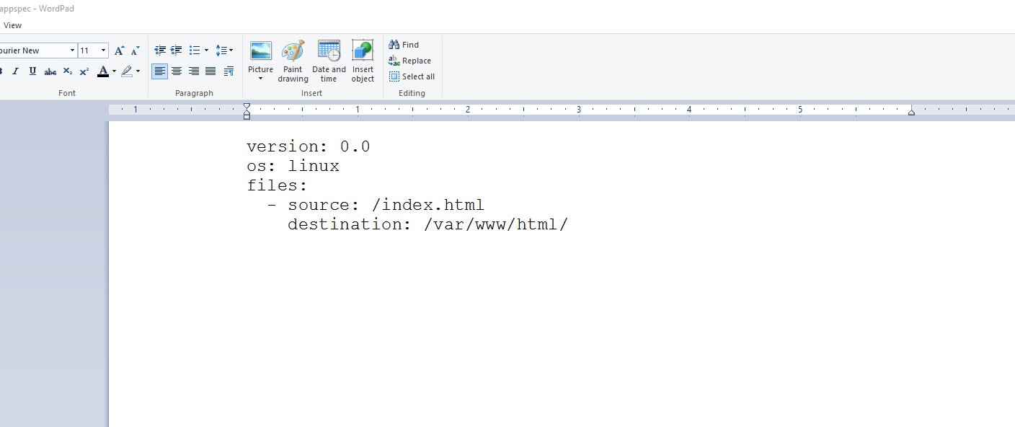

Now edit the “index.html” file. And add some content as below. And save it.
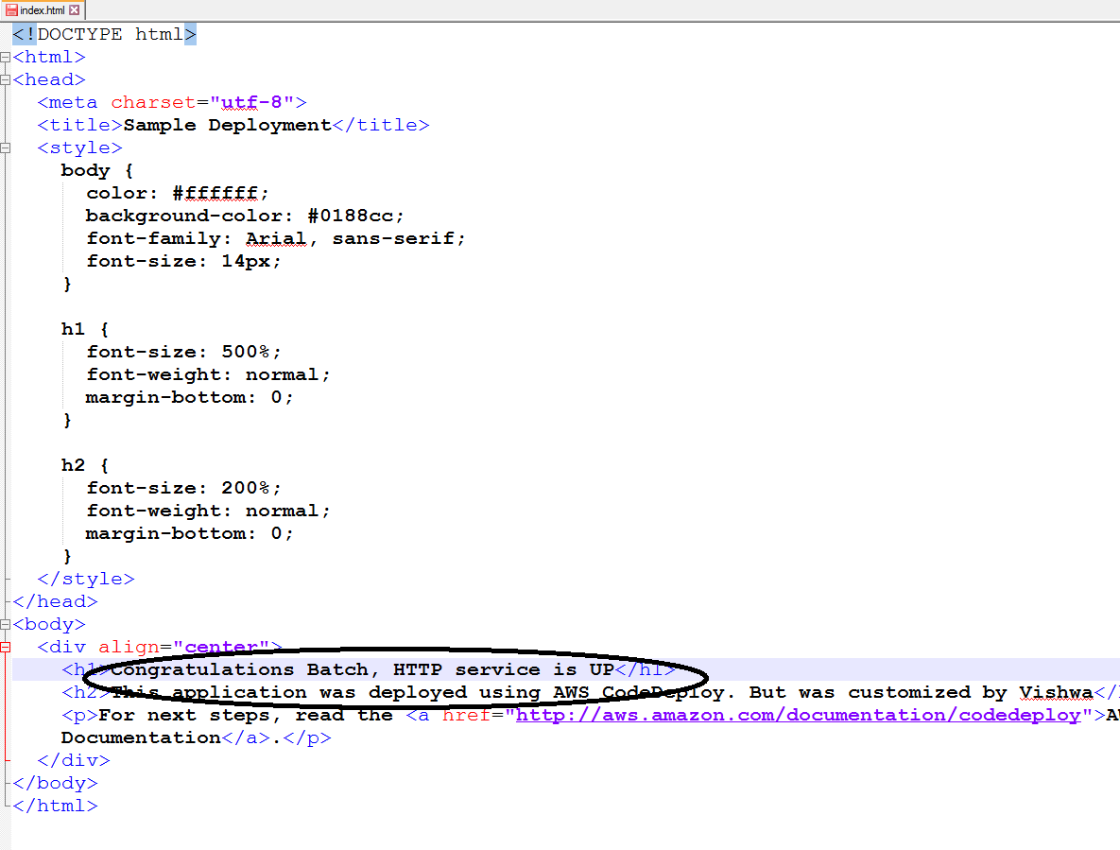

Now zip the file as shown. Select only the FILES and zip and NOT the folder itself, as CODEDEPLOY would be looking for “appsepc” file in the zip parent folder.

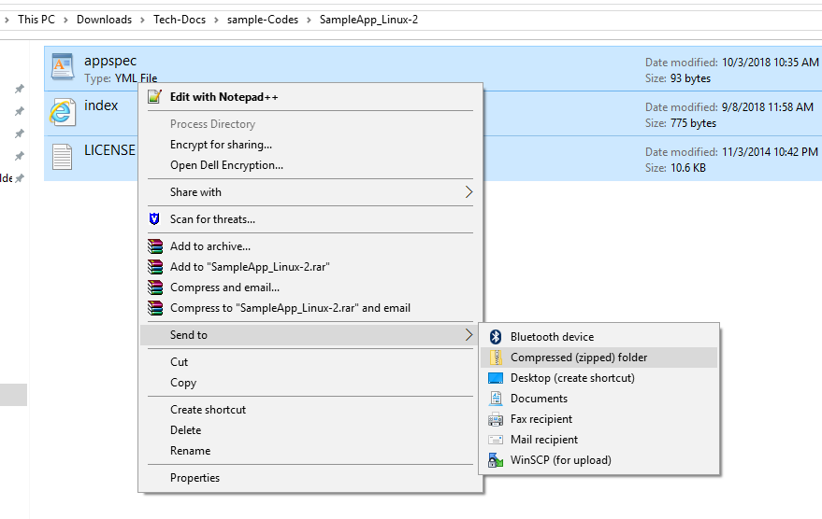
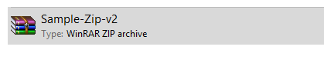
Now upload this Sample-zip-v2 to S3, and make it public.
Update the same Deployment Group with “new Revision” with new S3 link.

