Use Case: Configure Amazon CloudWatch to send a notification when CPU Utilization of an instance is lower than 15%.
Lets go through various steps involved.

Step 1 : Creating a CPU utilization metric
- Go to Amazon CloudWatch Management Console and select metrics from the navigation pane.
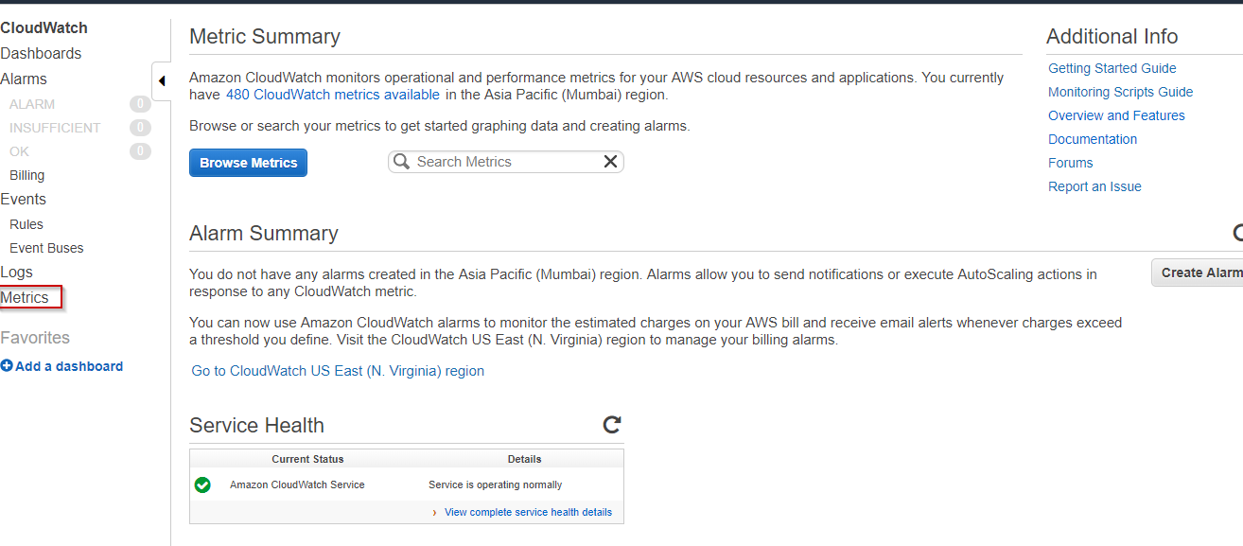
- On the metrics page type CPU Utilization in the search bar.
- From the displayed list of instances choose the instance for which you want to create a metric.
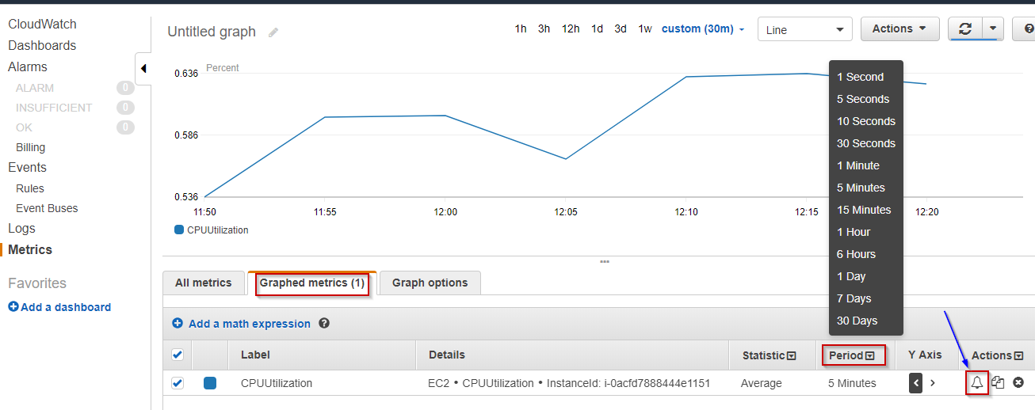

Step 2 : Creating an alarm to notify when CPU Utilization metric of the instance is lower than 15%
- Now select the Graphed Metrics option on the same page. Then set the time period according to your need. And choose an alarm icon located beside the selected instance.
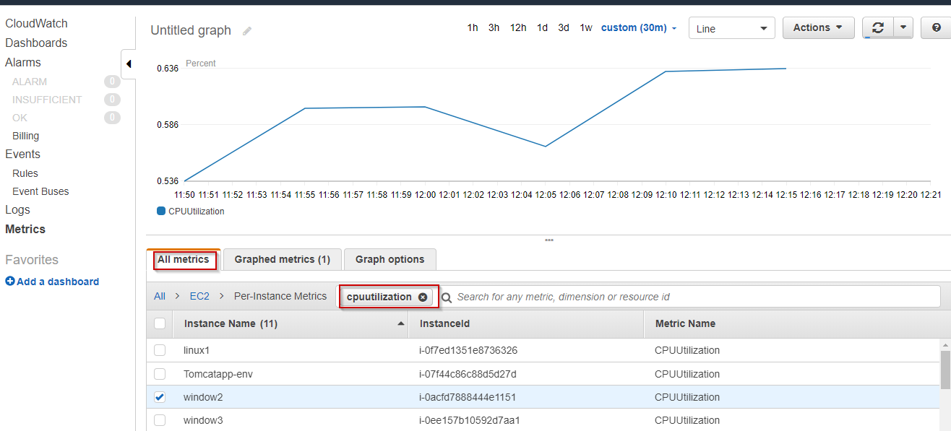
- Configure the alarm in the displayed dialog box. Give your alarm a name and description. Set the Threshold condition.
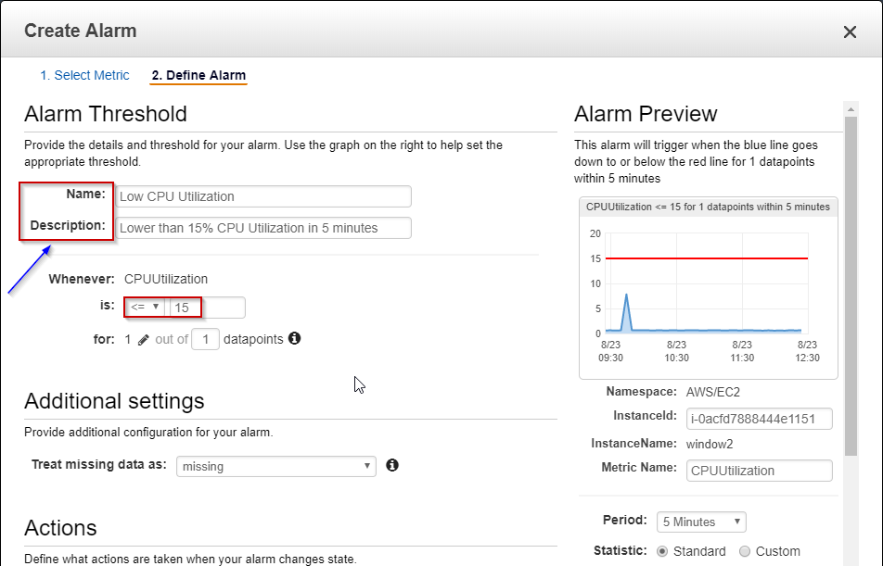
You want AWS to send you an email notification whenever the alarm condition is satisfied. The notification is sent through Amazon SNS Topic.
- Select New List option if want to add new email recipient, or If you want to choose the existing one, choose Enter List and enter the name of SNS topic.
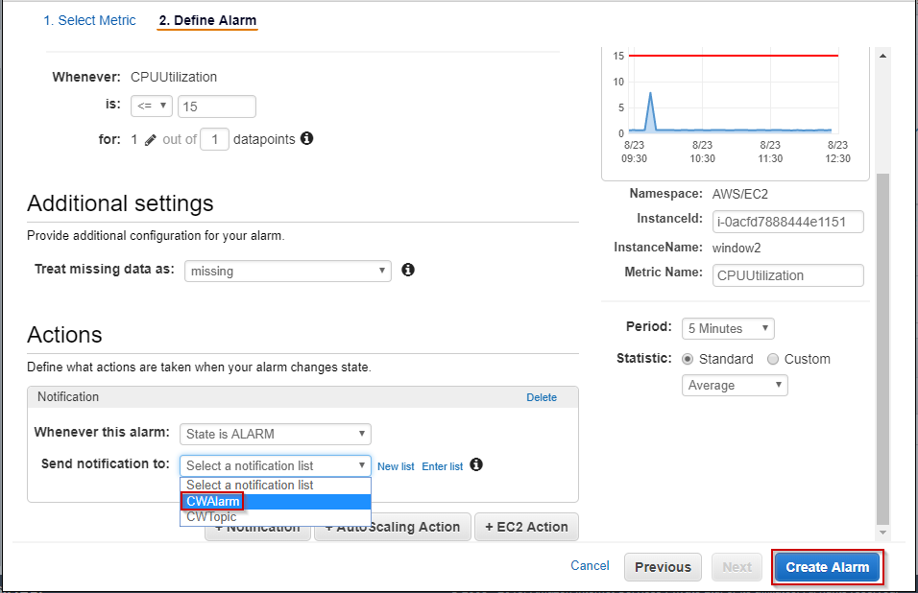
- Click Create Alarm.

