Lab manual – AutoScalling
- This Lab Manual would cover the topics of AutoScalling.
- It can Scale out and scale in of virtual machine (EC2 instances).
- Amazon EC2 Auto S calling helps you ensure that you have the correct number of amazon EC2 instances available to handle the load for your app’n.
- You create collection of EC2 instances called AutoS calling.

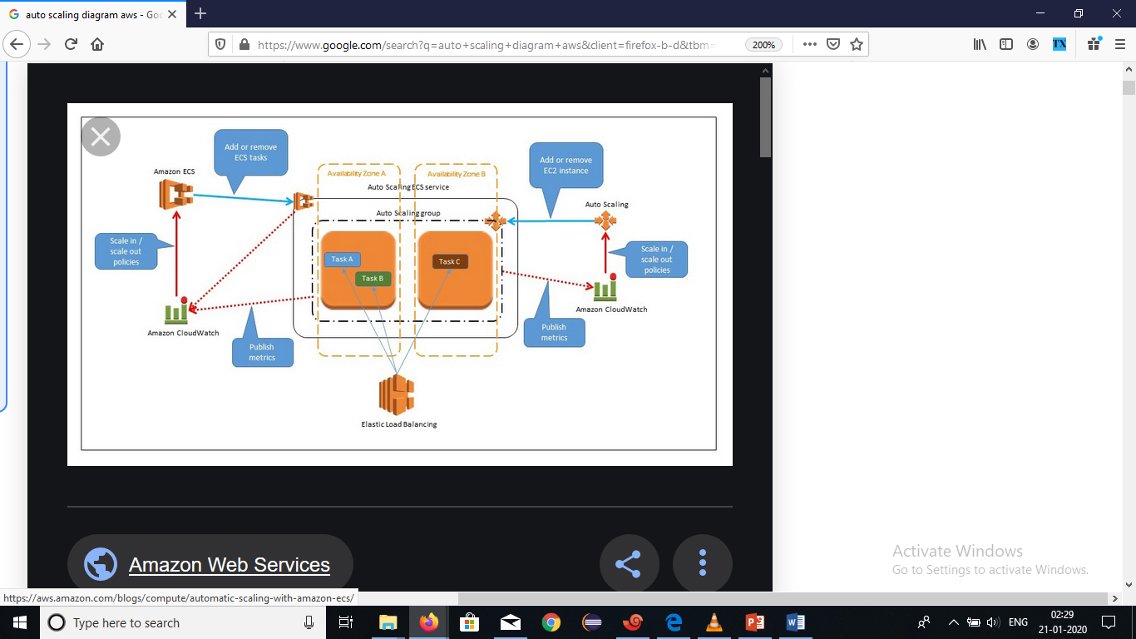

Objectives:
- Create a launch configuration.
- Create a load balancer.
- Create an Auto Scaling group.
- Define Auto Scaling policies.

Step1: Create a launch configuration
- Click on create launch configuration
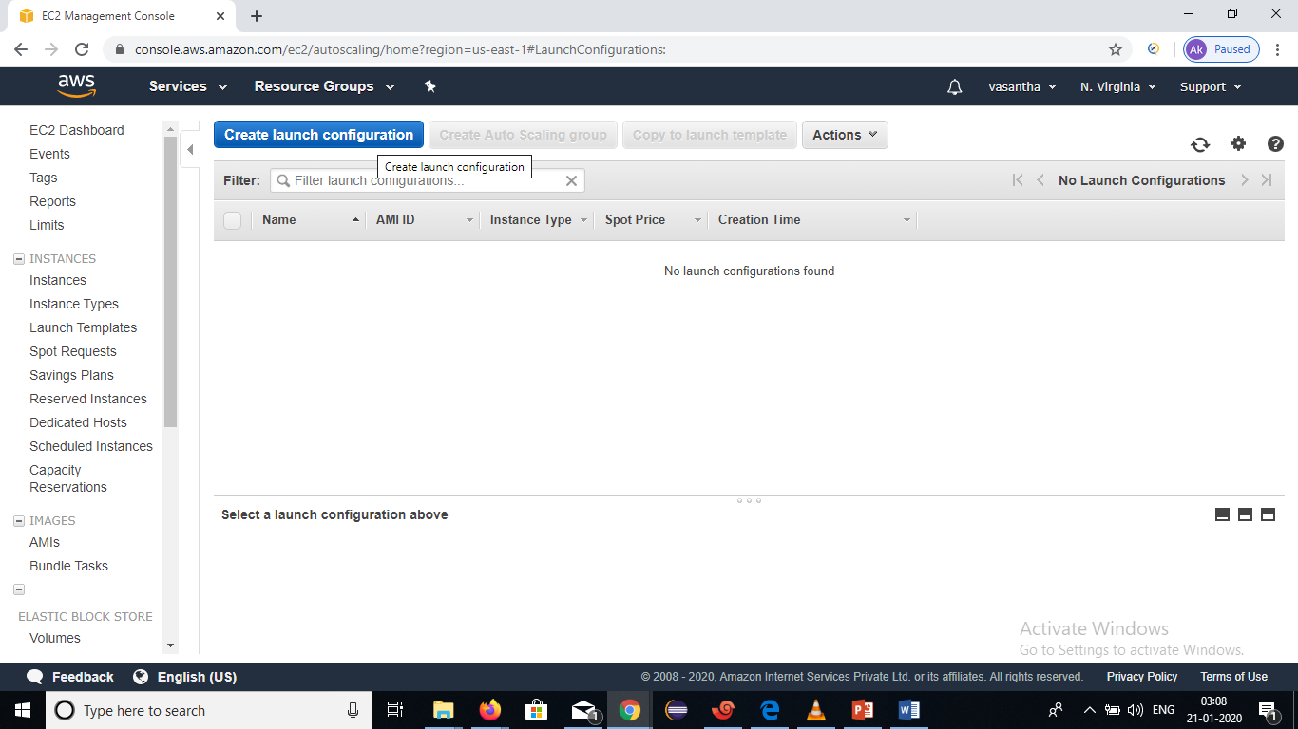

- Click on myAMI’S

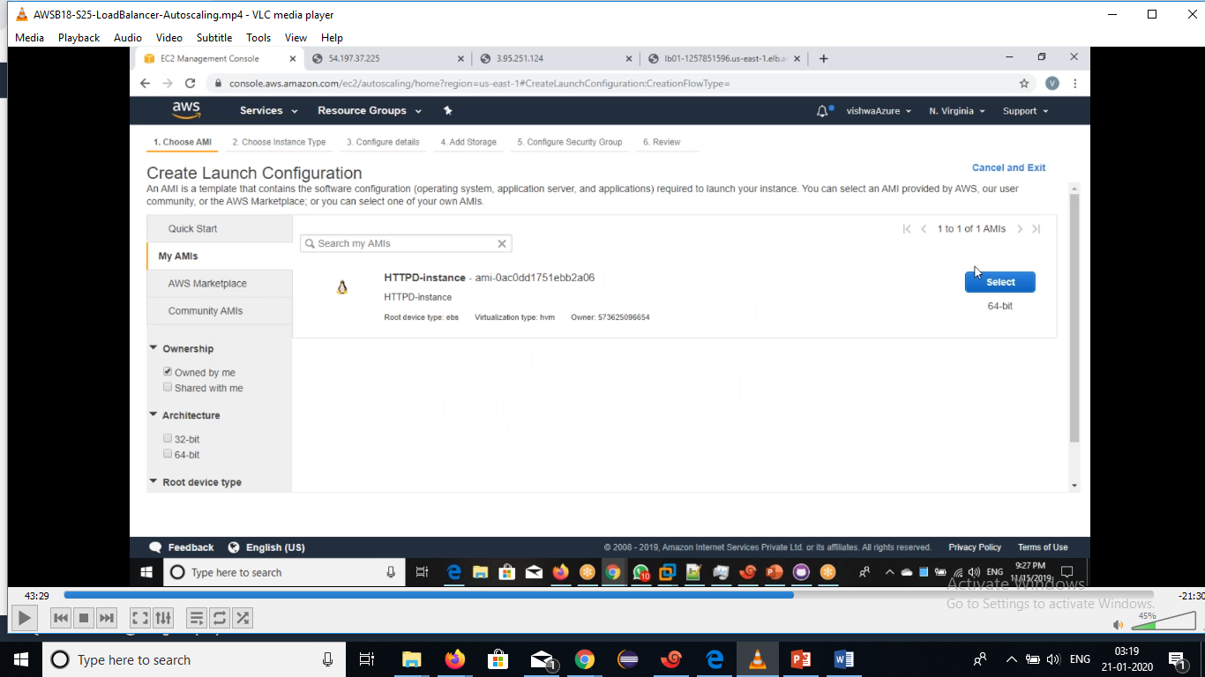
Click on Instance type:

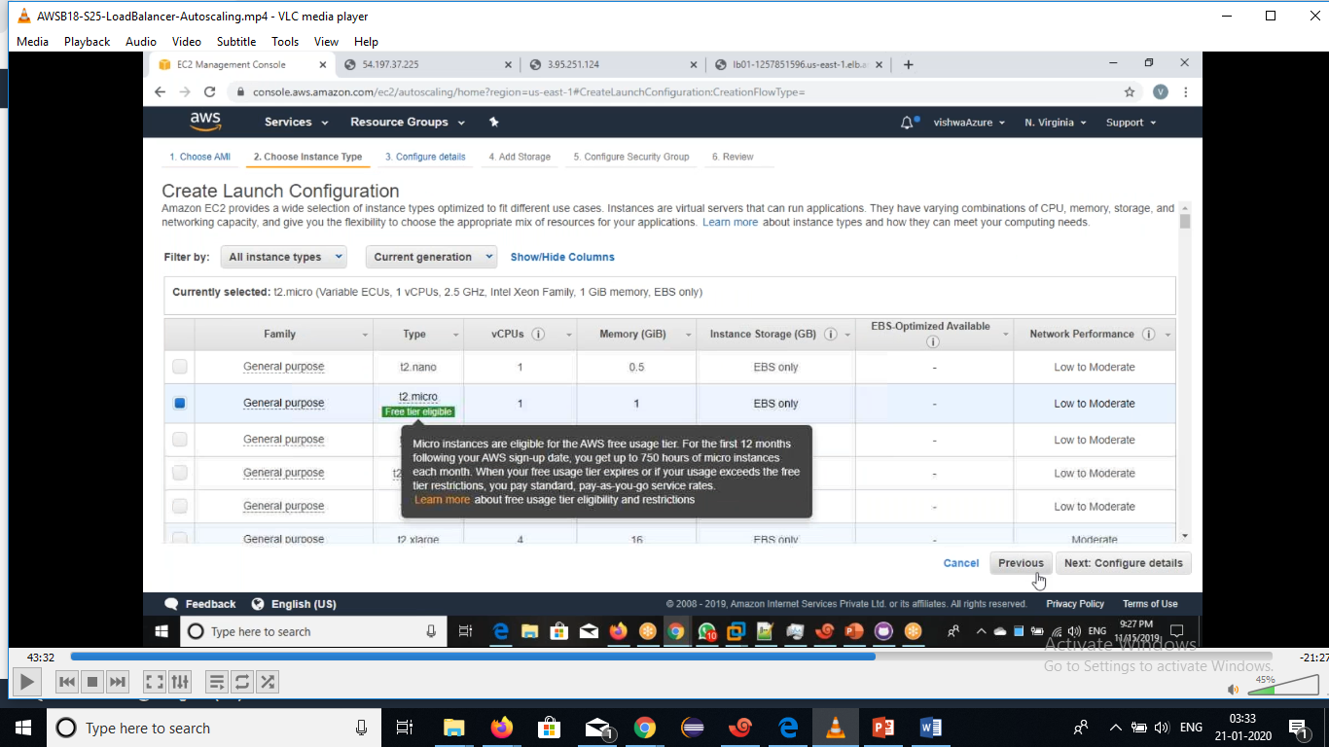

- Click on Next:configure details.
- Give a name and IAM role of create launch configuration.

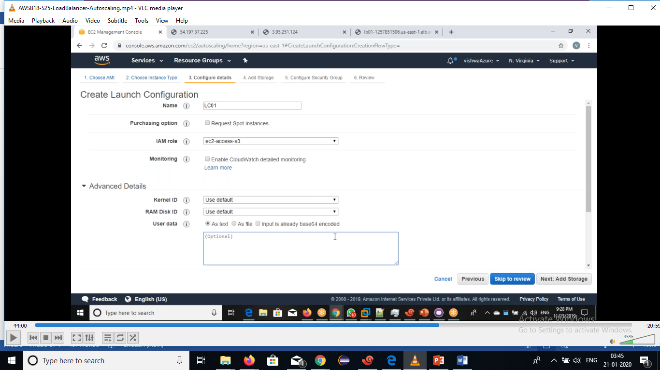

- Click on Next:Add storage.

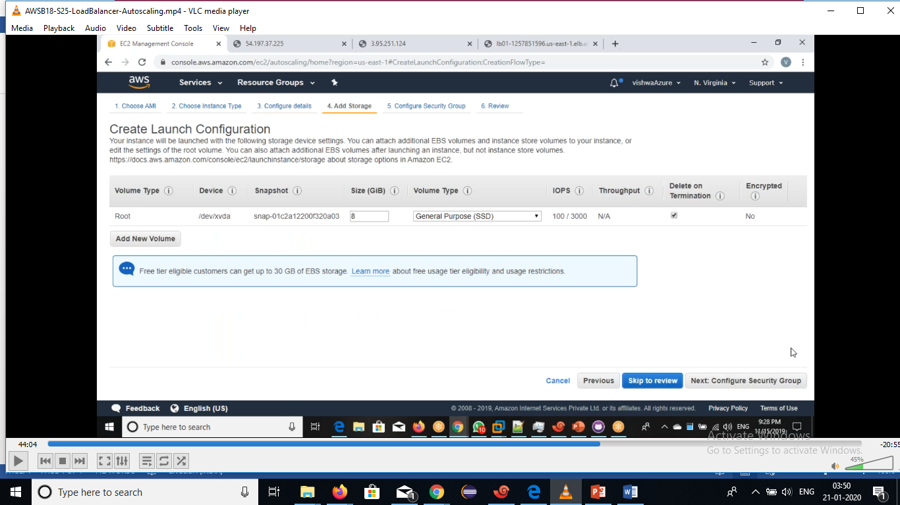

- click on Next:configure security group.

- Give a standard security group

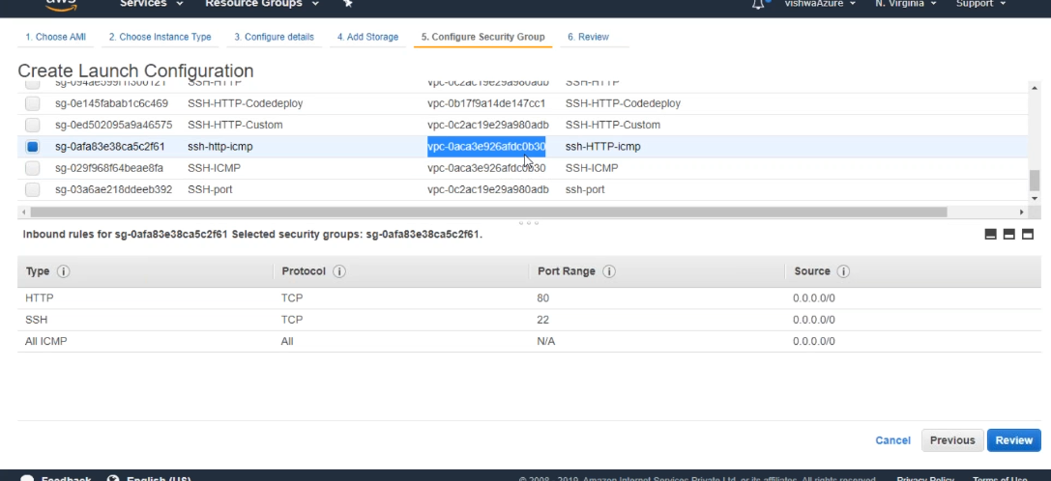

- Click on Review.

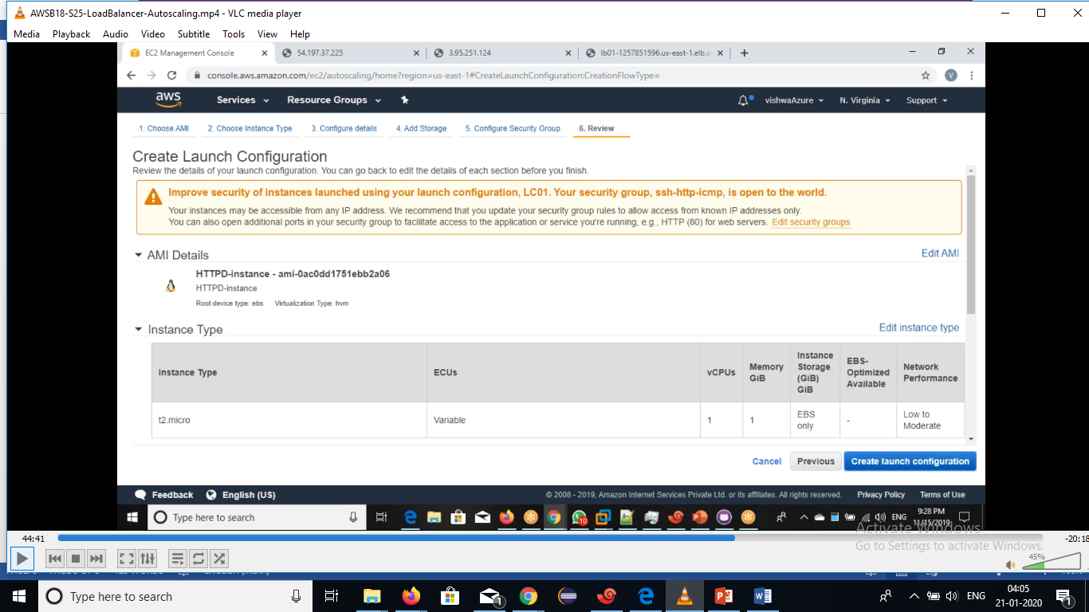

- Click on CreateLaunch configuration.

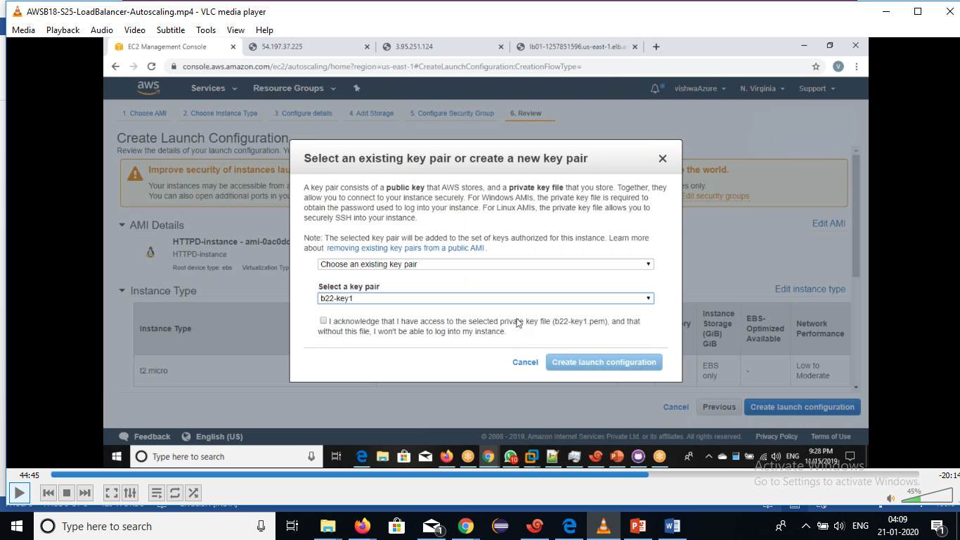

- Select an existing key-pair or create a new key pair.
- Click on create launch configuration.

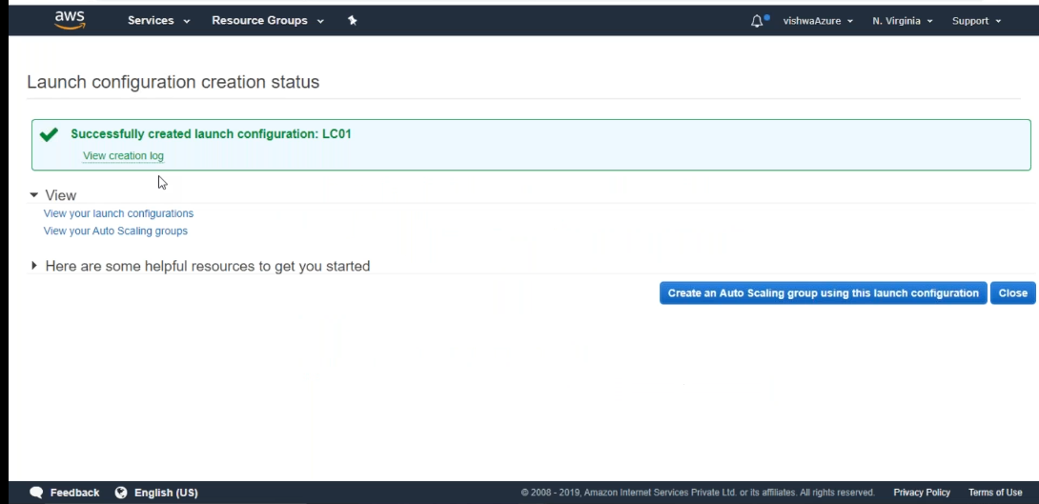

- Click on close.

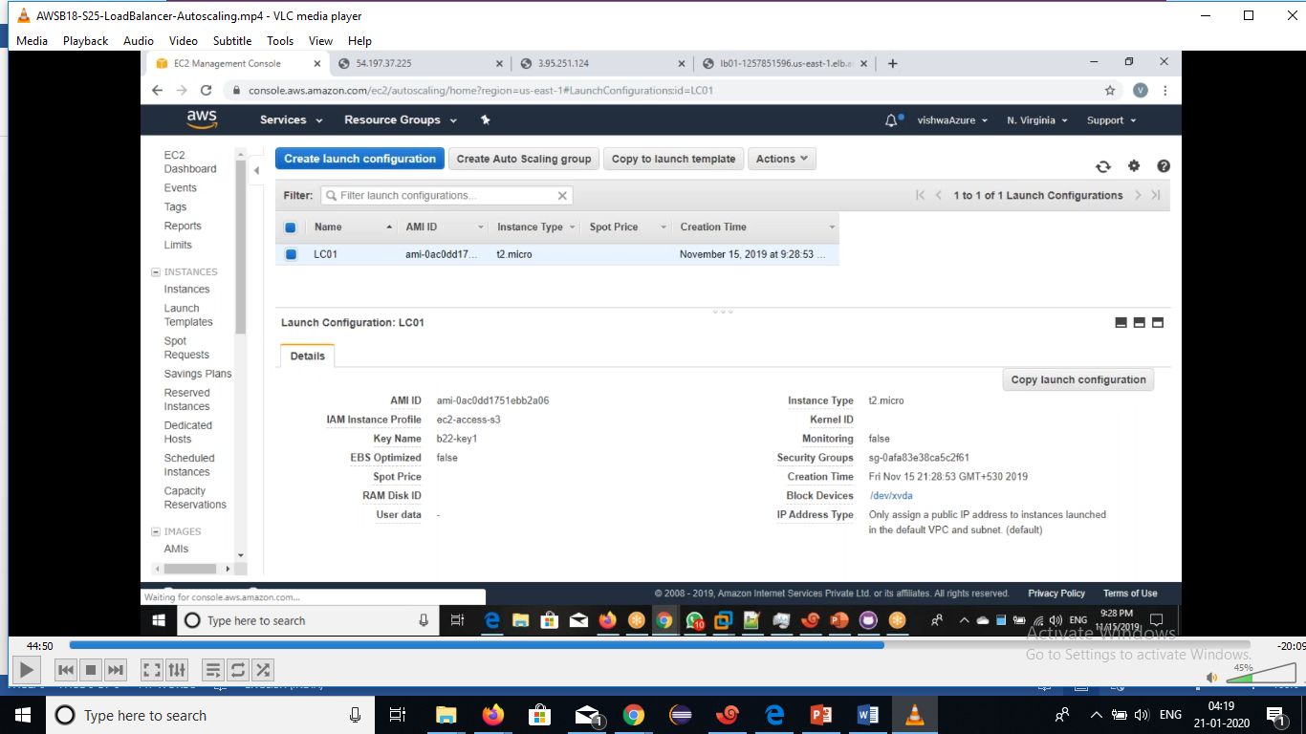
Step2:create a AutoScalling group.
- An Auto Scaling group contains a collection of Amazon EC2 instances that are treated as a logical grouping for the purposes of automatic scaling and management.
- An Auto Scaling group also enables you to use Amazon EC2 Auto Scaling features such as health check replacements and scaling policies.

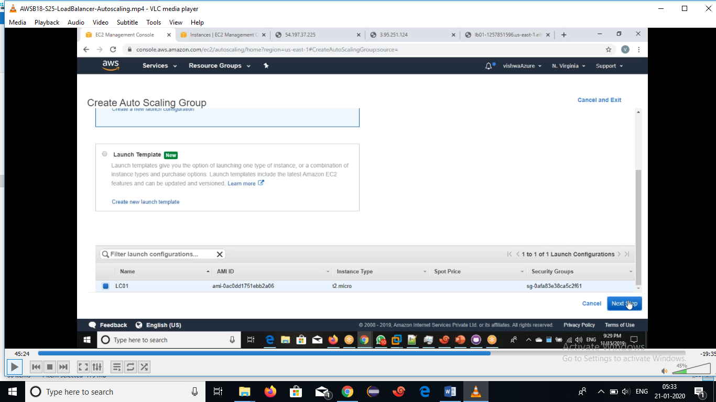
- Click on launchconfiguration and select LC.
- Click on Next, and it will show configure autoScalling group details.
- Enter the group name,size and select a correct vpc &subnets.

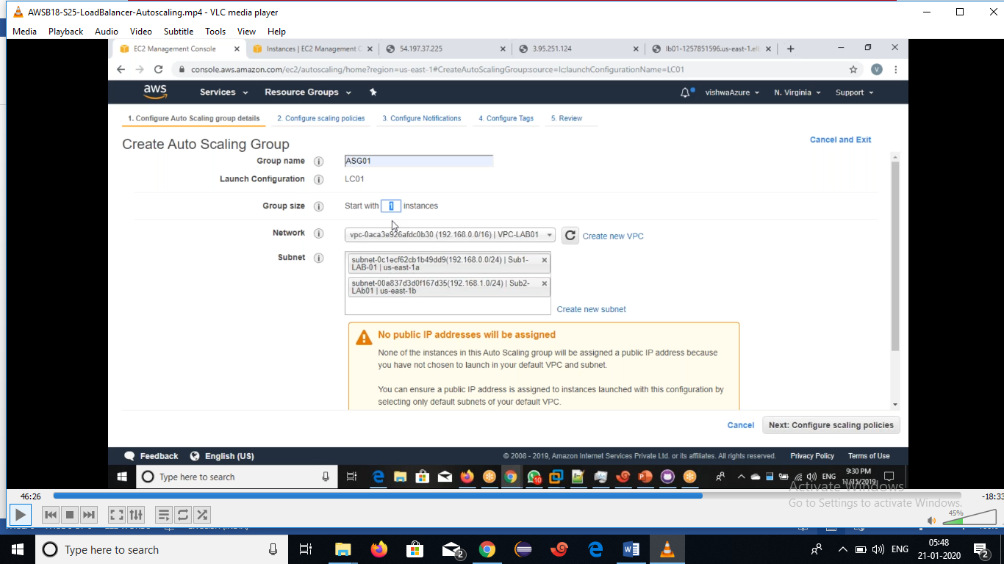
- Click on next

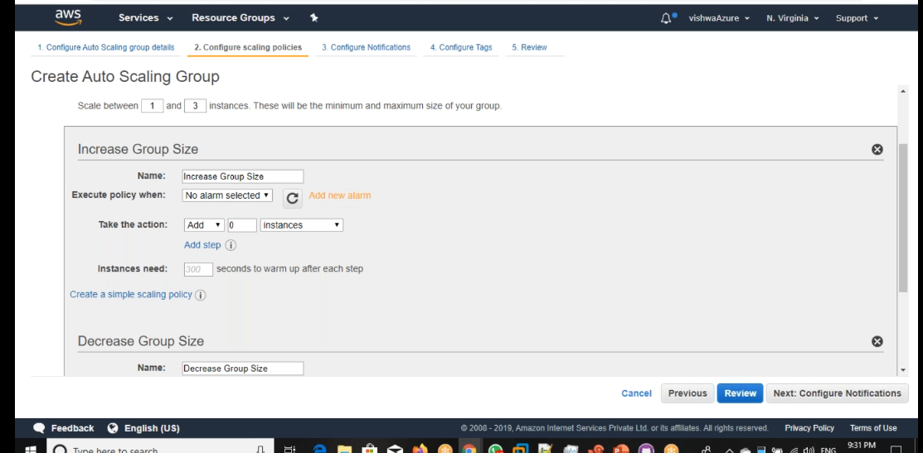
- Set an increase and decrease group size .
- Set an Alarms.
- Scale between1 &3 instances.These will be the minimum and maximum size of your group.

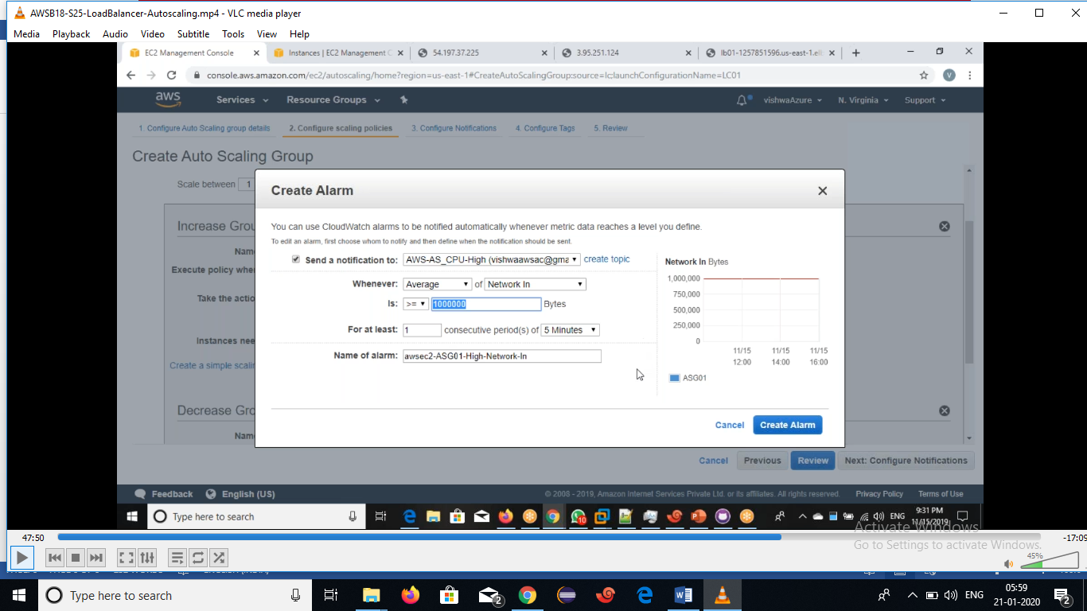

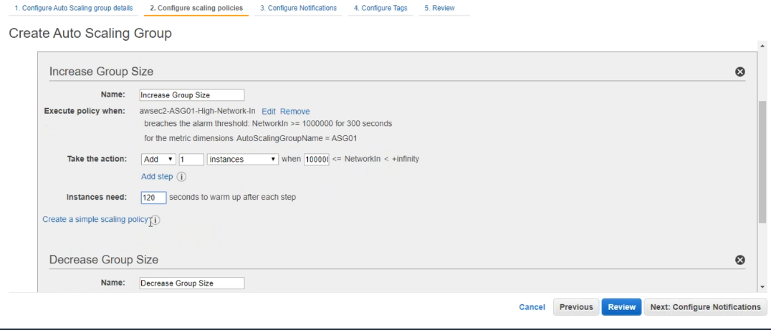
- Click on configure notification.
- Add notification.

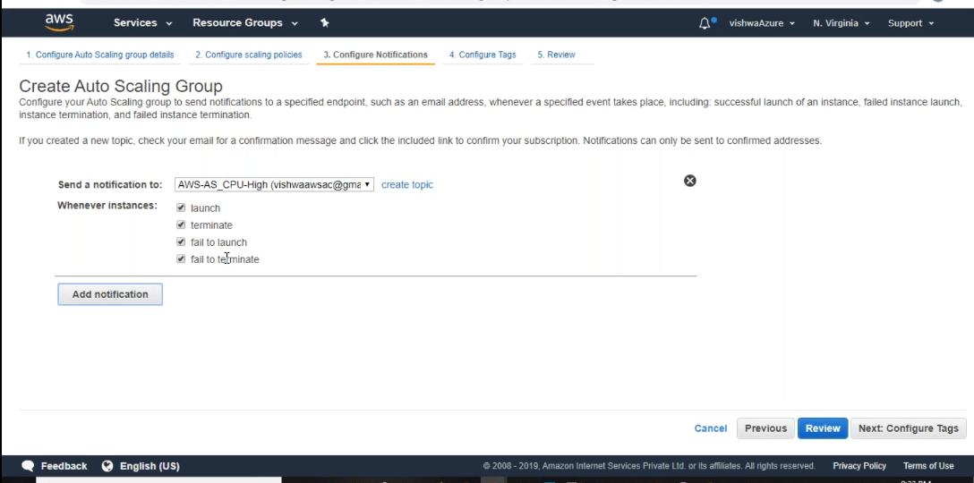

- Click on configure tags.

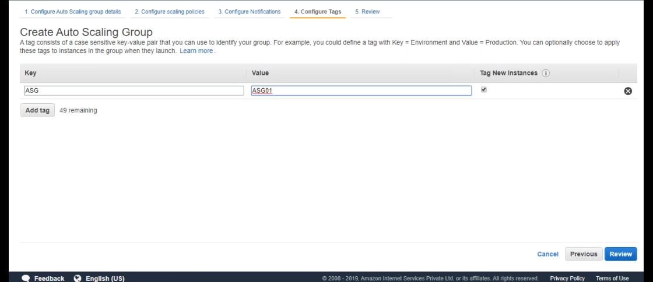
- Click on Review.

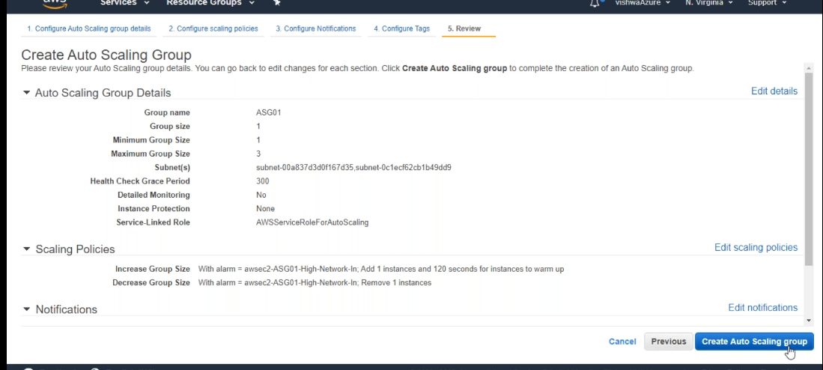

- Click on CreateAutoScalling group.

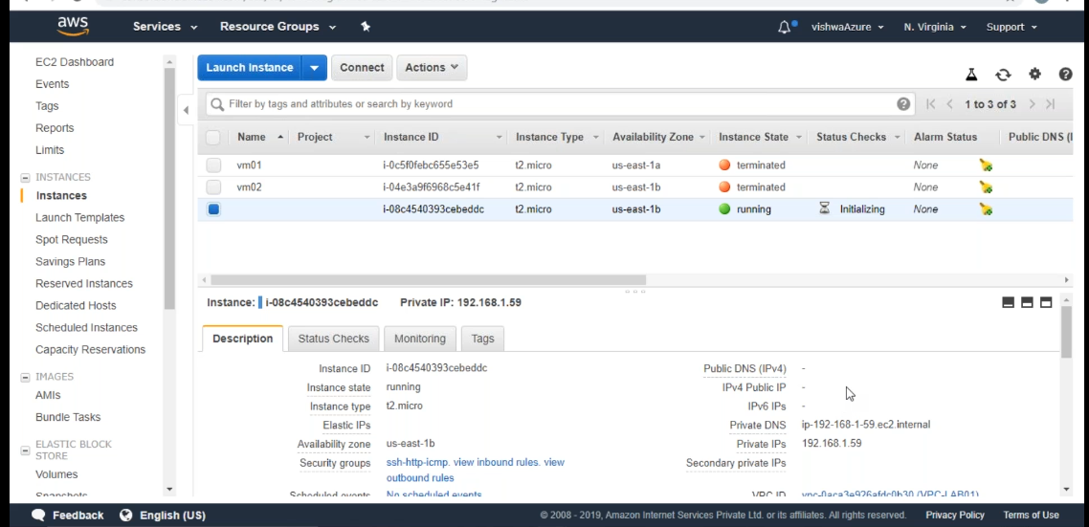

- Edit ASG and click on save.

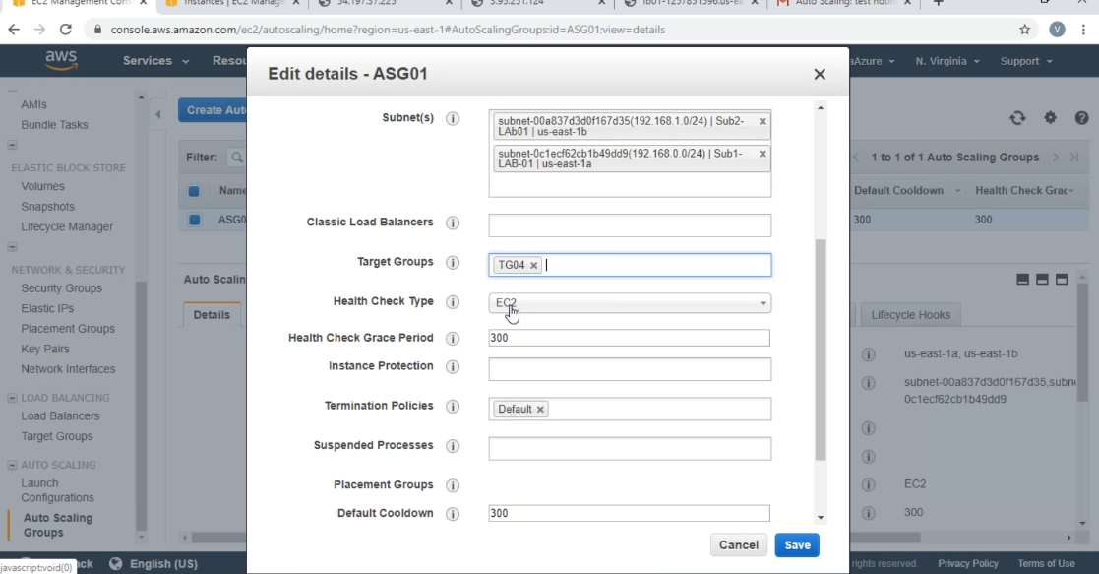

- Select an AutoScalling group & click on TG01 this target is currently passing group’s health check.

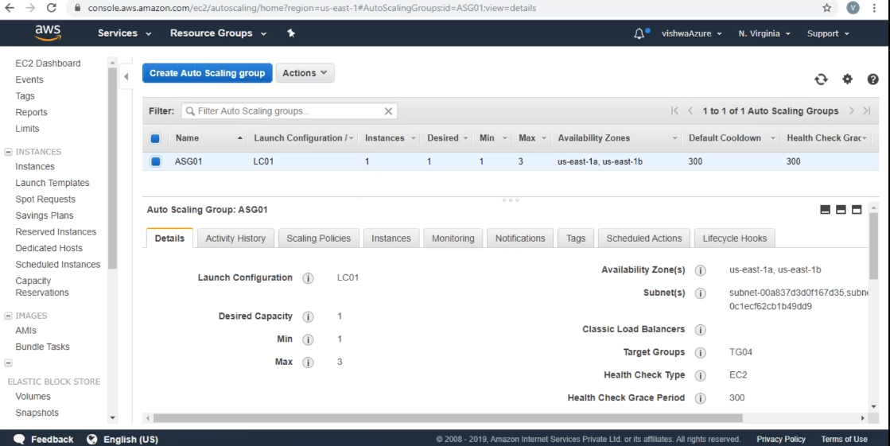

- Observe the output of Autoscalling group.

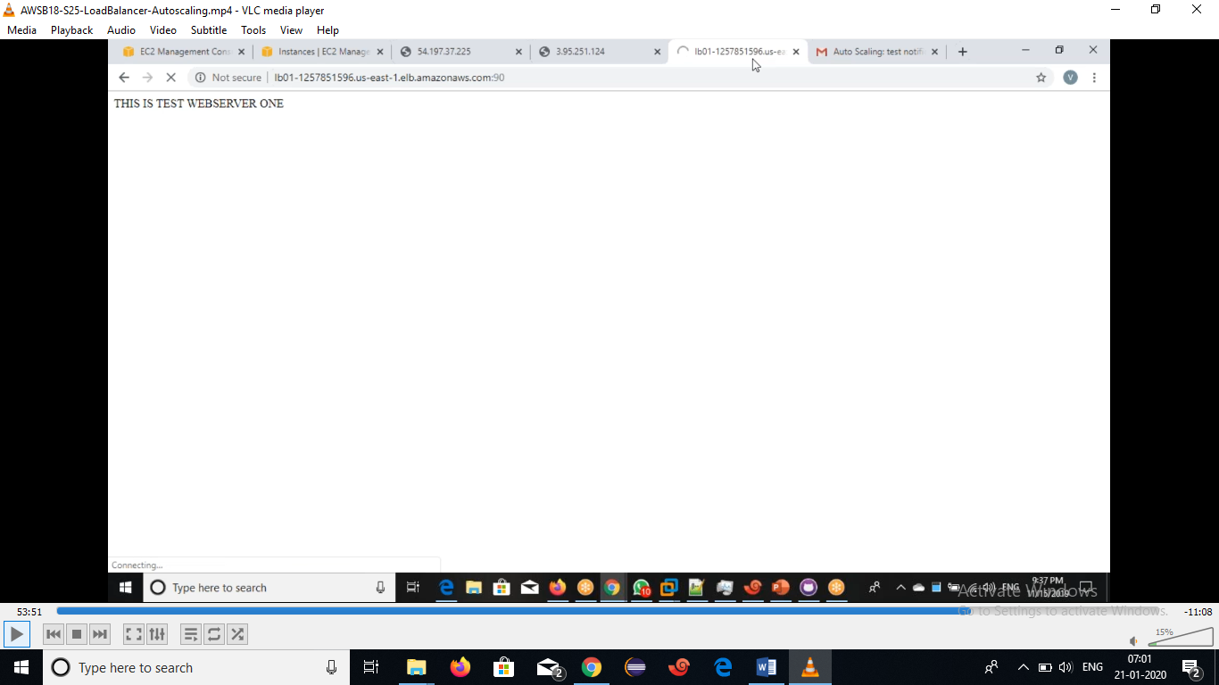

Observe the Launchinstances.

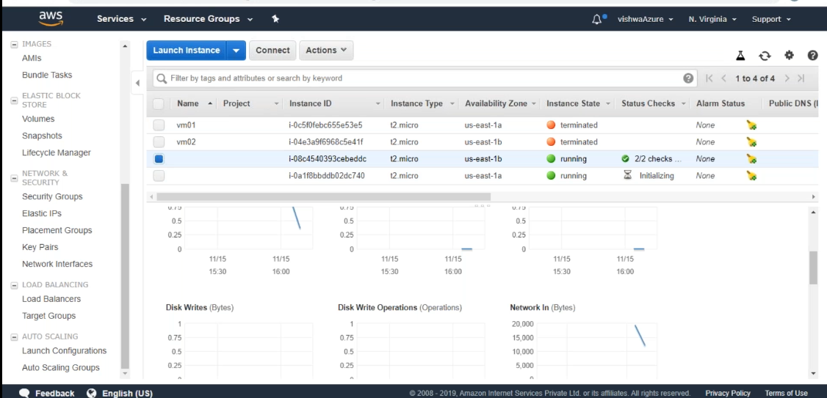

- Check the cloudwatch monitoring details.

