Rafay-Pre-setup

Step 1 — Remove the user from Organization Admins
Go to:
System → Users → <user> → Groups
You will probably see something similar to:

Groups

Organization Admins
All Local Users

Remove the user from:

Organization Admins

Do not remove All Local Users for a normal local user.
The Organization Admins group is what is giving the user the organization-wide access.

Step 2 — Create group

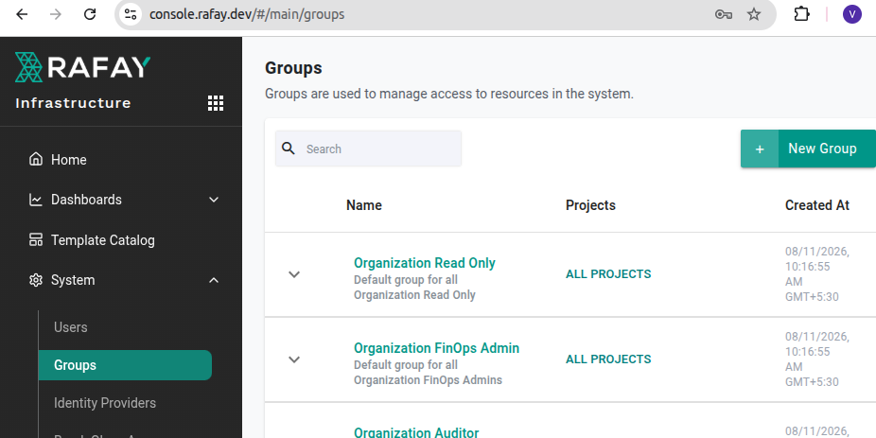
.

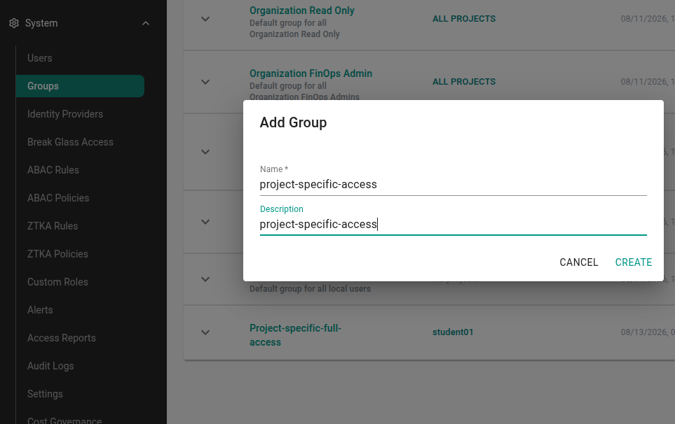
.

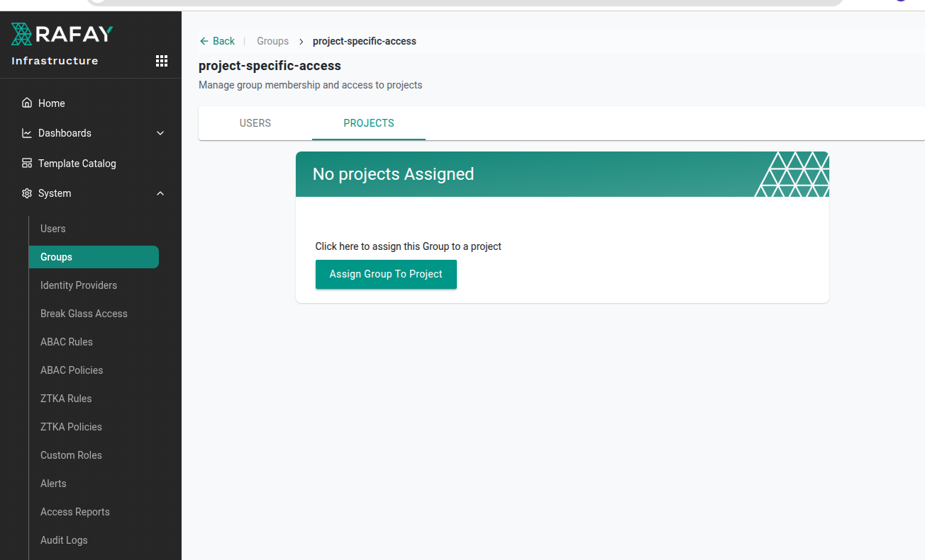
.
Click on “Project tab

then click on “assign group to project”.

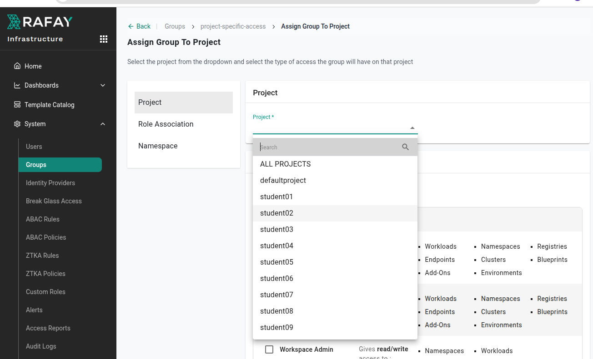
.
Select the project to provide the access

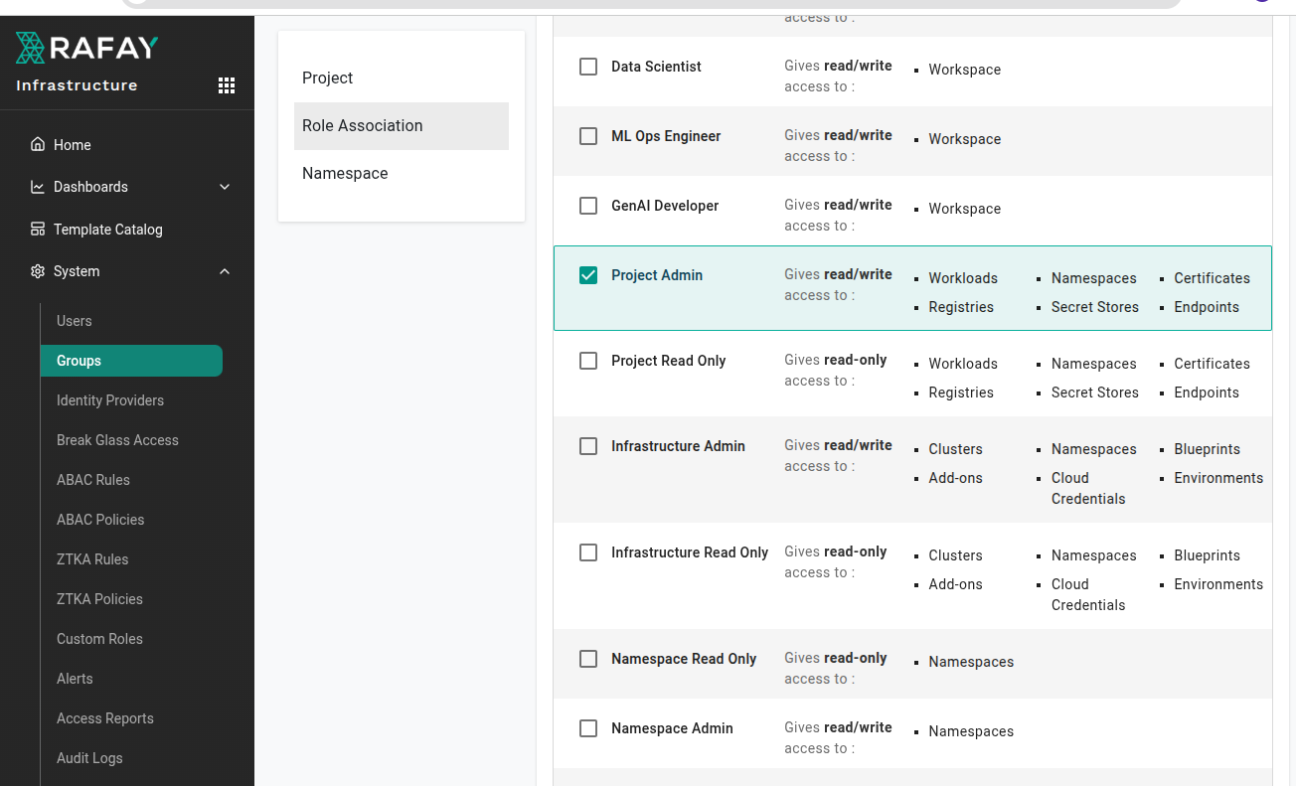
.
Tick mark the “Project Admin”.
Click on “save”

You will back to “Users” page

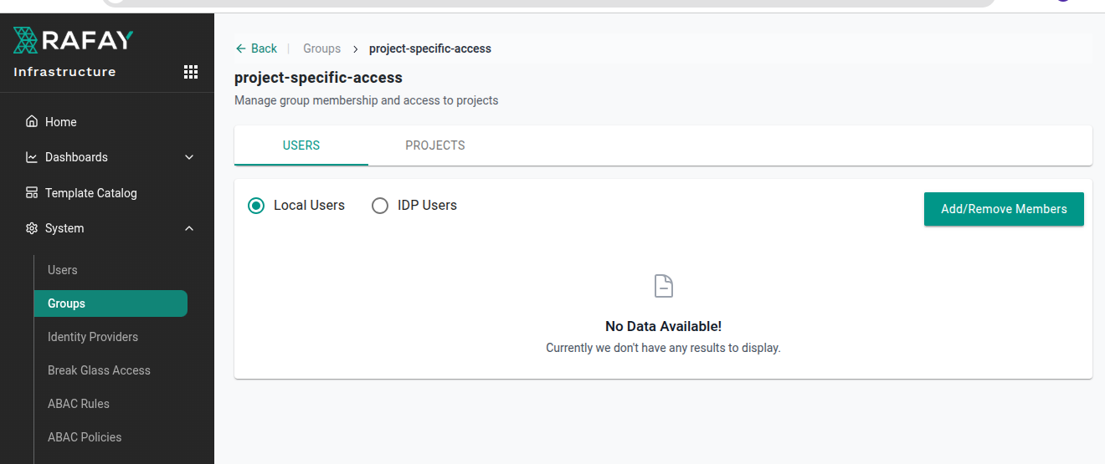
.
Add the user for it

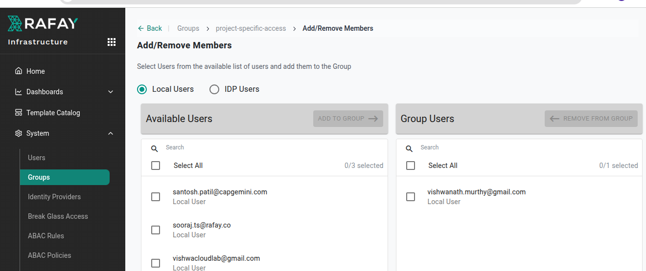
.

Click on “save & exit”
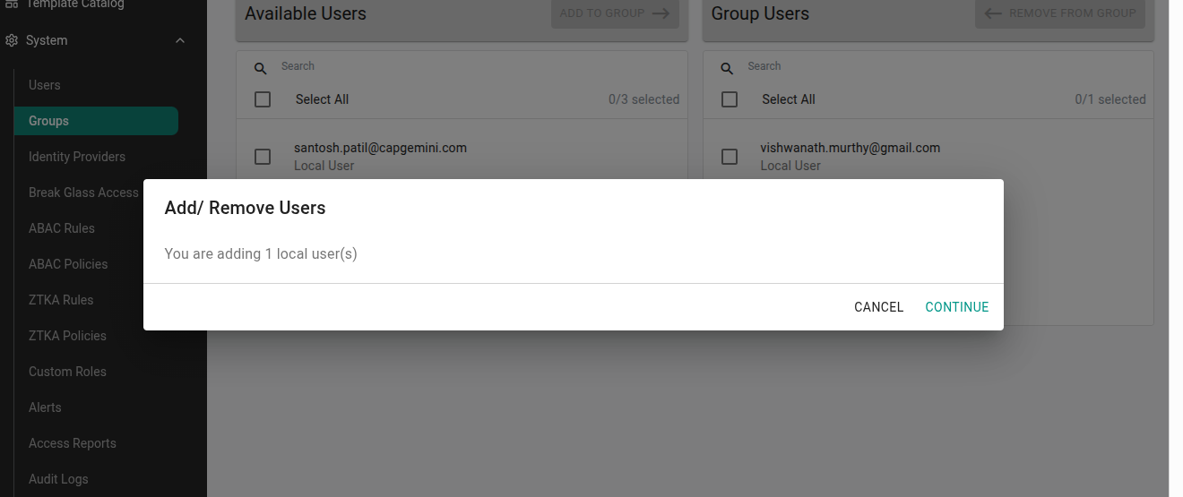
Click on “Continue”.
Now Login as a user

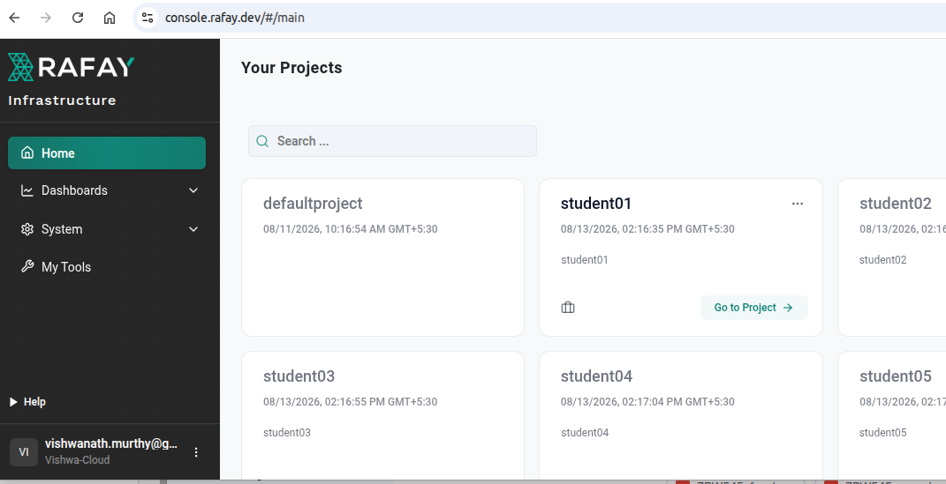
If you see , i could view all the projects , but only project “student01” is accessible for me

