Adding-eksanywhere-rafay

Step 9 — Open Infrastructure → Clusters
In the Rafay console, navigate to:
Infrastructure
|
+-- Clusters
You should see the cluster management page.
Click:
New Cluster
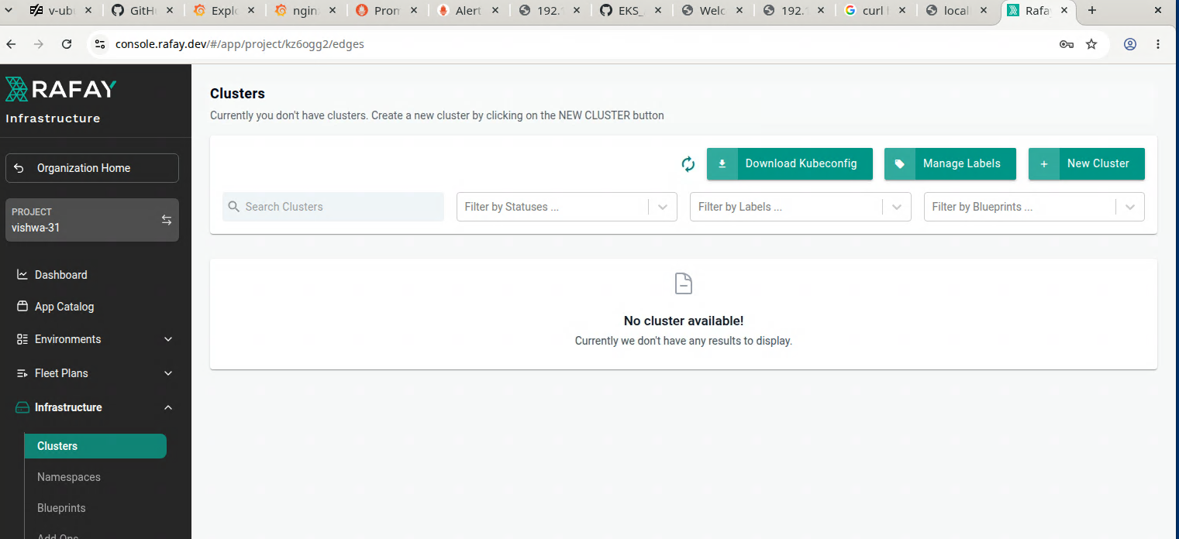

Step 10 — Select Import Existing Kubernetes Cluster
Select:
Import Existing Kubernetes Cluster
Click:
Continue
Rafay's current generic import workflow uses this option for existing/brownfield Kubernetes clusters.

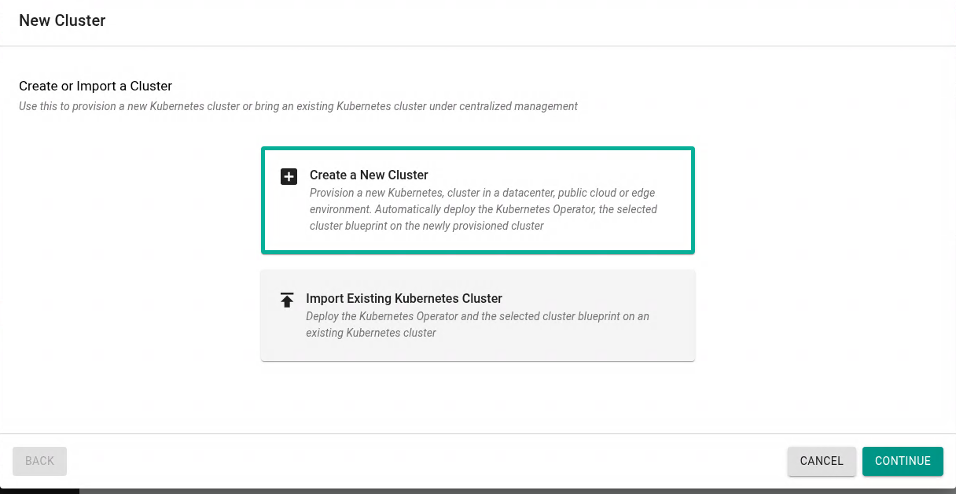
.

Step 11 — Select the Cluster Environment
For the EKS Anywhere cluster running on your private vSphere environment, use the generic imported-cluster workflow.
Select:
Environment / Type:

Datacenter / Edge
For the Kubernetes distribution, select:
Other
This is the current documented Rafay workflow for importing an existing Kubernetes cluster that is not one of the public-cloud managed distributions shown in the wizard.

Important
Do NOT select:
Amazon EKS
Your cluster is:
EKS Anywhere
running on:
VMware vSphere
It is not an AWS-managed EKS cluster.

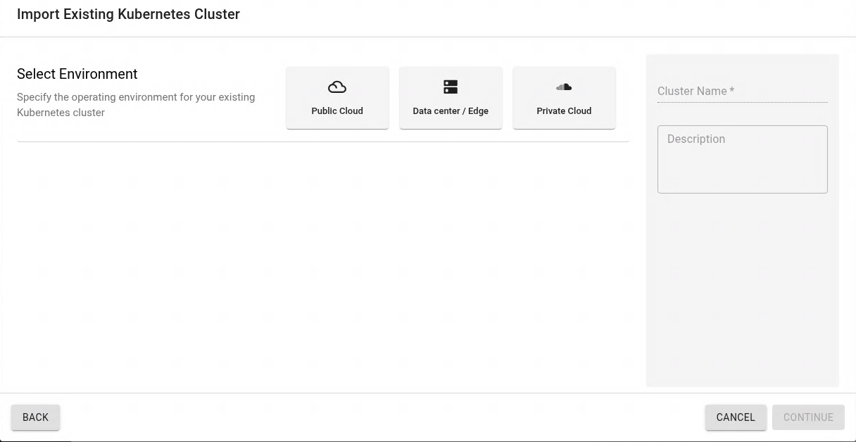
.

Step 12 — Enter Cluster Name
Enter a unique cluster name.
Recommended naming convention:
eksa-student01
For Student 02:
eksa-student02
For Student 03:
eksa-student03
Example:
Cluster Name:
eksa-student01
Use the same name consistently throughout the lab.
Click:
Continue

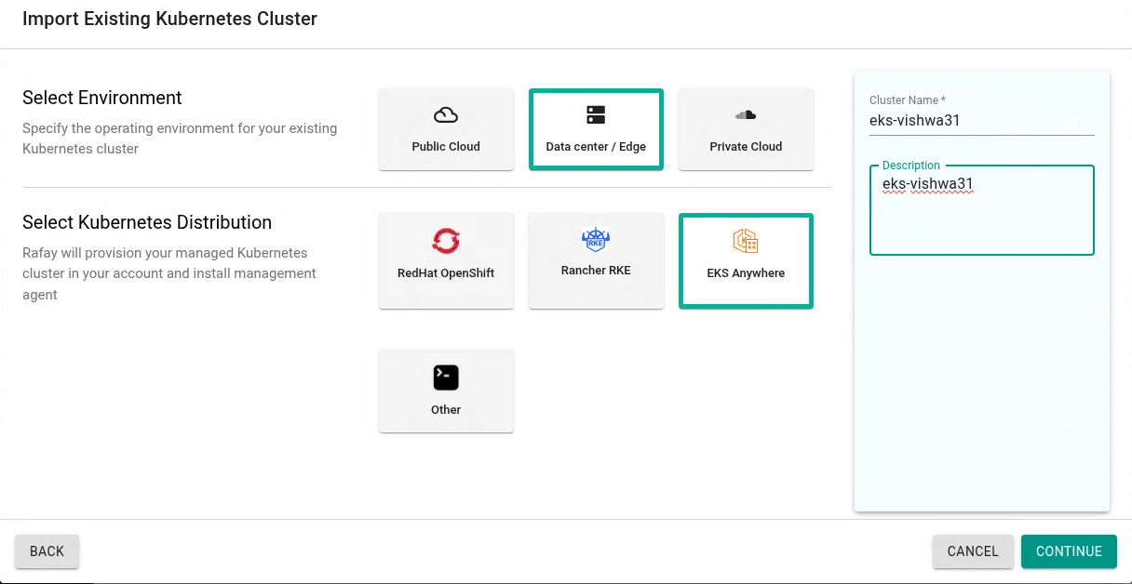

Step 13 — Select the Cluster Blueprint
Rafay will ask you to select a cluster blueprint.
For the initial import, select:
minimal
The current Rafay quick-start documentation recommends the minimal blueprint for the initial imported-cluster workflow. It installs the Kubernetes management components needed for the cluster to register with the controller.
Click:
Continue
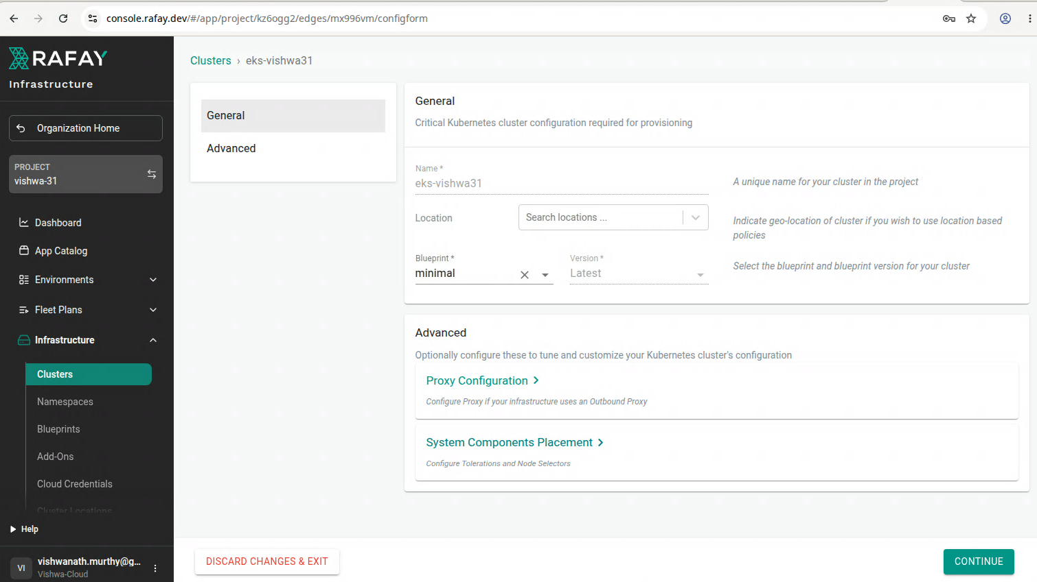
.
No changes,

Click “Confirm”

Step 14 — Download the Bootstrap YAML
Rafay will now generate a cluster-specific bootstrap YAML.
You should see an option similar to:
Download Bootstrap YAML
Click:
Download Bootstrap YAML
Save the file.
Example:
eksa-student01-bootstrap.yaml

VERY IMPORTANT
Do not rename it to another student's cluster.
Do not share it with another student.
Do not reuse it.
The bootstrap file is unique to the cluster registration.
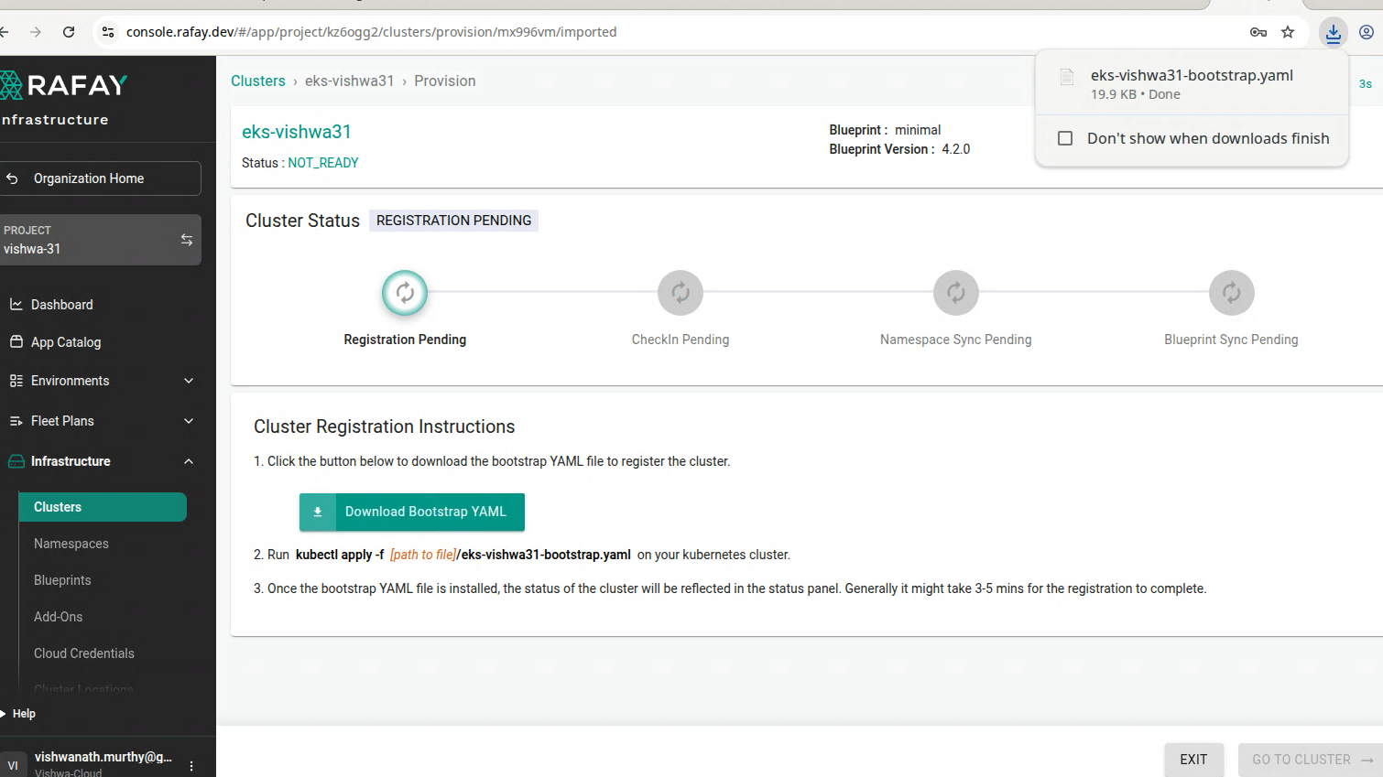

Step 15 — Copy Bootstrap YAML to the Lab VM
Move the downloaded file to the machine where you have access to the EKS Anywhere cluster.
Example:
/home/student/rafay/
Verify:
ls -l
You should see:
eksa-student01-bootstrap.yaml

21. Step 16 — Verify Kubernetes Context
Before applying the bootstrap file, make absolutely sure you are connected to the correct EKS Anywhere cluster.
Run:
kubectl config current-context
Then:
kubectl get nodes -o wide
Confirm:
You are connected to YOUR EKS Anywhere cluster.

WARNING
Do not run the bootstrap command until you have verified the Kubernetes context.
You are about to install Rafay management components into the cluster.

22. Step 17 — Apply the Rafay Bootstrap
Run:
kubectl apply -f eksa-student01-bootstrap.yaml
Replace the filename with the actual filename downloaded from Rafay.
You should see Kubernetes resources being created.
Examples may include:
namespace/rafay-system created
serviceaccount/... created
clusterrole/... created
clusterrolebinding/... created
deployment/... created
configmap/... created
The exact resource names may vary with the current Rafay release.
Rafay's documented import process uses kubectl apply against the generated bootstrap YAML.

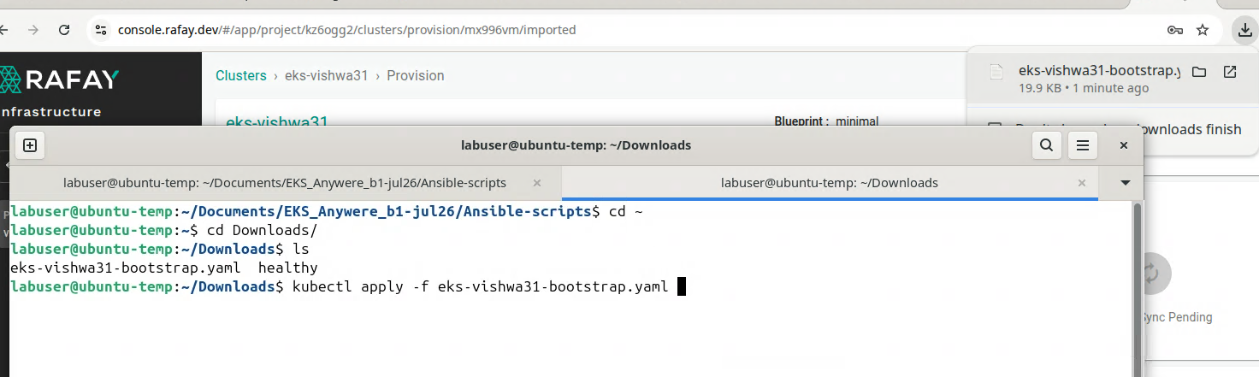
.

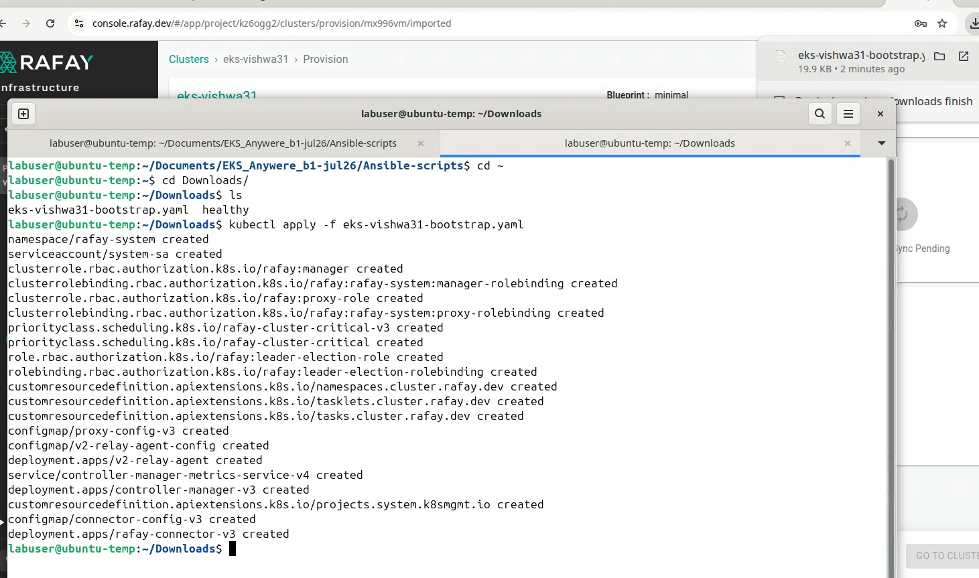
.

Step 18 — Verify rafay-system Namespace
Run:
kubectl get namespace rafay-system
Expected:
NAME STATUS AGE
rafay-system Active ...
If the namespace exists, the bootstrap process has started.

.

Step 19 — Check Rafay Pods
Run:
kubectl get pods -n rafay-system
Initially, some pods may be:
Pending
ContainerCreating
Wait for the components to start.
Run:
kubectl get pods -n rafay-system -w
Wait until the important Rafay components become:
Running
A current example from Rafay documentation includes components such as:
controller-manager-v3-xxxxx
rafay-connector-v3-xxxxx
edge-client-xxxxx
relay-agent-xxxxx
with the pods showing Ready/Running states.
Press:
Ctrl+C
to stop watching.
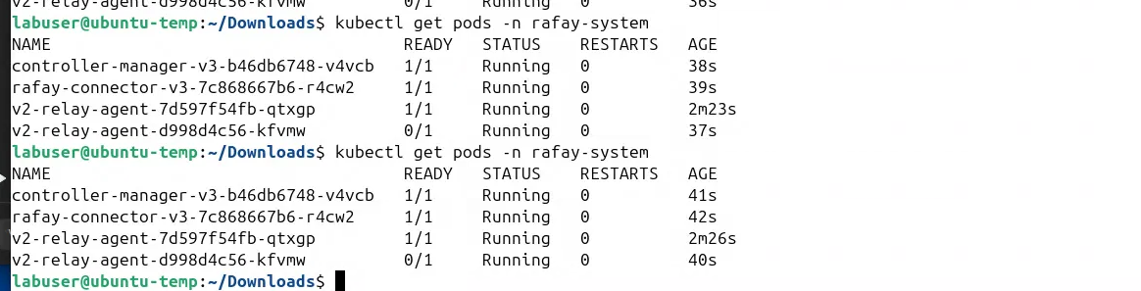
.

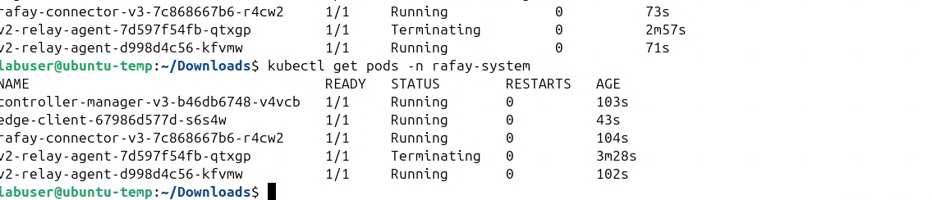
.
Everything is up

Check the logs
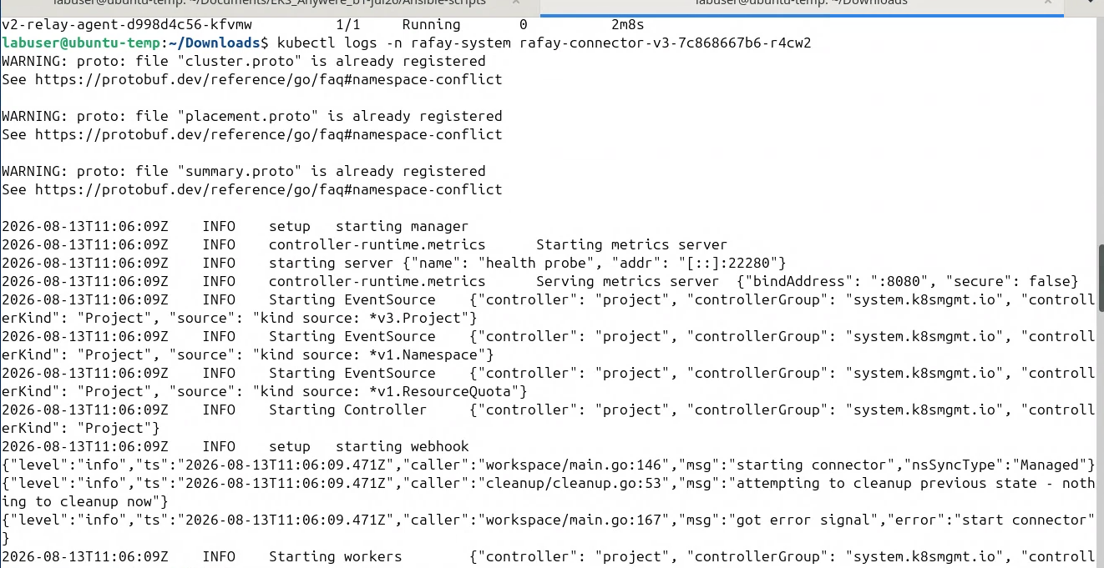
.

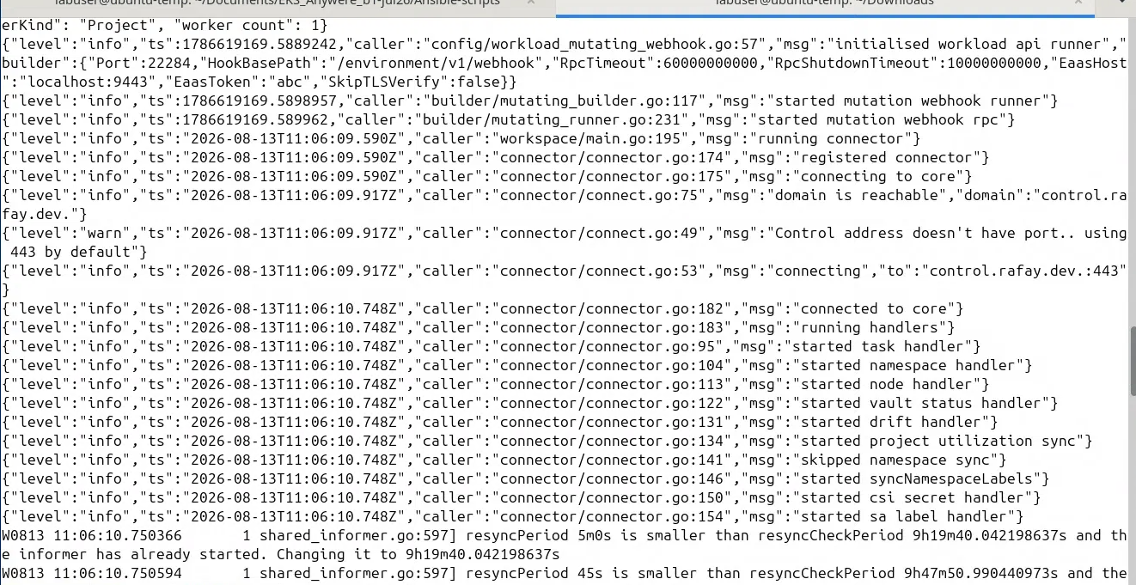
.
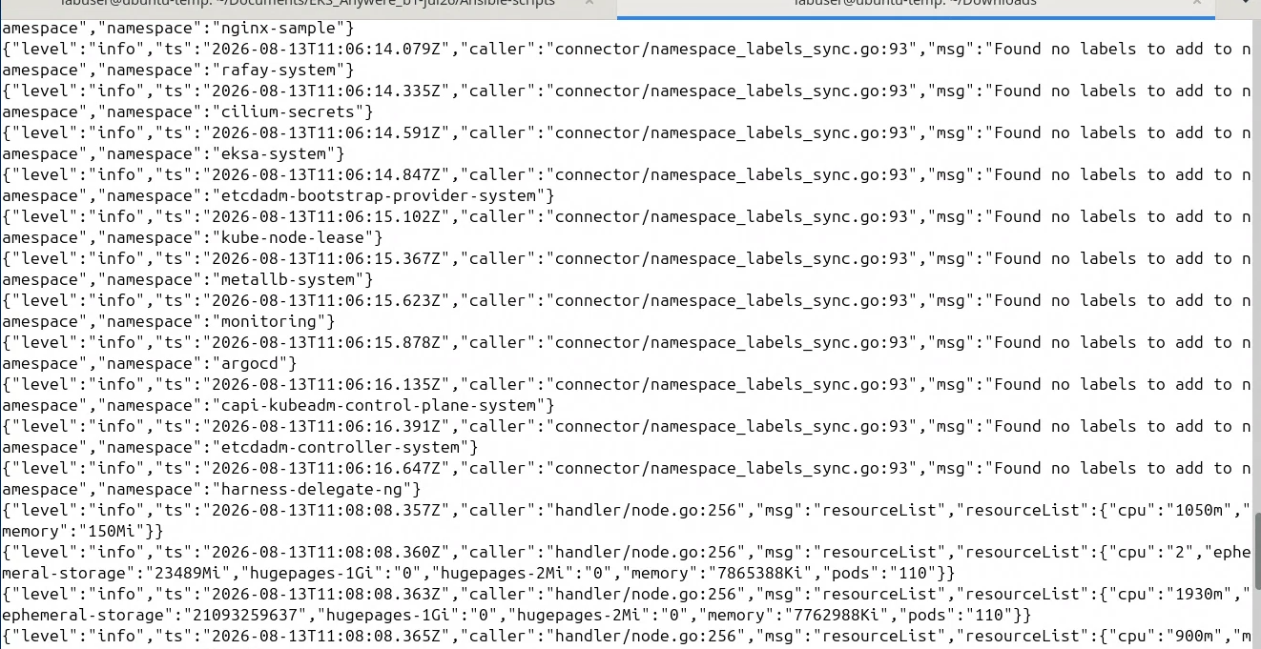
.

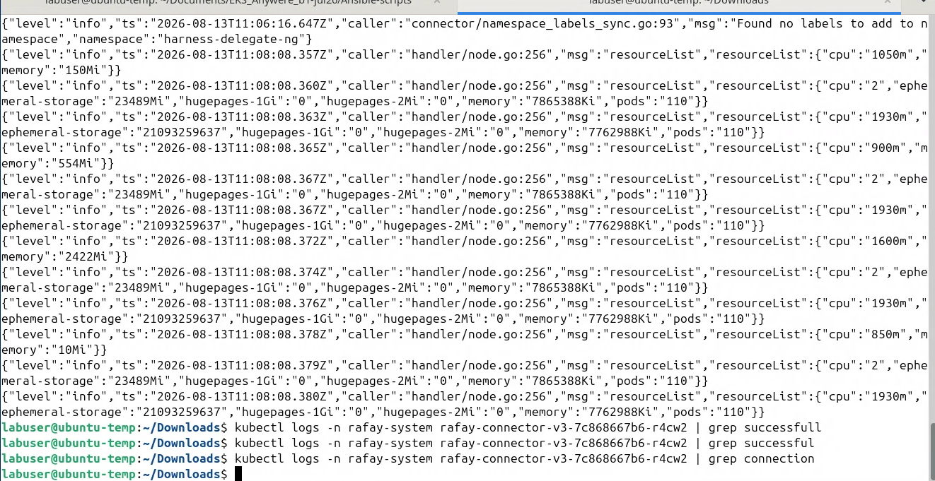
.

Back on Rafay

Step 22 — Return to Rafay Console
Go back to:
Rafay Console
|
+-- Your Project
|
+-- Infrastructure
|
+-- Clusters
You should now see:
eksa-student01
The status may initially be:
Initializing
or:
Provisioning
Wait for synchronization.



